**Aim:**

To create a Virtual Machine with 1 CPU, 2GB RAM, and 15GB storage disk using a Type-2 virtualization software (VirtualBox).

**Procedure:**

1. Install VirtualBox (Type-2 Hypervisor):
   * Download and install Oracle VirtualBox on the host system.
   * Ensure virtualization is enabled in the system BIOS/UEFI.
2. Create a New VM:
   * Open VirtualBox → Click New.
   * Enter a name for the VM and select the type of operating system (Windows/Linux).
   * Allocate 1 CPU from the processor settings.
   * Assign 2GB (2048MB) RAM to the VM.
   * Create a new virtual hard disk with 15GB storage capacity.
3. Configure the VM:
   * Attach the ISO image of the desired OS to the VM.
   * Configure additional settings (display, network, etc.) if required.
4. Install Operating System:
   * Start the VM and boot from the attached ISO.
   * Proceed with the installation steps of the selected OS.
5. Verify VM Configuration:
   * After installation, log in to the OS.
   * Check system properties inside the VM to confirm:
     + CPU: 1 Core
     + RAM: 2GB
     + Disk Storage: 15GB

**OUTPUT:**

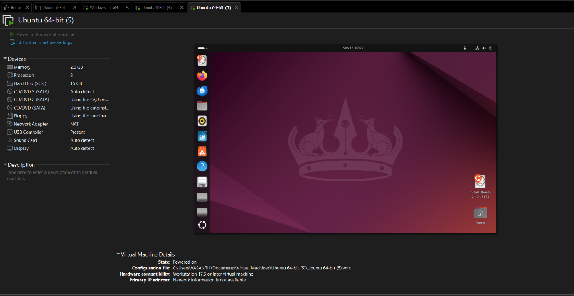

**Result:**

A Virtual Machine was successfully created using VirtualBox with 1 CPU, 2GB RAM, and 15GB disk space, and an operating system was installed and verified.