УДК 004.9:504.3.054

THE DEVELOPMENT OF A PERSONALIZED WEB MONITORING PLATFORM FOR AIR POLLUTION AND DUST ALLERGY: ASSESSING THE INFLUENCE OF PM2.5 ON DAILY LIFE IN ALMATY

BAKHITBEKOV Aibatyr
4th year student of EP «»,
International Information Technology University
34157@iitu.edu.kz
SAGYNBAY Aru
2th year student of EP “Political Science
and International Relations”,
Nazarbayev University
aru.sagynbay@nu.edu.kz
BAKHITBEKOV Arsen,
student of Nazarbayev Intellectual school
bakhitbekov_a0810@fmalm.nis.edu.kz

Scientific supervisor:

BAKIROVA G.S.

Master, senior lecturer
Kazakh-German University (DKU)
bakirova@dku.kz

Резюме
В статье анализируется влияние загрязнения атмосферного воздуха на развитие и обострение пылевой аллергии в городской среде Алматы. Исследуются биологические и экологические факторы, усиливающие аллергические реакции при воздействии мелких твердых частиц PM2,5, включая сезонные и климатические влияния. Особое внимание уделяется механизму проникновения PM2,5 в дыхательную систему и его роли в провоцировании воспалительных процессов и повышении чувствительности к аллергенам.
В теоретическом обзоре обобщены международные и местные исследования, связывающие концентрацию PM2,5 с аллергическим ринитом, бронхиальной астмой и снижением качества жизни. В практической части применяется смешанный метод, сочетающий данные мониторинга качества воздуха, опросы и полуструктурированные интервью с жителями. Результаты показывают устойчивую корреляцию между повышенным уровнем PM2,5 и усилением симптомов аллергии, влияющих на повседневное поведение.
На основе полученных результатов предлагается разработать персонализированную веб-платформу для мониторинга качества воздуха, интегрирующую данные об окружающей среде, отслеживание симптомов и алгоритмы рекомендаций. В исследовании подчеркивается его актуальность для планирования в области общественного здравоохранения и потенциальной интеграции в муниципальные информационные системы.

Түйіндеме

Мақала Алматы қаласының қалалық ортасында атмосфералық ауаның ластануы шаңға аллергияның дамуы мен асқынуына әсерін талдайды. Ол ұсақ дисперсті PM2,5 бөлшектерге ұшырау кезінде маусымдық және климаттық әсерлерді қоса алғанда, аллергиялық реакцияларды күшейтетін биологиялық және экологиялық факторларды қарастырады. Атап айтқанда, PM2,5 бөлшектерінің тыныс алу жүйесіне ену механизміне және оның қабынуды туындату мен аллергендерге сезімталдықты арттырудағы рөліне ерекше назар аударылады.

Теориялық шолу PM2,5 концентрацияларының аллергиялық ринит, бронхиалды астма және өмір сапасының төмендеуімен байланысын зерттейтін халықаралық және жергілікті зерттеулерді қорытындылайды. Практикалық бөлімде ауа сапасын бақылау деректерін, сауалнамалар мен тұрғындармен өткізілген жартылай құрылымдалған сұхбаттарды біріктіретін аралас әдіс қолданылды. Нәтижелер PM2,5 деңгейінің жоғарылауы мен аллергия белгілерінің күшеюі арасындағы тұрақты корреляцияны көрсетіп, күнделікті мінез-құлыққа әсер ететінін анықтады.

Нәтижелер негізінде қоршаған орта деректерін, симптомдарды бақылауды және ұсыныстар алгоритмдерін біріктіретін жекелендірілген ауа сапасын бақылау веб-платформасын әзірлеу ұсынылады. Зерттеу қоғамдық денсаулық сақтауды жоспарлау және оны қалалық ақпараттық жүйелерге ықтимал енгізу тұрғысынан оның өзектілігін көрсетеді.

Summary

The article analyzes the impact of atmospheric air pollution on the development and exacerbation of dust allergies in the urban environment of Almaty. It examines biological and environmental factors that intensify allergic reactions under exposure to fine particulate matter PM2.5, including seasonal and climatic influences. Special attention is given to the mechanism of PM2.5 penetration into the respiratory system and its role in triggering inflammation and increasing sensitivity to allergens.

The theoretical review summarizes international and local studies linking PM2.5 concentrations with allergic rhinitis, bronchial asthma, and reduced quality of life. The practical part applies a mixed-method approach, combining air quality monitoring data, surveys, and semi-structured interviews with residents. The findings reveal a consistent correlation between elevated PM2.5 levels and increased allergy symptoms, affecting daily behavior.

Based on the results, the development of a personalized web platform for air quality monitoring is proposed, integrating environmental data, symptom tracking, and recommendation algorithms. The study highlights its relevance for public health planning and potential integration into municipal information systems.

Introduction
Dust allergy is a widespread allergy condition affecting millions of people’s lives every day, mostly in urban environments. Commonly it is caused by allergens like house dust mites, however, environmental factors such as fine particulate matter (PM2.5) have been increasingly recognized as crucial causes of allergy. PM2.5 particles are so small and because of it, it can easily penetrate deep into our respiratory system, exacerbating allergic and respiratory diseases. In cities like Almaty with high air pollution exposure of PM2.5 represents a growing public health concern. In this review where used thematic approach, we will examine causes of dust allergy, symptoms and impacts on daily life, the role of PM2.5, existing strategies to help affected individuals and justify the development of personalized monitoring tools.
Dust allergy primarily results from an overactive immune response to allergens found in households and environmental dust. House dust mites are the main culprits, as their fecal proteins can induce immunoglobulin E-mediated reactions in sensitive individuals. When allergens contact the respiratory epithelium, histamines and cytokines are released, causing inflammation and typical allergy symptoms. Environmental pollution further intensifies the allergic response. Fine matter PM2.5 acts as a carrier for biological allergens and toxic substances, which can reach deeper sections of the respiratory tract. Prolonged exposure to PM2.5 damages epithelial barriers and increases the body’s sensitivity to allergens. Genetic predisposition additionally performs a role: people with a own circle of relatives records of allergic reactions display a higher risk of developing dust allergies, particularly in polluted urban environments. Altogether, literature suggests that both biological sensitivity and environmental exposure are necessary for the full manifestation of dust allergies.

Consequences of dust allergies
Typical dust allergy symptoms include sneezing, nasal congestion, itchy eyes, coughing, and asthma like breathing problems. These symptoms often persist year-round because dust mites are constantly present indoors [1]. Chronic symptoms reduce sleep quality, impair concentration and may cause fatigue. Environmental factors worsen symptom severity. Studies reveal that people exposed to high levels of PM2.5 experience more frequent and severe allergic episodes. For instance, exposure to increased particulate concentrations correlates with higher rates of hospital admissions for allergic rhinitis and asthma [2]. Beyond physical discomfort, persistent coughing and sneezing can lead to social embarrassment and emotional stress. Which reduces the quality of life and productivity [3-4]. Therefore, dust allergy no longer simplest impacts physical health, however also mental well-being and basic everyday performance.
Except urbanization there are other causes of ecological issues, as global warming, sea level rise, and air pollution. There are a lot of wastes in creating and producing drugs that helps timely from allergy. In USA every year, people spent 4.6 milliard dollars on pharmaceutical drugs that damage our environment. According to research, pharmaceutical drugs affect oceans, because most of them were thrown there, causing fishes to poison from it and reducing their population. However, despite the fact of our ways of reducing the effect of dust, main reason for ecological damage will be and still is urbanization. Because of air pollution in cities [5] with high population density, air pollution will continue the concentration of PM2.5, and this will continue causing more allergies, even when you didn’t have it, it can appear after the time. That’s why people will start buying more drugs that will increase the demand, and because of it, it will increase the production of pharmaceutical drugs. Therefore, people need to stop air pollution to not harm our nature, because people need to preserve it for our next generations.

PM2.5 refers to airborne particles smaller than 2.5 micrometers, which can easily bypass natural respiratory defenses and penetrate deep lung tissues. [6] identifies PM2.5 as one of the maximum risky air pollutants in the world. Chronic exposure contributes to inflammation and oxidative stress in the airways, making it more worser allergy condition that exists [7]. Epidemiological studies confirm that long term exposure to PM2.5 notably increases the superiority of allergic respiratory diseases [8]. Furthermore, even short-term spikes in PM2.5 concentrations can trigger acute allergic reactions or asthma exacerbations [9]. Urban residents are especially vulnerable because traffic, industry and heating systems contribute to continuous particulate emissions. Personalized exposure assessment is therefore essential. [10] argue that city wide averages may not reflect individual risks, as microenvironments differ in temperature, humidity and air circulation. For this reason, localized and real time monitoring technologies can help people with dust allergies manage exposure more effectively.

Methods
Nowadays methods for managing dust allergies are focused on symptoms control and exposure reduction. Common strategies include antihistamines, nasal sprays, and immunotherapy. Although these strategies show effective confrontation against allergies among patients, they don’t reduce environmental triggers directly [11]. There is also popular strategy that recommends doctors, patients must just avoid the triggers, such as using air purifiers or reducing indoor dust. However, [2] argue that such methods are not effective, because there are highly polluted urban environments where outdoor air quality strongly influences indoor conditions. Some studies explored air quality monitoring applications, but they often provide generated data instead of real analyzed data, making them more unreliable for individuals. Innovative solutions, such as Allergicard, demonstrate increasing interest in digital tools for allergy prevention. Moreover, research in environmental health shows that integrating sensor-based monitoring with personal health feedback could help individuals plan their daily life routines and avoid high risk periods [12]. Therefore, developing personalized monitoring systems that combine environmental and medical data is a promising direction for preventing dust allergies.
A consistent pattern in the literature shows that dust allergies are influenced by both biological allergens and environmental pollution, particularly PM2.5. Numerous studies confirm a strong association between elevated PM2.5 levels and increased severity of allergic symptoms. However, existing tools mainly focus on symptom management and often lack personalization and real-time monitoring, limiting their practical effectiveness.
These gaps justify the development of an integrated technological solution. Therefore, this study proposes a personalized web-based monitoring platform that combines real-time PM2.5 data, symptom tracking, and adaptive recommendations to support informed daily planning and exposure reduction.
The platform architecture follows a client–server model shown at Figure 1. The frontend provides a user dashboard with geospatial air quality visualization, while the backend processes environmental data and generates personalized recommendations. Integration with real-time air quality APIs allows the system to display PM2.5 levels across different districts of Almaty. By combining environmental indicators with user-reported symptoms, the platform creates a personalized exposure profile, improving preventive decision-making.

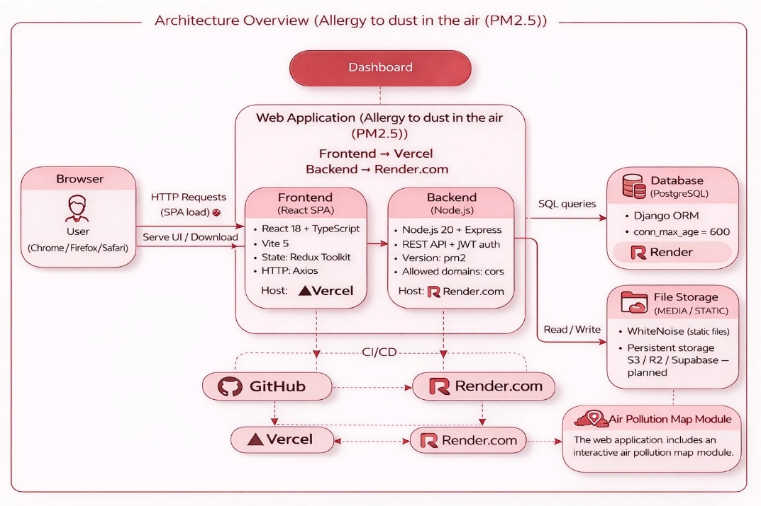

Figure 1. Client-Server Architecture of the Air Pollution
Monitoring Web Platform

To support personalized exposure assessment, the proposed web platform includes a geospatial air quality monitoring module. This component provides real-time visualization of PM2.5 concentrations across different districts of Almaty using an interactive map interface. The system applies a color-coded classification scale based on air quality standards, enabling users to quickly interpret pollution levels and identify potential health risks. The following figures illustrate the platform interface under different environmental conditions, demonstrating its functionality in both high and low pollution scenarios.
Figure 2 illustrates the interactive air quality map integrated into the personalized web monitoring platform. The visualization displays district-level PM2.5 concentrations across Almaty using a color-coded classification system (Good, Moderate, Unhealthy, Hazardous). In this scenario, several districts demonstrate elevated PM2.5 levels, indicating increased health risk. The map module enables users to identify pollution hotspots and assess potential exposure in real time, supporting informed daily planning and preventive decision-making.

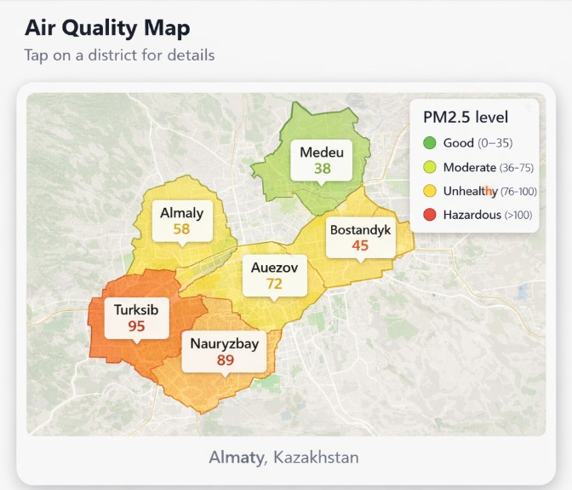

Figure 2. Interactive PM2.5 Air Quality Map of Almaty
(High Pollution Scenario)

Figure 3 presents the air quality map under favorable environmental conditions. PM2.5 concentrations across districts remain within the “Good” category, indicating reduced exposure risk. The geospatial interface allows users to monitor air quality fluctuations and compare pollution levels over time. The module supports personalized health management by providing localized environmental data integrated with the monitoring platform.

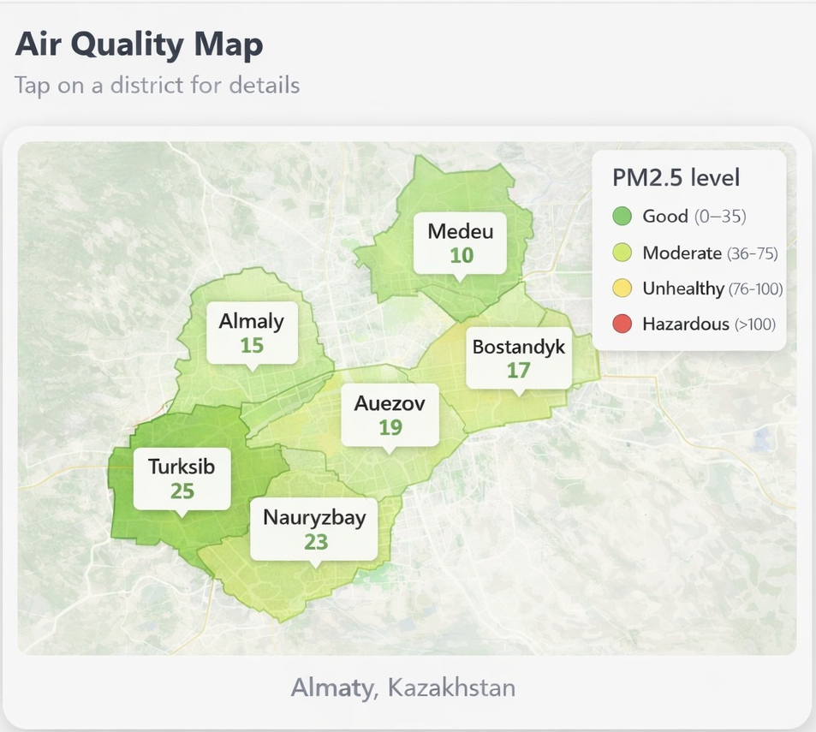

Figure 3. Interactive PM2.5 Air Quality Map of Almaty
(Low Pollution Scenario)

Methodology
This study used a mixed-methods design combining quantitative and qualitative approaches. The aim was not only to measure PM2.5 levels but also to examine how air quality monitoring influences daily life for individuals with dust allergies in Almaty. Integrating both methods allowed environmental data to be linked with personal experiences.
The quantitative component included environmental observation and a survey. Observations provided objective data on PM2.5 and weather conditions, while the survey assessed symptom frequency, behavioral changes, and air quality awareness. The qualitative component consisted of semi-structured interviews, offering deeper insight into coping strategies and desired monitoring features.
The framework assumed that higher PM2.5 exposure worsens allergy symptoms and affects daily activities. Combining both data types strengthened the credibility of the findings through cross-verification.
Sampling
The target population of this study consisted of residents of Almaty, particularly individuals experiencing dust allergy or dust-related symptoms, as this group was directly affected and most relevant to the research question. The study was conducted in Almaty because air quality issues are highly localized and influenced by urban infrastructure, traffic density, weather conditions, and geographical factors.
The sample size was total of 70 survey responses were collected, allowing for the identification of clear patterns related to symptom frequency and behavioral responses. In addition, three semi-structured interviews were conducted with participants who reported dust allergy symptoms. Although three interviews do not provide statistical generalization, they contributed qualitative depth and helped interpret survey findings.
Participant recruitment was based on a combination of convenience and purposive sampling methods. The survey was distributed online through Telegram communities where individuals discuss allergy-related issues, making access to the relevant target group practical and realistic. Interview participants were selected purposively from survey respondents who confirmed experiencing dust allergy symptoms and agreed to further participation. This approach ensured the relevance of qualitative data and alignment with the research objectives.
Ethical considerations were carefully addressed. Participation was voluntary, and survey responses were collected anonymously. No names, exact addresses, or sensitive identifying information were gathered. In cases where participants were under 18 years old, parental permission was requested. These measures ensured compliance with ethical standards for participant protection and responsible sampling practices.

Materials and Instruments
The materials and instruments used in this study were practical and accessible. For the observational component, publicly available air quality and weather monitoring platforms were used consistently throughout the observation period. AirVisual was used to obtain PM2.5 data, while temperature, humidity, and wind speed were collected from reliable meteorological sources. The same data sources were maintained throughout the study to minimize inconsistencies caused by differences in reporting systems or sensor networks.
The primary observational instrument was a structured data recording table in which measurements were documented twice daily. The table included the date, time, PM2.5 concentration, temperature, humidity, wind speed, and optional contextual notes (e.g., visibility conditions or strong wind). This structured format ensured repeatability of data collection and allowed for the calculation of daily averages and comparison of fluctuations over time.
For the survey component, a structured questionnaire was developed to collect data on demographic characteristics (age group, residence in Almaty), presence of dust allergy symptoms, symptom frequency, awareness of air quality indicators, behavioral responses to pollution, and perceived usefulness of monitoring information. The survey was administered using the Google Forms platform, which enabled efficient and anonymous data collection.
For the qualitative component, a short semi-structured interview guide (6–7 minutes) was used. Interview questions focused on symptom triggers, perceived connections between air quality and health, coping strategies, and desired features of a monitoring application. Interviews were recorded using a standard mobile recording application. This instrument was appropriate because it provided deeper insight into personal experience and practical daily challenges beyond numerical survey data. Research procedure was structured, sequential, and clearly documented to ensure reliability. First, a 10-day observation period was conducted in Almaty. Data were recorded twice daily from 08:00 to 20:00, including PM2.5 concentration, temperature, humidity, and wind speed. Each measurement was documented with the corresponding date and time in a structured data table.
Second, the survey was conducted during the same general period. All responses were collected anonymously. The analysis primarily focused on respondents residing in Almaty who reported dust allergy symptoms, as this group was most directly related to the research question.
Third, three semi-structured interviews were carried out with participants who confirmed experiencing dust allergy symptoms. Interviews were conducted either online or in person. Notes and transcripts were prepared, and no personal identifying information was collected in order to maintain confidentiality.
Finally, the data were analyzed using appropriate descriptive methods. For the observational data, daily average PM2.5 values were calculated, and line graphs were generated to illustrate changes over time. Scatter plots were used to examine possible relationships between PM2.5 and weather variables such as humidity, wind speed, and temperature. Survey responses were summarized using percentages and average severity scores. Interview data were categorized into thematic groups, including activity planning, symptom management, and desired application features. The integration of quantitative and qualitative findings strengthened the overall validity of the study.

Data Analysis and Results
To evaluate the relationship between air quality and dust allergy symptoms, the collected survey data were analyzed using descriptive statistical methods. A total of 70 valid responses were examined to identify patterns related to symptom frequency, behavioral changes, and awareness of air pollution levels. The analysis focused on understanding how PM2.5 exposure influences daily activities and whether personalized monitoring tools could support better planning decisions.
The results are presented in the following figures, which illustrate the distribution of allergy symptoms, the impact of poor air quality on daily plans, and the perceived usefulness of a PM2.5 monitoring application. Figure 8 shows the distribution of dust allergy symptoms among respondents. The majority reported experiencing symptoms, confirming the prevalence of allergy-related discomfort within the sample. Figure 9 demonstrates that a significant proportion of respondents reported changing their daily plans due to poor air quality, indicating a measurable impact of PM2.5 on lifestyle decisions. Figure 10 illustrates that most participants believe a PM2.5 monitoring application would help them plan daily activities better, supporting the necessity of personalized monitoring tools.

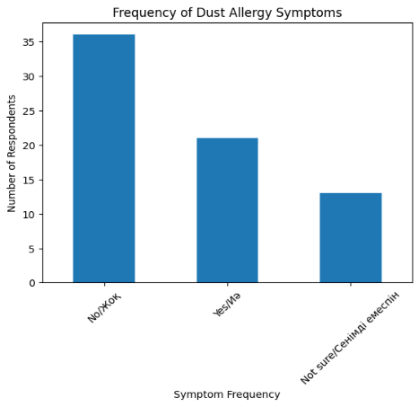 | 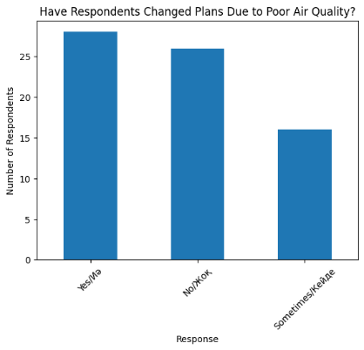 | 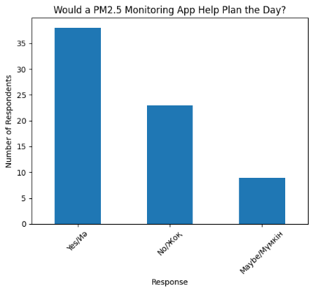
Figure 8. Frequency of Dust Allergy Symptoms | Figure 9. Changed Plans | Figure 10. Usefulness of App

Conclusion
There are a lot of factors like air pollution, allergens and environmental exposure that cause and make the allergy to dust. PM2.5 plays paramount role in making allergy symptoms even worser and reducing the quality of people’s life, especially those who live in urban areas. Even though current medical drugs and preventive strategies help to reduce the symptoms of allergy, they depend on the concentration of PM2.5 in the air that’s why it is not always effective. Predictive tools for monitoring concentration of PM2.5 could support individuals with dust allergies.

REFERENCES
- Aggarwal, P., & Senthilkumaran, S. (2023, August 8). Dust mite allergy. In StatPearls. Statpearls publishing.
- Wu, J., Ge, D., Zhou, L., Hou, L., Zhou, Y., & Li, Q. (2018). Effects of particulate matter on allergic respiratory diseases. Chronic Diseases and Translational Medicine, 4, 95 - 102.
- Hawrylowicz, C.M., & Santos, A.F. (2019). Vitamin D: can the sun stop the atopic epidemic? Current Opinion in Allergy and Clinical Immunology, 20(2), 181-187.
- Brożek, J.L., et al., (2017). Allergic Rhinitis and its Impact on Asthma (ARIA) guidelines - 2016 revision. The Journal of Allergy and Clinical Immunology, 140, 950–958.
- Voros, K., et al., (2019). The influence of air pollution on respiratory allergies, asthma and wheeze in childhood in Hungary. Minerva pediatrica.
- World Health Organization. (2021, September 22). WHO global air quality guidelines: Particulate matter (PM2.5 and PM10), ozone, nitrogen, dioxide, sulfur dioxide and carbon monoxide.
- Guarnieri, M.J., & Balmes, J.R. (2014). Outdoor air pollution and asthma. The Lancet, 383, 1581-1592.
- Manisalidis, I., et al., (2020). Environmental and Health Impacts of Air Pollution: A Review. Frontiers in Public Health, 8.
- Li, S., et al., (2021). Association between exposure to air pollution and risk of allergic rhinitis: A systematic review and meta-analysis. Environmental research, 112472.
- Jang, H., Park, S., & Lee, C. (2025). Time-weighted assessment of personal PM2.5 exposure of patients with allergies using portable monitors in Seoul Metropolitan Area, Korea. Environmental Monitoring and Assessment, 197.
- Pfaar, O., et al., (2022). Guideline on allergen immunotherapy in IgE-mediated allergic diseases. Allergologie Select, 6, 167 - 232.
- European Environment Agency. (2024, June 6). Europe’s air quality status 2024.

