Laboratory work 6
JOIN

- Write a query that displays all flights of a specific airline.
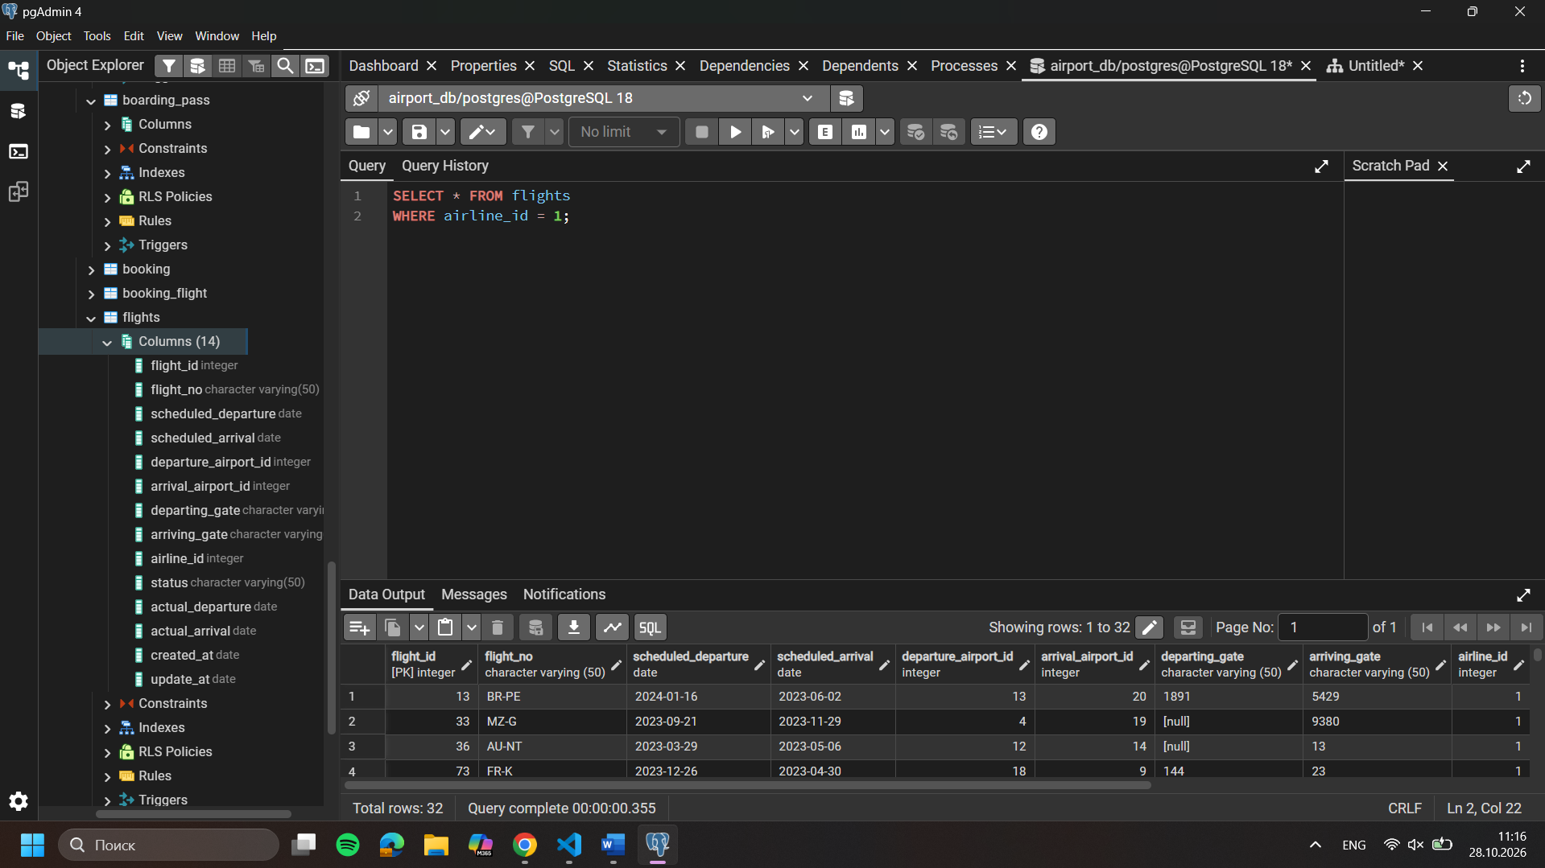
- Compose a query to obtain a list of all flights with the names of departure airports.
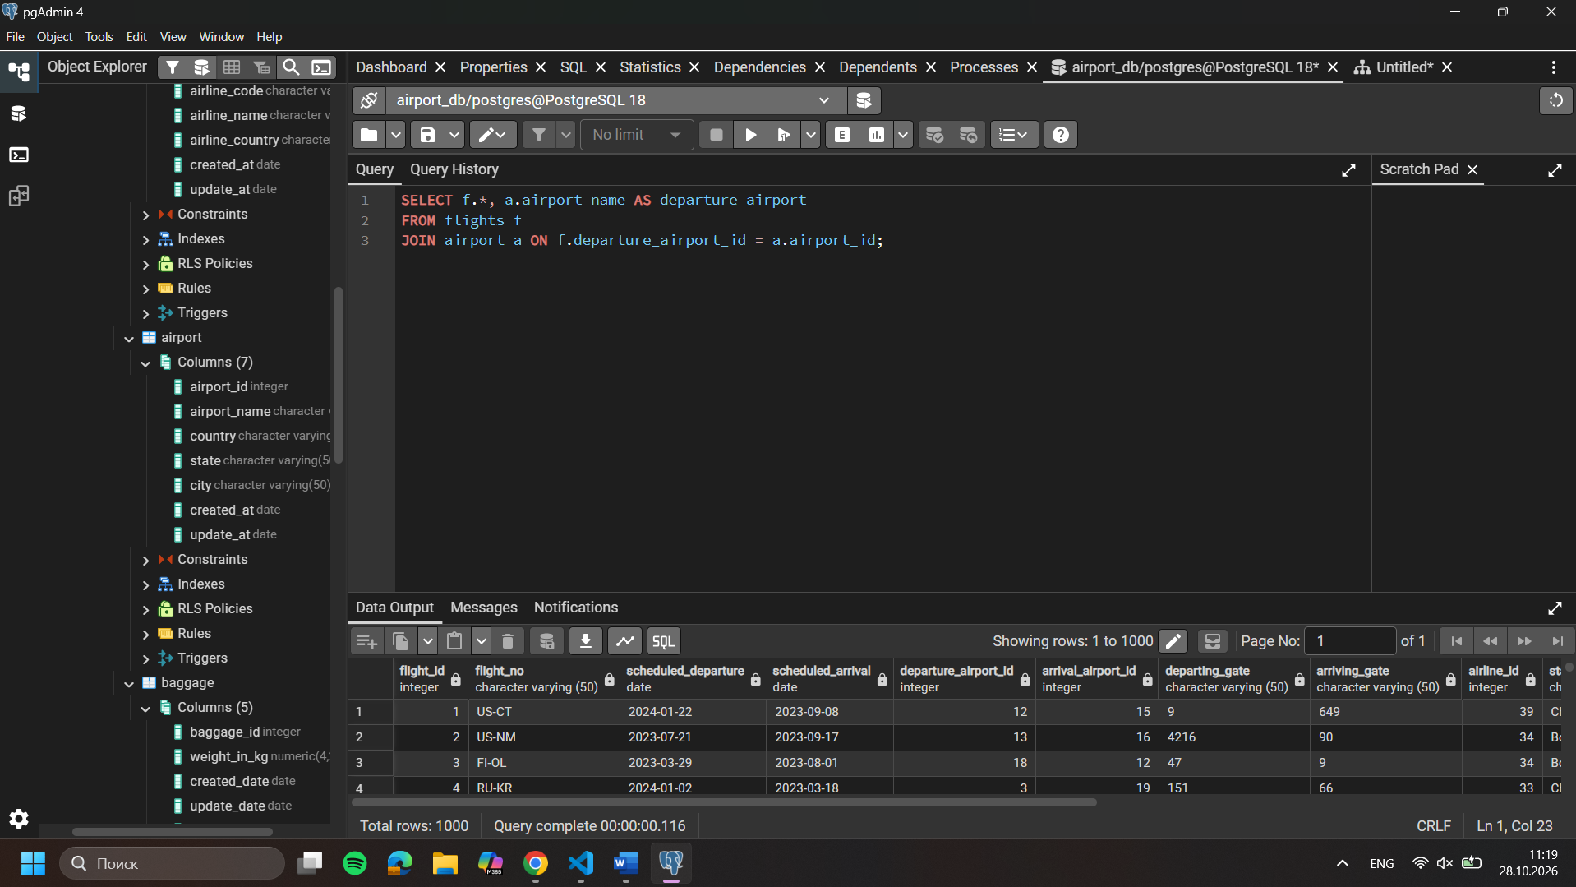
- Create a query that finds all airlines that have no flights scheduled for the next month.
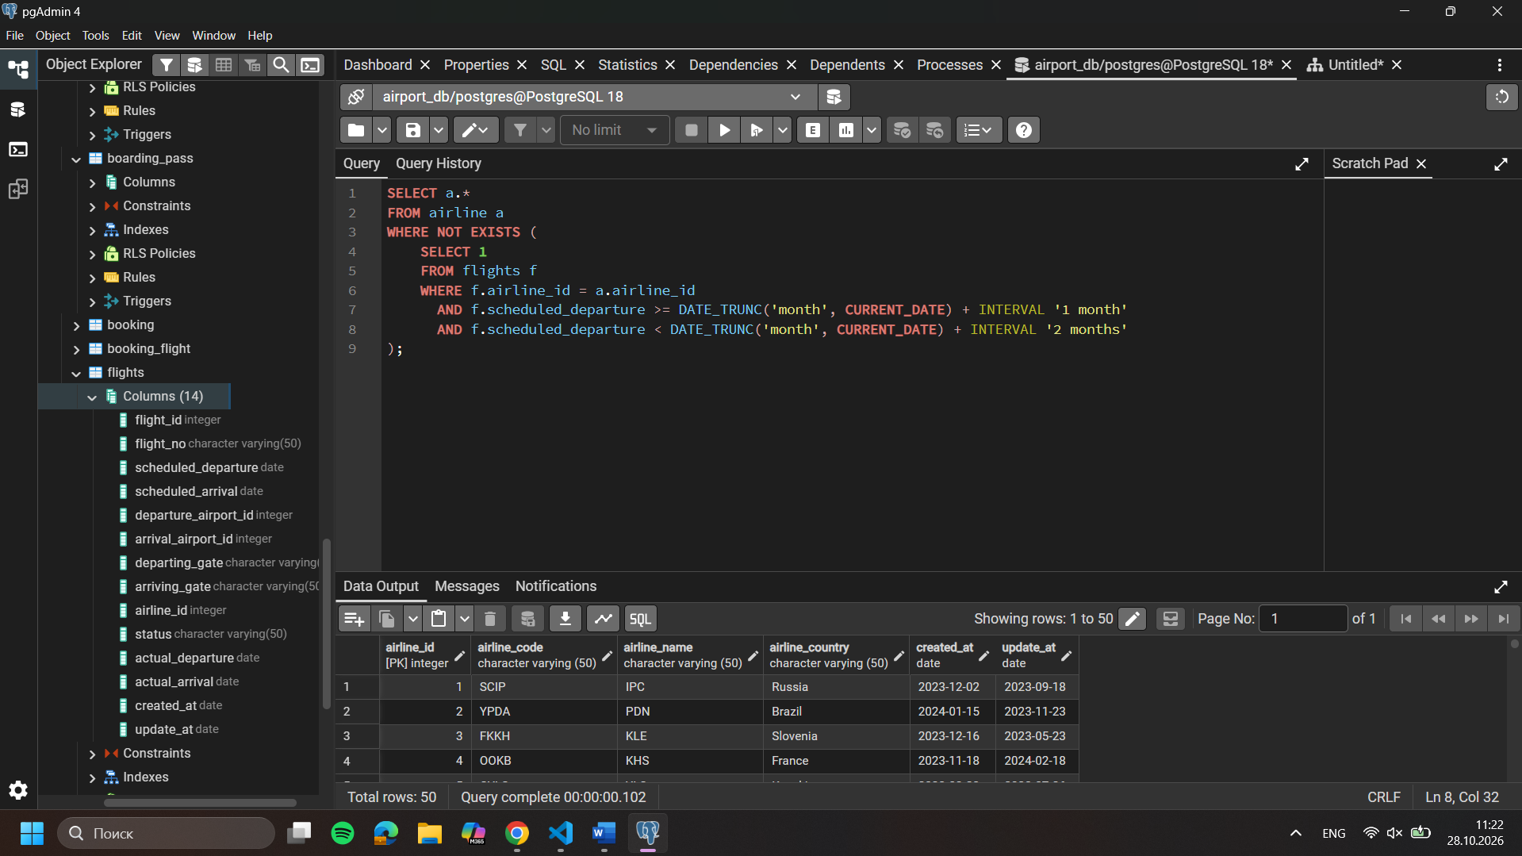
- Create a query to display a list of passengers on a specific flight.
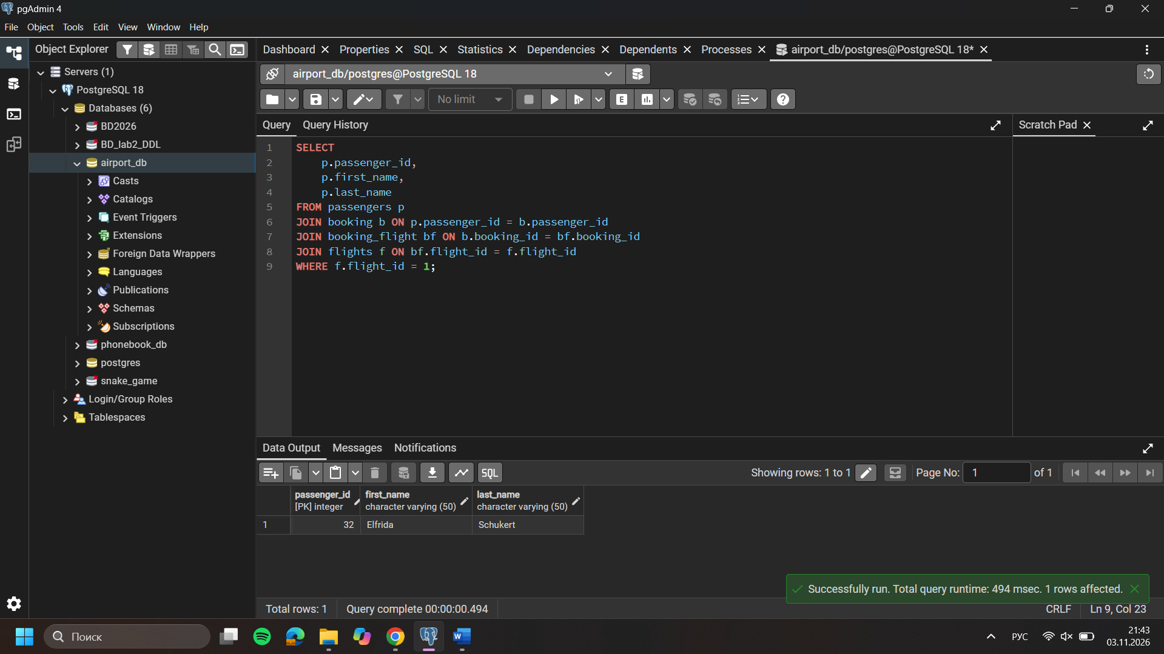
- Write a query that calculates the average, total, maximum and minimum price of tickets for each flight.
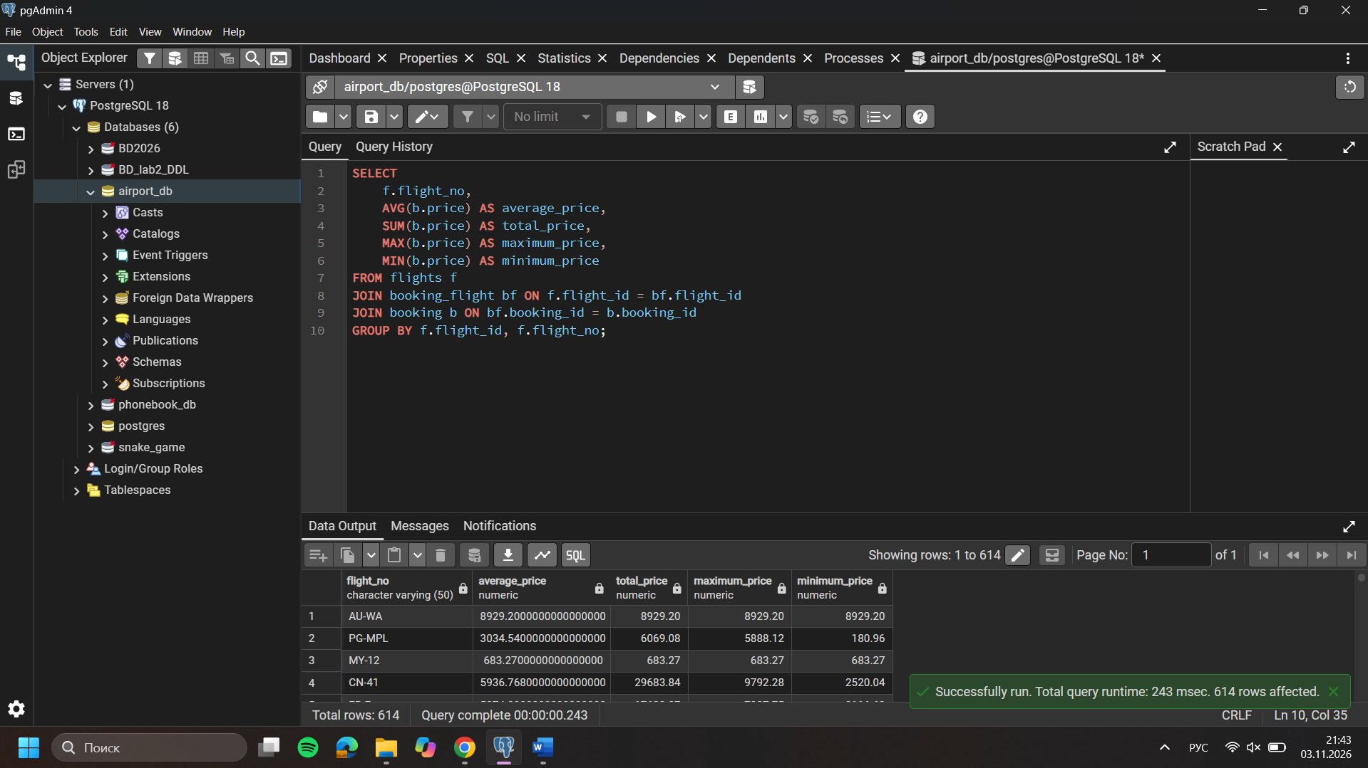
- Create a query that shows all flights flying to a specific country by combining flights, airports and airline, and using the condition on the country name.
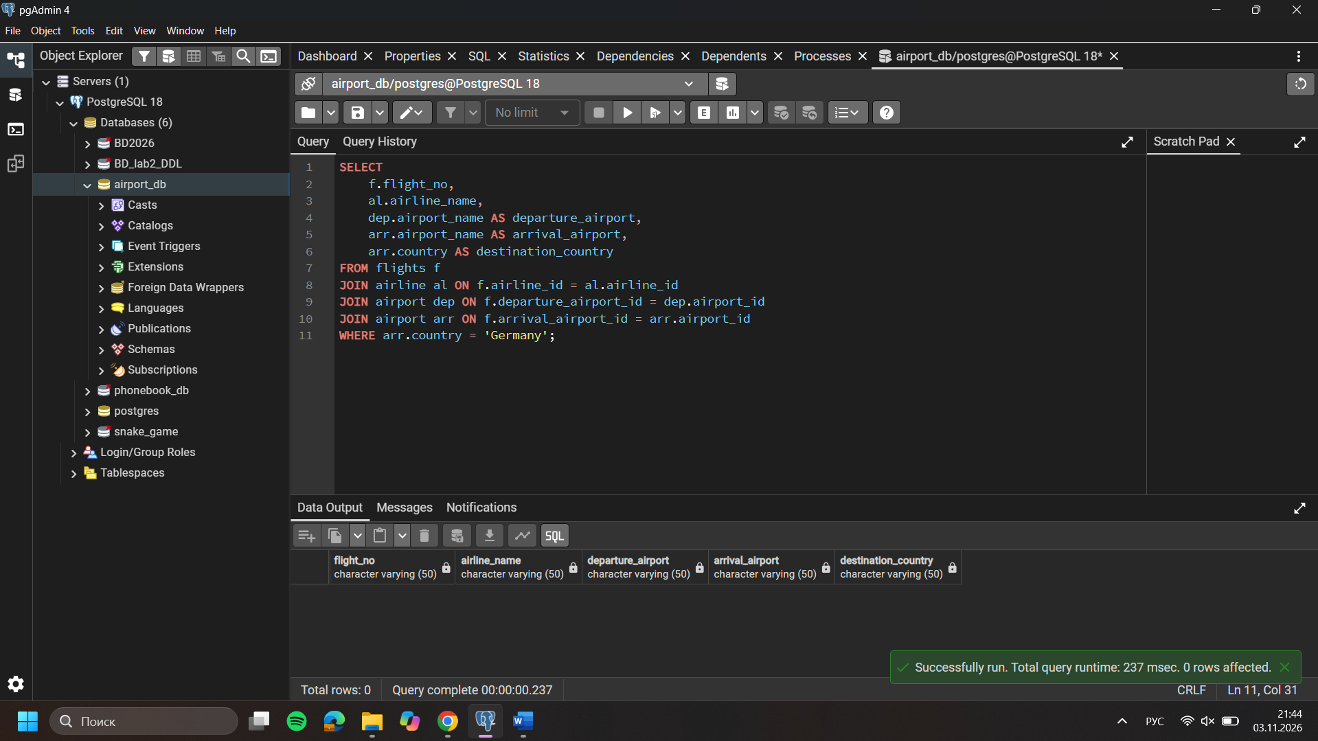
- Display a list of minor passengers and their arrival destination.
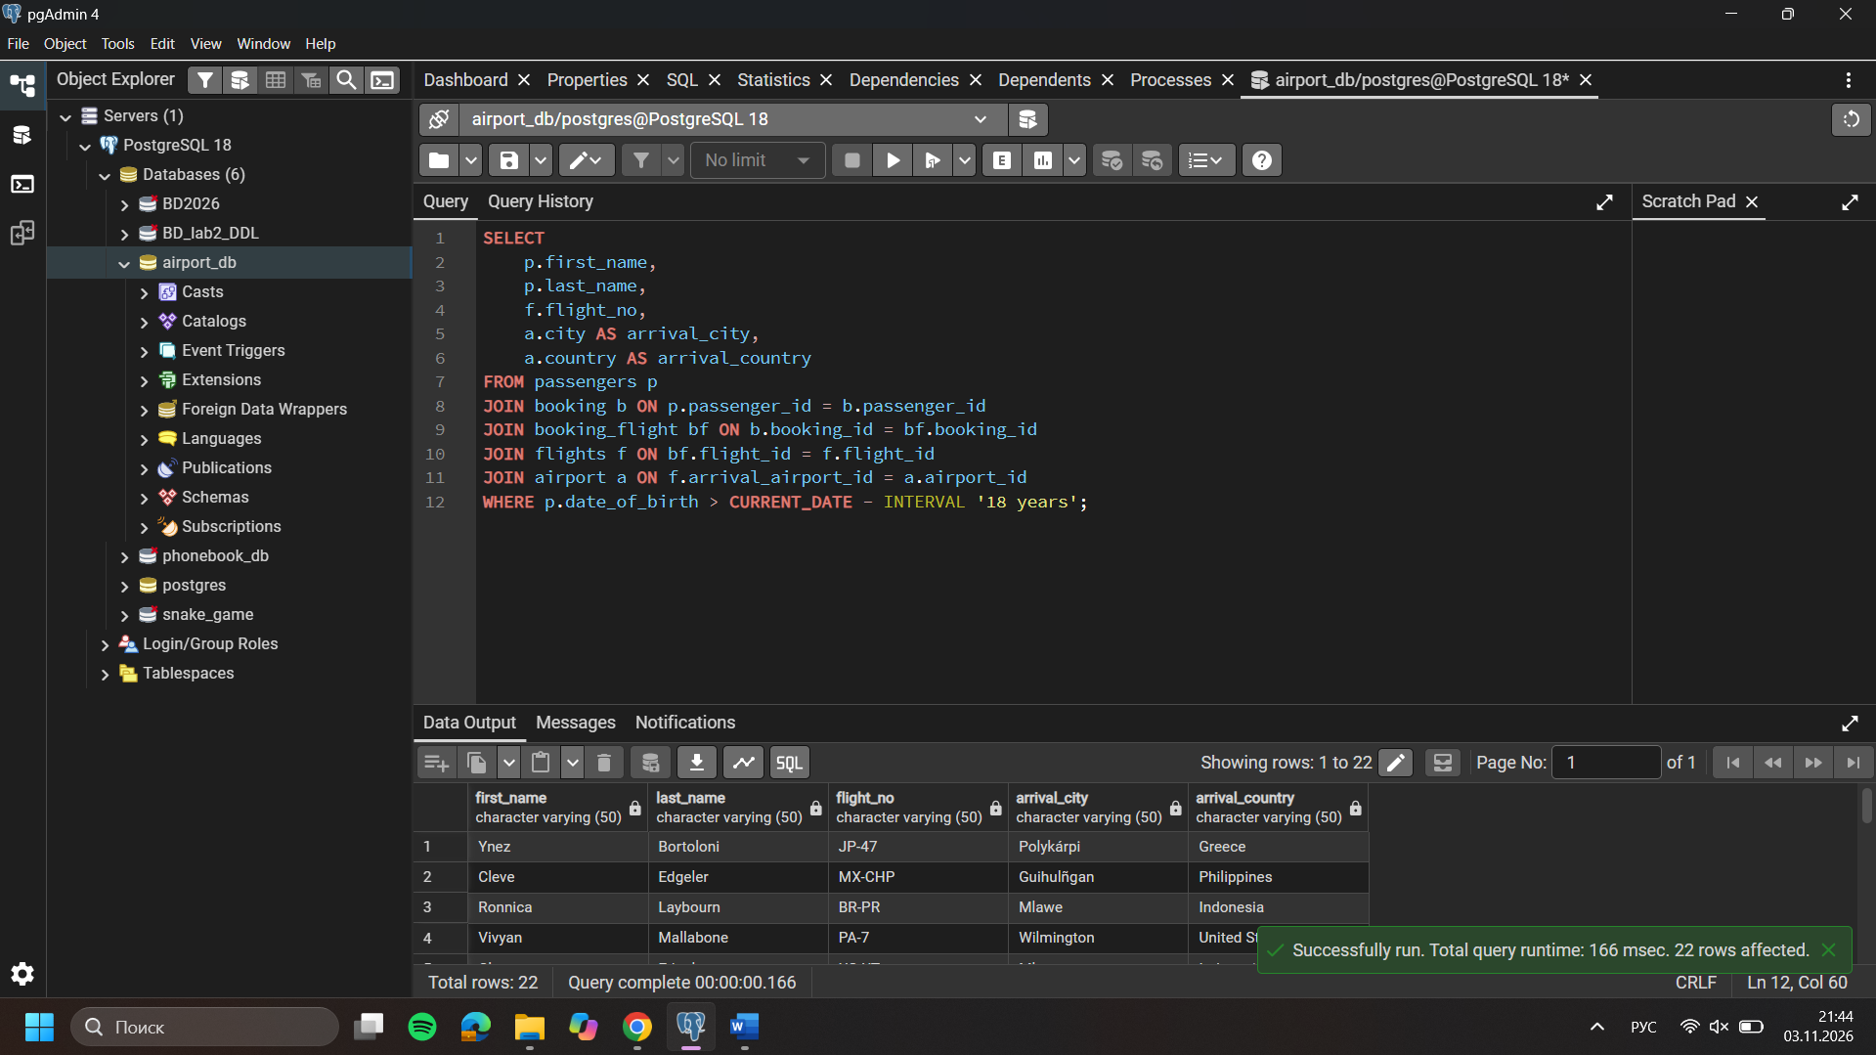
- Display the passenger’s full name, passport number, and the passenger’s current time of arrival at the destination.
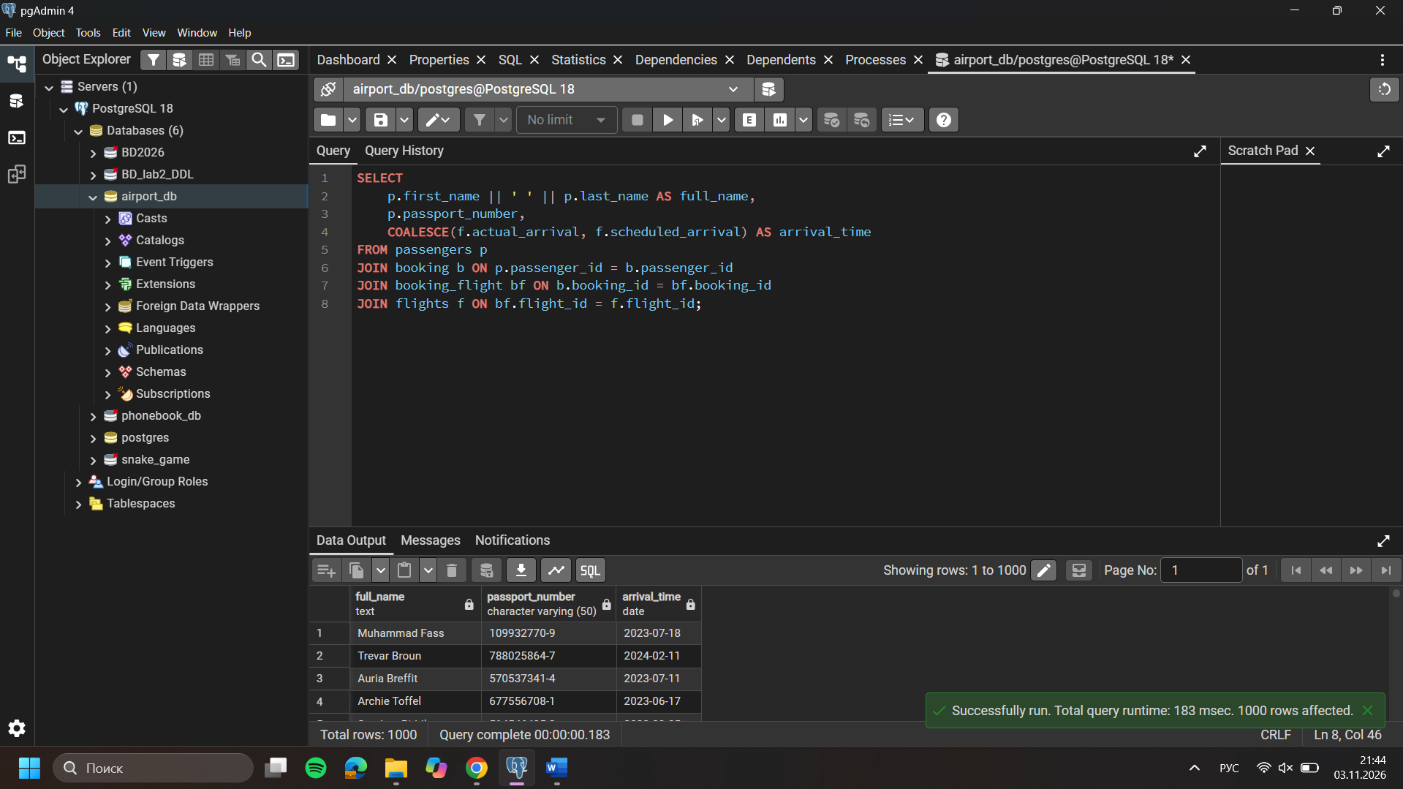
- Print a list of flights where the airline's home country and origin country are the same. Group them by the airport country.
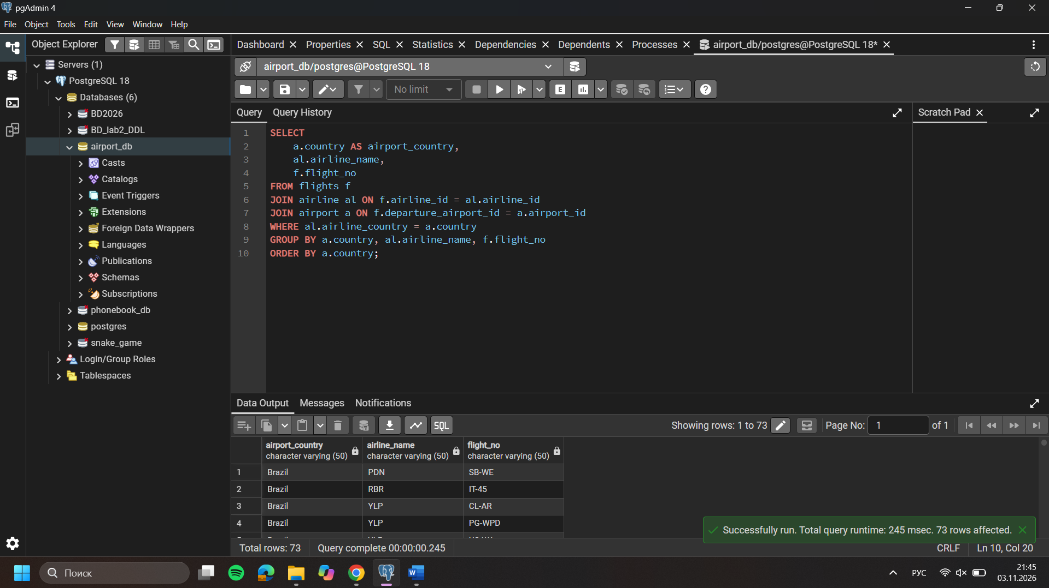
- Write a query that lists each flight number, airline name, departure airport, and arrival airport by joining the relevant tables.
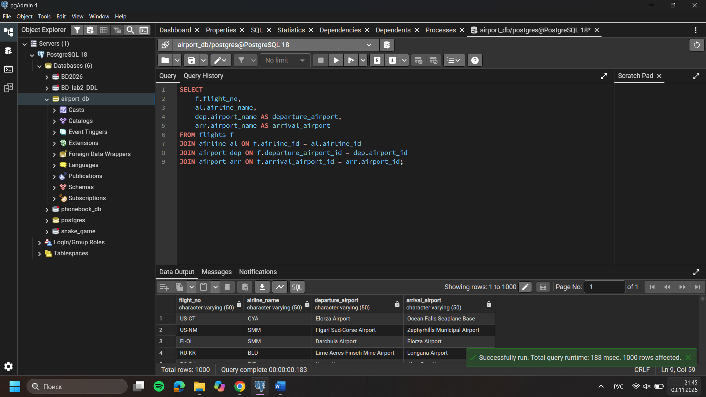
- Display all passengers who have booked tickets for flights operated by a specific airline, including the passenger's full name and flight number.
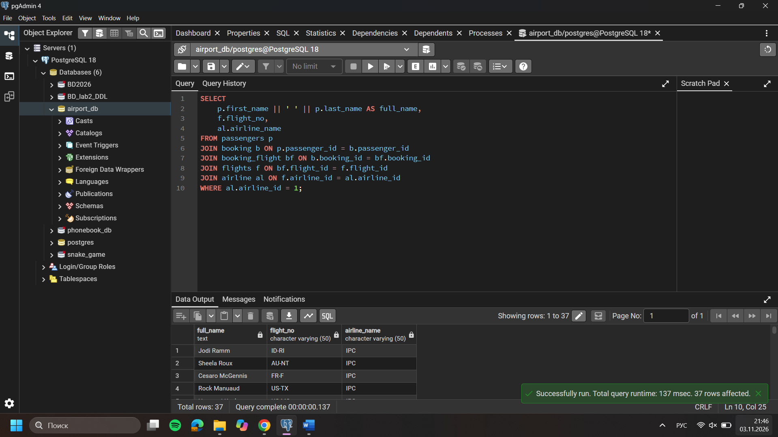
- Create a query that shows each flight's number, destination country, and number of passengers booked on that flight. Include flights with no booked passengers.
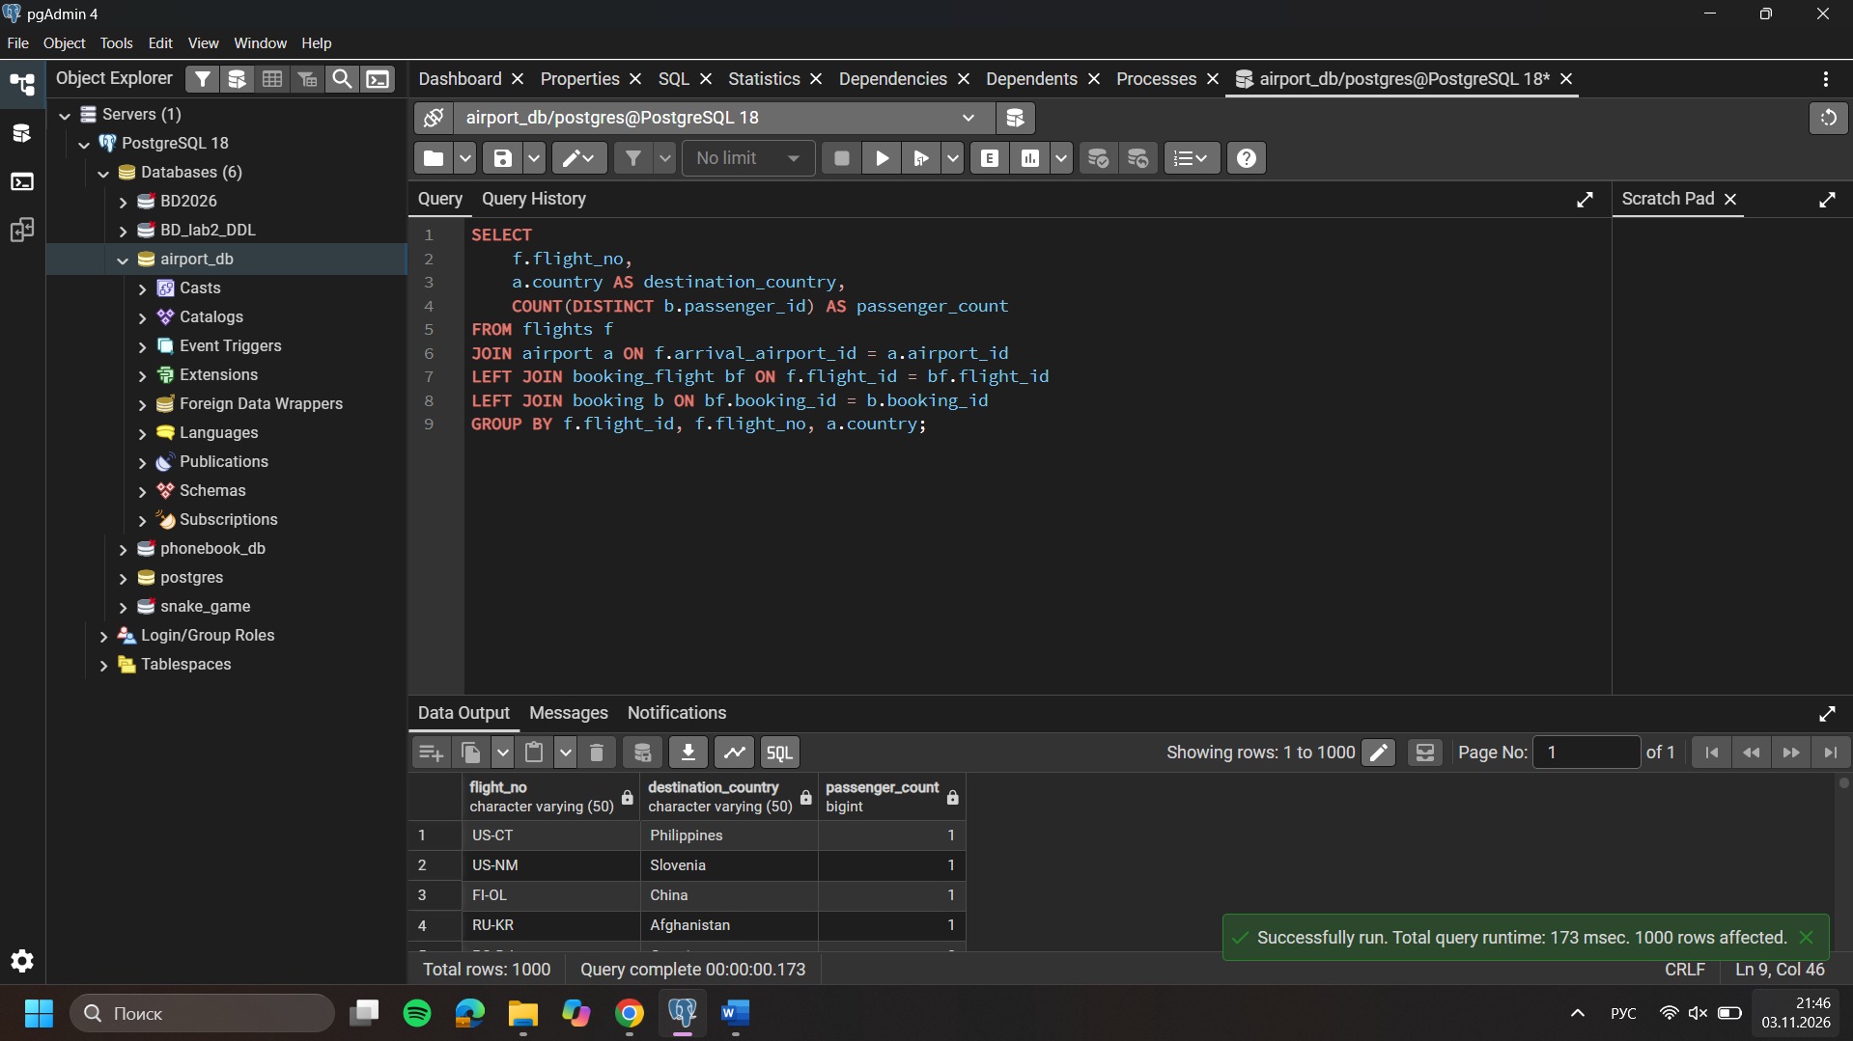
- Find passengers who have not booked any tickets, using an appropriate JOIN operation.
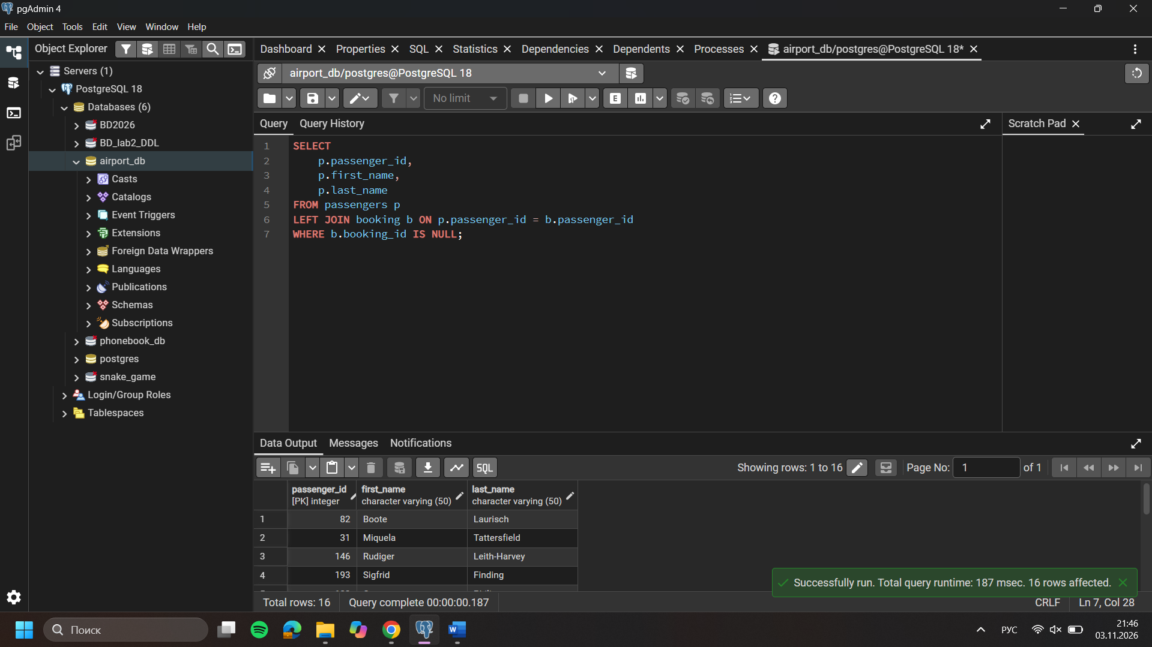
- Display each airline and the total number of flights it operates, including airlines that currently have no flights.
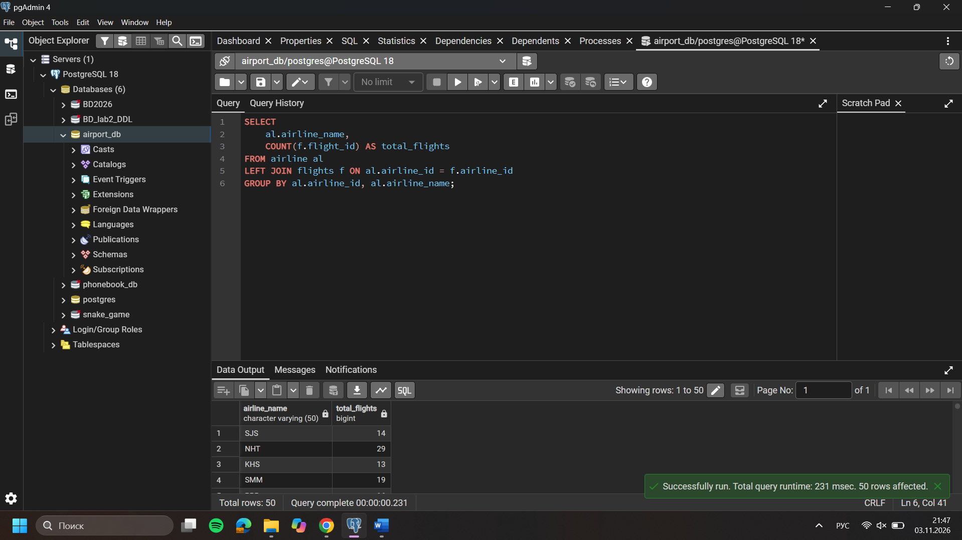
- List flights departing from airports in a specified country and show the airline name, flight number, and departure airport city.


