Laboratory work #2

Normalization
- The table Booking_receipt violates First Normal Form. The column seat_numbers contains multiple values(comma-separated list (e.g. "12A, 12B")). In the 1NF, a table is organized cleanly with atomic, single valued data. No lists or arrays are allowed in a single column.
- 1NF: For every seat/passenger create separate row, duplicating booking info
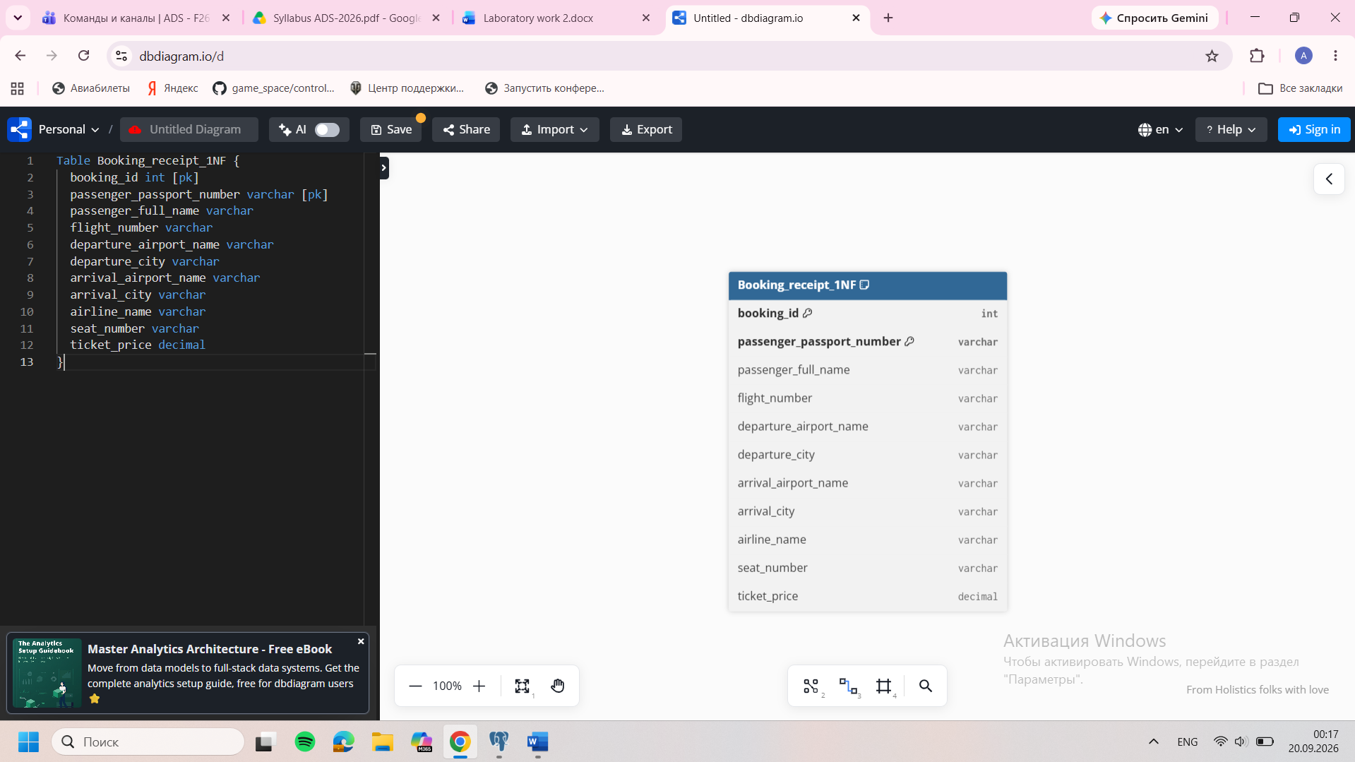
2NF: Separate the booking, flight, and passenger entities.
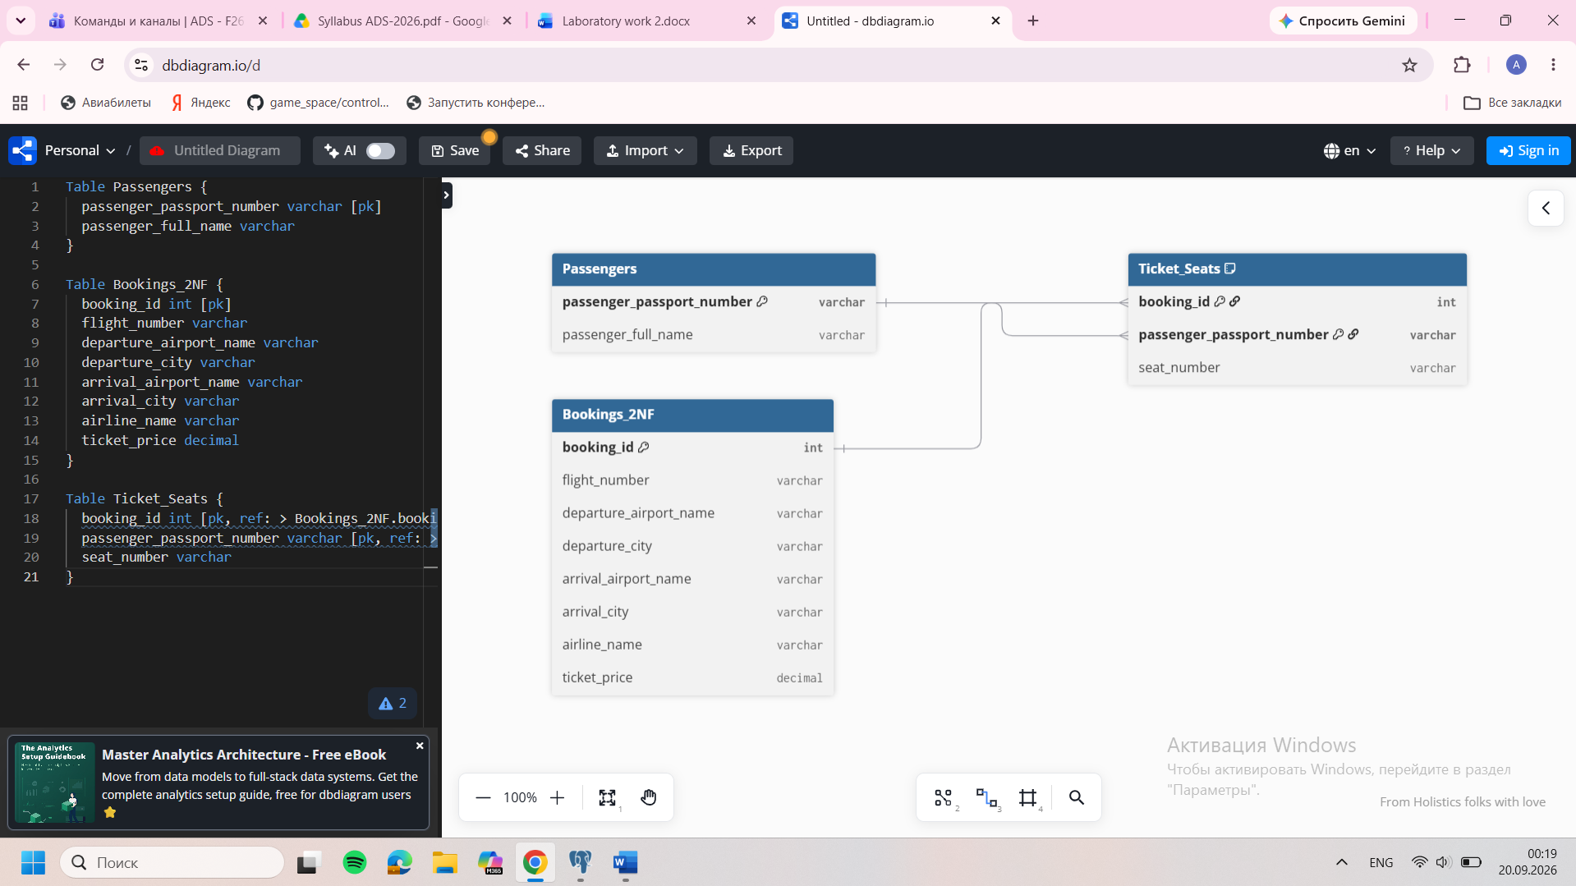
3NF: Eliminate transitive dependencies (where a non-key attribute depends on another non-key attribute). The city depends on the airport, while the airline and airports depend on the flight number. 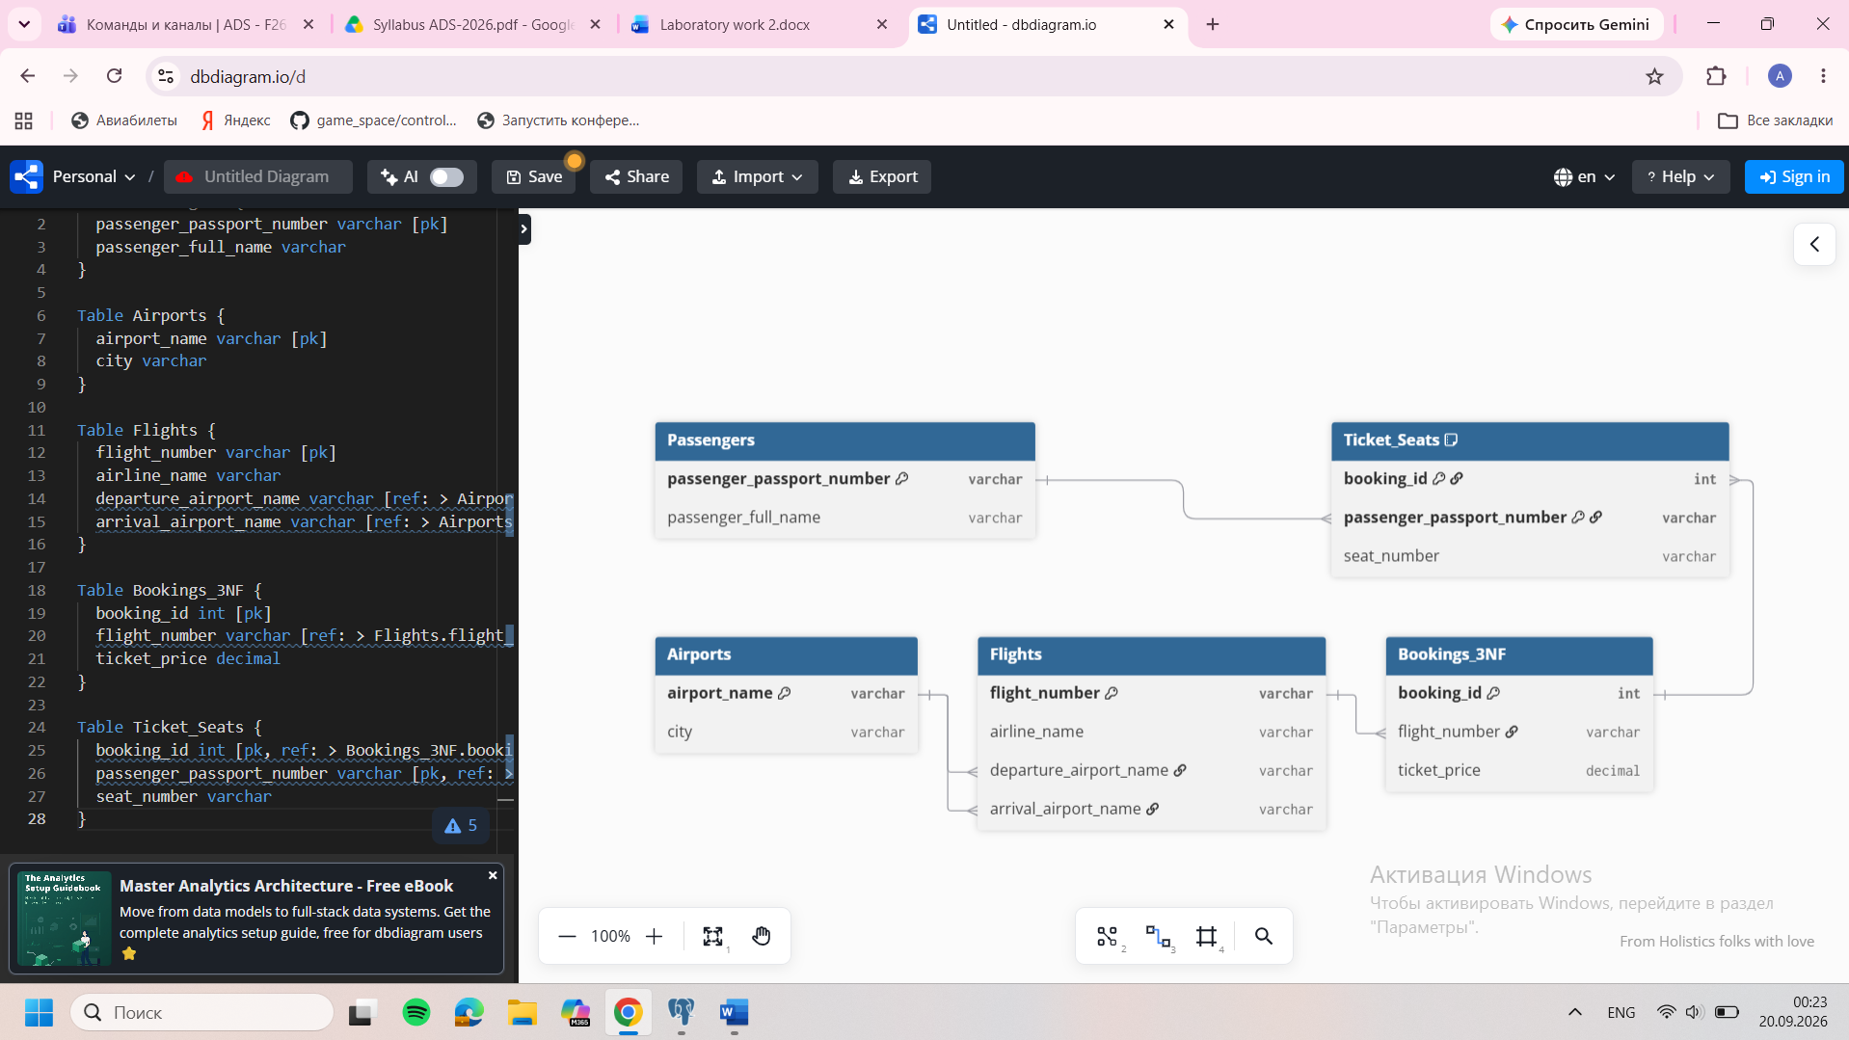
- 1NF: booking_id, passenger_passport_number -> seat_number
passenger_passport_number -> passenger_full_name
booking_id -> flight_number, departure_airport_name, departure_city, arrival_airport_name, arrival_city, airline_name, ticket_price
2NF: passenger_passport_number -> passenger_full_name
booking_id -> flight_number, departure_airport_name, departure_city, arrival_airport_name, arrival_city, airline_name, ticket_price
booking_id, passenger_passport_number -> seat_number
3NF: flight_number -> airline_name, departure_airport_name, arrival_airport_name
departure_airport_name -> departure_city
arrival_airport_name -> arrival_city
booking_id -> flight_number, ticket_price
- Current PK is flight_id. All attributes defined by flight_id; FD: flight_id -> scheduled_departure_time, sch_arrival_time, departing_airport_id, arriving_airport_id, departing_gate, arriving_gate, airline_id, act_departure_time, act_arrival_time, created_at, updated_at. There are no transitive dependencies between non-key attributes. The Flights table is in 3NF.

- 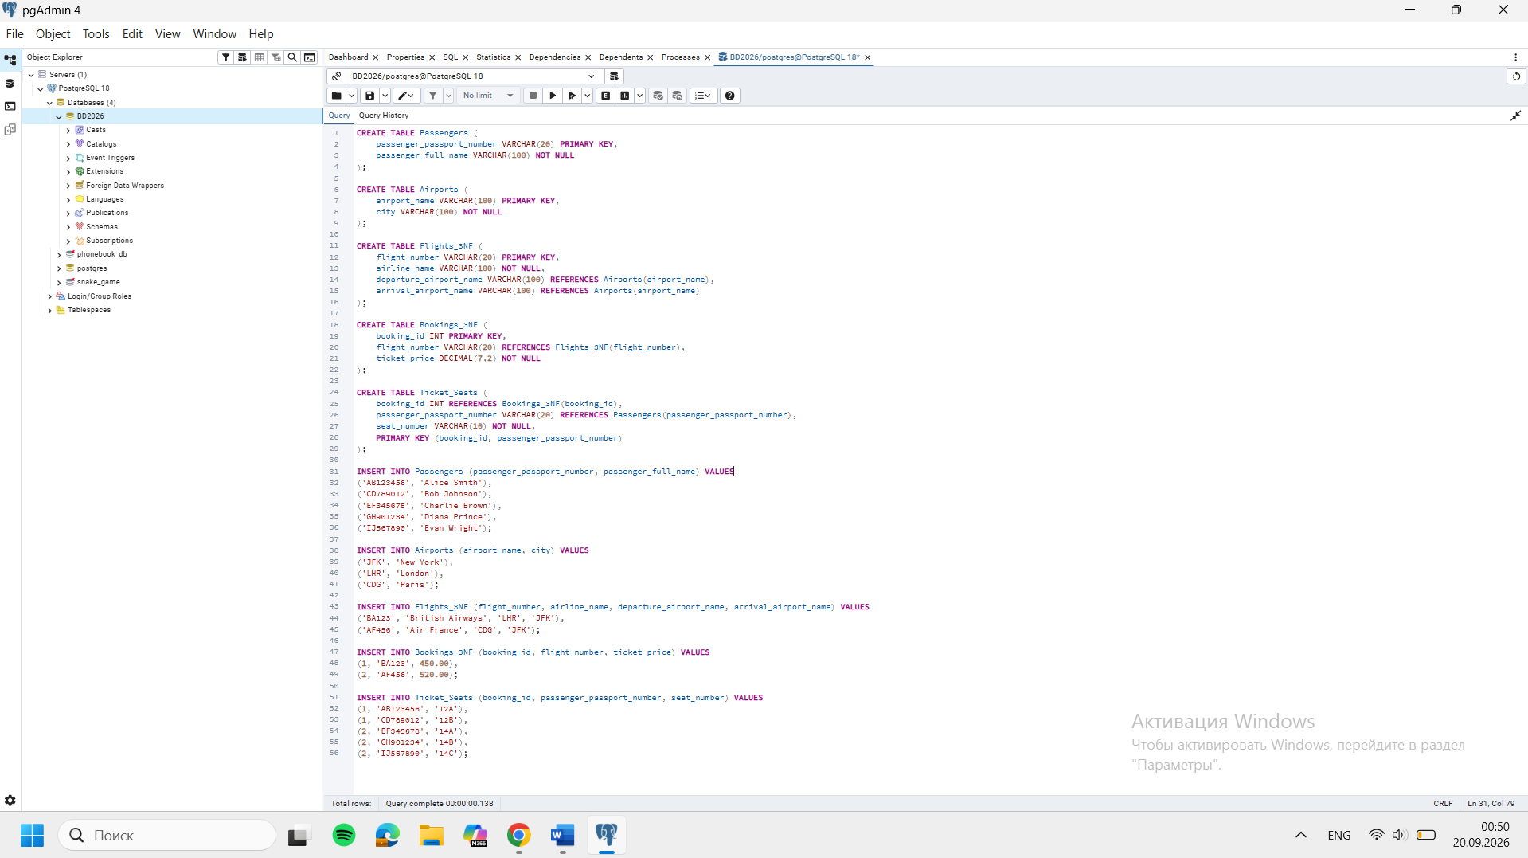

DDL
- 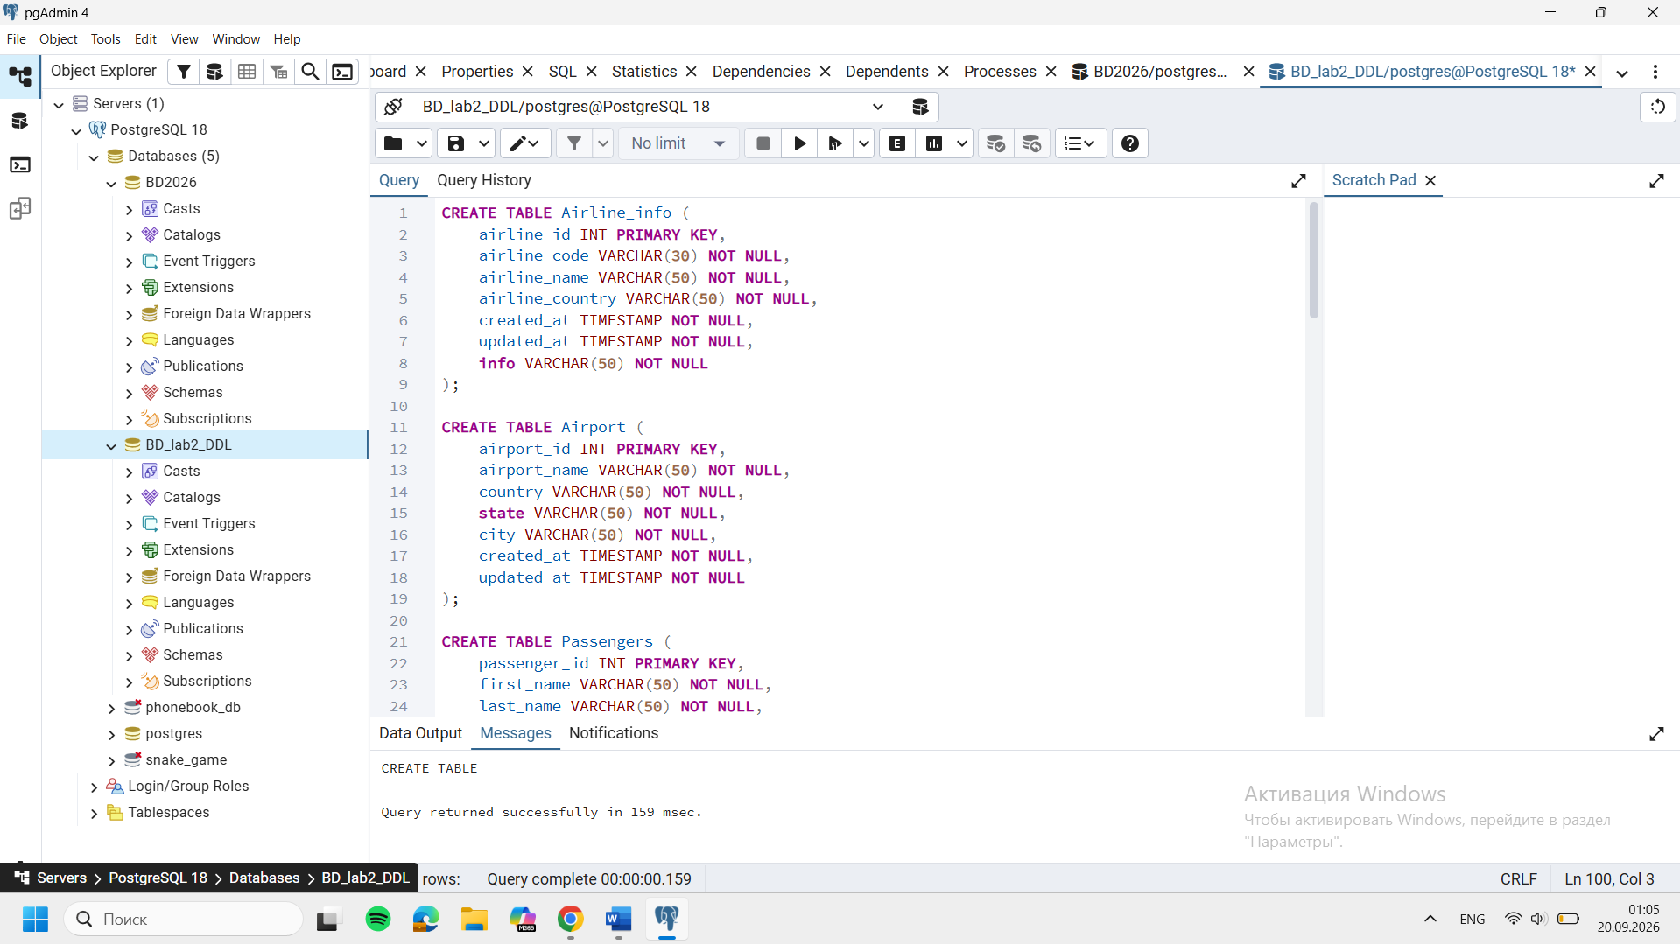
5, 6, 7, 8 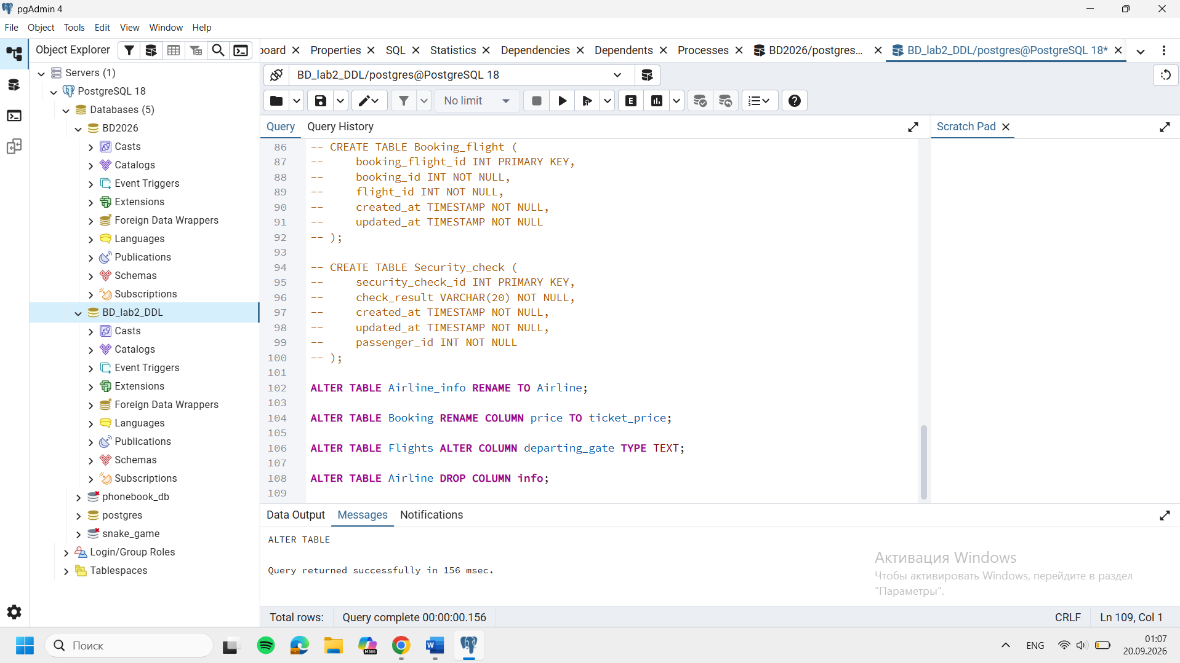
9. 