**OUTPUT SCREENSHOT:**

Here it ranks all the followers based on the number of accounts they individually follow.

It is followed by sending messages to each person and with the daily limit of **1000** we can send 200 messages to each account.

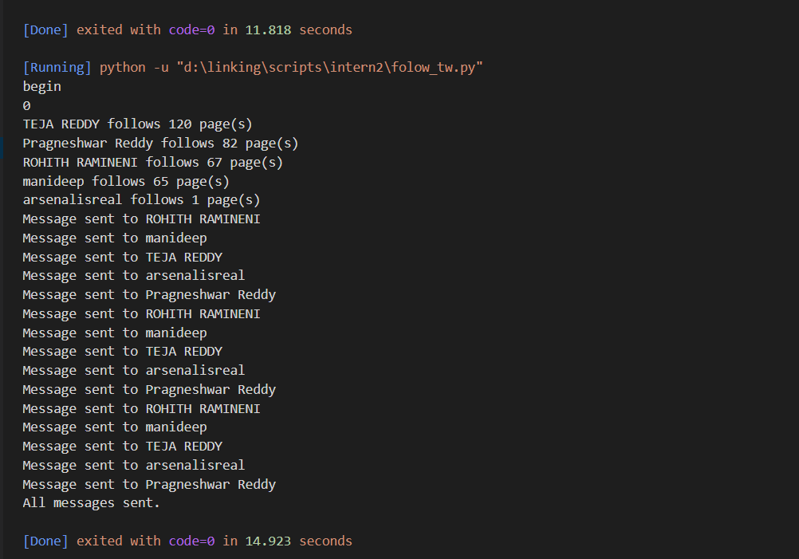

CSV FILE OUTPUT:  
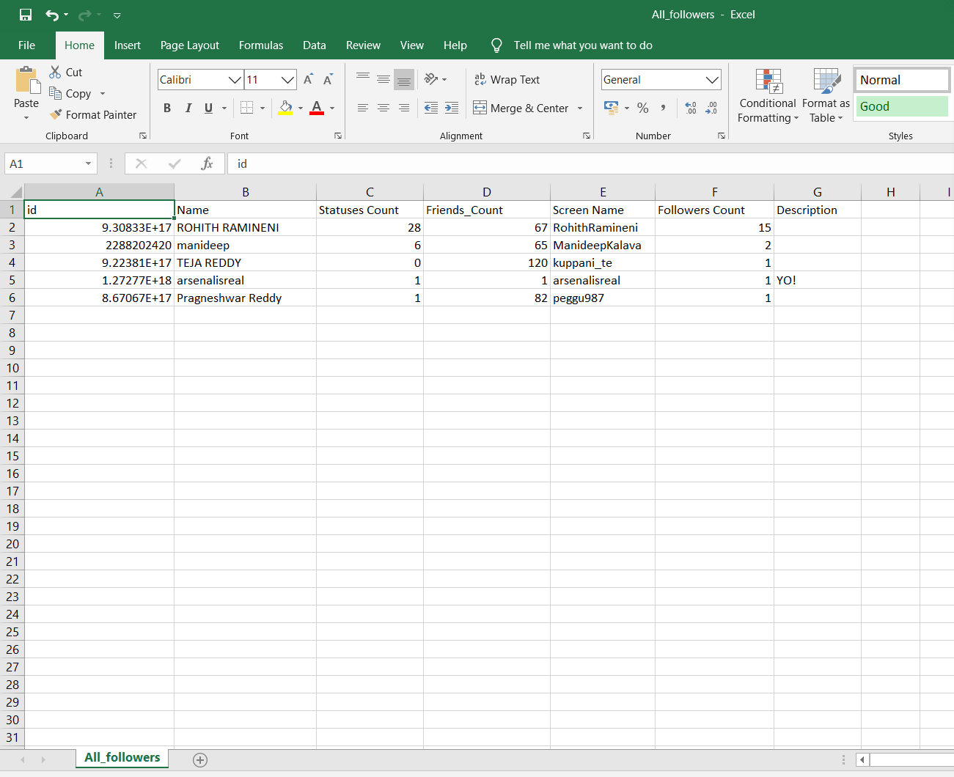

**OUTPUT SCREENSHOT :**

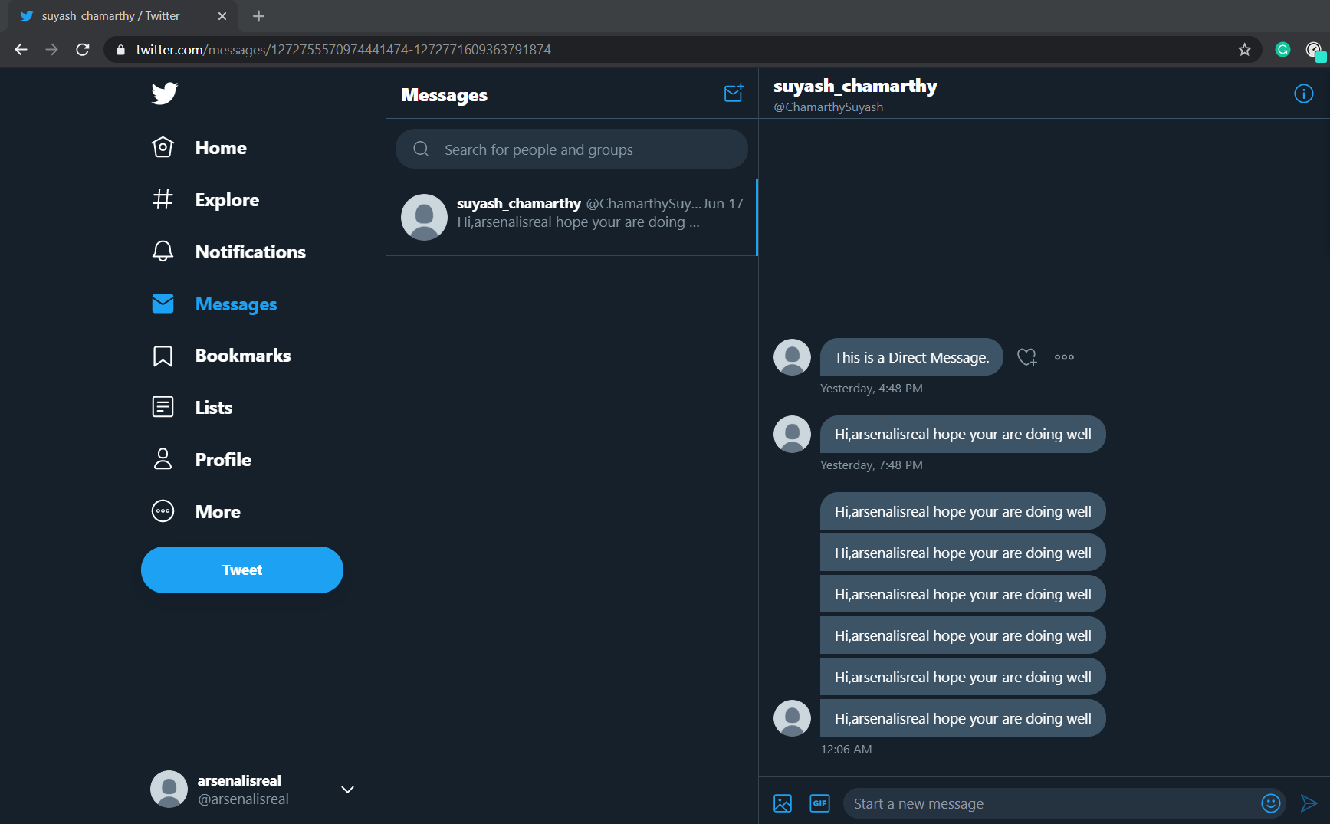

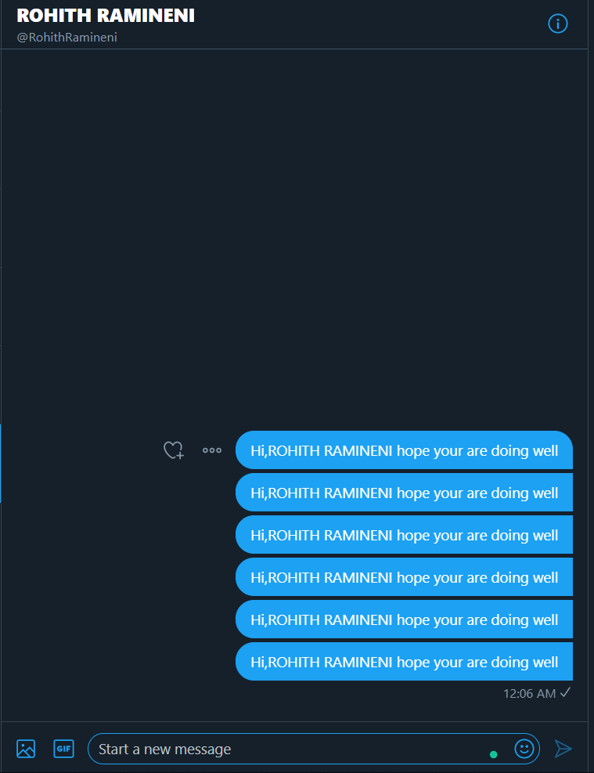 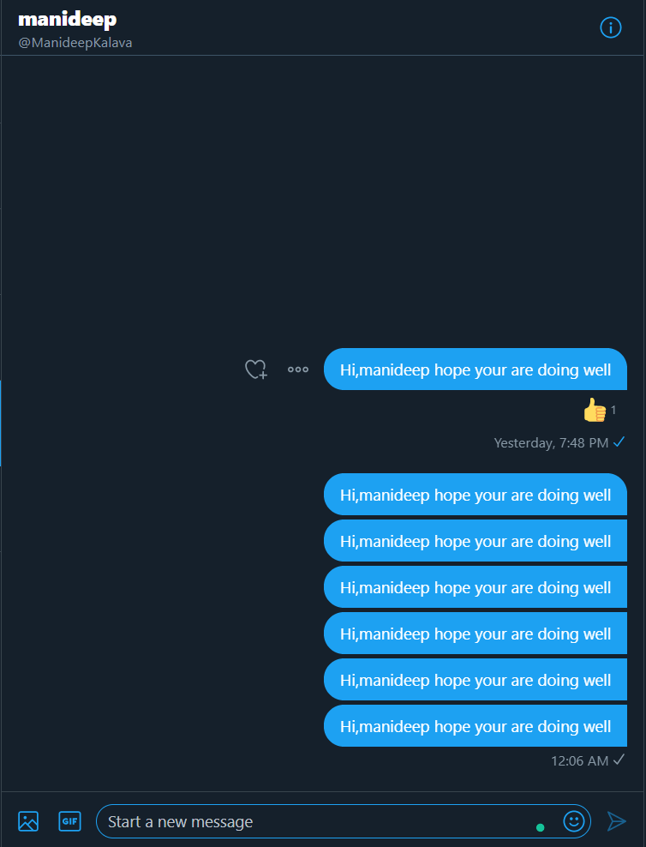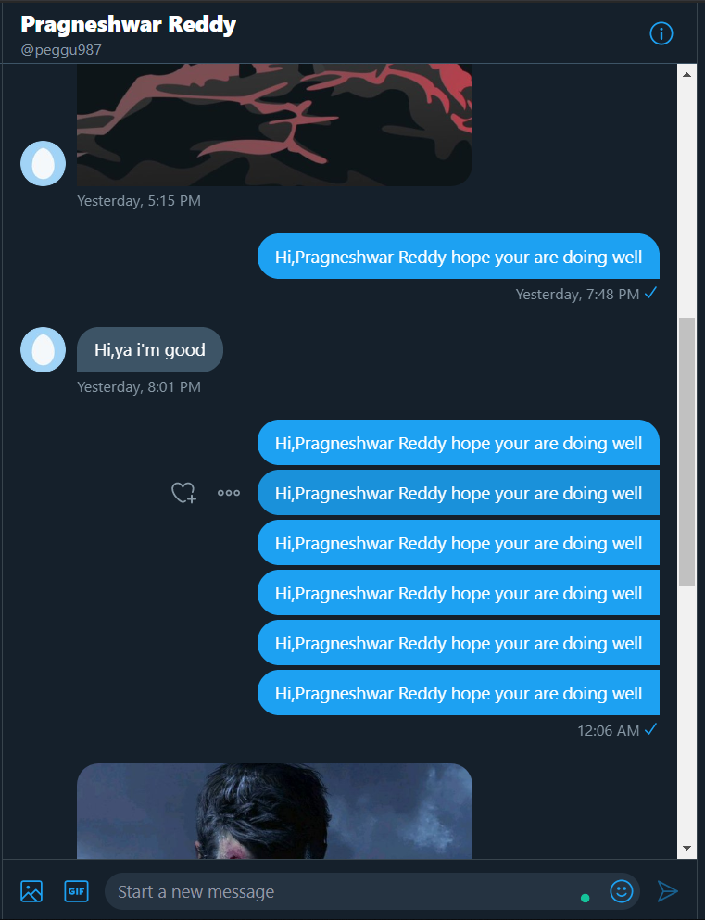 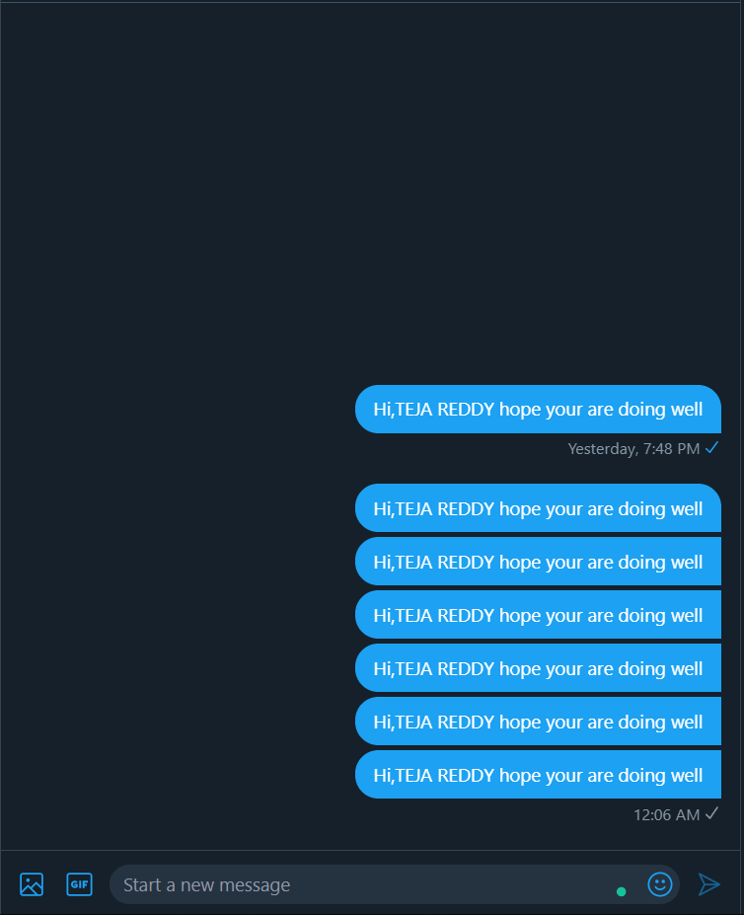

**The loop was set to send it 6 times only to reach the limit the loop has been set right in the code.**