Phonebook Application
Data Structures & Algorithms Report
Language: Python

1. Introduction
This report documents the data structures and algorithms implemented in a phonebook management system. The application allows users to add, search, update, and delete contacts through both a command-line interface and a graphical user interface (GUI). The core design prioritises efficient contact lookup using a hash table combined with linked list chaining.
Project Overview
The aim of this project is to build a simple phonebook application that stores contacts efficiently using data structures and algorithms. The application allows users to add, search, update, delete and display contacts through both a command-line interface and a graphical user interface (GUI). The project focuses on improving the efficiency of contact management by using a hash table with linked list chaining.

2. Data Structures Used

2.1 Hash Table
The hash table is the primary data structure of this project, implemented in hashtable.py. It stores contacts across an array of fixed size (default: 10 buckets). Each index (bucket) in the array holds either None (empty) or a chain of Contact nodes.
Structure:
buckets = [None, None, Contact→Contact, None, Contact, ...]
0 1 2 3 4
Why a Hash Table?
A hash table provides average O(1) time complexity for insert, search, and delete operations. Instead of scanning every contact one by one (O(n) linear search), the hash function immediately calculates which bucket a contact belongs to, making lookups very fast.

2.2 Linked List (Chaining)
Each bucket in the hash table is a singly linked list of Contact nodes. This handles collisions — situations where two different names hash to the same bucket index. When a collision occurs, the new contact is appended to the end of the existing chain at that bucket rather than overwriting it.
class Contact:
def __init__(self, name, phone_no):
self.name = name
self.phone_no = phone_no
self.next = None
Example: buckets[2] → Contact("Alice") → Contact("Bob") → None

2.3 Summary Table
Structure | Where Used | Purpose
Hash Table | hashtable.py | Fast O(1) average access to contacts
Linked List | Inside each bucket | Handle collisions
Contact Node | hashtable.py | Hold name, phone number and next pointer

2.4 Why these data structures were used
The phonebook performs operations like adding, searching, updating and deleting contacts frequently. A hash table was chosen because it allows these operations to be performed quickly by calculating the bucket where the contact is stored instead of searching every contact one by one. A linked list was used because more than one contact can be stored in the same bucket when collisions occur.

3. Algorithms

3.1 Hash Function
Converts a contact's name into a bucket index using the sum of ASCII values modulo the table size.

3.2 Insert Algorithm
Hashes the name, finds the bucket and inserts the contact. If a collision occurs, the contact is appended to the linked list. Before inserting, the business logic layer checks for an existing contact with the same name and phone number to prevent exact duplicates, while still allowing the same name to be stored with a different number.
Time Complexity: O(1) average, O(n) worst case.

3.3 Search Algorithm
Hashes the name, searches only the corresponding bucket and returns all matching contacts.
Time Complexity: O(1) average, O(n) worst case.

3.4 Delete Algorithm
Hashes the name, searches the bucket and removes the matching node while maintaining the linked list.
Time Complexity: O(1) average, O(n) worst case.

3.5 Update Algorithm
Uses the search function to find the contact and updates the phone number directly.

3.6 Display Algorithm
Traverses every bucket and linked list to display all contacts. If no contacts exist, 'Phonebook is empty.' is displayed.
Time Complexity: O(n).

4. Input Validation
Validation is handled in validation.py before any data reaches the hash table.
• Name validation rejects empty names and only allows letters, spaces and hyphens.
• Phone validation ensures only digits are entered and the number contains exactly 10 digits.
• The GUI also prevents non-digit characters from being entered in the phone number field.

5. Methodology
The project was developed in the following steps:
• Planned the features required for the phonebook application.
• Selected a hash table as the main data structure.
• Used linked list chaining to handle collisions.
• Implemented the insert, search, update, delete and display functions.
• Added input validation for names and phone numbers.
• Developed both the command-line interface and GUI.
• Tested the application using the built-in automated test suite (covering add, search, update and delete) as well as manual input testing to ensure each function worked correctly.

6. Application Architecture
File Responsibility
hashtable.py Stores and manages contacts
validation.py Input validation
Contactlogic.py Business logic
phonebook_gui.py GUI
phonebook_main.py CLI entry point and testing
Contactlogic.py acts as the middle layer between the user interface and the hash table.

7. Time Complexity
Operation | Average | Worst
Insert | O(1) | O(n)
Search | O(1) | O(n)
Delete | O(1) | O(n)
Update | O(1) | O(n)
Display | O(n) | O(n)

8. Code Screenshots
Insert the following screenshots:
• Figure 1 – Project Structure
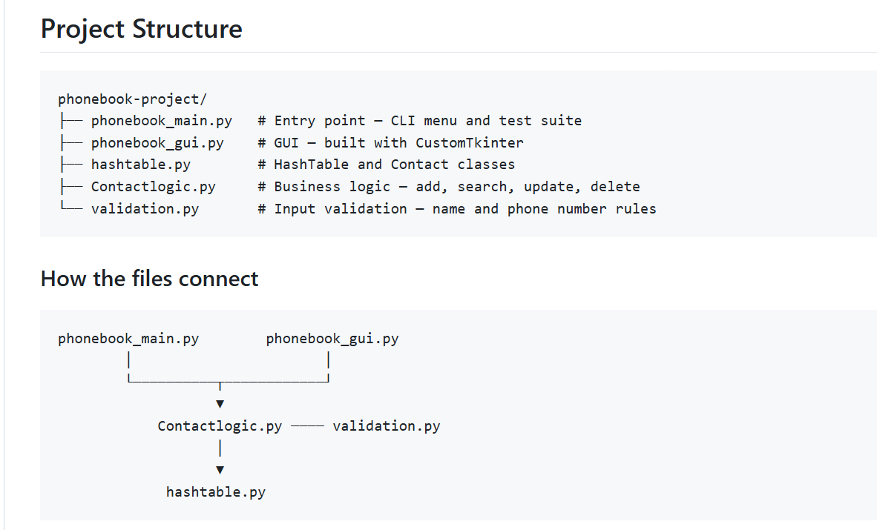
• Figure 2 – Hash Function
• Figure 3 – Insert Function
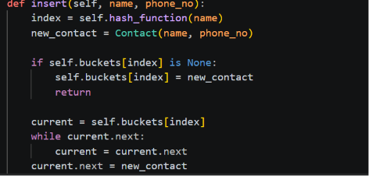
• Figure 4 – Search Function
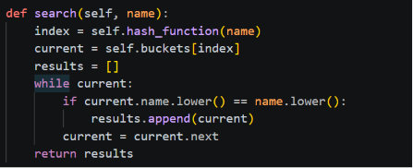
• Figure 5 – Delete Function
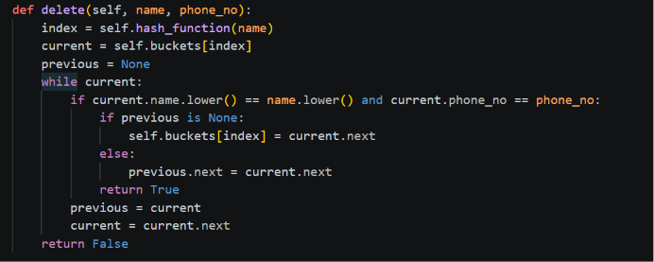
• Figure 6 – Display Function
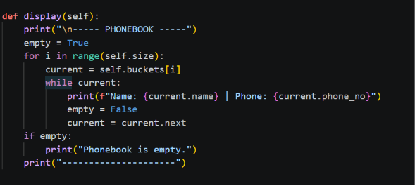
• Figure 7 – GUI Interface

9. Conclusion
This phonebook system demonstrates practical application of two fundamental data structures: the hash table for efficient contact lookup and the linked list for handling collisions. The layered architecture separates storage, validation, business logic and the user interface, making the application easier to maintain and extend.

