DRiST — Diabetes Risk Screening Tool
Dimensionality Reduction & Standardization Report
IT2011 — Artificial Intelligence and Machine Learning · Group 2026-Y2-S1-MLB-B12G1-06
This report documents how the 31-column feature-engineered dataset was reduced to its 15 strongest predictors, and how those features were standardized ahead of model training (Logistic Regression baseline, XGBoost, FT-Transformer). It includes the methodology, the code used, the resulting feature ranking, and supporting visuals: a pipeline diagram, a full correlation heatmap, and the correlation matrix of the final selected features.

1. Dimensionality Reduction — Method
The feature-engineered dataset has 31 columns. Rather than compressing them mathematically (e.g. PCA), which would blend features into abstract, uninterpretable components, feature selection was used instead — keeping the original, meaningful columns and simply dropping the weakest ones. This suits the dataset well, since most columns are binary or ordinal survey answers where interpretability matters (e.g. being able to say "HighBP mattered" rather than "Component 3 mattered").

Two ranking methods, combined
- Pearson correlation — measures the linear relationship between each feature and the target (Diabetes_binary). Fast and simple, but only detects straight-line relationships.
- Mutual information (mutual_info_classif) — measures how much knowing a feature reduces uncertainty about the target, including non-linear relationships correlation would miss.
Each method ranks all 31 features independently. The two rankings are then averaged into a single avg_rank, and the top 15 features by that combined rank are kept. Using two methods together is more robust than either alone — a feature that ranks well on both is a much safer choice than one that only looks strong under a single metric.

from sklearn.feature_selection import mutual_info_classif

# Method 1: correlation with target
train_with_target = X_train_fe.copy()
train_with_target["target"] = y_train.values
corr = train_with_target.corr(numeric_only=True)["target"].drop("target")
corr_rank = corr.abs().sort_values(ascending=False)

# Method 2: mutual information (train data only — avoids leakage)
mi = mutual_info_classif(X_train_fe, y_train, random_state=42)
mi_series = pd.Series(mi, index=X_train_fe.columns).sort_values(ascending=False)

# Combine both rankings
rank_df = pd.DataFrame({"correlation": corr_rank, "mutual_info": mi_series})
rank_df["corr_rank"] = rank_df["correlation"].rank(ascending=False)
rank_df["mi_rank"] = rank_df["mutual_info"].rank(ascending=False)
rank_df["avg_rank"] = (rank_df["corr_rank"] + rank_df["mi_rank"]) / 2
rank_df = rank_df.sort_values("avg_rank")

TOP_N = 15
selected_features = rank_df.head(TOP_N).index.tolist()
X_train_reduced = X_train_fe[selected_features]
X_test_reduced = X_test_fe[selected_features]

2. Standardization — Method
StandardScaler (z-score standardization) was used. Every selected feature is rescaled so it has a mean of 0 and a standard deviation of 1, using the formula:
z = (x − mean) / standard deviation
This method was chosen because Logistic Regression (and the FT-Transformer) are sensitive to the scale of input features — a column like BMI (range ~12–98) would otherwise dominate a column like GenHlth (range 1–5) simply because its raw numbers are bigger, not because it is more predictive. StandardScaler removes that bias by putting every feature on the same footing.
- The scaler is fit only on X_train_reduced (fit_transform), so it learns the mean/standard deviation from training data only.
- The same fitted scaler is then applied to X_test_reduced (transform only, not fit_transform), so no information from the test set leaks into the scaling.
- The fitted scaler object is saved (scaler_reduced.pkl) so any new/unseen data can be scaled identically later.

from sklearn.preprocessing import StandardScaler

scaler_reduced = StandardScaler()

X_train_final = pd.DataFrame(
scaler_reduced.fit_transform(X_train_reduced),
columns=X_train_reduced.columns, index=X_train_reduced.index)

X_test_final = pd.DataFrame(
scaler_reduced.transform(X_test_reduced),
columns=X_test_reduced.columns, index=X_test_reduced.index)

import joblib
joblib.dump(scaler_reduced, "processed_data/scaler_reduced.pkl")

Verified result (training set, after scaling)
All 15 selected features: mean = 0.000, standard deviation = 1.000
Confirms standardization was applied correctly with no leakage from the test set

3. Pipeline Diagram
The diagram below summarises the full flow from the 31-column feature-engineered dataset through to the final standardized data used for model training.
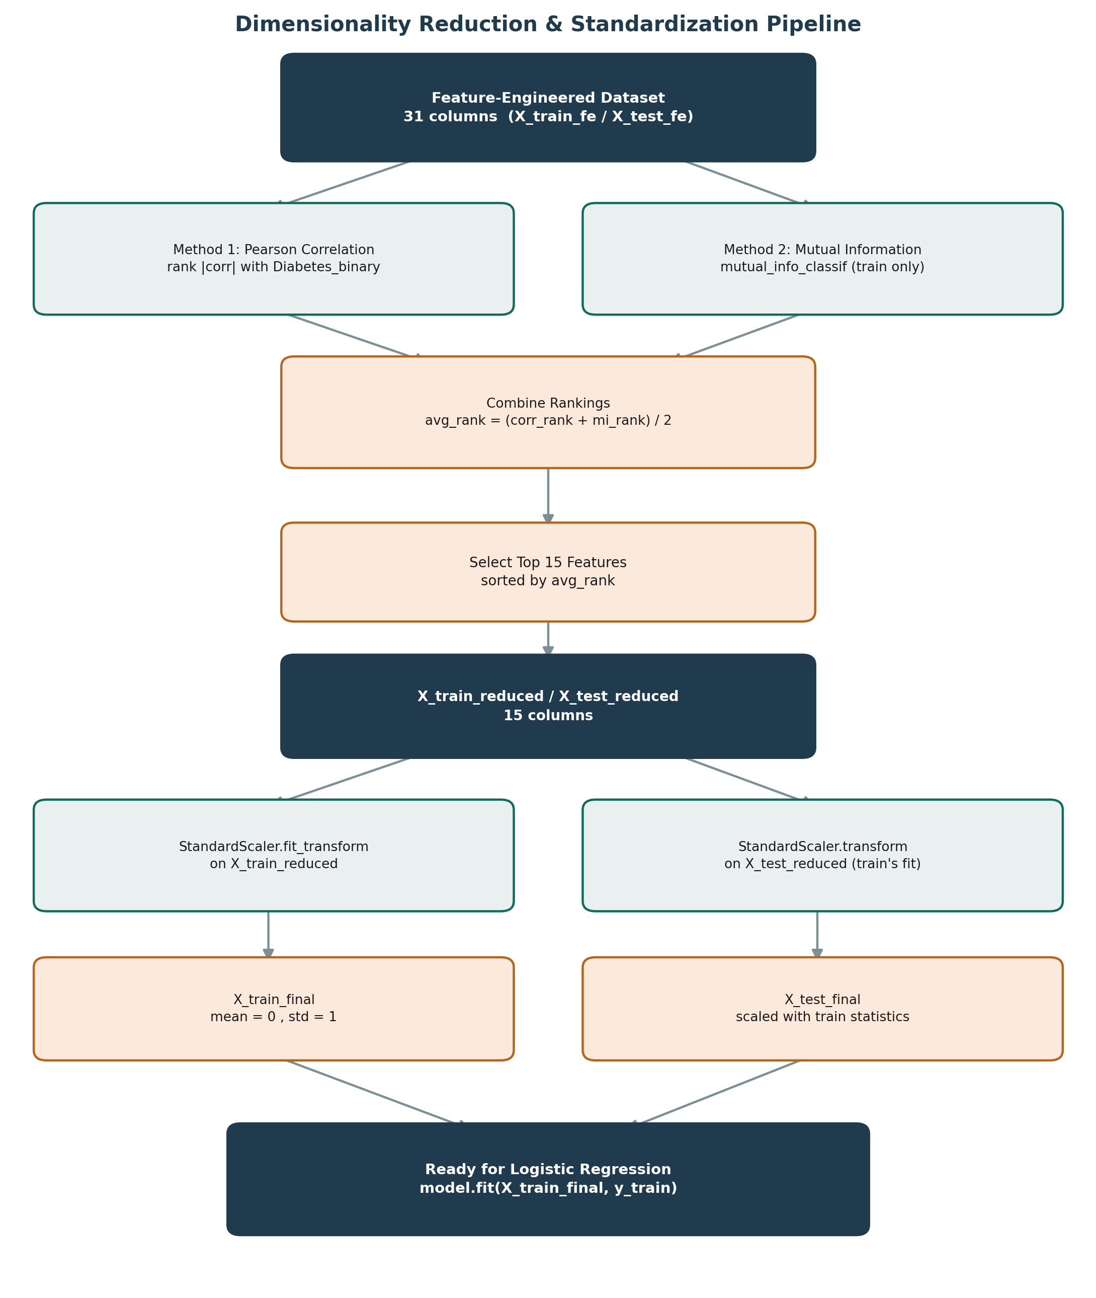
Figure 1 — Dimensionality reduction and standardization pipeline

4. Correlation Heatmap — All Engineered Features
This heatmap shows pairwise correlation across all 31 features plus the target (Diabetes_binary), from the feature-engineered dataset before reduction. Darker red indicates strong positive correlation, darker blue indicates strong negative correlation.
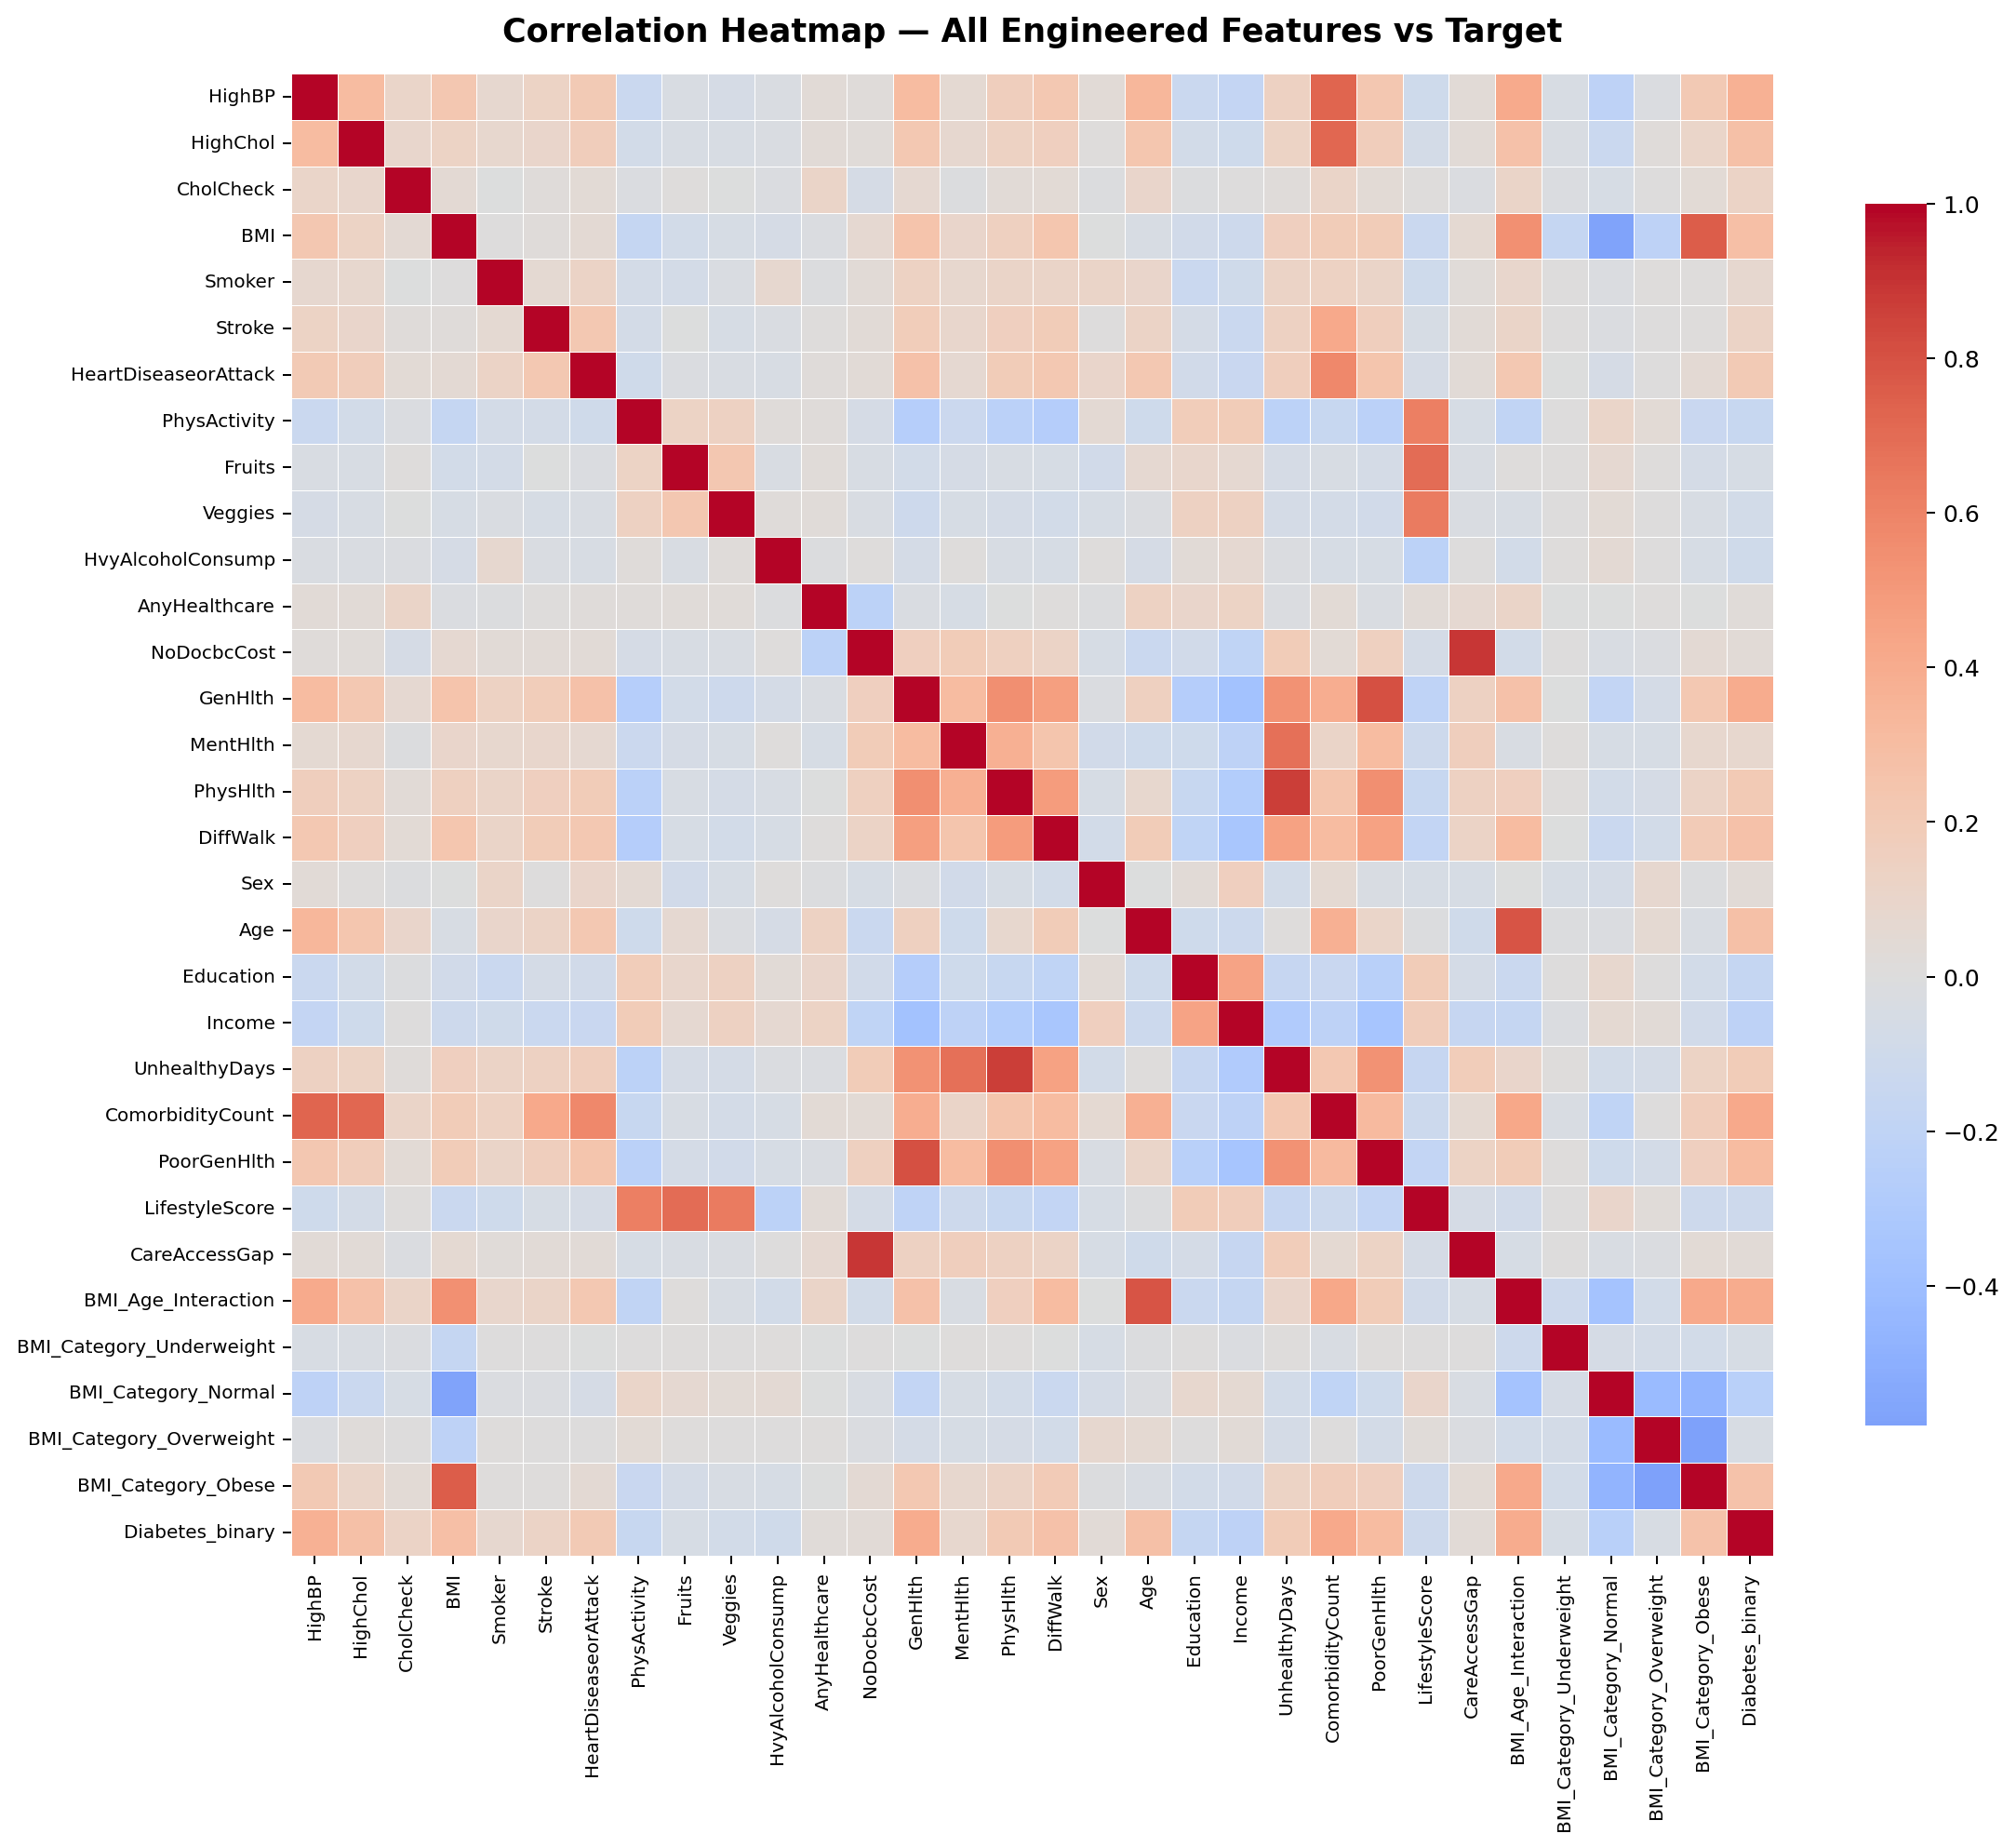
Figure 2 — Correlation heatmap across all 31 engineered features and the target
A few patterns worth noting: GenHlth, PhysHlth, MentHlth, and the derived UnhealthyDays / PoorGenHlth / ComorbidityCount features cluster together with strong mutual correlation, confirming they capture related aspects of overall health. BMI_Category_Normal is strongly negatively correlated with BMI itself (expected, since a 'Normal' BMI category directly implies a lower BMI value).

5. Correlation Matrix — Final 15 Selected Features
After dimensionality reduction, this is the correlation matrix of only the 15 features that were kept, plus the target. Each cell is annotated with its exact correlation coefficient.
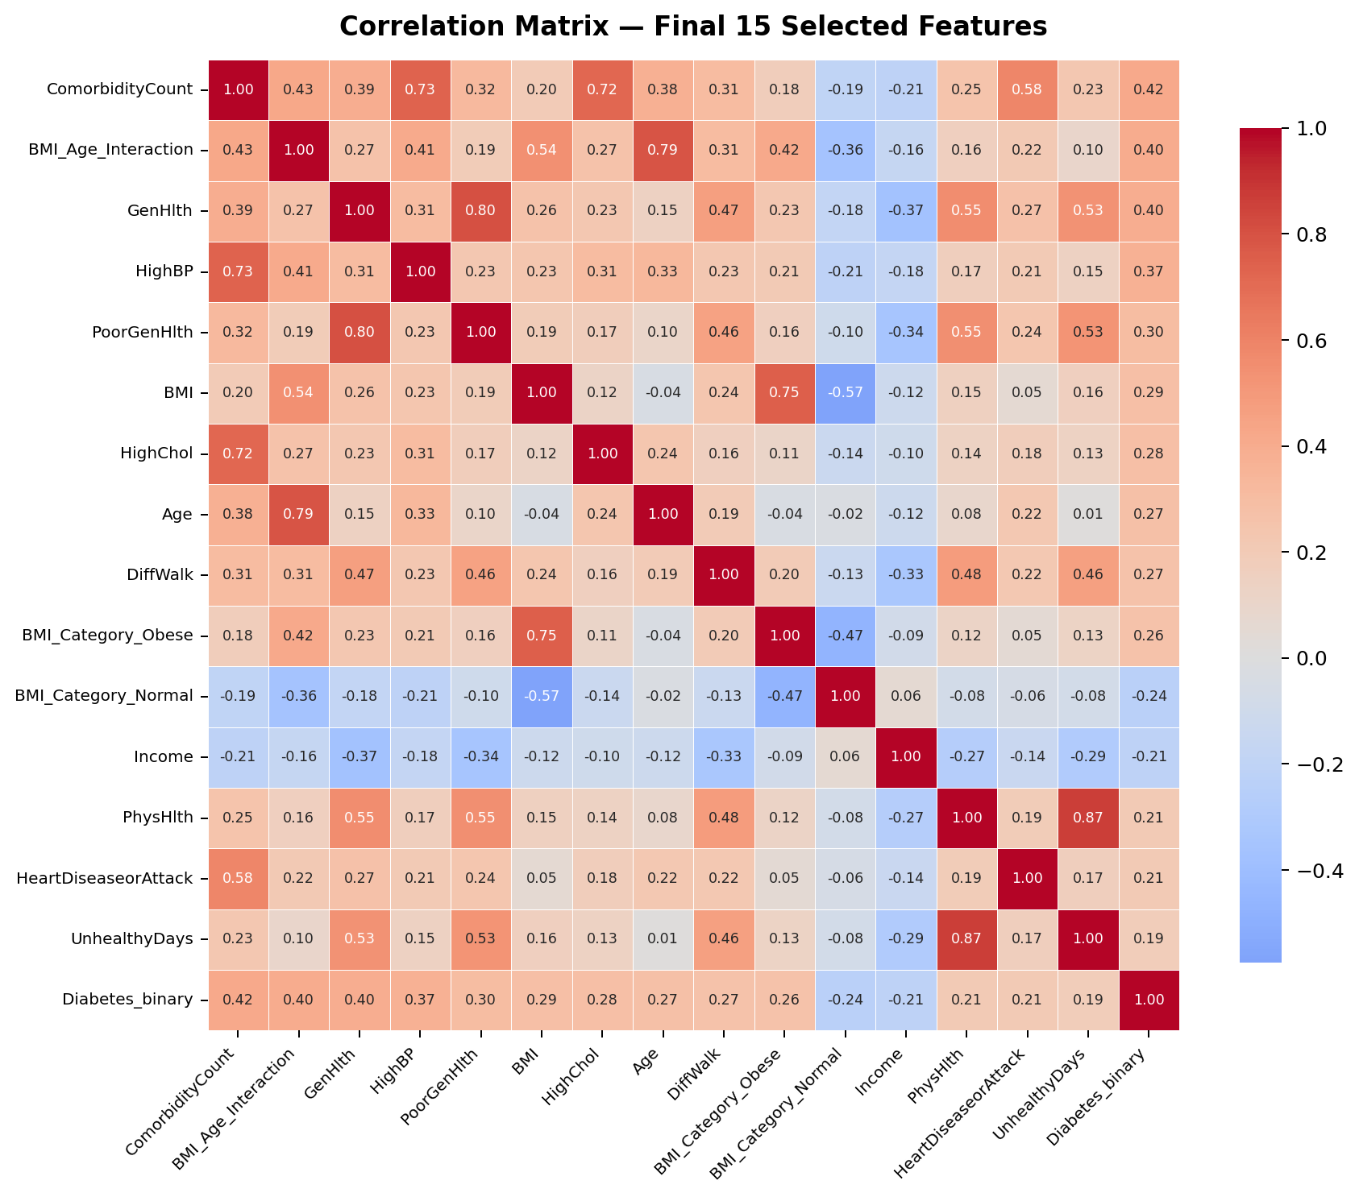
Figure 3 — Correlation matrix of the final 15 selected features

Feature ranking (top 15 selected)
Rank | Feature | Correlation | Mutual Info
1 | ComorbidityCount | 0.416 | 0.098
2 | BMI_Age_Interaction | 0.398 | 0.095
3 | GenHlth | 0.397 | 0.088
4 | HighBP | 0.372 | 0.073
5 | PoorGenHlth | 0.304 | 0.048
6 | BMI | 0.286 | 0.054
7 | HighChol | 0.283 | 0.048
8 | Age | 0.275 | 0.047
9 | DiffWalk | 0.268 | 0.039
10 | BMI_Category_Obese | 0.264 | 0.036
11 | BMI_Category_Normal | 0.242 | 0.032
12 | Income | 0.213 | 0.027
13 | PhysHlth | 0.207 | 0.025
14 | HeartDiseaseorAttack | 0.207 | 0.021
15 | UnhealthyDays | 0.186 | 0.022

Features dropped
The following 16 features ranked lowest on the combined score and were excluded from the final reduced dataset: NoDocbcCost, CareAccessGap, Sex, BMI_Category_Overweight, BMI_Category_Underweight, AnyHealthcare, Fruits, Smoker, Veggies, MentHlth, HvyAlcoholConsump, LifestyleScore, Stroke, CholCheck, PhysActivity, Education.

6. Summary
Final processed dataset
Original feature-engineered dataset: 31 columns
After dimensionality reduction: 15 columns retained
4 of our own engineered features made the top 15: ComorbidityCount (#1), BMI_Age_Interaction (#2), PoorGenHlth (#5), UnhealthyDays (#15)
Standardization: StandardScaler, fit on training data only, applied identically to test data
Final files: X_train_final.csv, X_test_final.csv, scaler_reduced.pkl

Why this matters for the model
Reducing from 31 to 15 features removes redundant and weakly-related columns, which lowers the risk of overfitting and speeds up training — particularly relevant for the FT-Transformer. Standardizing on top of that ensures Logistic Regression treats every remaining feature fairly by scale, rather than letting features with naturally larger numeric ranges dominate the model simply due to their units.

Mermaid diagram
