**DOCUMENT TRACKING SYSTEM WITH SENT MESSAGES (SMS) NOTIFICATION**

**A Capstone Project Proposal**

**Presented To Faculty of the**

**Information and Communication Technology Program**

**STI College Cotabato**

**In Partial Fulfillment**

**of the Requirements for the Degree**

**Bachelor of Science in Information Technology**

**Abdullah, Nurullajie S.**

**Bagundang, Zarah Mae G.**

**Daud, Sitty-Nor Shaina D.**

**Mancao, Nicole Haylynn G.**

**October 2021**

# APPROVAL SHEET

This capstone project proposal titled: **Document Tracking System with Sent Messages (SMS) Notification** prepared and submitted by **Nurullajie S. Abdullah**, **Zarah Mae G. Bagundang**, **Sitty Nor-Shaina D. Daud**, and **Nicole Haylynn G. Mancao**, in partial fulfillment of the requirements for the degree of Bachelor of Science in Information Technology, has been examined and is recommended for acceptance and approval.

**Mr. Junaidin Kamid**

Capstone Project Adviser

Accepted and approved by the Capstone Project Review Panel

in partial fulfillment of the requirements for the degree of

Bachelor of Science in Information Technology

|  |  |
| --- | --- |
| <Panelists' Given Name MI. Family Name> | <Panelists' Given Name MI. Family Name> |
| **Panel Member** | **Panel Member** |

<Panelists' Given Name MI. Family Name>

**Lead Panelist**

**Noted:**

|  |  |
| --- | --- |
| Norhamin K. Salim | Noria A. Ali, MIT |
| **Capstone Project Coordinator** | **Program Head** |

October 28, 2021

**EXECUTIVE SUMMARY**

The majority of organizations today generate massive amounts of data. Finding files along hundreds of others can truly be a time-consuming, and tedious process for administrators and employees at any institutions. Furthermore, in every institution, regardless of size, relies on a specific form of document management system to store, and track the countless documents generated every day. The main objective of this study is to develop a system that can be a great of help in document processing in a certain institution. One of the contributions of this proposed system is to lessen the workloads of an employee by easily to manage and to organize their documents/files. Furthermore, the processes in this system will be performed online since most of the transactions will need the use of internet connections. This system is an online-based system wherein administrative staff and employees do not need to be physically present in their offices just to access the system. The users can process their documents from wherever they are as long as they have access to the internet and the necessary hardware. The proposed system’s primarily transaction is to send and receive document files as well as to automate notification via SMS campaigns. By means of tracking number, the system can track the location of a document and verify whether the document has been submitted or not, and it automates the process of accessing, searching, and editing documents. The proposed capstone project, Document Tracking System with SMS Notification, will assist many institutions in reducing physical contact and focusing on their workloads. The proposed system aims to provide a great opportunity to optimize the employee’s day-to-day operations by accelerating the filing process, tracking documents, and make it easier to check the record.

**ACKNOWLEDGEMENT**

It is with sincere opportunity to thank all the people behind this successful Capstone 2 documentation.

First and foremost, we would like to thank our capstone adviser Mr. Junaidin Kamid, IT Instructor of STI College Cotabato, who has been very helpful in providing his full guidance to the success of this Capstone 1 documentation throughout the entire completion process.

To the faculty of ICT Department, Ma’am. Noria Ali, MIT, Ma’am. Nor-Ana Mama, Mr. Aldren Borja, and Mr. Norhamin Salim, we would like to express our gratitude for preparing and guiding us in this Capstone 2 journey. Also, to our grammarian, Ms. Mary Joy Esmundo, LPT, for your patience and humility in checking and improving the grammar as well as the content of this research documentation.

We, the researchers wish to also express our gratitude to our ever-supportive family members, friends, and loved ones for showing their unending care, moral and financial support until we successfully completed our Capstone 2 project.

Finally, we would like to thank the Almighty God for the unconditional guidance and abundant blessings that we received to successfully finish this project.

**TABLE OF CONTENTS**

**Page**

**Title Page**

**Approval Sheet i**

**Executive Summary ii**

**Acknowledgement iii**

**Table of Contents iv**

**List of Notations v**

**Introduction 1**

**Project Context 1-3**

**Purpose and Description of the Project 3**

**Objectives of the Study 3-6**

**Scope and Limitation of the Study 6-8**

**Review of Related Literature/System 9**

**Review of Related Literature 9-13**

**Related Studies and/or Systems 13-16**

**Synthesis 16-17**

**Use Case Diagram 17-20**

**Technical Background 21**

**Feature-driven Development Methodology 21-22**

**Overview of Current Technologies to be used in the System 23-26**

**Gantt chart of Activities 27-29**

**Calendar of Activities 30-34**

**Resources 35-36**

**Appendix 37**

**Appendix A (References) 38-39**

**Appendix B (Personal Technical Vitae) 40-44 Appendix C (Accomplishment and Consultation Forms) 45-53**

**LIST OF NOTATIONS**

**DTS** – Document Tracking System

**SMS** – Sent Messages

**DMS** – Document Management System

**EDMS** – Electronic Document Management System

**IDEAS** - Information and Data Exchange Advanced System

**FOSS** – Free and Open Source Software

**NIC** – National Informatics Centre

**ICT** – Information and communication technologies

**PRDP** – Philippine Rural Development Project

**DPWH** – Department of Public Works and Highways

**HTTP** - Hypertext Transfer Protocol or

**API** – Application Programming Interface

**CSS** – Cascading Style Sheets

**PHP** – Personal Home Page

**CGI** – Common Gateway Interface

**MYSQL** – My Sequel

**XAMPP** – Cross platform, Apache, MySQL, PHP, and Perl

**FDD** – Feature Driven Development

**INTRODUCTION**

**Project Context**

The continuous rise of advanced technology brought improvement in the lives of human beings. One of these technological products is the computer. Computers, primarily, can perform also what human beings can do such as solving any mathematical problems and so on. These manifest that computer systems are much a great of help among the human lives in doing their task easier. In line with this, this research study will provide a new system that will contribute to the continuous progress of the use of computer system that can easily to track and to notify the sent documents. The proposed project system is entitled as: Document Tracking System with Sent Messages Notification. In the current situation, the majority of organizations today generate massive amounts of data, finding files along hundreds of others can truly be a time-consuming, and tedious process for users at any institutions. This proposed system will assist many institutions in automating the way files and records are managed within their organization. Users can store, organize, and track electronic documents with this feature. It manages all document-related processes within an organization. It will assist employees in prioritizing the tasks based on their individual logic. The users of this system can still submit required documents online regardless of their absence in their office departments.

Furthermore, the scope of the system is exclusively for government offices, since the proposed system is limited for the said agencies, the researchers concluded the idea of having the need to test the system entitled: Document Tracking System with SMS Notification among different government agencies that have documented management process. Whereas the proposed system is dependent on the specific area of agencies as the scope of the study. DTS has advantages when it comes to efficient file sharing and document tracking. However, this system has proven to have limitations such as following problems:

The primary problem identified by the researchers in their proposed system is the difficulty in tracking the documents or files. Today, there are numerous platforms available that allow users to send files directly to the receiver. However, tracking of document is one of the problems that the researchers identified in some of the existing systems. Based on some proposed studies, one of the problems that they have encountered on their system is having difficulties in keeping track of the documents. It means they do not have any source or history regarding the movement of the document coming from its origin to its destination. Furthermore, users have no control over who can access and view the document sent by the sender.

Disorganize Document Files is the next problem. In saving files on the desktop or laptop, people used to practice sorting the files in one folder in order to keep the files well-organized. Organizing files on the computer is the same as organizing something else (Beck, 2016). This simply means that, folder structures can help keep the files well-organized just like organizing clothes in a drawer. In document tracking system, another problem is the documents or files are not organized which tend to create unnecessary file stores. This would be difficult for a user to monitor and view the file if it does not have a folder to store on.

The next problem is categorizing of files into a folder. This will consume much time and unnecessary energy from a user. If there are various documents stored in the system’s folder or in a document storage, the user will need to search the files one by one in which, it consumes a lot of time.

Next is the unauthorized access to the file. This problem is commonly circulating and most of the people are vulnerable to this kind of problem. The system might have security issues or problems. Therefore, in some cases, computer systems are prone to this kind of problem because the user of the system might not be an authorized user of the system thus, it tends to access the system without permission and authorization from the owner.

Lastly are the stored documents. This is one of the shortcomings of some existing systems. The researchers do not have the document storage where the user or employee can locate, place and save their document files. This can result in the missing or loss of important files, as well as a disruption in the company's operations.

**Purpose and Description of the Project**

The Document Tracking System aims to provide a great opportunity to optimize the day-to-day operations of the employee by accelerating the filing process, tracking of documents, and providing convenience in checking the record. The system will collect, send, and receive data from employees to track the documents sent by the employees.  This online document system is designed to automate the notification of sent messages (SMS) to staff in order to provide updates and remind them of the status of their submitted documents. It will also automate the process of accessing, searching, editing, and managing documents or files. By means of tracking number, the system can track the location of a document and verify whether the document has been submitted or not. Moreover, it will also track those individuals (staff) who have failed to submit their data reports or documents to their administrator by means of a tracking number.

**Objectives of the Study**

The primary aim of this study is to improve the transparency of tracking each document sent by each user from different office departments. This will also innovate the process of storing, locating, organizing, and sharing of files to fasten the workflow progression. More so, this will also automate sent messages notification to the personnel in order to provide an update and reminder with regards to the status of their sent and received files.

Given below are the objectives of the study and its significance to the proposed system and target users:

* To develop a module for automated SMS notification

*This system provides a module for SMS campaign. The administrative staff will benefit the most from this approach. Having a module for automated SMS notification can reduce the admin's workload of reminding their subordinates about their requirements.*

* To create a module for file organizing method

*In this objective, it will be easier to find previous version of files by organizing each folder in one specified module for document storage. By developing a module for document storage, the user can place all their document files into one folder structure.*

* To create an efficient file locating procedure

*Categorizing each document one by one will surely consume a lot of time to finish one specific task. To solve this problem, the system’s objective is to have an advanced file search procedure to easily search the previous and current documents sent by the other departments.*

* To provide accurate accounts for authorized users.

*This objective can solve the problem of unauthorized access to the file. Through this method, the admin user will be the one to provide accounts to its employees. This is to ensure that the employees are authorized users of the system and to avoid having problems with accessing accounts.*

* To develop an efficient archiving procedure

*Having a module for archiving procedure will help users specifically the employees of a particular institution to solve the problem of missing or lost document files. If the user has encountered unexpected data deletion, the user of the system can retrieve the files through an archiving procedure.*

* To create an approach that will allow users to monitor the incoming and recently processed documents

*This approach will help users to monitor and view the incoming and recently processed documents. By means of inbox, the users will get notified whenever they received incoming documents sent by the other users. This is also similar to an email application where it accepts incoming messages.*

* To develop a management module

*A configuration categories module is provided in this objective. Admin and department head will benefit from this module for they can easily manage department and document type by adding, editing, and deleting its document types.*

* To create a module for filter department

*It takes time to look up each employee’s information individually. This procedure will help administrative staff quickly find or view the list of employees’ information in each department by developing an inquiry module.*

* To develop a module for user profiles

*The batch upload will take place in this module, which contains the employees’ information. This goal will make it easier for users to send a batch of multiple employees into the system.*

* To setup employee’s account

*Authorized users, such as administrators and department heads per department, can create accounts for employees and assign roles based on their tasks. User profiles in batch upload will provide information about employees through having a search filter for employees’ names.*

**Scope and Limitations**

This study will focus only in providing a computer system that will easily send, receive, and track the status of documents sent by the user. Given below are the following information pertaining to the scope and limitation of the proposed system.

**Scope**

* **Document Storage**

It allows storing of documents on its document storage (e.g., folder name, date, document name, and document type). The user can access and download the digital files.

* **Advanced File Search**

It enables locating files, allowing user to search the documents from their office departments such as: document, originating office, transaction, movement status of document.

* **SMS Notification**

The user will be notified via sent message or SMS on their mobile phone regarding on the status of their sent and received documents.

* **Tracking of Documents**

It enables the admin user to track and monitor the status of document files sent by the other users from other departments.

* **Creation of Accounts**

Administrator and department head users are the authorized personnel to create employee’s account. The admin will be in charge of creating accounts for department head users and have the privilege to designate roles. In some other ways, admin users can also create employees’ accounts as an alternative if the department head user fails his/her job. More so, department head users can create their own employees and designate roles only in their department premises.

* **Inbox**

The user can view all incoming documents sent by the other departments by providing an inbox for the user. This will allow users to monitor all the sent and received documents.

* **Inquiry**

The admin users have easy access to user’s details, such as searching the list of departments as well as the status of documents, and tracking the movement and/or route of documents, etc.

**Limitation**

* The system has no message chat box option

The system has no message chat box option since the researchers would like to focus on its main objective, which is to send and receive documents as well as to track the movement of the document from its origin to its destination. The use of the chat box option is irrelevant to the system's function since there are numerous platforms available for conveying messages.

In general, the success of this system will assure a long-term service among the proponents as mentioned in the latter part of this research documentary. This will serve also as a future reference to the future researchers and developers.

**REVIEW OF RELATED LITERATURE/SYSTEMS**

**Review of Related Literature**

This section will present the relevant literature, systems, theories, and historical context of the study in relation to document tracking system of the various researchers. This will also present the gap of this study in comparison to other proposed studies, as well as discuss the traditional way of managing documents and its development to systematized document tracking. Moreover, it will also present the synthesis of the entire section for better comprehension of the study.

Traditionally, employees or personnel in an institution handled the management of document files and records by hands-on process. This traditional method of document management takes a long time to complete the task. Nowadays, majority of developing countries use a paper-based document management system (DMS) to manage the document records by hand. More so, the use of electronic forms of documentation, such as e-mails and web pages has increased (Arkan & Ibrahim, 2017). According to Abella (2019), the Department of Public Works and Highways (DPWH) Leyte 2nd district engineering has implemented Document Tracking System (DoTS) for civil works. Abella stated on her article that, DoTS was developed to monitor the status and track down slow-moving documents. It can determine who is responsible for the delay in the processing of documents. The department's primary goal is to expedite project completion and improve transparency in its operations in the procurement and implementation of local and foreign-assisted civil works projects. In the article of Abella (2019), Molleda stated that a week after they began using DoTS in November 2018, they had entered and completed a total of 141 documents. This system becomes the way for the contractors and other stakeholders to access and track their documents without any personal appearance. The system enables documents to be logged into the system. It stores dates received, sent, and returned, and allows viewing of all incoming, ongoing, and outgoing documents. It also assigns routes and target dates for the documents.

**Electronic Document Management System (EDMS)**

In the previous research, EDMS is an electronic document management system that is known for electronically tracking and storing electronic images and documents obtained from its physical form. An EDMS typically entails the use of a number of programs or systems. The technological application of EDMS benefits organizations by saving paper, expedite the communication process, and increased business productivity. In a broader sense, EDMS propels the growth of paper-based documents in the field of information management. The system acts as a mechanism that aids facilitation and coordination for the purpose of ensuring the safety and smooth flow of electronic and paper-based documents when required by authorized parties. Document storage, processing, routing, distribution, and retrieval are all part of the system’s flow. More so, EDMS also encourages searching and sharing of information. It also improves knowledge management and data mining (Rosa et al., 2019)..

**Web-based Document Management System in Life Science Organization**

A Web-based Document Management System developed by Sengol Mary J and Usha S in year 2015.This system is used to manage and protect the storage of any type of information in an organization.The content is stored within a centralized document management system (DMS) and is typically self-contained. It also stated that, web document system promotes searching and sharing of information. More so, document creation is the first step in the document lifecycle that initiates the document management workflow. The operations executed are creation, editing, review, approval, publishing, distribution, and reading. These phases are performed by the individuals who has a specific role with unique access to and responsibility for a document. Roles are important and these must be understood properly on what they can do to the system. The system adapts the previous system's document process and document management workflow; the current system is related to the developed system in terms of operations such as document creation, editing, and viewing. More so, it has also a similarity when it comes to who are accessing the documents.

**Development of a File Tracking System for Tertiary Institutions**

A file tracking and document tracking software was launched by in 2013. The software is a user-friendly barcode-based tracking system. Information and Data Exchange Advanced System (IDEAS) is a file tracking system developed using Free and Open Source Software (FOSS) by the National Informatics Centre (NIC) in Kerala, India. A tracking system is used to keep track of moving people or things and provide a timely sequence of location data for further processing. The aim of this study is to create and implement an Electronic File Tracking System (EFTS). The EFTS developed in this study is a web application that can handle the generation and transportation of files from one employee's desk to the next. After defining critical functional and non-functional needs as well as precise workflows, the system was built using open source software. The system can process and track files in real time, including reports, choices, requests, and reminders. The system facilitates online tracking and delivers location data. The researchers created a web application whose purpose is to keep track of files that come into a government office, allowing them to easily record or query information about petitions or files received within their respective offices via the Internet. Furthermore, users, who include both citizens and officers, can track the movement of files, making the system transparent (Omoregbe et al., 2013).

**Document Tracking Technology to Support Indonesian Local E-Governments**

To accelerate and expand economic development in Indonesia, the Indonesian government has launched many research and development programs and used many technologies including Information and communication technologies (ICT) to achieve the goal, especially in bureaucratic reformation. Having a document management system in place ensures that the documents can only be shared by the users that are authorized. Tracking documents ensures security, especially if your company interacts with sensitive or classified information frequently. To achieve the study's goal, the researchers created a Document Tracking Technology to Support Indonesian Local E-Governments. A document tracking system is intended to supplement these efforts at bureaucratic reform by facilitating government work processes across multiple sectors and layers. Furthermore, the researchers propose incorporating document tracking technology into the e-government business process. The use of document tracking systems is expected to make e-government implementation more efficient and effective. The document tracking system facilitates faster document delivery and easier document handling (Sunindyo et al., 2014).

**A Thesis Portal with Electronic Document Management System**

According to Del Rosario (2016) in his developed system entitled: A Thesis Portal with Electronic Document Management System is a system that acts as a centralized location for accessing various Web resources. This study recommended the use of tag and search. A Tag is a keyword assigned to a piece of data, such as an internet bookmark, digital image, database record, or computer file. A search, on the other hand, is used to access a file or find information in a computer system. According to this study, the system collects information from various sources and combines it all in a single system, in which, it allows multiple users to access the information. It provides user a centralized location for content, data, and servers. More so, electronic document management system helps to manage the documents electronically and provides security to the stored information. The developed system has three (3) distinct modules: storing, indexing, searching and retrieval. In the first module, storing, it handles the storage of approved proposal documents, thesis documents, teaser videos, request forms, and other documents uploaded in the digital repository. Second module is indexing, it handles the encoding of information about the document. It also includes tagging that would be used for easier searching. Lastly is the search and retrieval module that allows users of the system to search and view for the thesis documents in different ways. In conclusion, this system supports tag and search. It supports three different modules which are the storing, the indexing, the searching, and the retrieval.

**File Tracking System for University of Kashmir: Design Guidelines and Model Implementation**

This study proposes a project based on the implementation of the File-Tracking System for the University of Kashmir. It looks into the University of Kashmir's current file flow system, as well as the proposed file-tracking system and how it works. It can generate receipts and files, update their status, open new files, track file movement, dispatch letters/files, and follow their progress among other things. According to the researchers, the system when implemented shall improve efficiency and effectiveness of the existing system, consistency of file records, resource management, and quality of administration. The system will pave a way towards adoption of complete e-governance wherein paperless file processing and its tracking is possible. This paper provides information about how it works, including user screens, user responsibilities, and reports through a design overview. It explains why existing file-tracking systems used by various government agencies are insufficient for the University of Kashmir (Bandaya et al., 2015).

**Related Studies and/or Systems**

**Local**

According to Manondo (2015) in her development of PRDP web-based document tracking system (DTS), this system was developed and implemented by PRDP National Project Coordination Office Monitoring and Evaluation Unit to facilitate online updating of PRDP documents’ status as a solution to their work concerns. Primarily, the use of PRD web-based DTS is designed to track the documents and protect the files from being lost. This shows that DTS is highly relevant when it comes to saving, tracking, and protecting document files of a certain organization. It also stated that, by means of online document tracking tool, PRDP staff will no longer rummage through piles just to monitor the status of documents. It also allows users to create and receive a transactions or documents with a unique reference number given on this system. It also features sections for released and completed transactions or documents in real-time. It has also included filing and endorsement in the DTS such as: memoranda, letters, and copies of business plans, feasibility studies and accomplishment reports among others.

As what stated on the developed system, UP Document Tracking System (2020), technology has been more advanced and the increase emphasis on efficient information management, document tracking system have been a solution to improve the efficiency of retrieving documents online at any given time. One common problem that most of the staff or personnel have been facing is the tendency to lose track of document paths. Through the help of DTS, these systems are able to trace the movement of documents from origin to destination/s. It also said that the traditional way of processing paper is crucial because of some problems that the staff may encounter. However, determining when and how to transition from paper to digital documents can be challenging in this case. The Document Tracking System (DTS) of the University of the Philippines (UP) is an information system capable of tracking the paper trail of documents created within UP offices. The DTS includes information on the originating and receiving office and personnel, as well as the time elapsed between offices/units/departments. In this information system, document attachments, revisions, updates, and remarks are also supported.

**Foreign**

As stated in the existing document tracking system, GigaTrack (2021), it can benefit a variety of fields from identifying where important documents are located including: insurance firms, law offices, government agencies, corporations, and many more. This system also addresses the challenge of making it simple to record when items are moved or replaced. More so, the GigaTrack Document Tracking System has the implementation of barcodes and uses them to identify employees, locations, and material items. Through this feature, the user can simply scan the employee ID or location ID, particularly the documents that are assigned. Furthermore, the documents can be located quickly with a full chain of custody report available. This existing system has simple functionality, but it is more effective to use and faster to implement.

According to Zoho Project (2021) in his developed system, Document Management System, he provides cloud-based solutions to safely store, share and manage files. In this system, it allows all types of files to be stored in a centralized location by just using this document management software. This can benefit the users by easily accessing and sharing the documents or records with their team members every time and/or anywhere. More so, Zoho Docs offers an extensive document management system that contains Manage Files in one place, which includes documents, video clips, graphics, spreadsheets, and reports. The average project involves hundreds of different files, which are often spread across dozens of computers. Files are centrally stored and organized. Therefore, every user and team member are always informed regarding the status of their document files. One benefit of this system is that files can be shared from any location. Whether the user is in their house, office, outdoors, they can still share the files with their entire organization. Files can be also associated with tasks as well as organize in hierarchical folders that correspond to the organizational structure and workflow. The version of files is kept tracked. This system has automated key document process such as revision tracking, access control as well as search and retrieval.It makes sure that all changes and updates are displayed with notes, dates, and author information. This is to let everyone particularly users, be informed with the latest version of every file. The user can also find the files more efficiently. It offers search tool in order the user to easily locate their documents. Indeed, through having a file search, by just using the title or content of the document, the user can instantly view the file.

According to File Hawk Barcode File Tracking System by General Data Company (2021), File Hawk barcode file tracking system automates and records the movement of files in and out of a file room with a few quick barcode scans. Check files out to users and check them back in by scanning both the user barcode ID and the file ID. Print file barcodes, location barcodes, and user barcodes right through the system. Every transaction has date and time stamped providing an audit trail as to the movement of files. Files are checked in and checked out of the file room and moved from one location to another by scanning the file label barcode generated through the system and the user to whom the file was given. The Portable Data Terminal/Scanner will periodically capture a physical inventory by scanning all current files in the office and reporting discrepancies.

**Synthesis**

In general, the study of the Document Tracking System shows to us how this system can be a great help, not just only in one specific field, but as well as in other fields who have document processing and managing operation. This proves that the implementation of DTS accelerates the employee's workflow without further processes and improves convenience at all times. As all mentioned in the previous mentioned articles, majority of the researchers and developers were using electronic DTS, online DTS, and web-based DTS. This simply means that online based systems are great when it comes to fastening work because locating and managing of document files can be easily processed. However, there are also some lapses in the previous studies. Most of the previous researchers have focused their ideas based on the positive use of technology towards society just like the use of online-based system. They have not included some necessary features that will probably help their proposed systems improve. Therefore, this research proposal will add new features to the previous system, the Document Tracking System, which does not recognize by the previous researchers. The researchers in most of the cited articles focused solely on tracking the movement of the document by having a tracking number. Therefore, the researchers of this research proposal have proposed a new feature which is the Automated SMS Notification.

**Use Case Diagram**

The use case diagrams represent a system’s activity and help in capturing of its requirements. It is a diagram that describes a system’s high-level functionality and scope. These diagrams also demonstrate how the system, and its actors interact with one another. To sum up, use-case diagram can summarize the details of the system. The diagram above shows that actors can sign in or access the system.

A dashboard, documents, setup categories, employees, inquiry, and SMS campaigns for administrators are all illustrated in the diagram. The actor can access the first module, which is the module for “dashboard”. In this module, it displays the total number of registered users. It includes adding new documents, and, creating user accounts where admin assigns a department head per department and add employees. It also includes inquiry where all inquiries are stored. My recent documents are also included in this module. It displays a submenu that lists the recent activities or opened files, as well as repositories.

Second is the module for documents. This module includes the categories: Add new document, received document, drafts, repositories, and archive. In the first category of this module which is the adding of new document, the actor can add a new document and can send it directly to the recipients. They can also save the added document as a draft if the actors want to send it later. On the other hand, all incoming documents sent by other releasers will direct their sent documents to the received document. Another category is drafts, it allows actors to save work that they need to send later. The repositories which are a list of the actors’ locations where they store a set of files.

The third module is “setup categories,” which include managing departments and document types. The fourth module is about “employees,” which include employee’s profile, where the batch uploading occurred. Administrators have access to users account setup and manage users’ accounts where only the administrator has access to user account setup. When configuration takes place, administrator is allowed to configure or modify employee account-related information and inquiries, and to quickly find or view a list of employee’s information.

Fifth is the inquiry module. In this module, the admin actor can search for departments and the registered users under those departments can track the route of the documents and status of the sent documents. Lastly is the SMS campaign module which includes SMS Notification feature where the administrator can notify the department head according to announcements and if the employee in their department has not yet sent the documents.

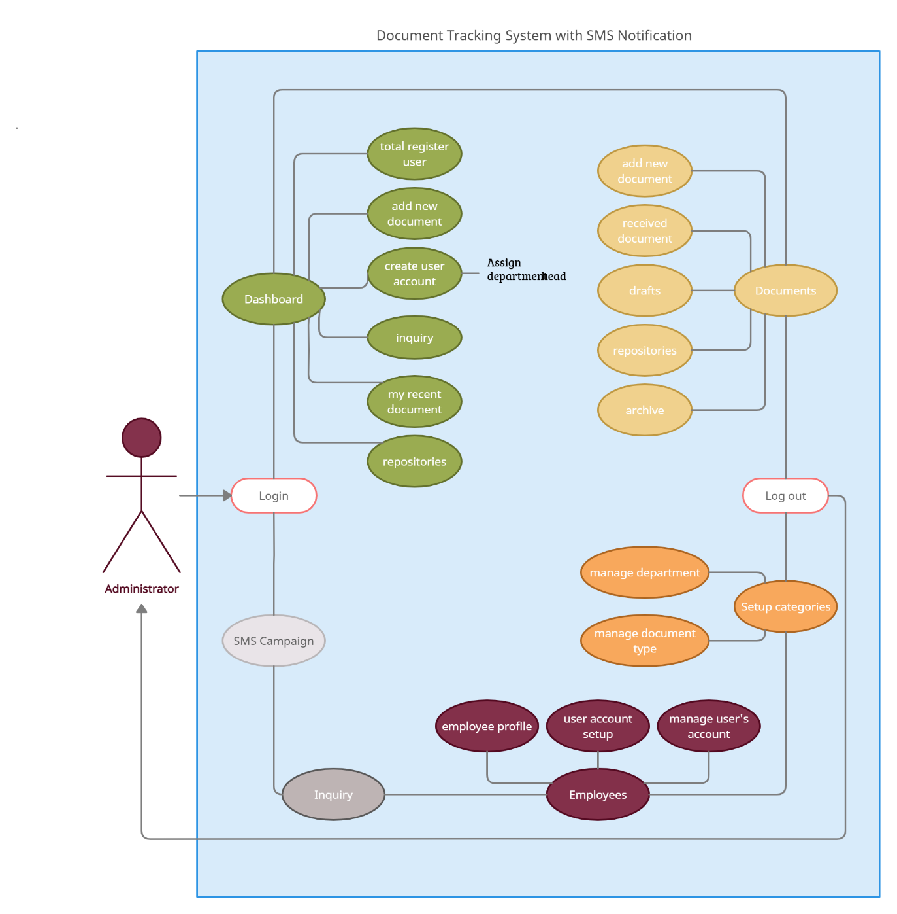Diagram 1

The second diagram illustrates the department head’s access. The module represented as a “dashboard” in the diagram below. It includes total employees, add new document, and create user account where each department head assigns a receiver and releasing officer, my recent documents, and repositories. The main purpose of “Documents,” is to add new document, receive a document, store drafts, repositories, and archive/archiving. “Setup categories,” includes manage department and manage document type. “Users” contains a list of employee’s names by department. Finally, the department head has also an access to the “SMS campaign” feature.

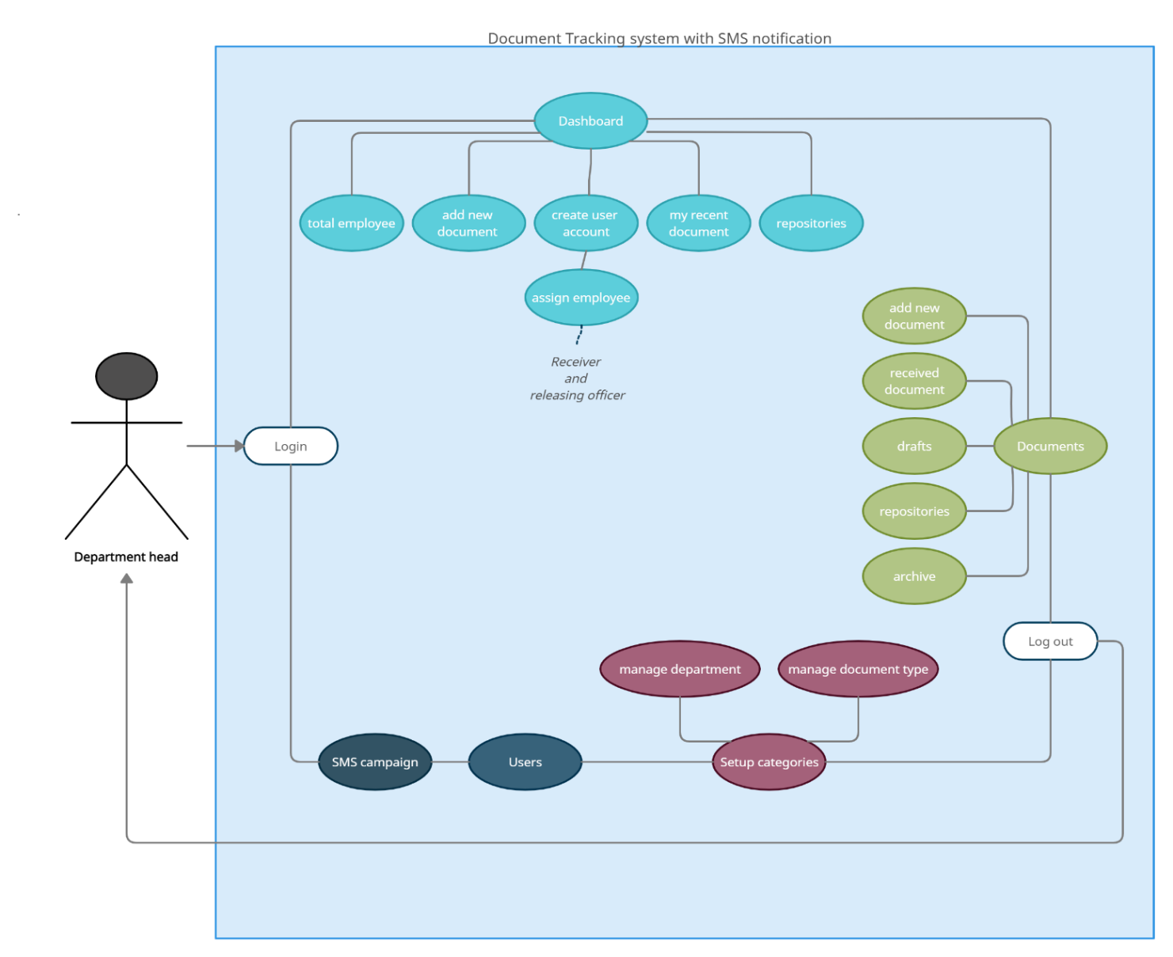Diagram 2

The diagram below illustrates the employee’s access. In the diagram, the modules represented as a “dashboard,” that primarily contains my recent documents and repositories. The “documents” module includes the following categories: add new documents, received documents, drafts, repositories, and archives/archiving categories.

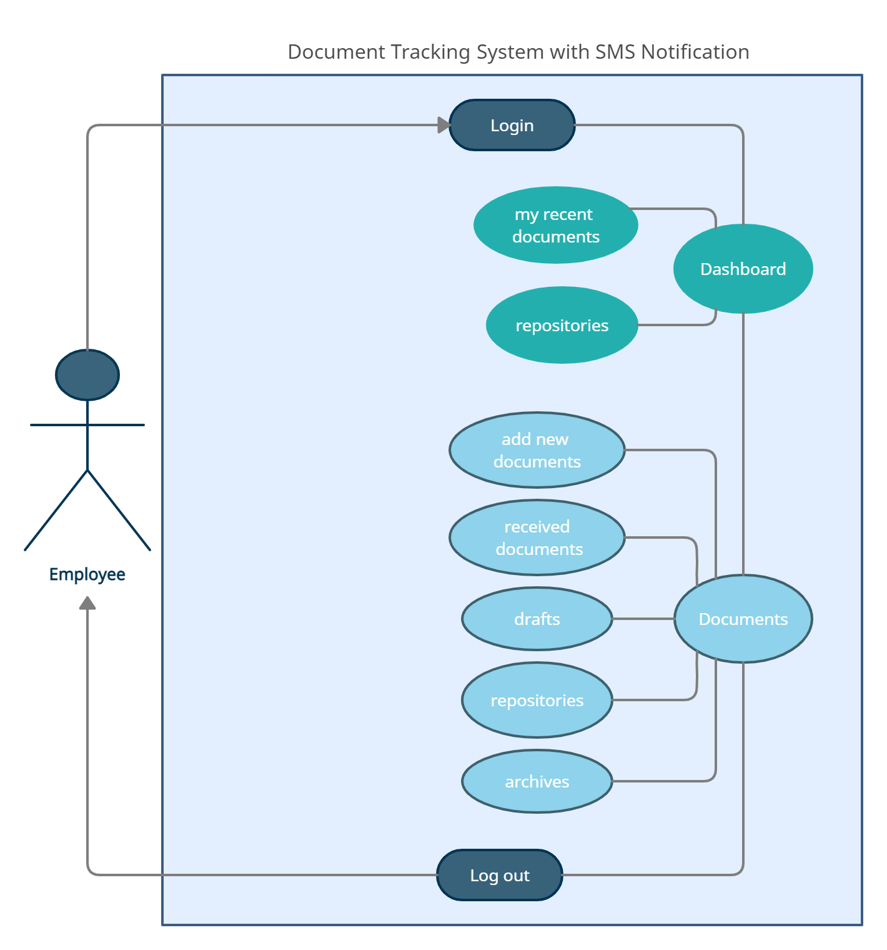Diagram 3

**TECHNOLOGICAL BACKGROUND**

**Overview of Current Technologies to be used in the System**

In this section, the researchers will provide information on how the researchers develop, accomplish, and implement its capstone project entitled: Document Tracking System with SMS Notification. Furthermore, this section will provide the background of online-based systems and the technical specifications that the researchers will utilize for the success of this project.

**Feature-driven Development Methodology**

In this capstone project, the researchers used the Feature Driven Development Methodology (FDD) to develop the system. FDD is an agile framework that process and generate outcome in repeatedly and consequently manner. It organizes and suggests development around making progress on the product and/or system features. FDD integrates cycling and collaborative process. It pertains that there are continuous release cycles with minor differences from the previous release.

In this methodology, FDD contains five-step development process namely: *Development an overall model*, *Build a features list*, *Plan by feature*, *Design by feature*, and *Build by feature*. These five steps development in FDD is largely used by most organizations. Furthermore, feature-driven development (FDD) promotes status reporting at all levels. Its primary purpose is to help in tracking the progress and outcomes of the projects. Through this process, it also allows organization to keep the project updated and quickly identify errors.

As stated in the above statement, feature-driven development methodology (FDD) plays a significant role in updating reports. The researchers decided to apply this methodology for the development or progress of the capstone project, the *DTS*. In applying this FDD method, the researchers applied the first method which is *the development an overall model*. Primarily, the researchers begin by making an outline and blueprint of the project. In this process, the team conducts brainstorming in determining the problems that must need to address and by providing some solutions. By applying this step, the team members can able to picture out the system/project through making a prototype. The second step is the *build a feature list*. After the brainstorming and prototyping session, the researchers had identified all the necessary actions and results must need to apply. In this step, the researchers had listed down all the features of the system and eventually propose some ways on how these features work. Third step is plan by features. After the researchers have identified the features, the researchers disseminate the task for each team members. The features were assigned to the members in order to identify the risks and other problems of the system. Fourth step is design by feature. The lead programmer of the group was the one who gave instructions to its members on which task should be prioritized in a specific time frame. Fifth step is, build by feature. When all steps from 1-4 is being addressed, the researchers were starting to write a code. This step includes the development of front-end, back-end, and database queries. After finishing this step, the researchers will begin to test the feature if all suggested requirements have been met or not. In monitoring the progress of the capstone project, the researchers check its checklists before 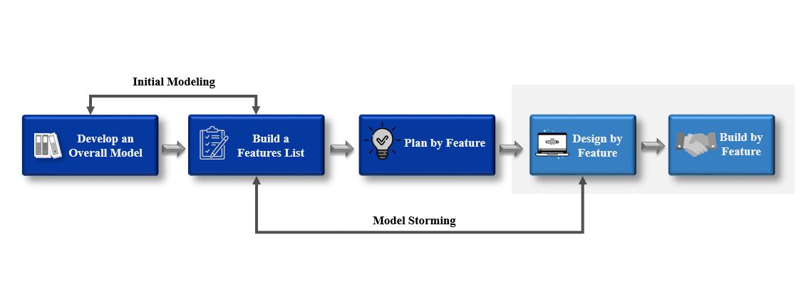proceeding in the next step.

**Online-based system**

Online-based system refers to a program that can be accessed through HTTP. Another term of online-based is web-based which means, a software that runs in a web browser. It also allows access to a software system through a computer and an internet connection. The host server of a web-based system can be accessed via a local server or through the internet.

As stated in the article entitled: The History of Web Application Development, nowadays, web applications are important for the growth of the internet. Through this, the function of internet is coherent and improves the quality of a browser’s exertion. More so, web application is a client-software application that allows the client to use a browser to run the software. The browser’s primary function is to show the information received from a server and send back the data to the users. This approach has its own advantages because the clients are not dependent on the user's specific operating system. Therefore, web applications are multiplatform services.

In late 1990s to 2000s, web apps became very popular due to this universal feature. The development of web applications has historical significance. Developers must find the most comprehensive and intensive solutions to their existing problems. In making web apps, it might be difficult to work on different operating systems fluently. The earliest computing models were inconvenient. Every app had its own precompiled client program and it had to be separately installed on every user's PC. Furthermore, the components of the client and server were tightly bound to a definite operating system and computer architecture. As a result, it is very expensive to port apps to other systems. To recall the Web in its earliest days, the client received a web page as a static document. It was difficult to have an interactive experience when working on such a page. By making changes to a web page, it is needed to wait for it to refresh because it is making a round trip back to the server.

The scope and complexity of current World Wide Web applications vary greatly, ranging from small-scale, short-lived services to large-scale enterprise applications distributed across the Internet and corporate intranets and extranets. As Web applications have evolved, so have the demands placed on Web-based systems, as well as the complexity of designing, developing, maintaining, and managing these systems. They provided vast, dynamic information in multiple media formats (graphics, images, and video). Web site design for these and many other applications demand balance among information content, aesthetics, and performance. In accordance with the growth of the Internet and World Wide Web, there has been some research on quality issues of Web-based software systems. The differences between the Web-based information systems and conventional information systems are discussed in a paper from the perspective of software quality.

**Sublime**

Sublime Text is a free source code editor for Windows, Mac, and Linux that incorporates a Python Programming Interface (API). It comes with built-in support for a variety of programming and markup languages, and users can extend its functionality by installing plugins, which are often community-developed and maintained under open-source licenses. Furthermore, sublime is a full-featured text editor for editing local files or a code base. It has a number of tools for modifying code bases that make it easier for developers to keep track of changes. A lot of features are available in Sublime such as auto-completion in sublime text, quickly insert text and code with sublime text snippets, jump the cursor where they want to go, and it can select multiple lines, words, and columns. Sublime text was created by Jon Skinner, a product of Sublime HQ Pty Ltd. This graphical user interface design was inspired by Vim. Its functionality is also extendable with plugins. Since its release, it has gained considerable attention and wide popularity.

**CSS**

CSS is a simple design language that is intended to make the process of making web pages presentable easier. CSS is a set of commands or rules that applies a style to all web pages, including the layout and fonts. It is a cornerstone technology of the World Wide Web, alongside HTML and JavaScript. Furthermore, it was created and maintained by a group of people within the W3C known as the CSS Working Group. The CSS Working Group creates specifications, which is documents. The W3C officially ratified these specifications, which are referred to as recommendations because the W3C has no control over the language. The software is developed by independent companies and organization.

**PHP**

PHP or Hypertext Preprocessor is a web programming language that is built into HTML. This means that, PHP code can be put into a Web page’s HTML. PHP is an open source in which, it is a free server-side scripting language for building web application. A scripting language is a program designed for the automation of tasks that are script-based or lines of code. Moreover, PHP was originally developed and created by a Rasmus Lerdorf, a Danish-Canadian programmer in late 1994. The PHP reference implementation is now produced by the PHP group. Originally, PHP is stood for personal home page but now, it stands for the recursive initial. PHP code is usually processed on a web server by PHP interpreter implemented as a module, a daemon or as a common gateway interface or (CGI) executable. The result of the interpreted and executed PHP code, which could be any type of data, such as HTML or binary image data, would constitute the entirety or a portion of an HTTP response on a web server. PHP can be used for a variety of programming tasks that are not related to the web, such as standalone graphical applications and robotic drone control. PHP code can also be directly executed from the command line. The standard PHP interpreter, which is powered by the Zend engine, is free software distributed under the PHP license. PHP has been widely ported and can be installed for free on almost any web server running almost any operating system or platform.

**MySQL**

MySQL is a free and open source relational database management system. MySQL is based on SQL and it has the following database language such as, add, delete, and alter data. MySQL supports the standard SQL commands are, ADD, DROP, INSERT, and UPDATE. Furthermore, this can also be used in various purposes and most typically seem on Web servers. The web pages than can access information from a database may be found on a MySQL-powered website. The website’s content is frequently referred to as dynamic wherein the material is generated from a database as the page loads. Database-driven websites make extensive use of dynamic web pages. Majority of database-driven website uses MySQL as well as web scripting language such like, PHP in order to access information from the database. The commands in MySQL can be compromised into the PHP code and it allows every part of a web page to be generated from database information. This is because MySQL and PHP are both open source which means they are free to download and use.

One of the platforms of MySQL is the XAMPP. It is a cross-platform free and open-source that allows developers to create and test their programs on a local web server. This platform is used to test a client’s website or program before uploading it to a remote web server. More so, this server software provides a suitable environment for local testing of MySQL, PHP, Apache, and Pearl projects. The aim of XAMPP is to build an easy to install distribution for developers to get into the world Apache and as well as to make it convenient for developers.

**Gantt Chart of Activities**

The Gantt chart activities is a representation of the researcher’s planned activities throughout the whole completion process. These activities help researchers to observe the development of their capstone 1 project by means of having a given schedule for each task. Through this, the researchers were able to successfully perform their tasks in the specified time frame.

In the first week of February of the Capstone 1, we were tasked by our capstone instructor to identify the members which consist of four person/students each group. Consequently, we were tasked also to select our own capstone adviser under Information Technology Department for the whole duration of our capstone project.

In the third week of February, we were instructed to prepare at least five initial titles that we are going to pursue. In the 11th day of February, we presented all the proposed titles to our respective adviser. Afterwards, the capstone in charge informed us about the approved titles of our proposed capstone project.

In the 17th day of February, we underwent with the consultation of our capstone adviser for the title description and features of the proposed system. On March 29, 2021, we had our first title defense. After the defense, revisions and suggestions were brought up by the panelists. Then, on May 25, 2021, our capstone adviser approved our research title that was approved by the panelists. After the title defense, we started documenting the following information as well designing the system prototype of our capstone project.

In the 31st day of May, we underwent with the second consultation to our capstone adviser for some clarification, and correction of our research manuscript. On June 12, 2021, we had our mocked defense and presentation of the system prototype in the selected panelist. In the other day, the researchers revised all the necessary information and suggestions from the panelist during the mocked defense in our research manuscript and the design of our system. On June 14, we submitted the revision list to our capstone adviser. On June 16, we started documenting the Chapter of our study. On June 20, we had system check to our adviser and initiated an open forum to our group for further improvement of our study. Lastly, our group is currently preparing for the upcoming Final defense on June 26, 2021.

**Gantt Chart of Activities**

**Figure 1:** Gantt Chart of Activities

**Legend:**  Complete  Ongoing

|  |  |  |  |  |  |  |  |  |  |  |  |  |  |  |  |  |  |  |  |  |  |  |  |  |  |  |  |  |  |  |  |  |  |  |  |  |  |  |  |  |  |
| --- | --- | --- | --- | --- | --- | --- | --- | --- | --- | --- | --- | --- | --- | --- | --- | --- | --- | --- | --- | --- | --- | --- | --- | --- | --- | --- | --- | --- | --- | --- | --- | --- | --- | --- | --- | --- | --- | --- | --- | --- | --- |
| **MONTH** | **FEBRUARY** | | | | **MARCH** | | | | **APRIL** | | | | **MAY** | | | | **JUNE** | | | | **JULY** | | | | **AUGUST** | | | | | **SEPTEMBER** | | | | **OCTOBER** | | | | **NOVEMBER** | | | |
| **ACTIVITY** |
| Group member selection |  |  |  |  |  |  |  |  |  |  |  |  |  |  |  |  |  |  |  |  |  |  |  |  |  |  |  |  |  | |  |  |  |  |  |  |  |  |  |  |  |
| Selection of capstone adviser |  |  |  |  |  |  |  |  |  |  |  |  |  |  |  |  |  |  |  |  |  |  |  |  |  |  |  |  |  | |  |  |  |  |  |  |  |  |  |  |  |
| Preparation of partial project titles |  |  |  |  |  |  |  |  |  |  |  |  |  |  |  |  |  |  |  |  |  |  |  |  |  |  |  |  |  | |  |  |  |  |  |  |  |  |  |  |  |
| Proposal of partial project titles to adviser |  |  |  |  |  |  |  |  |  |  |  |  |  |  |  |  |  |  |  |  |  |  |  |  |  |  |  |  |  | |  |  |  |  |  |  |  |  |  |  |  |
| Confirmation of project title |  |  |  |  |  |  |  |  |  |  |  |  |  |  |  |  |  |  |  |  |  |  |  |  |  |  |  |  |  | |  |  |  |  |  |  |  |  |  |  |  |
| First consultation to our adviser for title description and features |  |  |  |  |  |  |  |  |  |  |  |  |  |  |  |  |  |  |  |  |  |  |  |  |  |  |  |  |  | |  |  |  |  |  |  |  |  |  |  |  |
| Title Defense |  |  |  |  |  |  |  |  |  |  |  |  |  |  |  |  |  |  |  |  |  |  |  |  |  |  |  |  |  | |  |  |  |  |  |  |  |  |  |  |  |
| Revisions and Brainstorming |  |  |  |  |  |  |  |  |  |  |  |  |  |  |  |  |  |  |  |  |  |  |  |  |  |  |  |  |  | |  |  |  |  |  |  |  |  |  |  |  |
| Approval of title |  |  |  |  |  |  |  |  |  |  |  |  |  |  |  |  |  |  |  |  |  |  |  |  |  |  |  |  |  | |  |  |  |  |  |  |  |  |  |  |  |
| Making of Chapter 1 |  |  |  |  |  |  |  |  |  |  |  |  |  |  |  |  |  |  |  |  |  |  |  |  |  |  |  |  |  | |  |  |  |  |  |  |  |  |  |  |  |
| Designing of Prototype |  |  |  |  |  |  |  |  |  |  |  |  |  |  |  |  |  |  |  |  |  |  |  |  |  |  |  |  |  | |  |  |  |  |  |  |  |  |  |  |  |
| Second consultation with adviser for chapter 1 documentation |  |  |  |  |  |  |  |  |  |  |  |  |  |  |  |  |  |  |  |  |  |  |  |  |  |  |  |  |  | |  |  |  |  |  |  |  |  |  |  |  |
| Capstone 1 Mock Defense |  |  |  |  |  |  |  |  |  |  |  |  |  |  |  |  |  |  |  |  |  |  |  |  |  |  |  |  |  | |  |  |  |  |  |  |  |  |  |  |  |
| Revisions made for the document and system prototype |  |  |  |  |  |  |  |  |  |  |  |  |  |  |  |  |  |  |  |  |  |  |  |  |  |  |  |  |  | |  |  |  |  |  |  |  |  |  |  |  |
|  |  |  |  |  |  |  |  |  |  |  |  |  |  |  |  |  |  |  |  |  |  |  |  |  |  |  |  |  |  | |  |  |  |  |  |  |  |  |  |  |  |
| Submission of Revision’s List |  |  |  |  |  |  |  |  |  |  |  |  |  |  |  |  |  |  |  |  |  |  |  |  |  |  |  |  |  | |  |  |  |  |  |  |  |  |  |  |  |
| Making of Chapter 2 |  |  |  |  |  |  |  |  |  |  |  |  |  |  |  |  |  |  |  |  |  |  |  |  |  |  |  |  |  | |  |  |  |  |  |  |  |  |  |  |  |
| System Checking |  |  |  |  |  |  |  |  |  |  |  |  |  |  |  |  |  |  |  |  |  |  |  |  |  |  |  |  |  | |  |  |  |  |  |  |  |  |  |  |  |
| Final Documentation |  |  |  |  |  |  |  |  |  |  |  |  |  |  |  |  |  |  |  |  |  |  |  |  |  |  |  |  |  | |  |  |  |  |  |  |  |  |  |  |  |
| Final Defense |  |  |  |  |  |  |  |  |  |  |  |  |  |  |  |  |  |  |  |  |  |  |  |  |  |  |  |  |  | |  |  |  |  |  |  |  |  |  |  |  |

**Calendar of Activities**

This section contains the dates of the progress or the development of the capstone project from June up to the present. The calendar of activities contains the daily activities done by the researchers.

The researchers conducted a brainstorming for the development of the system on the month of July. Starting with establishing procedures and methods when the researchers always have a consultation to the project adviser. In the middle of July, the design and development of the system was begun. After a long study, on August 16, the researchers consulted the adviser of the system output for revision. As follows, the researchers tested the system after the adviser discussed the needs on the system. Continuing of adjustment and research to make the system functional were highly focused for the recommendation of the adviser. The necessity and consideration for the system’s developmental factors was enhanced and studied by the researchers in preparation for the evaluation as of August 21 and onwards.

All the recommendations and suggestions of the panelists were applied. The challenges had arisen when continuing of revisions of the system in the middle of August and onwards by always keeping the consultation to the adviser until we met the standards of the system in a first place. As of August 25, up to 29, the researchers studied and revised the system output towards development through checking and evaluate the output as the researchers took some place. On September 4, the project adviser conducted the fourth system check. Following the system testing, the researchers brainstormed about the system of the changes and recommendations, continued building the system in the second and third week of September. The next session with our capstone adviser was on the middle of September, the researchers proceeded on building the system and modifications to the document by October and onwards.

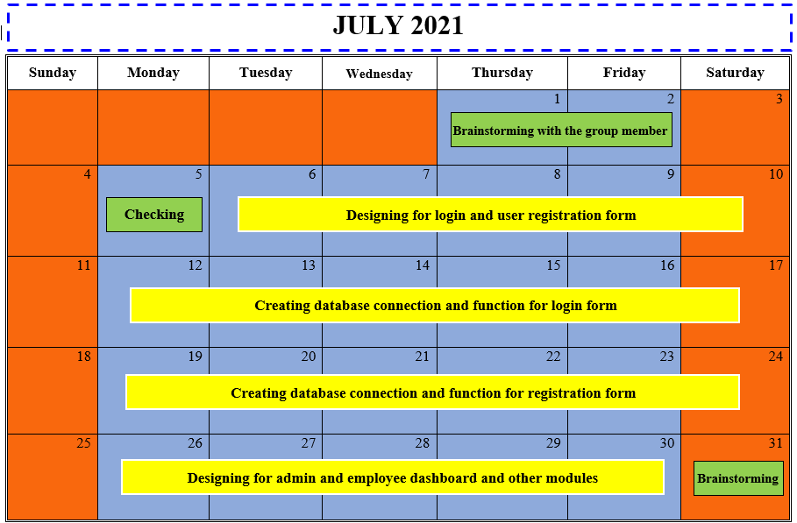

**Figure 2:** Calendar of Activities

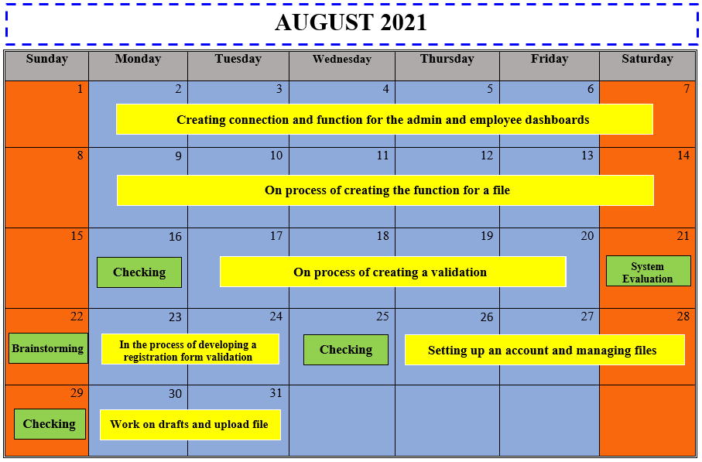

**Figure 3:** Calendar of Activities

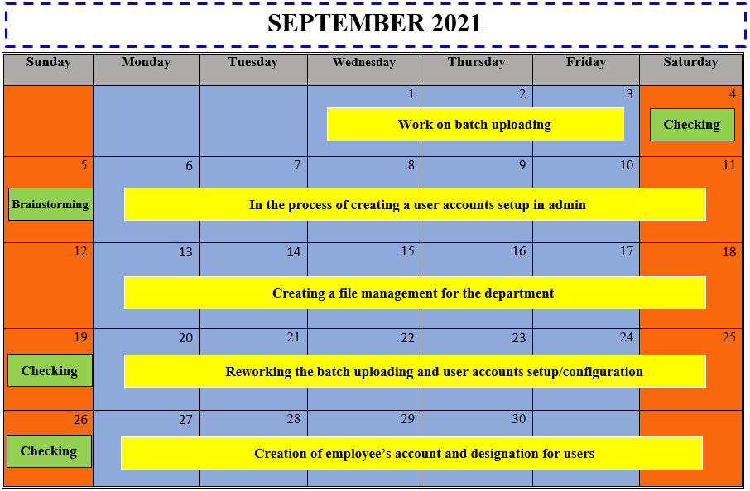

**Figure 4:** Calendar of Activities

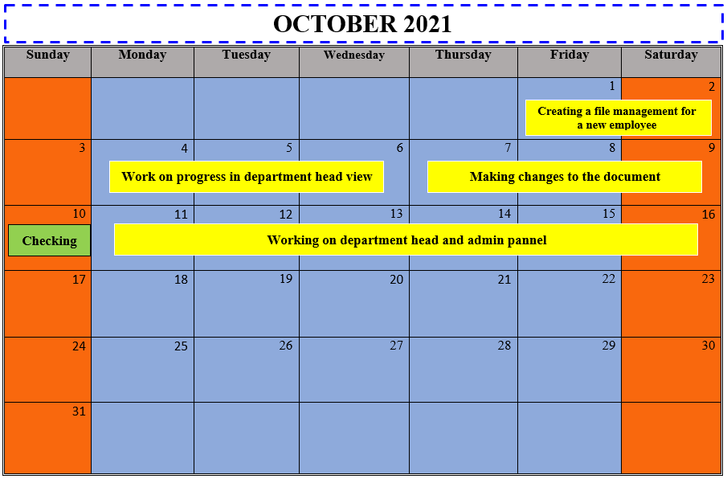

**Figure 5:** Calendar of Activities

**Resources**

**Hardware**

The succeeding section contains the hardware specifications that will be used by the researchers to develop and implement the project as mentioned below:

* Laptop

A proposed system would offer a laptop to store data input, process the data input and generate the output in a required format. It allows for a better understanding of a product's functioning requirements, leading to increased design efficiency in meeting product needs. A laptop can be used to accomplish many of the different activities within the broader design process. As each of these activities becomes more efficient, the total process becomes more efficient. Furthermore, it will be a great of assistance to the researchers in order to perform and run the program codes.

* Internet Connection

The essence of internet has made a significant contribution in most of our daily lives. Through the use of the internet, it can interconnect all computers. It manifests that internet connection is the primary material needed by the researchers in order to improve more their proposed system. This will be also their primary source of references throughout the study.

* Printer

This device is a great of help to the researchers most especially in reproducing the hard copies of their research outputs.

**Software**

The succeeding section contains the software specifications that will be used by the researchers to develop and implement the project as mentioned below:

* Sublime
* CSS
* PHP
* MySQL

**Appendix**

This section includes the following references of the documented studies, resource persons who helped support the researcher's study, and the researchers' curriculum vita

**APPENDIX A**

References

**References**

Arkan, I. & Ibrahim, O. (2017). Design and Implementation of Electronic Document Management System. Retrieved from [*https://dergipark.org.tr/en/pub/ma1kuubd/article/321093*](https://dergipark.org.tr/en/pub/ma1kuubd/article/321093).

Huda, M., Lydia E. L., Pustokhina I. V., Rosa A. T. R., Shankar K. (2019). Concept of Electronic Document Management System (EDMS) as an Efficient Tool for Storing Document. Retrieved from: [*https://www.bibliomed.org/?mno=302645110*](https://www.bibliomed.org/?mno=302645110)

Mary, J. S. & Usha, S. (2015). Web Document Management System in Life Science Organization. Retrieved from:[*https://ieeexplore.ieee.org/abstract/document/7453826*](https://ieeexplore.ieee.org/abstract/document/7453826)

Adewumi, A. O., Azeta, A. A., Eden, E. E., Omoregbe, N. A. (2014). Development of a File Tracking System for Tertiary Institutions. Retrieved from: [*http://eprints.covenantuniversity.edu.ng/5567/#.YLOKJ6gzY2w*](http://eprints.covenantuniversity.edu.ng/5567/#.YLOKJ6gzY2w)

Hendradjaya, B., Saptawati, G. A., Sumidyo, W., Widagdo, T. (2014). Document Tracking Technology to support Indonesian Local E-Government. Retrieved from: [*https://link.springer.com/chapter/10.1007/978-3-642-55032-4_33*](https://link.springer.com/chapter/10.1007/978-3-642-55032-4_33)

Del Rosario, C. J., Del Rosario, E. A., Nieva, M. R., Tan, T. T. (2015). A CCS IT Thesis Portal with Electronic Document Management System, De La Salle University Manila. Retrieved from: [*https://animosearch.dlsu.edu.ph/*](https://animosearch.dlsu.edu.ph/)

Banday, M. T., Sheika, S. A., Ratherb, J. A., (2015). File Tracking System for University Of Kashmir: Design Guidelines and Model Implementation. Retrieved from: [*https://www.researchgate.net/publication/283546729*](https://www.researchgate.net/publication/283546729)

Manondo, E. (2015). Web-based document tracking system to upgrade PRDP implementation in Bicol. Retrieved from: [*http://prdp.da.gov.ph/web-based-document-tracking-system-to-upgrade-prdp-implementation-in-bicol/*](http://prdp.da.gov.ph/web-based-document-tracking-system-to-upgrade-prdp-implementation-in-bicol/)

The UP Document Tracking System (2020). Retrieved from: [*https://itdc.up.edu.ph/news/the-up-document-tracking-system-dts*](https://itdc.up.edu.ph/news/the-up-document-tracking-system-dts)

GigaTrack (2021). Retrieved from: [*https://www.gigatrak.com/software/document-tracking-system/*](https://www.gigatrak.com/software/document-tracking-system/)

Zoho Project (2021). Document Management System. Retrieved from: [*https://www.zoho.com/projects/document-management.html*](https://www.zoho.com/projects/document-management.html)

General Data Company (2021). File Hawk Barcode File Tracking System. Retrieved from: [*https://www.general-data.com/products/software/tracking/file-hawk-barcode-file-tracking-system*](https://www.general-data.com/products/software/tracking/file-hawk-barcode-file-tracking-system)

Beck C. (2016). Find Files Faster: How to Organize Files and Folders. Retrieved from: [*https://zapier.com/blog/organize-files-folders/*](https://zapier.com/blog/organize-files-folders/)

Abella L. (2019). DPWH rolls out document tracking system. Retrieved from: [*https://www.pna.gov.ph/articles/1062639*](https://www.pna.gov.ph/articles/1062639)

**APPENDIX B**

Curriculum Vitae

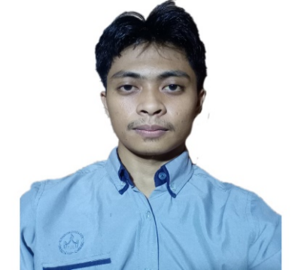Curriculum Vitae of

NURULLAJIE S. ABDULLAH

**Brgy. Limbo, Sultan Kudarat, Maguindanao**

[**nurullajie.abdullah18@gmail.com**](mailto:nurullajie.abdullah18@gmail.com)

**TM #: 09659467917**

EDUCATIONAL BACKGROUND

|  |  |  |  |  |
| --- | --- | --- | --- | --- |
| Level | Inclusive Dates | Name of school/ Institution |  |  |
| Tertiary | 2018-2022 | STI College Cotabato |  |  |
| Senior High | 2016-2018 | AMA Cotabato Campus |  |  |
| High School  Elementary | 2012-2016  2006-2012 | Nuling, National High School  Nuling, Central Elementary School |  |  |

PROFESSIONAL OR VOLUNTEER EXPERIENCE

|  |  |  |
| --- | --- | --- |
| Inclusive Dates | Nature of Experience/  Job Title | Name and Address of Company or Organization |
| N/A | N/A | N/A |

AFFILIATIONS

|  |  |  |
| --- | --- | --- |
| Inclusive Dates | Name of Organization | Position |
| 2019-2021 | GADGETS | Member |

**Listed in reverse chronological order (most recent first).**

SKILLS

|  |  |  |
| --- | --- | --- |
| SKILLS | Level of Competency | Date Acquired |
| Video Editing | Average | 2020 |
|  |  |  |

TRAININGS, SEMINARS, OR WORKSHOPS ATTENDED

|  |  |
| --- | --- |
| Inclusive Dates | Title of Training, Seminar, or Workshop |
| 2017  2017 | Video Editing  Photoshop Training |

**Listed in reverse chronological order (most recent first).**

****Curriculum Vitae of

ZARAH MAE G. BAGUNDANG

**Brgy. Nenita Herera Pob 2, Cotabato City**

**Zarahmaerakim3@gmail.com**

**TM #: 09752247232**

EDUCATIONAL BACKGROUND

|  |  |  |  |
| --- | --- | --- | --- |
| Level | Inclusive Dates | Name of school/ Institution |  |
| Tertiary | 2018-2022 | STI College Cotabato |  |
| High School | 2017-2018 | Alternative Learning System |  |
|  | 2013-2014 | Notre Dame University- JHS |  |
| Elementary | 2011-2013  2009-2011  2005-2009 | Agape School  Cotabato City Central Pilot School  Vilo Elementary School |  |
|  |  |  |  |

PROFESSIONAL OR VOLUNTEER EXPERIENCE

|  |  |  |
| --- | --- | --- |
| Inclusive Dates | Nature of Experience/  Job Title | Name and Address of Company or Organization |
| N/A | N/A | N/A |

**Listed in reverse chronological order (most recent first).**

AFFILIATIONS

|  |  |  |
| --- | --- | --- |
| Inclusive Dates | Name of Organization | Position |
| 2019-2021 | GADGETS | Member |

**Listed in reverse chronological order (most recent first).**

SKILLS

|  |  |  |
| --- | --- | --- |
| SKILLS | Level of Competency | Date Acquired |
| Photo & Video Editing | Average | 2020 |

TRAININGS, SEMINARS, OR WORKSHOPS ATTENDED

|  |  |
| --- | --- |
| Inclusive Dates | Title of Training, Seminar, or Workshop |
| 2019-2020 | ICT Days |
| 2019-2020 | Leadership Training |
| 2019-2020 | NSTP Orientation |
| 2017-2018 | Film Makers Association Workshop |

**Listed in reverse chronological order (most recent first).**

**.**

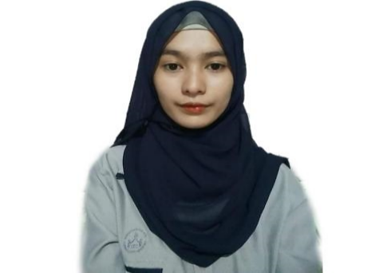Curriculum Vitae of

SITTY NOR-SHAINA D. DAUD

**Cotabato City, Poblacion V**

[**daud.sheen@gmail.com**](mailto:daud.sheen@gmail.com)

**TM #: 09066198242**

EDUCATIONAL BACKGROUND

|  |  |  |  |
| --- | --- | --- | --- |
| Level | Inclusive Dates | Name of school/ Institution |  |
| Tertiary | 2018-2022 | STI College Cotabato |  |
| Senior High | 2016-2018 | CCSPC-Laboratory High School |  |
| High School  Elementary | 2012-2016  2006-2012 | Cotabato City National High School-Rojas  Punta Central Elementary School |  |

PROFESSIONAL OR VOLUNTEER EXPERIENCE

|  |  |  |  |
| --- | --- | --- | --- |
| Inclusive Dates | Nature of Experience/  Job Title | Name and Address of Company or Organization | |
| 2018 | Work Immersion | United Doctors Hospital - Cotabato |
|  |  |

**Listed in reverse chronological order (most recent first).**

AFFILIATIONS

|  |  |  |
| --- | --- | --- |
| Inclusive Dates | Name of Organization | Position |
| 2021 | Muslim Youth Religious Organization | Member |
| 2019-2021 | GADGETS | Member |
|  |  |  |

**Listed in reverse chronological order (most recent first).**

SKILLS

|  |  |  |
| --- | --- | --- |
| SKILLS | Level of Competency | Date Acquired |
| Interpersonal Skills | Average | N/A |

TRAININGS, SEMINARS, OR WORKSHOPS ATTENDED

|  |  |
| --- | --- |
| Inclusive Dates | Title of Training, Seminar, or Workshop |
| 2021  2020  2019  2018 | MYROi  Data Privacy Act: The What and The How  NSTP Orientation  Video Editing Workshop |

**Listed in reverse chronological order (most recent first).**

****Curriculum Vitae of

NICOLE HAYLYNN G. MANCAO

**RH8 Blck 15, San Roque St. Notre Dame Village, Cotabato City**

[**nicolehaylynn@gmail.com**](mailto:nicolehaylynn@gmail.com)

**SMART #: 09064922237**

EDUCATIONAL BACKGROUND

|  |  |  |  |
| --- | --- | --- | --- |
| Level | Inclusive Dates | Name of school/ Institution |  |
| Tertiary | 2018-2022 | STI College Cotabato |  |
| Senior High | 2016-2018 | CCSPC-Laboratory High School |  |
| High School  Elementary | 2012-2016  2006-2012 | Notre Dame Village National High School  Notre Dame Village Central Elementary School |  |

PROFESSIONAL OR VOLUNTEER EXPERIENCE

|  |  |  |
| --- | --- | --- |
| Inclusive Dates | Nature of Experience/  Job Title | Name and Address of Company or Organization |
| 2018  2017 | Work Immersion  Product Marketing | Cotabato City Hall  DKT Smart |

**Listed in reverse chronological order (most recent first).**

AFFILIATIONS

|  |  |  |
| --- | --- | --- |
| Inclusive Dates | Name of Organization | Position |
| 2018-2019  2019-2021 | STI ARTS  GADGETS | Member  Secretary |

**Listed in reverse chronological order (most recent first).**

SKILLS

|  |  |  |
| --- | --- | --- |
| SKILLS | Level of Competency | Date Acquired |
| Photo & Video Editing | Average | 2020 |
| Computer Literate  Leadership | Average  Average | 2019  2018 |
|  |  |  |

TRAININGS, SEMINARS, OR WORKSHOPS ATTENDED

|  |  |
| --- | --- |
| Inclusive Dates | Title of Training, Seminar, or Workshop |
| 2020  2019-2020  2018-2019 | Data Privacy Act: The What and The How  NSTP Orientation  Video Editing Workshop |

**Listed in reverse chronological order (most recent first).**

**APPENDIX C**

Consultation Forms

**STI COLLEGE COTABATO**

**A. Dorotheo St., Cotabato City**

**Consultation / Progress Report**

**(With Adviser)**

Name of Student: Program: **BSIT**

1. Abdullah, Nurullajie S._______________________
2. Bagundang, Zarahh Mae G.____________________
3. Daud, Sitty Nor-Shaina D._____________________
4. Mancao, Nicole Haylynn G.____________________

Name of Adviser: Junaidin A. Kamid______________ Date/Time: June 20, 2021/2:00-3:00 PM

Project Title: Document Tracking System with SMS Notification

Presentation / Documentation

* System checking

Revisions on the System

* Remove the option for *remember me* in login form
* Must have an inbox for notification
* All files opened by the user must be visible in recent documents or activity history
* Recent document must have a remove option
* Remove the create tags
* Must have an archiving to hide the document

Follow Up Consultation on: _______________________________________________________

Adviser’s Signature____________________________ Date: _________________

**STI COLLEGE COTABATO**

**A. Dorotheo St., Cotabato City**

**Consultation / Progress Report**

**(With Adviser)**

Name of Student: Program: **BSIT**

1. Abdullah, Nurullajie S._______________________
2. Bagundang, Zarahh Mae G.____________________
3. Daud, Sitty Nor-Shaina D._____________________
4. Mancao, Nicole Haylynn G.____________________s

Name of Adviser: Junaidin A. Kamid________ Date/Time: August 16, 2021 / 11:30-1:00 PM

Project Title: Document Tracking System with SMS Notification

Presentation / Documentation

* System checking

Revisions on the System

* Login form - there must have three tries or countdown, change the email into username. Validation (weak or strong password) is required, and the appropriate system message is "Incorrect username and/or password”.
* Registration - must have file management, proper phone number format, and, if registered, message alerts are required.
* Dashboard **- t**he uploading of files have the capacity based on the database connection.
* Admin - must show the recent modified documents and add new button to add user; and admin should have new module for active status of an employees.
* Add a new document (label for special characters that allowed to be used), Date and time (must be automatic).
* Department (remove department, it must be automatic), Type of document (must have file management).

1. **Batch upload** (add new module of batch uploading for list of employees, and add new button for request approval).

Follow Up Consultation on: _______________________________________________________

Adviser’s Signature____________________________ Date: _________________

**STI COLLEGE COTABATO**

**A. Dorotheo St., Cotabato City**

**Consultation / Progress Report**

**(With Adviser)**

Name of Student: Program: **BSIT**

1. Abdullah, Nurullajie S._______________________
2. Bagundang, Zarahh Mae G.____________________
3. Daud, Sitty Nor-Shaina D._____________________
4. Mancao, Nicole Haylynn G.____________________

Name of Adviser: Junaidin A. Kamid____________ Date/Time: August 21, 2021 / 2:30-3:00 PM

Project Title: Document Tracking System with SMS Notification

Presentation / Documentation

* System evaluation

Revisions on the System

* Employee **-** file management to add new select department.
* Registration form (create a validation for password and confirm password, username, and phone number it must be 11 digits only, and when a form is incorrectly filled out, the other correct fill out should not be deleted.
* Dashboard - the user’s full name should be displayed in the user profile.
* Add new document - file management for type of document, validation for file name, and a message box for confirmation (such as “your file is saved as draft”) are all available in save as drafts.
* Admin- don’t put a hint in the login form after three attempts.
* Dashboard - put all modules required for a guide.
* Work on file management, validation, and proper setup.

Follow Up Consultation on: _______________________________________________________

Adviser’s Signature____________________________ Date: _________________

**STI COLLEGE COTABATO**

**A. Dorotheo St., Cotabato City**

**Consultation / Progress Report**

**(With Adviser)**

Name of Student: Program: **BSIT**

1. Abdullah, Nurullajie S._______________________
2. Bagundang, Zarahh Mae G.____________________
3. Daud, Sitty Nor-Shaina D._____________________
4. Mancao, Nicole Haylynn G.____________________

Name of Adviser: Junaidin A. Kamid________ Date/Time: August 25, 2021 / 10:00-11:00AM

Project Title: Document Tracking System with SMS Notification

Presentation / Documentation

* System checking

Revisions on the System

* In the login form, always use the appropriate message “Invalid username and/or password,” and after three attempts, the login button will automatically enable.
* In forgot password, if a user forgets their password, other than their phone number, they should have an alternative account for password retrieval.
* Employee’s registration (adjust the background, password validation, message box “successfully registered,” and connect the registration form in database. Employee can modify their own account).
* Admin (in user module, change the deletion action into status or active and inactive user).
* Admin can modify all employees.
* Add new document (In filename, when there is an existing file, the filename should not be duplicated).
* Create a new document subfield for drafts.
* Work on admin and employee’s modification account, validation, and operation/account setup.

Follow Up Consultation on: _______________________________________________________

Adviser’s Signature____________________________ Date: _________________

**STI COLLEGE COTABATO**

**A. Dorotheo St., Cotabato City**

**Consultation / Progress Report**

**(With Adviser)**

Name of Student: Program: **BSIT**

1. Abdullah, Nurullajie S._______________________
2. Bagundang, Zarahh Mae G.____________________
3. Daud, Sitty Nor-Shaina D._____________________
4. Mancao, Nicole Haylynn G.____________________

Name of Adviser: Junaidin A. Kamid________ Date/Time: August 29, 2021 / 9:30-10:00AM

Project Title: Document Tracking System with SMS Notification

Presentation / Documentation

* System checking

Revisions on the System

* Login form - username and password validation.
* Add new document - preview of the attached file is required.
* Drafts - In order to delete a file, the message button must be set to “Yes or No.” Change the upload file button to the sent button.
* Work on drafts and upload file.

Follow Up Consultation on: _______________________________________________________

Adviser’s Signature____________________________ Date: _________________

**STI COLLEGE COTABATO**

**A. Dorotheo St., Cotabato City**

**Consultation / Progress Report**

**(With Adviser)**

Name of Student: Program: **BSIT**

1. Abdullah, Nurullajie S._______________________
2. Bagundang, Zarahh Mae G.____________________
3. Daud, Sitty Nor-Shaina D._____________________
4. Mancao, Nicole Haylynn G.____________________

Name of Adviser: Junaidin A. Kamid________ Date/Time: September 04, 2021 / 1:30-2:00PM

Project Title: Document Tracking System with SMS Notification

Presentation / Documentation

* System checking

Revisions on the System

**Admin**

* The administrator has the ability to create departments and user accounts (head department and employees).
* Head department can create or add users to their department and assign people or users such as the releasing officer.
* The releasing officer is in charge of releasing and receiving documents and can provide the information such as tracking numbers, receiver names and departments, and dates received.

**Employee**

* Employees are not permitted to send documents directly to other departments unless authorized by the releasing officer.
* Employees submit their documents to the releasing officer.
* Can create, save, and send documents but with restriction.

Follow Up Consultation on: _______________________________________________________

Adviser’s Signature____________________________ Date: _________________

**STI COLLEGE COTABATO**

**A. Dorotheo St., Cotabato City**

**Consultation / Progress Report**

**(With Adviser)**

Name of Student: Program: **BSIT**

1. Abdullah, Nurullajie S._______________________
2. Bagundang, Zarahh Mae G.____________________
3. Daud, Sitty Nor-Shaina D._____________________
4. Mancao, Nicole Haylynn G.____________________

Name of Adviser: Junaidin A. Kamid________ Date/Time: September 19, 2021 / 1:00-1:30PM

Project Title: Document Tracking System with SMS Notification

Presentation / Documentation

* System checking

Revisions on the System

* The batch upload must be in the user profile.
* The filter department, adding a new department, and creating a new user should all be separate forms.
* Create a new inquiry module for filter department.
* File management for add new department. Creation of new user that belongs to the specific department.
* In user setup, the admin will assign the department head then the department head will assign or add an employee to their respective department.

Follow Up Consultation on: _______________________________________________________

Adviser’s Signature____________________________ Date: _________________

**STI COLLEGE COTABATO**

**A. Dorotheo St., Cotabato City**

**Consultation / Progress Report**

**(With Adviser)**

Name of Student: Program: **BSIT**

1. Abdullah, Nurullajie S._______________________
2. Bagundang, Zarahh Mae G.____________________
3. Daud, Sitty Nor-Shaina D._____________________
4. Mancao, Nicole Haylynn G.____________________

Name of Adviser: Junaidin A. Kamid________ Date/Time: October 10, 2021/1:00-1:30PM

Project Title: Document Tracking System with SMS Notification

Presentation / Documentation

* System checking

Revisions on the System

**Department Head**

* The department head cannot create employee user if the user is not listed/found in batch upload or in user profile.
* There must be a search filter where department head can directly search the employee.
* Department head users must add its own document type.

Follow Up Consultation on: _______________________________________________________

Adviser’s Signature____________________________ Date: _______________