Driver Drowsiness Detection and Safety Alert System Using Python

Submitted in partial fulfillment of the requirement
of the degree of

Diploma Engineering in

Computer Engineering

By

Arsh Mansuri 23291341055

Under the guidance of

Prof. 1 – Dharamsinh V Solanki
Prof. 2 – Hitesh A Momaya

Ganpat University
A.Y. 2025 – 2026

CERTIFICATE

This is to certify that the project entitled, “Driver Drowsiness Detection and Safety Alert System Using Python” is a Bonafide work of “Arsh Mansuri” (23291341055), submitted in the partial fulfillment of the requirement for the award of the Diploma Engineering in Computer Engineering

Prof. 1 – Dharamsinh V Solanki
Prof. 2 – Hitesh A Momaya

Place:

Date:

Declaration
We declare that this written submission represents our ideas in our own words and where others’ ideas or words have been included, we have adequately cited and referenced the original sources. We also declare that, we have adhered to all the principles of academic honesty and integrity and have not misrepresented or fabricated or falsified any idea/data/fact/source in our submission. We understand that any violation of the above will be a cause for disciplinary action by the Institute and can also evoke penal action from the sources, which have thus not been properly cited or from whom proper permission has not been taken, when needed.

Arsh Mansuri (23291341055)

Place:

Date:

APPROVAL SHEET

Project entitled, “Driver Drowsiness Detection and Safety Alert System Using Python”, submitted by “Arsh Mansuri” (23291341055), is approved for the award of the Diploma Engineering in Computer Engineering.

Signature of Internal Examiner Signature of External Examiner

Place:

Date:

Table of Contents

Chapter 1: Introduction ……………………………...………………………………………… 8
  - Background and Motivation
  - Project Overview
  - Limitations of Existing System
  - Objectives
  - Scope
1.6 Yawning Detection Overview
Chapter 2: Literature Review …………………………………………………...…………… 11
2.1 Study of Existing Systems
2.2 Summary of Literature Review
2.3 Area of Application
2.4 Mapping Design

Chapter 3: Problem Definition and Objectives …………………………...……………...…. 13
3.1 Problem Statement
3.2 Motivation
3.3 Objectives
3.4 Purpose of the System
3.5 Scope
3.6 Significance
3.7 Constraints
3.8 Limitations
3.9 Assumptions
3.10 Expected Outcomes
3.11 Application

Chapter 4: Design of the Project ……………………...…………………….…………….…. 17
4.1 Introduction
4.2 System Architecture
4.3 Flow Diagram
4.4 Design Framework
4.5 Front-End Pages
4.6 Back-End Methodology
4.7 Eye Aspect Ration Calculation
4.8 Yawning Detection Methodology
4.9 Alert System
4.10 Working of the System
4.11 Summary

Chapter 5: Results & Discussions ………………………………..…………………...…… 22
5.1 Introduction
5.2 Results
5.3 Performance Analysis
5.4 Discussion
5.5 Advantages
5.6 Limitations
5.7 Future Improvements
5.8 Summary

Chapter 6: Conclusion & Future Scope…………………………..…………………...…… 27
6.1 Conclusion
6.2 Future Scope

References ………………………………………………………………………………..…. 29

Abstract

Driver fatigue is one of the major causes of road accidents, especially during long-distance and night-
time driving. This project presents a Driver Drowsiness and Yawning Detection System using computer vision and deep learning techniques.
The system continuously monitors the driver using a webcam and detects signs of fatigue such as eye closure and yawning. Eye detection is performed using OpenCV and Dlib, while yawning detection is achieved by analyzing the mouth opening using facial landmarks.
A Convolutional Neural Network (CNN) is used to classify eye states, and a threshold-based approach is used for yawning detection. If the system detects prolonged eye closure or frequent yawning, an alert is triggered using an alarm.
This system enhances driver safety by providing real-time monitoring and early warning of fatigue.

Keywords – Driver Drowsiness, Computer Vision, OpenCV, CNN, Python, Safety Alert System.

Chapter 1
Introduction

Drowsiness detection is a safety technology that can prevent accidents that are caused by drivers who fell asleep while driving. The main objective is to build a drowsiness detection and alert system that will detect that a person’s eyes are closed for a few seconds and also will alert the driver when drowsiness of driver is detected. The risk, danger, and often tragic results of drowsy driving are alarming. Drowsy driving is the dangerous combination of driving and sleepiness or fatigu. Drowsiness detection technologies have attempted to prevent such incidents by predicting if a driver is falling asleep based on various inputs. The objective of this project is to measure the current activity of the eyes of the driver which is visualized by the camera and we can check the drowsiness of the driver. We present a system for drowsiness detection using CNN,OpenCV and python packages.

1.1 Background and Motivation
Driver drowsiness is one of the most critical factors contributing to road accidents worldwide, particularly during long-distance travel and late-night driving. Fatigue affects the driver’s ability to concentrate, reduces alertness, and slows down reaction time, which significantly increases the chances of accidents. In many situations, drivers are unable to recognize the early signs of drowsiness such as frequent blinking, eye closure, or yawning. As a result, they continue driving in an unsafe condition, which can lead to serious consequences. With the increasing number of vehicles and growing traffic conditions, it has become essential to develop intelligent systems that can monitor driver behavior in real time. A drowsiness detection system can act as a preventive safety mechanism by identifying fatigue at an early stage and alerting the driver before an accident occurs.

1.2 Project Overview
The proposed project aims to design and implement a real-time driver drowsiness detection system using computer vision and deep learning techniques. The system uses a webcam to continuously capture video of the driver and processes each frame to analyze facial features. The primary focus is on detecting eye closure and yawning, which are considered important indicators of fatigue. Eye detection is performed using a Convolutional Neural Network (CNN) model, which classifies whether the eyes are open or closed with high accuracy. In addition, yawning detection is carried out by analyzing the mouth region using facial landmark detection and calculating the mouth opening ratio. By combining both eye closure and yawning detection, the system provides more reliable results. When the system detects signs of drowsiness, it triggers an alert sound to notify the driver and help prevent accidents.

1.3 Limitations of Existing Systems
Despite its effectiveness, the system has certain limitations that need to be considered. The performance of the system is highly dependent on lighting conditions and the visibility of the driver’s face. In low-light environments or when the driver’s face is partially covered with accessories such as sunglasses or masks, the accuracy of detection may decrease. The system also requires proper camera positioning to capture clear facial features. Additionally, the system focuses mainly on eye closure and yawning and may not detect all possible indicators of fatigue. However, under normal conditions, the system performs efficiently and provides reliable results for real-time drowsiness detection.

1.4 Objectives
The main objective of this project is to develop an efficient and reliable system that can detect driver drowsiness in real time. The system aims to continuously monitor the driver’s facial features and identify signs of fatigue such as prolonged eye closure and yawning. Another important objective is to generate immediate alerts whenever drowsiness is detected, thereby reducing the risk of accidents. The project also focuses on achieving high accuracy using deep learning techniques while maintaining low cost and simplicity. Additionally, the system is designed to be user-friendly and easily deployable without the need for complex hardware.

1.5 Scope
The scope of this project includes the development of a real-time driver monitoring system that can be used in various types of vehicles. It is suitable for personal vehicles as well as commercial transportation systems such as buses, trucks, and taxis. The system can be integrated with existing vehicle systems to enhance safety features. In the future, the project can be extended by incorporating advanced technologies such as mobile applications for remote monitoring, cloud-based data storage for analysis, and IoT-based alert mechanisms. Furthermore, additional fatigue indicators such as head movement, facial expressions, and driver behavior patterns can be included to improve the accuracy and reliability of the system.

1.6 Yawning Detection Overview
Yawning is one of the earliest signs of driver fatigue. Detecting yawning helps identify drowsiness before the driver falls asleep.

In this project, yawning is detected by analyzing the mouth opening using facial landmark points. When the mouth remains open beyond a certain threshold, the system identifies it as a yawn and contributes to the drowsiness score.

Chapter 2
Literature Review

2.1 Study of Existing Systems
Driver drowsiness detection has been widely studied using different approaches, including behavioral methods, vehicle-based methods, and physiological signal-based systems. Behavioral methods focus on observing physical changes in the driver such as eye blinking, yawning, and head movement. These methods are commonly used because they are simple and do not require direct contact with the driver. Vehicle-based systems analyze driving patterns such as steering behavior, lane deviation, and speed variations to detect fatigue. However, these systems may not always provide accurate results because driving patterns can vary depending on road conditions. Physiological methods involve measuring biological signals such as heart rate, brain activity, and muscle movement using sensors. Although these systems provide high accuracy, they are expensive and intrusive, making them less practical for everyday use. Among all these approaches, vision-based systems have gained popularity because they are non-intrusive, cost-effective, and capable of providing real-time detection using cameras and image processing techniques.

2.2 Summary of Literature Review
From the analysis of existing systems and research studies, it is observed that eye detection is one of the most reliable indicators of driver drowsiness. The use of parameters such as Eye Aspect Ratio (EAR) helps in identifying whether the eyes are open or closed. In addition, yawning detection using Mouth Aspect Ratio (MAR) provides another important indication of fatigue. Deep learning techniques, especially Convolutional Neural Networks (CNN), have significantly improved the accuracy of detection compared to traditional image processing methods. It is also found that systems that combine multiple indicators, such as eye closure and yawning, provide better performance and reduce false detection. Real-time processing is another important factor, as the system must respond quickly to prevent accidents.

2.3 Area of Application
The driver drowsiness detection system has a wide range of applications in different fields. It can be used in personal vehicles to ensure driver safety during long journeys. In commercial transportation, such as trucks, buses, and taxis, the system can help reduce accidents caused by driver fatigue. It is also useful in fleet management systems, where monitoring driver behavior is essential for maintaining safety standards. In addition, the system can be applied in safety-critical environments where continuous monitoring of human alertness is required. By providing real-time alerts, the system plays an important role in preventing accidents and improving overall safety.

2.4 Mapping Design
The mapping design of the system describes the overall flow of data from input to output. The process begins with capturing video input using a webcam. The system then applies face detection techniques to identify the driver’s face in each frame. Once the face is detected, specific regions such as the eyes and mouth are extracted for further analysis. The eye region is processed using a CNN model to determine whether the eyes are open or closed, while the mouth region is analyzed using facial landmark detection to identify yawning. Based on the calculated values and predefined thresholds, the system determines whether the driver is drowsy. If drowsiness is detected, an alert signal is generated. This structured mapping ensures smooth operation and efficient real-time performance of the system.

Chapter 3
Problem Definition and Objectives

3.1 Problem Statement
Driver fatigue is one of the major causes of road accidents, especially during long-distance travel, continuous driving, and night journeys. When a driver becomes tired, their ability to concentrate decreases, and their reaction time becomes slower, which increases the chances of accidents. One of the major issues is that drivers often fail to recognize the early signs of drowsiness such as frequent blinking, eye closure, and yawning. As a result, they continue driving in an unsafe condition. Existing systems for detecting drowsiness are either expensive, require additional hardware, or are not efficient in real-time scenarios. Many of these systems also rely on a single parameter, which reduces their accuracy. Therefore, there is a need for a reliable, efficient, and cost-effective system that can detect multiple signs of fatigue and provide timely alerts to prevent accidents.

3.2 Motivation
The main motivation behind this project is to enhance road safety by reducing accidents caused by driver drowsiness. With the rapid growth in the number of vehicles, ensuring driver safety has become a major concern. Advances in computer vision and deep learning have made it possible to develop intelligent systems that can monitor human behavior in real time. This project is motivated by the idea of using these technologies to create a practical and effective solution that can detect fatigue early and alert the driver before a dangerous situation occurs.

3.3 Objectives
The primary objective of this project is to design and develop a system that can detect driver drowsiness in real time using computer vision techniques. The system aims to monitor the driver continuously and identify important indicators such as eye closure and yawning. Another objective is to ensure that the system provides accurate results with minimal delay so that timely alerts can be generated. The project also focuses on developing a solution that is cost-effective, easy to use, and does not require complex hardware. In addition, it aims to improve overall road safety by reducing the number of accidents caused by fatigue.

3.4 Purpose of the System
The purpose of the system is to continuously monitor the driver’s condition and detect signs of fatigue before they lead to critical situations. By analyzing facial features such as eyes and mouth, the system can identify whether the driver is alert or drowsy. When signs of fatigue are detected, the system generates an alert to warn the driver. This helps in preventing accidents and ensures a safer driving experience. The system is designed to act as an assistance tool that supports the driver and enhances safety.

3.5 Scope
The scope of this project includes the development of a real-time drowsiness detection system that can be implemented in different types of vehicles. It can be used in personal cars as well as commercial vehicles such as trucks and buses. The system can also be integrated with modern vehicle technologies to provide advanced safety features. In the future, the system can be expanded by incorporating additional functionalities such as mobile notifications, cloud-based monitoring, and data analysis for tracking driver behavior over time. These enhancements can improve the usability and effectiveness of the system.

3.6 Significance
The significance of this project lies in its ability to improve road safety by detecting driver fatigue at an early stage. By providing real-time alerts, the system helps prevent accidents and protects both drivers and passengers. It also reduces the risk of damage to vehicles and infrastructure. Furthermore, the project contributes to the development of intelligent transportation systems by integrating modern technologies such as computer vision and deep learning. It promotes the use of automated systems in safety applications and highlights the importance of technology in reducing human errors.

3.7 Constraints
The system has certain constraints that affect its performance. One of the main constraints is the dependency on proper lighting conditions, as poor lighting can reduce the accuracy of facial feature detection. Another constraint is the requirement for correct camera positioning to ensure that the driver’s face is clearly visible. The system also depends on the processing capability of the device, as real-time detection requires efficient computation. These constraints must be considered while implementing the system.

3.8 Limitations
Although the system provides effective results, it has some limitations. The accuracy of detection may decrease in low-light conditions or when the driver’s face is partially covered by objects such as sunglasses, masks, or hands. The system mainly focuses on eye closure and yawning and may not detect all possible signs of fatigue such as head nodding or body posture changes. Additionally, variations in facial features among different individuals may slightly affect the performance. Despite these limitations, the system performs well under normal conditions.

3.9 Assumptions
The system is designed based on certain assumptions to ensure proper functioning. It assumes that the driver’s face is clearly visible to the camera and that the lighting conditions are sufficient for detection. It also assumes that eye closure and yawning are reliable indicators of drowsiness. These assumptions help simplify the design and implementation of the system.

3.10 Expected Outcomes
The expected outcome of this project is the successful development of a real-time driver drowsiness detection system that can accurately identify signs of fatigue. The system should be able to detect eye closure and yawning effectively and generate alerts without delay. It is expected to improve driver safety and reduce the number of accidents caused by fatigue. The project also demonstrates the practical application of computer vision and deep learning techniques in solving real-world problems.

3.11 Applications
The system can be applied in various fields where monitoring human alertness is important. It can be used in personal vehicles to ensure safe driving during long journeys. In commercial transportation, it can help reduce accidents involving truck and bus drivers. The system can also be used in fleet management systems to monitor driver behavior and improve safety standards. Additionally, it can be applied in other areas such as surveillance systems and workplace safety monitoring

Chapter 4
Design of Project

4.1 Introduction
This chapter describes the design and implementation of the Driver Drowsiness Detection System. The system is developed using computer vision and deep learning techniques to monitor the driver in real time. It processes video input captured from a webcam and analyzes facial features such as the eyes and mouth to detect signs of fatigue. The design focuses on achieving accurate detection while maintaining real-time performance and efficiency.

4.2 System Architecture
The system architecture consists of three main components: input, processing, and output. The input component is responsible for capturing real-time video using a webcam. The processing component analyzes the captured frames by detecting the face and extracting important facial features such as the eyes and mouth. This component uses image processing techniques and deep learning models to identify signs of drowsiness. The output component generates alerts when fatigue is detected. This architecture ensures smooth data flow and enables the system to operate efficiently in real time.
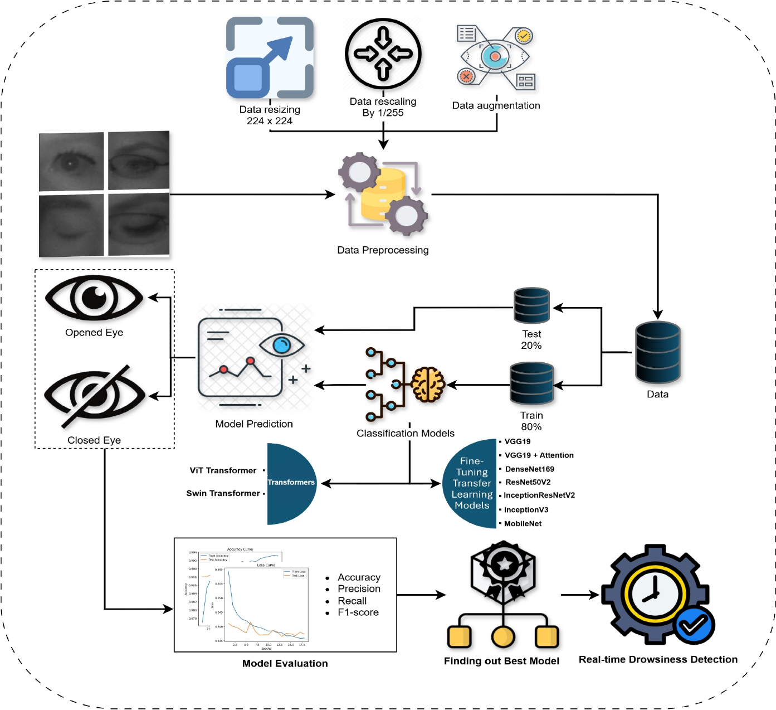
Fig 4.1 System Architecture of Driver Drowsiness Detection System

4.3 Flow Diagram
The flow diagram represents the step-by-step working of the system. The process begins with capturing video frames from the webcam. The system then detects the driver’s face in each frame and extracts the eye and mouth regions. These regions are analyzed to calculate parameters such as eye closure and mouth opening. Based on predefined thresholds, the system determines whether the driver is drowsy. If drowsiness is detected, an alert is generated. The flow diagram helps in understanding the logical sequence of operations in the system.
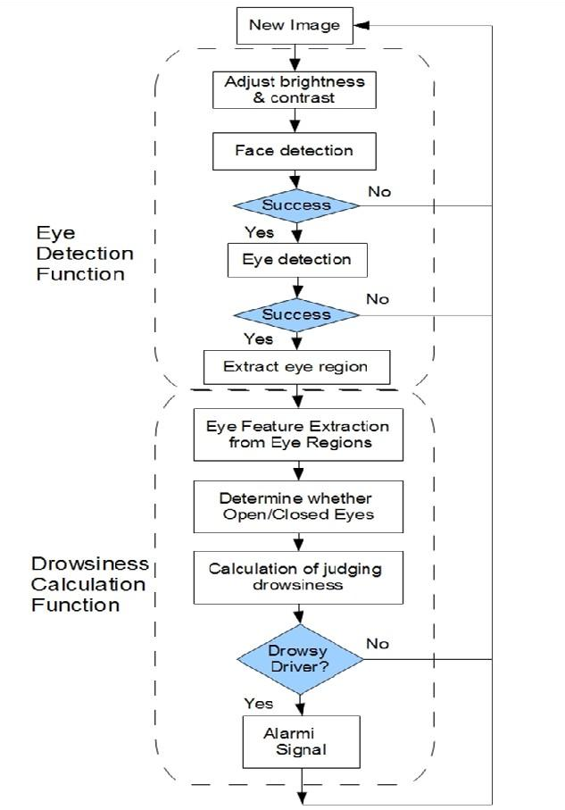

Figure

4.2:
Flowchart

of

Application

4.4 Design Framework
The design framework of the system is based on the integration of computer vision and deep learning techniques. The system uses facial landmark detection to identify key points on the face, which helps in locating the eyes and mouth. A Convolutional Neural Network (CNN) model is used to classify the eye state as open or closed. For yawning detection, the system calculates the mouth opening using geometric measurements. These components work together to provide accurate detection of driver drowsiness. The framework ensures that the system is both efficient and reliable.

4.5 Front-End Design
The front-end of the system is responsible for displaying the real-time video feed and detection results. It shows the driver’s face along with indicators such as eye status and yawning detection. The interface is simple and user-friendly, allowing easy monitoring of the system’s output. The visual feedback helps in understanding how the system is analyzing the driver’s condition

4.6 Back-End Methodology
The backend of the system handles the main processing tasks. It captures video frames, detects the face, and extracts facial features using image processing techniques. The system then calculates important parameters such as Eye Aspect Ratio (EAR) and Mouth Aspect Ratio (MAR). These values are used to determine whether the driver is drowsy. The backend also manages the alert system and ensures that the detection process runs continuously without delay.

4.7 Eye Aspect Ratio (EAR) Calculation
Eye detection is one of the key components of the system. The system uses facial landmarks to locate the eye region and then applies a CNN model to classify whether the eyes are open or closed. The Eye Aspect Ratio (EAR) is calculated to measure the degree of eye openness. When the EAR value falls below a certain threshold for a continuous period, it indicates that the driver’s eyes are closed, which is a sign of drowsiness. This method provides accurate and reliable detection of eye closure.

4.8 Yawning Detection Methodology
Yawning detection is implemented by analyzing the mouth region using facial landmarks. The system calculates the Mouth Aspect Ratio (MAR) to measure the extent of mouth opening. A high MAR value indicates that the driver is yawning, which is an early sign of fatigue. By including yawning detection along with eye detection, the system improves its ability to identify drowsiness more accurately.

4.9 Alert System
The alert system is an important part of the project, as it provides feedback to the driver when drowsiness is detected. When the system identifies prolonged eye closure or frequent yawning, it triggers an alarm sound using a sound module. This alert helps in waking the driver and restoring their attention. The alert system is designed to respond quickly to ensure maximum safety

4.10 Working of the System
The overall working of the system begins with capturing video from the webcam. The system processes each frame to detect the face and extract the eye and mouth regions. It then calculates EAR and MAR values to analyze the driver’s condition. If these values indicate drowsiness, the system triggers an alert. This process continues continuously in real time, ensuring constant monitoring of the driver.

4.11 Summary
This chapter explained the design and working of the driver drowsiness detection system. It described the system architecture, flow of operation, and key components such as eye detection, yawning detection, and alert generation. The design ensures accurate and real-time detection, making the system effective for practical use.

Chapter 5
Results & Discussions

5.1 Introduction
This chapter presents the results obtained from the implementation of the Driver Drowsiness and Yawning Detection System and evaluates its performance under different conditions. The system was tested in real-time using a webcam to monitor the driver’s facial features. The main objective of this chapter is to analyze how effectively the system detects eye closure, yawning, and overall drowsiness, and to discuss its accuracy and limitations.

5.2 Results
The system was successfully able to detect different driver states such as open eyes, closed eyes, yawning, and drowsiness in real time. During testing, the webcam continuously captured video frames, and the system processed each frame to analyze facial features. When the driver’s eyes remained open, the system correctly identified the alert state. When the eyes were closed for a longer duration, the system detected drowsiness and triggered an alert. Similarly, yawning was detected based on the increase in mouth opening using facial landmarks. The system provided immediate feedback and generated an alarm sound whenever fatigue was detected. These results demonstrate that the system is capable of monitoring driver behavior effectively.

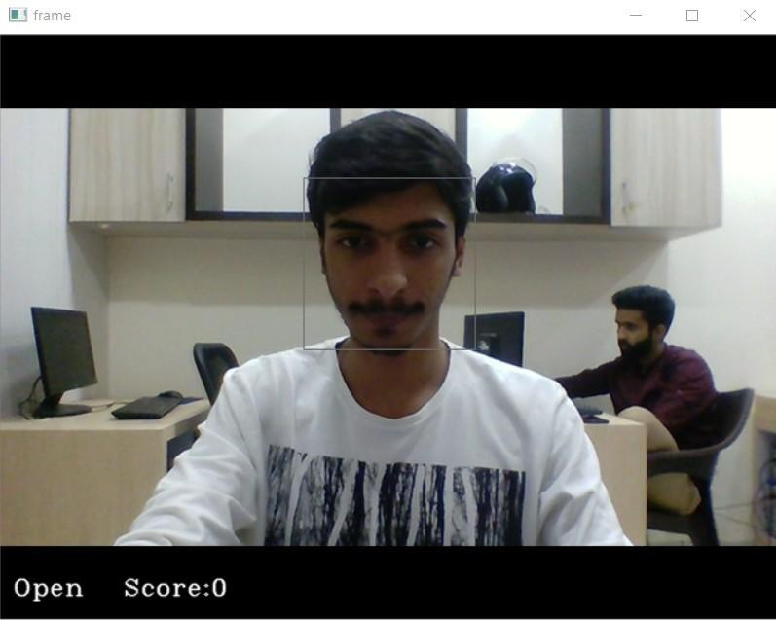
Fig 5.2 Detection of Open Eyes
The system correctly identifies when the driver’s eyes are open. The EAR value remains above the threshold, indicating alertness.
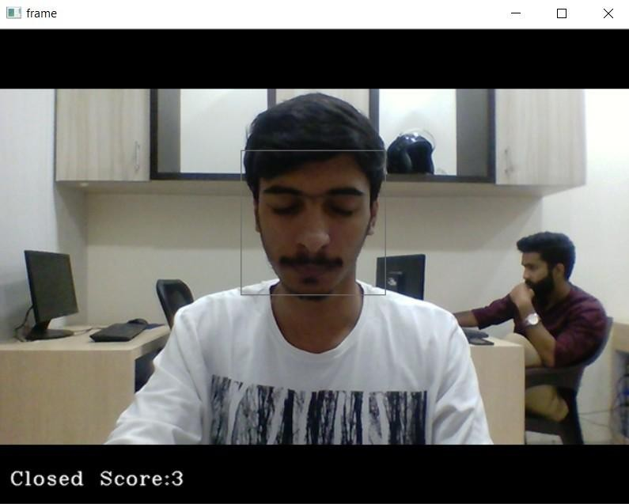
Fig 5.1 Detection of Closed Eyes
The system successfully detects when the driver’s eyes are closed. The Eye Aspect Ratio (EAR) falls below the threshold, indicating eye closure.

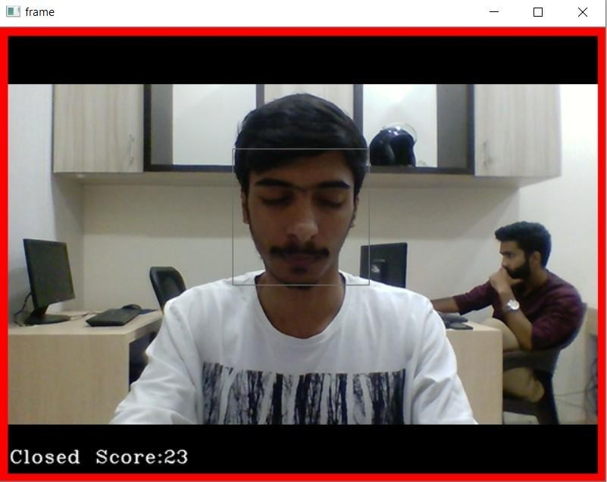
Fig 5.3 Drowsiness Alert Triggered
When the driver’s eyes remain closed for a prolonged duration, the system triggers an alert using an alarm sound.

5.3 Performance Analysis
The performance of the system was evaluated based on accuracy, real-time response, and reliability. The system showed good accuracy in detecting eye closure using the CNN model, especially under normal lighting conditions. The use of Eye Aspect Ratio (EAR) helped in identifying prolonged eye closure effectively. Yawning detection using Mouth Aspect Ratio (MAR) further improved the system’s ability to detect early signs of fatigue. The system was able to process video frames efficiently and provide real-time output with minimal delay. However, slight variations in accuracy were observed under poor lighting conditions or when the driver’s face was partially obstructed.
5.4 Discussion
The results indicate that the system performs effectively in detecting driver drowsiness by combining eye detection and yawning detection. The integration of multiple indicators reduces the chances of false detection and improves overall accuracy. The system provides timely alerts, which can help prevent accidents by warning the driver in advance. However, certain challenges were observed, such as reduced performance in low-light environments and difficulty in detecting facial features when the driver’s face is not clearly visible. Despite these challenges, the system demonstrates reliable performance in most practical scenarios.

5.5 Advantages
The system offers several advantages in terms of functionality and implementation. It is cost-effective, as it uses a simple webcam and software-based techniques without requiring expensive hardware. The system operates in real time, providing immediate feedback to the driver. It also improves detection accuracy by using both eye closure and yawning as indicators of fatigue. Additionally, the system is easy to implement and can be integrated with existing vehicle safety systems.

5.6 Limitations
Although the system performs well, it has certain limitations that affect its performance. The accuracy of detection depends on proper lighting conditions and a clear view of the driver’s face. In low-light environments or when the driver’s face is partially covered, the system may not detect fatigue accurately. The system also focuses mainly on eye closure and yawning and may not detect other signs of fatigue such as head movement or body posture. These limitations highlight areas for further improvement.

5.7 Future Improvements
The system can be enhanced by incorporating additional features and improving existing functionalities. Future improvements may include adding head movement detection and facial expression analysis to identify more indicators of fatigue. The use of infrared cameras can improve performance in low-light conditions. The system can also be integrated with mobile applications and cloud-based platforms for remote monitoring and data analysis. These enhancements can make the system more robust and suitable for real-world applications.

5.8 Summary
This chapter presented the results and performance analysis of the driver drowsiness detection system. The system successfully detected eye closure, yawning, and drowsiness in real time and generated alerts to warn the driver. The discussion highlighted the strengths and limitations of the system and suggested possible improvements. Overall, the system demonstrates effective performance and has the potential to improve road safety.

Chapter 6
Conclusion and Future Scope

6.1 Conclusion
The Driver Drowsiness and Yawning Detection System developed in this project successfully demonstrates the use of computer vision and deep learning techniques for real-time driver monitoring. The system continuously captures video input using a webcam and analyzes facial features such as the eyes and mouth to detect signs of fatigue. By using a Convolutional Neural Network (CNN) model for eye state classification and facial landmark detection for yawning analysis, the system is able to identify important indicators of drowsiness with good accuracy.

The system effectively detects conditions such as prolonged eye closure and yawning, which are strong indicators of driver fatigue. When such conditions are observed, it generates an alert sound to warn the driver, thereby helping to prevent accidents. The combination of eye detection and yawning detection improves the overall reliability of the system compared to systems that rely on a single parameter. The system also performs well in real-time conditions and provides immediate feedback without significant delay.

The implementation of this project shows that it is possible to develop a cost-effective and efficient driver monitoring system using software-based techniques without the need for expensive hardware. Although the system has certain limitations, such as dependency on lighting conditions and clear visibility of the driver’s face, it still provides reliable performance under normal conditions. Overall, the project achieves its objective of detecting driver drowsiness and contributes to improving road safety.

6.2 Future Scope
The proposed system can be further improved and enhanced by incorporating advanced features and technologies. One possible improvement is the inclusion of additional fatigue indicators such as head movement, facial expressions, and driver posture analysis. These features can help in detecting drowsiness more accurately and reduce false detection. The use of infrared cameras can improve the system’s performance in low-light or night conditions, making it more reliable in all environments.
The system can also be integrated with mobile applications to provide alerts and notifications to users in real time. Cloud-based integration can be used to store and analyze driver data over time, which can help in identifying long-term driving patterns and fatigue behavior. Another important improvement is the integration of the system with vehicle control mechanisms, such as automatically slowing down the vehicle or activating safety measures when drowsiness is detected.
In addition, the use of more advanced deep learning models and larger datasets can improve the accuracy and efficiency of the system. The project can also be extended to support multiple users and different environmental conditions. These enhancements will make the system more robust, scalable, and suitable for real-world applications. Overall, the future scope of this project is wide, and it has the potential to become an important component of modern intelligent transportation systems.

References
- DataFlair. Driver Drowsiness Detection System using Python.
https://data-flair.training/blogs/python-project-driver-drowsiness-detection-system/
- Towards Data Science. Drowsiness Detection using OpenCV.
https://towardsdatascience.com/drowsiness-detection-system-in-real-time-using-opencv-and-flask-in-python-b57f4f1fcb9e
- Pantech Solutions. Driver Drowsiness Detection using Python.
https://www.pantechsolutions.net/driver-drowsiness-detection-using-opencv-and-python
- Skyfi Labs. Driver Drowsiness Detection Project.
https://www.skyfilabs.com/project-ideas/driver-drowsiness-detection-using-python
- OpenCV Documentation.
https://docs.opencv.org
- LearnOpenCV. CNN Tutorials.
https://learnopencv.com
- PyImageSearch. CNN Object Detection.
https://www.pyimagesearch.com

***

