Project 01

Deploying a Node.js App Using Minikube Kubernetes

Overview
This project guides you through deploying a Node.js application using Minikube Kubernetes. You'll use Git for version control, explore branching and fast-forward merges, and set up Kubernetes services and deployment pods, including ClusterIP and NodePort service types.

Prerequisites
- Minikube installed
- kubectl installed
- Git installed
- Node.js installed (https://nodejs.org/en/download/package-manager/all#debian-and-ubuntu-based-linux-distributions)

Project Steps

1. Set Up Git Version Control
1.1. Initialize a Git Repository
Create a new directory for your project:

mkdir nodejs-k8s-project
cd nodejs-k8s-project

Initialize a Git repository:

git init

1.2. Create a Node.js Application
Initialize a Node.js project:
npm init -y

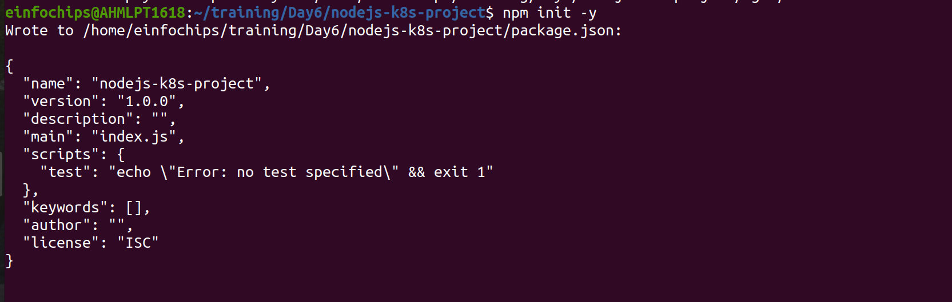

Install Express.js:
npm install express
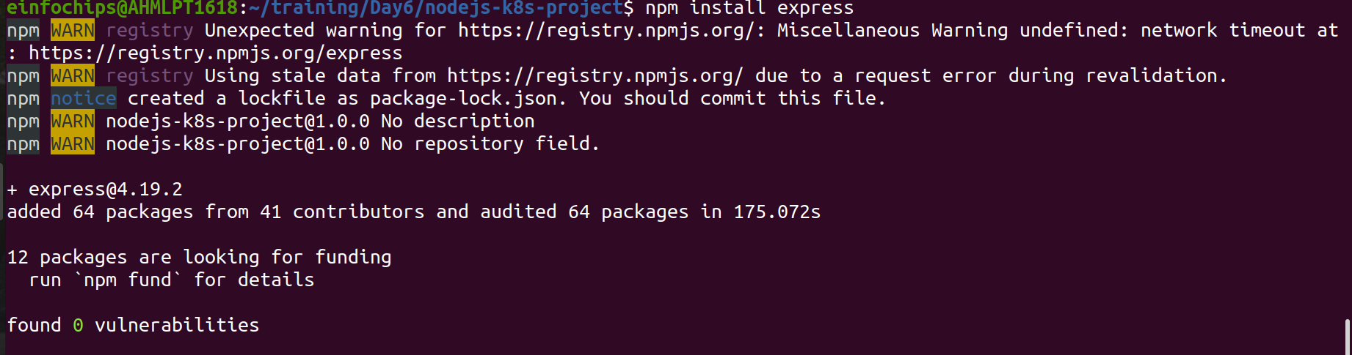

Create an index.js file with the following content:
const express = require('express');
const app = express();
const port = 3000;

app.get('/', (req, res) => {
res.send('Hello, Kubernetes!');
});

app.listen(port, () => {
console.log(`App running at http://localhost:${port}`);
});

Create a .gitignore file to ignore node_modules:
node_modules
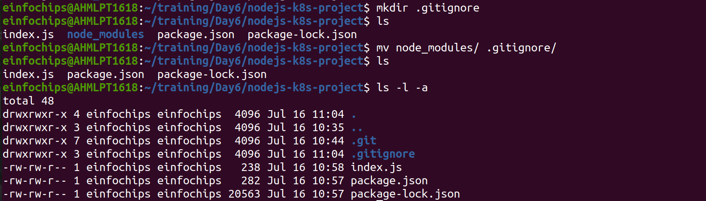
1.3. Commit the Initial Code
Add files to Git:
git add .

Commit the changes:
git commit -m "Initial commit with Node.js app"
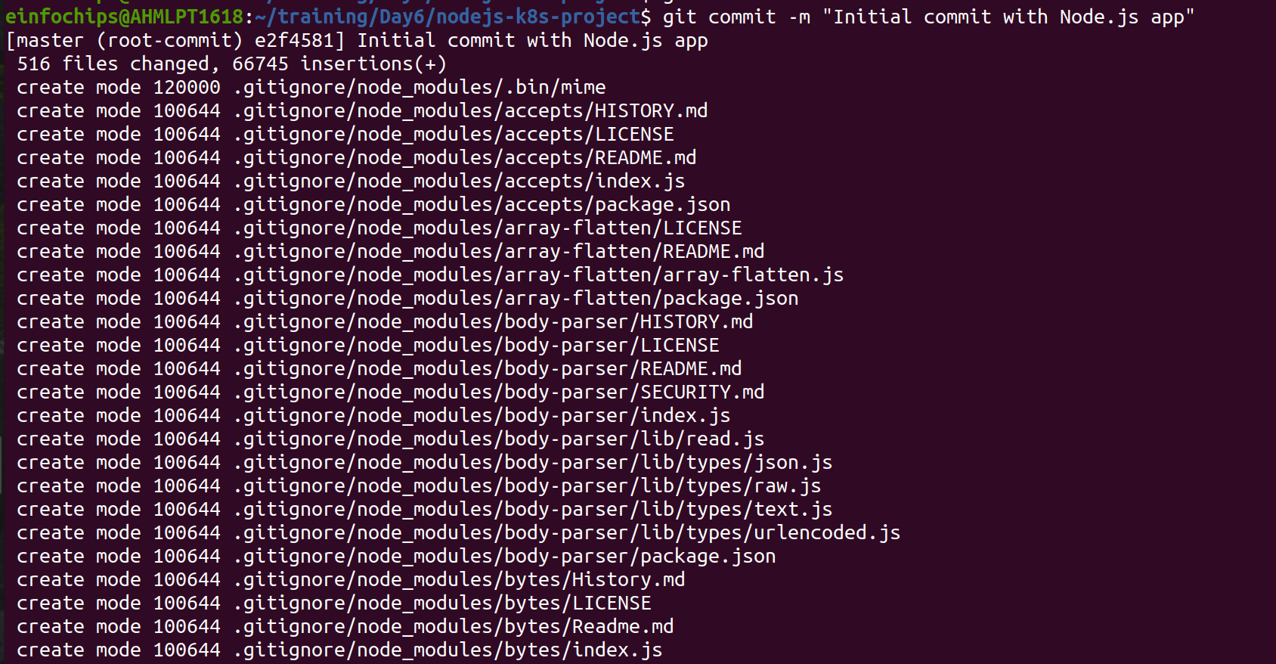

2. Branching and Fast-Forward Merge
2.1. Create a New Branch
Create and switch to a new branch feature/add-route:
git checkout -b feature/add-route
2.2. Implement a New Route
Modify index.js to add a new route:
app.get('/newroute', (req, res) => {
res.send('This is a new route!');
});
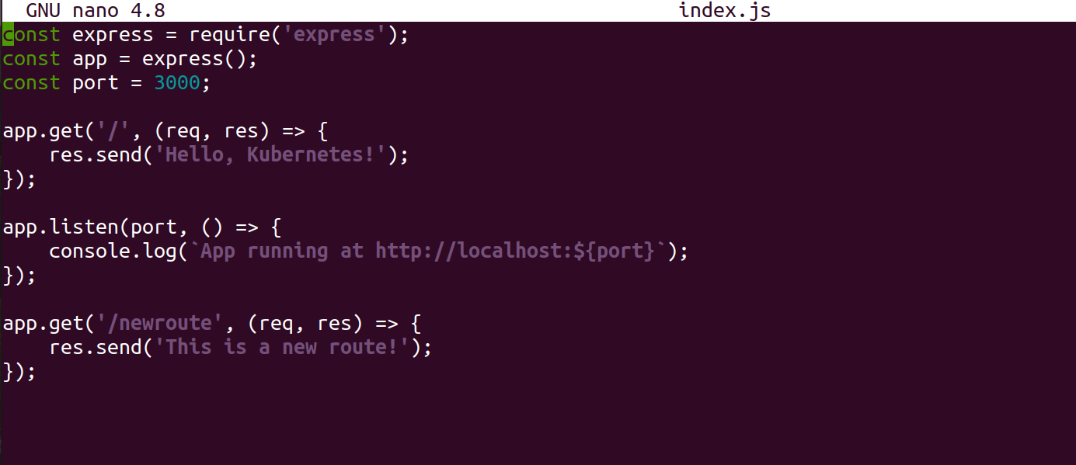
Commit the changes:
git add .
git commit -m "Add new route"
2.3. Merge the Branch Using Fast-Forward
Switch back to the main branch:
git checkout main
Merge the feature/add-route branch using fast-forward:
git merge --ff-only feature/add-route

Delete the feature branch:
git branch -d feature/add-route

3. Containerize the Node.js Application
3.1. Create a Dockerfile
Create a Dockerfile with the following content:
FROM node:14
WORKDIR /app
COPY package*.json ./
RUN npm install
COPY . .
EXPOSE 3000
CMD ["node", "index.js"]
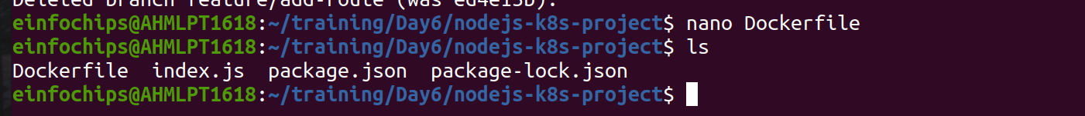

3.2. Build and Test the Docker Image
Build the Docker image:
docker build -t nodejs-k8s-app .

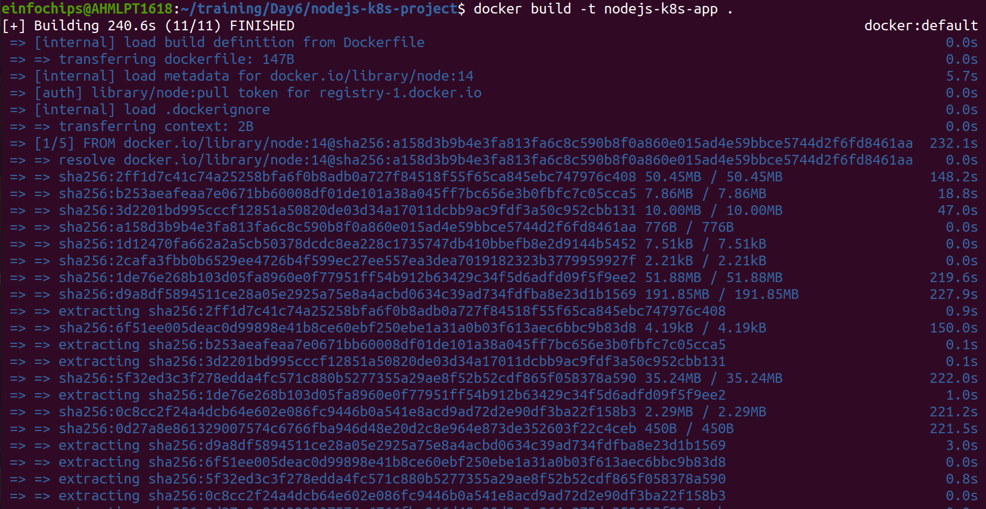
Run the Docker container to test:
docker run -p 3000:3000 nodejs-k8s-app
- Access http://localhost:3000 to see the app running.
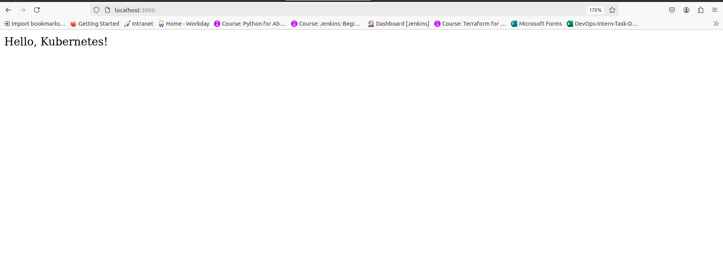

4. Deploying to Minikube Kubernetes
4.1. Start Minikube
Start Minikube:
minikube start

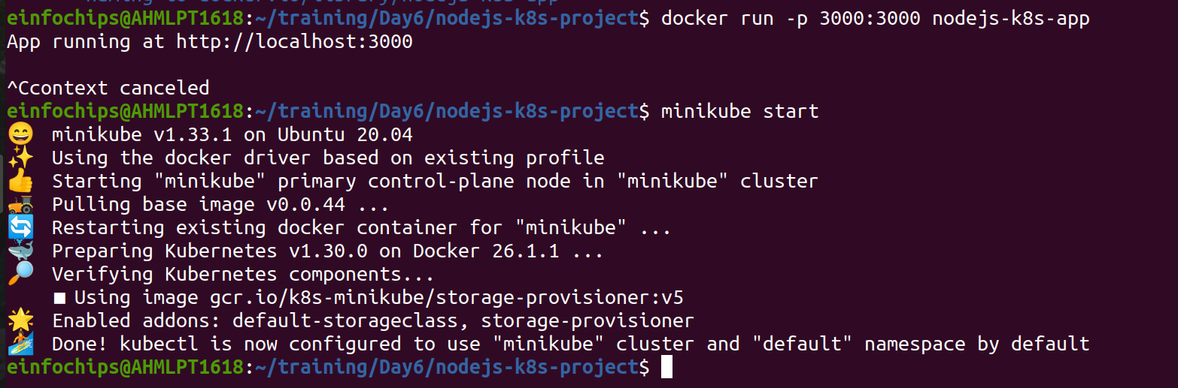
4.2. Create Kubernetes Deployment and Service Manifests
Create a deployment.yaml file:
apiVersion: apps/v1
kind: Deployment
metadata:
name: nodejs-app
spec:
replicas: 2
selector:
matchLabels:
app: nodejs-app
template:
metadata:
labels:
app: nodejs-app
spec:
containers:
- name: nodejs-app
image: nodejs-k8s-app:latest
ports:
- containerPort: 3000

Create a service.yaml file for ClusterIP:
apiVersion: v1
kind: Service
metadata:
name: nodejs-service
spec:
selector:
app: nodejs-app
ports:
- protocol: TCP
port: 80
targetPort: 3000
type: ClusterIP

Create a service-nodeport.yaml file for NodePort:
apiVersion: v1
kind: Service
metadata:
name: nodejs-service-nodeport
spec:
selector:
app: nodejs-app
ports:
- protocol: TCP
port: 80
targetPort: 3000
nodePort: 30001
type: NodePort

4.3. Apply Manifests to Minikube
Apply the deployment:
kubectl apply -f deployment.yaml
Apply the ClusterIP service:
kubectl apply -f service.yaml
Apply the NodePort service:
kubectl apply -f service-nodeport.yaml
4.4. Access the Application
Get the Minikube IP:
minikube ip

Making Changes to the App and Redeploying Using Kubernetes

6. Making Changes to the Node.js Application
6.1. Create a New Branch for Changes
Create and switch to a new branch feature/update-message:
git checkout -b feature/update-message
6.2. Update the Application
Modify index.js to change the message:
const express = require('express');
const app = express();
const port = 3000;

app.get('/', (req, res) => {
res.send('Hello, Kubernetes! Updated version.');
});

app.get('/newroute', (req, res) => {
res.send('This is a new route!');
});

app.listen(port, () => {
console.log(`App running at http://localhost:${port}`);
});
6.3. Commit the Changes
Add and commit the changes:
git add .
git commit -m "Update main route message"
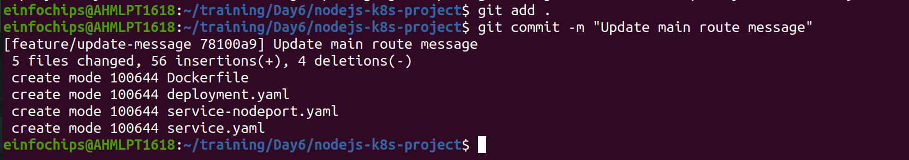

7. Merge the Changes and Rebuild the Docker Image
7.1. Merge the Feature Branch
Switch back to the main branch:
git checkout main

Merge the feature/update-message branch:
git merge --ff-only feature/update-message
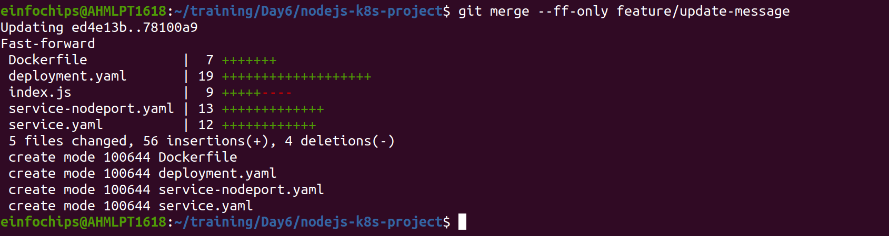
Delete the feature branch:
git branch -d feature/update-message
7.2. Rebuild the Docker Image
Rebuild the Docker image with a new tag:
docker build -t nodejs-k8s-app:v2 .

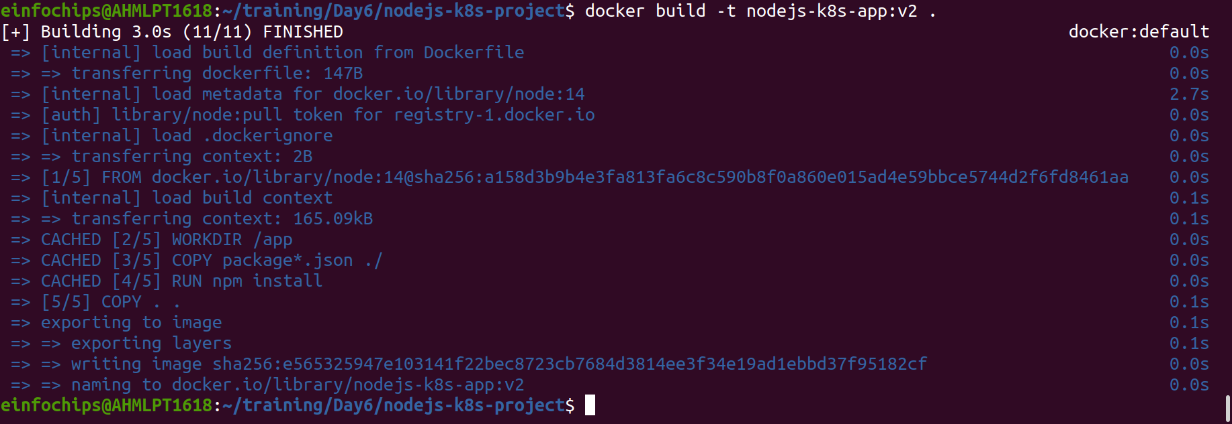

8. Update Kubernetes Deployment
8.1. Update the Deployment Manifest
Modify deployment.yaml to use the new image version:
apiVersion: apps/v1
kind: Deployment
metadata:
name: nodejs-app
spec:
replicas: 2
selector:
matchLabels:
app: nodejs-app
template:
metadata:
labels:
app: nodejs-app
spec:
containers:
- name: nodejs-app
image: nodejs-k8s-app:v2
ports:
- containerPort: 3000
8.2. Apply the Updated Manifest
Apply the updated deployment:
kubectl apply -f deployment.yaml
8.3. Verify the Update
Check the status of the deployment:
kubectl rollout status deployment/nodejs-app

9. Access the Updated Application
9.1. Access Through ClusterIP Service
Forward the port to access the ClusterIP service:
kubectl port-forward service/nodejs-service 8080:80
- Open your browser and navigate to http://localhost:8080 to see the updated message.

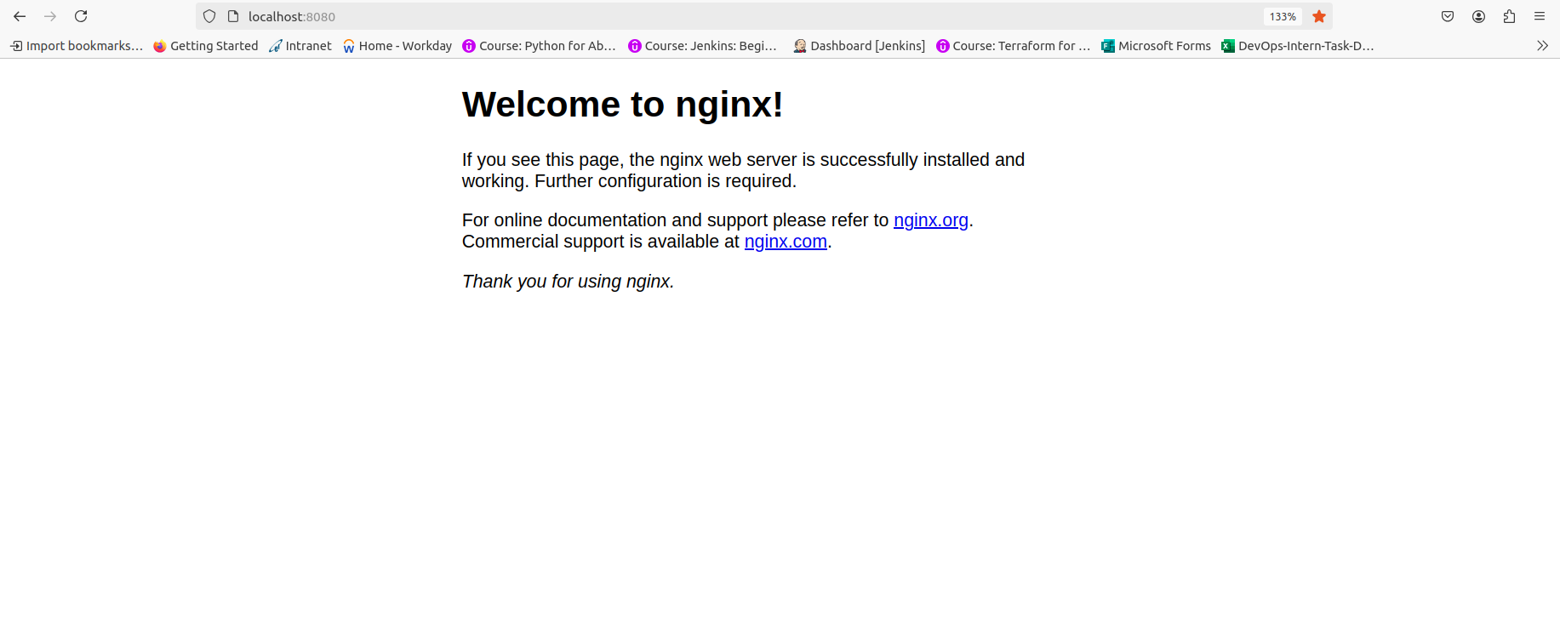
Project 02

Deploying a Python Flask App Using Minikube Kubernetes

Overview
This project guides you through deploying a Python Flask application using Minikube Kubernetes. You'll use Git for version control, explore branching and fast-forward merges, and set up Kubernetes services and deployment pods, including ClusterIP and NodePort service types.

Prerequisites
- Minikube installed
- kubectl installed
- Git installed
- Python installed

Project Steps

1. Set Up Git Version Control
1.1. Initialize a Git Repository
Create a new directory for your project:
mkdir flask-k8s-project
cd flask-k8s-project
Initialize a Git repository:
sh
Copy code
git init
1.2. Create a Python Flask Application
Create a virtual environment:
python -m venv venv
source venv/bin/activate
Install Flask:
sh
Copy code
pip install Flask
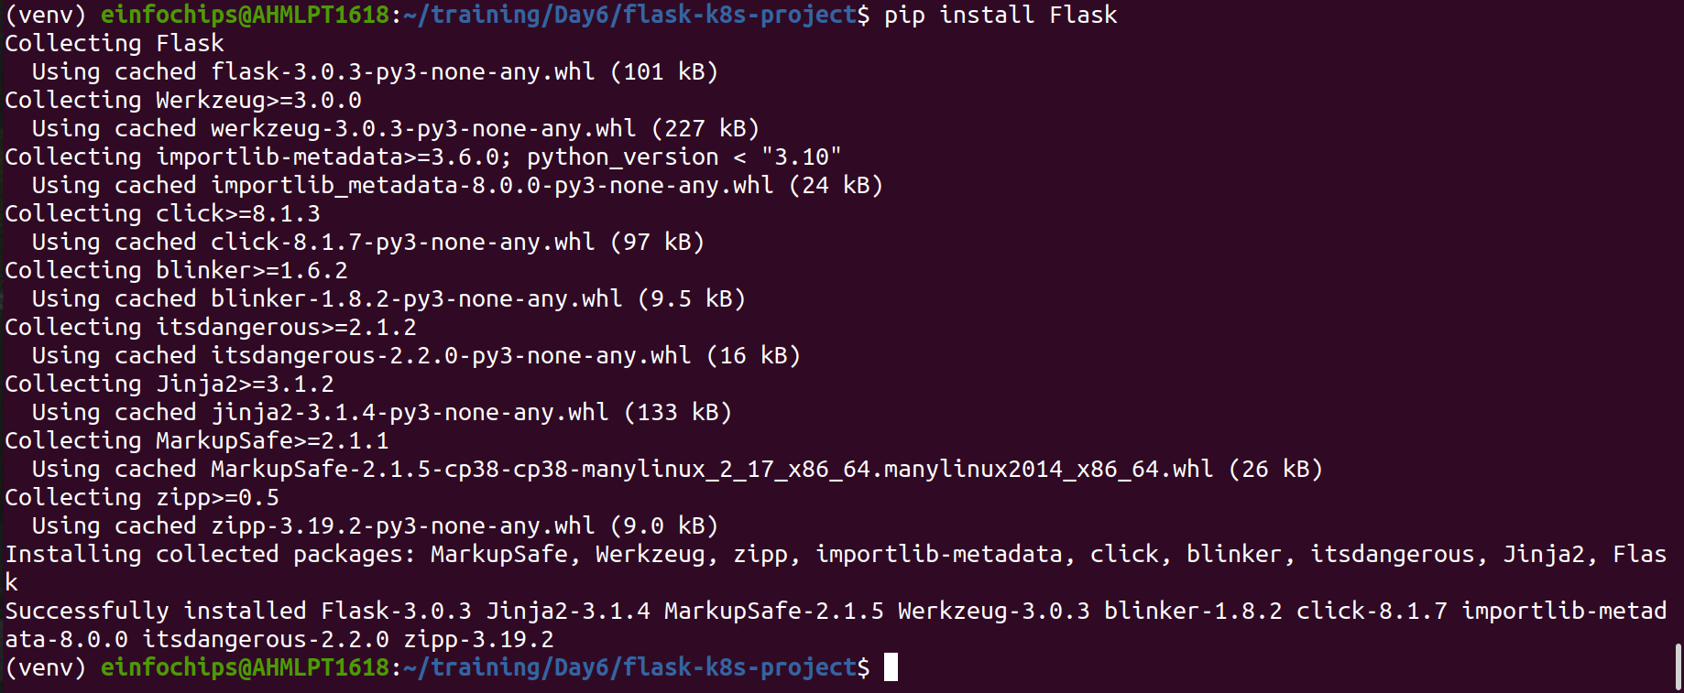

Create an app.py file with the following content:
python
Copy code
from flask import Flask

app = Flask(__name__)

@app.route('/')
def hello_world():
return 'Hello, Kubernetes!'

if __name__ == '__main__':
app.run(host='0.0.0.0', port=5000)
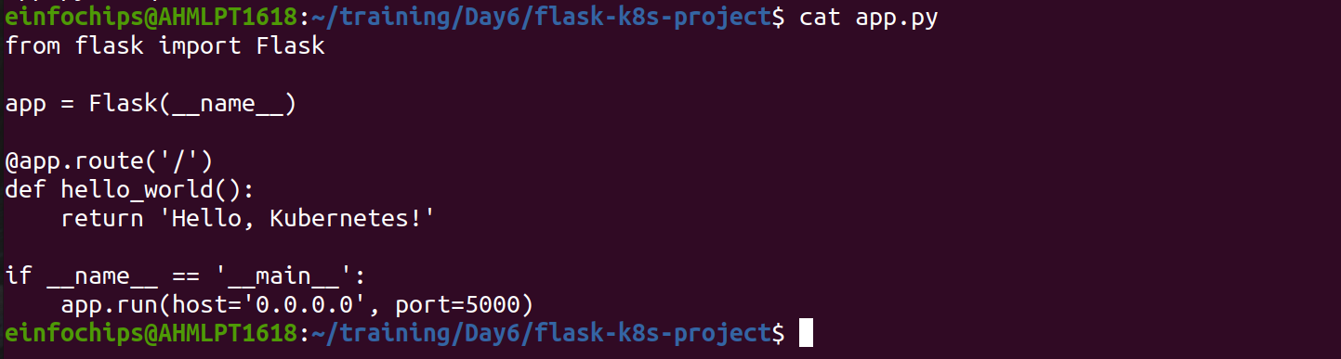

Create a requirements.txt file to list the dependencies:
Copy code
Flask
Create a .gitignore file to ignore venv:
Copy code
venv
1.3. Commit the Initial Code
Add files to Git:
git add .
Commit the changes:
git commit -m "Initial commit with Flask app"
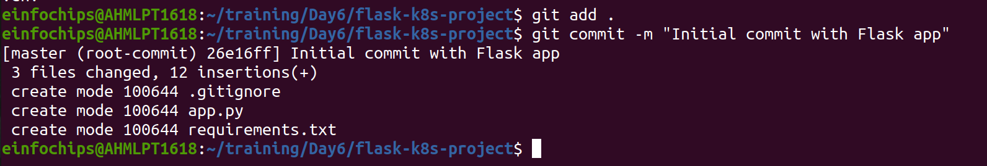

2. Branching and Fast-Forward Merge
2.1. Create a New Branch
Create and switch to a new branch feature/add-route:
git checkout -b feature/add-route

2.2. Implement a New Route
Modify app.py to add a new route:
@app.route('/newroute')
def new_route():
return 'This is a new route!'
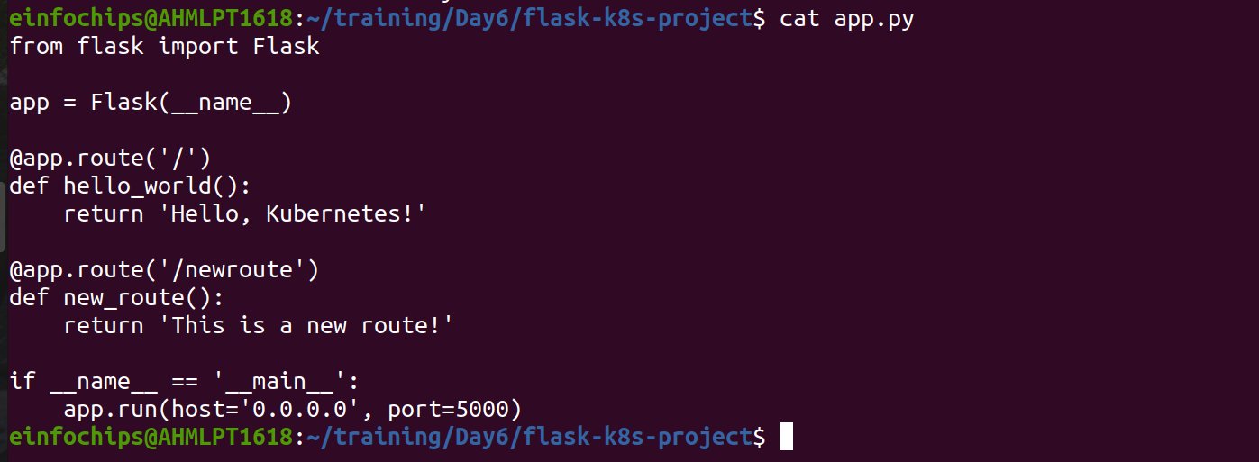

Commit the changes:
git add .
git commit -m "Add new route"
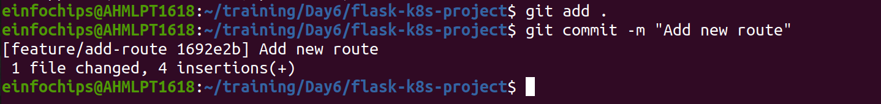
2.3. Merge the Branch Using Fast-Forward
Switch back to the main branch:
git checkout main
Merge the feature/add-route branch using fast-forward:
git merge --ff-only feature/add-route

Delete the feature branch:
git branch -d feature/add-route

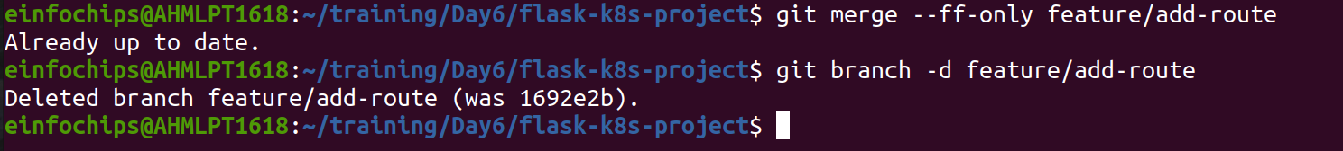

3. Containerize the Flask Application
3.1. Create a Dockerfile
Create a Dockerfile with the following content:
FROM python:3.8-slim

WORKDIR /app

COPY requirements.txt requirements.txt
RUN pip install -r requirements.txt

COPY . .

EXPOSE 5000

CMD ["python", "app.py"]
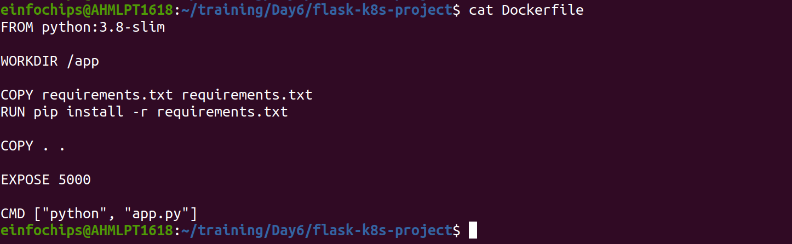
3.2. Build and Test the Docker Image
Build the Docker image:
docker build -t flask-k8s-app .
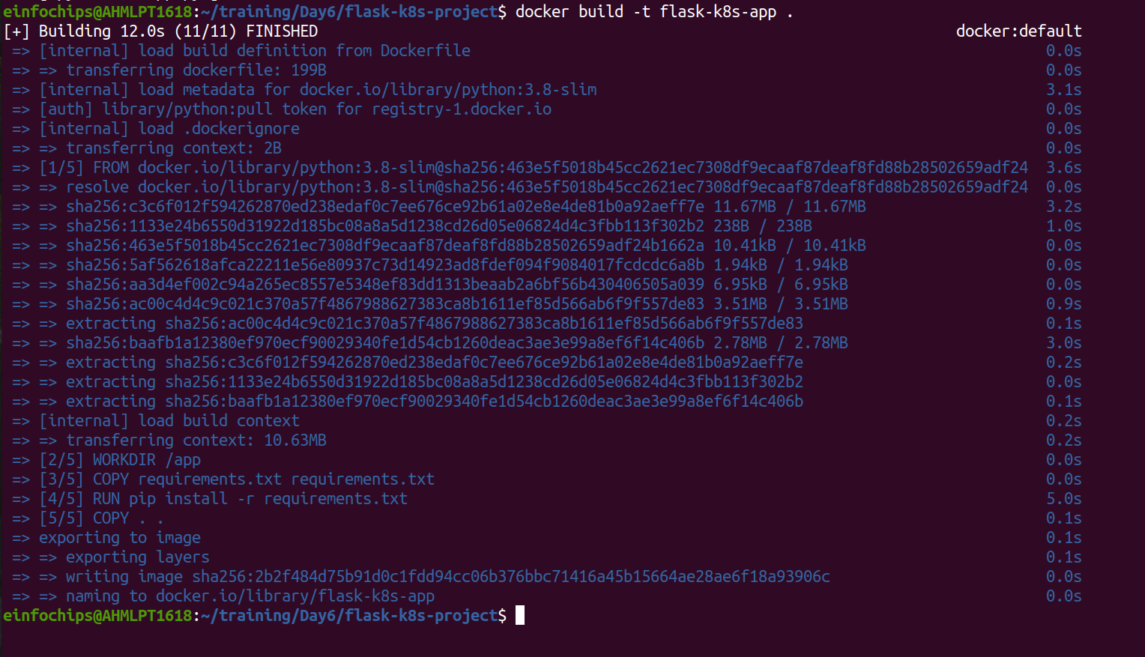
Run the Docker container to test:
docker run -p 5000:5000 flask-k8s-app

4. Deploying to Minikube Kubernetes
4.1. Start Minikube
Start Minikube:
minikube start
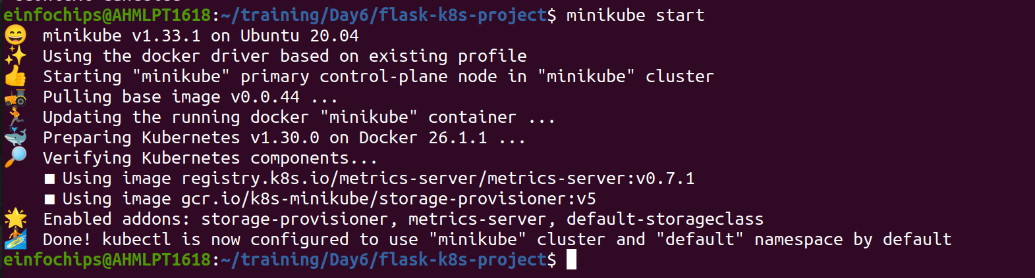

4.2. Create Kubernetes Deployment and Service Manifests
Create a deployment.yaml file:
apiVersion: apps/v1
kind: Deployment
metadata:
name: flask-app
spec:
replicas: 2
selector:
matchLabels:
app: flask-app
template:
metadata:
labels:
app: flask-app
spec:
containers:
- name: flask-app
image: flask-k8s-app:latest
ports:
- containerPort: 5000
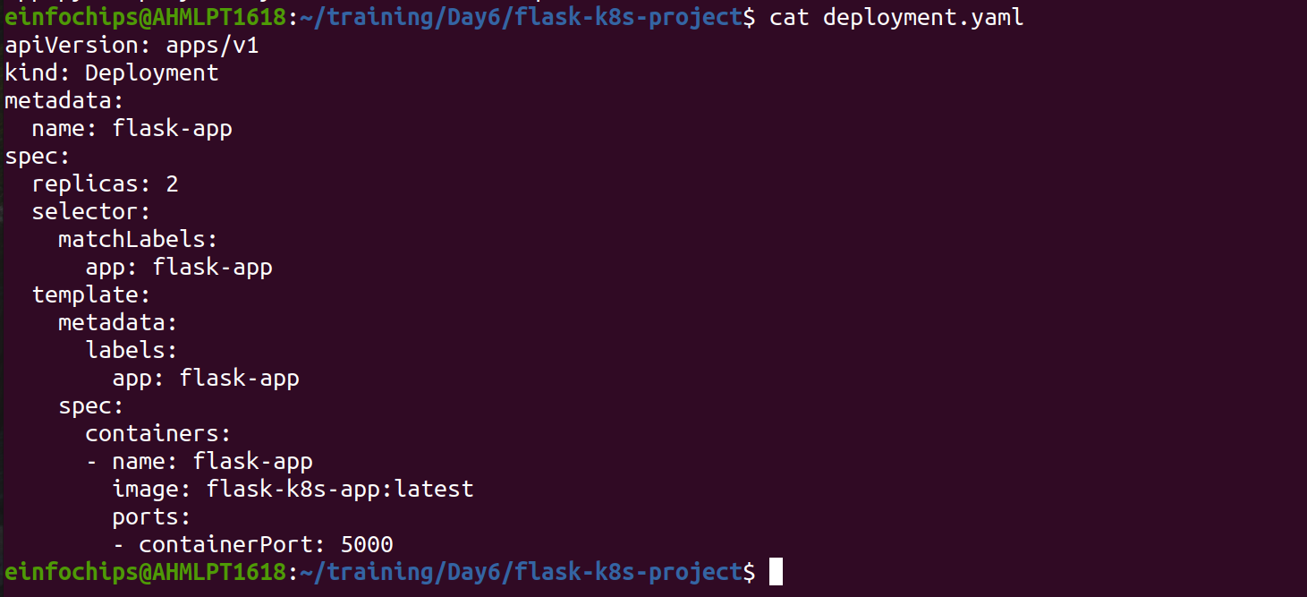
Create a service.yaml file for ClusterIP:
apiVersion: v1
kind: Service
metadata:
name: flask-service
spec:
selector:
app: flask-app
ports:
- protocol: TCP
port: 80
targetPort: 5000
type: ClusterIP
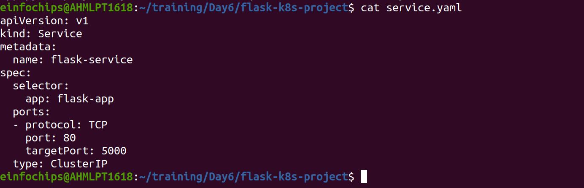
Create a service-nodeport.yaml file for NodePort:
apiVersion: v1
kind: Service
metadata:
name: flask-service-nodeport
spec:
selector:
app: flask-app
ports:
- protocol: TCP
port: 80
targetPort: 5000
nodePort: 30001/30004
type: NodePort
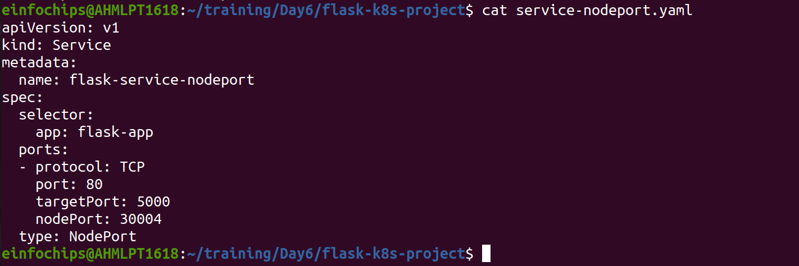
4.3. Apply Manifests to Minikube
Apply the deployment:
kubectl apply -f deployment.yaml
Apply the ClusterIP service:
kubectl apply -f service.yaml
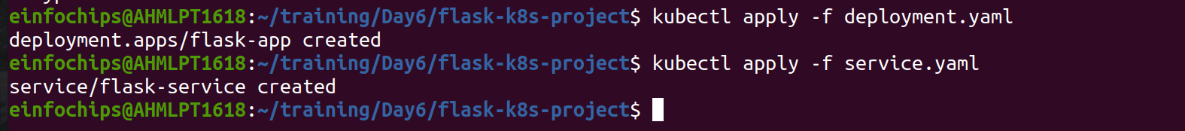
Apply the NodePort service:
kubectl apply -f service-nodeport.yaml

4.4. Access the Application
Get the Minikube IP:
minikube ip

5. Clean Up
Stop Minikube:
minikube stop
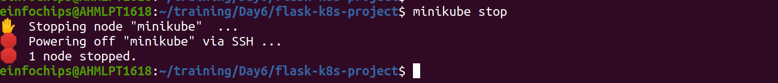
Delete Minikube cluster:
minikube delete
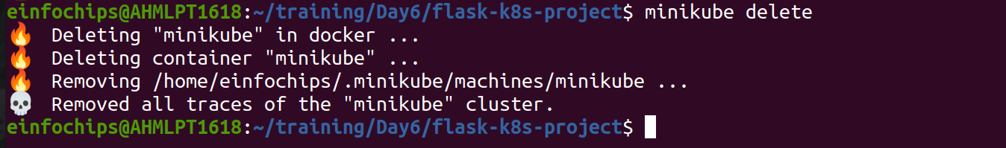
6. Making Changes to the Flask Application
6.1. Create a New Branch for Changes
Create and switch to a new branch feature/update-message:
git checkout -b feature/update-message

6.2. Update the Application
Modify app.py to change the message:
@app.route('/')
def hello_world():
return 'Hello, Kubernetes! Updated version.'

@app.route('/newroute')
def new_route():
return 'This is a new route!'
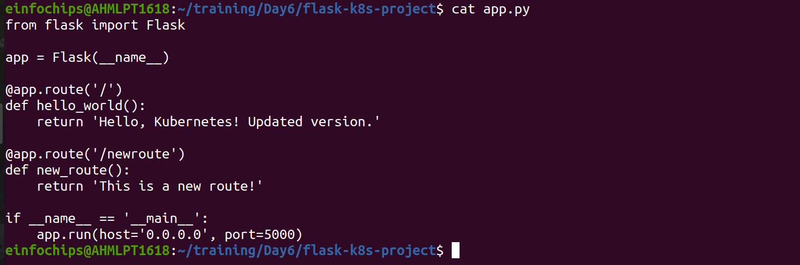
6.3. Commit the Changes
Add and commit the changes:
git add .
git commit -m "Update main route message"
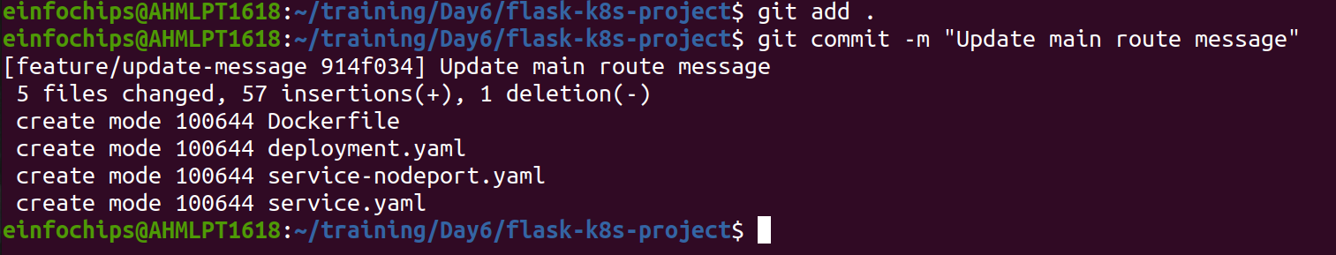
7. Merge the Changes and Rebuild the Docker Image
7.1. Merge the Feature Branch
Switch back to the main branch:
git checkout main

Merge the feature/update-message branch:
git merge --ff-only feature/update-message

Delete the feature branch:
git branch -d feature/update-message
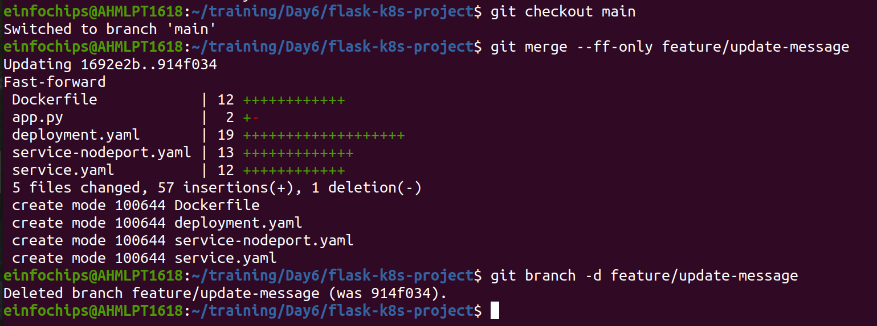

7.2. Rebuild the Docker Image
Rebuild the Docker image with a new tag:
docker build -t flask-k8s-app:v2 .
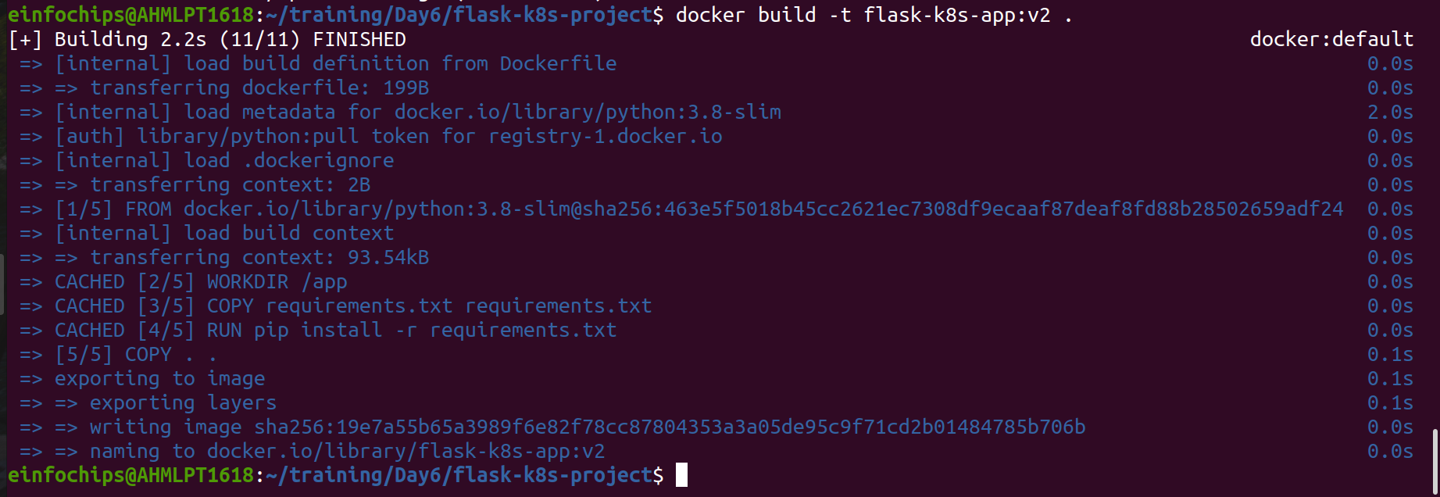

8. Update Kubernetes Deployment
8.1. Update the Deployment Manifest
Modify deployment.yaml to use the new image version:
apiVersion: apps/v1
kind: Deployment
metadata:
name: flask-app
spec:
replicas: 2
selector:
matchLabels:
app: flask-app
template:
metadata:
labels:
app: flask-app
spec:
containers:
- name: flask-app
image: flask-k8s-app:v2
ports:
- containerPort: 5000

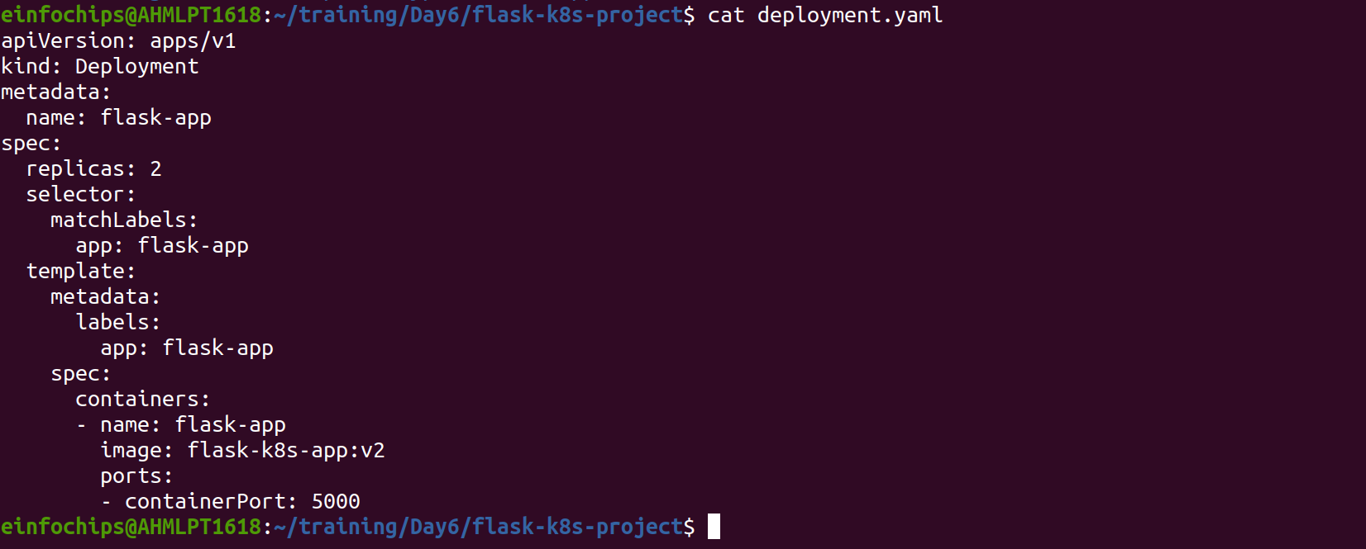

8.2. Apply the Updated Manifest
Apply the updated deployment:
sh
Copy code
kubectl apply -f deployment.yaml

8.3. Verify the Update
Check the status of the deployment:
sh
Copy code
kubectl rollout status deployment/flask-app

9. Access the Updated Application
9.1. Access Through ClusterIP Service
Forward the port to access the ClusterIP service:
kubectl port-forward service/flask-service 8080:80

