Project Overview

Aim: This project spans various aspects of Linux system administration, including file management, user and group management, service control, process handling, and more. You will be completing tasks that simulate real-world scenarios, providing hands-on experience with Linux commands and configurations.

Project Breakdown

Part 1: Creating and Editing Text Files (20 minutes)
Scenario: You are tasked with documenting the configurations and settings for a new server. You'll use different text editors to create and update these documents.
- Create a file server_config.txt using Nano:
nano server_config.txt
- Add the following content:
Server Name: WebServer01
IP Address: 192.168.1.100
OS: Ubuntu 20.04
- Edit the same file with Vi:
vi server_config.txt
- Append the following text:
Installed Packages: Apache, MySQL, PHP
- Further edit the file with Vim:
vim server_config.txt
- Add the following text:
Configuration Complete: Yes

Output:

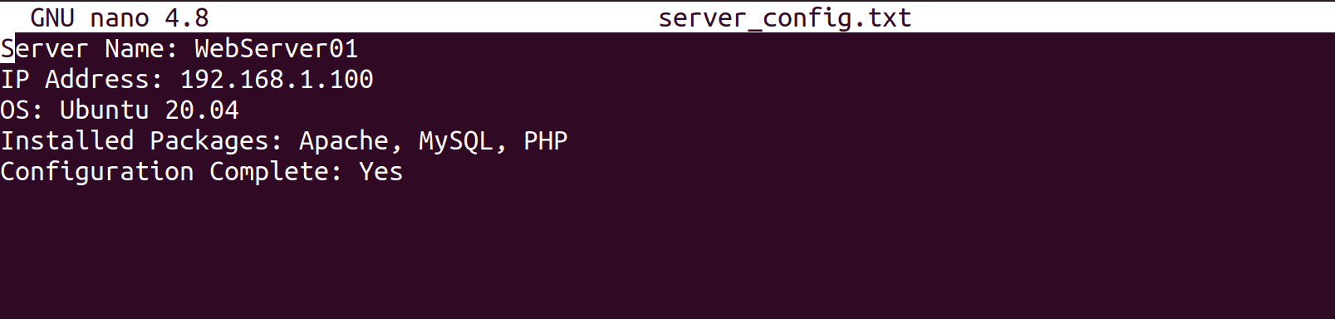

Part 2: User & Group Management (20 minutes)
Scenario: You need to set up user accounts and groups for a new team joining the project.
- Add a new user developer:
sudo adduser developer

Output:

- Create a group devteam:
sudo groupadd devteam
- Add the user developer to the devteam group:
sudo usermod -aG devteam developer
- Remove the user developer from the devteam group:
sudo gpasswd -d developer devteam
- Changing Permissions and Ownership
- Change permissions to read/write for the owner and read-only for others:
chmod 644 server_config.txt
- Verify the change:
ls -l server_config.txt

Output:


- Change the owner to developer and the group to devteam:
sudo chown developer:devteam server_config.txt

Part 4: Controlling Services and Daemons (20 minutes)
Scenario: Manage the web server service to ensure it is running correctly and starts on boot.
- Managing Services with systemctl
- Start the Apache service:
sudo systemctl start apache2

Output:

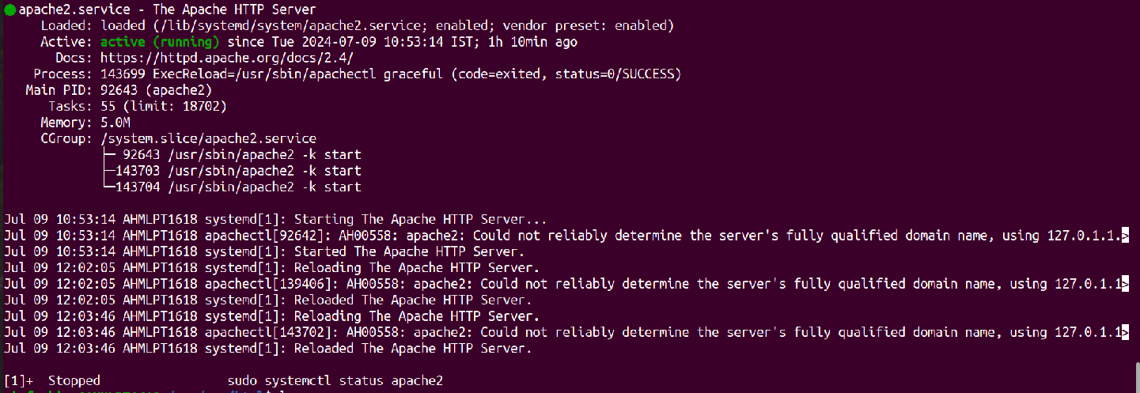
- Stop the Apache service:
sudo systemctl stop apache2
- Enable the Apache service to start on boot:
sudo systemctl enable apache2
- Disable the Apache service:
sudo systemctl disable apache2
- Check the status of the Apache service:
sudo systemctl status apache2

Final: Creating and Deploying a Static Website with Apache2
- Preparation (5 minutes)
- Ensure you have access to a Linux environment (e.g., virtual machines, EC2 instances, or local installations) with sudo privileges.

Activity Breakdown

Part 1: Installing Apache2 (5 minutes)
- Open the terminal and run:
sudo apt update
- Install Apache2 by running:
sudo apt install apache2
- Start the Apache2 service:
sudo systemctl start apache2
- Enable Apache2 to start on boot:
sudo systemctl enable apache2
- Verify Installation
- Open a web browser and navigate to http://your_server_ip. You should see the Apache2 default page.

Part 2: Creating the Website (10 minutes)
- Navigate to the Web Directory
- Change to the web root directory:
cd /var/www/html
- Create a New Directory for the Website
- Create a directory named mystaticwebsite:
sudo mkdir mystaticwebsite
- Change ownership of the directory:
sudo chown -R $USER:$USER /var/www/html/mystaticwebsite
- Create HTML File
- Create and edit the index.html file:
nano /var/www/html/mystaticwebsite/index.html
- Add the following content

<!DOCTYPE html>
<html>
<head>
<title>My Static Website</title>
<link rel="stylesheet" type="text/css" href="styles.css">
</head>
<body>
<h1>Welcome to My Static Website</h1>
<p>This is a simple static website using Apache2.</p>
<script src="script.js"></script>
</body>
</html>

- Create CSS File
- Create and edit the styles.css file:
nano /var/www/html/mystaticwebsite/styles.css
- Add the following content:

body {
font-family: Arial, sans-serif;
background-color: #f0f0f0;
text-align: center;
margin: 0;
padding: 20px;
}

h1 {
color: #333;
}

- Create JavaScript File
- Create and edit the script.js file:
nano /var/www/html/mystaticwebsite/script.js
- Add the following content:

document.addEventListener('DOMContentLoaded', function() {
console.log('Hello, World!');
});

- Add an Image
- Download or copy an image file (e.g., logo.png) to the website directory:
cp /home/einfochips/Pictures /var/www/html/mystaticwebsite/logo.png
- Update index.html to include the image:
<body>
<h1>Welcome to My Static Website</h1>
<img src="logo.png" alt="Logo">
<p>This is a simple static website using Apache2.</p>
<script src="script.js"></script>
</body>

Part 3: Configuring Apache2 to Serve the Website (10 minutes)
- Create a Virtual Host File
- Create and edit the virtual host configuration file:
sudo nano /etc/apache2/sites-available/mystaticwebsite.conf
- Add the following content:

<VirtualHost *:80>
ServerAdmin webmaster@localhost
DocumentRoot /var/www/html/mystaticwebsite
ErrorLog ${APACHE_LOG_DIR}/error.log
CustomLog ${APACHE_LOG_DIR}/access.log combined
</VirtualHost>

- Enable the New Virtual Host
- Enable the virtual host configuration:
sudo a2ensite mystaticwebsite.conf
- Disable the Default Site
- Disable the default site configuration:
sudo a2dissite 000-default.conf
- Reload Apache2
- Reload the Apache2 service to apply the changes:
sudo systemctl reload apache2
- Test the Configuration
- Open a web browser and navigate to http://your_server_ip. You should see the static website with the HTML, CSS, JS, and image.

Output:

