Git Project (2.5 Hours)

Objective:
You will work on a project involving a simple website. You will learn and practice various Git concepts including branching, merging, handling merge conflicts, rebasing, pulling, versioning, and rolling back changes. This project is designed to be completed in 1 hour.

Project Setup (15 minutes)
Install Git: Ensure Git is installed on your system. Verify with git –version

Set Up Git: Configure your Git username and email:

git config --global user.name "Your Name"
git config --global user.email "your.email@example.com"

- Create a GitHub Repository:
  - Go to GitHub and create a new repository named website-project.
Clone the repository to your local machine:

git clone https://github.com/your-username/website-project.git

Initialize the Project:
Navigate to the project directory:

Create initial project structure:
mkdir src
touch src/index.html
echo "<!DOCTYPE html><html><head><title>My Website</title></head><body><h1>Welcome to my website!</h1></body></html>" > src/index.html

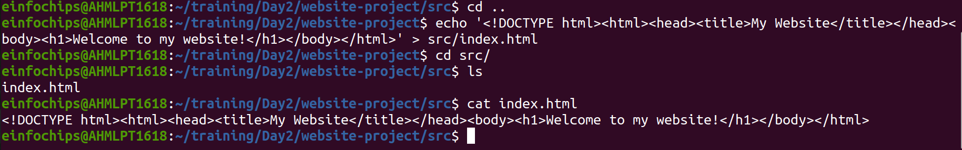

Commit and push the initial project structure:
git add .
git commit -m "Initial commit: Added project structure and index.html"
git push origin main

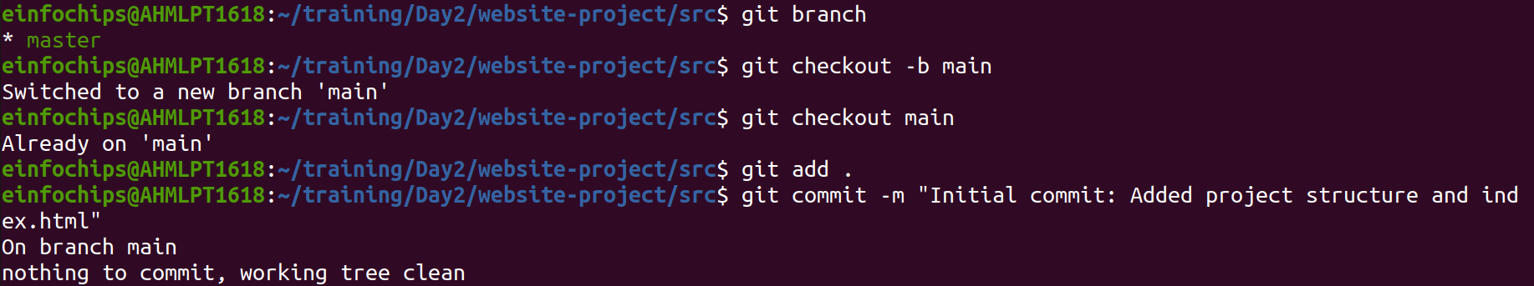
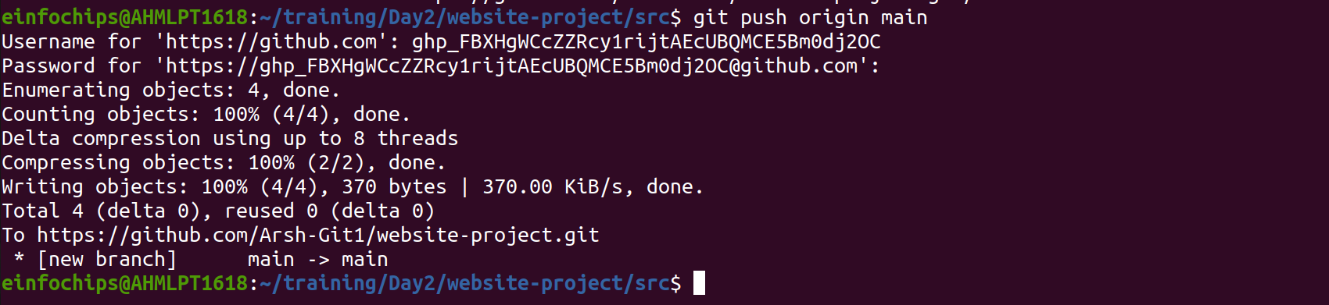

Exercise 1: Branching and Basic Operations (10 minutes)
Create a New Branch:
git checkout -b feature/add-about-page

Add a New Page:
Create about.html:
touch src/about.html
echo "<!DOCTYPE html><html><head><title>About Us</title></head><body><h1>About Us</h1></body></html>" > src/about.html
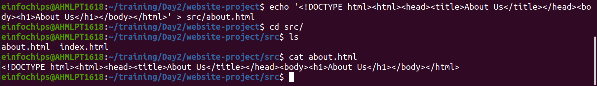

Commit and push changes:
git add src/about.html
git commit -m "Added about page"
git push origin feature/add-about-page

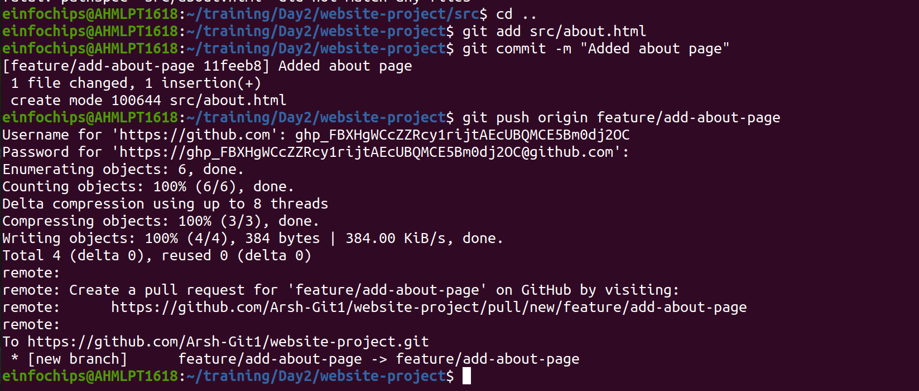

Exercise 2: Merging and Handling Merge Conflicts (15 minutes)
Create Another Branch:
git checkout main
git checkout -b feature/update-homepage

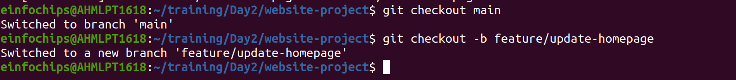

Update the Homepage:
Modify index.html:
echo "<p>Updated homepage content</p>" >> src/index.html

Commit and push changes:
git add src/index.html
git commit -m "Updated homepage content"
git push origin feature/update-homepage

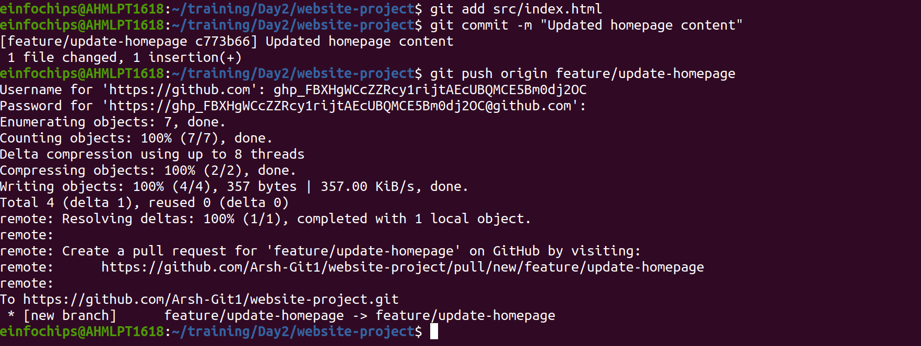

Create a Merge Conflict:
Modify index.html on the feature/add-about-page branch:
git checkout feature/add-about-page
echo "<p>Conflict content</p>" >> src/index.html
git add src/index.html
git commit -m "Added conflicting content to homepage"
git push origin feature/add-about-page

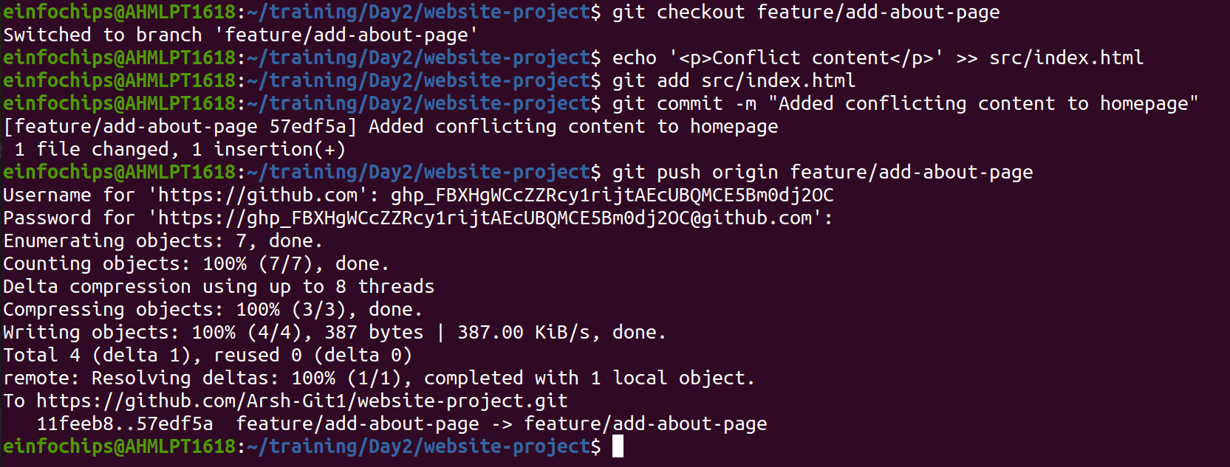

Merge and Resolve Conflict:
Attempt to merge feature/add-about-page into main:
git checkout main
git merge feature/add-about-page

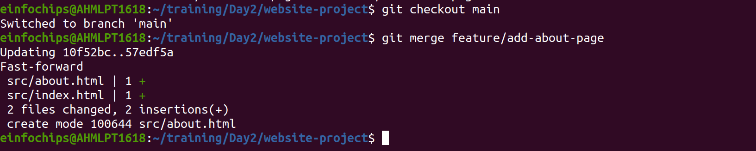

Resolve the conflict in src/index.html, then:
git add src/index.html
git commit -m "Resolved merge conflict in homepage"
git push origin main

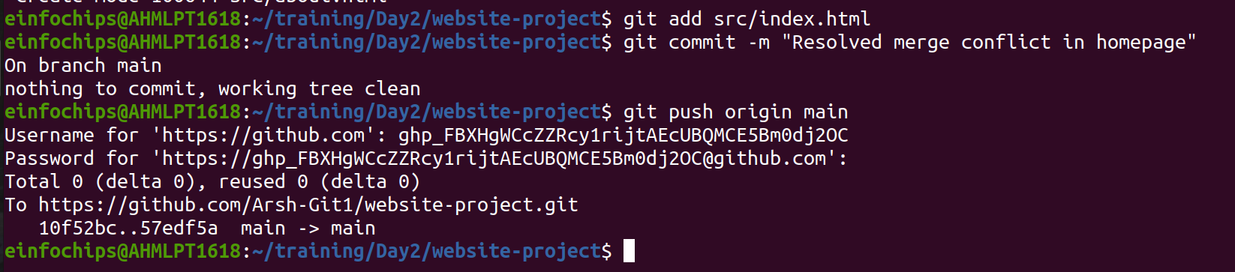

Exercise 3: Rebasing (10 minutes)
- Rebase a Branch:
Rebase feature/update-homepage onto main:
git checkout feature/update-homepage
git rebase main

- Resolve any conflicts that arise during rebase.

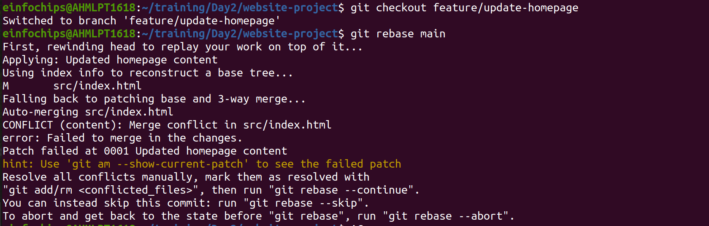
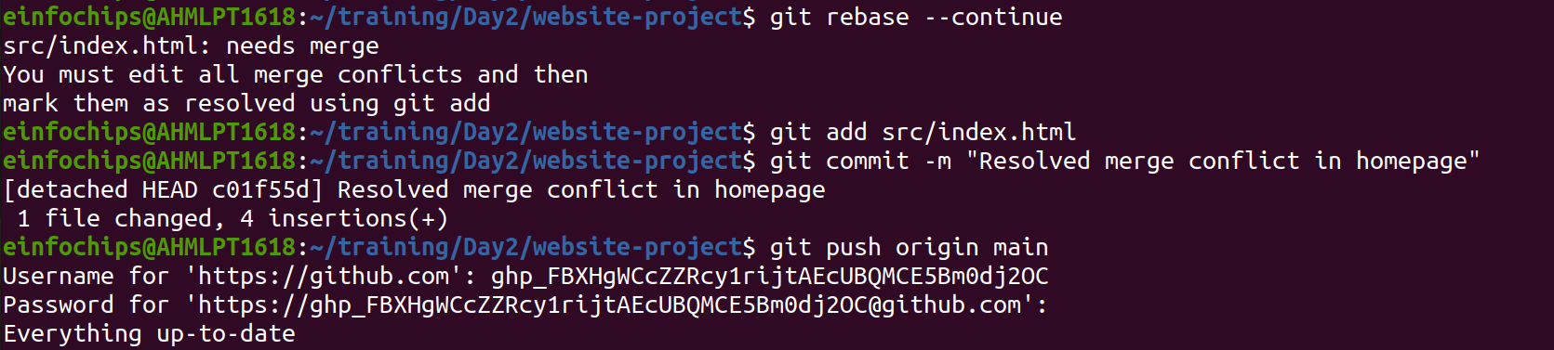

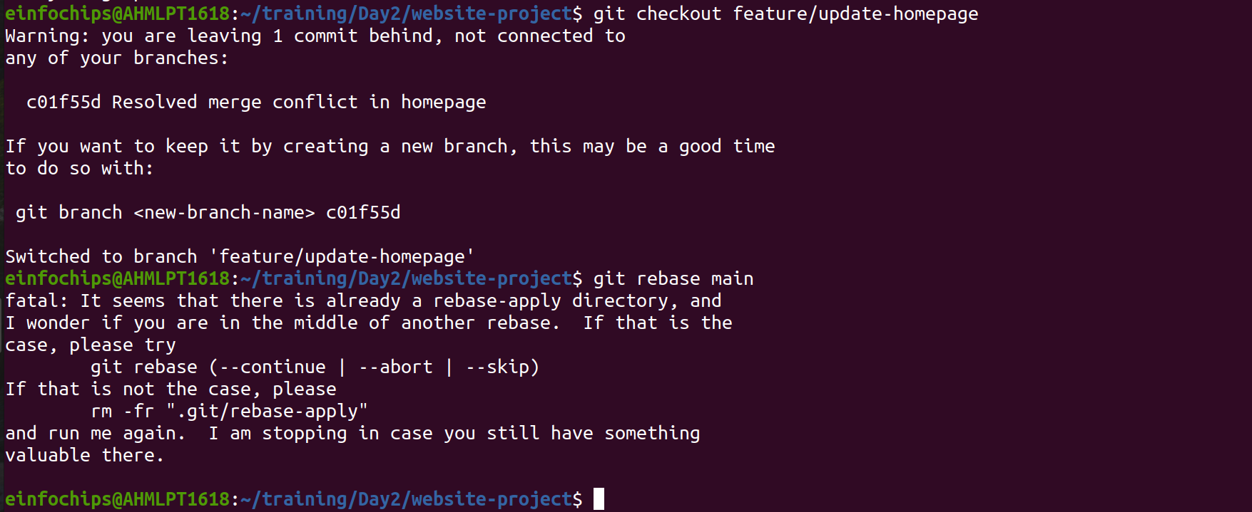

Push the Rebased Branch:
git push -f origin feature/update-homepage

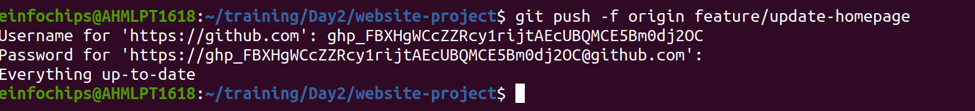

Exercise 4: Pulling and Collaboration (10 minutes)
- Pull Changes from Remote:
Ensure the main branch is up-to-date:
git checkout main
git pull origin main

- Simulate a Collaborator's Change:
  - Make a change on GitHub directly (e.g., edit index.html).
- Pull Collaborator's Changes:
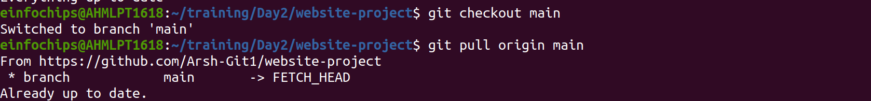
Pull the changes made by the collaborator:
git pull origin main
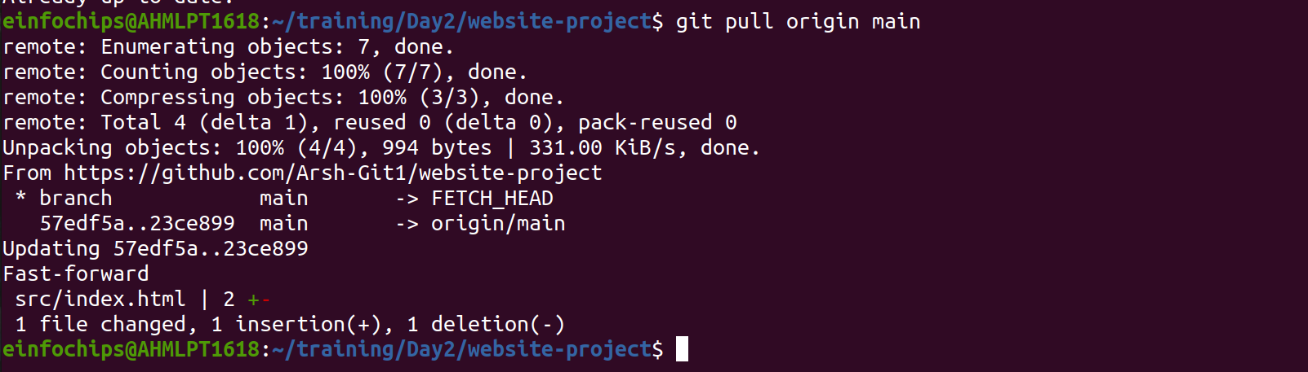

Exercise 5: Versioning and Rollback (15 minutes)
- Tagging a Version:
Tag the current commit as v1.0:
git tag -a v1.0 -m "Version 1.0: Initial release"
git push origin v1.0

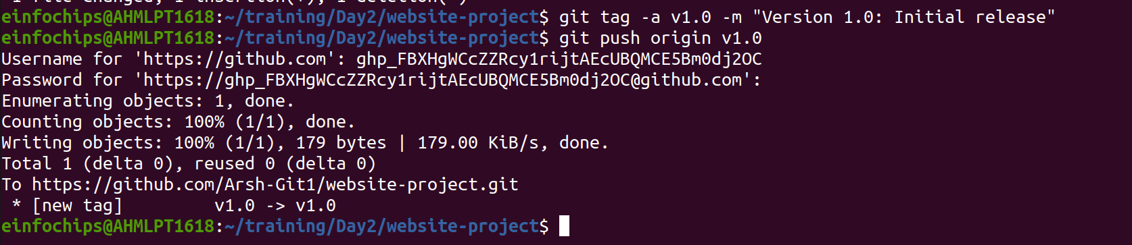

Make a Change that Needs Reversion:
Modify index.html:
echo "<p>Incorrect update</p>" >> src/index.html
git add src/index.html
git commit -m "Incorrect update"
git push origin main

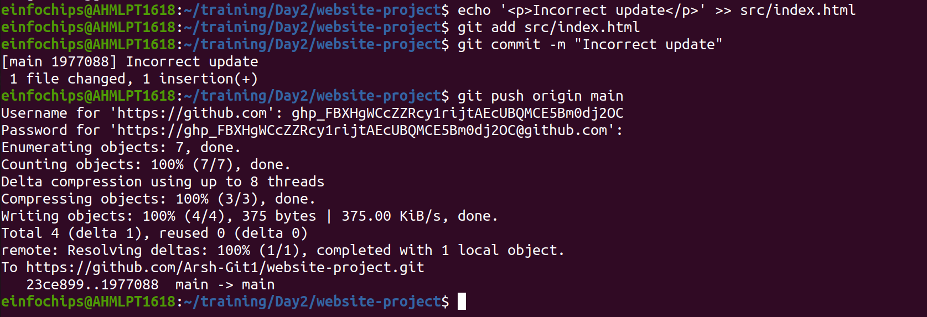

Revert to a Previous Version:
Use git revert to undo the last commit:
git revert HEAD
git push origin main

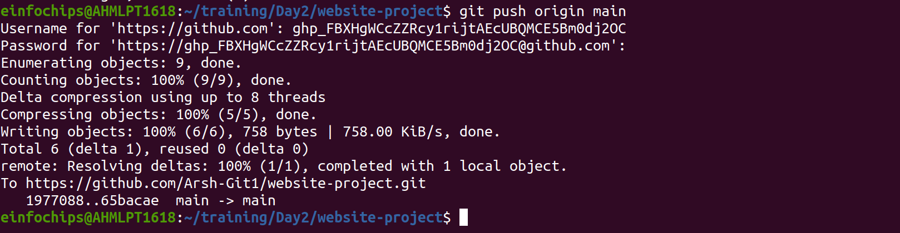

Alternatively, reset to a specific commit (use with caution):
sh
Copy code
git reset --hard v1.0
git push -f origin main

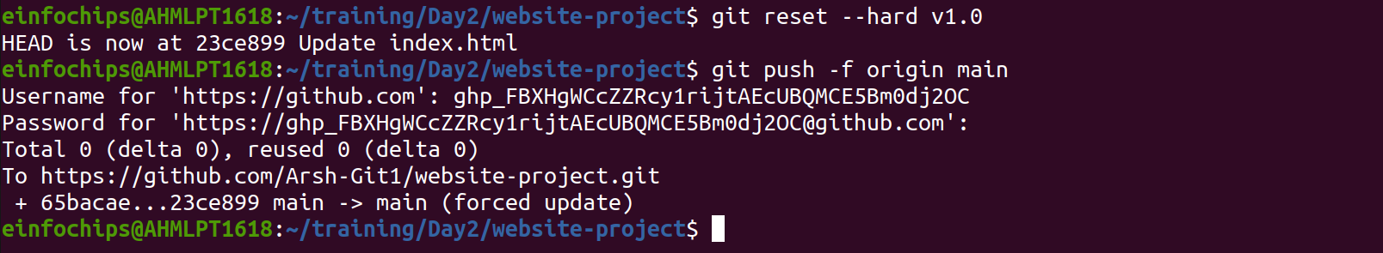

Extra Activities (10 minutes)
- Stashing Changes:
Make some local changes without committing:
echo "<p>Uncommitted changes</p>" >> src/index.html
Stash the changes:
git stash

Apply the stashed changes:
git stash apply

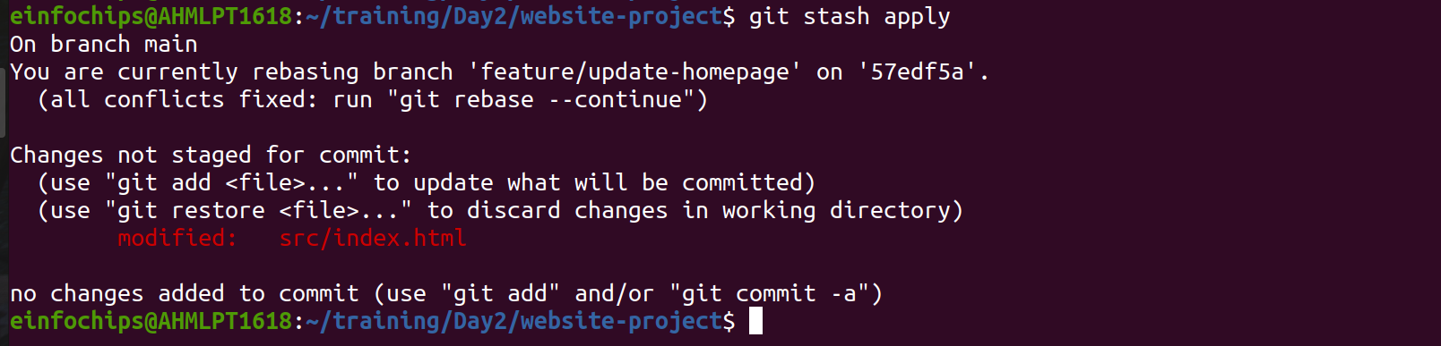

Viewing Commit History:
Use git log to view commit history:
git log –oneline

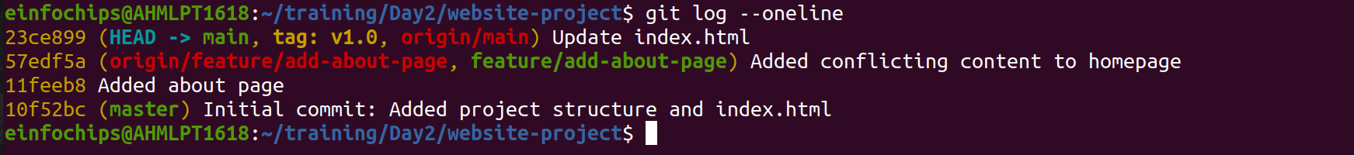

Cherry-Picking Commits:
Create a new branch and cherry-pick a commit from another branch:
git checkout -b feature/cherry-pick
git cherry-pick <commit-hash>
git push origin feature/cherry-pick

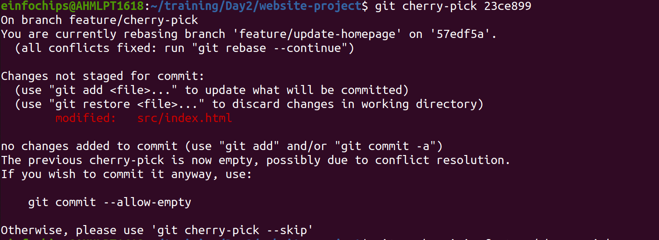
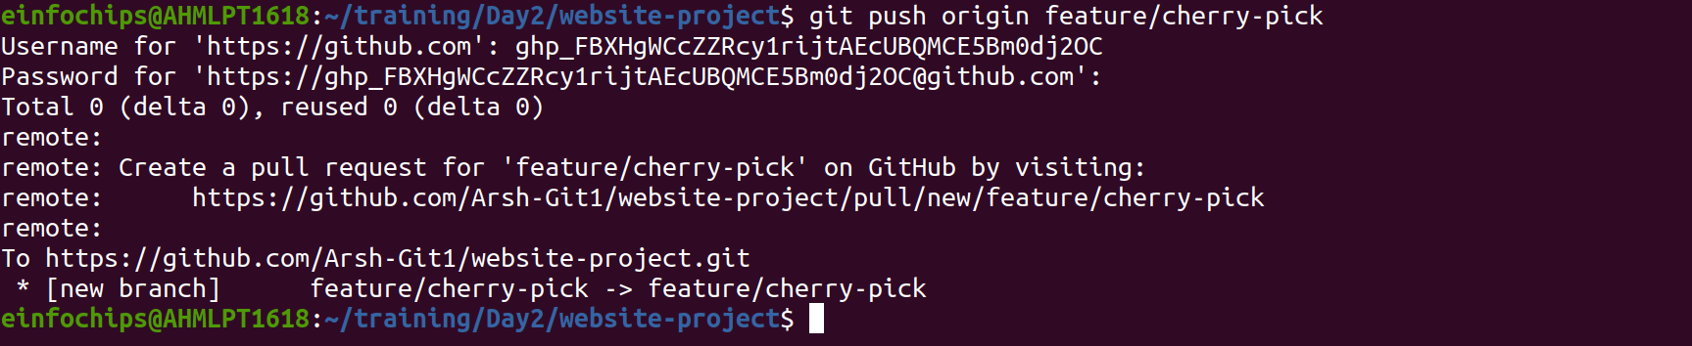

Interactive Rebase:
Use interactive rebase to squash commits:
git checkout main
git rebase -i HEAD~3

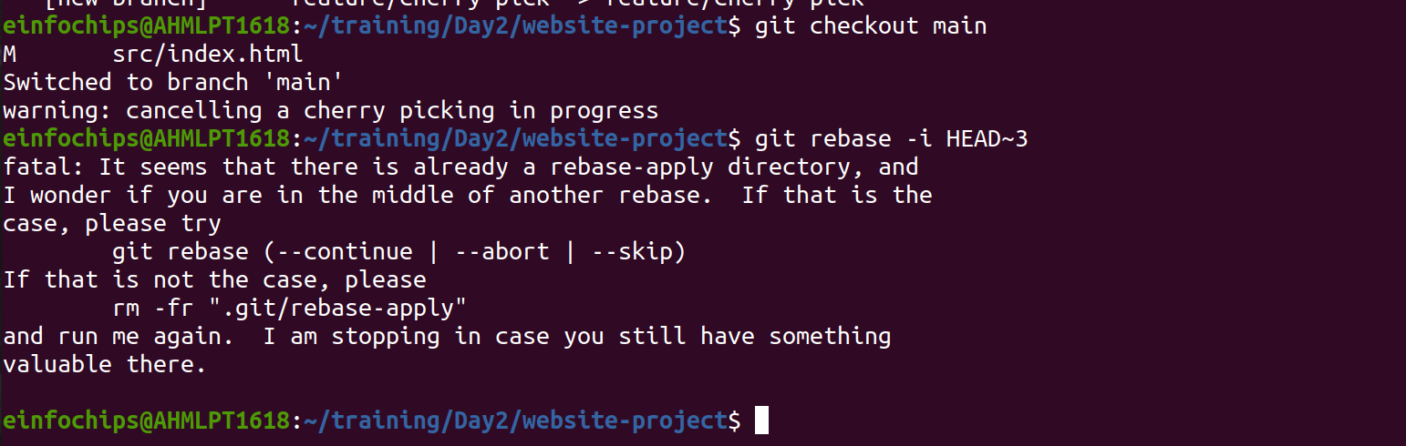

Collaborative Blogging Platform

Objective:
You will work on a project to collaboratively develop a simple blogging platform. You will practice various Git concepts including branching, merging, handling merge conflicts, rebasing, pulling, versioning, rolling back changes, stashing, and cherry-picking commits. The project is designed to be completed in 1.5 Hours

- Create a GitHub Repository:
  - Go to GitHub and create a new repository named blogging-platform.
Clone the repository to your local machine:
git clone https://github.com/your-username/blogging-platform.git

Initialize the Project:
Navigate to the project directory:
cd blogging-platform

Create initial project structure:
mkdir src
touch src/index.html
echo "<!DOCTYPE html><html><head><title>Blogging Platform</title></head><body><h1>Welcome to the Blogging Platform!</h1></body></html>" > src/index.html
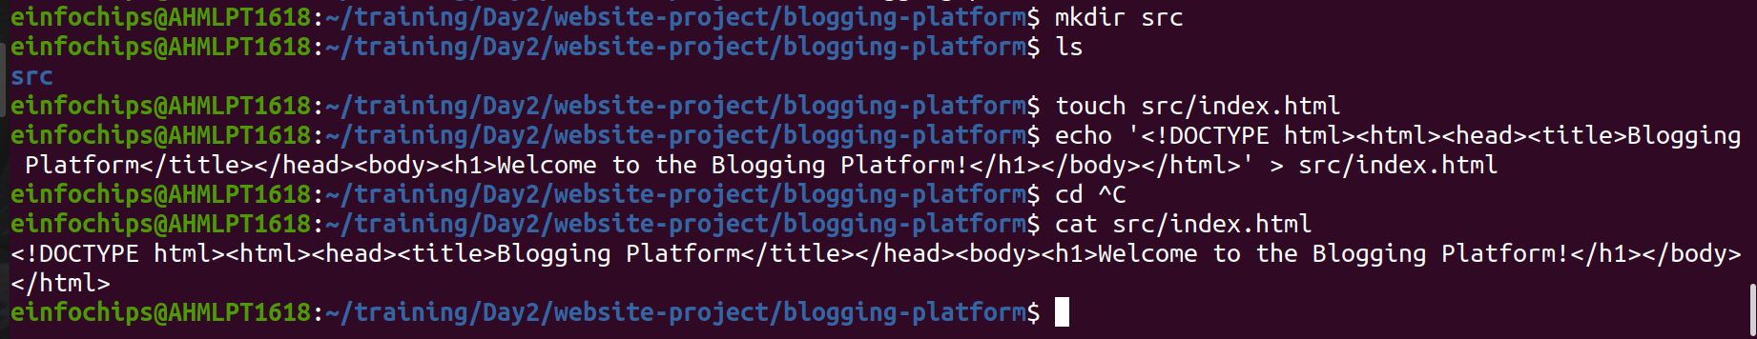
Commit and push the initial project structure:
git add .
git commit -m "Initial commit: Added project structure and index.html"
git push origin main

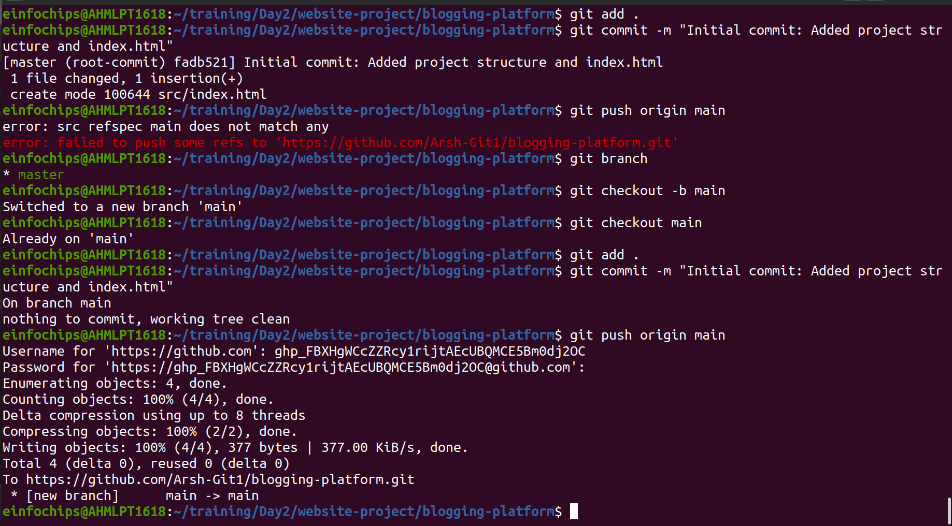

Exercise 1: Branching and Adding Features (20 minutes)
Create a New Branch for Blog Post Feature:
git checkout -b feature/add-blog-post
Add a Blog Post Page:
Create blog.html:
touch src/blog.html
echo "<!DOCTYPE html><html><head><title>Blog Post</title></head><body><h1>My First Blog Post</h1></body></html>" > src/blog.html
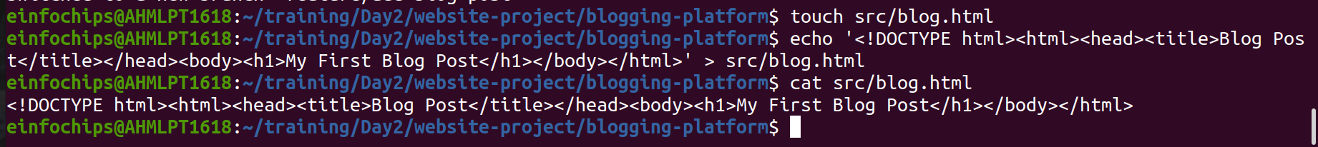

Commit and push changes:
git add src/blog.html
git commit -m "Added blog post page"
git push origin feature/add-blog-post
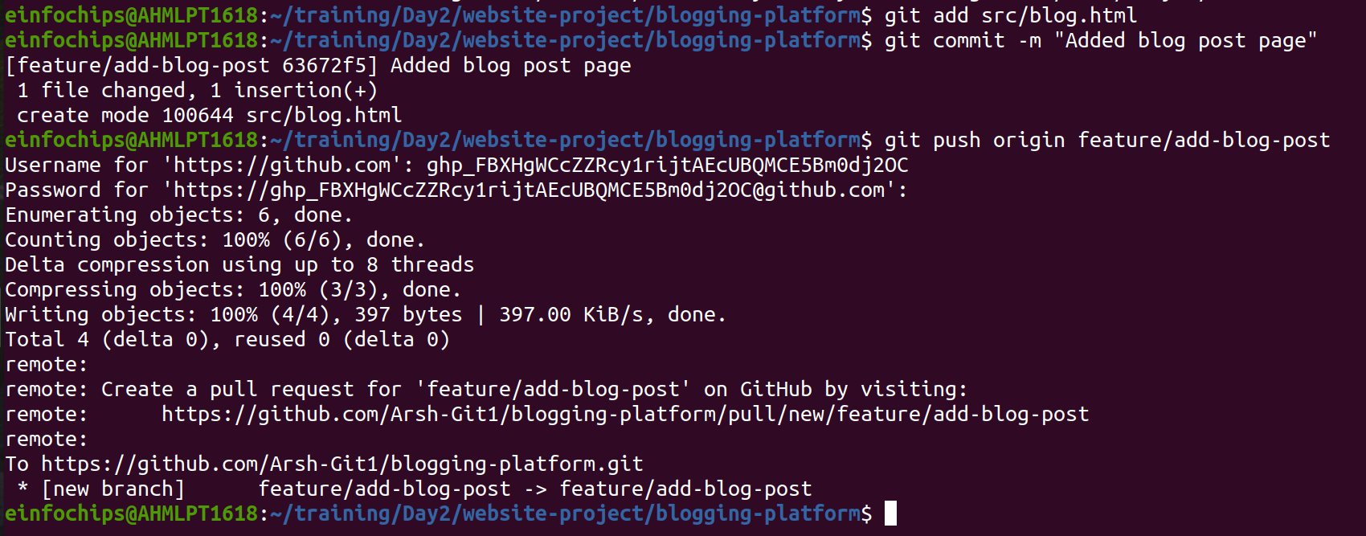

Exercise 2: Collaborating with Merging and Handling Merge Conflicts (25 minutes)
Create Another Branch for Author Info:
git checkout main
git checkout -b feature/add-author-info
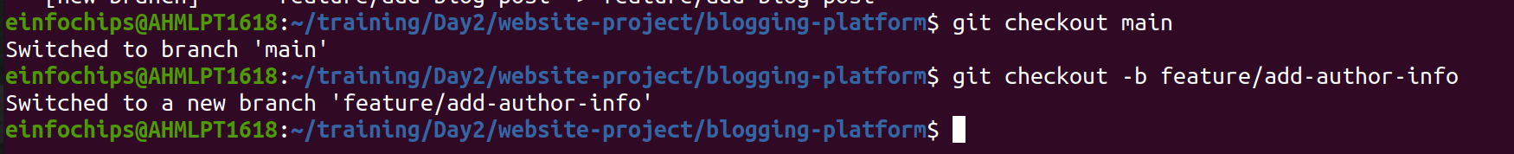
- Add Author Info to Blog Page:
Modify blog.html:
echo "<p>Author: John Doe</p>" >> src/blog.html

Commit and push changes:
git add src/blog.html
git commit -m "Added author info to blog post"
git push origin feature/add-author-info
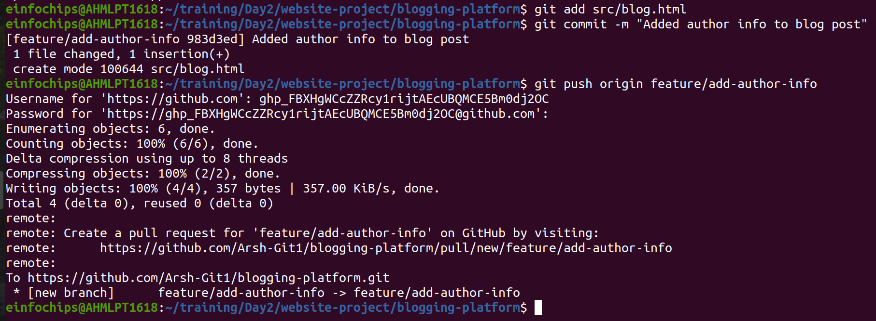

Create a Merge Conflict:
Modify blog.html on the feature/add-blog-post branch:
git checkout feature/add-blog-post
echo "<p>Published on: July 10, 2024</p>" >> src/blog.html
git add src/blog.html
git commit -m "Added publish date to blog post"
git push origin feature/add-blog-post

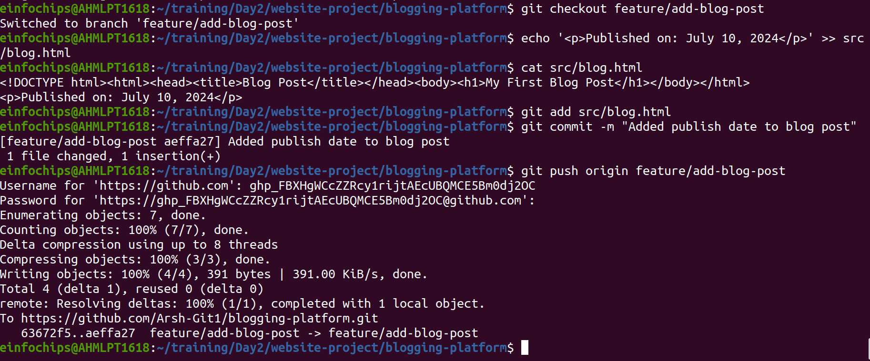

Merge and Resolve Conflict:
Attempt to merge feature/add-blog-post into main:
git checkout main
git merge feature/add-blog-post
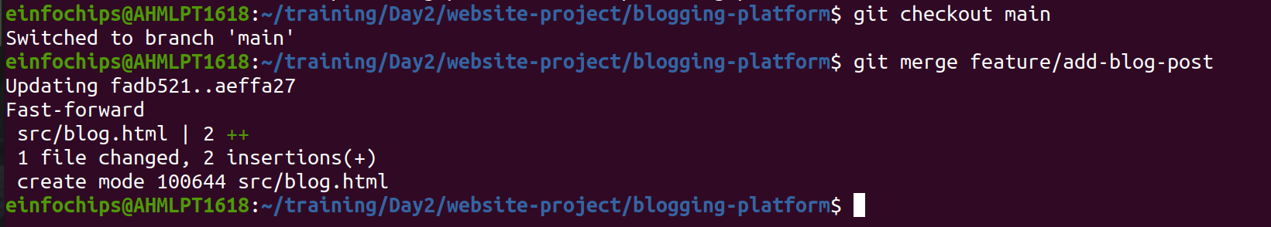
Resolve the conflict in src/blog.html, then:
git add src/blog.html
git commit -m "Resolved merge conflict in blog post"
git push origin main
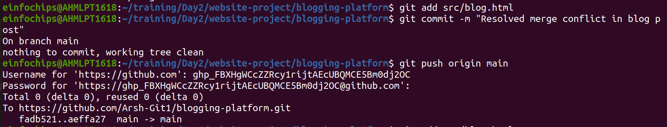

Exercise 3: Rebasing and Feature Enhancement (25 minutes)
- Rebase a Branch for Comment Feature:
Rebase feature/add-author-info onto main:
git checkout feature/add-author-info
git rebase main
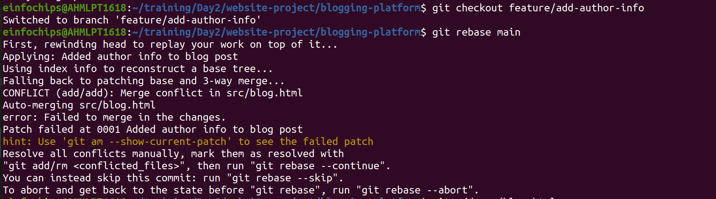
Resolve any conflicts that arise during rebase.

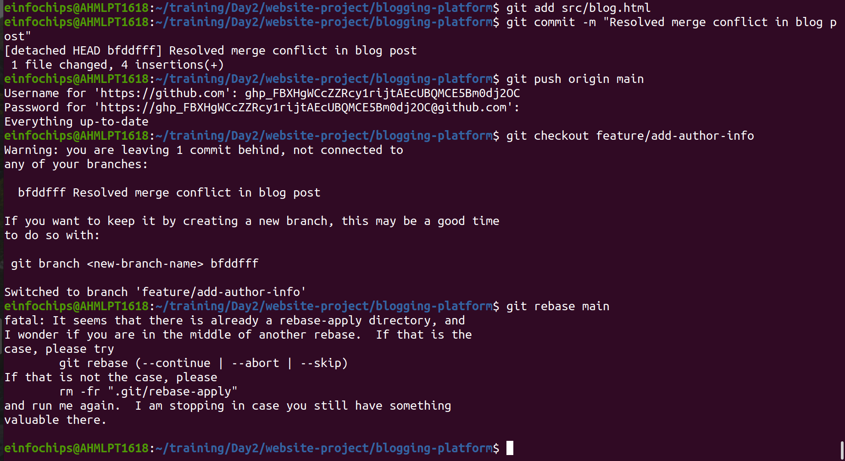

Add Comment Section:
Modify blog.html to add a comment section:
echo "<h2>Comments</h2><p>No comments yet.</p>" >> src/blog.html
git add src/blog.html
git commit -m "Added comment section"
git push origin feature/add-author-info
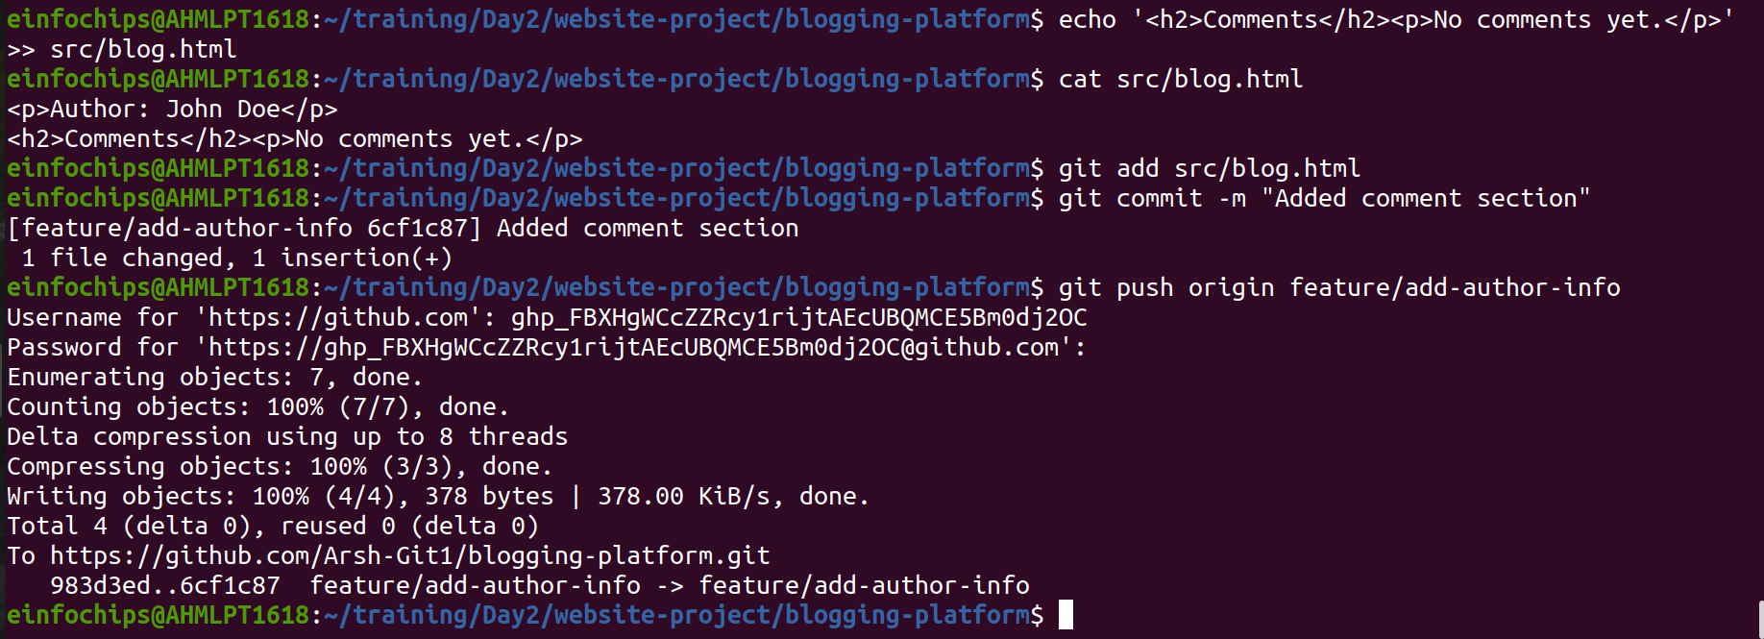

Exercise 4: Pulling and Simulating Collaboration (20 minutes)
- Pull Changes from Remote:
Ensure the main branch is up-to-date:
git checkout main
git pull origin main
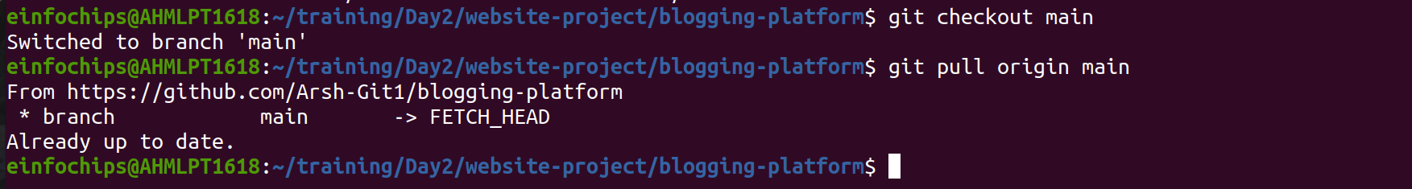

Simulate a Collaborator's Change:
  - Make a change on GitHub directly (e.g., edit blog.html to add a new comment).
- Pull Collaborator's Changes:
Pull the changes made by the collaborator:
git pull origin main
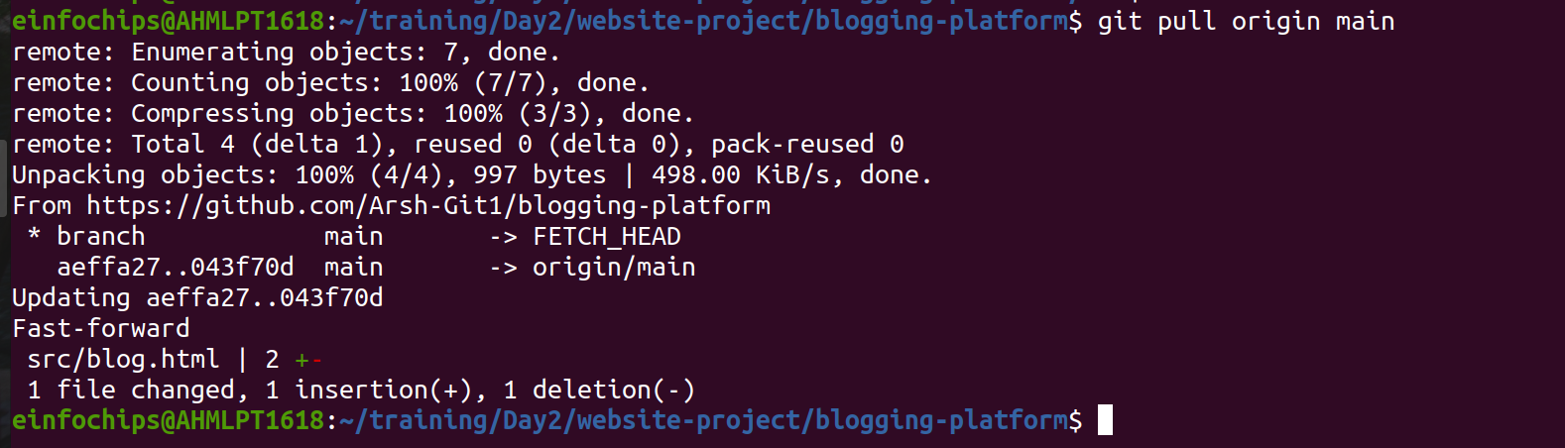

Exercise 5: Versioning and Rollback (30 minutes)
- Tagging a Version:
Tag the current commit as v1.0:
git tag -a v1.0 -m "Version 1.0: Initial release"
git push origin v1.0
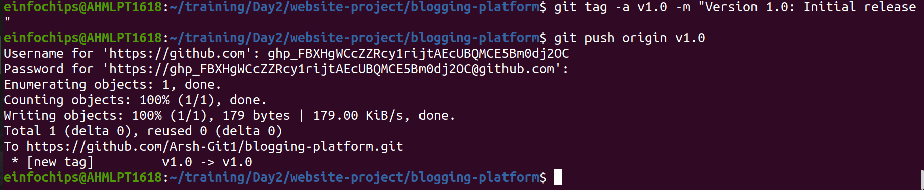

Make a Change that Needs Reversion:
Modify blog.html:
echo "<p>Incorrect comment</p>" >> src/blog.html
git add src/blog.html
git commit -m "Incorrect comment update"
git push origin main
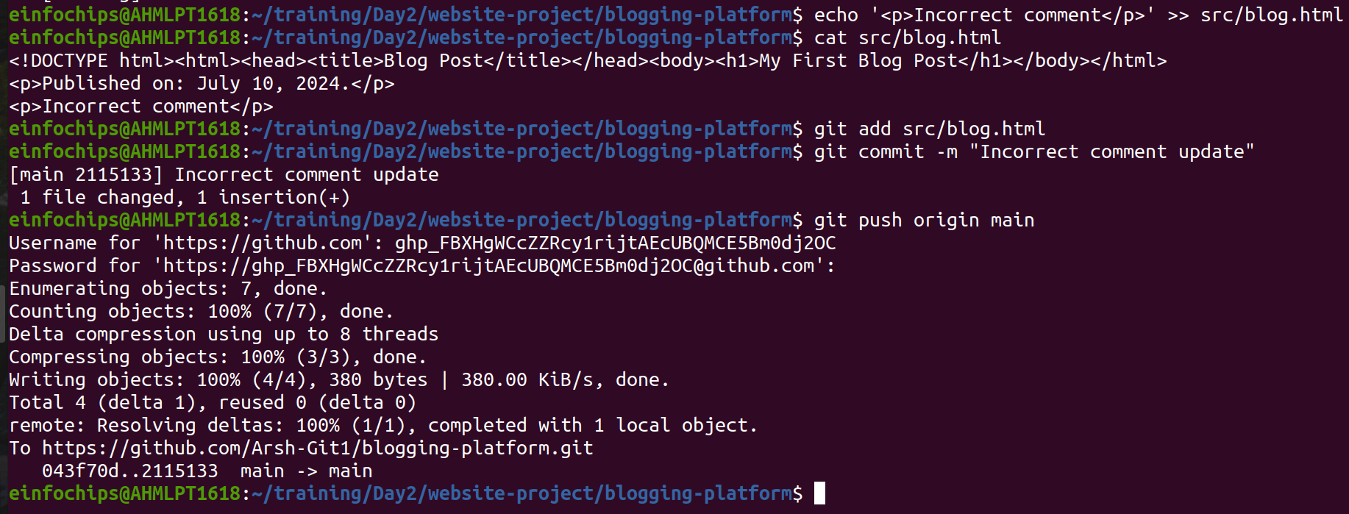
Revert to a Previous Version:
Use git revert to undo the last commit:
git revert HEAD
git push origin main
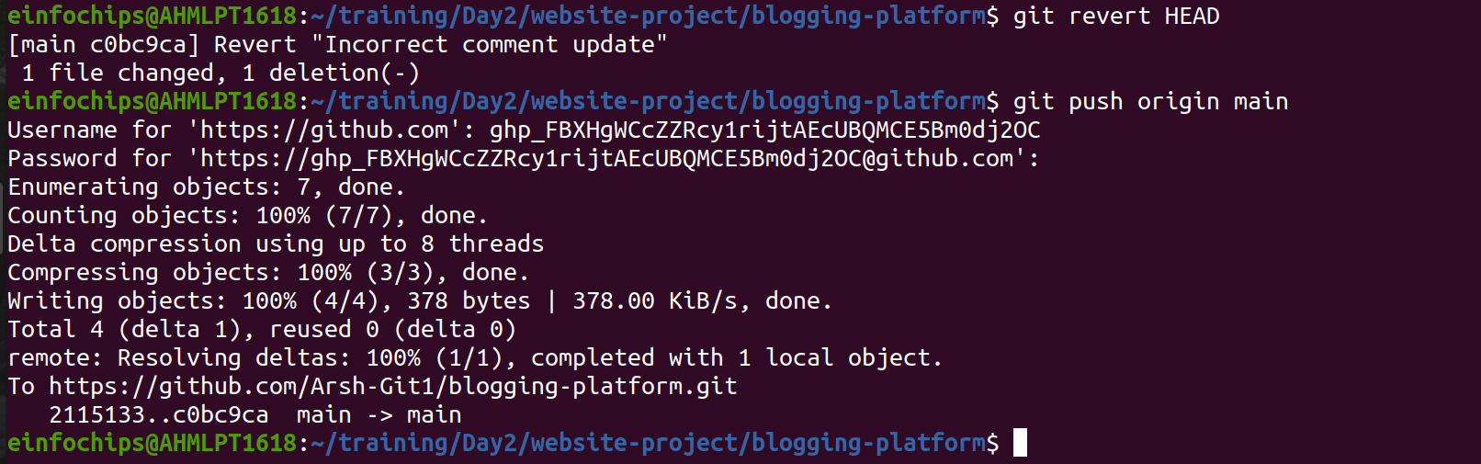
Alternatively, reset to a specific commit (use with caution):
git reset --hard v1.0
git push -f origin main
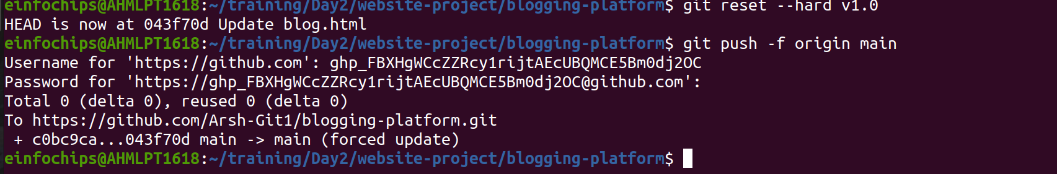

Extra Activities (25 minutes)
- Stashing Changes:
Make some local changes without committing:
echo "<p>Uncommitted changes</p>" >> src/blog.html
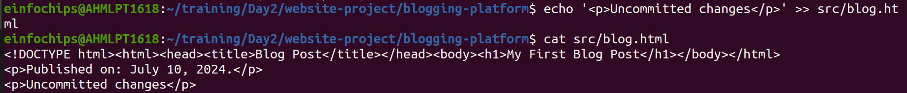
Stash the changes:
git stash
Apply the stashed changes:
git stash apply
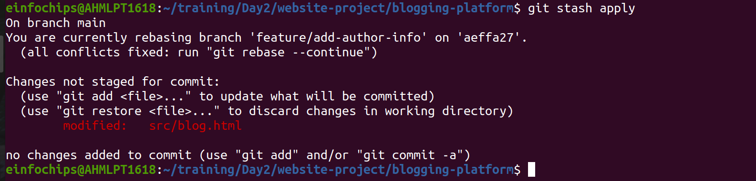
Viewing Commit History:
Use git log to view commit history:
git log –oneline
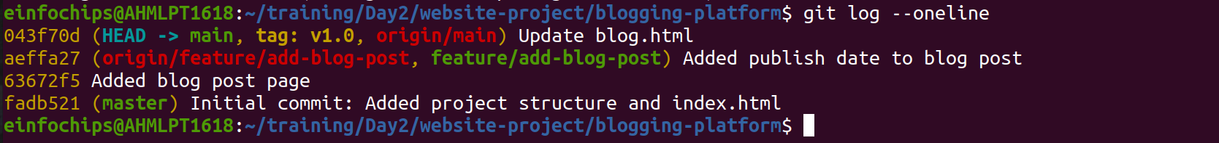
Cherry-Picking Commits:
Create a new branch and cherry-pick a commit from another branch:
git checkout -b feature/cherry-pick
git cherry-pick <commit-hash>
git push origin feature/cherry-pick
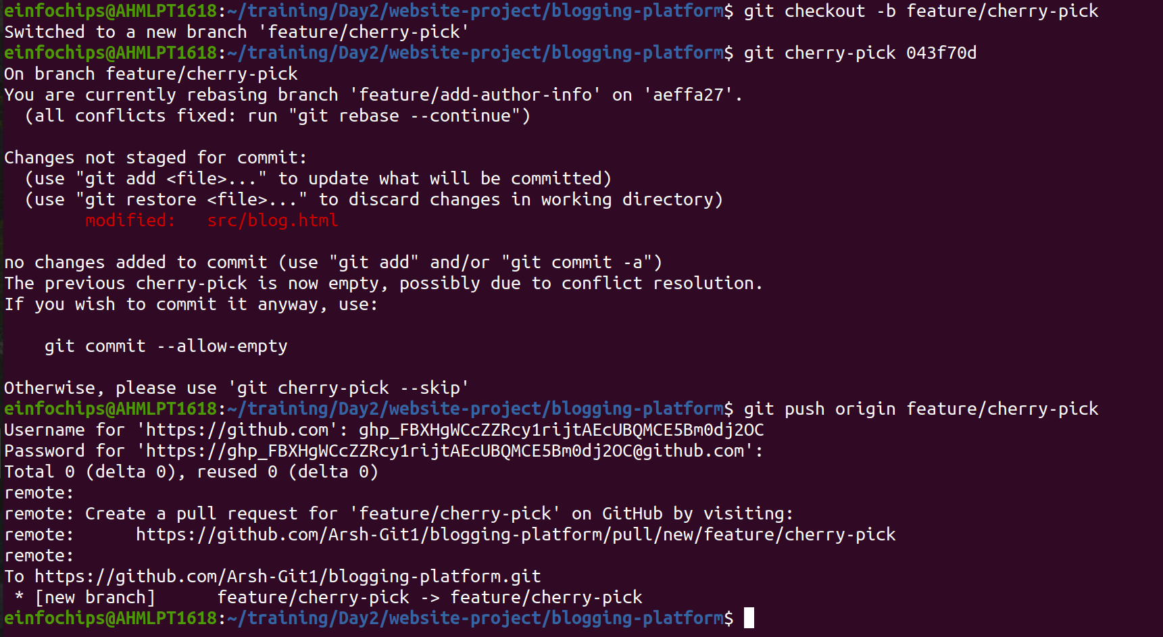

Interactive Rebase:
Use interactive rebase to squash commits:
git checkout main
git rebase -i HEAD~3


