Docker Project 01

Project Overview
In this project, you'll go through all three lifecycles of Docker: pulling an image and creating a container, modifying the container and creating a new image, and finally, creating a Dockerfile to build and deploy a web application.

Part 1: Creating a Container from a Pulled Image
Objective: Pull the official Nginx image from Docker Hub and run it as a container.
Steps:
Pull the Nginx Image:
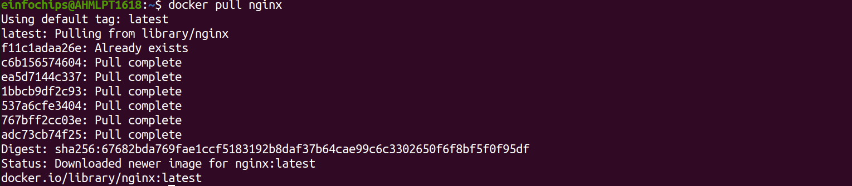
Run the Nginx Container:

- --name my-nginx: Assigns a name to the container.
- -d: Runs the container in detached mode.
- -p 8080:80: Maps port 8080 on your host to port 80 in the container.
Verify the Container is Running:

- Visit http://localhost:8080 in your browser. You should see the Nginx welcome page.

Part 2: Modifying the Container and Creating a New Image
Objective: Modify the running Nginx container to serve a custom HTML page and create a new image from this modified container.
Steps:
Access the Running Container:

Create a Custom HTML Page:

Exit the Container:

Commit the Changes to Create a New Image:
Run a Container from the New Image:
- Verify the New Container:
  - Visit http://localhost:8081 in your browser. You should see your custom HTML page.

Part 3: Creating a Dockerfile to Build and Deploy a Web Application
Objective: Write a Dockerfile to create an image for a simple web application and run it as a container.
Steps:
Create a Project Directory:
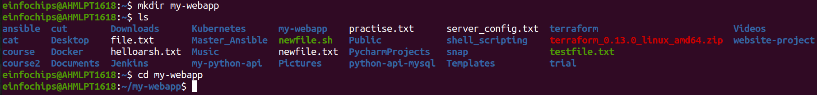

1.
2. Create a Simple Web Application:
Create an index.html file:
<!DOCTYPE html>
<html>
<body>
<h1>Hello from My Web App!</h1>
</body>
</html>

- Save this file in the my-webapp directory.
Write the Dockerfile:
Create a Dockerfile in the my-webapp directory with the following content:
# Use the official Nginx base image
FROM nginx:latest

# Copy the custom HTML file to the appropriate location
COPY index.html /usr/share/nginx/html/

# Expose port 80
EXPOSE 80

Build the Docker Image:

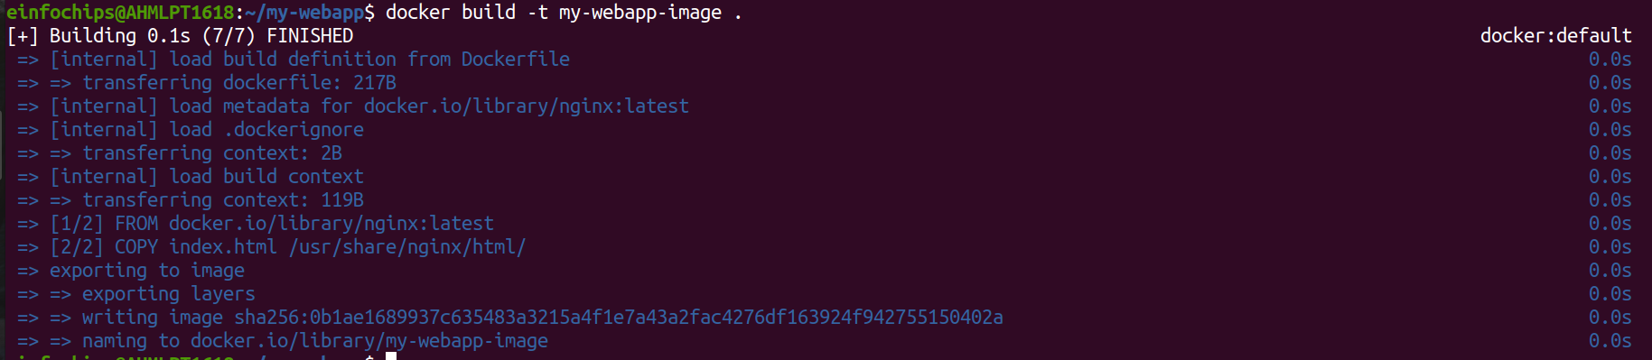

Run a Container from the Built Image:

6. Verify the Web Application:
  - Visit http://localhost:8082 in your browser. You should see your custom web application.

Part 4: Cleaning Up
Objective: Remove all created containers and images to clean up your environment.
Steps:
Stop and Remove the Containers:
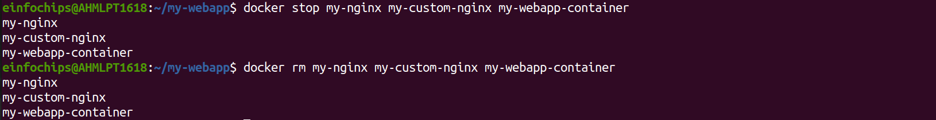

Remove the Images:
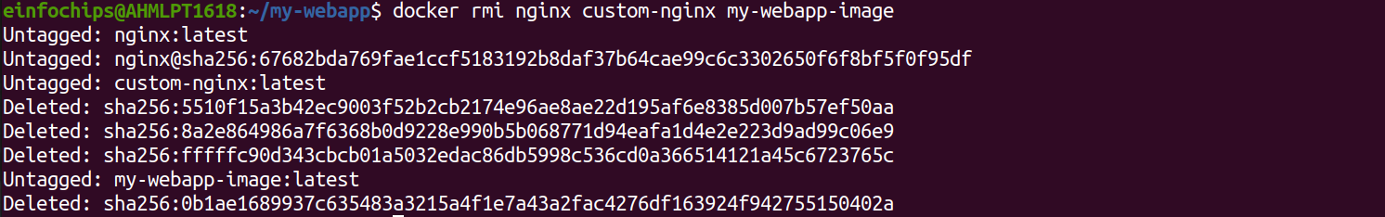
Docker Project 02

Project Overview
In this advanced project, you'll build a full-stack application using Docker. The application will consist of a front-end web server (Nginx), a back-end application server (Node.js with Express), and a PostgreSQL database. You will also set up a persistent volume for the database and handle inter-container communication. This project will take more time and involve more detailed steps to ensure thorough understanding.

Part 1: Setting Up the Project Structure
Objective: Create a structured project directory with necessary configuration files.
Steps:
Create the Project Directory:
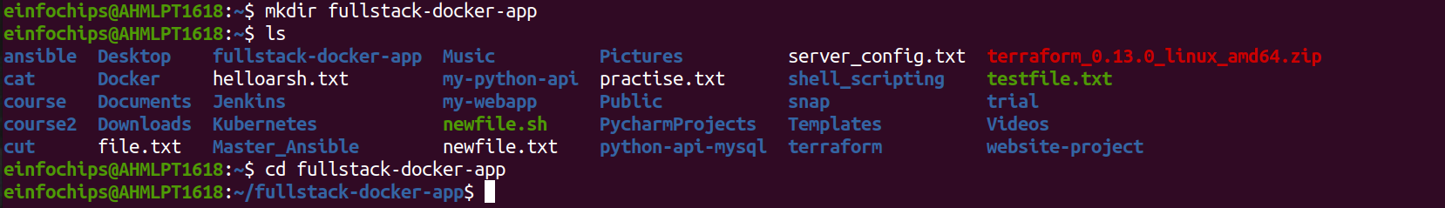
Create Subdirectories for Each Service:

- Create Shared Network and Volume:
  - Docker allows communication between containers through a shared network.

Create a volume for the PostgreSQL database

Part 2: Setting Up the Database
Objective: Set up a PostgreSQL database with Docker.
Steps:
- Create a Dockerfile for PostgreSQL:
In the database directory, create a file named Dockerfile with the following content:
Build the PostgreSQL Image:
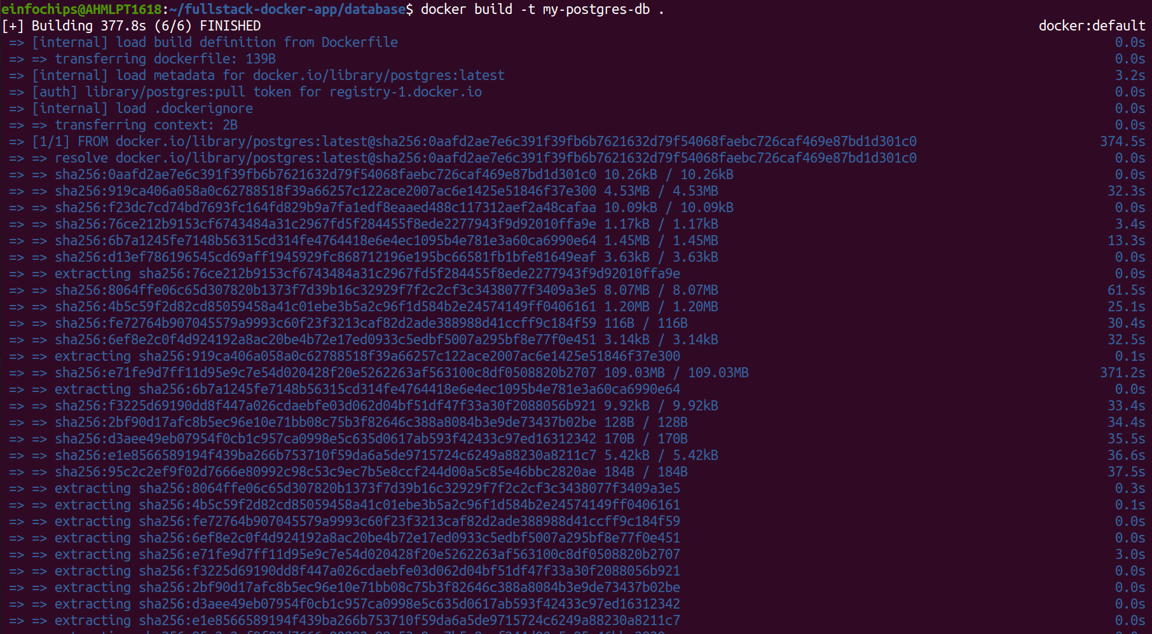

Run the PostgreSQL Container:

Part 3: Setting Up the Backend (Node.js with Express)
Objective: Create a Node.js application with Express and set it up with Docker.
Steps:
Initialize the Node.js Application:

cd backend
npm init -y
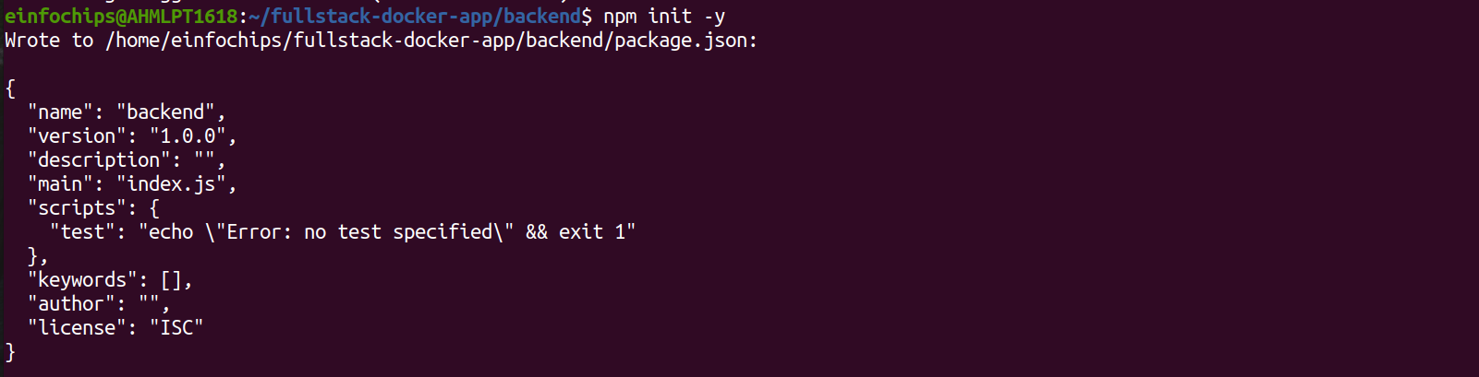
Install Express and pg (PostgreSQL client for Node.js):
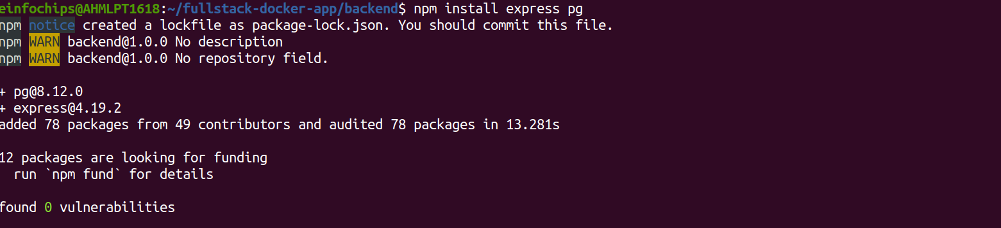

Create the Application Code:
In the backend directory, create a file named index.js with the following content:
Create a Dockerfile for the Backend:
In the backend directory, create a file named Dockerfile with the following content:
Build the Backend Image:

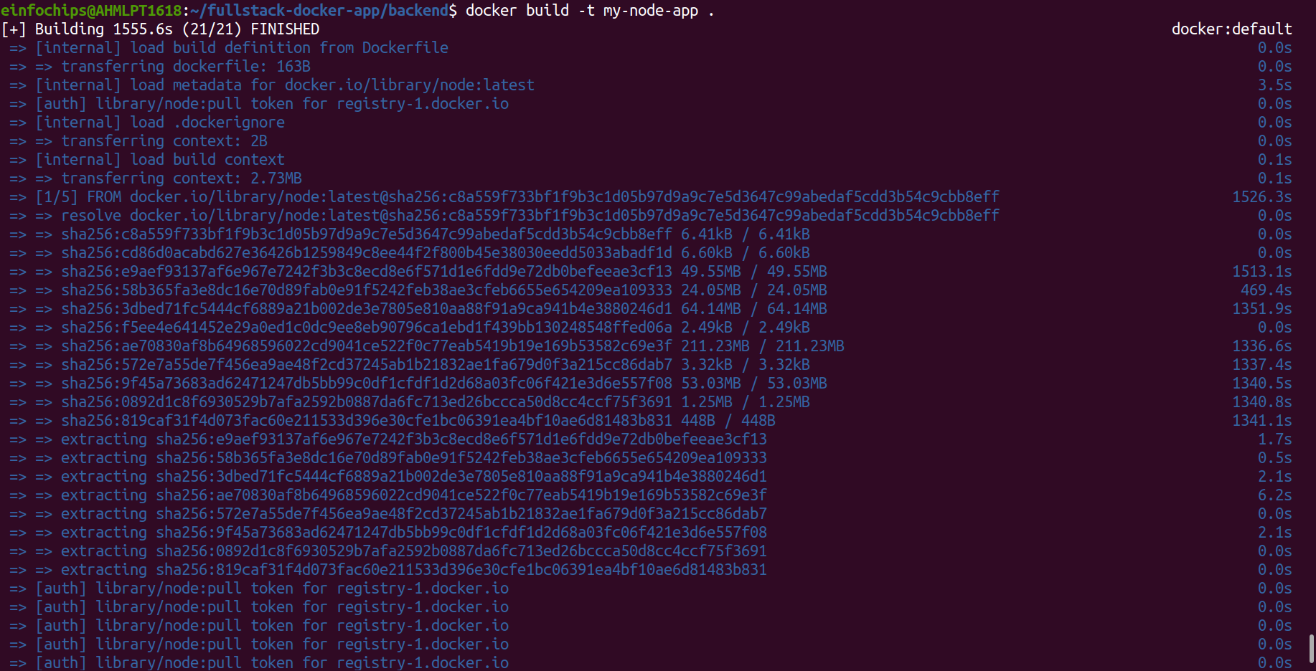
Run the Backend Container:

Part 4: Setting Up the Frontend (Nginx)
Objective: Create a simple static front-end and set it up with Docker.
Steps:
- Create a Simple HTML Page:
In the frontend directory, create a file named index.html with the following content:
2. Create a Dockerfile for the Frontend:
In the frontend directory, create a file named Dockerfile with the following content:

Build the Frontend Image:
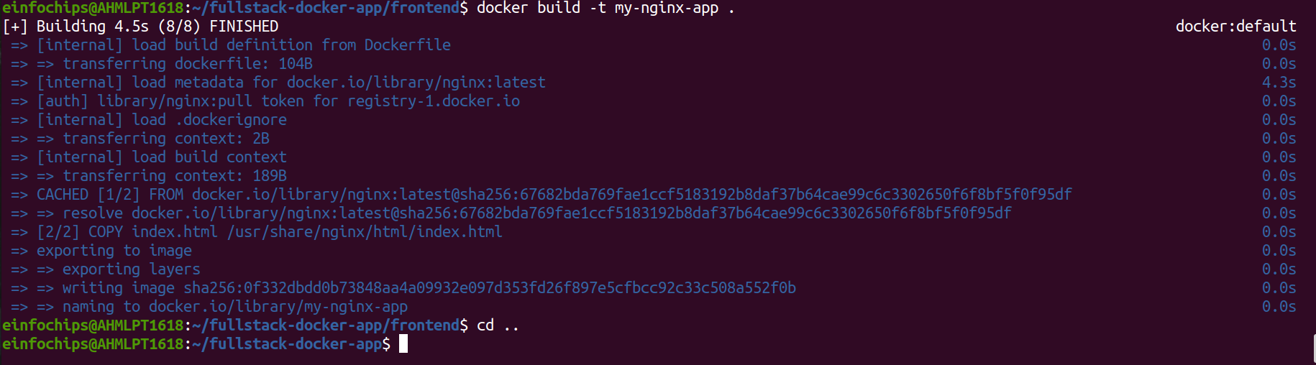
Run the Frontend Container:

Part 5: Connecting the Backend and Database
Objective: Ensure the backend can communicate with the database and handle data requests.
Steps:
- Update Backend Code to Fetch Data from PostgreSQL:
  - Ensure that the index.js code in the backend handles /data endpoint correctly as written above.
- Verify Backend Communication:
Access the backend container:
Test the connection to the database using psql:

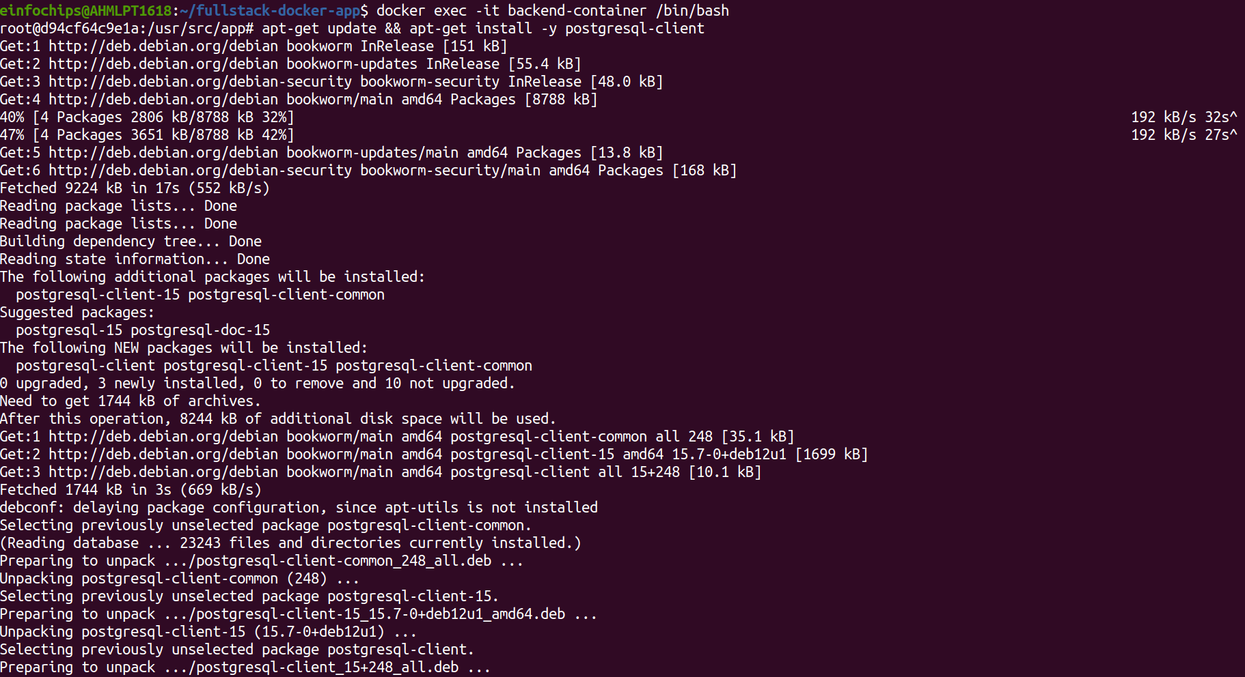

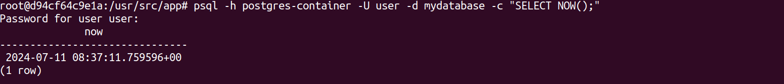
Exit the container:
- Test the Backend API:
  - Visit http://localhost:3000 to see the basic message.
  - Visit http://localhost:3000/data to see the current date and time fetched from PostgreSQL.

Part 6: Final Integration and Testing
Objective: Ensure all components are working together and verify the full-stack application.
Steps:
- Access the Frontend:
  - Visit http://localhost:8080 in your browser. You should see the Nginx welcome page with the custom HTML.
- Verify Full Integration:
Update the index.html to include a link to the backend:
<!DOCTYPE html>
<html>
<body>
<h1>Hello from Nginx and Docker!</h1>
<p>This is a simple static front-end served by Nginx.</p>
<a href="http://localhost:3000/data">Fetch Data from Backend</a>
</body>
</html>

Rebuild and Run the Updated Frontend Container:

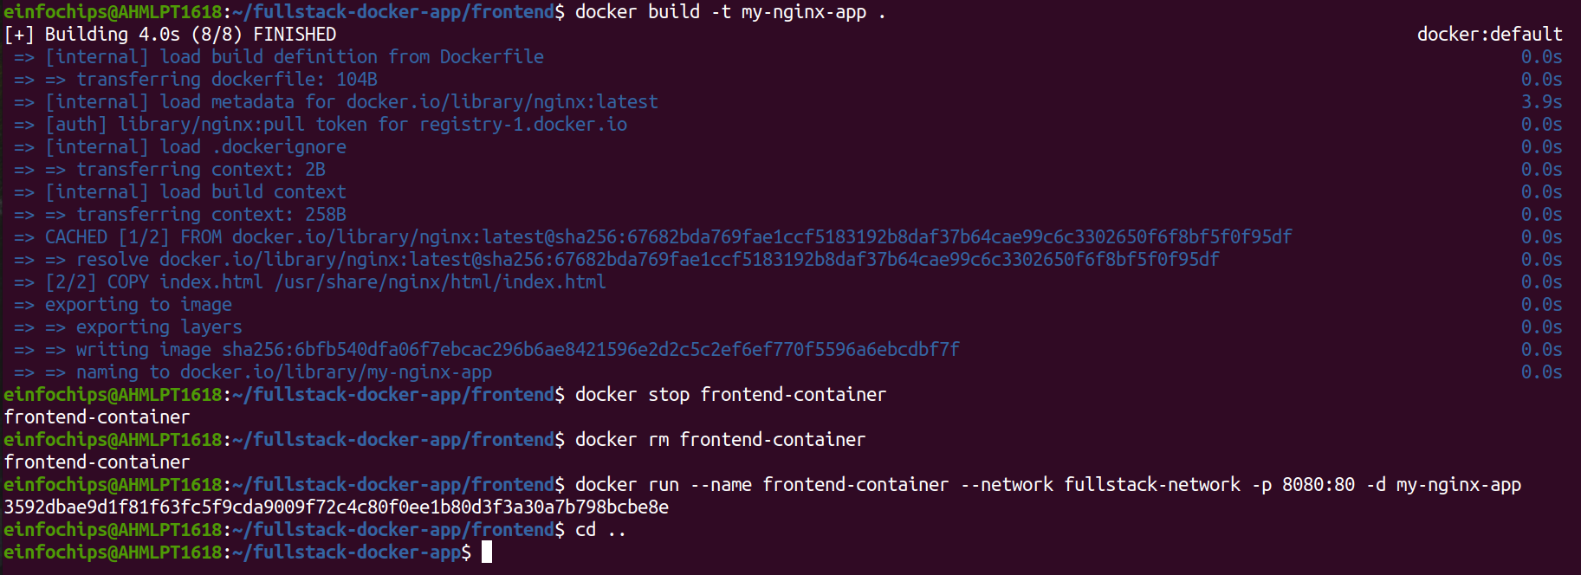

Final Verification:
  - Visit http://localhost:8080 and click the link to fetch data from the backend.
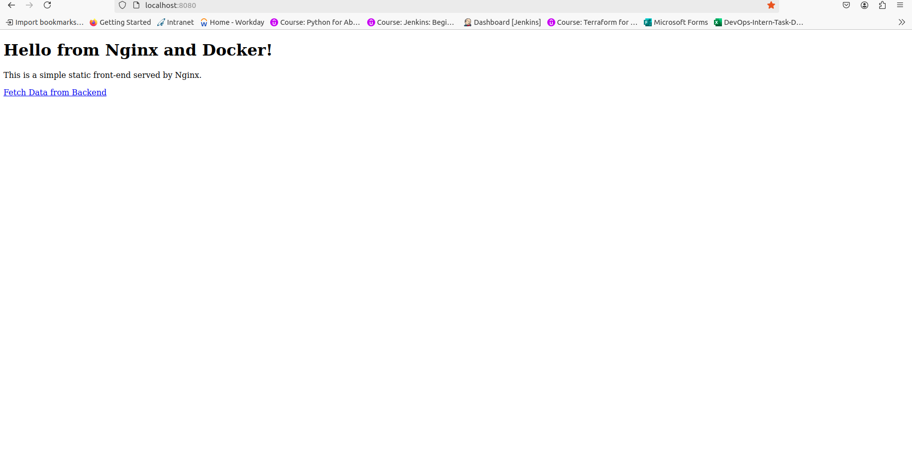

Part 7: Cleaning Up
Objective: Remove all created containers, images, networks, and volumes to clean up your environment.
Steps:
Stop and Remove the Containers:

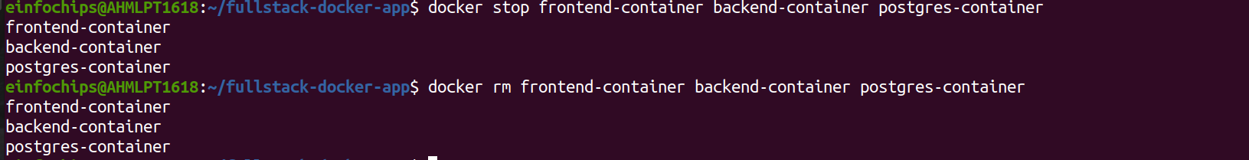
Remove the Images:

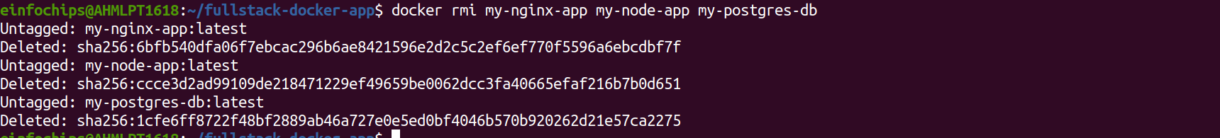
Remove the Network and Volume:

