Project 01

Objectives:
- Create and manage Docker volumes for data persistence.
- Set up a Docker network for container communication.
- Use Docker Compose to manage multi-container applications.
- View and manage Docker logs.
- Deploy the application using Docker Swarm.

Project Outline:
- Create Docker Volumes
- Create a Docker Network
- Write a Docker Compose File
- Deploy the Application with Docker Compose
- Manage Docker Logs
- Deploy the Application Using Docker Swarm

Step-by-Step Guide

1. Create Docker Volumes
Docker volumes are used to persist data generated by and used by Docker containers.

2. Create a Docker Network
Create a custom network for the containers to communicate.

3. Write a Docker Compose File
Create a docker-compose.yml file to define and manage the services.
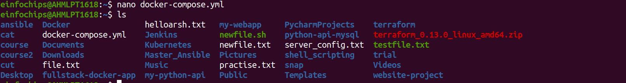

4. Deploy the Application with Docker Compose
Run the following command to start the services defined in the docker-compose.yml file.
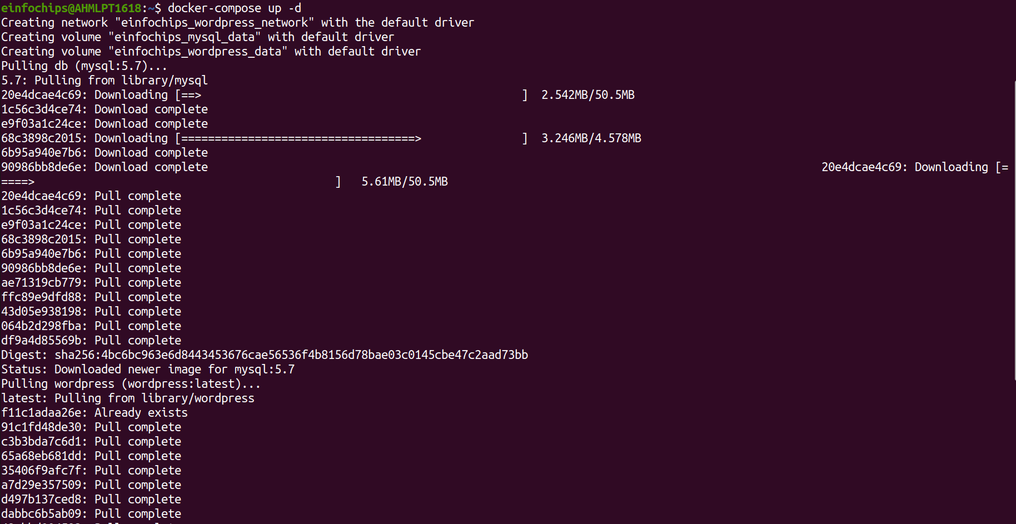
Verify that the containers are running.

Access the WordPress setup by navigating to http://localhost:8000.
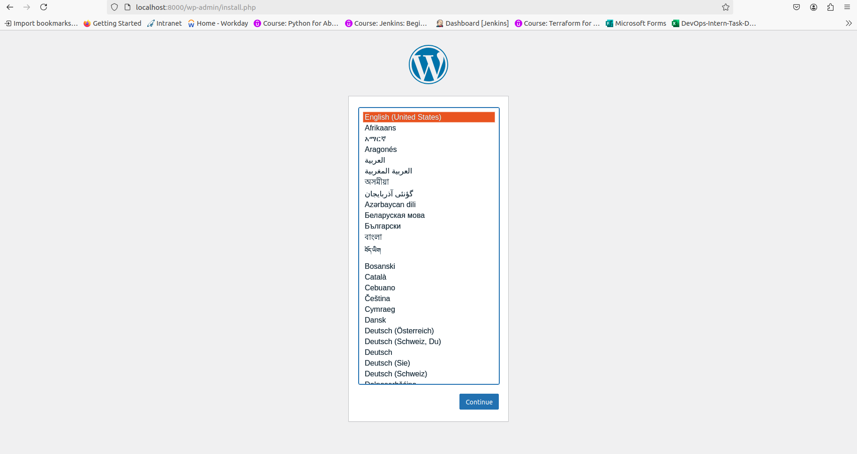

5. Manage Docker Logs
- View logs for a specific service.
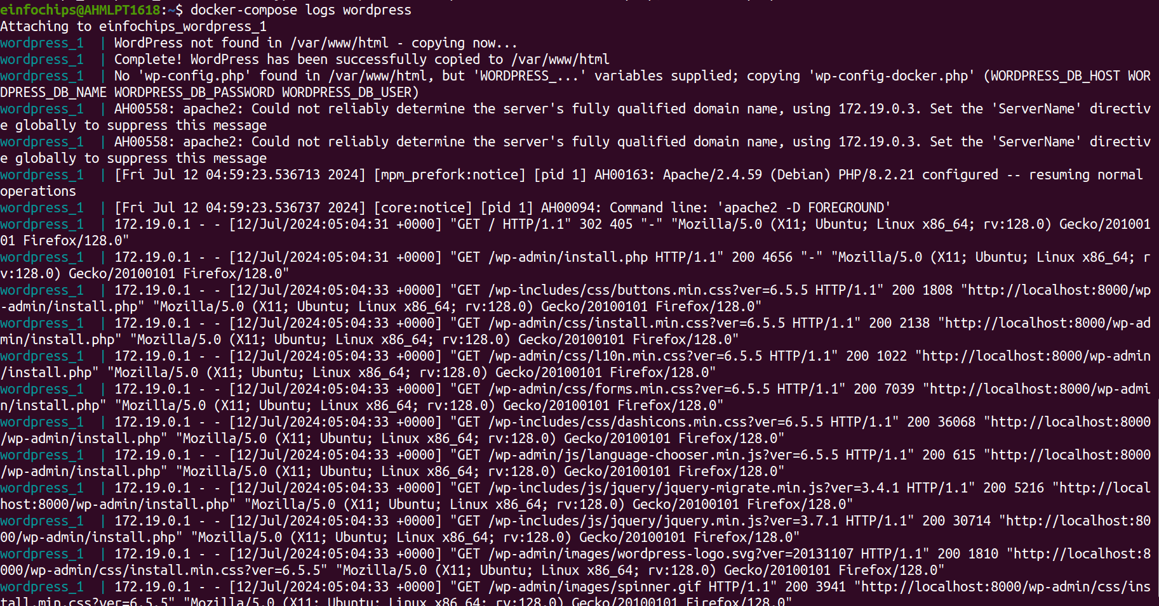
Follow logs for real-time updates.
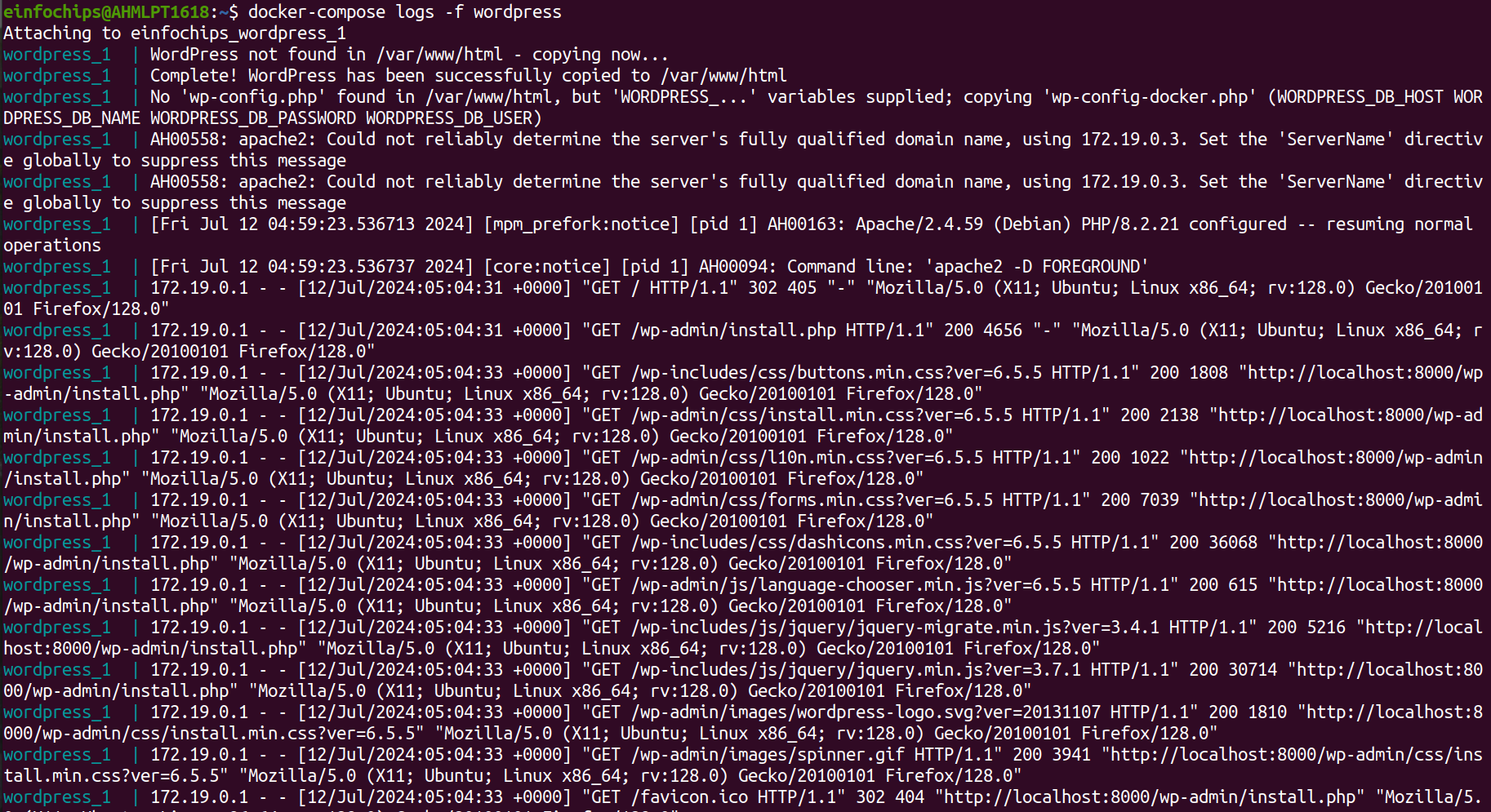

6. Deploy the Application Using Docker Swarm
Docker Swarm is a native clustering and orchestration tool for Docker.
- Initialize Docker Swarm.
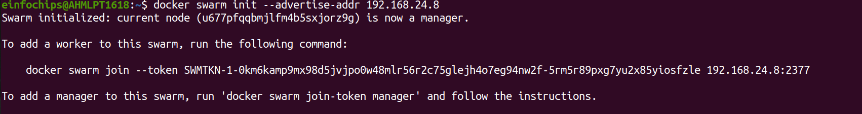
Convert the Docker Compose file to a Docker Stack file, docker-stack.yml.
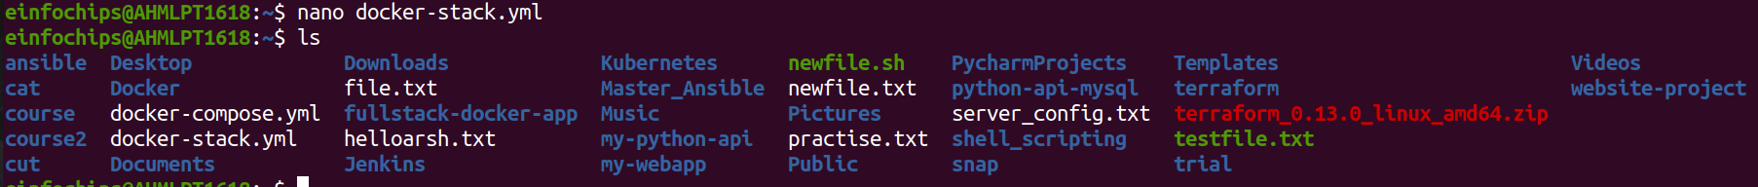

Deploy the stack using Docker Swarm.
Verify the stack is running.

Project 02:

Objectives:
- Deploy an application across multiple Docker Swarm worker nodes.
- Place specific components on designated nodes.
- Monitor and troubleshoot using Docker logs.
- Modify and redeploy the application.

Project Outline:
- Initialize Docker Swarm and Join Worker Nodes
- Label Nodes for Specific Component Placement
- Create a Docker Stack File
- Deploy the Application
- Monitor and Troubleshoot Using Docker Logs
- Modify and Redeploy the Application

Step-by-Step Guide

1. Initialize Docker Swarm and Join Worker Nodes
On the manager node, initialize Docker Swarm:
Join the worker nodes to the swarm. On each worker node, run the command provided by the docker swarm init output:

Step 2: . Label Nodes for Specific Component Placement
- Label nodes to specify where certain components should run. For example, label a node for the database service:
docker node update --label-add db=true <NODE-ID>
- Label another node for the application service:
docker node update --label-add app=true <NODE-ID>
- Verify the labels:
docker node inspect <NODE-ID>

Output
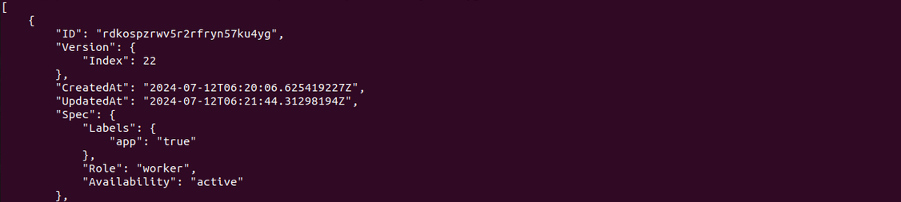

Step 3: Create a Docker Stack File
- Create a docker-stack.yml file to define the services and node placement constraints:
version: '3.8'

services:
db:
image: mysql:5.7
volumes:
- mysql_data:/var/lib/mysql
networks:
- app_network
environment:
MYSQL_ROOT_PASSWORD: example
MYSQL_DATABASE: appdb
MYSQL_USER: user
MYSQL_PASSWORD: password
deploy:
placement:
constraints:
- node.labels.db == true

app:
image: your-app-image
networks:
- app_network
ports:
- "8000:80"
environment:
DB_HOST: db
deploy:
replicas: 2
placement:
constraints:
- node.labels.app == true
volumes:
mysql_data:
networks:
app_network:

Step 4 Deploy the Application
- Deploy the stack using Docker Swarm:
docker stack deploy -c docker-stack.yml app_stack
docker stack services app_stack
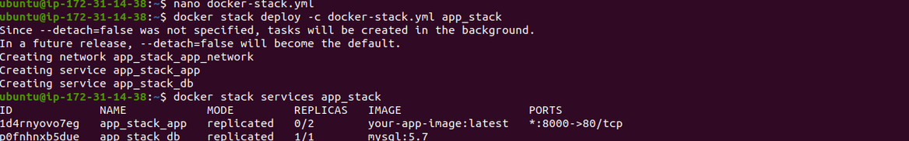

Step 5: Monitor and Troubleshoot Using Docker Logs
- Check the logs for the services:
docker service logs app_stack_db
docker service logs app_stack_app

Step 6: Modify and Redeploy the Application
- Make modifications to the application or the stack file as needed. For example, change the number of replicas:
services:
app:
deploy:
replicas: 3
Update the stack with the new configuration:
docker stack deploy -c docker-stack.yml app_stack
- Verify the changes:
docker stack services app_stack

Output
