Project 01 - 1 Hour

Deploying a Scalable Web Application with Persistent Storage and Advanced Automation

Objective:
Deploy a scalable web application using Docker Swarm and Kubernetes, ensuring data persistence using a single shared volume, and automate the process using advanced shell scripting.

Overview:
- Step 1: Set up Docker Swarm and create a service.
- Step 2: Set up Kubernetes using Minikube.
- Step 3: Deploy a web application using Docker Compose.
- Step 4: Use a single shared volume across multiple containers.
- Step 5: Automate the entire process using advanced shell scripting.

Step 1: Set up Docker Swarm and Create a Service

1.1 Initialize Docker Swarm
# Initialize Docker Swarm

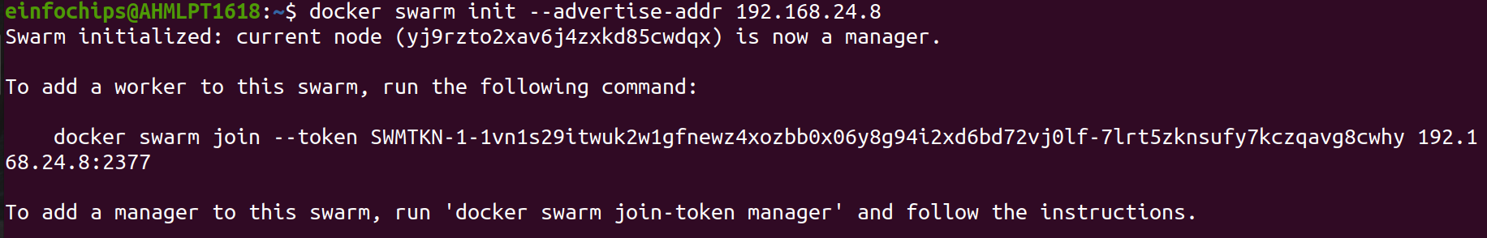

Swarm initialized: current node (yj9rzto2xav6j4zxkd85cwdqx) is now a manager.

To add a worker to this swarm, run the following command:

docker swarm join --token SWMTKN-1-1vn1s29itwuk2w1gfnewz4xozbb0x06y8g94i2xd6bd72vj0lf-7lrt5zknsufy7kczqavg8cwhy 192.168.24.8:2377

To add a manager to this swarm, run 'docker swarm join-token manager' and follow the instructions.

1.2 Create a Docker Swarm Service

# Create a simple Nginx service in Docker Swarm

Step 2: Set up Kubernetes Using Minikube

2.1 Start Minikube

# Start Minikube

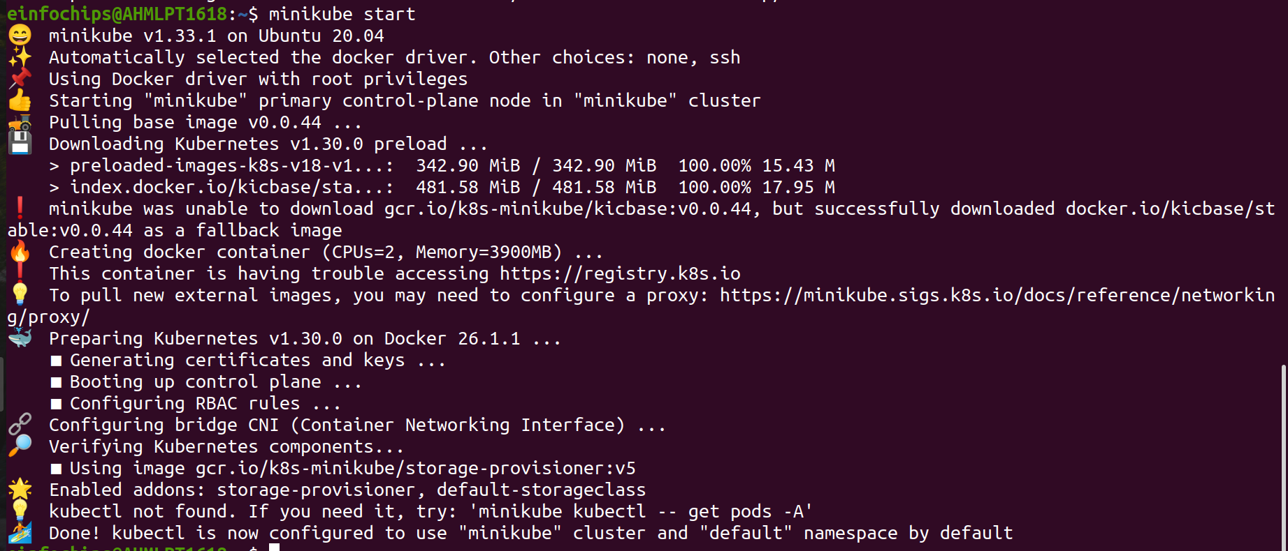

2.2 Deploy a Web App on Kubernetes
Create a deployment file named webapp-deployment.yaml:
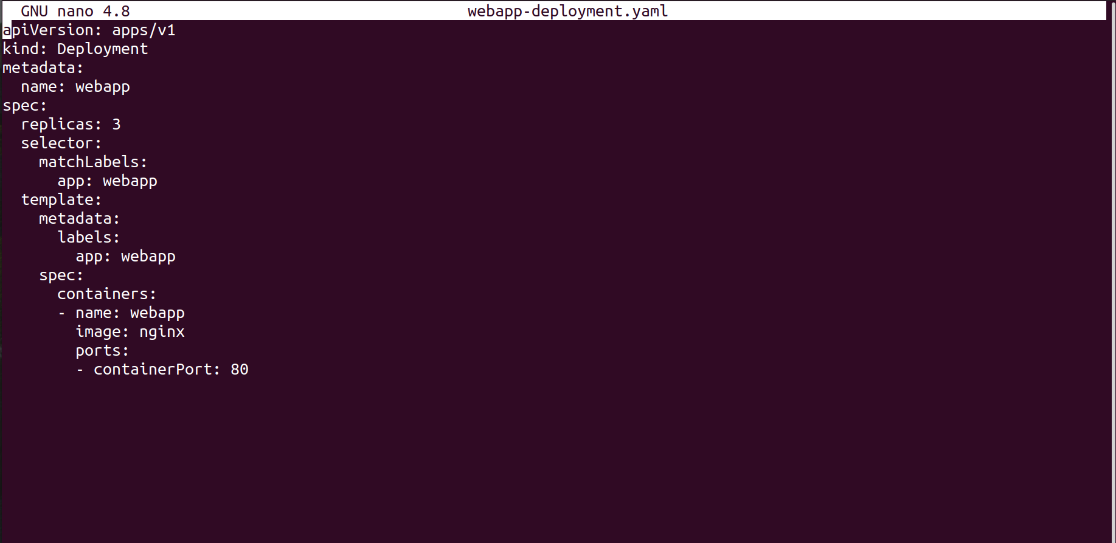

Apply the deployment:

2.3 Expose the Deployment

Step 3: Deploy a Web Application Using Docker Compose

3.1 Create a docker-compose.yml File
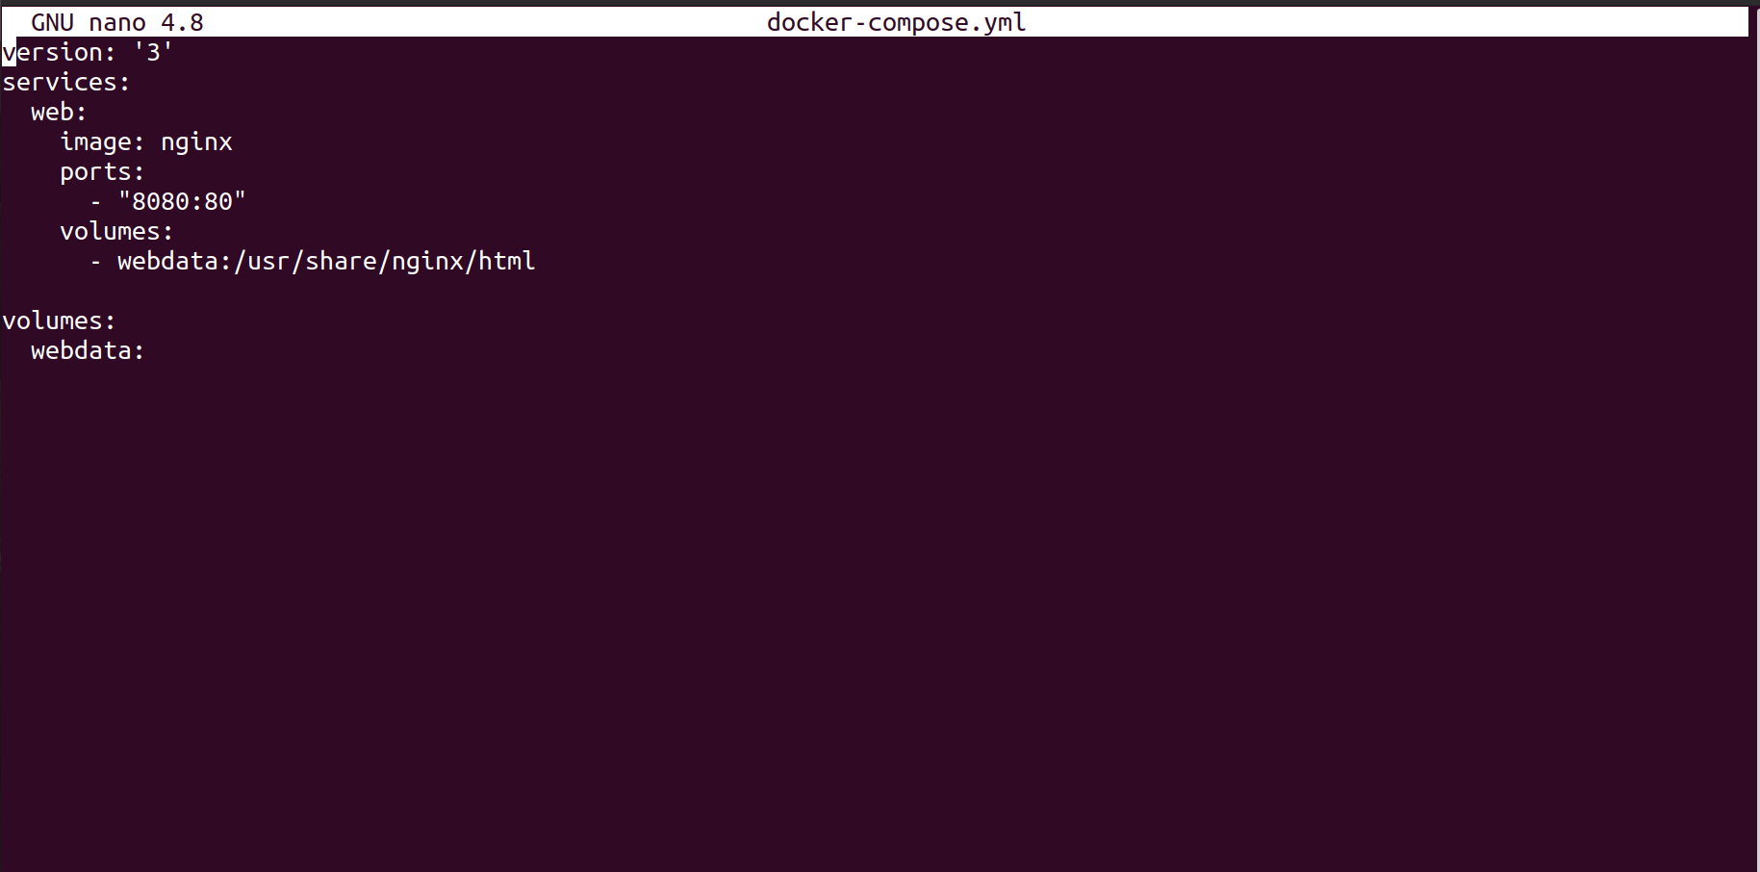

3.2 Deploy the Web Application

# Deploy using Docker Compose

Step 4: Use a Single Shared Volume Across Multiple Containers

4.1 Update docker-compose.yml to Use a Shared Volume

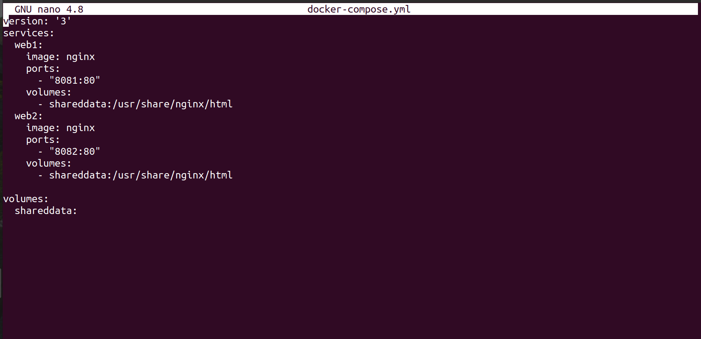

4.2 Deploy with Docker Compose

# Deploy using Docker Compose

docker-compose up -d

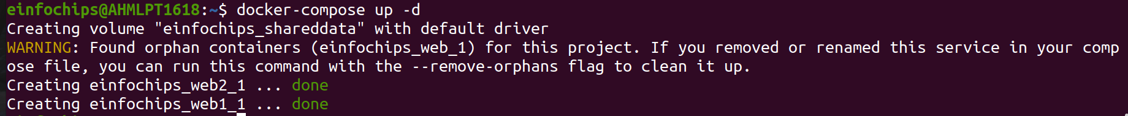

Step 5: Automate the Entire Process Using Advanced Shell Scripting

5.1 Create a Shell Script deploy.sh

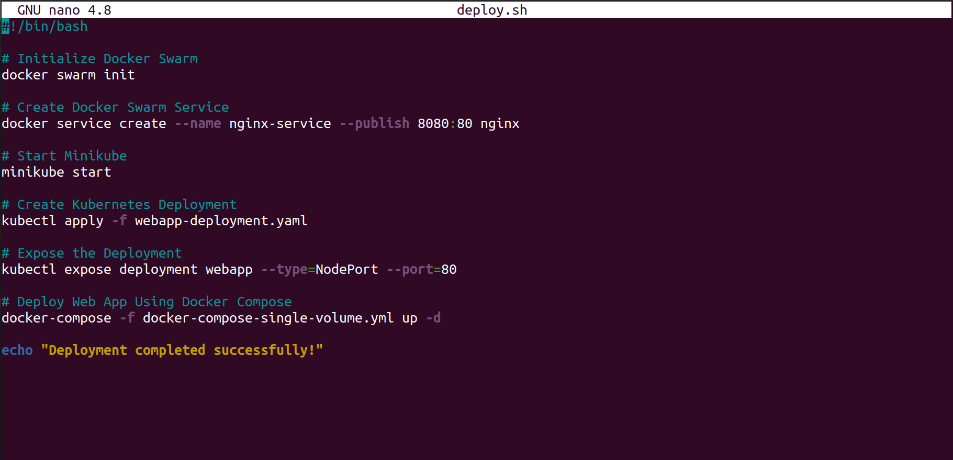

5.2 Make the Script Executable

# Make the script executable

5.3 Run the Script

# Run the deployment script

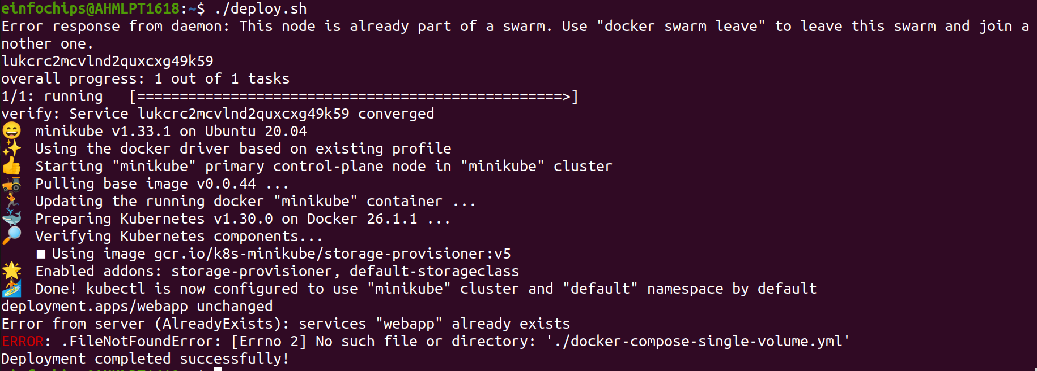

Project 02 - 1 Hour

Comprehensive Deployment of a Multi-Tier Application with CI/CD Pipeline

Objective:
Deploy a multi-tier application (frontend, backend, and database) using Docker Swarm and Kubernetes, ensuring data persistence using a single shared volume across multiple containers, and automating the entire process using advanced shell scripting and CI/CD pipelines.

Overview:
- Step 1: Set up Docker Swarm and create a multi-tier service.
- Step 2: Set up Kubernetes using Minikube.
- Step 3: Deploy a multi-tier application using Docker Compose.
- Step 4: Use a single shared volume across multiple containers.
- Step 5: Automate the deployment process using advanced shell scripting.

Step 1: Set up Docker Swarm and Create a Multi-Tier Service

1.1 Initialize Docker Swarm

# Initialize Docker Swarm

1.2 Create a Multi-Tier Docker Swarm Service
Create a docker-compose-swarm.yml file:
version: '3.7'
services:
frontend:
image: nginx
ports:
- "8080:80"
deploy:
replicas: 2
volumes:
- shareddata:/usr/share/nginx/html
backend:
image: mybackendimage
ports:
- "8081:80"
deploy:
replicas: 2
volumes:
- shareddata:/app/data
db:
image: postgres
environment:
POSTGRES_DB: mydb
POSTGRES_USER: user
POSTGRES_PASSWORD: password
deploy:
replicas: 1
volumes:
- dbdata:/var/lib/postgresql/data

volumes:
shareddata:
dbdata:

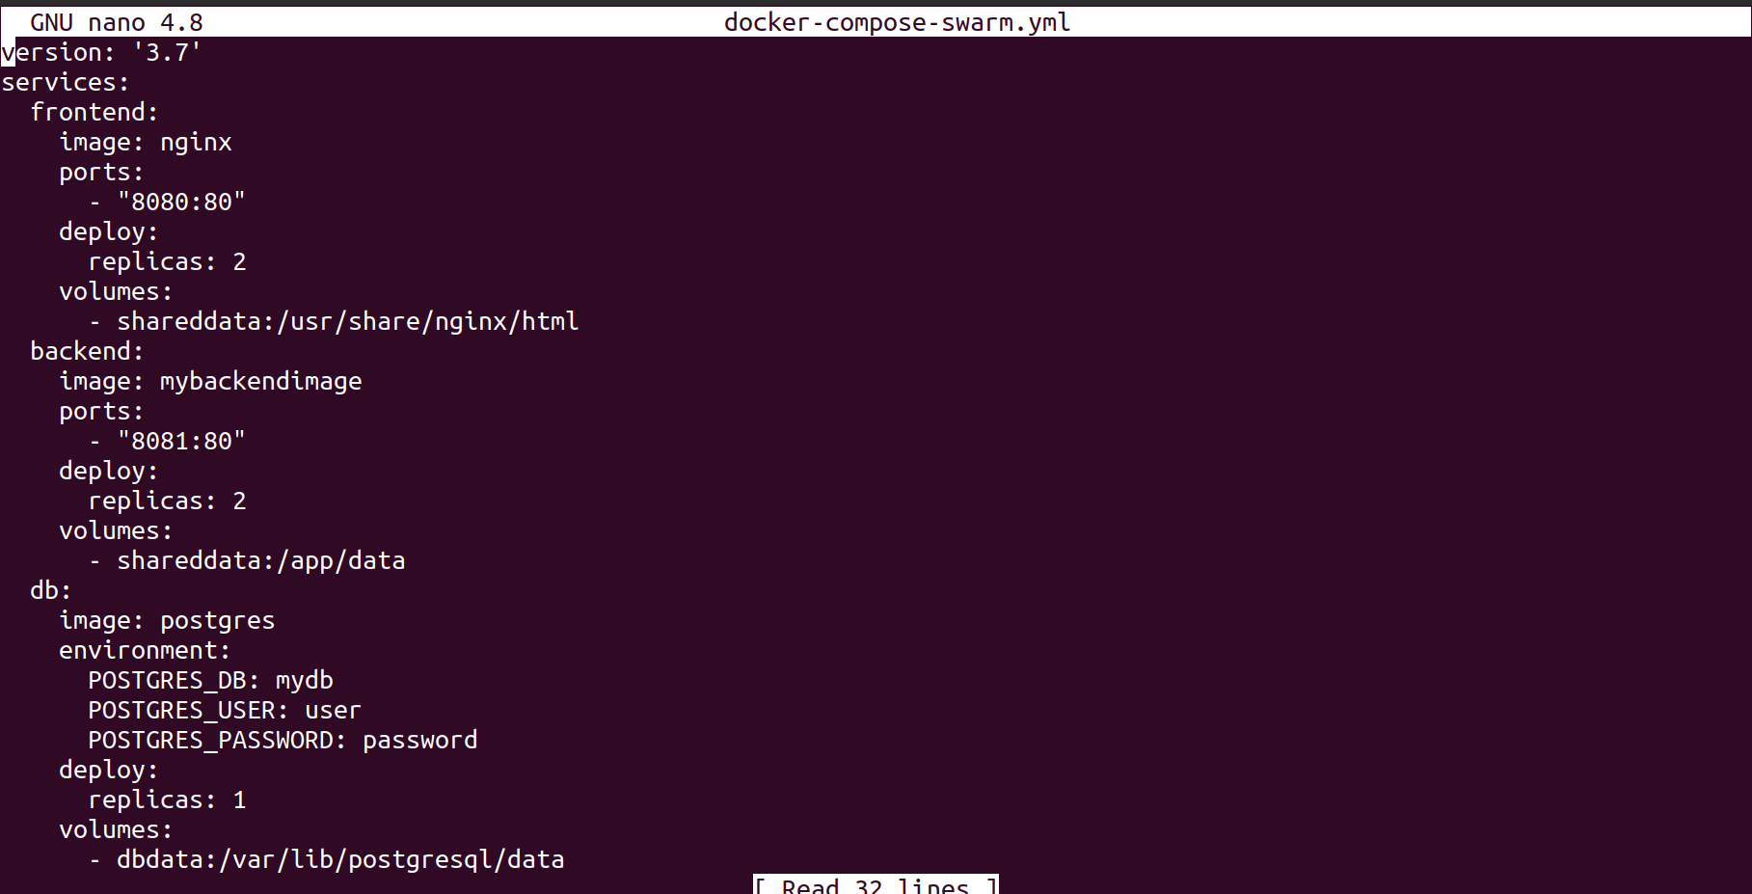
Deploy the stack:
# Deploy the stack using Docker Swarm

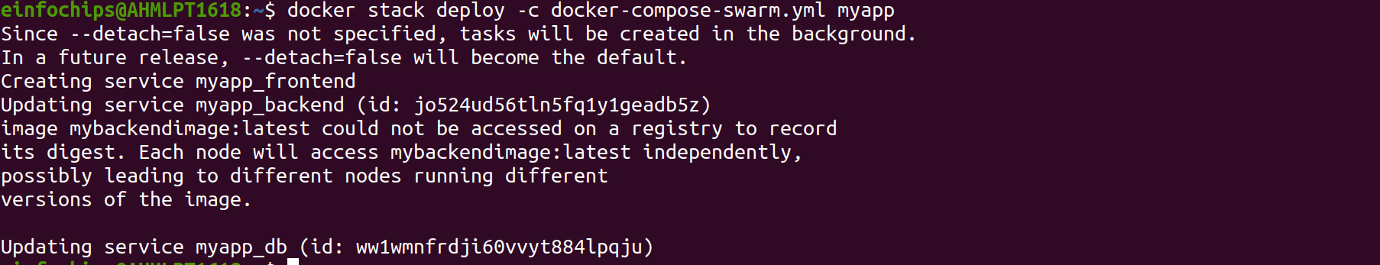

Step 2: Set up Kubernetes Using Minikube

2.1 Start Minikube

# Start Minikube

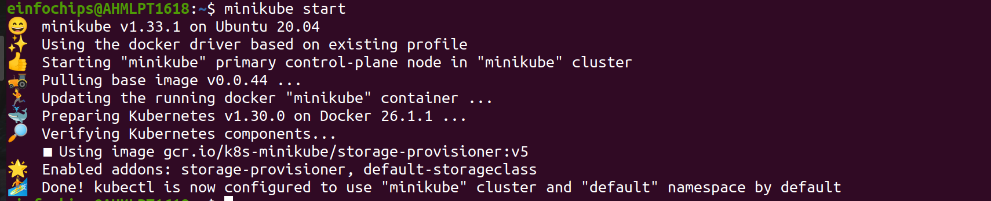

2.2 Create Kubernetes Deployment Files
Create frontend-deployment.yaml:
apiVersion: apps/v1
kind: Deployment
metadata:
name: frontend
spec:
replicas: 2
selector:
matchLabels:
app: frontend
template:
metadata:
labels:
app: frontend
spec:
containers:
- name: frontend
image: nginx
ports:
- containerPort: 80
volumeMounts:
- name: shareddata
mountPath: /usr/share/nginx/html
volumes:
- name: shareddata
persistentVolumeClaim:
claimName: shared-pvc

Create backend-deployment.yaml
apiVersion: apps/v1
kind: Deployment
metadata:
name: backend
spec:
replicas: 2
selector:
matchLabels:
app: backend
template:
metadata:
labels:
app: backend
spec:
containers:
- name: backend
image: mybackendimage
ports:
- containerPort: 80
volumeMounts:
- name: shareddata
mountPath: /app/data
volumes:
- name: shareddata
persistentVolumeClaim:
claimName: shared-pvc

Create db-deployment.yaml:

apiVersion: apps/v1
kind: Deployment
metadata:
name: db
spec:
replicas: 1
selector:
matchLabels:
app: db
template:
metadata:
labels:
app: db
spec:
containers:
- name: db
image: postgres
env:
- name: POSTGRES_DB
value: mydb
- name: POSTGRES_USER
value: user
- name: POSTGRES_PASSWORD
value: password
volumeMounts:
- name: dbdata
mountPath: /var/lib/postgresql/data
volumes:
- name: dbdata
persistentVolumeClaim:
claimName: db-pvc

Create shared-pvc.yaml:

apiVersion: v1
kind: PersistentVolumeClaim
metadata:
name: shared-pvc
spec:
accessModes:
- ReadWriteMany
resources:
requests:
storage: 1Gi

Create db-pvc.yaml:

apiVersion: v1
kind: PersistentVolumeClaim
metadata:
name: db-pvc
spec:
accessModes:
- ReadWriteOnce
resources:
requests:
storage: 1Gi

Apply the deployments:
kubectl apply -f shared-pvc.yaml
kubectl apply -f db-pvc.yaml
kubectl apply -f frontend-deployment.yaml
kubectl apply -f backend-deployment.yaml
kubectl apply -f db-deployment.yaml

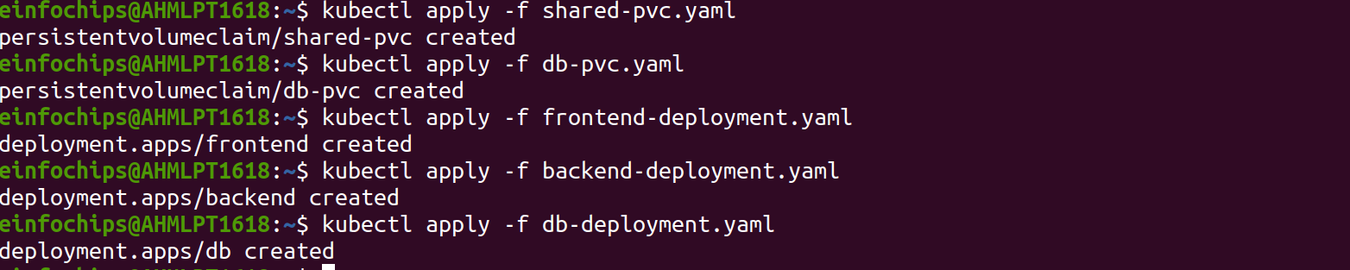

Step 3: Deploy a Multi-Tier Application Using Docker Compose

3.1 Create a docker-compose.yml File

version: '3'
services:
frontend:
image: nginx
ports:
- "8080:80"
volumes:
- shareddata:/usr/share/nginx/html
backend:
image: mybackendimage
ports:
- "8081:80"
volumes:
- shareddata:/app/data
db:
image: postgres
environment:
POSTGRES_DB: mydb
POSTGRES_USER: user
POSTGRES_PASSWORD: password
volumes:
- dbdata:/var/lib/postgresql/data

volumes:
shareddata:
dbdata:

3.2 Deploy the Application

# Deploy using Docker Compose
docker-compose up -d

Step 4: Use a Single Shared Volume Across Multiple Containers
Update docker-compose.yml as shown in Step 3.1 to use the shareddata volume across the frontend and backend services.

