FINAL MAJOR PROJECT

## Part 1: Project Proposal

Step 1: College admission Project for development final major project in ASP.NET



**Systems Analysis –** This platform was built with ASP.NET. The key feature is the ability to purchase Jeans. We focused the target system's requirements with a emphasis on user demands, which included learning about software product limits, learning about system-related issues or modifications, and addressing the project's influence on the organization and employees, among other things.

The project team assessed the project's scope and devised a timetable and resource allocation strategy based on their findings.

**Systems design** – This is a high-level description of how a computer-based system would satisfy the requirements; it is expected to be a single-user system that does not rely on data connection for the primary facility.

**Systems Specifications**

OS -Windows 10

IDE- Visual Studio

**Programming** – ASP.NET and C# was used for functionality completed as a working system in an MVC model.

Step 2***:*** Produced a project proposal contained that includes home page, order Jeans, check availability and User login etc.

Project Goal – Build a platform for users to buy and search Jeans.

Project Objectives – The main objectives of the project was to register students and Courses to have a record for future.

Project Scope – A full-fledge website develop 5 page website development

1. Context – Add courses Facility
2. ASP.NET language platform
3. Registration of Students

Project Deliverables –

1. Analysis documentation
2. Design documentation
3. Executable program
4. User documentation

|  |  |  |
| --- | --- | --- |
| **Milestone** | **Time taken** | **Finalized** |
| Designing | 2 Days | Yes |
| Programming | 2 Days | Yes |
| Documentation | 2 days | Yes |

Resources

|  |  |
| --- | --- |
| Processor | 1 GHz |
| RAM | 512 MB |
| Disk space (minimum) |  |
| 32-bit | 4.5 GB |
| 64-bit | 4.5 GB |

Project Schedule

1. The conclusion of the preliminary inquiry

2. Drafted design

3. Approval of the design

4. The prototype programme has been finished.

5. Signed-off stages of programme refinement

6. The programme has been completed.

7. The programme was put to the test

8. Completed system documentation

9. The user acceptance process has been finished.

10. Completion of the user report on system acceptability

Project Assumptions

1. Users are available during the project to provide information and software is available at the client site.

**Design**:



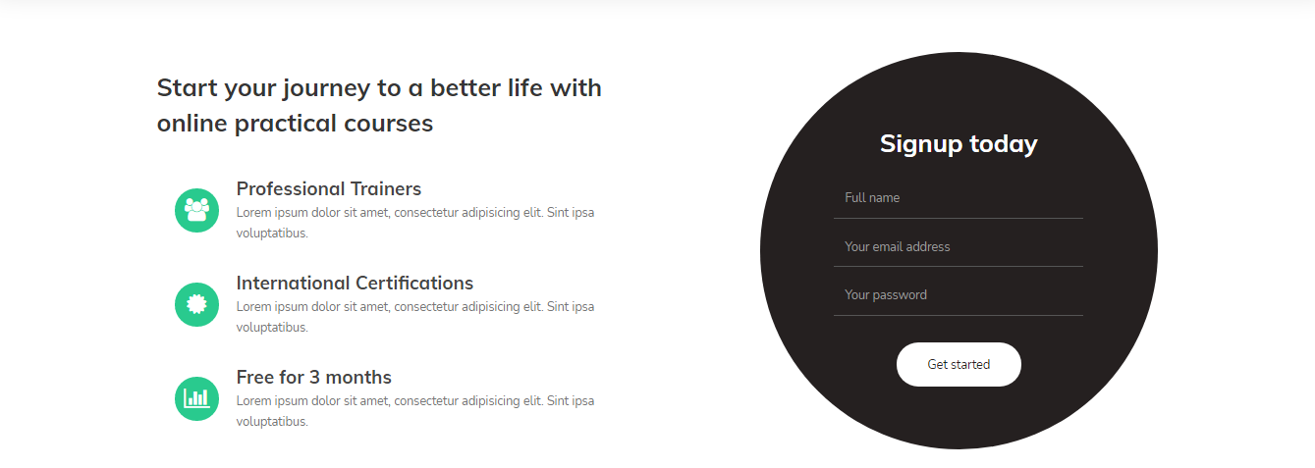



Admin Login for adding Courses

Name : [Admin@admin.com](mailto:Admin@admin.com)

Password: admin

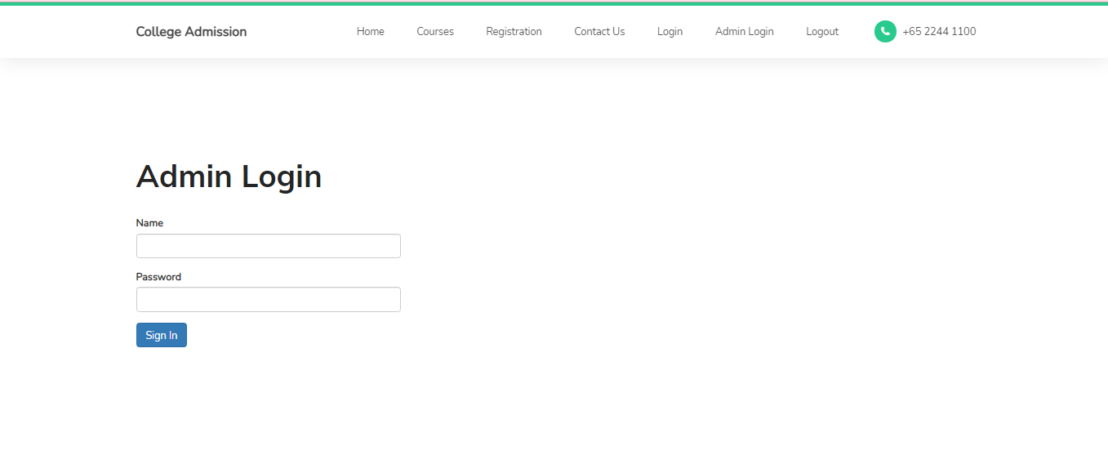

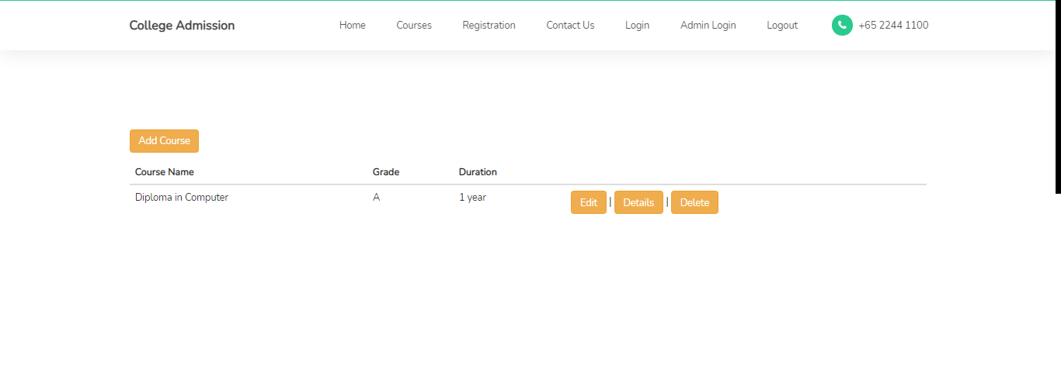

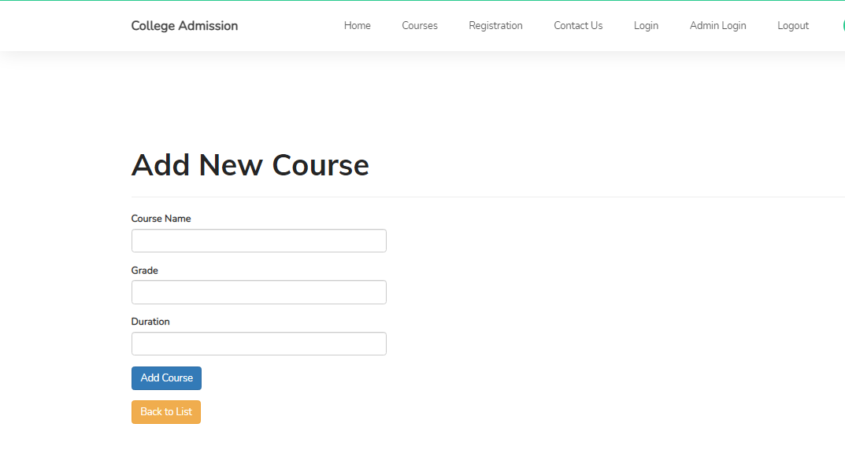

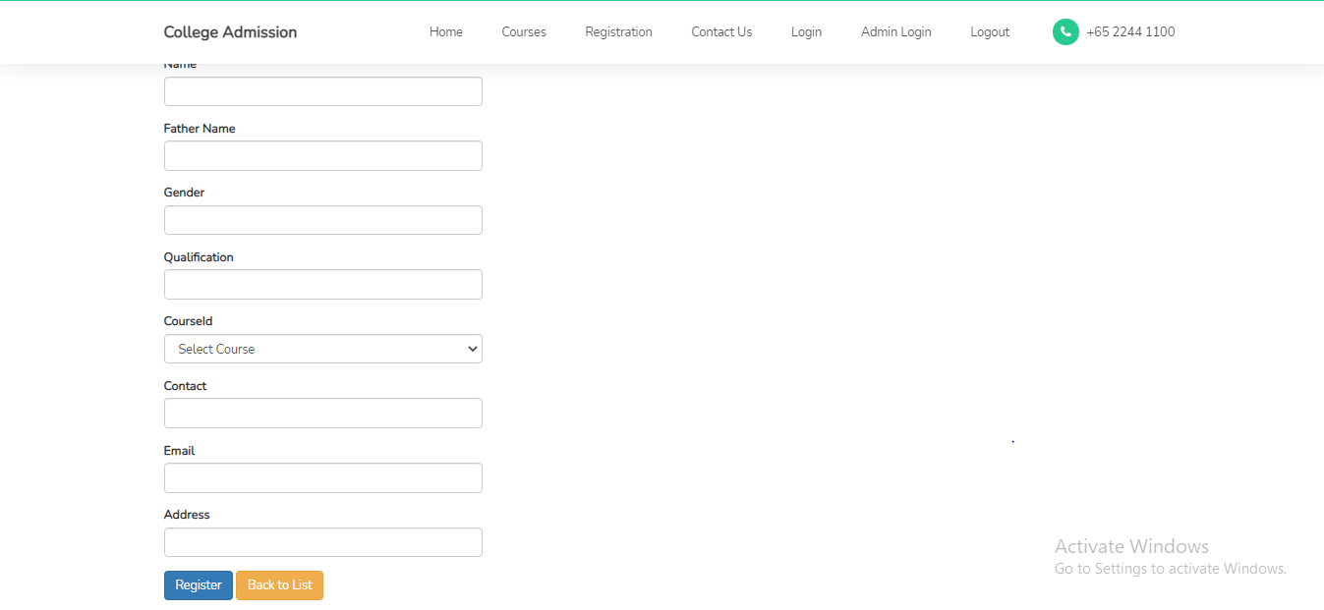

# **Part 2: Review your project**

Step 1: Final Product/Outcome – Review Courses and students