# Data Analytics and Visualization

**Lab Assignment 5**

**Name:** Akshat Srivastava

**ID:** 201851013

**Question 1:**

a) Poisson Distribution

x = rpois(1000, 2)

hist(x, main = "Histogram for Poisson Distribution")

negloglike<-function(lam){

n<-length(x)

n*lam-sum(x)*log(lam)+sum(log(factorial(x)))

}

out1<-nlm(negloglike,p=c(0.5),hessian = TRUE)

out1$estimate

mean(x)

Output 2.023999

2.024

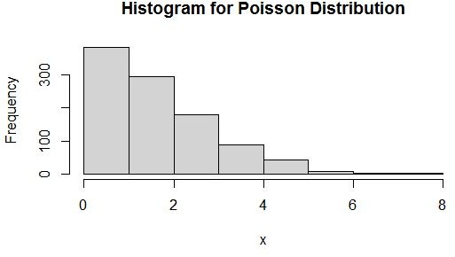

c) Gaussian Distribution when sigma is known

n=500

X<-rnorm(500, mean=2, sd=3)

sig=3

hist(X, main = "Histogram for Normal Distribution")

negloglike<-function(mu){

(n)*log(sqrt(2*pi)*sig)+(1/(2*sig**2))*sum((X-mu)**2)

}

out4<-nlm(negloglike,p=c(2),hessian = TRUE)

out4$estimate

mean(X)

Output 1.910687

1.910687

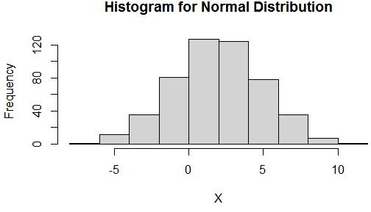

1. Gaussion Distribution when mu is known

n=500

X<-rnorm(500,mean=2,sd=3) mu=2

hist(X,main="Histogram for Normal Distribution") negloglike<-function(sig){ (n)*log(sqrt(2*pi)*sig)+(1/(2*sig**2))*sum((X-mu)**2)

}

out4<-nlm(negloglike,p=c(3),hessian = TRUE) out4$estimate

sqrt(sum((X-mean(X))^2)/(n-1))

Output 2.948891

2.950346

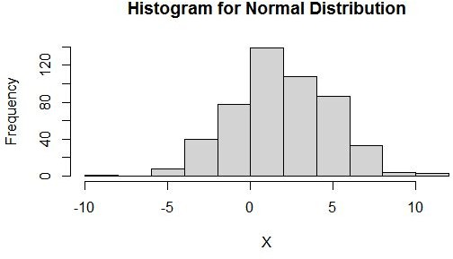

1. Gaussian Distribution when both parameters are unknown

n=5000

X<-rnorm(n,3,10)

hist(X, main = "Histogram for Normal Distribution")

negloglike<-function(parvec){

sum(0.5*log(parvec[2])+0.5*(X-parvec[1])^2/parvec[2])

}

out4<-nlm(negloglike, p=c(0,1),hessian = TRUE)

out4$estimate

mean(X) var(X)

Output

2.772752 100.947391

2.772756

100.9676

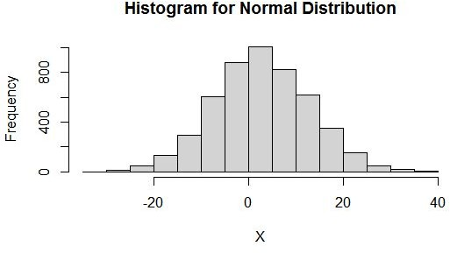

1. Exponential Distribution

n=1000

X<-rexp(n,2)

hist(X,main="Histogram for Exponential Distribution")

negloglike<-function(lam){

-n*log(lam)+sum(X)*lam

}

out2<-nlm(negloglike, p=c(0.5), hessian = TRUE)

out2$estimate

1/mean(X)

Output 2.087439

2.087439

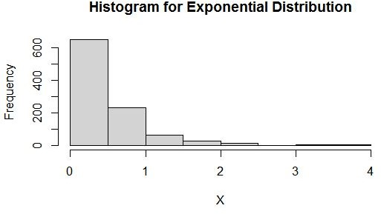

1. Gamma Distribution when both parameters are unknown

alpha=2 beta=3

X<-round(rgamma(1000,shape=alpha,scale=beta),2) hist(X,main="Histogram for Gamma Distribution")

negloglike<-function(theta,data){

a<-theta[1] b<-theta[2]

n<-length(data) sumd<-sum(data)

sumlogd<-sum(log(data)) n*a*log(b)+n*lgamma(a)+sumd/b-(a-1)*sumlogd

}

out5<-nlm(negloglike,c(2,4),hessian = TRUE,data=X)

out5$estimate

momentofalpha<-mean(X)^2/var(X) momentofbeta<-var(X)/mean(X) momentofalpha

momentofbeta

Output

1.964036 3.113893

2.037376

3.001802

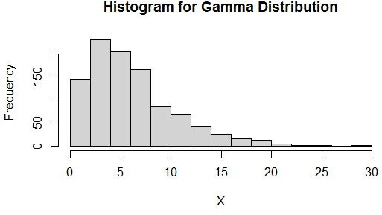

**Question 2:**

x<-c(3,7,5,3,2)

negloglike<-function(p){ n<-length(x)

-n*log(p)-sum(x-1)*log(1-p)

}

out6<-nlm(negloglike,c(0.2),hessian =TRUE) out6$estimate

1/mean(x)

0.25

0.25

**Question 3:**

x<-c(0.33,0.51,0.02,0.15,0.12)

n<-length(x)

negloglike<-function(theta)

{

-log(theta+1)-theta*sum(log(x))

}

out7<-nlm(negloglike,c(0.2),hessian=TRUE)

out7$estimate

-1/sum(log(x))-1

Output

-0.8970288

-0.8970284