

|  |  |  |  |  |  |  |
| --- | --- | --- | --- | --- | --- | --- |
|  | | | | | | |
|  | | **Practical Assignment -2**  **Report** | | |  | |
|  |  | | | | |  |
|  | | |  |  | | |
|  | | | Submitted by:  **Arsh Kataria**  **12132176**  Due date:  **Friday, 23 September 2022, 11:45 PM** |  | | |

**Table of Contents:**

Git-repository Link 3

Screen shot(s) of testing and annotation 4

Summary 13

# Git-repository Link

<https://github.com/Arsh2022/Practical-Assignment-2.git>

# Screen shot(s) of testing and annotation

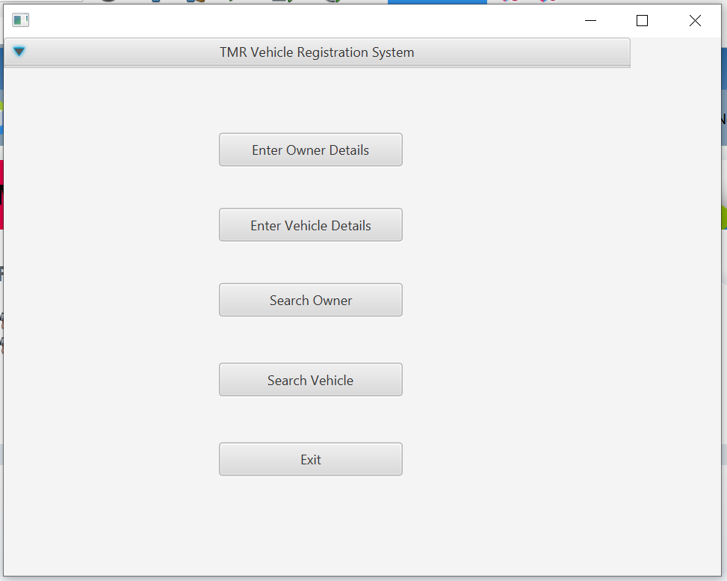

Figure

The Figure 1 shows the main menu page for TMR Vehicle registration system with multiple scenes such as ‘Enter Owner Details, Enter Vehicle Details, Search Owner, Search Vehicle and Exit button.

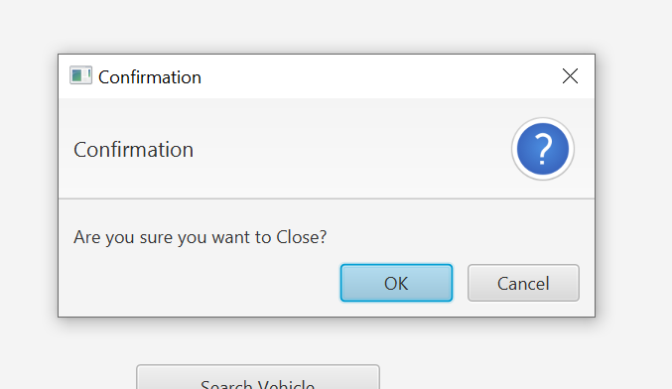

Figure

Figure 2 shows the dialog box when ‘exit’ button is pressed.

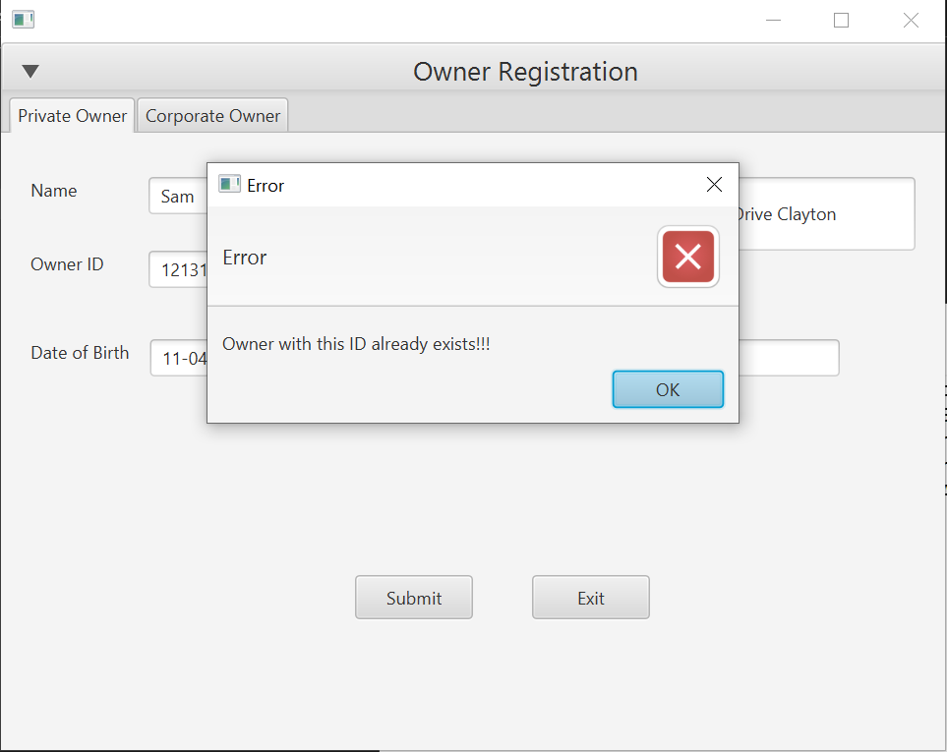

Figure

Figure 3 shows the error message if the details for Private Owner in the ‘Enter Owner Details’ already exists.

Figure

Figure 4 shows if the Owner ID is searched, with the owner ID.

Figure

Figure 5 shows an error if no Owner id is specified.

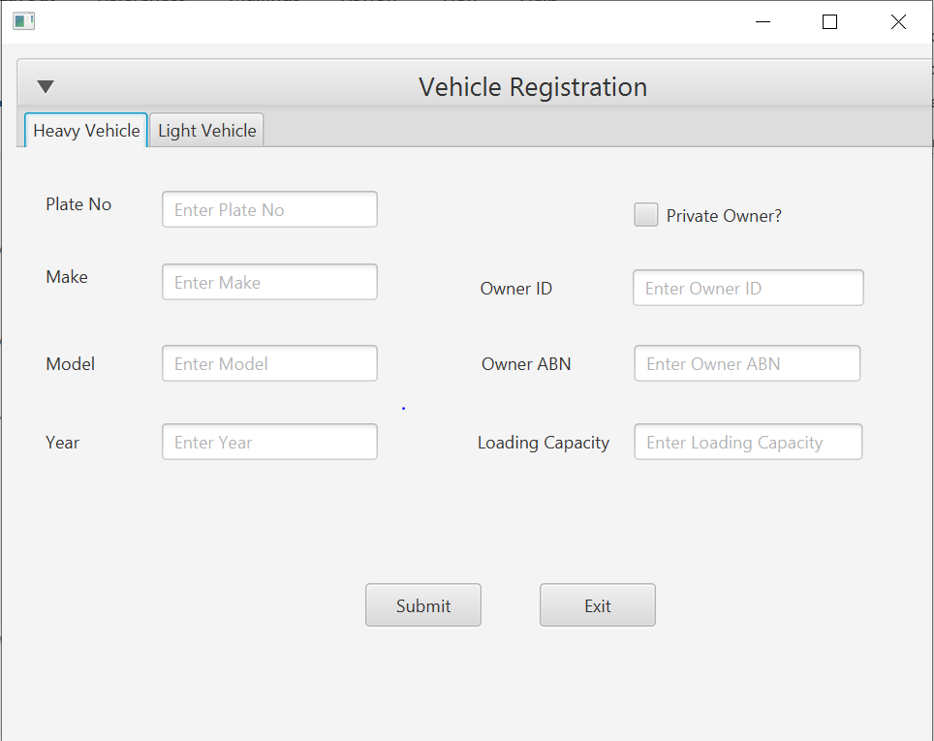

Figure

Figure 6 shows the scene when ‘Enter Vehicle Details’ button is pressed with the text fields to enter. This tab shows the details for Heavy Vehicle.

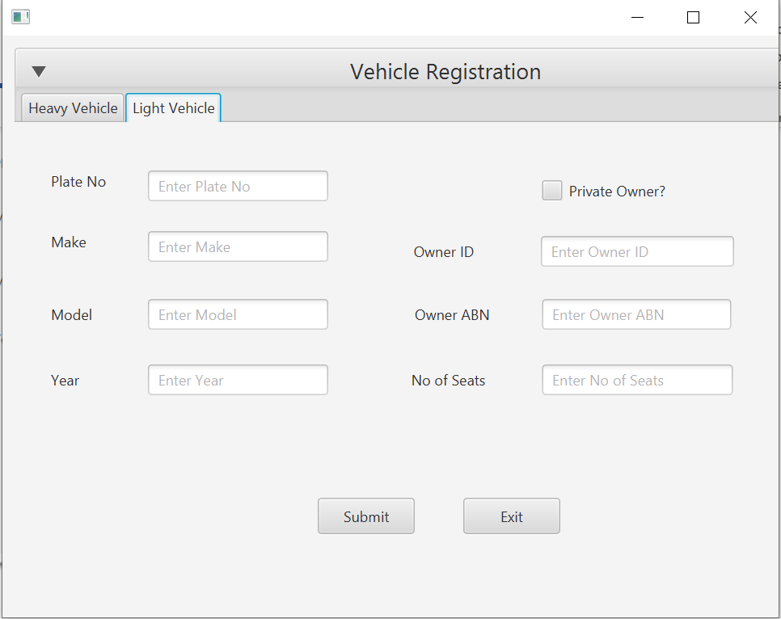

Figure

Figure 7 shows Vehicle registration scene for Light vehicle.

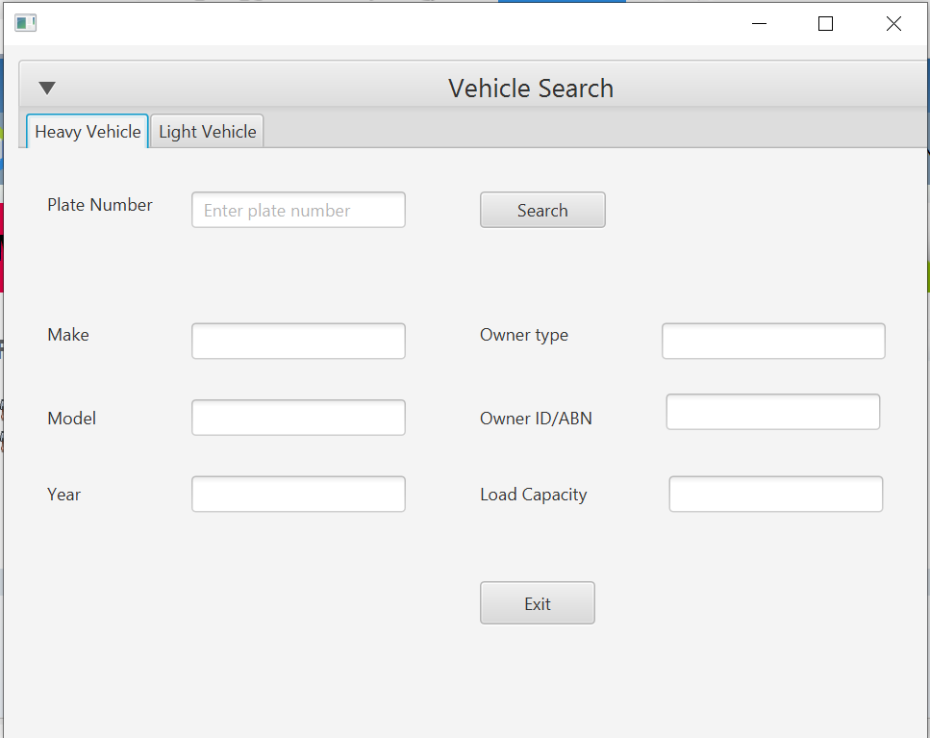

Figure

Figure 8 shows the scene when ‘Vehicle Search’ button is pressed from the main menu, this scene shows vehicle search for Heavy Vehicle.

Figure

Figure 9 shows the Light vehicle tab for Vehicle Search.

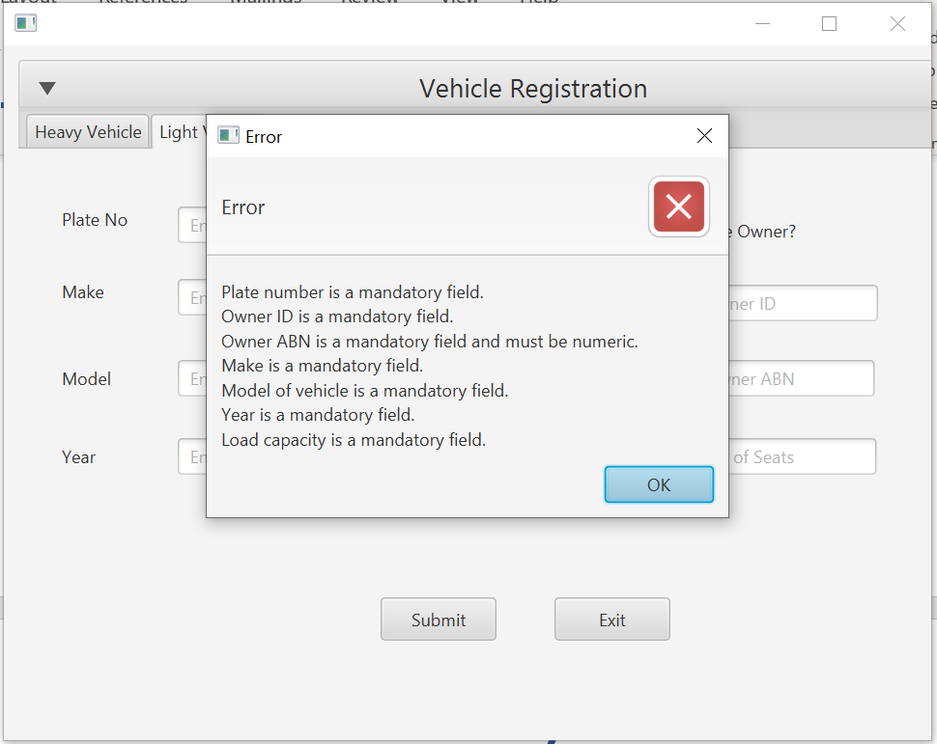

Figure

Figure 10 Shows an error if nothing is entered in the fields on Vehicle Registration.

# Summary

In this assignment, we are required to develop a GUI Java Program to demonstrate you can use Java constructs including input/output via the GUI. The whole assignment too about 4 days and I’ve encountered many problems such as

* Case sensitive fxID for scene builder buttons and text fields.
* While pressing make controller it generates controller in Other Sources, but I have to drag it to the top.
* Got this error ‘JavaFX: Exception in thread "JavaFX Application Thread"’ while running Vehicle Search.
* Also got Java runtime error which was fixed when I chose the main class in the properties manually.