

CS322:Big Data

Final Class Project Report

**Project (FPL Analytics / YACS coding): FPL Analytics** **Date: 1/12/2020**

|  |  |  |  |
| --- | --- | --- | --- |
| SNo | Name | SRN | Class/Section |
| 1 | ANAND VARDHAN | PES1201800133 | E |
| 2 | ARSH GOYAL | PES1201800254 | G |
| 3 | ARPIT KUMAR | PES1201800406 | E |
| 4 | SUJITH K | PES1201802029 | G |

## Introduction

The objective of the project i.e. Fantasy Premier League Analytics project is to analyse events occurring during football matches of English Premier League

streaming spark ,match rdd followed by the list of rdd of team

every possible team

rdd’s of event

event-making a pass, a free kick, penalty

## Related work

Any background study material that you may have read and referenced

## Design

At first we used a streaming spark. batch is coming from port number 6110. The processing of the following d streams can be divided into following segments:

1)setting up a rdd for a match event details

-calculating player metric for every match

-calculating player performance with normalization for every match

-updating the state of player rating

-updating the state of chemistry of the players

2)user interface:

-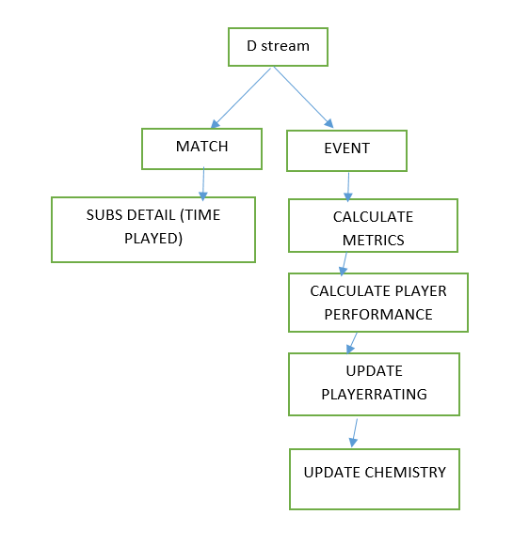

## Results

Discuss the results you got. What inferences could you draw from the results? Was any result unexpected? Any fine-tuning done to parameters so that the results changed?

## Problems

Mention problems faced and how were they solved

## Conclusion

What was your main learning from this project?

## EVALUATIONS:

|  |  |  |  |
| --- | --- | --- | --- |
| SNo | Name | SRN | Contribution (Individual) |
| 1 | ANAND VARDHAN | PES1201800133 |  |
| 2 | ARSH GOYAL | PES1201800254 |  |
| 3 | ARPIT KUMAR | PES1201800406 |  |
| 4 | SUJITH K | PES1201802029 |  |

## (Leave this for the faculty)

|  |  |  |  |
| --- | --- | --- | --- |
| Date | Evaluator | Comments | Score |
|  |  |  |  |

## CHECKLIST:

|  |  |  |
| --- | --- | --- |
| SNo | Item | Status |
| 1. | Source code documented |  |
| 2. | Source code uploaded to GitHub – (access link for the same, to be added in status 🡪) |  |
| 3. | Instructions for building and running the code. Your code must be usable out of the box. |  |