**ARSH SHIRSEKAR** EMAIL:arshshirsekar@gmail.com

**WEB DEVELOPER** PHONE:8657248724

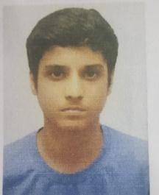

* + EDUCATION
    - PASSED SSC WITH 90.6%
    - PASSED HSC WITH 81%
    - PASSED JEE MAIN WITH 75%
    - PASSED MHTCET WITH 86%
    - SKILLS
      * HTML,CSS,JAVASCRIPT,VB.NET
      * WEB DEVELOPING
      * PROBLEM SOLVING
      * (WEB DEVELOPING)
    - LANGUAGES
      * ENGLISH/HINDI
    - PROJECTS
      * IMAGE PROJECTOR
      * PARTICIPATION
      * DRAWING
      * PPT PRESENTATION
    - CERTIFICATES
      * NATIONAL SCIENCE OLYMPIAD COMPETITION
      * DRAWING COMPETITION