

Final Exam

|  |  |
| --- | --- |
| **Program Name** | BSCS |
| **Course Code** | CSSE3143 |
| **Course Name** | Web Application Development |
| **Course Instructor** | Muhammad Arham Tariq, Muhammad Aamer Ejaz, Engr. Anees ur Rhaman Khattak, Muhammad Umair Munir |
| **Time Allowed** | 150 Minutes |
| **Total marks** | 50 |
| **Academic Honesty Policy** | Academic dishonesty will not be tolerated. Academic dishonesty includes cheating, plagiarism (copying) or any other attempts to gain an academic advantage in a dishonest or unfair manner. |

# Submission

Compress all the files into a zip file and submit.

# Instructions

10 Minutes for setup

Follow the instructions step by step.

1. Download the zip file final.zip and extract it.
2. Open your XAMPP, and run Apache and MySQL server.
3. Now go to <http://localhost/phpmyadmin/>.
4. Create a new database with name “final”
5. Go to the import tab in phpMyAdmin and import the file “final.sql” from the extracted folder “final”.
6. There is a reference file “Reference-Syntax.pdf” for your help, you can consult it.

10 + 10 Marks (30 Minutes)

# Part 1 – User Login & Registration

1. Goto localdisk C://XAMPP/htdocs, and paste the extracted folder by the name “final”.
2. Open your browser and type <http://localhost/final>. You will see the following page.

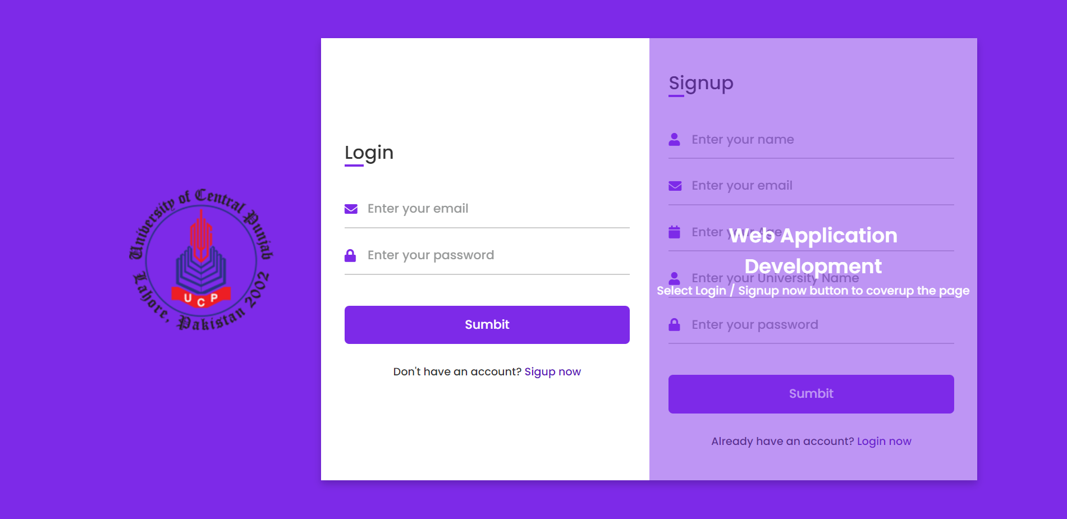

* Now **your task** is to convert the extension of this file from .html to .php, and **write down the php code for user login and user signup.**
* Make sure when the user successfully login, you will start it’s session and redirect it to “dashboard.html”.
* When the user press logout button, you will end it’s session and redirect the page toward index.php

# Part 2 – Selection of Data

10 Marks (30 Minutes)

1. On successful login, you will redirect the user towards dashboard.html
2. Convert dashboard.html to dashboard.php file.

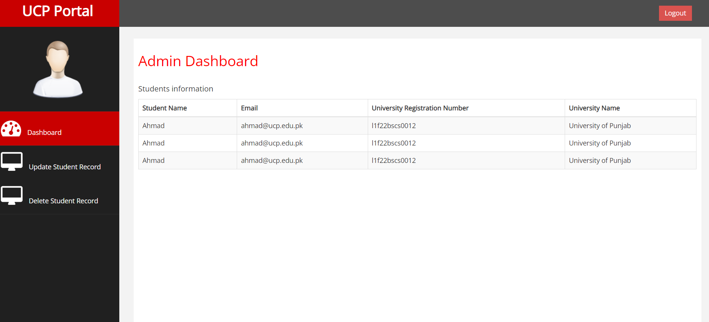

* Your task is to start the session and check if the session is already set by using if (isset($_SESSION['username'])).If not set then redirect the user towards index.php.
* If the session is already set, your **task is to fetch students information** from database and **show the student’s information in the given table template.**

10 Marks (20 Minutes)

# Part 3 – Update Student Record.

1. If the user selects “Update Student Record Button”, you will redirect the user towards update.html
2. Convert update.html to update.php file.

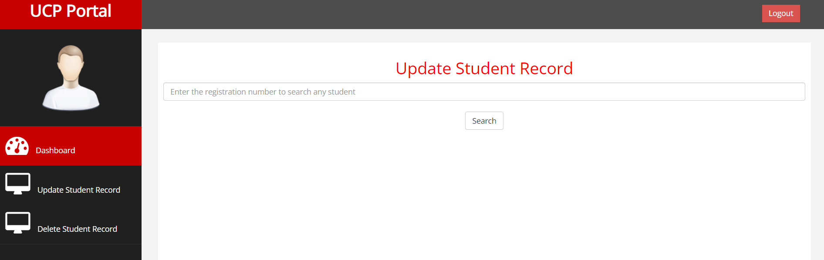

* Now **your task** is to **take the input**(registration number) from user and **search it in the database**.
* **If** you **found** the specific record, **fetch the information**, and **show** the information in the given table.

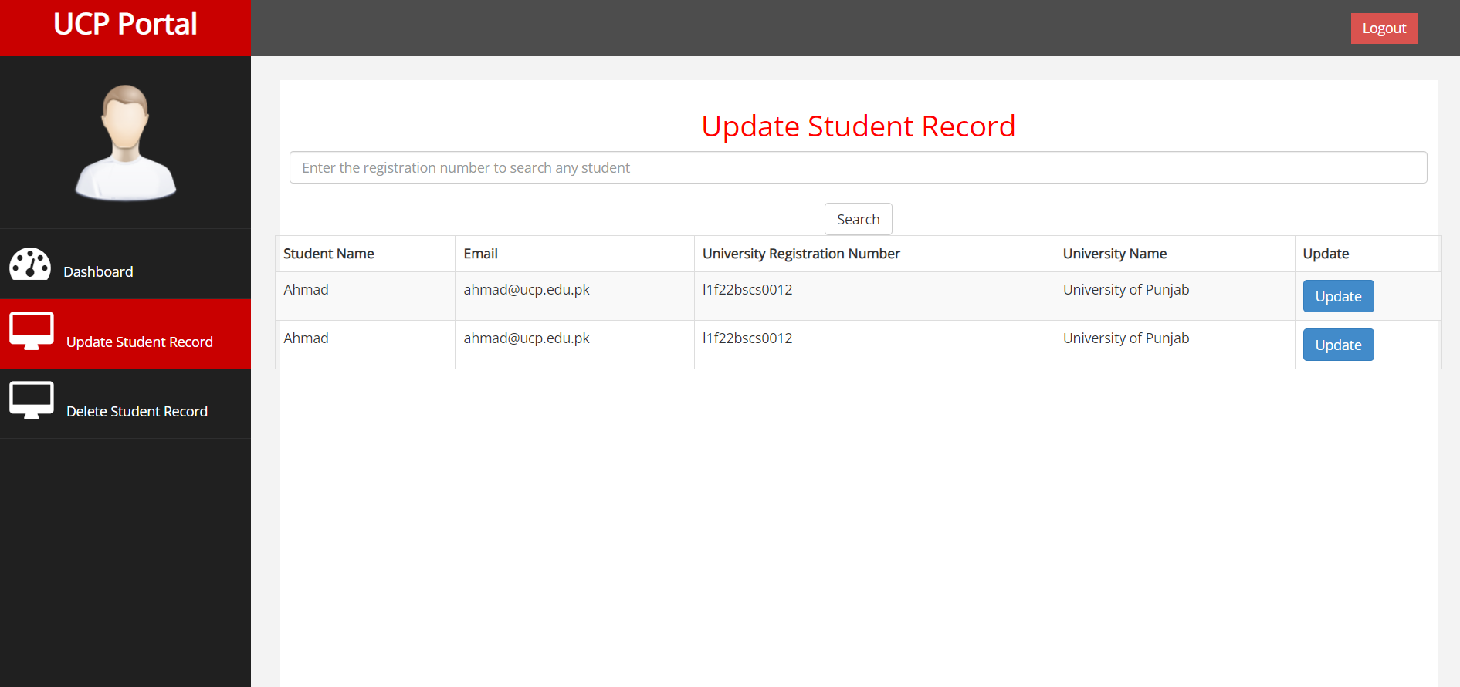

* After Showing the record, **user can select any row** by clicking update button. When the user select update button, pass the user data towards **updateSelectedRecord.html and show** the user record inside **input tags.**

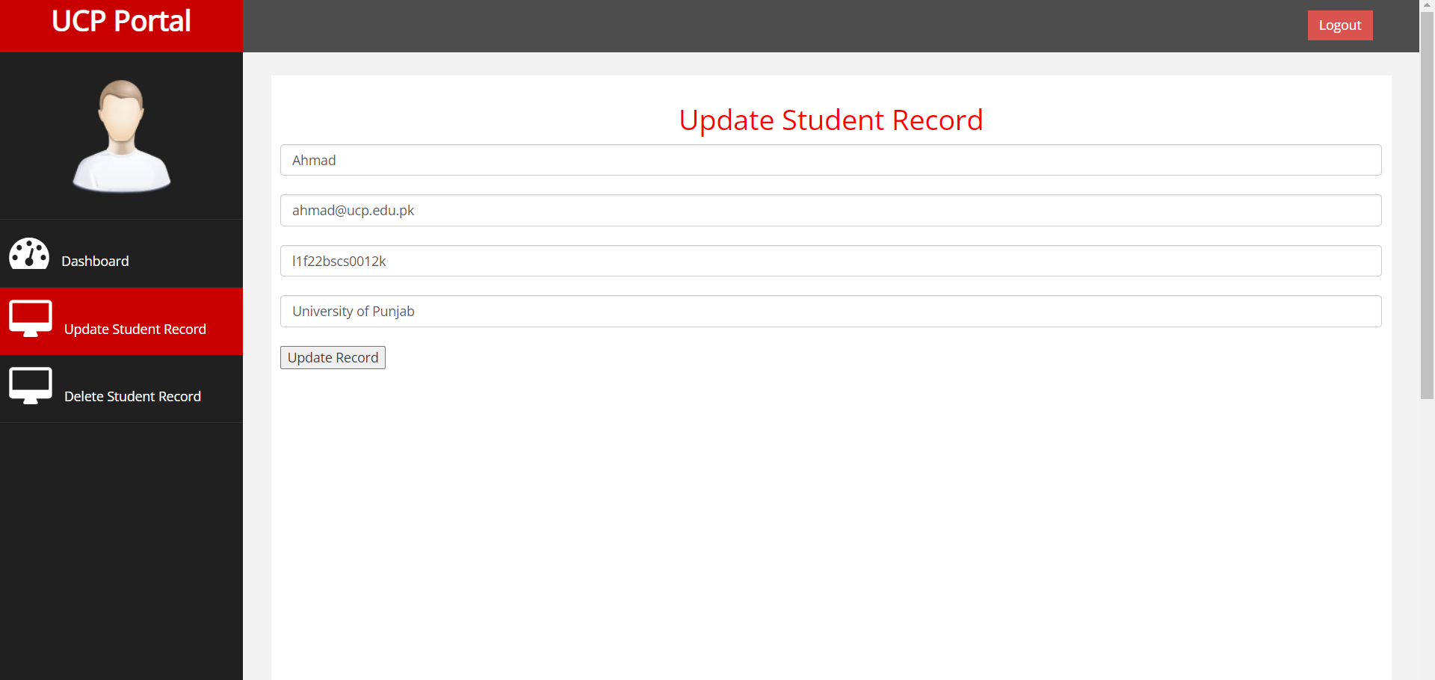

* Now user should update any field and in pressing “Update Record” button, you will update the record of student in the database and redirect the page towards update.php

10 Marks (20 Minutes)

# Part 4 – Delete Record

1. If the user selects “Delete Student Record Button”, you will redirect the user towards delete.html
2. Convert delete.html to delete.php file.

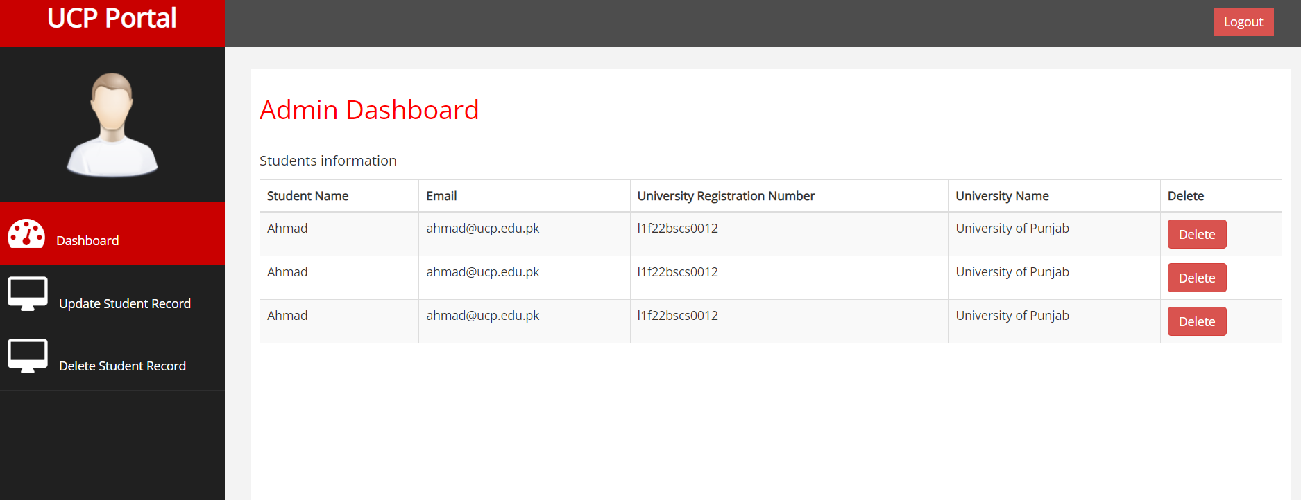

* Now your task is to **fetch all student’s information’s** from database and **show** the student’s information **in the given table template**.
* **If** the user **press delete button** from any name, your task is to **delete the record** from database and show the students updated data.

**ZIP Your Final Folder and Submit it, make sure you’re submitting whole completed folder. If you don’t know to compress the file you can consult “how to make zip file”.**

**Good Luck**