Velammal Engineering College

Department: cse

Year of Study: 3

Section: c

Exam Type: cie 1

Overall Analysis:

Total number of students: 60

Number of students passed in all subjects: 45

Number of students did not pass in all subjects: 15

Overall pass percentage: 75.00%

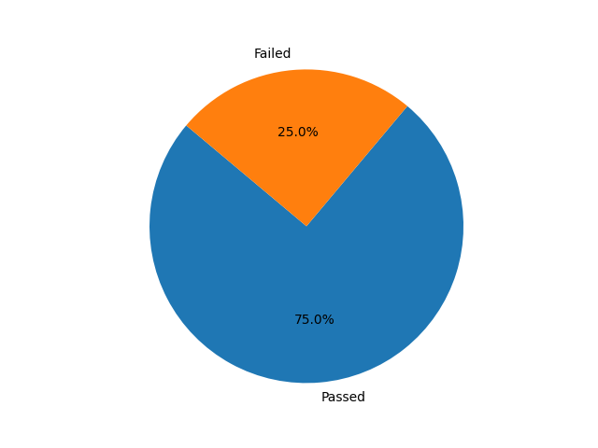

Overall Analysis Chart

# Java

Number of students passed: 45

Number of students failed: 15

Total pass percentage: 75.00%



Java Performance Chart

# Python

Number of students passed: 45

Number of students failed: 15

Total pass percentage: 75.00%



Python Performance Chart

# TOC

Number of students passed: 48

Number of students failed: 12

Total pass percentage: 80.00%

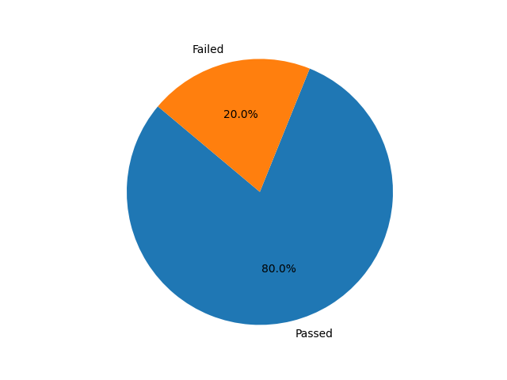

TOC Performance Chart

# DS

Number of students passed: 45

Number of students failed: 15

Total pass percentage: 75.00%



DS Performance Chart

# CN

Number of students passed: 45

Number of students failed: 15

Total pass percentage: 75.00%



CN Performance Chart