**CSE 211 Midterm Examination, Summer 2020**

3. Prove that n^3 + 20n + 1 is O(n^lg3_27)

● c=10, n0=1

● c=22, n0=1

● c=11, n0=1

● Can't be proved.

4(a). Use substitution method to solve: T(n) = 2T(5n/10) + Θ(n), T(1)=0

● O(nlgn)

● O(n^2)

● O(lgn)

● O(n)

4(b). Use substitution method to solve: T(n) = T(n^(1/3)) + Θ(1), T(3) = 1

● O(nlg2_n)

● O(nlg3_n)

● O(lg3_lg3_n)

●O(lg2_lg2_n)

5. What is the running time of the following pseudocode?

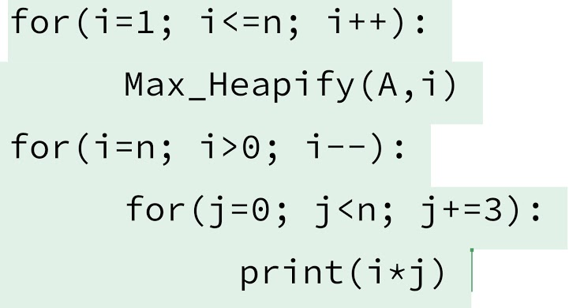● O(n)

● O(nlgn)

● O(n^2)

● O(n^3

6. Suppose, you are working in a travel company and you have to design a system that takes IDs of the passengers and sorts them. If all the IDs are nonnegative numbers and a person’s ID can be 100000 at max. If the system is given 25000 numbers at a given then please suggest an algorithm that will be best suited for this situation and why? [15]

**CSE211, Final Examination, Summer 2020, Part 1**

3^n = O(2^n) can’t be proven. *

● True

● False

Suppose you have ten thousand four-digit numbers which also contains negative numbers. If the minimum number is added to all the numbers then we can use the counting sort. *

● True

● False

The following array is a max heap [14, 9, 13, 7, 8, 10, 15, 4, 6, 3, 2] *

● True

● False

In a connected weighted graph, the edge with maximum weight is never in the minimum spanning tree. *

● True

● False

If we use insertion sort instead of counting sort in radix sort it will work. *

● True

● False

What is the summation of i*lgi where i ranges from 1 to n inclusive in worst case notation? *

● nlgn

● nlg(n^2)

● n^2lgn

● n^2lg(n^2)

● None

What is the summation of 2^i/3^i where i ranges from 1 to n inclusive in worst case notation? *

● 1

● n

● nlgn

● n^2

● None

CSE211, Final Examination, Summer 2020, Part 2

1. What is the running time of the following algorithm? *

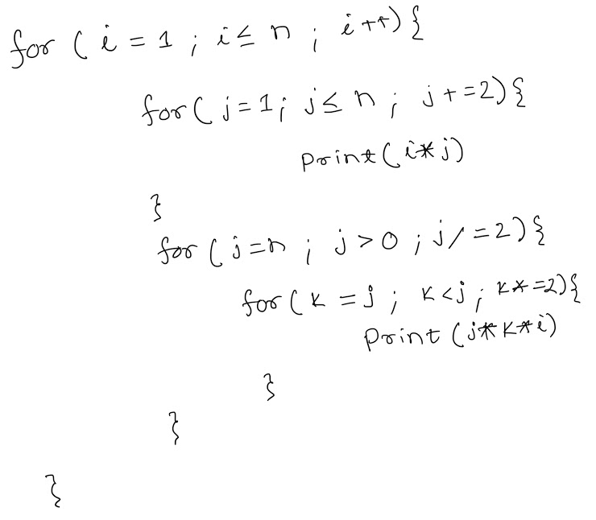

1. How many asterisks(*) [asymptotically] does the following program prints? *

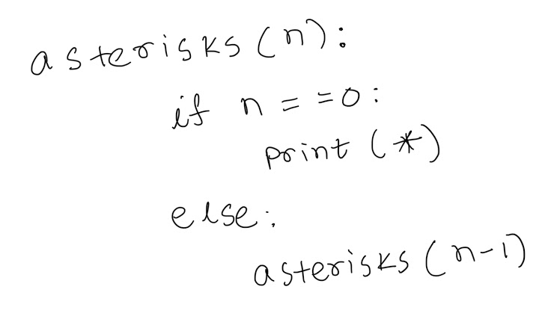

1. .Suppose you have a kid brother and you have to play a game of alphabet with him. You two are given a bunch of alphabets, say n alphabets ranging from a-z and A-Z. Now suggest the most efficient sorting algorithm that can help you sort all the alphabets. How will you use the algorithm? Sorting criteria [A-Z and then a-z] *

4.A Bangladeshi tender company named BTC won a tender that requires it to rebuild only those roads which ensures communication from one location to another. There are multiple ways to reach from one location to another and not all the roads dictate the shortest path. As BTC is a profitable company it wants to cleverly select those roads which will guarantee them maximum profit. If there are n locations and r roads then suggest the most efficient algorithm that will help them reach their goal. Why did you suggest that algorithm? *