**Bike Sharing Demand Prediction**

**Introduction**

* The project focuses on Developing a robust prediction model for bike rentals in Seoul City using advanced machine learning regression algorithms, integrating exploratory data analysis (EDA) to uncover hidden customer behavior patterns.
* Predict bike demand accurately to ensure bikes are available when and where people need them in Seoul City. Use data to manage resources better, making bike rentals easy and convenient for everyone.

**Dataset description**

* Dataset has 8760 rows & 14 columns.
* There are no Null values in the dataset.
* There are some Duplicate values in the dataset.
* The columns contained in the dataset are Date, Rented Bike count, Hour, Temperature, Humidity, Windspeed, Visibility, Dew point temperature, Solar radiation, Rainfall, Snowfall, Seasons, Holiday, Functional Day

**Methodology:** Machine Learning Development Life Cycle

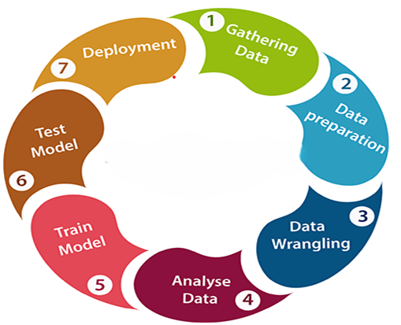

**Preprocessing Steps:**

* Converted object data types to string data types for specified columns.
* Utilized a loop to iterate through the specified columns and apply the conversion.
* Changed the data type of the 'Date' column from object to datetime.
* Separated the 'Day', 'Month', and 'Year' from the 'Date' column and added them as separate columns.
* Dropped the 'Date' column as it was no longer needed.

**Model Training and Evaluation:**

**ML Models used for training & testing:**

1. XgBoost
2. Decision Tree
3. Polynomial
4. Ridge Regression
5. Lasso Regression
6. Multilinear
7. Elastic Net Regression
8. KNN
9. Dual form SVR
10. SVR

* Discussions with domain experts should guide the choice of metric. For this task, Adjusted R Square is selected as the primary evaluation metric, though other metrics can also be considered.
* XGBoost Regressor emerges with the highest Adjusted R Square value among the models explored.
* Therefore, the recommendation is to utilize XGBoost Regression for predicting rental bike demand.

**Deployment on streamlit**

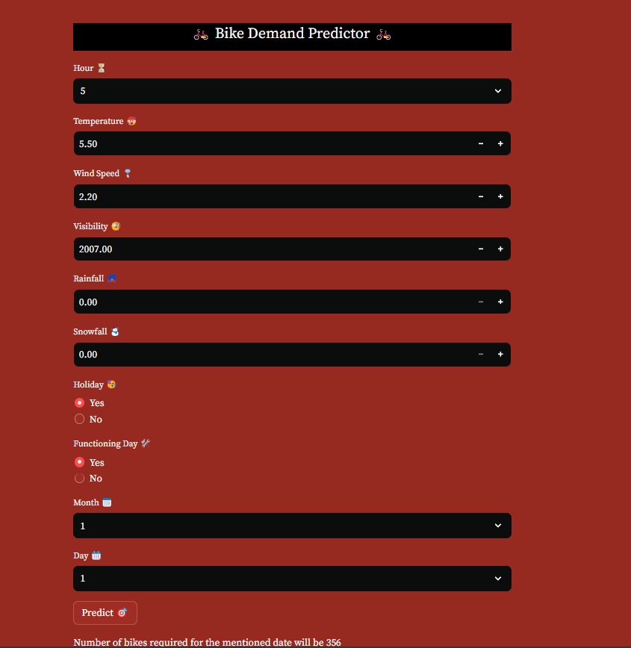

**Conclusion**

* Businesses need to factor in this mindset. and strategize accordingly. Consider offering diverse bike types (leisure bikes, cargo bikes) and flexible rental packages (multi-day passes, family plans) to cater to a wider range of needs. Explore collaborations with local attractions, businesses, or event organizers to promote bike rentals as part of leisure activities or errand trips.