**Experiment No. 1**

**AIM – To implement arithmetic operations (ADD, SUB, MUL, DIV) on 8-bit numbers**.

**Software required** – emu8086

**Programs-**

1. **Addition of two  8-bit numbers.**

data segment

    n1 db 12h   ; add your data here!

    n2 db 02h

    result db 00h

ends

stack segment

    dw   128  dup(0)

ends

code segment

start:

    mov  ax, data   ; set segment registers

    mov  ds, ax

    mov  al,n1

    mov  bl,n2

    add al, bl

    mov  result, al

    mov  ax, 4c00h ; exit to operating system.

    int 21h

ends

end start ; set entry point and stop the assembler.

-------------------------------------------------------------------------------------------------------------------------------------

1. **Subtraction of two  8-bit numbers.**

data segment

    n1  db 12h   ; add your data here!

    n2  db 02h

    result  db  00h

ends

stack segment

    dw   128  dup(0)

ends

code segment

start:

    mov  ax, data   ; set segment registers

    mov  ds, ax

    mov  al,n1

    mov  bl,n2

    sub al, bl

    mov  result, al

    mov  ax, 4c00h ; exit to operating system.

    int 21h

ends

end start ; set entry point and stop the assembler.

1. **Multiplication of two 8-bit numbers.**

data segment

    n1  db 12h    ; add your data here!

    n2  db 02h

    result  dw  0000h

ends

stack segment

    dw   128  dup(0)

ends

code segment

start:

    mov  ax, data   ; set segment registers

    mov  ds, ax

    mov  al,n1

    mov  bl,n2

    mul   bl

    mov  result, ax

    mov  ax, 4c00h ; exit to operating system.

    int 21h

ends

end start ; set entry point and stop the assembler.

**IV) Division of two 8-bit numbers.**

data segment

    n1 db 12h    ; add your data here!

    n2 db 02h

    quo db 00h

    rem db 00h

ends

stack segment

    dw   128  dup(0)

ends

code segment

start:

    mov  ax, data   ; set segment registers

    mov  ds, ax

   mov ax,0000h

   mov bx,0000h

    mov  al,n1

    mov  bl,n2

    div bl

    mov  quo, al

    mov  rem, ah

    mov  ax, 4c00h ; exit to operating system.

    int 21h

ends

end start ; set entry point and stop the assembler.

--------------------------------------------------------------------------------------------------------------------------------------

**Procedure** –

1. **Launch** **emu8086 IDE** from menu.
2. **Edit** your program , save as   file_name.asm
3. **Compile** your program to check for syntax errors, rectify if any error is present. Save and recompile your program.
4. **Run** to observe output of your program.

**Output –**

1. **Addition of two  8-bit numbers.**

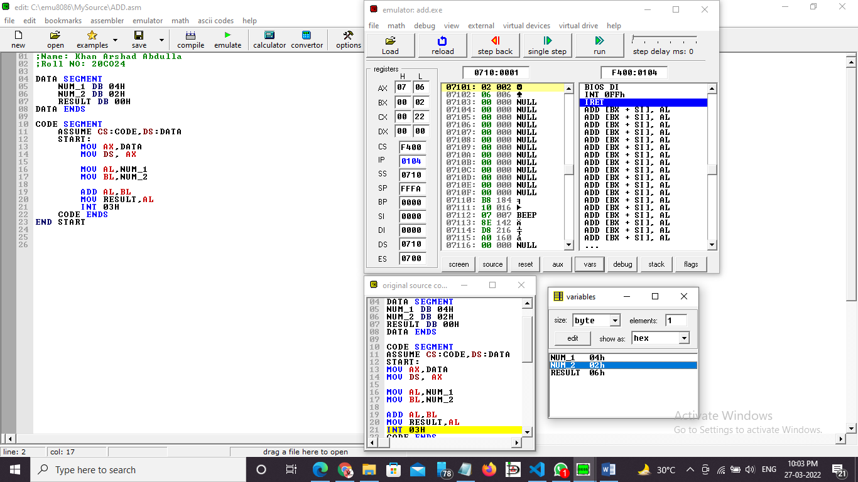

1. **Subtraction of two  8-bit numbers.**

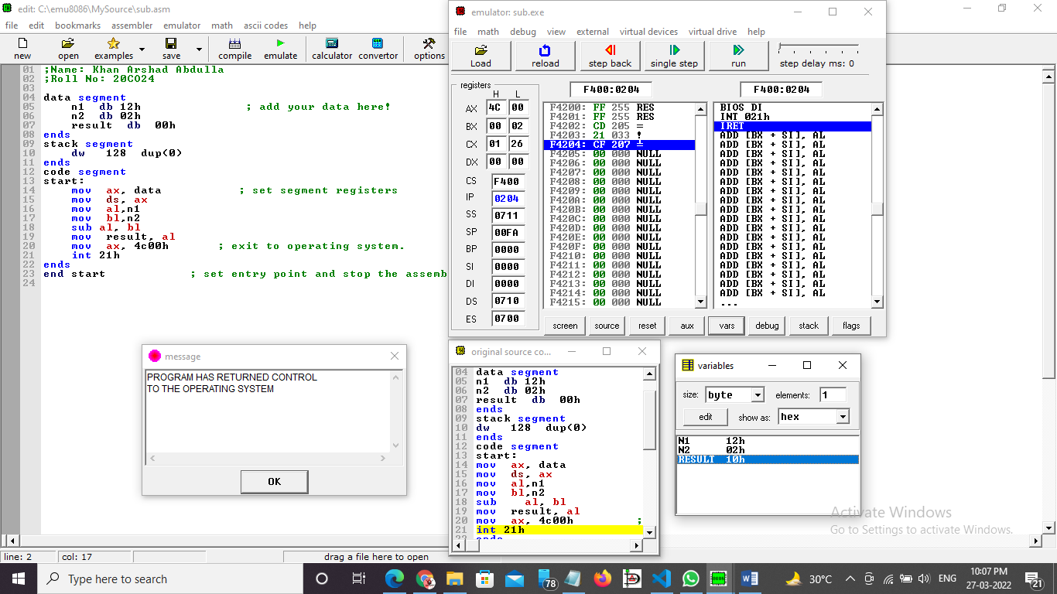

1. **Multiplication of two 8-bit numbers.**

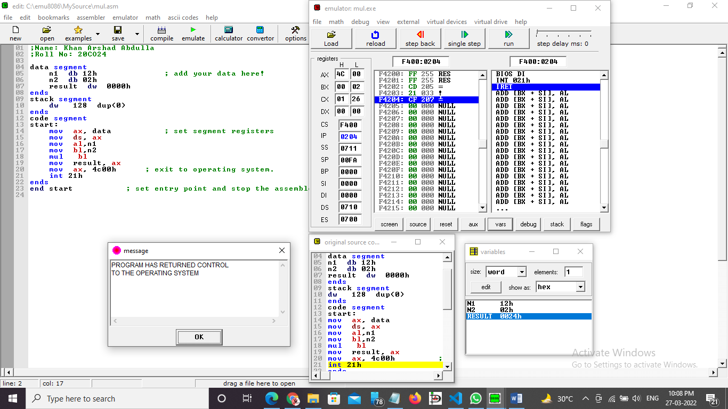

1. **Division of two 8-bit numbers.**

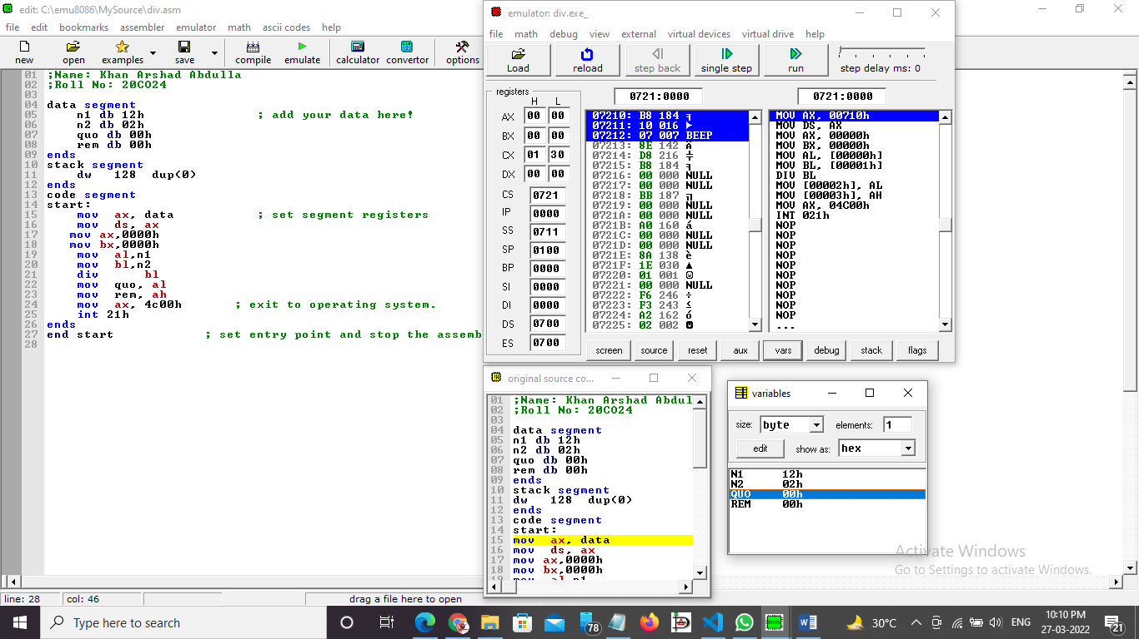

**Conclusion -**  To perform arithmetic operations we have to use ADD , SUB , MUL , DIV instructions.

______________________________END________________________________________________