**Experiment No. 2**

**AIM – To implement arithmetic operations (ADD, SUB, MUL, DIV) on 16-bit numbers**.

**Software required** – emu8086

**Programs-**

1. **Addition of two  16-bit numbers.**

data segment

    n1  dw  1111h   ; add your data here!

    n2  dw  2222h

    result  dw  0000h

ends

stack segment

    dw   128  dup(0)

ends

code segment

start:

    mov  ax, data   ; set segment registers

    mov  ds, ax

**mov  ax,n1**

**mov  bx,n2**

    add ax, bx

    mov  result, ax

    INT 03H

ends

end start ; set entry point and stop the assembler.

-------------------------------------------------------------------------------------------------------------------------------------

1. **Subtraction of two  16-bit numbers.**

data segment

    n1 dw  3333h ; add your data here!

    n2 dw  1111h

    result  dw  0000h

ends

stack segment

    dw   128  dup(0)

ends

code segment

start:

    mov  ax, data   ; set segment registers

    mov  ds, ax

    mov  ax,n1

    mov  bx,n2

    sub ax, bx

    mov  result, ax

    mov  ah, 4ch ; exit to operating system.

    int 21h

ends

end start ; set entry point and stop the assembler.

--------------------------------------------------------------------------------------------------------------------------------------

1. **Multiplication of two 16-bit numbers.**

data segment

    n1 dw  1111h    ; add your data here!

    n2 dw  2222h

    result_low  dw  0000h

result_high  dw  0000h

ends

stack segment

    dw   128  dup(0)

ends

code segment

start:

    mov  ax, data   ; set segment registers

    mov  ds, ax

    mov  ax,n1

    mov  bx,n2

    mul   bx

    mov  result_l, ax

    mov  result_h, dx

    mov  ax, 4c00h ; exit to operating system.

    int 21h

ends

end start ; set entry point and stop the assembler.

--------------------------------------------------------------------------------------------------------------------------------------

1. **Division of two 16-bit numbers.**

data segment

    n1 dw 2222h     ; add your data here!

    n2 db 1111h

    quo db 00h

    rem db 00h

ends

stack segment

    dw   128  dup(0)

ends

code segment

start:

    mov  ax, data   ; set segment registers

    mov  ds, ax

    mov  ax,n1

    mov  bx,n2

    div bx

    mov  quo, al

    mov  rem, ah

    mov  ax, 4c00h ; exit to operating system.

    int 21h

ends

end start ; set entry point and stop the assembler.

--------------------------------------------------------------------------------------------------------------------------------------

**Procedure** –

1. **Launch** **emu8086 IDE** from menu.
2. **Edit** your program , save as   file_name.asm
3. **Compile** your program to check for syntax errors, rectify if any error is present. Save and recompile your program.
4. **Run** to observe output of your program.

**Output** –

1. **Addition of two  16-bit numbers.**

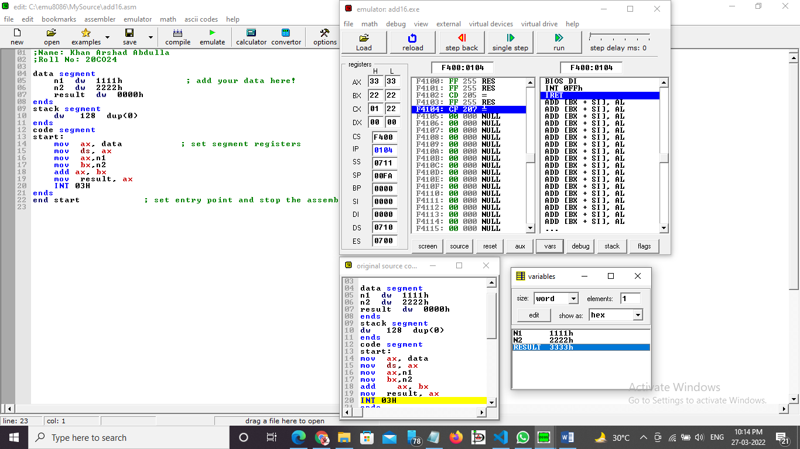

1. **Subtraction of two  16-bit numbers.**

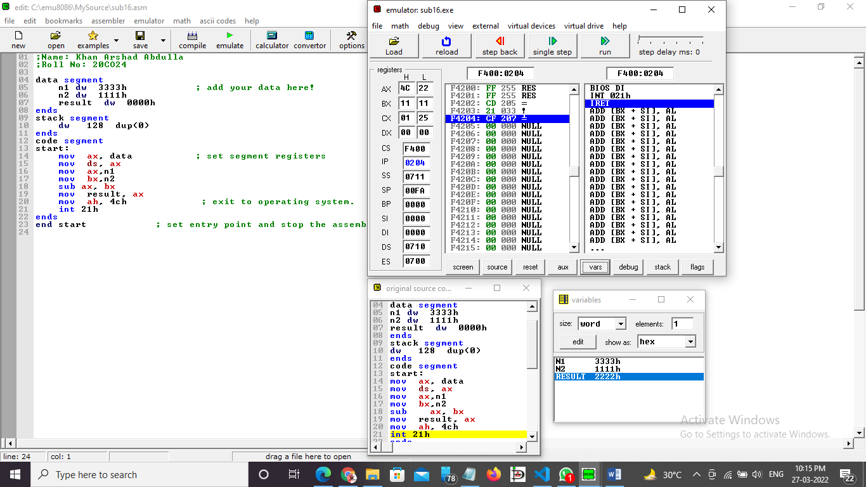

1. **Multiplication of two 16-bit numbers.**

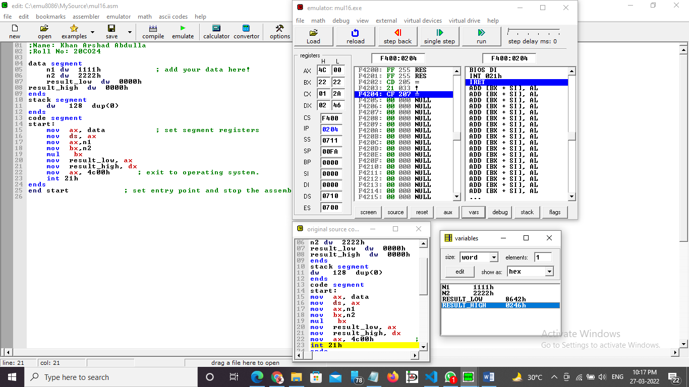

1. **Division of two 16-bit numbers.**

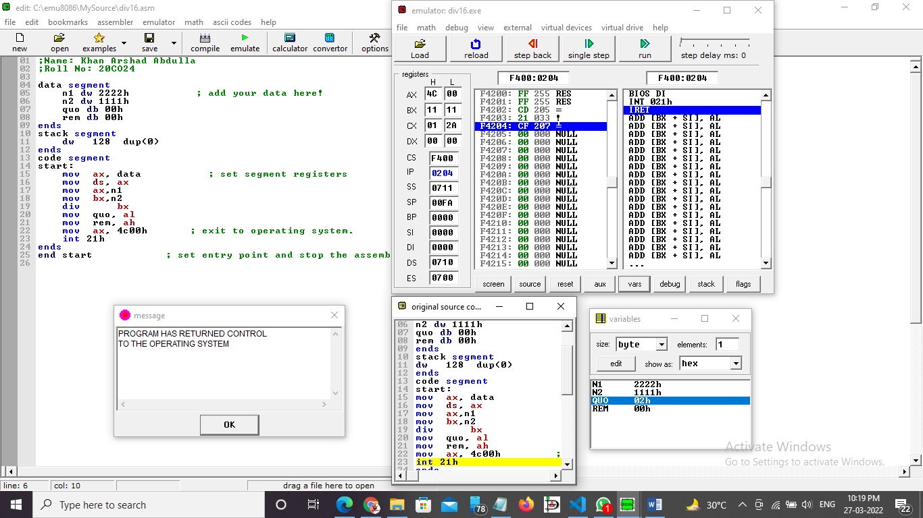

**Conclusion -**  To perform arithmetic operations we have to use ADD , SUB , MUL , DIV instructions.

______________________________END________________________________________________