**Experiment No. 3**

**Aim- To perform arithmetic operations on 32-bit numbers.**

**32-bit operations**

**N1 (32-bits) 12345678h =     1234h 5678h**

**+ +   +             +**

**N2 (32-bits) 11112222h =     1111h 2222h**

**Result (32-bit) 2345789Ah =     2345h 789Ah**

**(16-bits) (16-bits)**

1. **Program for addition of two 32-bit numbers**

data segment

n1 dd 12345678h

n2 dd 11112222h

result dd 00000000h

ends

code segment

start:

mov ax , data

mov ds , ax

mov es , ax

mov si , offset[n1]

mov di , offset[n2]

mov ax , [si]

mov cx , [di]

add ax , cx

mov bx , offset[result]

mov [bx] , ax

mov ax , [si+2]

mov cx , [di+2]

adc ax , cx

mov [bx+2] , ax

mov ax , 4c00h ; exit to operating system.

int 21h

ends

end start ; set entry point and stop the assembler.

--------------------------------------------------------------------------------------------------------------------------------------

1. **Program for subtraction of two 32-bit numbers**

data segment

n1 dd    12345678h

n2 dd    11112222h

result dd    00000000h

ends

code segment

start:

mov ax , data

mov ds , ax

mov es , ax

mov si , offset[n1]

mov di , offset[n2]

mov ax , [si]

mov cx , [di]

sub ax , cx

mov bx , offset[result]

mov [bx] , ax

mov ax , [si+2]

mov cx , [di+2]

sbb ax , cx

mov [bx+2] , ax

mov ax , 4c00h ; exit to operating system.

int 21h

ends

end start

**Procedure** –

1. **Launch** **emu8086 IDE** from menu.
2. **Edit** your program, save as   file_name.asm
3. **Compile** your program to check for syntax errors, rectify if any error is present. Save and recompile your program.
4. **Run** to observe output of your program.

**Output** –

1. **Program for addition of two 32-bit numbers**

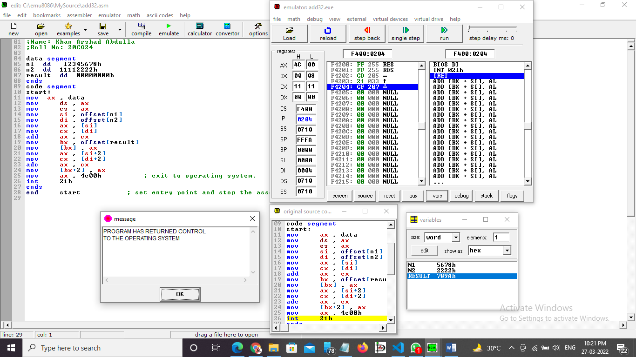

1. **Program for subtraction of two 32-bit numbers**

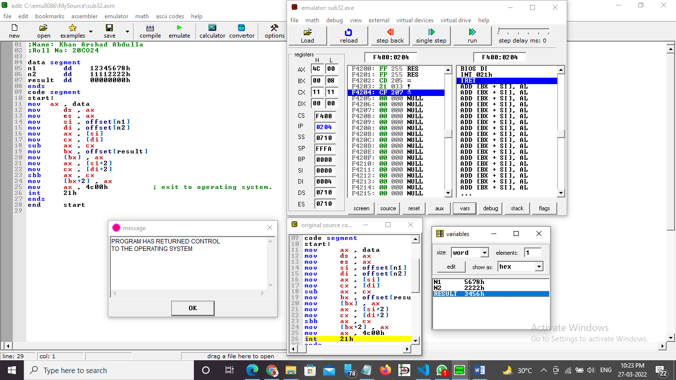

**Conclusion -** To perform arithmetic operations we have to use ADD, SUB, MUL, DIV instructions.

______________________________END________________________________________________