**Experiment No. 4**

**Aim - To transfer a block of 5 elements from data segment to extra segment using string instructions.**

**software required - emu8086**

**Program - 1**

**8-bit block transfer**

**data segment**

**block1 db 11h,22h,33h,44h,55h**

**ends**

**extra segment**

**block2 db 5 dup(?)**

**ends**

stack segment

    dw   128  dup(0)

ends

**code segment**

**start:**

**assume CS:code, DS:data, ES:extra**

**mov ax, data**

**mov ds, ax**

**mov ax, extra**

**mov es, ax**

**lea si, block1**

**lea di, block2**

**mov cx,0005h**

**cld**

**rep movsb**

**mov ax, 4c00h ; exit to operating system.**

**int 21h**

**ends**

**end start**

**Output =>**

Data segment = 11 22 33 44 55

Extra segment = 11 22 33 44 55

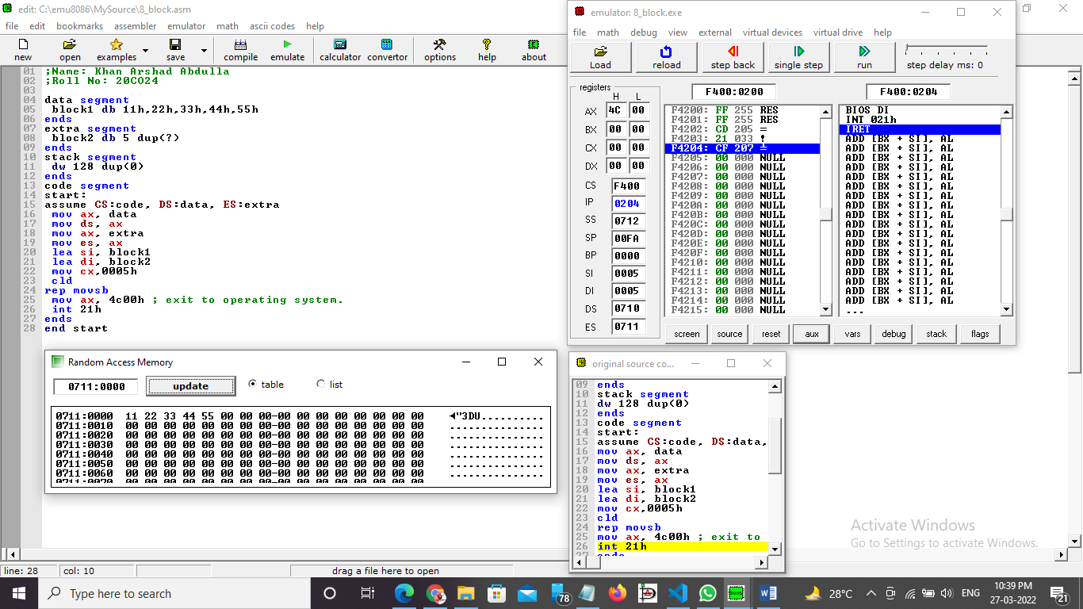

**Program - 2**

**16-bit block transfer**

data segment

  block1 dw 1111h,2222h,3333h,4444h,5555h

ends

extra segment

  block2 dw 5 dup(?)

ends

stack segment

    dw   128  dup(0)

ends

**code segment**

**start:**

**assume CS:code, DS:data, ES:extra**

**mov ax, data**

**mov ds, ax**

**mov ax, extra**

**mov es, ax**

**lea si, block1**

**lea di, block2**

**mov cx,0005h**

**cld**

**rep movsw**

**mov ax, 4c00h**

**int 21h**

**ends**

**end start**

**Output =>**

Data segment = 1111 2222 3333 4444 5555

Extra segment = 1111 2222 3333 4444 5555

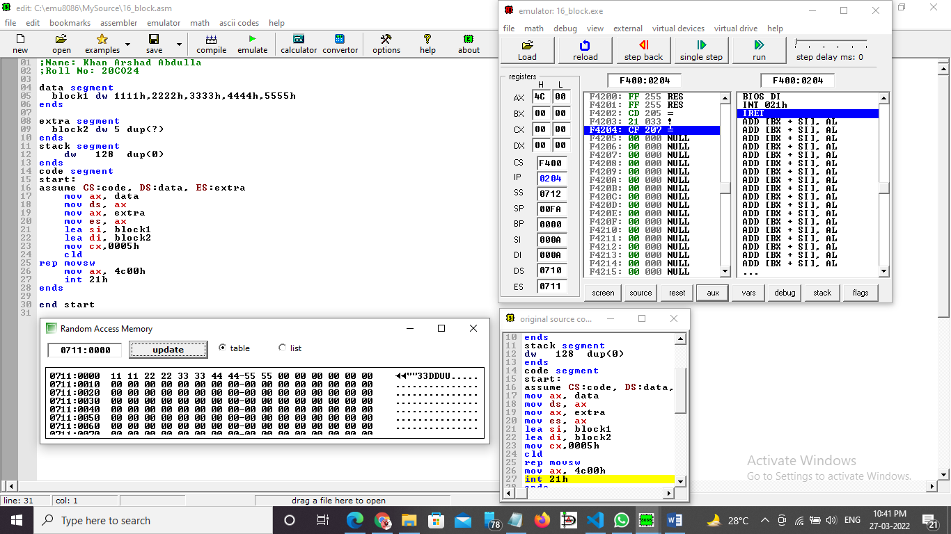

**Procedure** –

1. **Launch** **emu8086 IDE** from menu.
2. **Edit** your program , save as   file_name.asm
3. **Compile** your program to check for syntax errors, rectify if any error is present. Save and recompile your program.
4. **Run** to observe output of your program.

**Conclusion -**  To perform 8- Bit and 16-Bit Block transfer from Code Segment to Extra Segment we have to repeatedly use MOVSB and MOVSW instructions respectively.

______________________________END________________________________________________