**Experiment No. 5**

**Aim- To find largest no. & smallest no.  From an array of 5 elements.**

1. **Find Largest no:**

data segment

block      db    31h,23h,45h,0AFh,72h

largest    db  1 DUP(?)

ends

code segment

START:

assume CS: code, DS: data

**mov ax, data**

**mov  ds, ax**

lea  si, block

mov  cl, 04h

cld

mov  al , [si]

UP  :  cmp  al , [si+1]

jnc DOWN

mov al,[si+1]

DOWN: inc si

dec cl

jnz  UP

mov  largest , al

mov  ax,  4c00h

int    21h

ends

end start

1. **Find Smallest no:**

data segment

block      db    31h,23h,45h,0AFh,72h

smallest    db  1 DUP(?)

ends

code segment

start:

    mov  ax , data

    mov  ds , ax

    lea  si , block

    mov  cl , 04h

    cld

    mov  al , [si]

UP  :  cmp  al , [si+1]

          jc DOWN

         mov al,[si+1]

    DOWN: inc si

         dec cl

        jnz  UP

       mov  smallest , al

       mov  ax,  4c00h

       int    21h

ends

end start

**Output** –

1. **Find Largest no:**

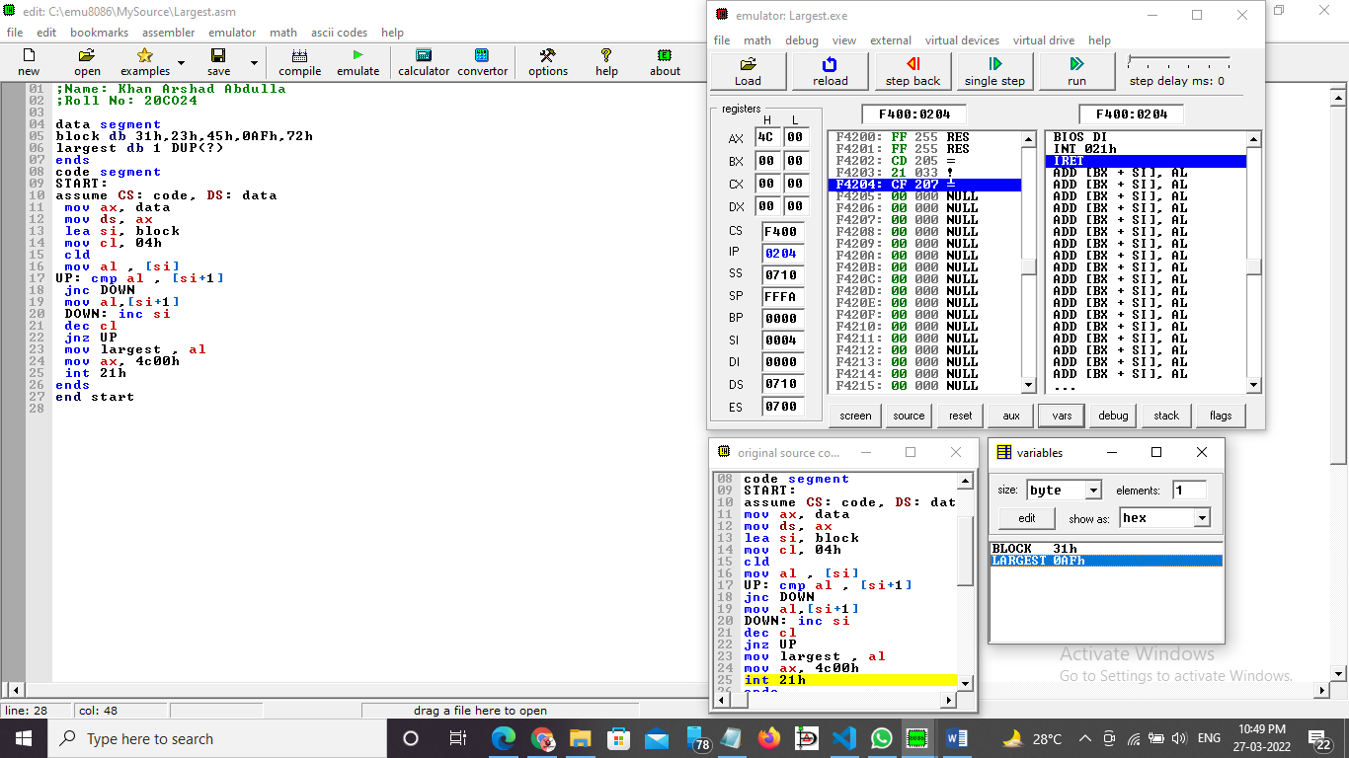

1. **Find Smallest no:**

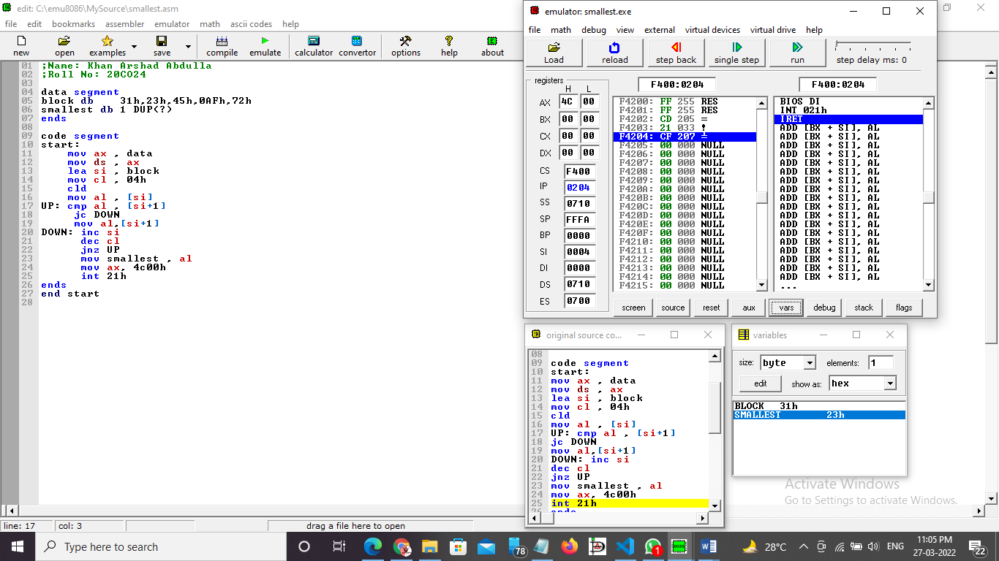

**Procedure** –

1. **Launch** **emu8086 IDE** from menu.
2. **Edit** your program , save as   file_name.asm
3. **Compile** your program to check for syntax errors, rectify if any error is present. Save and recompile your program.
4. **Run** to observe output of your program.

**Conclusion -**  To find largest no. & smallest no from an array of 5 elements, we use the CMP Instruction. We have also use the Carry Flag and the Zero Flag