**Experiment No. 6**

**Aim – ALP to sort an array in ascending order / descending order.**

**Program –**

**Ascending order -**

DATA SEGMENT

STRING1 DB 99H,12H,56H,45H,36H

DATA ENDS

CODE SEGMENT

ASSUME CS:CODE,DS:DATA

START: MOV AX,DATA

MOV DS,AX

MOV CH,04H

UP2: MOV CL,04H

LEA SI,STRING1

UP1: MOV AL,[SI]

MOV BL,[SI+1]

CMP AL,BL

JC DOWN

MOV DL,[SI+1]

XCHG [SI],DL

MOV [SI+1],DL

DOWN: INC SI

DEC CL

JNZ UP1

DEC CH

JNZ UP2

INT 03H

CODE ENDS

END START

-------------------------------------xxxxxxxxxx------------------------------------xxxxxxxxxxxxxxxxx----------------------

**Procedure** –

1. **Launch** **emu8086 IDE** from menu.
2. **Edit** your program , save as   file_name.asm
3. **Compile** your program to check for syntax errors, rectify if any error is present. Save and recompile your program.
4. **Run** to observe output of your program.

**Output** –

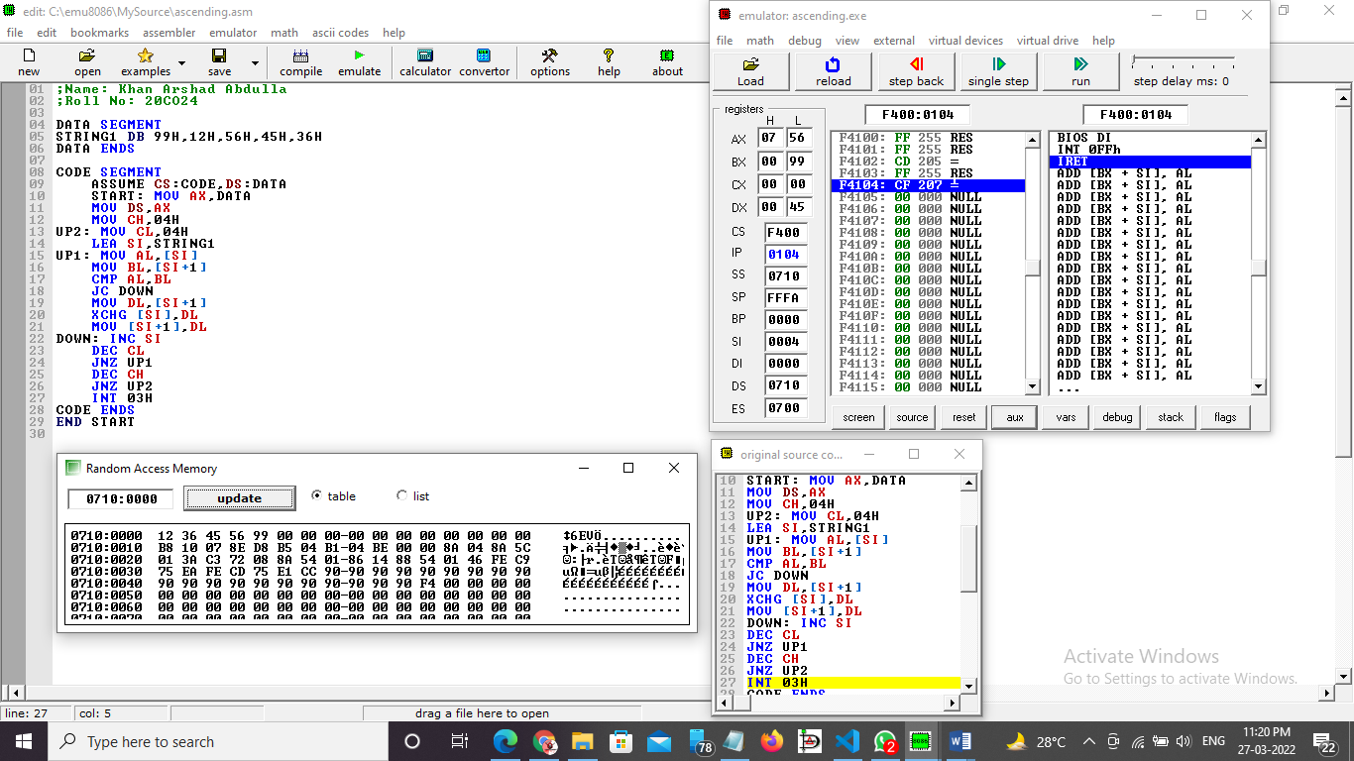

Conclusion-  To sort an array in ascending order / descending order, we use the CMP Instruction along with loops.