**Experiment No. 7**

**AIM -** Write an assembly language program to display the contents of 16 bit flag register.

**Description:**

To display the contents of flag register pushf and popf instruction are used.

Each bit of flag register is then masked off with 1 and all 0’s (i.e. 1000 0000 0000 0000BOR  8000h) and based on the result of masking either 0 (30h) or 1 (31h) is get displayed on the screen.

Each bit of the above 16 bit number gets shifted in right direction by 1 position before masking to obtain the next bit position of flag register.

This whole procedure gets repeated 16 times.

**Algorithm:**

1. Start
2. Initialize data segment through AX register in the DS register.
3. Display the flag bit names as “X X X X O D I T SF ZF x AF X PF X CF ”
4. Push the contents of flag register to a stack
5. Pop the contents of stack to register to any 16 bit register (say BX =0000 0100 1000 1001)
6. Move the contents of  BX to temporary variable say t
7. Move the 8000h number to AX.(AX🡨 8000h)
8. Move the count as 16(in decimal) to CX register (as 16 bit flag register)
9. Move the contents of temporary variable t to BX.
10. And the contents of BX and AX.
11. If zero flag is set then goto the step no 14   otherwise goto step no. 12
12. Move the 31h to DL register.
13. Make the unconditional jump to a step no. 15
14. Move the 30h to DL register.
15. Preserve the (8000h ) number from AX in t1 temporary variable. (As while displaying 30h or 31 h AH register get modified as 02h function is moved of INT 21h).
16. Display the contents of DL register.
17. Move the contents of t1 to AX register back (As while displaying 30h or 31 h AH register get modified as 02h function is moved of INT 21h).
18. Rotate the contents of AX by 1 positions in right direction.
19. Repeat step no 5 to 17 till count CX reaches to 0.
20. Stop.

**ROR Instruction :**

Syntax   -    **ROR destination, count.**

This Rotate Instruction in 8086 with example all bits in a specified byte or word to the right some number of bit positions. LSB is placed as a new MSB and a new CF.

The destination can be a byte or a word. It can be in a register or in a memory location. The number of shifts are indicated by count. If number of shifts required is one, you can place 1 in the count position. If number of shifts are greater than 1 then shift count must be loaded in CL register and CL must be placed in the count position of the instruction.

Diagram shows ROR instruction for byte rotation.

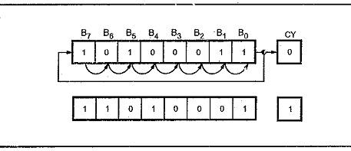

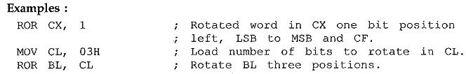

**ALP –**

Data Segment

msg   db   0dh,0ah,"-- -- -- -- OF DF IF TF SF ZF -- AF -- PF -- CF $"

newl  db  0dh,0ah,"$"

flag  dw  ?

Data ends

Code Segment

assume  CS:Code , DS:Data

start:

mov ax,Data

mov DS,ax

mov dx,offset msg

mov ah,09h

int 21h

mov dx,offset newl

mov ah,09h

int 21h

cli

stc

std

pushf

pop  bx

mov  flag,bx

mov cx,16

mov  bx,8000h

BACK:

mov  ax,flag

and  ax,bx

jz  zero

mov  dl,31h

mov  ah,02h

int  21h

jmp  space

zero:  mov dl,30h

mov  ah,02h

int  21h

space:  mov dl,' '

mov  ah,02h

int  21h

mov  ah,02h

int  21h

ror  bx,1

loop    BACK

mov  ah,4ch

int  21h

Code  ends

End  start

**Procedure** –

1. **Launch** **emu8086 IDE** from menu.
2. **Edit** your program , save as   file_name.asm
3. **Compile** your program to check for syntax errors, rectify if any error is present. Save and recompile your program.
4. **Run** to observe output of your program.

**Output** –

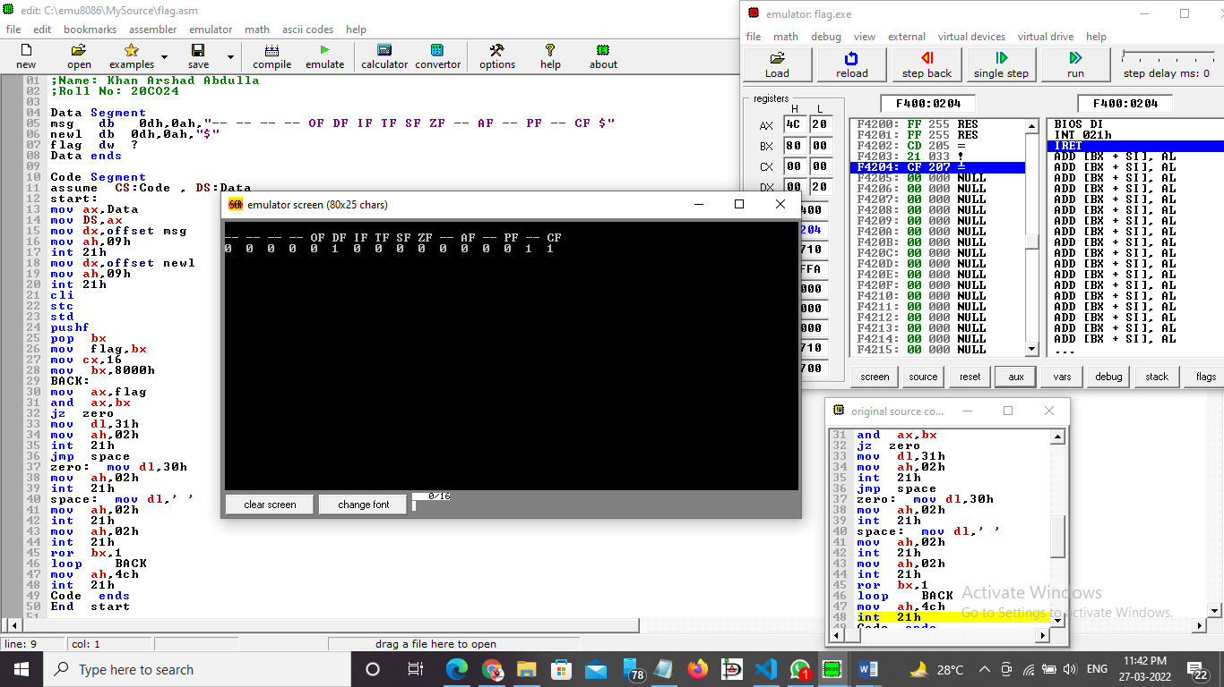

**Conclusion –** To display the contents of 16 bit flag register, we use PUSHF and POPF Instructions.

-----------------------------------------------------end----------------------------------