**Experiment No. 8**

**AIM –** Write a ALP to display a string using INT 10H   & INT 21 H.

**Program - (1)**

; this is an example of bios function: int 10h / ah=13h.

name "int10h"

org     100h

; set es (just in case):

push    cs

pop     es

mov     bh, 0    ; page.

lea     bp, msg  ; offset.

mov     bl, 0f3h ; default attribute.

mov     cx, 12   ; char number.

mov     dl, 2    ; col.

mov     dh, 1    ; row.

mov     ah, 13h  ; function.

mov     al, 1    ; sub-function.

int     10h

; show current cursor position:

mov     al, '<'

mov     ah, 0eh

int     10h

mov     bh, 0    ; page.

lea     bp, cmsg ; offset of string with attributes.

mov     bl, 0f3h ; default attribute (not used when al=3).

mov     cx, 12   ; char number.

mov     dl, 2    ; col.

mov     dh, 3    ; row.

mov     ah, 13h  ; function.

mov     al, 3    ; sub-function.

int     10h

; show current cursor position:

mov     al, '<'

mov     ah, 0eh

int     10h

; wait for any key press....

mov     ah, 0

int     16h

ret  ; return control to the operating system.

msg db 'hello world!'

cmsg   db 'h', 0cfh, 'e', 8bh, 'l', 0f0h, 'l', 5fh, 'o', 3ch, ' ', 0e0h

     db 'w', 0b3h, 'o', 2eh, 'r', 0cah, 'l', 1ah, 'd', 0ach, '!', 2fh

-----------------------------------------end---------------------------------------------------------

**Program (2)**

; The easiest way to print out "Hello, World!"

name "hi"

org 100h

jmp start       ; jump over data declaration

msg:    db      "Hello, World!", 0Dh,0Ah, 24h

start:  mov     dx, msg  ; load offset of msg into dx.

        mov     ah, 09h  ; print function is 9.

        int     21h      ; do it!

ret ; return to operating system.

**Procedure** –

1. **Launch** **emu8086 IDE** from menu.
2. **Edit** your program , save as   file_name.asm
3. **Compile** your program to check for syntax errors, rectify if any error is present. Save and recompile your program.
4. **Run** to observe output of your program.

**Output** –

1. **Program(a)**

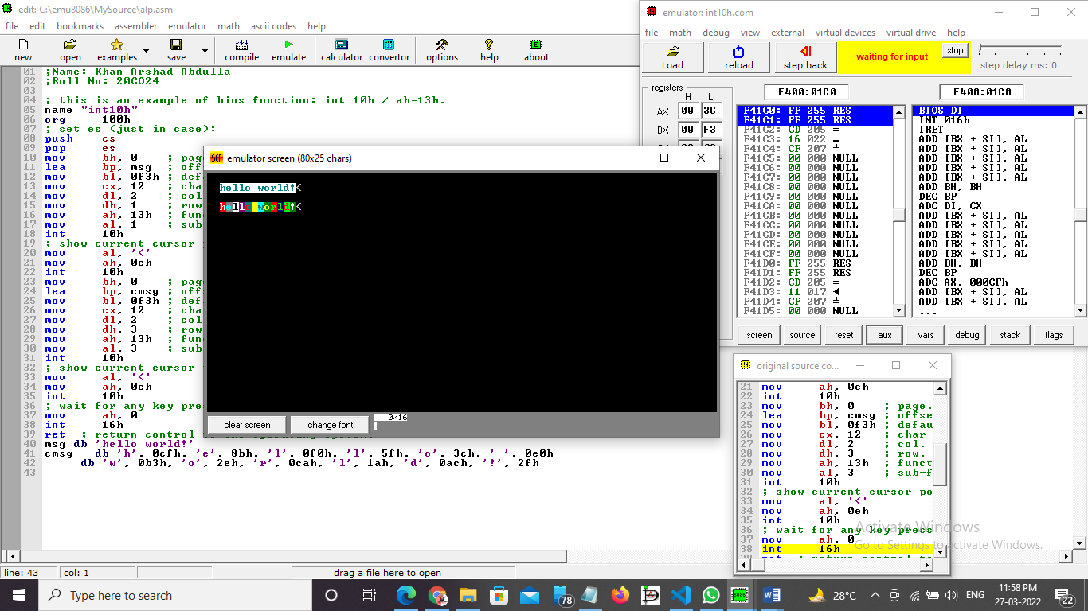

1. **Program(b)**

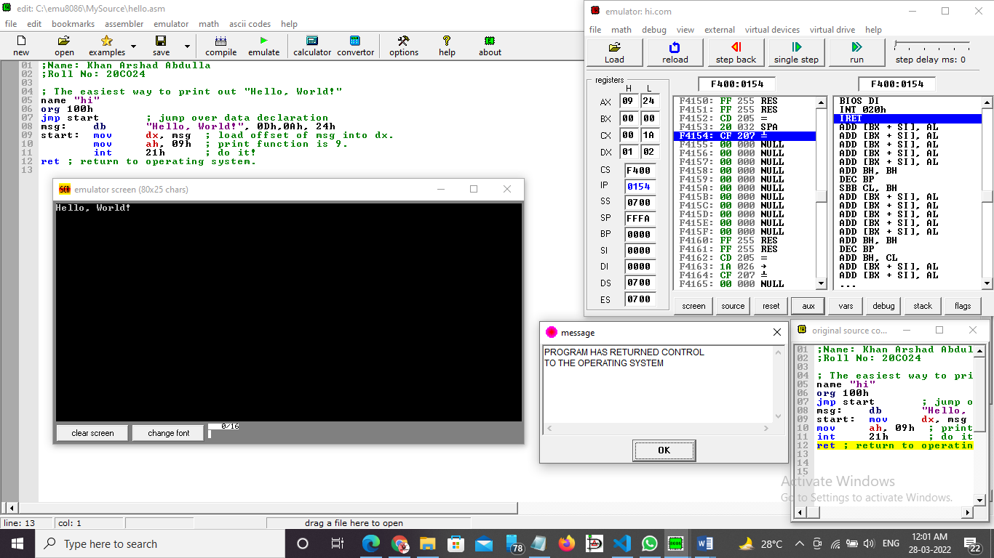

**Conclusion –** To display a string “HELLO WORLD!” using INT 10H & INT 21 H.

-----------------------------------------end ------------------------------------------------