**Experiment No. 9**

**AIM - 8086 ALP to find Factorial of a number using MACRO and PROCEDURE.**

**Theory –** **A Macro** is a set of instructions grouped under a single unit. It is another method for implementing modular programming in the 8086 microprocessors

The Macro is different from the Procedure in a way that unlike calling and returning the control as in procedures, the processor generates the code in the program every time whenever and wherever a call to the Macro is made.

A Macro can be defined in a program using the following assembler directives:

MACRO (used after the name of Macro before starting the body of the Macro) ,

ENDM (at the end of the Macro).

All the instructions that belong to the Macro lie within these two assembler directives.

The following is the syntax for defining a Macro in the 8086 Microprocessor:

**Macro_name  MACRO  [ list of parameters ]**

**Instruction 1**

**Instruction 2**

**- - - - - - - - - - -**

**- - - - - - - - - - -**

**- - - - - - - - - - -**

**Instruction n**

**ENDM**

**MACRO call in main function -**

**Macro_name [ list of parameters]**

**Procedure -** A procedure is a set of code that can be branched to and returned from in such a way that the code is as if it were inserted at the point from which it is branched to. The branch to procedure is referred to as the call, and the corresponding branch back is known as the return. The return is always made to the instruction immediately following the call regardless of where the call is located.

**Procedure_name PROC parametres**

**---------------------------**

**---------------------------**

**Procedure name ENDP**

**Procedure call –**

**PUBLIC   ARY, COUNT, SUM**

**Program –**

DATA SEGMENT

NUM DB ?

FACT DB 1H

RES DB 10 DUP ('$')

MSG1 DB "ENTER NUMBER : $"

MSG2 DB 10,13,"RESULT : $"

DATA ENDS

CODE SEGMENT

ASSUME DS:DATA,CS:CODE

START:

MOV AX,DATA

MOV DS,AX

LEA DX,MSG1

MOV AH,9

INT 21H

MOV AH,1

INT 21H

SUB AL,30H

MOV NUM,AL

MOV AH,0

MOV AL,FACT

MOV CH,0

MOV CL,NUM

LABEL1: MUL CL

LOOP LABEL1

LEA SI,RES

CALL HEX2DEC

LEA DX,MSG2

MOV AH,9

INT 21H

LEA DX,RES

MOV AH,9

INT 21H

MOV AH,4CH

INT 21H

CODE ENDS

HEX2DEC PROC NEAR

MOV CX,0

MOV BX,10

LOOP1: MOV DX,0

DIV BX

ADD DL,30H

PUSH DX

INC CX

CMP AX,9

JG LOOP1

ADD AL,30H

MOV [SI],AL

LOOP2: POP AX

INC SI

MOV [SI],AL

LOOP LOOP2

RET

HEX2DEC ENDP

END START

**Output** –

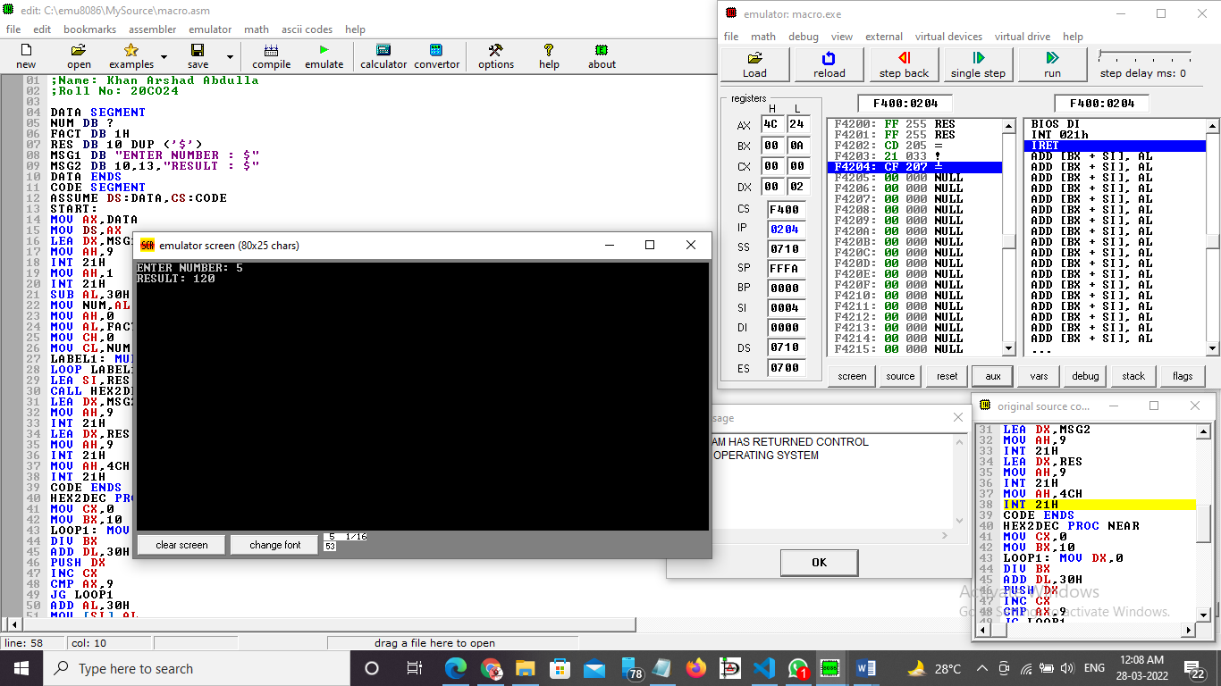

**Conclusion –** To find Factorial of a number using MACRO and PROCEDURE.