**Experiment 1**

**Aim:** Study of RJ45 and Cat6 cabling and connect using cramping tool.

**Theory:**

**RJ45:**

RJ45 is a type of connector commonly used for [Ethernet](https://techterms.com/definition/ethernet) networking. It looks similar to a telephone jack, but is slightly wider. Since Ethernet cables have an RJ45 connector on each end, Ethernet cables are sometimes also called RJ45 cables.

The "RJ" in RJ45 stands for "registered jack," since it is a standardized networking interface. The "45" simply refers to the number of the interface standard. Each RJ45 connector has eight pins, which means an RJ45 cable contains eight separate wires. If you look closely at the end of an Ethernet cable, you can actually see the eight wires, which are each a different color. Four of them are solid colors, while the other four are striped.

RJ45 cables can be wired in two different ways. One version is called T-568A and the other is T-568B.

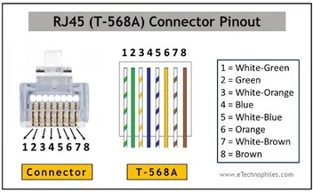

**Cat6:**

Category 6 cable (Cat 6) is a standardized [twisted pair](https://en.wikipedia.org/wiki/Twisted_pair) cable for [Ethernet](https://en.wikipedia.org/wiki/Ethernet) and other network [physical layers](https://en.wikipedia.org/wiki/Physical_layer) that is [backward compatible](https://en.wikipedia.org/wiki/Backward_compatible) with the [Category 5/5e](https://en.wikipedia.org/wiki/Category_5_cable) and [Category 3 cable](https://en.wikipedia.org/wiki/Category_3_cable) standards.

Cat 6 must meet more stringent specifications for [crosstalk](https://en.wikipedia.org/wiki/Crosstalk) and system noise than Cat 5 and Cat 5e. The cable standard specifies performance of up to 250 MHz, compared to 100 MHz for Cat 5 and Cat 5e.

Whereas Category 6 cable has a reduced maximum length of 55 metres (180 ft) when used for [10GBASE-T](https://en.wikipedia.org/wiki/10GBASE-T), Category 6A cable is characterized to 500 MHz and has improved [alien crosstalk](https://en.wikipedia.org/wiki/Alien_crosstalk) characteristics, allowing 10GBASE-T to be run for the same 100-metre (330 ft) maximum distance as previous [Ethernet variants](https://en.wikipedia.org/wiki/Ethernet_over_twisted_pair).

A Cat 6 cable is used mainly for computer networks reaching a Gb, 1000 Mbps or one Gbps of data transfer speed (DTR) or higher. Characteristics are as follows:

* Consists of four pairs of copper wires, which are all utilized for data transfer
* Provides bandwidth of 250 MHz, speed up to 10 Gbps and may be stretched to 100 meters in length
* Provides more enhanced crosstalk and attenuation protection than its previous twisted pair cable versions.

The Cat 6 cable is supported by Ethernet networks, including 10BaseT, 100Base-TX, 1000 Base-T and 10 GBase-T.

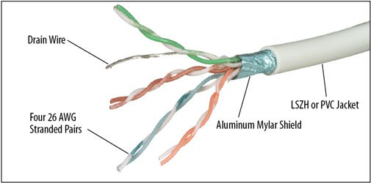

**Crimping Tool:**

A crimping tool is a device used to conjoin two pieces of metal by deforming one or both of them to hold each other. The result of the tool's work is called a crimp. An example of crimping is affixing a connector to the end of a cable. For instance, network cables and phone cables are created using a crimping tool (shown below) to join [RJ-45](https://www.computerhope.com/jargon/r/rj45.htm) and [RJ-11](https://www.computerhope.com/jargon/r/rj11.htm) connectors to both ends of phone or [Cat 5](https://www.computerhope.com/jargon/c/cat5.htm) cable.

To use this crimping tool, each wire is first placed into the connector. Then, the connector with wires are placed into the crimping tool, and the handles are squeezed together. Crimping punctures the plastic [connector](https://www.computerhope.com/jargon/c/connect.htm) and holds each of the wires, allowing data to transmit through the connector.

