**Experiment 2**

**Aim:** Use basic networking commands in Linux(ping, tracert, ns lookup, netstat, arp,rarp,ip,ifconfig,dig,route).

**Theory:**

**1.Ping:**

PING (Packet Internet Groper) command is used to check the network connectivity between host and server/host. This command takes as input the IP address or the URL and sends a data packet to the specified address with the message “PING” and get a response from the server/host this time is recorded which is called latency. Fast ping low latency means faster connection.

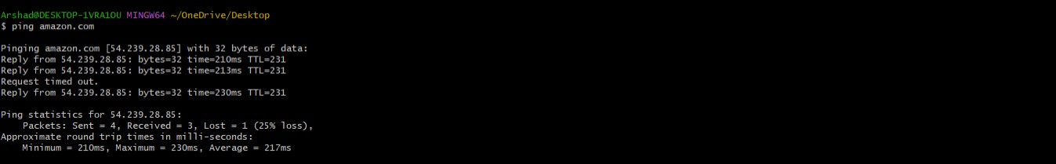

**2.Tracert:**

traceroute command in Linux prints the route that a packet takes to reach the host. This command is useful when you want to know about the route and about all the hops that a packet takes. Below image depicts how traceroute command is used to reach the Google(172.217.26.206) host from the local machine and it also prints detail about all the hops that it visits in between.

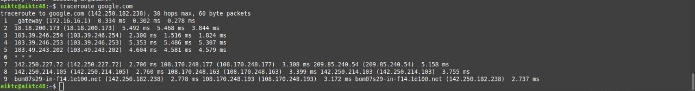

**3.Nslookup:**

Nslookup (stands for “Name Server Lookup”) is a useful command for getting information from the DNS server. It is a network administration tool for querying the Domain Name System (DNS) to obtain domain name or IP address mapping or any other specific DNS record. It is also used to troubleshoot DNS-related problems.

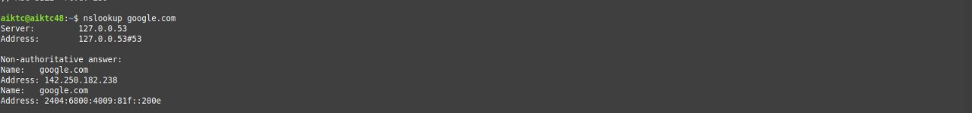

**4.Netstat:**

Netstat command displays various network related information such as network connections, routing tables, interface statistics, masquerade connections, multicast memberships etc.

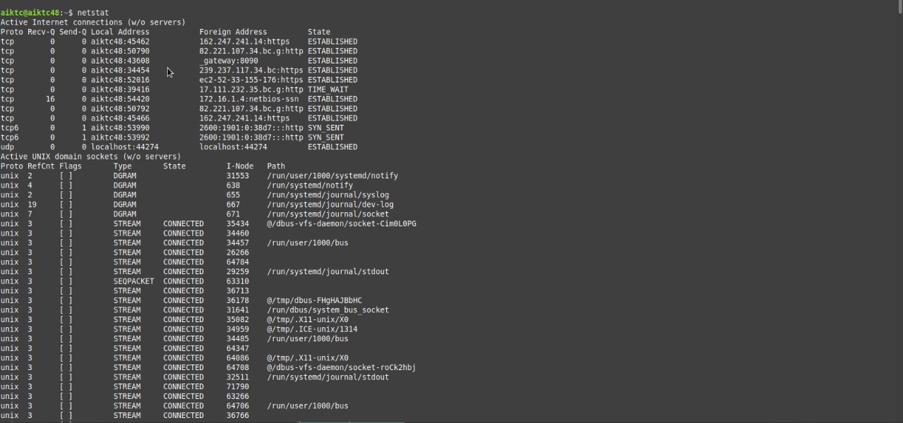

**5.Arp:**

arp command manipulates the System’s ARP cache. It also allows a complete dump of the ARP cache. ARP stands for Address Resolution Protocol. The primary function of this protocol is to resolve the IP address of a system to its mac address, and hence it works between level 2(Data link layer) and level 3(Network layer).

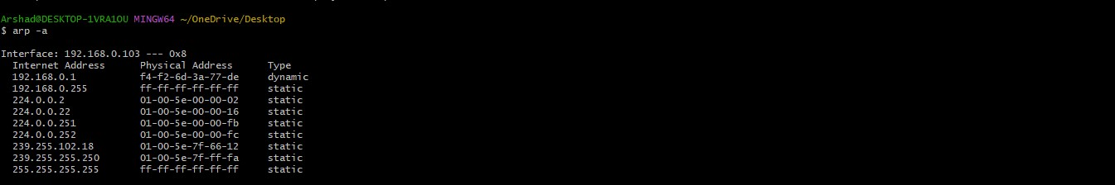

**6.Rarp:**

[RARP](https://www.geeksforgeeks.org/arp-reverse-arprarp-inverse-arp-inarp-proxy-arp-and-gratuitous-arp/) is abbreviation of Reverse Address Resolution Protocol which is a protocol based on computer networking which is employed by a client computer to request its IP address from a gateway server’s Address Resolution Protocol table or cache. The network administrator creates a table in gateway-router, which is used to map the MAC address to corresponding [IP address](https://www.geeksforgeeks.org/introduction-of-classful-ip-addressing/).



**7.IP:**

ip command in Linux is present in the net-tools which is used for performing several network administration tasks. IP stands for Internet Protocol. This command is used to show or manipulate routing, devices, and tunnels. It is similar to [*ifconfig*](https://www.geeksforgeeks.org/ifconfig-command-in-linux-with-examples/) command but it is much more powerful with more functions and facilities attached to it.

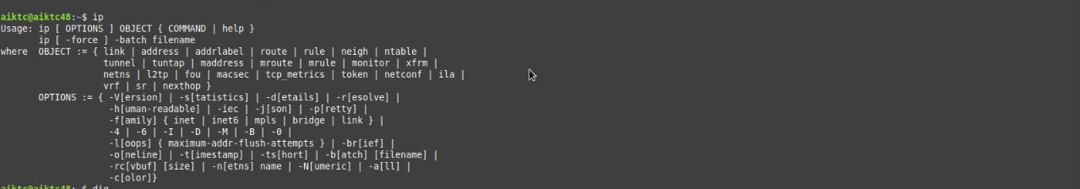

**8.Ifconfig:**

ifconfig(interface configuration) command is used to configure the kernel-resident network interfaces. It is used at the boot time to set up the interfaces as necessary. After that, it is usually used when needed during debugging or when you need system tuning.

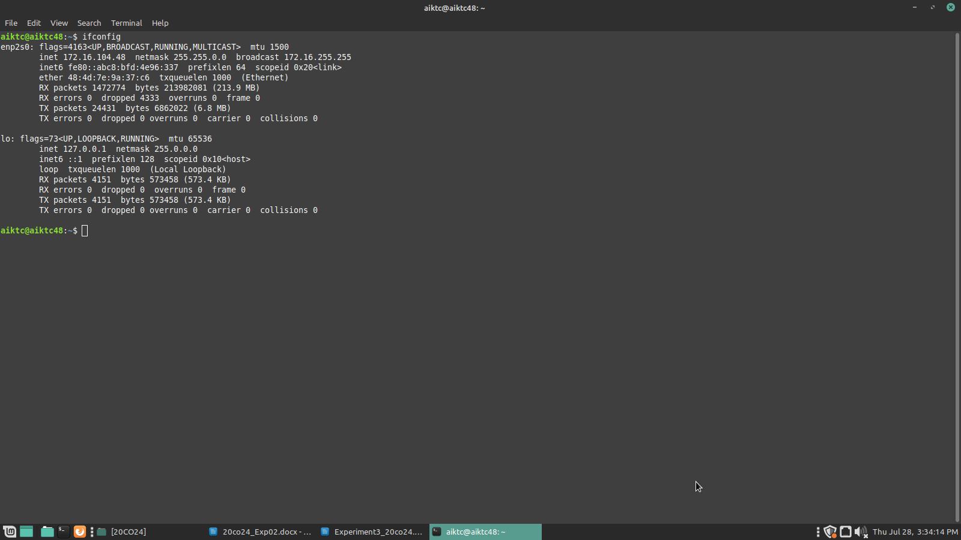

**9.Dig:**

dig command stands for *Domain Information Groper*. It is used for retrieving information about DNS name servers. It is basically used by network administrators. It is used for verifying and troubleshooting DNS problems and to perform DNS lookups. Dig command replaces older tools such as [nslooku](https://www.geeksforgeeks.org/nslookup-command-in-linux-with-examples/)p and the [host](https://www.geeksforgeeks.org/host-command-in-linux-with-examples/).

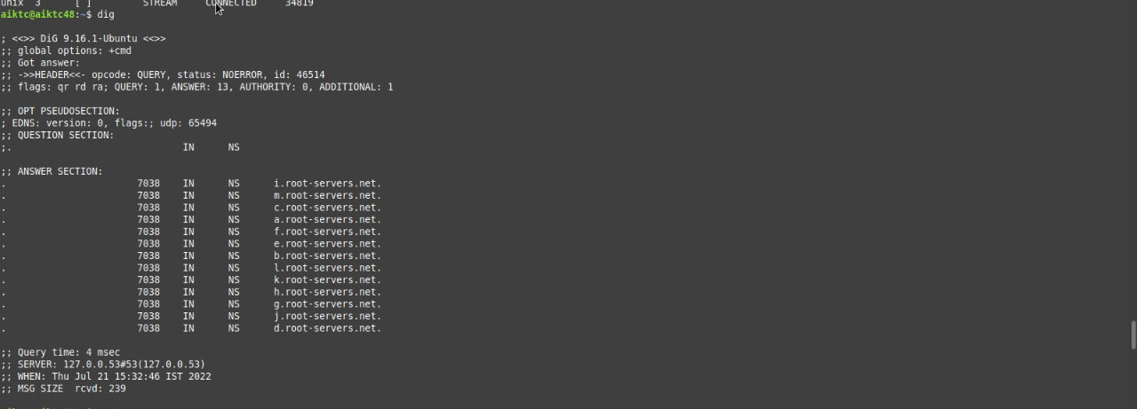

**10.Route:**

route command in Linux is used when you want to work with the IP/kernel routing table. It is mainly used to set up static routes to specific hosts or networks via an interface. It is used for showing or update the IP/kernel routing table.

