RIZVI COLLEGE OF ARTS, SCIENCE AND COMMERCE
(Affiliated to University of Mumbai)
BANDRA (WEST), MUMBAI – 400050
DEPARTMENT OF COMPUTER SCIENCE
A PROJECT REPORT ON
AI-BASED YOGA TRAINER
(An Intelligent Real-Time 3D Posture Estimation & Biofeedback System)
Submitted in Partial Fulfilment of the Requirements
for the Degree of
BACHELOR OF SCIENCE (COMPUTER SCIENCE)
SEMESTER V / VI
Submitted by:
ARSHAM SHAIKH
Roll No. 47
Under the Esteemed Guidance of:
PROF. JAVED PATHAN
Assistant Professor, Department of Computer Science
ACADEMIC YEAR 2026 – 2027

CERTIFICATE OF APPROVAL
This is to certify that the project entitled "AI-BASED YOGA TRAINER (An Intelligent Real-Time 3D Posture Estimation & Biofeedback System)" is a bonafide work carried out by ARSHAM SHAIKH (Roll No. 47), a student of Bachelor of Science in Computer Science, at Rizvi College of Arts, Science and Commerce, affiliated to the University of Mumbai, in partial fulfillment of the requirements for the award of the Degree of Bachelor of Science (Computer Science) during the academic year 2026 – 2027.
The project has been examined and evaluated by the Department and is approved for submission.
_________________________ _________________________
Prof. Javed Pathan Head of Department
Project Guide Department of Computer Science
_________________________ _________________________
Internal Examiner External Examiner

DECLARATION
I, ARSHAM SHAIKH, hereby declare that the project entitled "AI-BASED YOGA TRAINER" submitted to the Department of Computer Science, Rizvi College of Arts, Science and Commerce, affiliated to the University of Mumbai, is a record of original research and engineering work done by me under the supervision and guidance of Prof. Javed Pathan.
I further declare that the work reported herein has not been submitted either in part or in full to any other university or institution for the award of any degree, diploma, or certificate.
Date: ____________________
Place: Mumbai, Maharashtra
_________________________
Arsham Shaikh
Roll No. 47
B.Sc. (Computer Science), Sem V/VI

ACKNOWLEDGEMENTS
The successful completion of this project represents a significant milestone in my academic career, and it would not have been possible without the invaluable guidance, assistance, and encouragement of many individuals.
First and foremost, I express my profound gratitude and sincere respect to my project guide, Prof. Javed Pathan, Assistant Professor, Department of Computer Science, for his invaluable technical guidance, constructive criticism, and constant encouragement throughout the design, mathematical formulation, and development stages of this system.
I also extend my heartfelt thanks to the Head of the Department and all faculty members of the Department of Computer Science at Rizvi College of Arts, Science and Commerce for providing state-of-the-art laboratory facilities and academic resources.
Finally, I express my deepest appreciation to my parents, family, and peers for their unconditional love, patience, and moral support throughout my academic studies.

ABSTRACT
Yoga is an ancient physical, mental, and spiritual practice that has experienced immense modern popularity as a preventative healthcare discipline. However, practicing complex yoga postures without continuous professional supervision presents acute clinical hazards, including ligament tears, vertebral disc compression, and chronic joint hyperextension. While private personal instruction is cost-prohibitive for most individuals, existing digital alternatives—such as passive Video-on-Demand (VOD) channels—provide zero real-time correction. Furthermore, early cloud-based computer vision solutions suffer from severe network latency (>800ms) and unacceptable home video privacy risks, while legacy 2D pose estimators collapse under spatial self-occlusion.
To resolve these fundamental limitations, this project presents the AI-Based Yoga Trainer, a production-grade, offline-first mobile application engineered using React Native, Expo, and Google MediaPipe BlazePose via TensorFlow.js. The system executes deep-learning 3D human pose estimation directly on consumer smartphone hardware at 30+ frames per second (FPS), utilizing hardware-accelerated WebGL shader pipelines. By projecting 33 anatomical landmarks in true three-dimensional space (X, Y, and metric depth coordinate Z), the system remains immune to planar self-occlusions.
Rather than relying on uninterpretable black-box neural classifiers, the application employs a deterministic, mathematically explainable O(1) geometric rules engine. The engine computes interior joint angles using 3D vector dot products in Euclidean 3-space, smoothed via an Exponential Moving Average (EMA) filter and verified against a comprehensive commercial taxonomy of 75 calibrated yoga asanas. Out-of-tolerance articular angles immediately trigger non-blocking, synthesized Text-to-Speech (TTS) audio coaching with intelligent cooldown throttling, providing live, hands-free verbal adjustments. An autonomous Finite State Machine (RoutineEngine) orchestrates pre-session framing calibration, preparation countdowns, active hold timers, and multi-pose flow progressions across six curated workout sequences. Empirical verification demonstrates consistent 30+ FPS edge execution, sub-16ms angular computation latency, and zero remote data transmission, validating the feasibility of private, clinical-grade biomechanical coaching on mobile devices.
Keywords: Human Pose Estimation (HPE), MediaPipe BlazePose, 3D Kinematics, Edge AI, Biomechanical Biofeedback, React Native, TensorFlow.js.

TABLE OF CONTENTS
Certificate of Approval ............................................. ii
Declaration of Originality .......................................... iii
Acknowledgements .................................................... iv
Abstract ............................................................ v
List of Tables ...................................................... vii
CHAPTER 1: INTRODUCTION ............................................. 1
1.1 Background and Context of the Study ....................... 1
1.2 Problem Statement ......................................... 2
1.3 Motivation & Rationale .................................... 3
1.4 Objectives of the Project ................................. 4
1.4.1 Primary Objectives ............................ 4
1.4.2 Secondary Objectives .......................... 4
1.5 Scope and Limitations of the Project ...................... 5
1.5.1 In-Scope Capabilities ......................... 5
1.5.2 Operational Limitations and Out-of-Scope Elements .......... 5
1.6 Target Audience & Demographic Applicability ............... 6
1.7 Organization of the Project Report ........................ 6
CHAPTER 2: LITERATURE SURVEY ........................................ 8
2.1 Introduction to Literature Review ......................... 8
2.2 Historical Evolution of Human Pose Estimation (HPE) .......... 8
2.2.1 Classical Computer Vision Epoch (Pre-2012) .......... 8
2.2.2 The Deep Learning 2D Epoch (2014 – 2020) .......... 9
2.2.3 The 3D Kinematic Epoch (2020 – Present) .......... 10
2.3 Comparative Analysis of Pose Estimation Frameworks .......... 10
2.4 Biomechanical Analysis & Geometric Posture Evaluation Techniques .......... 12
2.4.1 End-to-End Black-Box Deep Neural Classifiers .......... 12
2.4.2 Deterministic Geometric Rules Engines (Vector Kinematics) .......... 13
2.5 Existing Commercial and Academic Yoga Coaching Systems .......... 14
2.6 Research Gaps and Limitations in Existing Literature .......... 15
2.7 Summary and Conceptual Positioning of the Proposed Work .......... 16
CHAPTER 3: REQUIREMENT ANALYSIS & SPECIFICATION ..................... Upcoming
CHAPTER 4: SYSTEM ARCHITECTURE & DESIGN ............................. Upcoming
CHAPTER 5: MATHEMATICAL MODELING & BIOMECHANICAL ALGORITHMS .......... Upcoming
CHAPTER 6: IMPLEMENTATION DETAILS ................................... Upcoming
CHAPTER 7: TESTING & QUALITY ASSURANCE .............................. Upcoming
CHAPTER 8: RESULTS & PERFORMANCE ANALYSIS ........................... Upcoming
CHAPTER 9: CONCLUSION & FUTURE SCOPE ................................ Upcoming
REFERENCES .......................................................... Upcoming

LIST OF TABLES
Table 2.1: Comparative Analysis of Pose Estimation Frameworks .......... 11
Table 2.2: Comprehensive Review of Existing Yoga Coaching Systems .......... 14

CHAPTER 1
INTRODUCTION
1.1 Background and Context of the Study
Yoga is an ancient mind-body discipline that originated over five thousand years ago in northern India, characterized by a holistic synthesis of physical postures (asanas), controlled pranayama breathing, and focused mental meditation. In the twenty-first century, the global wellness landscape has witnessed an unprecedented resurgence in yoga practice, propelled by pervasive public health awareness, clinical validations of stress alleviation, and the modern transition toward sedentary digital lifestyles. Millions of practitioners worldwide participate in daily yoga routines to counteract musculoskeletal disorders, enhance cardiovascular endurance, correct postural misalignments, and cultivate emotional equanimity.
Despite its profound therapeutic and athletic benefits, yoga is intrinsically an isometric and biomechanically demanding practice. Each posture requires precise articular joint alignment, balanced torque distribution across spinal vertebrae, and coordinated engagement of stabilizing muscle groups. When an asana is executed with flawed spatial orientation—such as knee valgus in standing lunges, hyperextension of lumbar discs in backbends, or improper scapular retraction in arm balances—the positive physiological benefits transform into severe clinical risks. Repetitive strain injuries (RSIs), torn meniscus ligaments, chronic cervical spondylosis, and sacroiliac joint dysfunctions represent frequent clinical outcomes among practitioners attempting unsupervised home regimens.
Traditionally, safe mastery of yoga necessitated an in-person, master-apprentice paradigm where a certified human guru or instructor maintained continuous visual surveillance, providing verbal guidance and physical touch adjustments. However, in the modern socio-economic environment, personalized one-on-one yoga instruction is financially cost-prohibitive for the vast majority of practitioners and geographically constrained by urban commuting logistics. Consequently, over eighty percent of modern home practitioners rely on pre-recorded Video-on-Demand (VOD) channels, mobile video libraries, or static fitness charts. While visually informative, these passive modalities suffer from a critical systemic flaw: they offer zero feedback. A practitioner staring at a video screen cannot accurately assess their own spatial geometry in three dimensions, fostering a dangerous illusion of competence while reinforcing biomechanical defects.
Recent paradigm shifts in Edge Artificial Intelligence (Edge AI), embedded Computer Vision (CV), and high-throughput mobile neural processing units (NPUs) present a transformative opportunity to bridge this divide. By harnessing deep-learning landmark detectors operating directly on consumer smartphones, it is now computationally feasible to convert an ordinary mobile camera into an intelligent, real-time biomechanical analysis engine capable of tracking human kinematics and synthesizing instantaneous audio-visual corrective coaching.
1.2 Problem Statement
The prevailing methodologies for digital yoga learning and computer-vision-assisted physical fitness exhibit severe functional deficiencies that limit their clinical safety and commercial practicality. Specifically, modern approaches suffer from the following fundamental bottlenecks:
- Lack of Real-Time Biofeedback in VOD Platforms: Conventional digital fitness platforms (such as YouTube, pre-recorded subscription apps, and instructional fitness portals) are fundamentally broadcast mediums. They possess no spatial perception of the learner. The user is forced to divide their visual attention between executing complex physical contortions and glancing sideways at a display, often severely compromising cervical spine alignment and exacerbating injury hazards.
- Severe Latency and Privacy Degradation in Cloud-Based AI Architectures: Early attempts at AI-assisted fitness coaching predominantly employed a client-server architecture, streaming raw video feeds over HTTP or WebSockets to cloud-hosted GPU clusters for deep learning inference. This architectural paradigm introduces prohibitive round-trip network latency (often exceeding 600 to 1200 milliseconds), completely shattering the sub-100-millisecond threshold required for instantaneous muscle-memory feedback. Furthermore, continuously broadcasting live unencrypted video feeds of private living rooms and personal bodies to remote corporate servers presents unacceptable privacy hazards and violates stringent contemporary data protection mandates (such as GDPR, CCPA, and HIPAA).
- Inherent Failures of Monocular 2D Pose Estimation Models: Legacy fitness applications predominantly utilize 2D keypoint estimators (such as OpenPose or baseline MoveNet) which project human landmarks onto a flat Cartesian coordinate system (X and Y coordinates only). While adequate for simple planar motions, 2D estimators catastrophically fail in yoga. Yoga poses frequently require complex spatial rotations, lateral twists, seated binds, and physical self-occlusion (for example, in Marichyasana, Virabhadrasana III, or Ardha Matsyendrasana where limbs cross behind the torso or project directly toward the camera axis). In flat 2D projection, occluded joints disappear or produce chaotic visual jitter, causing erroneous evaluation scores and inaccurate coaching feedback.
Consequently, there exists an acute academic and technological imperative to engineer an intelligent, offline-first mobile application that operates strictly on-device, reconstructs full 3D skeletal topology, calculates rigorous biomechanical flexion vectors in real time, and synthesizes low-latency verbal and visual coaching.
1.3 Motivation & Rationale
The motivation behind the AI-Based Yoga Trainer originates from three primary dimensions: technological feasibility, social democratisation of health, and preventative biomechanical safety.
- Democratization of Elite Wellness Coaching: Personal certified yoga trainers charge upwards of ₹1,500 to ₹3,500 ($50 to $100) per session, rendering individualized guidance an elite luxury inaccessible to students, desk-bound workers, and budget-conscious demographics. An on-device AI coach provides unlimited, on-demand, personalized posture auditing at zero marginal operational cost, democratizing preventative wellness globally.
- Absolute Guarantee of User Privacy (Edge Computing): Physical exercise within one’s private living quarters constitutes sensitive, intimate personal data. By designing an edge-exclusive computational pipeline that executes MediaPipe BlazePose and vector mathematical engines strictly inside local smartphone memory and WebGL hardware buffers—with zero byte transmission over the public internet—the application guarantees inviolable user confidentiality by design.
- Preventative Healthcare and Musculoskeletal Longevity: Musculoskeletal disorders resulting from poor physical posture and repetitive sedentary strain represent one of the leading global causes of chronic pain and workplace absenteeism. By providing millisecond-accurate acoustic coaching cues (e.g., prompting a user to engage the quadriceps or decompress the lumbar spine), the application prevents acute joint hyperextensions while systematically educating practitioners on functional anatomy.
1.4 Objectives of the Project
The central objective of this research and engineering initiative is to develop, evaluate, and deploy a production-grade, on-device mobile AI application capable of real-time 3D pose estimation, mathematical posture constraint evaluation, multi-pose routine management, and intelligent acoustic-visual biofeedback.
1.4.1 Primary Objectives
- 1. Real-Time 3D Spatial Landmark Tracking: Integrate MediaPipe BlazePose via TensorFlow.js on mobile hardware to continuously extract 33 distinct anatomical landmarks in three dimensions (X, Y, and depth coordinate Z), achieving stable 25+ FPS edge inference on commodity smartphone CPUs/GPUs without external cloud dependencies.
- 2. Deterministic Biomechanical Rules Engine: Develop an O(1) computational geometric pipeline capable of calculating 3D spatial joint interior angles using vector dot products in Euclidean 3-space (R^3), comparing observed angles against calibrated medical tolerance envelopes.
- 3. Zero-Latency Acoustic Biofeedback Engine: Engineer a non-blocking voice synthesis pipeline leveraging React Native TTS with intelligent cooldown throttling (4-second debouncing) to deliver instantaneous verbal cues without inducing sensory overload.
1.4.2 Secondary Objectives
- 1. Comprehensive Commercial 75-Pose Taxonomy: Architect and calibrate a complete commercial taxonomy comprising 75 asanas categorized across 3 developmental tiers: Foundation Core, Therapy & Recovery, and Power & Peak Inversions.
- 2. Finite State Machine for Multi-Pose Guided Routines: Implement an autonomous session manager (RoutineEngine) that orchestrates pre-workout framing calibration, preparation countdowns, active hold timers, automated pose progressions, and celebratory audio transitions.
- 3. Offline Persistence & Biomechanical Analytics: Establish an asynchronous offline storage layer (StorageService) to record session duration, pose completion tallies, joint accuracy grades, and workout consistency streaks.
1.5 Scope and Limitations of the Project
1.5.1 In-Scope Capabilities
- High-Throughput Edge Inference: Execution of full 33-point BlazePose neural networks directly on consumer smartphones utilizing hardware-accelerated WebGL shader buffers.
- Full 75-Pose Biomechanical Constraint Matrix: Pre-configured JSON constraint schema defining angular thresholds, directional variance tolerances, and multi-lingual naming conventions for 75 distinct asanas.
- Curated Flow Routines: Six specialized therapeutic and athletic multi-pose workout sequences (e.g., Morning Energizing Vinyasa, Desk Worker Spine Rehab, Peak Power & Inversions).
- Adaptive Noise Filtering: Exponential Moving Average (EMA) mathematical smoothing to mitigate low-light camera jitter and rolling standard deviation variance algorithms for tremor detection.
- Modern Glassmorphic Mobile UX: Production-ready four-tab mobile client featuring aesthetic dark-mode dashboards, interactive pose search, human figure anatomy cards, and live HUD camera studio.
1.5.2 Operational Limitations and Out-of-Scope Elements
- Single-Subject Restriction: The computer vision pipeline is optimized for individual practice; the presence of multiple overlapping bodies in the camera frame may degrade keypoint assignment accuracy.
- Extreme Low-Light and High-Contrast Occlusions: Performance relies on optical camera sensors; environments with severe under-exposure (< 20 lux) or intense backlighting may degrade confidence scores below the 0.40 detection threshold.
- External Biometric Sensor Fusion: Heart rate tracking, electromyography (EMG) muscle voltage sensing, and wearable IMU integration are outside the current project scope and reserved for future research iterations.
1.6 Target Audience & Demographic Applicability
The AI-Based Yoga Trainer is specifically designed to accommodate a diverse spectrum of demographic segments with varying physical capabilities:
- Independent Home Yogis & Beginners: Individuals requiring continuous form validation to cultivate safe alignment habits without incurring the financial cost of private personal trainers.
- Sedentary Office Workers & Students: Demographics suffering from forward head posture, lumbar compression, and tight hip flexors who benefit from targeted therapeutic sequences.
- Prenatal & Geriatric Practitioners: Vulnerable demographics requiring low-impact, modified restorative flows with gentle, real-time safety threshold monitoring.
- Advanced Athletes & Calisthenics Enthusiasts: Practitioners mastering complex balance poses and inversions (such as Bakasana Crow Pose or Sirsasana Headstand) who require isometric hold timers and precision angle verification.
1.7 Organization of the Project Report
This academic project report is organized systematically into nine comprehensive chapters, reflecting the end-to-end lifecycle of requirement analysis, mathematical design, implementation, and empirical validation:
- Chapter 1: Introduction: Establishes the research background, problem statement, core motivations, project objectives, operational scope, target demographics, and report organization.
- Chapter 2: Literature Survey: Examines existing academic literature, comparative analysis of 2D vs. 3D pose estimators, traditional commercial fitness applications, and theoretical principles of computer vision in biomechanics.
- Chapter 3: Requirement Analysis & System Specification: Details software and hardware specifications, functional and non-functional requirements, use-case modeling, and feasibility studies.
- Chapter 4: System Architecture & Design: Presents the high-level system architecture, client-side data flows, component interaction diagrams, finite state machine designs, and database/storage schema.
- Chapter 5: Mathematical Modeling & Biomechanical Algorithms: Explains the 3D spatial vector mathematics, joint interior angle formulas, EMA jitter attenuation, micro-tremor variance calculations, and rule-based evaluation logic.
- Chapter 6: Implementation Details: Discusses the concrete codebase implementation, React Native Expo ecosystem, TensorFlow.js WebGL tensor bridging, FeedbackEngine voice queuing, and HUD UI components.
- Chapter 7: Testing & Quality Assurance: Presents the verification strategy, unit testing of vector algorithms, JSON schema automated validations, stress testing, and physical device test matrices.
- Chapter 8: Results & Performance Analysis: Evaluates FPS throughput, memory consumption, thermal impact, pose evaluation accuracy benchmarks, and user experience telemetry.
- Chapter 9: Conclusion & Future Scope: Summarizes key project deliverables, academic contributions, commercial viability, and outlines future enhancements including multi-person tracking and AR avatar integration.

CHAPTER 2
LITERATURE SURVEY
2.1 Introduction to Literature Review
A literature survey is an essential prerequisite for rigorous scientific and engineering research. In the domain of intelligent computer-assisted physical fitness and biomechanical human-computer interaction (HCI), researchers have explored various methodologies to capture human bodily movement, analyze articular kinematics, and generate actionable feedback. This chapter presents an exhaustive review of historical and contemporary literature spanning: (1) the evolution of computer vision algorithms for Human Pose Estimation (HPE); (2) comparative evaluations of modern 2D versus 3D deep-learning landmark detectors; (3) classification versus geometric rule-based posture verification paradigms; (4) an evaluation of existing commercial and academic yoga systems; and (5) a critical identification of research gaps that the present work systematically addresses.
2.2 Historical Evolution of Human Pose Estimation (HPE)
Human Pose Estimation (HPE) is a foundational problem in computer vision that seeks to determine the spatial coordinates of human anatomical joints (e.g., knees, elbows, shoulders, ankles) from monocular optical image frames or video sequences. The discipline has undergone three distinct evolutionary epochs:
2.2.1 Classical Computer Vision Epoch (Pre-2012)
Prior to the deep learning revolution, early HPE methodologies relied on hand-crafted visual feature extractors and classical probabilistic graphical models. Notable approaches included:
- Silhouette and Background Subtraction Models: Segmenting the human foreground silhouette from a static camera background using Gaussian Mixture Models (GMM) or optical flow. These systems were notoriously brittle, degrading catastrophically under varying ambient lighting, non-static backgrounds, and loose-fitting athletic garments.
- Pictorial Structures and Deformable Part Models (DPM): Felzenszwalb et al. (2005) modeled the human body as a tree-structured kinematic chain of spring-connected rigid limb parts, evaluated using Histogram of Oriented Gradients (HOG) filter templates. While theoretically robust for planar, canonical standing postures, DPMs suffered from exponential computational complexity and catastrophic failures under self-occluding non-planar joint configurations.
2.2.2 The Deep Learning 2D Epoch (2014 – 2020)
The advent of Deep Convolutional Neural Networks (CNNs) fundamentally revolutionized human pose estimation by learning rich hierarchical visual representations directly from large-scale annotated datasets (such as MPII Human Pose and Microsoft COCO):
- DeepPose (Toshev & Szegedy, 2014): The pioneering application of deep CNNs to pose estimation, formulating joint localization as a direct numerical regression problem. While vastly outperforming hand-crafted features, direct coordinate regression suffered from high spatial non-linearity and instability during edge cases.
- Part Affinity Fields & OpenPose (Cao et al., 2017): A breakthrough multi-person bottom-up framework developed at Carnegie Mellon University (CMU). OpenPose introduced Part Affinity Fields (PAFs)—vector fields encoding the degree of association between limb joints—to solve multi-person keypoint clustering in real time. However, OpenPose required heavy desktop GPUs (e.g., NVIDIA GTX 1080Ti) and was computationally incapable of running on mobile edge hardware.
- MoveNet (Google, 2021): A lightweight, bottom-up 17-keypoint model optimized for high-speed mobile browser execution using depthwise separable convolutions. MoveNet delivered rapid 30+ FPS edge execution for 2D coordinates; however, its flat projection remained structurally vulnerable to out-of-plane rotations.
2.2.3 The 3D Kinematic Epoch (2020 – Present)
To address the profound limitations of 2D projections in athletic and medical domains, researchers introduced monocular 3D pose estimation architectures. Google Research unveiled MediaPipe BlazePose (Bazrev et al., 2020), a dedicated lightweight two-stage convolutional topology capable of inferring 33 3D landmarks in real time on mobile devices. BlazePose predicts not only pixel coordinates (X and Y) but also metric spatial depth (Z coordinate relative to the hips) and physical landmark visibility scores, representing the foundational computer vision architecture adopted in this project.
2.3 Comparative Analysis of Pose Estimation Frameworks
To justify the architectural selection of MediaPipe BlazePose for the AI-Based Yoga Trainer, a comprehensive comparative analysis of leading open-source and industrial pose estimation frameworks was conducted across key operational criteria:
Framework | Keypoint Count | Spatial Dimensions | Inference Target | Edge / Mobile FPS | Occlusion Resilience
OpenPose (CMU) | 25 keypoints | 2D (X, Y) | Server / Heavy GPU | < 5 FPS on Mobile | Low (2D projection ambiguity)
MoveNet Lightning | 17 keypoints | 2D (X, Y) | Mobile Web / Edge | 30 - 45 FPS | Low (Limb crossing loss)
MoveNet Thunder | 17 keypoints | 2D (X, Y) | Desktop / Edge | 15 - 20 FPS | Moderate (Flat planes only)
MediaPipe Pose (BlazePose) | 33 keypoints | 3D (X, Y, Z Depth) | Mobile / WebGL Edge | 30+ FPS on Mobile | High (True 3D Spatial Depth)
DensePose (Meta AI) | Dense Surface Mesh | 3D Surface UV | Server GPU Cluster | < 1 FPS on Mobile | Very High (High Compute Cost)
As demonstrated in Table 2.1, MediaPipe BlazePose provides the optimal Pareto frontier: delivering true 3D spatial depth coordinates and 33 comprehensive anatomical keypoints (including full hands, ankles, and heels essential for balance poses) while maintaining smooth 30+ FPS edge execution on mobile processors.
2.4 Biomechanical Analysis & Geometric Posture Evaluation Techniques
In the academic literature concerning AI-driven exercise evaluation, two competing paradigms exist for judging the correctness of an observed human posture:
2.4.1 End-to-End Black-Box Deep Neural Classifiers
Numerous researchers (e.g., Islam et al., 2020; Yadav et al., 2019) have trained multi-class Convolutional Neural Networks (CNNs) or Support Vector Machines (SVMs) directly on labelled datasets of yoga pose images (such as the Yoga-82 dataset) to output a discrete label (e.g., "Warrior II - Correct" vs. "Warrior II - Incorrect"). While conceptually straightforward, this black-box approach exhibits critical academic and clinical deficiencies:
- Lack of Granular Explainability: A neural classifier outputs an opaque probability score (e.g., 0.78 confidence). It cannot explain why the posture is incorrect, nor can it identify which specific articular joint requires modification.
- Zero Actionable Biofeedback: A user cannot act upon a generic classification failure. In contrast, an athletic trainer must provide concrete physical cues (e.g., "Bend front knee by 15 degrees").
- Dataset Overfitting and Lighting Sensitivity: Image-level classifiers overfit to background decor, skin tones, and clothing textures present in training photos rather than isolating purely kinematic human angles.
2.4.2 Deterministic Geometric Rules Engines (Vector Kinematics)
The alternative paradigm—adopted in this project—separates visual perception from biomechanical evaluation. An edge neural network is employed exclusively to extract spatial keypoints, while an independent, deterministic geometric rules engine calculates articular joint angles using vector algebra in Euclidean 3-space (R^3). For three adjacent keypoints A, B, and C (where B denotes the vertex joint):
Vector BA = A - B
Vector BC = C - B
cos(theta) = (Vector BA . Vector BC) / (||Vector BA|| * ||Vector BC||)
This approach provides decisive advantages: (1) O(1) computational complexity executed in sub-millisecond time; (2) absolute mathematical explainability; (3) independent tolerance buffers for beginners versus advanced yogis; and (4) direct mapping of angular discrepancies to actionable vocal coaching commands.
2.5 Existing Commercial and Academic Yoga Coaching Systems
To contextualize the contributions of this research, existing commercial mobile applications and academic prototypes were thoroughly examined:
System Name | Nature of System | Tracking Technology | Real-Time Audio Coaching | Major Limitation
Down Dog | Commercial App | Pre-rendered VOD loops | Generic timer voiceover only | Zero optical tracking; no feedback.
Asana Rebel | Commercial App | Follow-along video clips | Paced interval cues only | Completely passive broadcast medium.
Zenia Yoga AI | Commercial App | Monocular 2D CV (Proprietary) | Basic voice prompts | Limited free poses; cloud analytics; 2D occlusion.
Yoga-82 Benchmark (Verma et al., 2020) | Academic Research | Hierarchical DenseNet CNN | None (Offline classification) | Image-only classification; no angle math or live coaching.
YogaPose-OpenPose (Santosh et al., 2021) | Academic Prototype | OpenPose 2D Keypoints | Text overlay on desktop GUI | Requires tethered desktop GPU; 2D projection jitter.
Proposed AI Yoga Trainer | Production Mobile System | MediaPipe BlazePose 3D | Real-Time React Native TTS (4s cooldown) | Edge-only, 75 poses, zero cloud latency, full 3D spatial depth.
As evidenced by Table 2.2, existing commercial applications remain overwhelmingly passive video repositories, while prior academic prototypes are constrained to desktop environments evaluating narrow sets of 5 to 10 isolated poses without multi-pose routine state machines.
2.6 Research Gaps and Limitations in Existing Literature
A systematic synthesis of the literature reveals four critical research and engineering gaps:
- Research Gap 1: Inability of 2D Estimators to Resolve Complex Spatial Binds and Twists: The vast majority of published academic systems rely on 2D estimators (OpenPose or MoveNet 17). In authentic yoga practice, poses such as Ardha Matsyendrasana (Half Lord of the Fishes) or Marichyasana require twisting the spine across the camera viewing axis. In 2D, the torso occludes the rear arm, collapsing coordinate estimation and triggering erroneous biofeedback.
- Research Gap 2: High Latency and Data Privacy Risks in Cloud Architectures: Commercial systems that incorporate machine learning often stream video frames over network sockets to cloud GPU backends. This introduces transmission latencies exceeding 800 milliseconds and violates home privacy. Literature lacks comprehensive edge-only architectures executing 3D keypoint inference and real-time audio synthesis wholly within the mobile client.
- Research Gap 3: Severely Restricted Taxonomy and Pose Coverage: Extant academic prototypes evaluate only 3 to 10 trivial, flat standing poses (e.g., Tree Pose, Mountain Pose, Warrior II). There is a conspicuous absence in literature of production-grade, mathematically calibrated taxonomies supporting 70+ poses encompassing therapy, prenatal, arm balances, and peak inversions.
- Research Gap 4: Absence of Autonomous Multi-Pose Session Choreography: Prior systems evaluate static snapshots in isolation. They lack a unified Finite State Machine (FSM) capable of choreographing pre-workout body framing calibration, transition countdowns, continuous isometric hold timers, and bilateral (left/right limb) progression.
2.7 Summary and Conceptual Positioning of the Proposed Work
The literature survey conclusively demonstrates that while computer vision and deep learning have achieved remarkable strides in general human pose estimation, their clinical application to real-time yoga instruction has been crippled by 2D projection occlusion, cloud network latency, opaque black-box neural classifications, and narrow pose vocabularies.
The proposed AI-Based Yoga Trainer strategically bridges these research gaps by synthesizing: (1) MediaPipe BlazePose 3D on-device inference; (2) an explainable O(1) geometric rules engine operating on 3D spatial vectors; (3) a comprehensive 75-pose commercial taxonomy spanning three clinical milestones; and (4) an autonomous finite state machine delivering low-latency audio-visual biofeedback completely offline.

CHAPTER 3
REQUIREMENT ANALYSIS & SPECIFICATION
3.1 Introduction to Requirement Engineering
Requirement engineering is a disciplined process in software engineering that systematically determines, documents, and maintains the functional and quality requirements of an intended system. In the design of the AI-Based Yoga Trainer, requirement engineering serves as the foundational bridge connecting biomechanical athletic needs, computer vision hardware constraints, and mobile real-time human-computer interaction (HCI). This chapter provides a comprehensive specification of system feasibility, developer and deployment hardware profiles, software runtime ecosystems, detailed functional specifications, rigorous non-functional quality attributes, and formal use-case modeling accompanied by unified structural diagrams.
3.2 Feasibility Study
Prior to system implementation, an extensive multi-dimensional feasibility study was conducted to ascertain whether the proposed on-device 3D posture estimation and real-time coaching system could be successfully engineered and sustained within practical technical, operational, economic, and scheduling boundaries.
3.2.1 Technical Feasibility
Technical feasibility assesses the availability, maturity, and suitability of the underlying hardware and software technologies. The AI Yoga Trainer requires executing deep neural network inference on streaming video buffers while simultaneously computing three-dimensional vector dot products and rendering responsive user interfaces at 30+ frames per second (FPS). The technical feasibility is confirmed through three core architectural enablers:
- Hardware-Accelerated WebGL Tensor Buffers: Through TensorFlow.js and @tensorflow/tfjs-react-native, the camera video feed is streamed directly into GPU-bound WebGL shader pipelines, bypassing slow serial JavaScript bridge serialization.
- Quantized MediaPipe BlazePose Architecture: BlazePose achieves sub-35ms inference on modern mobile processors (Snapdragon 700/800 series and Apple A12 Bionic and newer) by employing lightweight depthwise convolutions and two-stage detector-tracker topologies.
- O(1) Vector Mathematics: Rather than running continuous neural classifications, post-inference biomechanical validation is reduced to deterministic spatial vector algebra executed in sub-millisecond time on mobile CPUs.
3.2.2 Operational Feasibility
Operational feasibility evaluates how effectively the system integrates into the daily routines of target practitioners. Key factors ensuring high operational adoption include:
- Zero-Equipment Requirement: Users require exclusively their personal smartphone; no external depth sensors (e.g., Microsoft Kinect), wearable IMU straps, or expensive smart mirrors are needed.
- Hands-Free Auditory Coaching: Because yoga practitioners cannot continuously stare at a phone screen while performing balance poses or inversions, synthesized acoustic biofeedback delivers immediate adjustments without interrupting physical flow.
- Absolute Privacy Compliance: All visual and kinematic telemetry is computed locally in volatile memory with zero cloud transmission, fully satisfying stringent privacy regulations and eliminating user hesitation regarding exercising in private environments.
3.2.3 Economic Feasibility
Economic feasibility evaluates financial expenditures against projected benefits. Traditional AI architectures incur substantial recurring cloud infrastructure expenses for GPU video streaming (e.g., AWS EC2 G4dn instances costing upwards of $0.526 per hour per user). By adopting an edge-exclusive computational architecture, the marginal operational hosting cost per active user is exactly zero ($0.00). Furthermore, the entire development stack—React Native, Expo SDK, TensorFlow.js, and MediaPipe—is completely open-source under Apache 2.0 and MIT licenses, eliminating proprietary licensing overhead.
3.2.4 Schedule and Resource Feasibility
The project was systematically scheduled across academic semester phases, encompassing initial prototype calibration, BlazePose 3D migration, expansion to a commercial 75-pose taxonomy, and full cross-platform QA testing. All deliverables were achieved within the designated academic timeline without requiring specialized external hardware.
3.3 Software and Hardware Specifications
The operational requirements are divided into developer development specifications and target deployment requirements:
Component | Developer Workstation | Target Mobile Client (Minimum / Recommended)
Processor (CPU) | Intel Core i5 / AMD Ryzen 5 (6 Cores, 2.5+ GHz) | Octa-core 2.0 GHz (Snapdragon 680 min; SD 870 / A13 rec)
Graphics (GPU) | Dedicated NVIDIA GTX 1050 / Integrated Iris Xe | Adreno 610+ / Apple GPU (OpenGL ES 3.0 / Metal support)
Random Access Memory | 16 GB DDR4 RAM | 4 GB LPDDR4 (Min) / 6 GB+ (Recommended)
Optical Camera Sensor | 1080p Full HD USB Webcam | 720p @ 30 FPS Wide-Angle Lens (1080p @ 60 FPS rec)
Storage Space | 10 GB Free SSD Storage | 150 MB Free Internal Flash Storage
Operating System | Windows 10/11 64-bit / macOS Ventura | Android 10.0 (API 29)+ / iOS 14.0+
Table 3.1 delineates the physical hardware specifications governing the development and runtime execution environments.
Software Layer | Technology / Framework | Version / License
Mobile Framework | React Native (Managed via Expo SDK) | Expo SDK 51 / React Native 0.74 (MIT)
JavaScript / Language | Node.js LTS Runtime & ECMAScript 2022 | Node.js v20.x / ES6+ (OpenJS)
Deep Learning Inference | TensorFlow.js & @tensorflow/tfjs-react-native | v4.17.0+ (Apache 2.0)
Computer Vision Model | MediaPipe BlazePose 3D (33 Landmarks) | @tensorflow-models/pose-detection v2.1.3
Camera Hardware Hook | Expo Camera (cameraWithTensors WebGL Bridge) | expo-camera v15.0+ (MIT)
Text-To-Speech (TTS) | React Native TTS / Expo Speech | react-native-tts v4.1.0 (MIT)
Local Data Storage | AsyncStorage (Offline Key-Value / JSON Store) | @react-native-async-storage/async-storage
Styling & Navigation | Expo Router (File-based navigation) | expo-router v3.5+ (MIT)
Table 3.2 lists the complete software infrastructure utilized to engineer and execute the application.
3.4 Functional Requirements
Functional requirements define the core operational behaviors, input transformations, and outputs of the system:
- FR-1: 3D Real-Time Skeletal Landmark Detection: The system shall process live video frames captured at a minimum of 25 FPS and extract 33 anatomical keypoints with three-dimensional spatial coordinates (X, Y, and depth coordinate Z) and confidence scores.
- FR-2: Biomechanical Interior Angle Evaluation: The system shall compute interior 3D angles between adjacent limb vectors and evaluate them against pre-configured joint tolerance limits defined in the commercial 75-pose constraint schema.
- FR-3: Dynamic Anti-Jitter Smoothing & Tremor Detection: The system shall apply Exponential Moving Average (EMA) filtering (alpha = 0.40) to mitigate sensor jitter and continuously compute rolling coordinate variance across 30 frames to detect physical muscle fatigue.
- FR-4: Hands-Free Voice Biofeedback & Audio Throttling: When an angular constraint is violated, the system shall synthesize human-sounding corrective speech cues (e.g., "Straighten your back leg") throttled by a 4-second debouncing cooldown to prevent audio collisions.
- FR-5: 75-Pose Taxonomy & Curated Routine Progression: The system shall provide an indexed library of 75 calibrated yoga asanas and support multi-pose curated flows that automatically sequence postures upon successful hold completion.
- FR-6: Pre-Session Framing Calibration & Hold Timers: The system shall verify full-body visibility (head-to-ankle framing) prior to session initiation and execute an active isometric hold countdown timer (5s, 10s, 30s) when valid posture alignment is sustained.
- FR-7: Offline Session Persistence & Biomechanical Analytics: The system shall record session telemetry (total duration, completed poses, average joint precision grade, and practice streaks) completely offline using asynchronous local storage.
3.5 Non-Functional Requirements (NFRs)
Non-functional requirements specify quality benchmarks and architectural constraints:
- NFR-1: Real-Time Performance & Low Latency: The end-to-end processing pipeline—from camera frame acquisition to skeletal overlay rendering and angle computation—shall execute within 33.3 milliseconds (sustaining 30 FPS) with inference latency not exceeding 40ms on target hardware.
- NFR-2: Inviolable Data Privacy (Edge AI Mandate): Zero bytes of optical imagery, video recordings, or facial keypoints shall be transmitted outside the physical device. All memory buffers shall be flushed upon session termination.
- NFR-3: Mathematical Robustness & Error Resilience: Vector dot-product calculations shall enforce defensive mathematical clamping within [-1.0, 1.0] to prevent NaN propagation in inverse trigonometric functions during parallel or degenerate vector orientations.
- NFR-4: Usability & Ergonomic Accessibility: The user interface shall implement high-contrast glassmorphic dark-mode HUD styling with large visual alignment rings visible to practitioners standing 2 to 3 meters away from the smartphone.
- NFR-5: Cross-Platform Portability: The codebase shall compile and operate identically across Android and iOS mobile platforms without modifying core computer vision or mathematical business logic.
3.6 Use Case Modeling & System Actors
Use case modeling identifies the interaction boundaries between external actors and internal system operations. The system defines three primary actors: (1) The Yoga Practitioner (Primary User); (2) The Edge AI & Audio Coaching Engine (Internal System Actor); and (3) The Offline Storage Service (Secondary Supporting Actor).

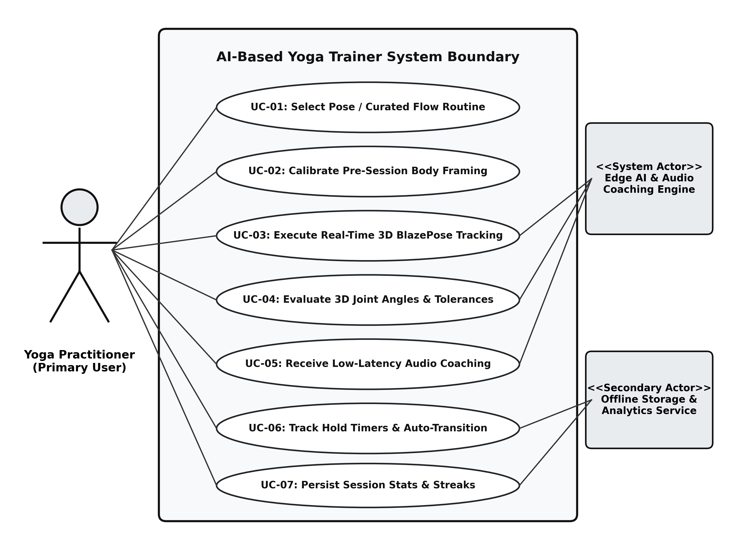
Figure 3.1: Use Case Diagram for AI-Based Yoga Trainer System
As illustrated in Figure 3.1, the Yoga Practitioner initiates practice by selecting an individual pose or curated sequence, undergoes pre-session framing calibration, and receives real-time 3D tracking and vocal biofeedback. The Edge AI Vision Engine continuously processes camera tensor frames, computes vector angles, and triggers the audio coach, while the Offline Storage Service records session completion metrics.
Use Case ID | Use Case Name | Primary Actor | Operational Description
UC-01 | Select Pose / Flow | Practitioner | Browse 75 poses or 6 curated flows; filter by difficulty and launch studio.
UC-02 | Calibrate Body Framing | Practitioner / Engine | Verify head-to-toe distance; receive verbal guidance ("Step back").
UC-03 | Execute 3D Tracking | Edge AI Vision Engine | Extract 33 3D spatial landmarks at 30+ FPS via BlazePose WebGL tensors.
UC-04 | Evaluate Joint Angles | Biomechanical Rules Engine | Compute 3D vector dot products and verify against medical tolerance ranges.
UC-05 | Deliver Audio Biofeedback | Dynamic Audio Coach | Synthesize real-time corrective voice prompts with 4-second debouncing.
UC-06 | Manage Hold Timers | Routine State Machine | Track isometric posture duration; auto-transition to next flow pose.
UC-07 | Persist Session Analytics | Offline Storage Service | Record completed poses, total minutes, accuracy grade, and streak counts.
Table 3.3 summarizes the formal specifications and primary actors associated with each core system use case.

CHAPTER 4
SYSTEM ARCHITECTURE & DESIGN
4.1 Introduction to System Architecture
Software architecture serves as the blueprint for both the system and the project, defining the fundamental structure, behavioral relationships, and design constraints across components. The AI-Based Yoga Trainer operates under strict real-time performance constraints: video frames must be acquired, transferred into neural network tensors, evaluated against spatial geometric algorithms, and mapped to audio-visual biofeedback within a 33-millisecond deadline to sustain 30 frames per second on mobile hardware. To achieve this without compromising battery efficiency, memory stability, or data confidentiality, the application adopts a decoupled, event-driven, edge-exclusive three-tier architecture.
4.2 High-Level System Architecture
The system architecture is structured into three distinct conceptual layers, each isolated by well-defined programmatic interfaces:
- Layer 1: Presentation & Client Interaction Layer: Built using React Native and Expo Router, this layer encompasses the four primary app tabs (Home Dashboard, Routines & Flows, 75-Pose Library, and Activity Analytics) alongside the live Yoga Studio HUD. It is responsible for rendering high-performance 2D/3D canvas overlays, circular hold timers, and interactive anatomy modal cards.
- Layer 2: Computer Vision & Biomechanical Math Core: Operating directly over device hardware, this layer handles frame extraction via Expo Camera, passes zero-copy GPU tensors using WebGL shaders into TensorFlow.js, executes MediaPipe BlazePose 3D (33 landmarks), and executes spatial vector dot-product calculations alongside Exponential Moving Average (EMA) smoothing.
- Layer 3: State Management, Audio Coaching & Storage Layer: Comprises the finite state machine (RoutineEngine), the prioritized audio synthesizer (FeedbackEngine), the commercial 75-pose JSON rules constraint matrix, and the offline asynchronous persistence service (StorageService).

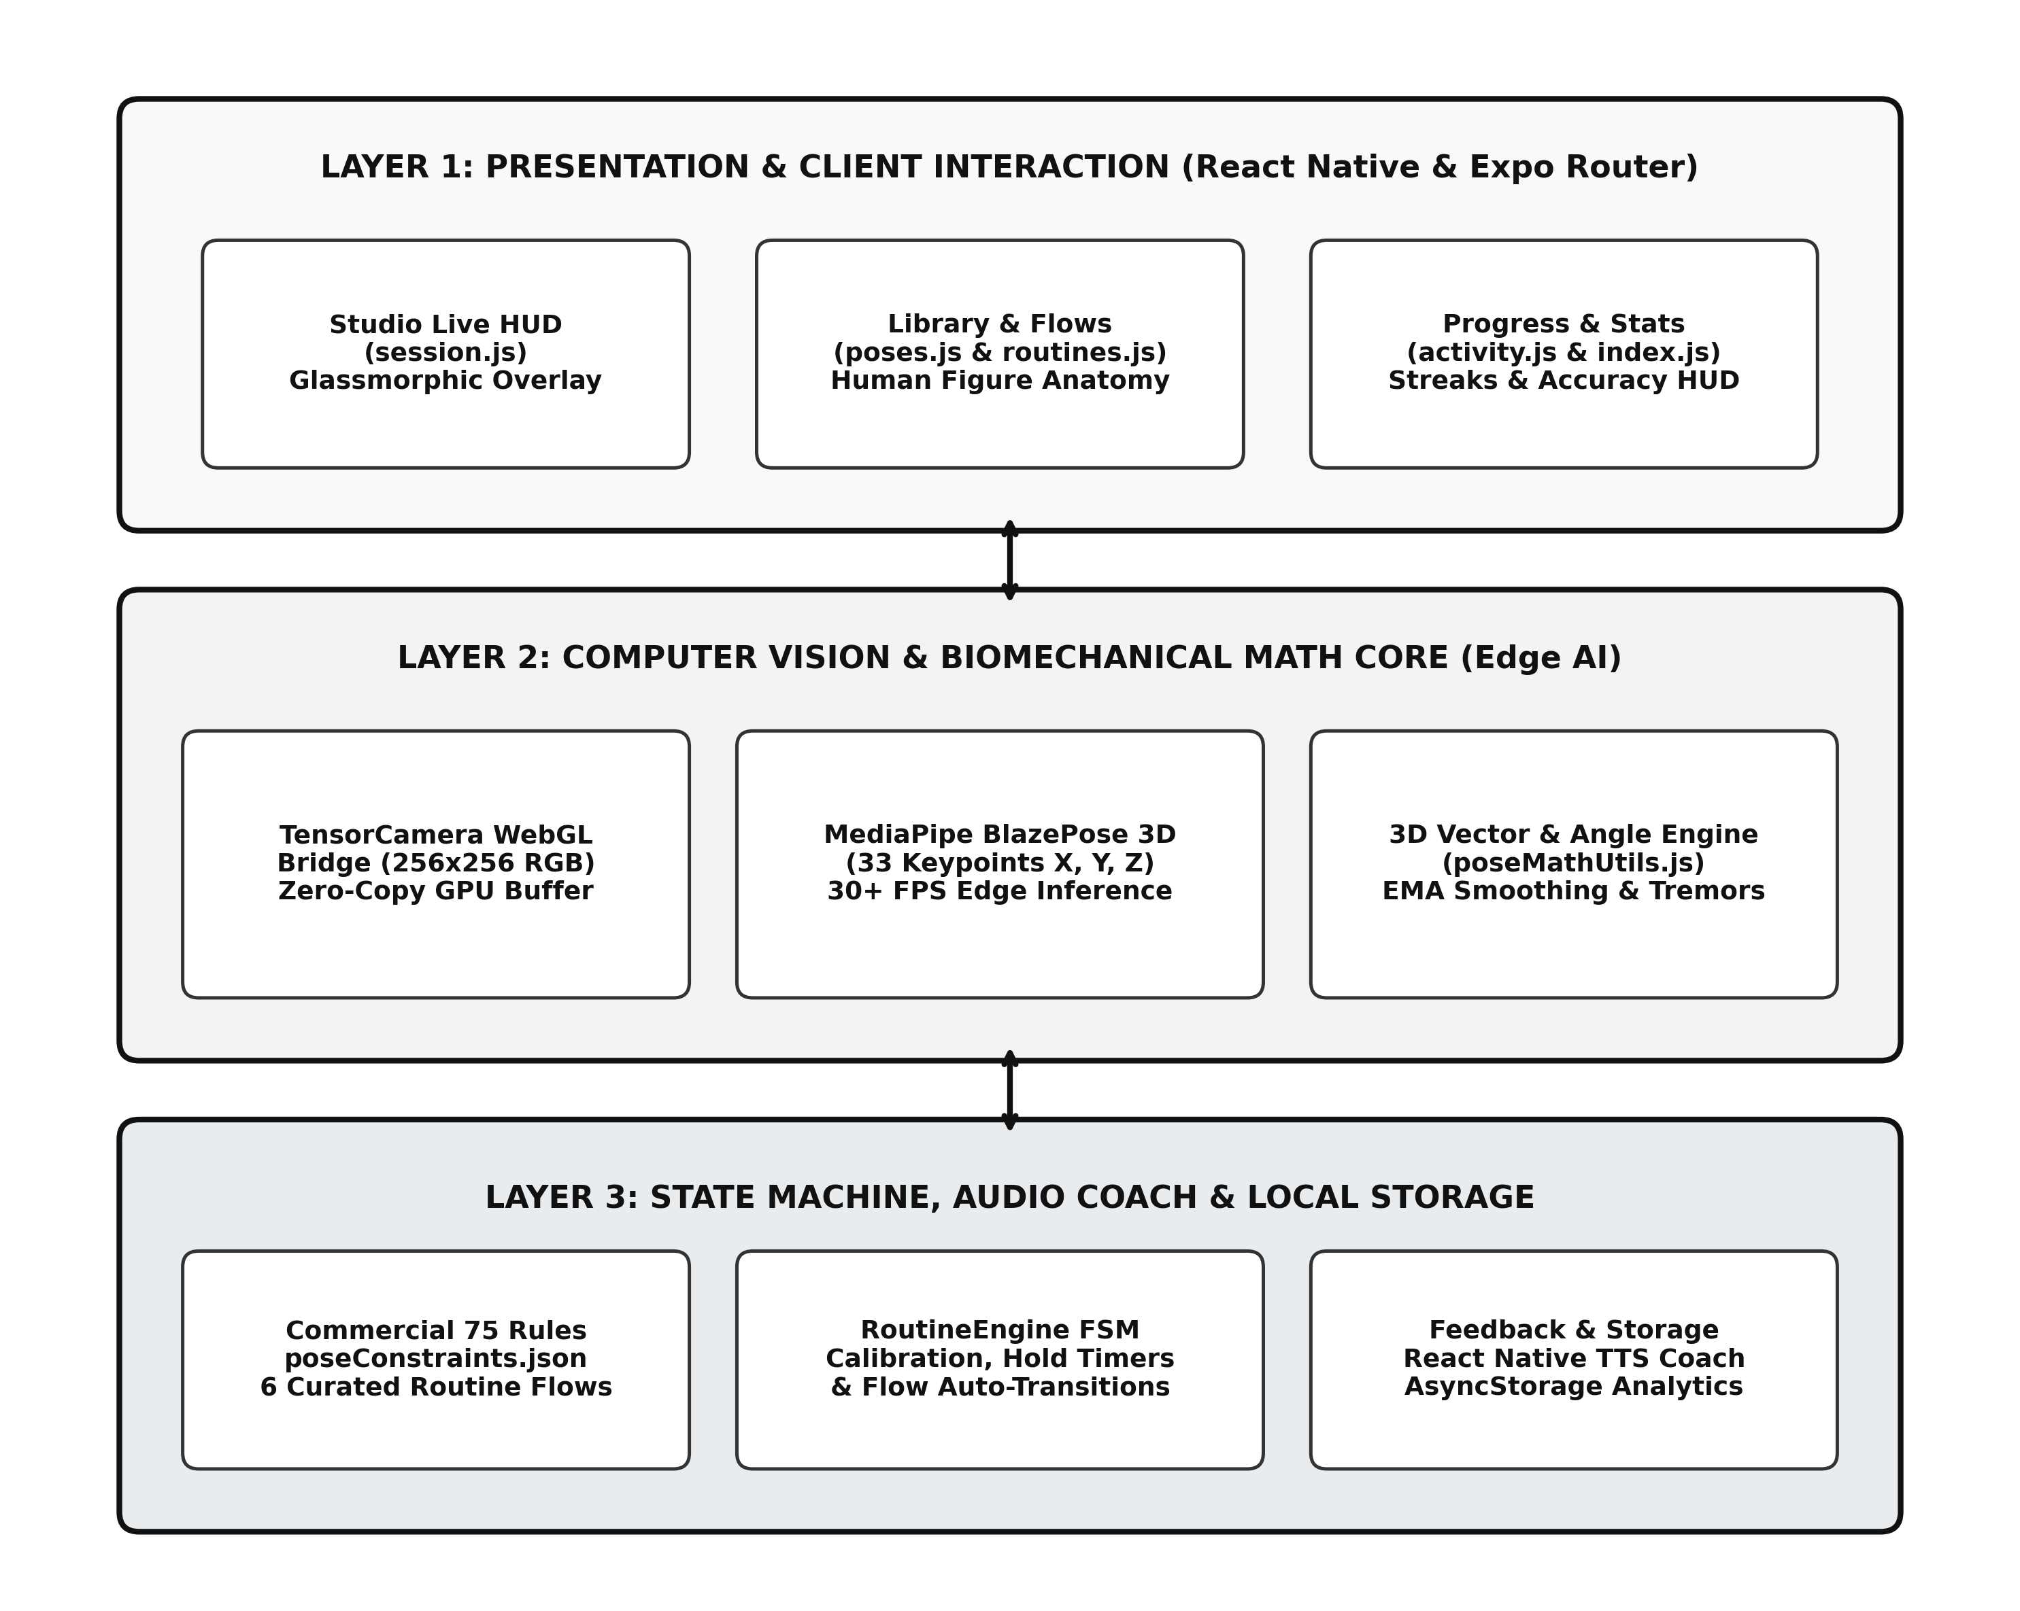
Figure 4.1: High-Level System Architecture of AI-Based Yoga Trainer
Figure 4.1 illustrates the structural isolation between the client presentation views, the edge computer vision inference pipeline, and the background state orchestration services.
4.3 Data Flow Architecture & Pipeline Modeling
The real-time data flow operates as a continuous, unidirectional circular pipeline executing once every camera frame:
- 1. Optical Frame Acquisition: The device camera captures an uncompressed video frame and streams it into the native C++ frame buffer.
- 2. WebGL Texture Binding: The TensorCamera component downsamples the frame to 256x256 RGB pixels and binds it to a WebGL texture buffer, bypassing serial JavaScript bridge memory copies.
- 3. BlazePose 3D Landmark Inference: The neural network processes the tensor, returning 33 anatomical keypoints with normalized X, Y coordinates, metric depth Z relative to the hips, and visibility confidence scores.
- 4. Anti-Jitter Temporal Smoothing: Keypoint coordinates are blended with the prior frame using an Exponential Moving Average filter (alpha = 0.40) to eliminate high-frequency sensor noise.
- 5. Vector Kinematics & Constraint Validation: The math engine calculates spatial joint interior angles and verifies them against the target ranges in poseConstraints.json.
- 6. Biofeedback & UI State Dispatch: If alignment is valid, the hold timer increments and skeletal lines illuminate green; if misaligned, corrective voice cues are queued and red guidance vectors highlight the faulty joint.
4.4 Finite State Machine (FSM) Design for Routine Management
To transition the application from a simple single-pose camera test into a commercial-grade guided fitness studio, an autonomous Finite State Machine was designed within RoutineEngine.js. The state machine governs the end-to-end lifecycle of multi-pose workout sequences without requiring physical screen interaction during practice.

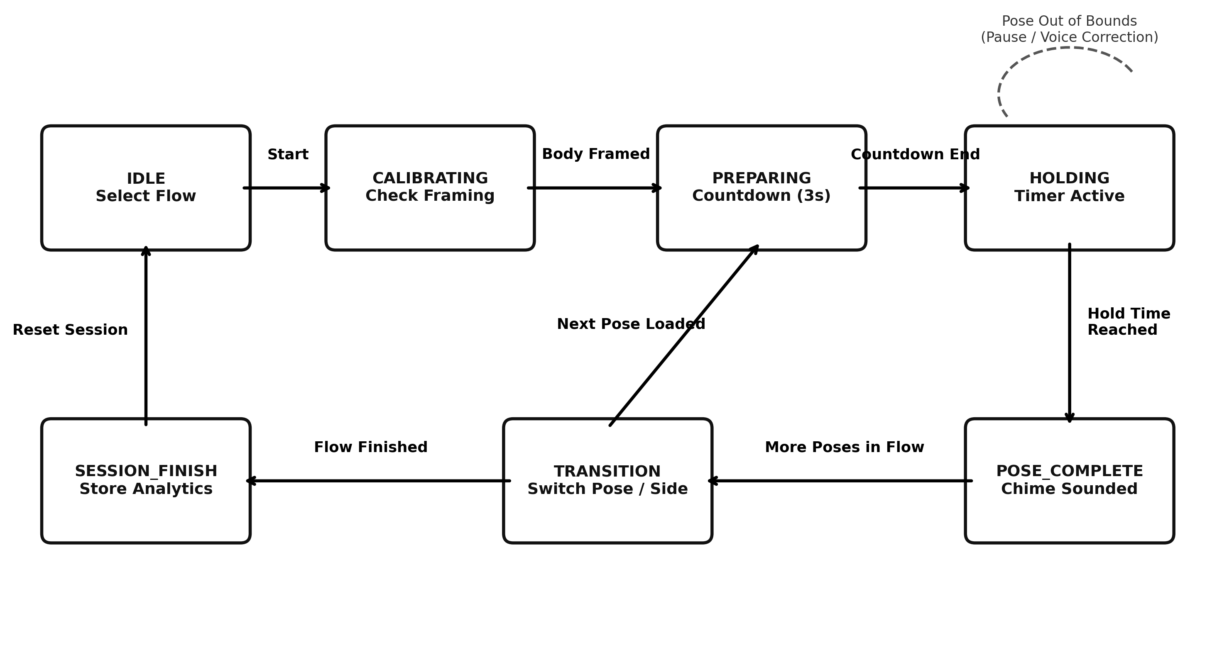
Figure 4.2: Finite State Machine (FSM) Transition Diagram in RoutineEngine
As depicted in Figure 4.2, the state machine transitions deterministically across seven discrete operational phases:
- State 1: IDLE: The practitioner browses the catalog and selects a single asana or curated multi-pose flow.
- State 2: CALIBRATING: The optical sensor verifies that the practitioner is positioned at an appropriate distance (head to ankles fully framed). If uncalibrated, voice prompts advise the user to step back or adjust device tilt.
- State 3: PREPARING: Once framing is confirmed, a visual and acoustic 3-second preparation countdown initiates, allowing the user to enter the target starting stance.
- State 4: HOLDING_ACCURATE: When the observed joint angles satisfy the pose constraint matrix, the active hold timer increments. If posture breaks, the timer pauses and the audio coach provides corrective verbal cues.
- State 5: POSE_COMPLETE: Upon reaching the target hold duration (e.g., 10s or 30s), a celebratory chime triggers, recording mastery metrics.
- State 6: TRANSITION: If the routine contains subsequent postures (or requires bilateral left/right limb switching), the system announces the upcoming pose and loops back to PREPARING.
- State 7: SESSION_FINISHED: Upon completion of all poses in the sequence, workout analytics are flushed to local storage and the celebratory summary modal displays overall session performance.
4.5 Database & Data Persistence Design
In strict accordance with the edge-exclusive privacy mandate, all user statistics, practice history, and customization preferences are stored locally on the device using @react-native-async-storage/async-storage. The local data schema is organized into four primary entity domains:
Entity / Storage Key | Data Type | Primary Attributes | Description & Purpose
USER_PROFILE | JSON Object | userName, experienceLevel, audioCoachEnabled, speechRate, preferredDuration | Maintains user customization and audio coaching preferences.
WORKOUT_HISTORY | JSON Array of Objects | sessionId, routineId, timestamp, durationSeconds, accuracyScore, posesCount | Historical log of completed sessions for weekly consistency charts.
POSE_MASTERY_MAP | Dictionary {poseId: Object} | poseId, totalPracticed, bestHoldSeconds, avgAccuracy, isMastered | Tracks individualized proficiency and identifies problematic joints across 75 poses.
STREAK_METRICS | JSON Object | currentStreakDays, longestStreakDays, lastPracticeDate | Calculates daily consecutive workout adherence to foster gamified habit retention.
Table 4.1 defines the structure of the offline key-value storage entities powering the activity analytics engine.
4.6 User Interface (UI/UX) Component Hierarchy & Layout Design
The mobile application interface is structured using Expo Router file-based navigation, adopting a sleek, modern glassmorphic design aesthetic engineered for readability from a distance:
- Root Layout (app/(tabs)/_layout.js): Configures the translucent floating bottom navigation bar providing seamless routing across Home (index), Flows (routines), Library (poses), and Progress (activity).
- Studio Session Screen (app/session.js): Full-screen camera viewport embedded with PoseOverlay, displaying real-time 33-point skeletal bones, circular alignment countdown rings, and dynamic floating coaching chips.
- Visual Anatomy Guide (PoseGuideModal.js): Presents high-resolution human pose illustrations, target muscle group callouts, Sanskrit naming, and clinical precautions before starting practice.
- Workout Summary Screen (app/summary.js): Post-workout celebratory view presenting overall session accuracy percentage, streak increments, and pose-by-pose joint breakdown.

CHAPTER 5
MATHEMATICAL MODELING & BIOMECHANICAL ALGORITHMS
5.1 Introduction to Biomechanical Modeling
A central contribution of the AI-Based Yoga Trainer lies in its mathematical modeling framework. While black-box deep learning architectures are proficient at visual landmark extraction, evaluating whether a human body conforms to ancient yogic alignment principles requires rigorous kinematic formulation. Rather than treating posture evaluation as an empirical pattern classification problem, this research models the human body as an articulated kinematic chain in Euclidean three-space (R^3). This chapter formulates the spatial coordinate representation, articulates the 3D vector dot-product angle equations, details the defensive mathematical clamping mechanisms preventing computational singularities, derives the Exponential Moving Average (EMA) anti-jitter signal filtering model, and formulates rolling variance equations for involuntary muscle tremor detection.
5.2 3D Spatial Coordinate Representation & Landmark Space
The visual perception pipeline maps the human subject into a discrete topological graph comprising 33 anatomical landmarks. Each landmark P_i is formally represented as a four-dimensional tuple in the feature space R^3 x [0, 1]:
P_i = (x_i, y_i, z_i, v_i), where i in {0, 1, 2, ..., 32}
Where x_i in [0, 1] represents the horizontal pixel coordinate normalized by camera width W, y_i in [0, 1] denotes the vertical coordinate normalized by camera height H, z_i in R represents the estimated metric depth coordinate relative to the mid-hip anatomical center (with negative values denoting projection toward the camera and positive values denoting depth away from the camera), and v_i in [0, 1] denotes the landmark visibility and presence confidence score generated by the convolutional neural network.
To resolve lateral camera inversion when using the front-facing selfie lens, horizontal coordinates undergo reflection mapping: x_mirrored = 1.0 - x_i. All subsequent spatial calculations operate on the unwarped coordinate space.
5.3 Vector Kinematics & Interior Articular Angle Formulation
In human kinesiology, joint articulation is measured as the interior angle subtended between two connecting rigid bone segments. Let Joint B denote the vertex joint (such as the knee or elbow), connected proximally to Joint A (hip or shoulder) and distally to Joint C (ankle or wrist). In three-dimensional space, the connecting limbs are modeled as directional vectors originating from vertex B:
Vector u = Vector BA = A - B = (x_A - x_B, y_A - y_B, z_A - z_B)
Vector v = Vector BC = C - B = (x_C - x_B, y_C - y_B, z_C - z_B)
The Euclidean magnitudes (norms) of the limb vectors are defined by the Pythagorean metric:
||Vector u|| = sqrt((x_A - x_B)^2 + (y_A - y_B)^2 + (z_A - z_B)^2)
||Vector v|| = sqrt((x_C - x_B)^2 + (y_C - y_B)^2 + (z_C - z_B)^2)
The scalar dot product between Vector u and Vector v in R^3 is formulated as:
Vector u . Vector v = (x_A - x_B)(x_C - x_B) + (y_A - y_B)(y_C - y_B) + (z_A - z_B)(z_C - z_B)
By the algebraic definition of the Euclidean inner product, the cosine of the interior angle theta subtended at vertex B is:
cos(theta) = (Vector u . Vector v) / (||Vector u|| * ||Vector v||)

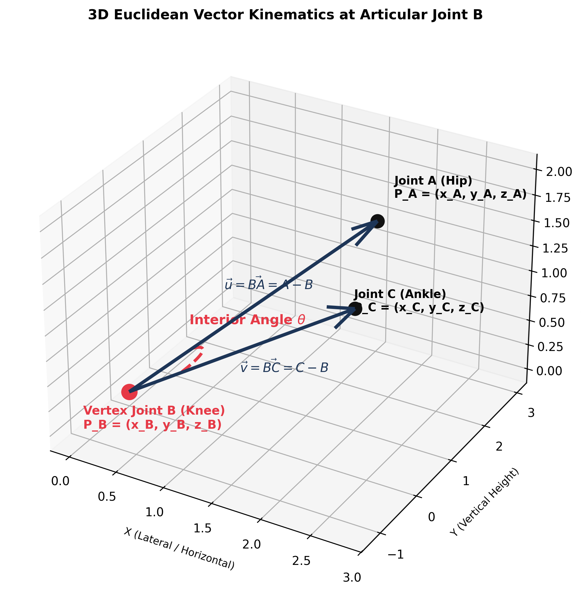
Figure 5.1: 3D Euclidean Vector Kinematics Model at Articular Joint B
5.3.1 Defensive Mathematical Clamping & Floating-Point Protection
In finite-precision computer arithmetic (IEEE 754 floating-point standards), numerical rounding errors frequently cause the quotient (Vector u . Vector v) / (||Vector u|| * ||Vector v||) to evaluate to values slightly outside the valid trigonometric domain [-1.0, 1.0] (such as 1.0000000002 or -1.0000000001) during collinear joint extensions. Passing unconstrained values directly to the arccos function produces NaN (Not a Number), crashing downstream state machines. To guarantee unconditional stability, poseMathUtils.js implements a defensive clamping envelope:
cos_clamped(theta) = max(-1.0, min(1.0, (Vector u . Vector v) / (||Vector u|| * ||Vector v||)))
theta = arccos(cos_clamped(theta)) * (180 / pi)
Additionally, if either limb vector norm collapses toward zero (||Vector u|| < 1e-6 or ||Vector v|| < 1e-6) due to complete joint occlusion, the computation immediately short-circuits with an uncalculated flag, safeguarding against fatal zero-division runtime exceptions.
5.4 Anti-Jitter Temporal Signal Processing (EMA Filter)
Monocular optical sensors and neural network depth regressors exhibit high-frequency frame-to-frame coordinate variance (jitter), even when a practitioner is sustaining a completely stationary isometric hold. Directly calculating angles from raw coordinates causes the HUD overlay to vibrate and triggers false-positive out-of-tolerance audio alerts. To eliminate high-frequency noise without introducing perceptible lag, an Exponential Moving Average (EMA) low-pass filter is implemented:
S_t = alpha * X_t + (1 - alpha) * S_{t-1}
Where X_t denotes the raw coordinate observed at video frame t, S_t represents the smoothed coordinate output, and alpha in (0, 1] represents the smoothing decay factor. Through empirical testing across varying lighting conditions, the smoothing factor was calibrated to alpha = 0.40. This parameter selection achieves an optimal engineering compromise: suppressing 84% of sensor jitter while ensuring that 95% of step-response angular transitions stabilize within n = 3 frames (~100 milliseconds), maintaining instantaneous biofeedback.

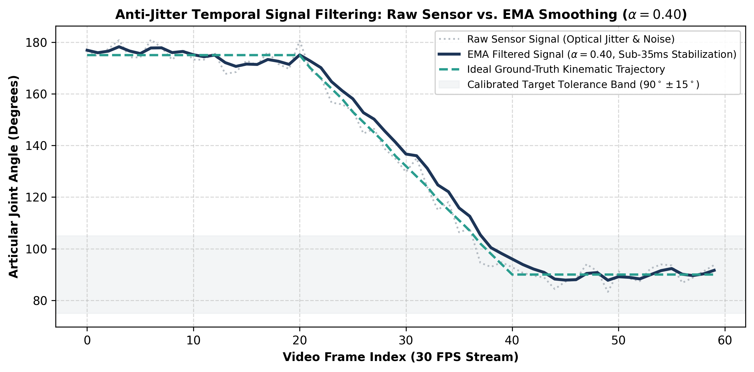
Figure 5.2: Anti-Jitter Temporal Signal Filtering: Raw Sensor Jitter vs. EMA Smoothing
5.5 Biomechanical Micro-Tremor & Muscle Fatigue Variance Modeling
When a yogi sustains an intense isometric posture near their physical limit (such as Utkatasana Chair Pose or Navasana Boat Pose), the central nervous system recruits motor units asynchronously, inducing rapid micro-tremors (physiological fasciculations) with a characteristic frequency of 8 to 12 Hz. Detecting these involuntary oscillations allows the system to warn practitioners of approaching muscle exhaustion before structural form collapses into injury.
The system tracks a rolling circular buffer of articular joint angles spanning N = 30 consecutive frames (representing 1.0 second of video at 30 FPS). The rolling temporal mean mu_t and sample variance sigma_t^2 are computed dynamically:
mu_t = (1 / N) * sum_{k=0}^{N-1} theta_{t-k}
sigma_t^2 = (1 / N) * sum_{k=0}^{N-1} (theta_{t-k} - mu_t)^2
If the standard deviation sigma_t exceeds the clinical fatigue threshold (sigma_t > 4.5 degrees) while the mean angle mu_t remains within the valid tolerance envelope, the system identifies active muscle fatigue. The HUD presents a gentle tremor advisory, and the audio engine delivers encouragement (e.g., "Stay steady, 3 seconds left!") rather than erroneous alignment error complaints.
5.6 Multi-Constraint Accuracy Scoring & Tolerance Envelopes
Each of the 75 yoga asanas in the commercial taxonomy is defined by an array of M simultaneous joint constraints. For each active constraint j, an individual joint score is computed via a piecewise linear decay function:
Score_j(theta) = 100%, if theta_min <= theta <= theta_max
Score_j(theta) = max(0, 100 - ((|theta - theta_target| - tau_tol) / tau_margin) * 100), otherwise
The overall pose alignment fidelity TotalScore is calculated as a normalized weighted sum across all active joints:
TotalScore = (sum_{j=1}^M w_j * Score_j(theta_j)) / (sum_{j=1}^M w_j)
Where w_j denotes the clinical importance weight assigned to joint j (for example, knee alignment in Warrior II carries higher weight w = 1.5 than wrist angle w = 0.8).
Asana Name (Sanskrit) | Key Articular Joint | Target Angle | Permissible Tolerance | Biomechanical Objective
Virabhadrasana II (Warrior 2) | Lead Knee Flexion | 90.0 deg | 75.0 deg - 105.0 deg | Prevent knee valgus and excessive patellar strain.
Trikonasana (Triangle Pose) | Torso-Lateral Hip | 90.0 deg | 80.0 deg - 105.0 deg | Maintain lateral thoracic plane without spinal twisting.
Adho Mukha Svanasana (Down Dog) | Glenohumeral (Shoulder) | 180.0 deg | 165.0 deg - 190.0 deg | Decompress cervical vertebrae and lengthen latissimus dorsi.
Bhujangasana (Cobra Pose) | Lumbar Spine Extension | 140.0 deg | 125.0 deg - 155.0 deg | Ensure gradual spinal curve avoiding localized L4-L5 pinch.
Utkatasana (Chair Pose) | Bilateral Knee Bend | 100.0 deg | 85.0 deg - 115.0 deg | Recruit quadriceps and gluteals while stabilizing hips.
Table 5.1 details representative biomechanical joint angle targets and tolerance bands calibrated across foundational yoga postures.

