**Experiment No :- 02**

**Name:** Arshan Sayyadahamad Attar.

**Roll no:** 231408

* **Theory of CSS with inline/ internal / External CSS discussion**

**CSS (Cascading Style Sheets)** is a stylesheet language used to describe the presentation (look and formatting) of a web page written in HTML.  
It controls the **layout, colors, fonts, spacing**, and **responsive design** of web pages.

CSS works by **selecting HTML elements** and applying styles to them. It allows separation of content (HTML) from design (CSS), making websites easier to maintain and scale.

* **Inline CSS :**

**Inline CSS** is a way to apply styling directly to an individual HTML element using the **style** attribute inside the opening tag. It is used to style specific elements on a page without using a separate CSS file or **<style>** block.

* **Key Point:**
* Written **directly inside the HTML tag** using the style attribute.
* Affects only the specific element it is written in.
* Used for quick testing or small changes.

**Code:**

<!DOCTYPE html>

<html lang="en">

<head>

    <meta charset="UTF-8">

    <meta name="viewport" content="width=device-width, initial-scale=1.0">

    <title>Inline CSS</title>

</head>

<body>

    <h1 style="color:#444; font-size: 36px;">Welcome to Inline CSS Example</h1>

    <p style="color: darkblue; font-size: 24px; text-align: justify;">This paragraph shows how we can apply inline CSS directly to HTML elements.

        It controls the color, size, and alignment of the text.</p>

    <p style="color: darkred; font-size: 22px; ">Inline CSS is useful for quick styling.</p>

</body>

</html>

**Output:**

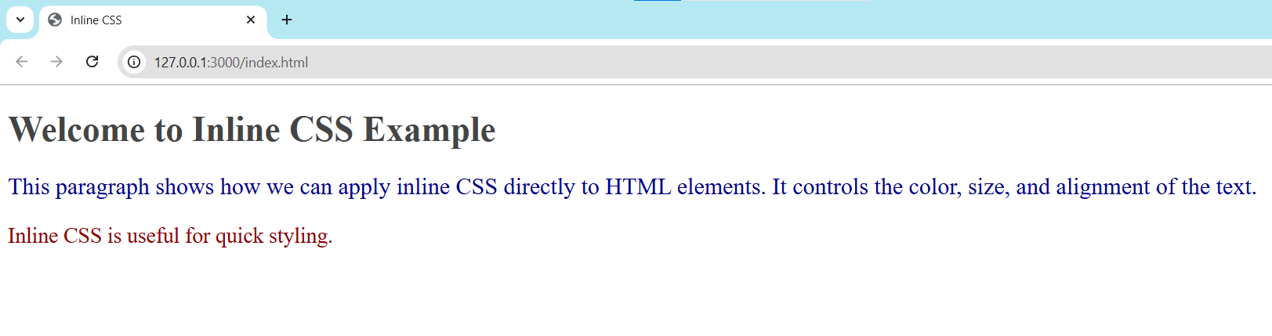

* **Internal CSS:**

**Internal CSS** is used to apply styles to a single HTML page. It is written inside a **<style>** tag within the **<head>** section of the HTML document. The styles written here apply to the entire page.

It allows better organization of styles compared to inline CSS and keeps the HTML elements clean.

* **Key Point:**
* Written inside the **<head>** of the HTML file.
* Affects all matching elements on the same page.
* Good for styling one-page websites or projects.

**Code:**

<!DOCTYPE html>

<html lang="en">

<head>

    <meta charset="UTF-8">

    <meta name="viewport" content="width=device-width, initial-scale=1.0">

    <title>Internal CSS</title>

    <style>

        h1{

            color: darkblue;

            font-size: 32px;

        }

        p{

            color: darkorange;

            font-family: 24px;

        }

    </style>

</head>

<body>

    <h1>Welcome to Internal CSS Example</h1>

    <p>This paragraph shows how we can apply Internal CSS directly to HTML elements.

        It controls the color, size, and alignment of the text.</p>

</body>

</html>

**Output:**

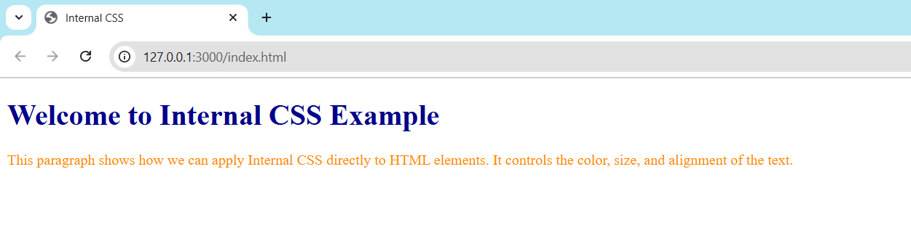

* **External CSS:**

**External CSS** is used to apply styles to multiple HTML pages using a separate **.css file**. It helps keep HTML and CSS code separate, making the website easier to manage and update.

The external CSS file is linked in the **<head>** section of the HTML using the **<link>** tag.

* **Key point:**
* Written in a separate file (e.g**., style.css**).
* Linked to HTML using **<link>** tag.
* Ideal for styling multiple pages with consistent design.

**Code:**

1. **Index.html:**

<!DOCTYPE html>

<html lang="en">

<head>

    <meta charset="UTF-8">

    <meta name="viewport" content="width=device-width, initial-scale=1.0">

    <title>External CSS</title>

    <link rel="stylesheet" href="style.css">

</head>

<body>

    <h1>Welcome to External CSS Example</h1>

    <p>This is a paragraph styled using external CSS.</p>

</body>

</html>

1. **Style.css:**

h1{

    color: darkred;

    font-size: large;

}

p{

    color: darkgreen;

    font-size: medium;

}

**Output:**

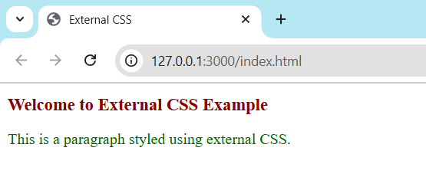

* **Implementation of user  Registration / Login Form using  CSS.**

**Code:**

1. **Index.html:**

<!DOCTYPE html>

<html lang="en">

<head>

    <meta charset="UTF-8">

    <title>Login Page</title>

    <link rel="stylesheet" href="style.css">

</head>

<body>

    <div class="login-container">

        <h2>Login to Your Account</h2>

        <form>

            <input type="text" placeholder="Username or Email" required>

            <input type="password" placeholder="Password" required>

            <input type="submit" value="Login">

        </form>

        <div class="form-footer">

            <p>Don't have an account? <a href="#">Register</a></p>

            <p><a href="#">Forgot Password?</a></p>

        </div>

    </div>

</body>

</html>

1. **Style.css:**

* {

    margin: 0;

    padding: 0;

    box-sizing: border-box;

}

body {

    height: 100vh;

    display: flex;

    align-items: center;

    justify-content: center;

    background: linear-gradient(to right, #ece9e6, #ffffff);

    font-family: Arial, sans-serif;

}

.login-container {

    width: 350px;

    background-color: #fff;

    padding: 30px;

    box-shadow: 0 0 15px rgba(0, 0, 0, 0.1);

    border-radius: 10px;

    text-align: center;

}

.login-container h2 {

    margin-bottom: 25px;

    color: #333;

}

input[type="text"],

input[type="password"] {

    width: 100%;

    padding: 12px;

    margin-bottom: 15px;

    border: 1px solid #ccc;

    border-radius: 6px;

    font-size: 16px;

}

input[type="submit"] {

    width: 100%;

    padding: 12px;

    background-color: #4caf50;

    color: white;

    border: none;

    border-radius: 6px;

    font-size: 16px;

    cursor: pointer;

}

input[type="submit"]:hover {

    background-color: #43a047;

}

.form-footer {

    margin-top: 15px;

    font-size: 14px;

}

.form-footer a {

    color: #4caf50;

    text-decoration: none;

}

.form-footer a:hover {

    text-decoration: underline;

}

**Output:**

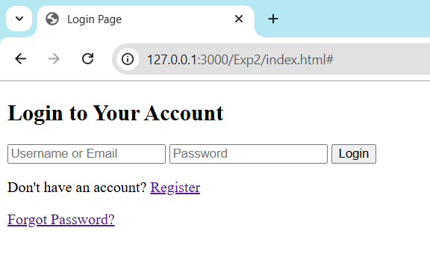

* **Implementation of E-commerce Using CSS.**

**Code:**

**1) E-commerce.html:**

<!DOCTYPE html>

<html lang="en">

<head>

    <meta charset="UTF-8">

    <title>My E-commerce Store</title>

    <link rel="stylesheet" href="E-commerce.css">

</head>

<body>

    <header>

        <h1>My E-commerce Store</h1>

    </header>

    <main class="product-section">

        <div class="product-card">

            <img src="download.jpg" alt="Smartphone">

            <h2>Smartphone</h2>

            <p>Price: ₹15,000</p>

            <button>Add to Cart</button>

        </div>

        <div class="product-card">

            <img src="download (1).jpg" alt="Laptop">

            <h2>Laptop</h2>

            <p>Price: ₹45,000</p>

            <button>Add to Cart</button>

        </div>

        <div class="product-card">

            <img src="download (2).jpg" alt="Headphones">

            <h2>Headphones</h2>

            <p>Price: ₹2,000</p>

            <button>Add to Cart</button>

        </div>

        <div class="product-card">

            <img src="download (3).jpg" alt="Electronics">

            <h2>Electronics</h2>

            <p>Price: ₹2000-100000</p>

            <button>Add to Cart</button>

        </div>

    </main>

</body>

</html>

**2) E-commerce.css:**

body {

    margin: 0;

    padding: 0;

    font-family: Arial, sans-serif;

    background-color: #090909;

}

header {

    background-color: #4caf50;

    padding: 20px;

    text-align: center;

    color: white;

    font-size: 28px;

}

.product-section {

    display: flex;

    justify-content: center;

    flex-wrap: wrap;

    gap: 30px;

    padding: 40px;

}

.product-card {

    background-color: white;

    width: 220px;

    padding: 20px;

    text-align: center;

    border-radius: 8px;

    box-shadow: 0 2px 8px rgba(2, 255, 19, 0.912);

}

.product-card img {

    width: 100%;

    height: auto;

    margin-bottom: 10px;

}

.product-card h2 {

    font-size: 20px;

    color: #333;

}

.product-card p {

    font-size: 16px;

    color: #555;

}

.product-card button {

    background-color: #4caf50;

    color: white;

    border: none;

    padding: 10px 16px;

    border-radius: 4px;

    font-size: 14px;

    cursor: pointer;

}

.product-card button:hover {

    background-color: #43a047;

}

**Output:**

