**Lab Report #10**

**Experiment Name #**  Page Replacement Algorithm (FIFO).

**Aim and Objective:**

The purpose of the experiment is to learn page replacement (FIFO) algorithm and execute a code by using C.

* To learn round page replacement algorithm (FIFO).
* To implement this algorithm using C.

**Algorithm:**

1. Start the process

2. Declare the size with respect to page length

3. Check the need of replacement from the page to memory

4. Check the need of replacement from old page to new page in memory

5. Forma queue to hold all pages

6. Insert the page require memory into the queue

7. Check for bad replacement and page fault

8. Get the number of processes to be inserted

9. Display the values

10. Stop the process

**Code:**

#include<stdio.h>

int main()

{

int i,j,n,a[50],frame[10],no,k,avail,count=0;

printf("\nNUMBER OF PAGES:\n");

scanf("%d",&n);

printf("\nPAGE NUMBER :\n");

for(i=1;i<=n;i++)

scanf("%d",&a[i]);

printf("\nNUMBER OF FRAMES :");

scanf("%d",&no);

for(i=0;i<no;i++)

frame[i]= -1;

j=0;

printf("\tref string\t page frames\n");

for(i=1;i<=n;i++)

{

printf("%d\t\t",a[i]);

avail=0;

for(k=0;k<no;k++)

if(frame[k]==a[i])

avail=1;

if (avail==0)

{

frame[j]=a[i];

j=(j+1)%no;

count++;

for(k=0;k<no;k++)

printf("%d\t",frame[k]);

}

printf("\n");

}

printf("Page Fault Is %d",count);

return 0;

}

**Output:**

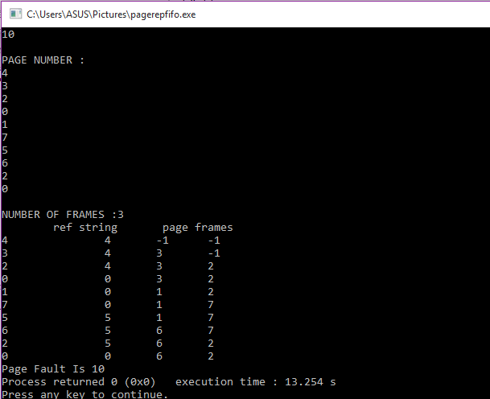

**Conclusion:**

By following these steps one can perform page replacement (fifo) algorithm using c. In this algorithm data that comes first gets into the frame first and also replace by next value first. It is quite important CPU scheduling in operation system.