**Lab Report #08**

**Experiment Name #**  Priority Scheduling Algorithm.

**Aim and Objective:**

The purpose of the experiment is to learn Priority scheduling algorithm and execute a code by using C.

* To learn Priority scheduling algorithm.
* To implement priority scheduling algorithm using C.

**Code:**

#include<stdio.h>

int main()

{

int burst_time[20], process[20], waiting_time[20], turnaround_time[20], priority[20];

int i, j, limit, sum = 0, position, temp;

float average_wait_time, average_turnaround_time;

printf("Number of Processes:\t");

scanf("%d", &limit);

for(i = 0; i < limit; i++)

{

printf("\nProcess[%d]\n", i + 1);

printf("Process Burst Time:\t");

scanf("%d", &burst_time[i]);

printf("Process Priority:\t");

scanf("%d", &priority[i]);

process[i] = i + 1;

}

for(i = 0; i < limit; i++)

{

position = i;

for(j = i + 1; j < limit; j++)

{

if(priority[j] < priority[position])

{

position = j;

}

}

temp = priority[i];

priority[i] = priority[position];

priority[position] = temp;

temp = burst_time[i];

burst_time[i] = burst_time[position];

burst_time[position] = temp;

temp = process[i];

process[i] = process[position];

process[position] = temp;

}

waiting_time[0] = 0;

for(i = 1; i < limit; i++)

{

waiting_time[i] = 0;

for(j = 0; j < i; j++)

{

waiting_time[i] = waiting_time[i] + burst_time[j];

}

sum = sum + waiting_time[i];

}

average_wait_time = sum / limit;

sum = 0;

printf("\nProcess ID\t\tBurst Time\t Waiting Time\t Turnaround Time\n");

for(i = 0; i < limit; i++)

{

turnaround_time[i] = burst_time[i] + waiting_time[i];

sum = sum + turnaround_time[i];

printf("\nProcess[%d]\t\t%d\t\t %d\t\t %d\n", process[i], burst_time[i], waiting_time[i], turnaround_time[i]);

}

average_turnaround_time = sum / limit;

printf("\nAverage Waiting Time:\t%f", average_wait_time);

printf("\nAverage Turnaround Time:\t%f\n", average_turnaround_time);

return 0;

}

**Output:**

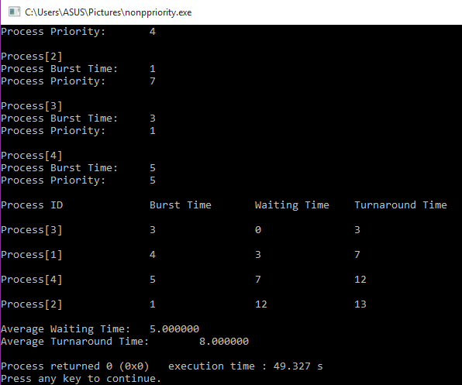

**Conclusion:**

By following these steps one can perform priority scheduling algorithm using c. In this algorithm the process which has higher priority has to do the job first. It is quite important CPU scheduling in operation system.