**Lab Report #09**

**Experiment Name #**  Round Robin (RR) Scheduling Algorithm.

**Aim and Objective:**

The purpose of the experiment is to learn round robin scheduling algorithm and execute a code by using C.

* To learn round robin scheduling algorithm.
* To implement this scheduling algorithm using C.

**Code:**

#include<stdio.h>

int main()

{

int i, limit, total = 0, x, counter = 0, time_quantum;

int wait_time = 0, turnaround_time = 0, arrival_time[10], burst_time[10], temp[10];

float average_wait_time, average_turnaround_time;

printf("\nNumber of Processes:\t");

scanf("%d", &limit);

x = limit;

for(i = 0; i < limit; i++)

{

printf("Arrival Time:\t");

scanf("%d", &arrival_time[i]);

printf("Burst Time:\t");

scanf("%d", &burst_time[i]);

temp[i] = burst_time[i];

}

printf("\nTime Quantum:\t");

scanf("%d", &time_quantum);

printf("\nProcess ID\t\tBurst Time\t Turnaround Time\t Waiting Time\n");

for(total = 0, i = 0; x != 0;)

{

if(temp[i] <= time_quantum && temp[i] > 0)

{

total = total + temp[i];

temp[i] = 0;

counter = 1;

}

else if(temp[i] > 0)

{

temp[i] = temp[i] - time_quantum;

total = total + time_quantum;

}

if(temp[i] == 0 && counter == 1)

{

x--;

printf("\nProcess[%d]\t\t%d\t\t %d\t\t\t %d", i + 1, burst_time[i], total - arrival_time[i], total - arrival_time[i] - burst_time[i]);

wait_time = wait_time + total - arrival_time[i] - burst_time[i];

turnaround_time = turnaround_time + total - arrival_time[i];

counter = 0;

}

if(i == limit - 1)

{

i = 0;

}

else if(arrival_time[i + 1] <= total)

{

i++;

}

else

{

i = 0;

}}

average_wait_time = wait_time * 1.0 / limit;

average_turnaround_time = turnaround_time * 1.0 / limit;

printf("\n\nAverage Waiting Time:\t%f", average_wait_time);

printf("\nAverage Turnaround Time:\t%f\n", average_turnaround_time);

return 0;}

**Output:**

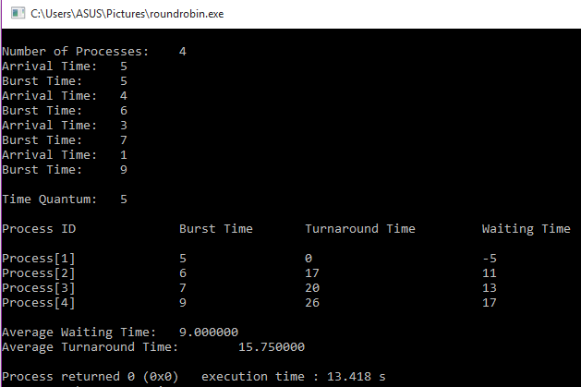

**Conclusion:**

By following these steps one can perform round robin scheduling algorithm using c. In this algorithm a time quantum is defined and it’s preemptive in nature. It is quite important CPU scheduling in operation system.