A Project Report

On

**LANGUAGE TUTOR**

Submitted in partial fulfillment of the

Requirements for the award of

**DIPLOMA**

IN

**COMPUTER ENGINEERING**

BY

**Mr. GNANESHWAR GAJWEL**

**13047-CM-052**

Under the esteemed guidance of

Sri. M. Shravan Reddy, M.Tech

**Lecturer of Computer Engineering (CME)**

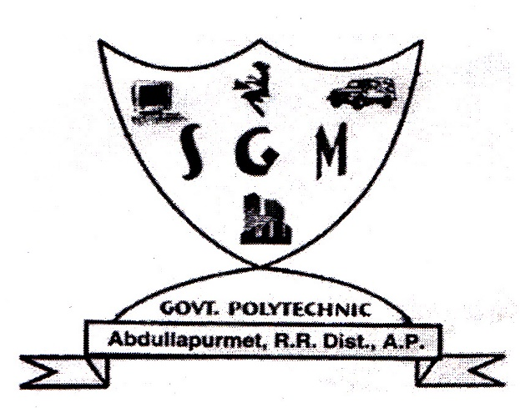

**S.G.M. Government Polytechnic**

**Abdullapurmet, R. R. District**

(2015-2016)

A Project Report

On

**LANGUAGE TUTOR**

Submitted in partial fulfillment of the

Requirements for the award of

**DIPLOMA**

IN

**COMPUTER ENGINEERING**

BY

**Mr. ARSHAQUE MOHAMMED**

**13047-CM-027**

Under the esteemed guidance of

Sri. M. Shravan Reddy, M.Tech

**Lecturer of Computer Engineering (CME)**



**S.G.M. Government Polytechnic**

**Abdullapurmet, R. R. District**

(2015-2016)

A Project Report

On

**LANGUAGE TUTOR**

Submitted in partial fulfillment of the

Requirements for the award of

**DIPLOMA**

IN

**COMPUTER ENGINEERING**

BY

**Mr. M. SUDHIR KUMAR**

**13047-CM-040**

Under the esteemed guidance of

Sri. M. Shravan Reddy, M.Tech

**Lecturer of Computer Engineering (CME)**



**S.G.M. Government Polytechnic**

**Abdullapurmet, R. R. District**

(2015-2016)

A Project Report

On

**LANGUAGE TUTOR**

Submitted in partial fulfillment of the

Requirements for the award of

**DIPLOMA**

IN

**COMPUTER ENGINEERING**

BY

**Mr. D. NIKHIL DUTH**

**13047-CM-038**

Under the esteemed guidance of

Sri. M. Shravan Reddy, M.Tech

**Lecturer of Computer Engineering (CME)**



**S.G.M. Government Polytechnic**

**Abdullapurmet, R. R. District**

(2015-2016)

A Project Report

On

**LANGUAGE TUTOR**

Submitted in partial fulfillment of the

Requirements for the award of

**DIPLOMA**

IN

**COMPUTER ENGINEERING**

BY

**Mr. AZIZ MOHAMMED**

**13047-CM-035**

Under the esteemed guidance of

Sri. M. Shravan Reddy, M.Tech

**Lecturer of Computer Engineering (CME)**



**S.G.M. Government Polytechnic**

**Abdullapurmet, R. R. District**

(2015-2016)