Prgram 1:
<!DOCTYPE html>
<html lang="en">
<head>
<meta charset="UTF-8">
<meta name="viewport" content="width=device-width, initial-scale=1">
<title>Arshath | Portfolio</title>
<link href="https://cdn.jsdelivr.net/npm/bootstrap@5.3.3/dist/css/bootstrap.min.css" rel="stylesheet">
<link rel="stylesheet" href="css/style.css">
</head>
<body>
<script src="https://cdn.jsdelivr.net/npm/bootstrap@5.3.3/dist/js/bootstrap.bundle.min.js"></script>

<nav class="navbar navbar-expand-lg navbar-dark bg-dark fixed-top">
<div class="container">
<a class="navbar-brand fw-bold" href="#">Arshath</a>

<button class="navbar-toggler" type="button" data-bs-toggle="collapse" data-bs-target="#navbarNav">
<span class="navbar-toggler-icon"></span>
</button>

<div class="collapse navbar-collapse" id="navbarNav">
<ul class="navbar-nav ms-auto">
<li class="nav-item"><a class="nav-link" href="#about">About</a></li>
<li class="nav-item"><a class="nav-link" href="#skills">Skills</a></li>
<li class="nav-item"><a class="nav-link" href="#projects">Projects</a></li>
<li class="nav-item"><a class="nav-link" href="#contact">Contact</a></li>
</ul>
</div>
</div>
</nav>
<section class="pt-5 mt-5" id="about">
<div class="container">
<div class="row align-items-center">

<div class="col-md-4 text-center">
<img src="images\IMG-20250213-WA0010.jpg"
class="img-fluid rounded-circle mb-3"
alt="Profile">
</div>
<div class="col-md-8">
<h2>Hello, I'm Arshath 👋</h2>
<p class="lead">
Computer Science student passionate about Java, AI, IoT and Full-Stack Development.
I build intelligent systems and clean web applications.
</p>
<p>
Interested in Deep Learning, Smart Devices, and impactful real-world projects.
</p>
</div>

</div>
</div>
</section>
<section class="bg-light py-5" id="skills">
<div class="container">
<h2 class="text-center mb-4">Skills</h2>

<div class="row">
<div class="col-md-6">
<p>Java</p>
<div class="progress mb-3">
<div class="progress-bar bg-success" style="width: 85%">85%</div>
</div>

<p>Python</p>
<div class="progress mb-3">
<div class="progress-bar bg-info" style="width: 50%">50%</div>
</div>
</div>
<div class="col-md-6">
<p>Machine Learning</p>
<div class="progress mb-3">
<div class="progress-bar bg-warning" style="width: 75%">75%</div>
</div>

<p>React & Web Dev</p>
<div class="progress mb-3">
<div class="progress-bar bg-primary" style="width: 70%">70%</div>
</div>
</div>
</div>
</div>
</section>
<section class="py-5" id="projects">
<div class="container">
<h2 class="text-center mb-4">Projects</h2>

<div class="row g-4">

<div class="col-md-4">
<div class="card h-100 shadow-sm">
<div class="card-body">
<h5 class="card-title">Solar Flare Prediction</h5>
<p class="card-text">
Hybrid deep learning model for binary & multiclass solar flare prediction.
</p>
<a href="#" class="btn btn-outline-primary btn-sm">Project Link</a>
</div>
</div>
</div>

<div class="col-md-4">
<div class="card h-100 shadow-sm">
<div class="card-body">
<h5 class="card-title">Recipe Blog Web App</h5>
<p class="card-text">
Full-stack MERN recipe application with REST API.
</p>
<a href="#" class="btn btn-outline-primary btn-sm">Project Link</a>
</div>
</div>
</div>

<div class="col-md-4">
<div class="card h-100 shadow-sm">
<div class="card-body">
<h5 class="card-title">IoT Fire Detection System</h5>
<p class="card-text">
Smoke & fire detection with real-time alerts using sensors.
</p>
<a href="#" class="btn btn-outline-primary btn-sm">Project Link</a>
</div>
</div>
</div>

</div>
</div>
</section>
<section class="bg-dark text-white py-5" id="contact">
<div class="container">
<h2 class="text-center mb-4">Contact Me</h2>

<div class="row justify-content-center">
<div class="col-md-6">

<form>
<input type="text" class="form-control mb-3" placeholder="Your Name">
<input type="email" class="form-control mb-3" placeholder="Your Email">
<textarea class="form-control mb-3" rows="4" placeholder="Message"></textarea>
<button class="btn btn-primary w-100">Send Message</button>
</form>

</div>
</div>
</div>
</section>
</body></html>

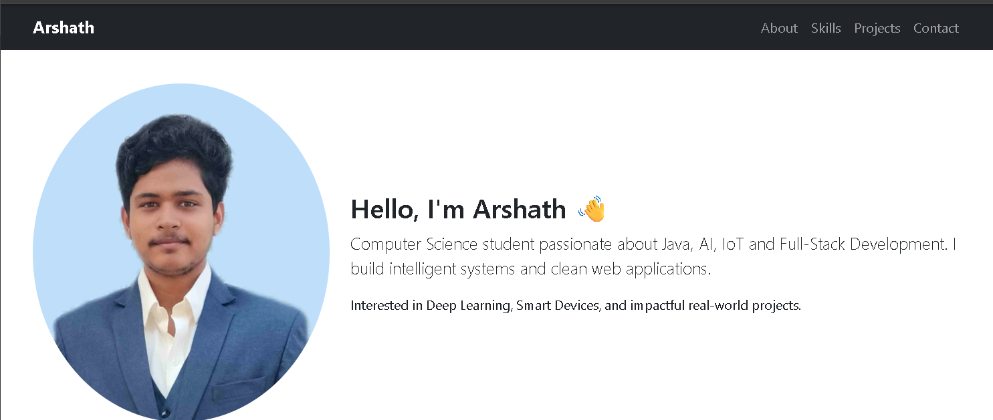
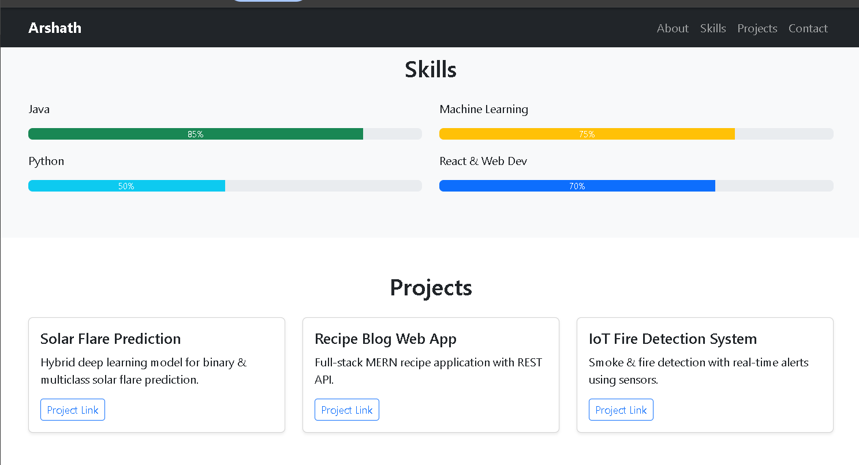
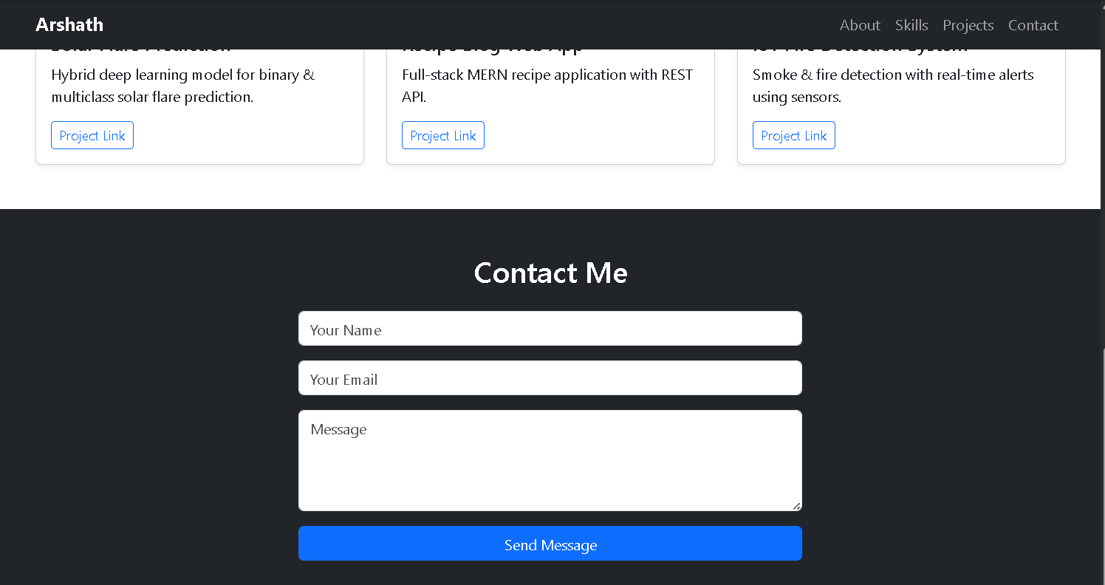
Program 2:

<!DOCTYPE html>
<html lang="en">
<head>
<meta charset="UTF-8">
<meta name="viewport" content="width=device-width, initial-scale=1.0">
<title>TechNova Solutions</title>
<style>
html{scroll-behavior:smooth}
.custom-navbar{background:linear-gradient(90deg,#0d6efd,#6610f2)}
.navbar .nav-link{position:relative;font-weight:500}
.navbar .nav-link::after{content:'';position:absolute;width:0;height:2px;background:#ffc107;left:0;bottom:0;transition:.3s}
.navbar .nav-link:hover::after,.navbar .nav-link.active::after{width:100%}
</style>
<link href="https://cdn.jsdelivr.net/npm/bootstrap@5.3.2/dist/css/bootstrap.min.css" rel="stylesheet">
<link href="https://cdn.jsdelivr.net/npm/bootstrap-icons/font/bootstrap-icons.css" rel="stylesheet">
</head>
<body>

<nav class="navbar navbar-expand-lg navbar-dark sticky-top shadow-lg custom-navbar">
<div class="container">
<a class="navbar-brand fw-bold fs-4" href="#"><i class="bi bi-lightning-charge-fill me-1"></i> TechNova</a>
<button class="navbar-toggler" type="button" data-bs-toggle="collapse" data-bs-target="#navbarNav"><span class="navbar-toggler-icon"></span></button>
<div class="collapse navbar-collapse" id="navbarNav">
<ul class="navbar-nav ms-auto align-items-lg-center gap-lg-2">
<li class="nav-item"><a class="nav-link active" href="#home">Home</a></li>
<li class="nav-item"><a class="nav-link" href="#about">About</a></li>
<li class="nav-item"><a class="nav-link" href="#services">Services</a></li>
<li class="nav-item"><a class="nav-link" href="#team">Team</a></li>
<li class="nav-item"><a class="nav-link" href="#testimonials">Testimonials</a></li>
<li class="nav-item ms-lg-3"><a class="btn btn-warning fw-semibold px-3" href="#contact">Contact</a></li>
</ul>
</div>
</div>
</nav>

<div id="heroCarousel" class="carousel slide" data-bs-ride="carousel">
<div class="carousel-indicators">
<button type="button" data-bs-target="#heroCarousel" data-bs-slide-to="0" class="active"></button>
<button type="button" data-bs-target="#heroCarousel" data-bs-slide-to="1"></button>
<button type="button" data-bs-target="#heroCarousel" data-bs-slide-to="2"></button>
</div>
<div class="carousel-inner">
<div class="carousel-item active">
<img src="images/photo-1535223289827-42f1e9919769.jpg" class="d-block w-100" style="height:90vh;object-fit:cover">
<div class="carousel-caption d-none d-md-block"><h1 class="fw-bold">Innovative Digital Solutions</h1><p>We build smart, scalable, and secure technology.</p></div>
</div>
<div class="carousel-item">
<img src="images/photo-1519389950473-47ba0277781c.jpg" class="d-block w-100" style="height:90vh;object-fit:cover">
<div class="carousel-caption d-none d-md-block"><h1 class="fw-bold">Transforming Businesses</h1><p>Empowering companies through cutting-edge tech.</p></div>
</div>
<div class="carousel-item">
<img src="images/photo-1521737604893-d14cc237f11d.jpg" class="d-block w-100" style="height:90vh;object-fit:cover">
<div class="carousel-caption d-none d-md-block"><h1 class="fw-bold">Future-Ready Teams</h1><p>Driven by innovation, powered by people.</p></div>
</div>
</div>
<button class="carousel-control-prev" type="button" data-bs-target="#heroCarousel" data-bs-slide="prev"><span class="carousel-control-prev-icon"></span></button>
<button class="carousel-control-next" type="button" data-bs-target="#heroCarousel" data-bs-slide="next"><span class="carousel-control-next-icon"></span></button>
</div>

<section class="py-5 bg-light" id="about">
<div class="container">
<div class="text-center mb-5"><h2 class="fw-bold">About TechNova Solutions</h2><p class="text-muted">Innovating today for a smarter tomorrow</p></div>
<div class="row g-4">
<div class="col-md-4"><div class="card h-100 text-center shadow-sm"><div class="card-body"><i class="bi bi-rocket-takeoff-fill text-primary fs-1"></i><h5 class="mt-3">Our Mission</h5><p>To deliver innovative, scalable, and secure digital solutions that help businesses grow.</p></div></div></div>
<div class="col-md-4"><div class="card h-100 text-center shadow-sm"><div class="card-body"><i class="bi bi-eye-fill text-success fs-1"></i><h5 class="mt-3">Our Vision</h5><p>To become a global leader in technology services through smart digital transformation.</p></div></div></div>
<div class="col-md-4"><div class="card h-100 text-center shadow-sm"><div class="card-body"><i class="bi bi-people-fill text-warning fs-1"></i><h5 class="mt-3">Our Values</h5><p>Innovation, integrity, collaboration, and customer focus.</p></div></div></div>
</div>
</div>
</section>

<section class="py-5" id="services">
<div class="container">
<div class="text-center mb-5"><h2 class="fw-bold">Our Services</h2><p class="text-muted">Smart solutions tailored for your business</p></div>
<div class="row g-4">
<div class="col-md-4"><div class="card h-100 text-center text-white bg-primary shadow"><div class="card-body"><i class="bi bi-code-slash fs-1"></i><h5 class="mt-3">Web Development</h5><p>Responsive and secure web applications.</p></div></div></div>
<div class="col-md-4"><div class="card h-100 text-center text-white bg-success shadow"><div class="card-body"><i class="bi bi-phone-fill fs-1"></i><h5 class="mt-3">Mobile Apps</h5><p>High-performance Android and iOS apps.</p></div></div></div>
<div class="col-md-4"><div class="card h-100 text-center text-white bg-warning shadow"><div class="card-body"><i class="bi bi-cpu-fill fs-1"></i><h5 class="mt-3">AI & Cloud</h5><p>Intelligent automation and cloud solutions.</p></div></div></div>
</div>
</div>
</section>

<section class="py-5 bg-light" id="team">
<div class="container">
<div class="text-center mb-5"><h2 class="fw-bold">Meet Our Team</h2><p class="text-muted">Experts who drive innovation</p></div>
<div class="row g-4">
<div class="col-md-4"><div class="card text-center shadow-sm h-100"><img src="images/32.jpg" class="card-img-top"><div class="card-body"><h5>Arjun Kumar</h5><p class="text-muted">CEO & Founder</p><p>Visionary leader in digital transformation.</p></div></div></div>
<div class="col-md-4"><div class="card text-center shadow-sm h-100"><img src="images/44.jpg" class="card-img-top"><div class="card-body"><h5>Neha Sharma</h5><p class="text-muted">Lead Developer</p><p>Expert in scalable web systems.</p></div></div></div>
<div class="col-md-4"><div class="card text-center shadow-sm h-100"><img src="images/76.jpg" class="card-img-top"><div class="card-body"><h5>Rahul Verma</h5><p class="text-muted">UI/UX Designer</p><p>Designing intuitive user experiences.</p></div></div></div>
</div>
</div>
</section>

<section class="py-5 bg-white" id="testimonials">
<div class="container">
<div class="text-center mb-5"><h2 class="fw-bold">What Our Clients Say</h2><p class="text-muted">Trusted by businesses worldwide</p></div>
<div id="testimonialCarousel" class="carousel slide" data-bs-ride="carousel">
<div class="carousel-inner text-center">
<div class="carousel-item active"><div class="p-4"><p class="fs-5 fst-italic">“TechNova transformed our digital presence.”</p><h6 class="fw-bold mt-3">— Amit Patel</h6></div></div>
<div class="carousel-item"><div class="p-4"><p class="fs-5 fst-italic">“Excellent service and cutting-edge solutions.”</p><h6 class="fw-bold mt-3">— Priya Nair</h6></div></div>
<div class="carousel-item"><div class="p-4"><p class="fs-5 fst-italic">“Highly skilled and professional team.”</p><h6 class="fw-bold mt-3">— Daniel Joseph</h6></div></div>
</div>
<button class="carousel-control-prev" type="button" data-bs-target="#testimonialCarousel" data-bs-slide="prev"><span class="carousel-control-prev-icon"></span></button>
<button class="carousel-control-next" type="button" data-bs-target="#testimonialCarousel" data-bs-slide="next"><span class="carousel-control-next-icon"></span></button>
</div>
</div>
</section>

<footer class="bg-dark text-white py-4">
<div class="container text-center">
<h5 class="fw-bold">TechNova Solutions</h5>
<p class="mb-1">Innovating the future through technology</p>
<small>© 2026 TechNova Solutions. All Rights Reserved.</small>
</div>
</footer>

<script src="https://cdn.jsdelivr.net/npm/bootstrap@5.3.2/dist/js/bootstrap.bundle.min.js"></script>
</body>
</html>
