Digital Assignment 1 / Review 1

SafeBite - Restaurant Food Safety Transparency Platform

Student: Arshdeep Singh | Reg. No.: 24BAI1501
Date: 30 July 2026

1. Vision Document
(As Markdown in the repository README.md - content reproduced here)

1.1 Project Name & Overview
SafeBite is a restaurant discovery platform that prioritises food safety transparency, helping customers make informed dining decisions based on comprehensive inspection histories, safety scores, and violation records from FSSAI health department data.

1.2 Problem It Solves
- Lack of Food Safety Transparency - customers have no easy access to inspection histories
- Hidden Violation Records - critical health violations buried in government databases
- Uninformed Dining Decisions - people cannot assess food safety risks before visiting
- Scattered Safety Information - inspection data and violation codes are not centralised

1.3 Target Users (Personas)
Persona | Role / Age | Goal | Pain Point
Sarah | Health-Conscious Customer, 32 | Find restaurants with excellent safety records for family dining | Cannot easily access inspection histories
Mike | Restaurant Owner, 45 | Showcase excellent safety practices and improve visibility | Customers do not see safety improvements
Lisa | Health Inspector, 38 | Ensure restaurants maintain safety standards | Limited public visibility of inspection data

1.4 Vision Statement
"To create a transparent ecosystem where food safety information is accessible, empowering customers to make informed dining decisions while helping restaurants showcase their commitment to health standards."

1.5 Key Features / Goals
- 1. Comprehensive Inspection History - complete timeline of all inspections with violation details
- 2. Real-time Safety Scores - 0-100 safety ratings based on latest FSSAI inspections
- 3. Violation Transparency - detailed FSSAI violation codes with corrective actions
- 4. Inspector Credibility - health inspector profiles with credentials and experience
- 5. Restaurant Discovery - advanced filtering by safety scores, cuisine, and location
- 6. Admin Approval Workflow - quality control for restaurant listings
- 7. Mobile-Responsive Design - accessible on all devices

1.6 Success Metrics
Metric | Target
User Engagement | 80%+ of users check inspection history before restaurant visits
Data Accuracy | 95%+ accuracy in safety score calculations
Restaurant Adoption | 500+ restaurants onboarded in first 6 months
Customer Trust | 4.5+ star average app rating
Health Impact | 20% reduction in food poisoning reports in coverage areas

1.7 Assumptions & Constraints
Assumptions:
- FSSAI inspection data is publicly available
- Restaurants will voluntarily participate for transparency benefits
- Customers value safety information when choosing restaurants
- Mobile-first usage patterns for restaurant discovery
Constraints:
- Limited to publicly available FSSAI inspection data
- Dependent on health department data accuracy and timeliness
- Must comply with data privacy and health information regulations
- Initial MVP budget of Rs.40,00,000 for development and infrastructure

2. 25 User Stories (GitHub Issues)
All 25 stories are created as GitHub Issues and organised in a GitHub Projects board.

Epic 1: Authentication & Management
Story 1: User Registration
As a new user, I want to register for an account, so that access SafeBite features.
Story 2: User Login
As a registered user, I want to login to my account, so that access personalised features.
Story 3: Role-Based Access Control
As a system admin, I want to assign different access levels, so that maintain security.

Epic 2: Restaurant Search & Discovery
Story 4: Browse Restaurant Listings
As a customer, I want to browse a list of restaurants, so that discover dining options.
Story 5: Filter by Criteria
As a customer, I want to filter by location, cuisine, and safety rating, so that find restaurants matching my preferences.
Story 6: Search by Name
As a customer, I want to search for restaurants by name, so that quickly find specific restaurants.
Story 7: View Restaurant Details
As a customer, I want to view detailed information about a restaurant, so that make informed dining decisions.

Epic 3: Food Safety & Inspection History
Story 8: View Safety Score
As a customer, I want to see a restaurant's food safety score, so that assess the safety risk.
Story 9: View Inspection History Timeline
As a customer, I want to see a complete timeline of inspections, so that understand the safety track record.
Story 10: View Violation Details
As a customer, I want to see specific violations found during inspections, so that understand what safety issues occurred.
Story 11: View Inspector Information
As a customer, I want to see information about health inspectors, so that trust the credibility of inspections.
Story 12: View Violation Photos
As a customer, I want to see photos from health inspections, so that visually understand safety conditions.

Epic 4: Restaurant Owner Management
Story 13: Create Restaurant Listing
As a restaurant owner, I want to create a listing for my restaurant, so that customers can discover my establishment.
Story 14: Edit Restaurant Information
As a restaurant owner, I want to update my restaurant's information, so that customers have current details.
Story 15: View Listing Approval Status
As a restaurant owner, I want to see approval status of my listing, so that know when it will be visible to customers.
Story 16: Manage Multiple Locations
As a restaurant owner with multiple locations, I want to manage all my restaurant listings, so that efficiently maintain my business presence.

Epic 5: Admin Management
Story 17: Review Pending Applications
As a admin, I want to review restaurant applications, so that ensure quality and accuracy.
Story 18: Approve Restaurant Listings
As a admin, I want to approve listings that meet requirements, so that make them visible to customers.
Story 19: Reject Restaurant Listings
As a admin, I want to reject listings that don't meet standards, so that maintain platform quality.
Story 20: Manage Users
As a admin, I want to view and manage all user accounts, so that maintain platform security.

Epic 6: User Experience
Story 21: Responsive Mobile Design
As a mobile user, I want to use the platform on my phone, so that access restaurant info on the go.
Story 22: Intuitive Navigation
As a user, I want to navigate intuitively throughout the platform, so that easily find information.
Story 23: Loading States & Performance
As a user, I want to experience fast loading times, so that have a smooth browsing experience.

Epic 7: Data Management
Story 24: Data Import System
As a system administrator, I want to import restaurant data from CSV files, so that update the database with health department records.
Story 25: Health Department Sync
As a system administrator, I want to keep inspection data synchronised, so that users always have the most current safety info.

3. MoSCoW Prioritisation & Figma Wireframes

3a. MoSCoW Prioritisation
Must Have - Critical for MVP
- Story 1 - User Registration
- Story 2 - User Login
- Story 4 - Browse Restaurant Listings
- Story 7 - View Restaurant Details
- Story 8 - View Safety Score
- Story 9 - View Inspection History Timeline
- Story 13 - Create Restaurant Listing
- Story 17 - Review Pending Applications
- Story 18 - Approve Restaurant Listings
- Story 21 - Responsive Mobile Design
- Story 24 - CSV Data Import System

Should Have - Important for User Experience
- Story 3 - Role-Based Access Control
- Story 5 - Filter Restaurants by Criteria
- Story 6 - Search Restaurants by Name
- Story 10 - View Inspection Violation Details
- Story 14 - Edit Restaurant Information
- Story 15 - View Listing Approval Status
- Story 19 - Reject Restaurant Listings
- Story 22 - Navigation and Site Structure
- Story 23 - Loading States & Performance

Could Have - Nice to Have
- Story 11 - View Inspector Information
- Story 12 - View Violation Photos
- Story 16 - Manage Multiple Locations
- Story 20 - Manage Users
- Story 25 - Data Synchronization with Health Departments

Won't Have - Future Releases
- Advanced Analytics Dashboard
- Live Notifications
- Mobile Application
- Customer Review System

3b. Figma Wireframes
Figma wireframes created using Figma Free. Figma Link:
https://www.figma.com/design/bKqw8mWVk8IHUb1oXcNMG2/Untitled?node-id=0-1&p=f&t=ayZDpOpgXNiVLV9q-0
Screens wireframed:
Screen | Purpose | Key UI Elements
1. Login / Sign Up | User authentication | Email, Password, Login, Register
2. Home Page | Browse restaurants | Search bar, Categories, Restaurant cards
3. Restaurant Details | Restaurant information | Safety score, Images, Details
4. Owner Dashboard | Restaurant management | Listing status, Edit button
5. Admin Dashboard | Approve/Reject listings | Pending applications, Approve/Reject

4. Architecture Diagram (Draw.io)

4.1 System Architecture
+------------------+ HTTP/REST +------------------+
| FRONTEND | ----------> | BACKEND |
| | | |
| React 18 + Vite | | FastAPI |
| Tailwind CSS | | Python 3.12 |
| Axios | | Uvicorn ASGI |
| React Router v6 | | JWT Auth |
| Port: 3001 | <---------- | Port: 8000 |
+------------------+ JSON resp +--------+----------+
|
SQLAlchemy ORM
|
v
+------------------+
| DATABASE |
| SQLite |
| safebite.db |
| 1000+ Indian |
| Restaurants |
+------------------+
CONTAINERISATION (Docker Compose):
+-----------------------------------------------+
| safebite-network (bridge) |
| +--------------------+ +------------------+ |
| | frontend container| | backend container| |
| | Port: 3001 | | Port: 8000 | |
| +--------------------+ +------------------+ |
+-----------------------------------------------+
DATA FLOW: User --> React(3001) --> FastAPI(8000) --> SQLite DB
AUTH FLOW: Login --> JWT Token --> Protected Routes --> Resources

4.2 Stack Summary
Layer | Technology | Purpose | Port
Frontend | React 18 + Vite + Tailwind CSS | User interface and interaction | 3001
Backend | FastAPI + Python 3.12 + Uvicorn | REST API, business logic, JWT auth | 8000
Database | SQLite + SQLAlchemy ORM | Persistent data storage (1000 restaurants) | File
Auth | JWT + bcrypt (passlib) | Secure authentication and role control | -
Container | Docker + Docker Compose | Reproducible dev environment | -

5. Dev Setup - Screenshots & Proof

5a. GitHub Repository - Folder Structure
safebite/
+-- frontend/ <- React 18 + Vite + Tailwind CSS
| +-- src/
| | +-- components/ <- Reusable UI components
| | +-- pages/ <- Page-level components
| | +-- services/ <- Axios API calls
| | +-- context/ <- Auth context
| +-- Dockerfile <- node:18-alpine container
| +-- .dockerignore
| +-- package.json
+-- backend/ <- FastAPI + Python 3.12
| +-- app/
| | +-- api/ <- REST endpoint routers
| | +-- core/ <- Config, DB, security
| | +-- models/ <- SQLAlchemy models
| | +-- schemas/ <- Pydantic schemas
| +-- Dockerfile <- python:3.12-slim container
| +-- .dockerignore
| +-- requirements.txt
+-- database/
| +-- safebite.db <- Pre-seeded SQLite (1000 restaurants)
+-- docs/ <- Project documentation
+-- .gitignore <- Comprehensive ignore rules
+-- docker-compose.yml <- Multi-container orchestration
+-- README.md <- Vision document + Quick Start

5b. .gitignore File
A comprehensive .gitignore is committed to the repository covering Node.js, Python, OS-generated files, IDE directories, and environment variable files. The SQLite database file (safebite.db) is intentionally tracked since it contains the pre-seeded production dataset of 1000 Indian restaurants.

5c. Branching Strategy - GitHub Flow
We follow GitHub Flow:
- main - production-ready code, always deployable
- feature/[name] - short-lived feature branches
- Pull Request -> Code Review -> Squash & Merge -> Delete branch
Feature branch created for this DA-1 submission:
git checkout -b feature/docker-setup

5d. Docker Setup

Backend Dockerfile (backend/Dockerfile)
FROM python:3.12-slim
WORKDIR /app
RUN apt-get update && apt-get install -y gcc && rm -rf /var/lib/apt/lists/*
COPY requirements.txt .
RUN pip install --no-cache-dir -r requirements.txt
COPY . .
RUN mkdir -p /app/database
EXPOSE 8000
CMD ["uvicorn", "app.main:app", "--host", "0.0.0.0", "--port", "8000", "--reload"]

Frontend Dockerfile (frontend/Dockerfile)
FROM node:18-alpine
WORKDIR /app
COPY package*.json ./
RUN npm install
COPY . .
EXPOSE 3001
CMD ["npm", "run", "dev", "--", "--host", "0.0.0.0", "--port", "3001"]

docker-compose.yml
services:
backend:
build: { context: ./backend, dockerfile: Dockerfile }
ports: ["8000:8000"]
volumes: ["./backend:/app", "./database:/app/database"]
environment: ["DATABASE_URL=sqlite:///database/safebite.db"]
command: uvicorn app.main:app --host 0.0.0.0 --port 8000 --reload
healthcheck:
test: ["CMD", "python", "-c", "import urllib.request; urllib.request.urlopen('http://localhost:8000/')"]
interval: 10s | timeout: 5s | retries: 5 | start_period: 15s
frontend:
build: { context: ./frontend, dockerfile: Dockerfile }
ports: ["3001:3001"]
volumes: ["./frontend:/app", "/app/node_modules"]
depends_on: { backend: { condition: service_healthy } }
networks:
safebite-network:
driver: bridge

Quick Start - Local Development (from README.md)
# Prerequisites: Docker Desktop installed and running
docker-compose up --build
# Frontend --> http://localhost:3001
# Backend --> http://localhost:8000
# API Docs --> http://localhost:8000/docs

Local Development Tools (documented in README.md)
Tool | Purpose | Version
Docker Desktop | Container orchestration, local environment | 28.3.0
Git | Version control, GitHub Flow branching | Latest
Visual Studio Code | Primary IDE (Docker + Python + React extensions) | Latest
Swagger UI | API testing at http://localhost:8000/docs | Built-in
Python 3.12 | Backend runtime (inside Docker container) | 3.12-slim
Node.js 18 | Frontend runtime (inside Docker container) | 18-alpine

5e. Proof That Everything Works
Screenshots demonstrating a fully working Docker setup:

docker-compose.yml configuration
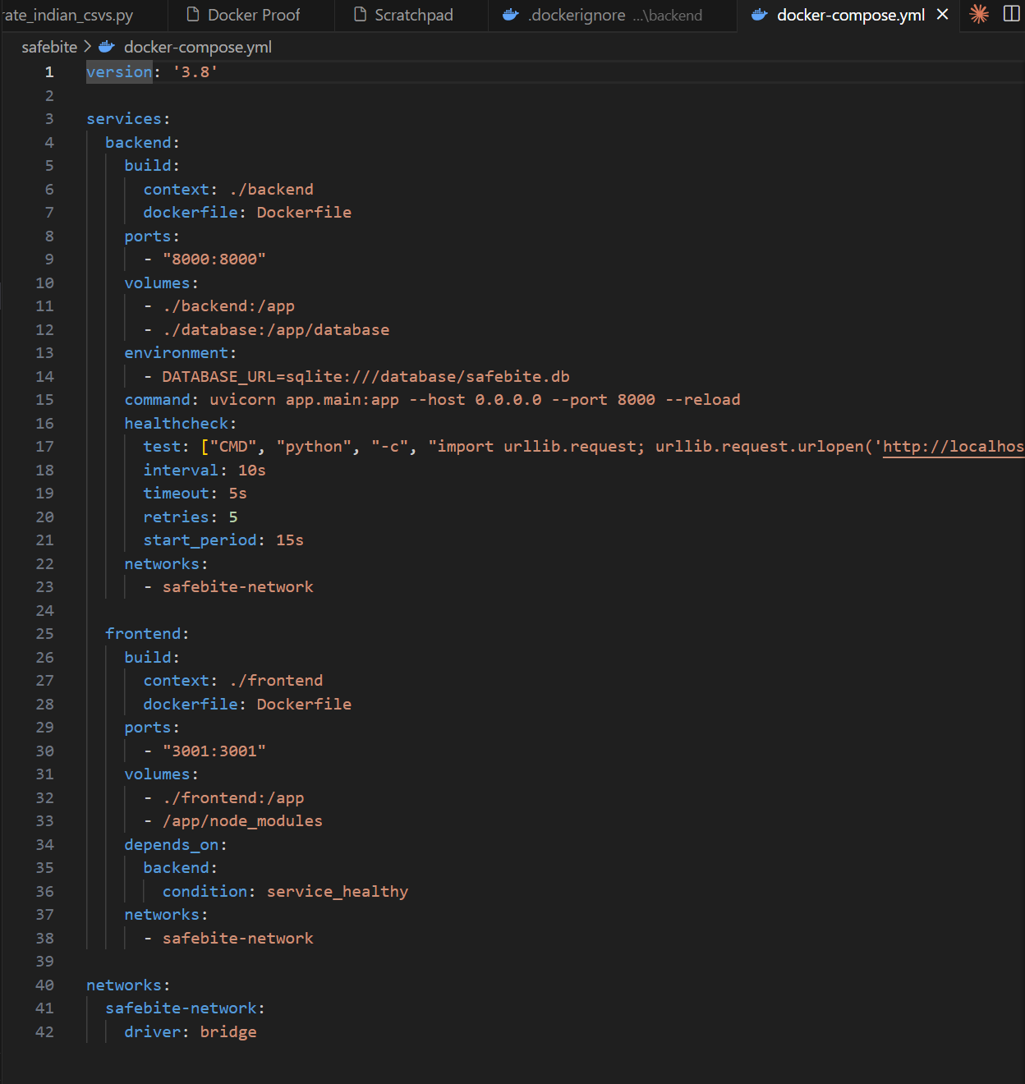

Terminal: docker-compose up --build (Building and running)
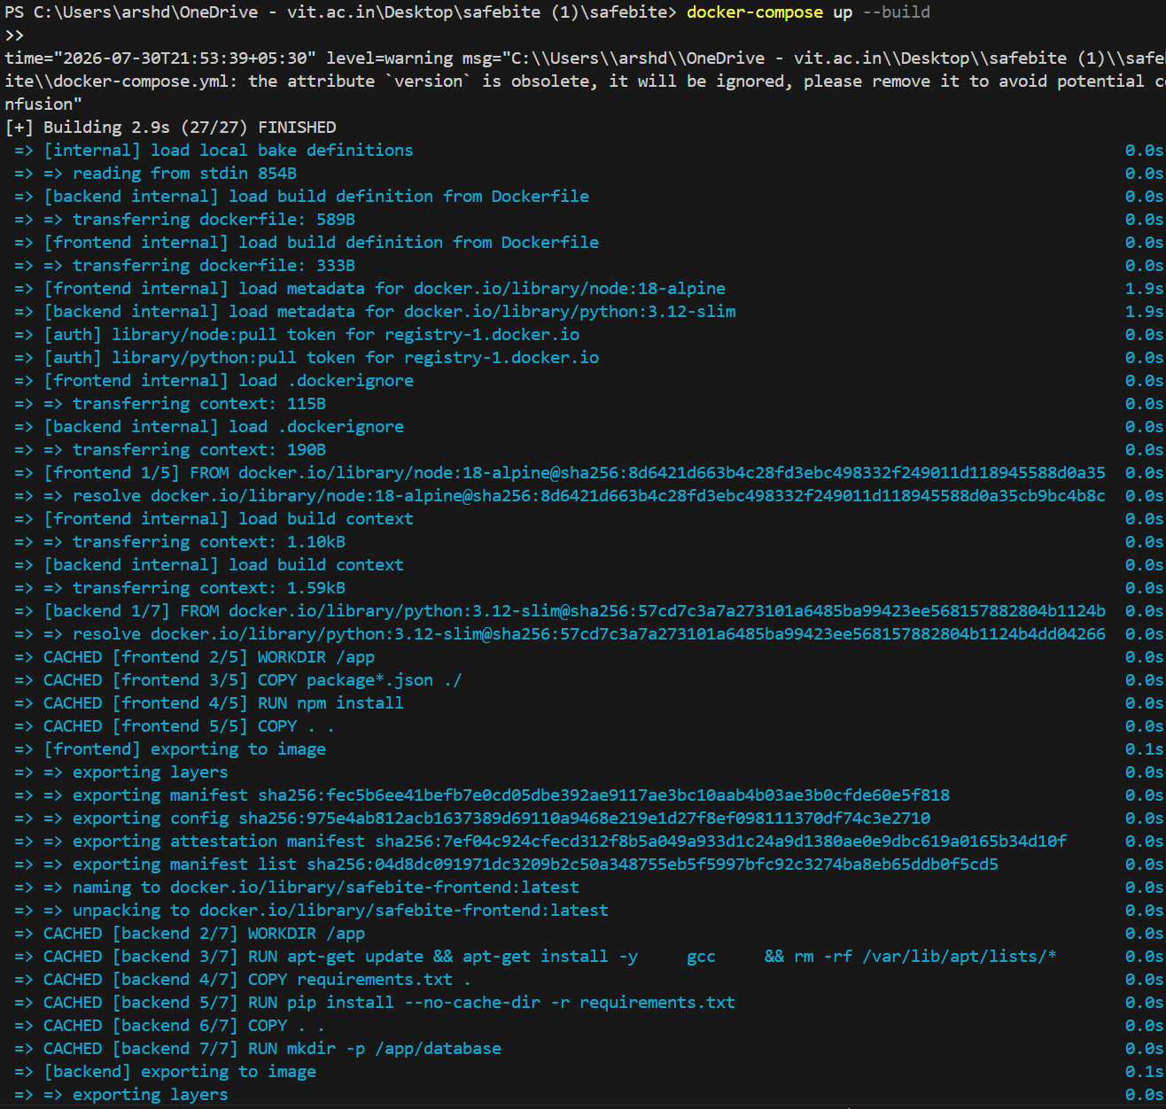

Terminal: Uvicorn and Vite servers running
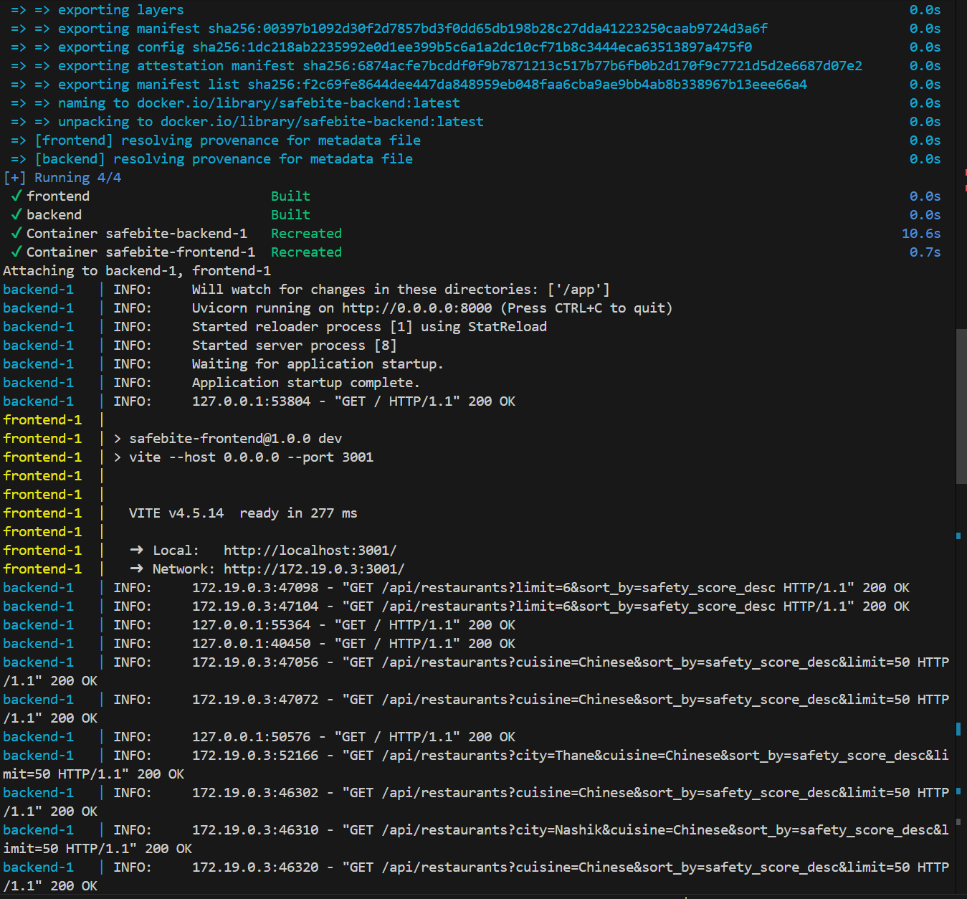

Docker Desktop showing healthy containers
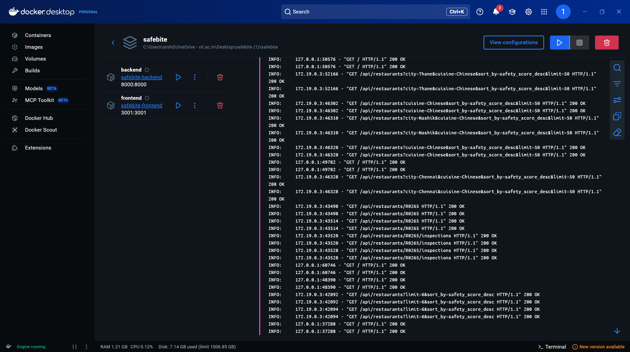

GitHub repository showing folder structure and branches
