Railway website

Arshdeep Singh

Continental institute of international studies

IMDW-18003

Asst. Prof. Amandeep Singh Sohal

November 12, 2018

DESCRIPTION

A site of train is the best and understood site. It contains all information about the courses of the rail and information about the deferment and dropped course of the train. The train voyaging is outstandingly terrible and pleasant. Since it cover the long partition in less periods when stood out from the vehicles and distinctive vehicles. It is like manner depicts the courses and entry portrayal of the trains. It is like manner consolidates the AC seats and essential seats as shown by choice of the voyagers. A voyager train includes two completions train and a couple of guides.

Application programming must be downloaded on to the compact handset. These convenient applications are utilitarian on most of the GPRS/Browser based PDAs, from basic model to top notch ones. Subsequent to beginning enlistment and downloading of sensible programming on the compact handset, it will be extremely straightforward for the flexible customers to book a hold ticket through their very own adaptable. Resulting to booking, the explorer will get a reservation message with full purposes of enthusiasm of the ticket including PNR, Train No, date of experience, class et cetera. This virtual message would be treated at standard with the print-out of the e-ticket. Showing the reservation message of the attested ticket on their adaptable in the midst of development will be sufficient. Adventures for booking Railway Reserved Ticket on IRCTC site from a program enabled wireless: Tap on Book Ticket and fill in inconspicuous components for plan my development. Select the train and continue with the booking. Use existing explorer rundown or incorporate voyagers. Confirm booking inconspicuous components and pay through Credit/charge card to get compelling

FEATURES:-

➢ Trains between stations-A railroad stop is a spot along a rail course line, generally between stations or at an occasionally used station, where voyagers can stack up and leave the train. While a crossing point or interlocking principle speaking isolates no less than two lines or courses, and thusly has remotely or secretly worked signs, a station stop does not.

➢ Running status of trains-Live train running status for Indian railroad trains suggests the right territory of any train and its nonstop concede status. It may in like manner join the assessed section of the train at a particular station in travel. Trains do recover time.

➢ Online ticket booking-An Internet booking engine (IBE) is a webpage that grants customers and travel administrators to book flights, hotels, event groups, insurance and diverse organizations on the web. An electronic ticket (generally consolidated as e-ticket) is the mechanized ticket similarity a paper ticket. The term is most frequently associated with bearer issued tickets. Electronic ticketing for urban or rail open transport is for the most part escaped to as development card or travel pass.

Purposes:

The explanation behind an organization based business site is to convince site visitors that they should twist up customers of the organization association. This is done by arranging the association as a dependable, trust honorable and experienced pro association in the goal showcase. Visitors will pre-screen potential pro associations by reviewing their locales already they make any phone calls. In the midst of this system, they are trying to find the best organization that will meet their particular needs. They are attempting to find out how master the association is the idea of the work they will get, paying little heed to whether the provider has a good reputation and to what degree the association has been working together. The explanation behind electronic business site is to pitch things to customers. The best destinations are decisively streamlined to achieve an abnormal state of purchases. To gain ground online business locales need to consolidate most of the latest electronic quiet and down offer techniques open which have been exhibited to extend the chances that a visitor will purchase. There are various basic segments that go into building a viable electronic business site, for instance, emptying contact in the midst of the purchasing strategy, making the checkout smooth and straightforward, making the site speedy and charming, up offering customers on related things, boosting buyers, reducing truck surrender, continuing past buyers to buy again, remarketing to past visitors who haven't yet gotten, using the right portion decisions, having a convenient arranged arrangement, et cetera.

Plan of action:

Rail transport is a strategy for trading of explorers and stock on wheeled vehicles running on rails, generally called tracks. It is moreover by and large insinuated as train transport. Rather than road transport, where vehicles continue running on a prepared level surface, rail vehicles (moving stock) are directionally guided by the tracks on which they run. Tracks as a general rule contain steel rails, presented on ties (sleepers) and offset, on which the moving stock, ordinarily fitted with metal wheels, moves. Diverse assortments are in like manner possible, for instance, segment track, where the rails are connected to a strong foundation laying on a prepared subsurface. Moving stock in a rail transport system generally encounters cut down frictional restriction than road vehicles, so voyager and load automobiles (carriages and wagons) can be coupled into longer trains. The movement is finished by a railroad association, giving transport between train stations or load customer workplaces. Power is given via trains which either draw electric power from a railroad shock system or make their own special limit, when in doubt by diesel engines. Most tracks are joined by a hailing structure. Railways are a protected land transport structure when stood out from various sorts of transport. Railroad transport is set up to do raised measures of voyager and load utilize and imperativeness efficiency, yet is as often as possible not so much versatile yet rather more capital-concentrated than road transport, while cut down movement levels are considered.

Case diagram

Passenger

Enquire

Right Details

Availability

Journey Details

Confirm

The work of passenger is firstly passenger enquire details, after that get right details, then check

Availability. Next step is get journey details, after confirm.

Deposit Funds

Open Account

Close Account

Withdraw Funds

Customer

For this situation chart, client right off the bat stores reserves. At that point client should open record, after that pull back assets. Finally, client should close record.

Verification

Get Details

Submit

Login

Issue Ticket

Successful

Penalty as per law

Unsuccessful

For this situation graph, the procedure of capacities is clarified. In first login account that as of now exists. From that point forward, present that subtle elements. At that point get subtle elements and confirm points of interest that you get as of late. On the off chance that the check is fruitful then you get Issued Ticket however in the event that confirmation unsuccessful then you need to pay punishment according to law.

Content designs:-

The railroad voyaging is terrible and safe. The organization orchestrating various philosophies to fulfill the desires for the all-inclusive community.

Login Page

A login, marking in or marking on is the entering of identifier information into a system by a customer with the true objective to get to that structure (e.g., a PC or a site). It is a crucial bit of PC security methodologies. A login generally requires the customer to enter two pieces of information, beginning a customer name and a while later a mystery word. This information is gone into a login window on a GUI (graphical UI) or on the request line in a help, dependent upon the structure and condition. A customer name, furthermore implied as a record name, is a string that strangely perceives a customer. Customer names can be the equal as or related to the honest to goodness names of customers, or they can be absolutely optional. A mystery word is in like way a string, anyway it contrasts from a customer name in that it is proposed to be kept a riddle that is known just to its customer and, perhaps, to the system administrator(s).

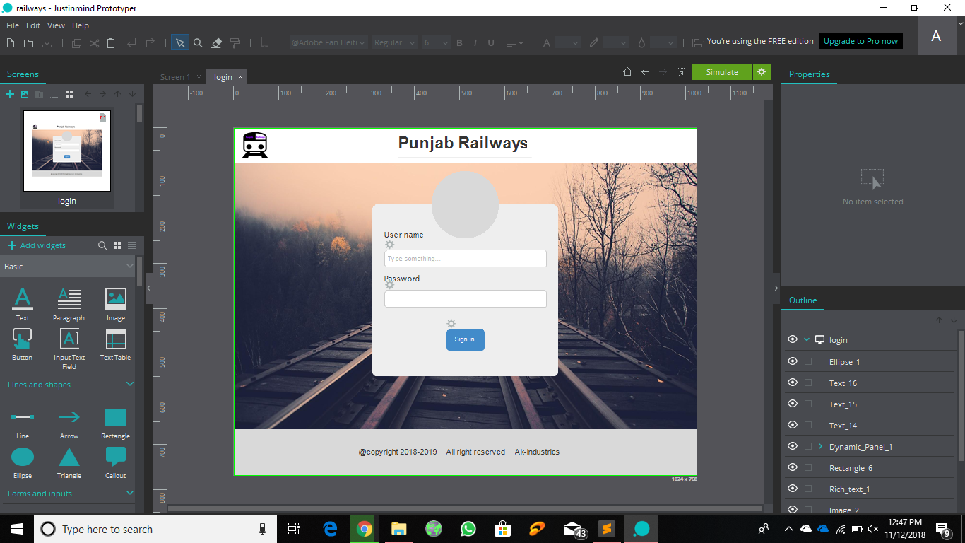

Fare Page

A toll is the money that you pay for a voyage that you make, for example, in a vehicle, train, or taxi. He could barely bear the expense of the railroad section taxi tolls. Comparable words: charge, esteem, ticket esteem, transport cost More Synonyms of confirmation uncountable thing.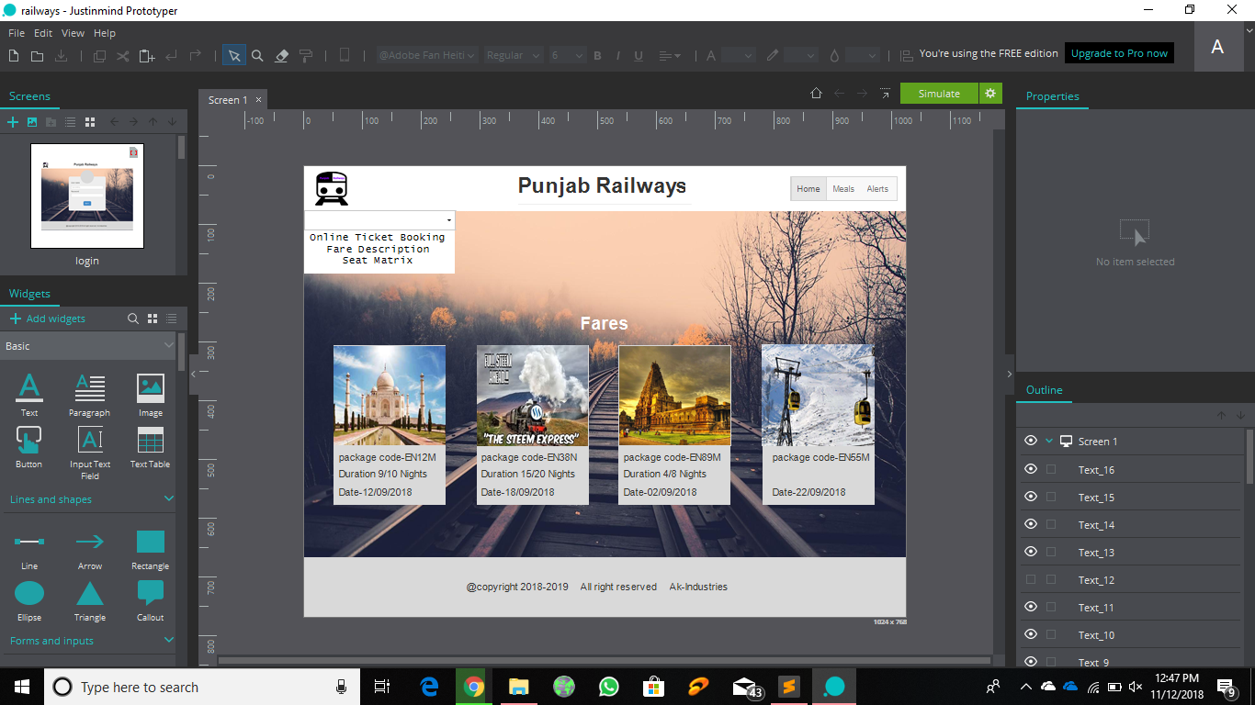

Seat Matrix

Most lessened class where the seats are in kind of seats could be with cushion. CC infers AC situate auto, usually favored for short partitions and is frequently found in Shatabdi trains. Seat structures resemble transport or flights.

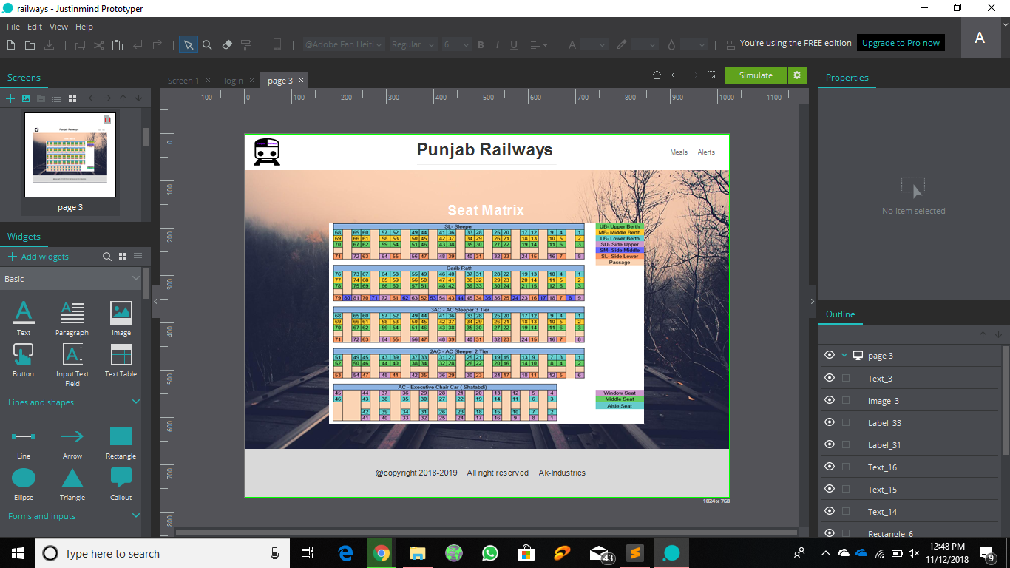

Ticket Booking

A train ticket is a ticket issued by a railroad chairman that engages the transporter to go on the manager's framework or an associate's framework.

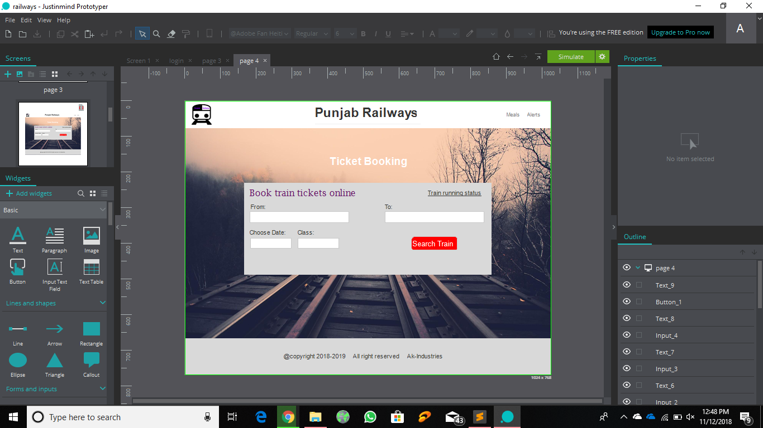

Train running status

Live train running status for Indian railroad trains suggests the right zone of any train and its progressing puts off status. It may in like manner fuse the evaluated passage of the train at a particular station in transit. Trains do recover time particular station in transit. Trains do recover time.

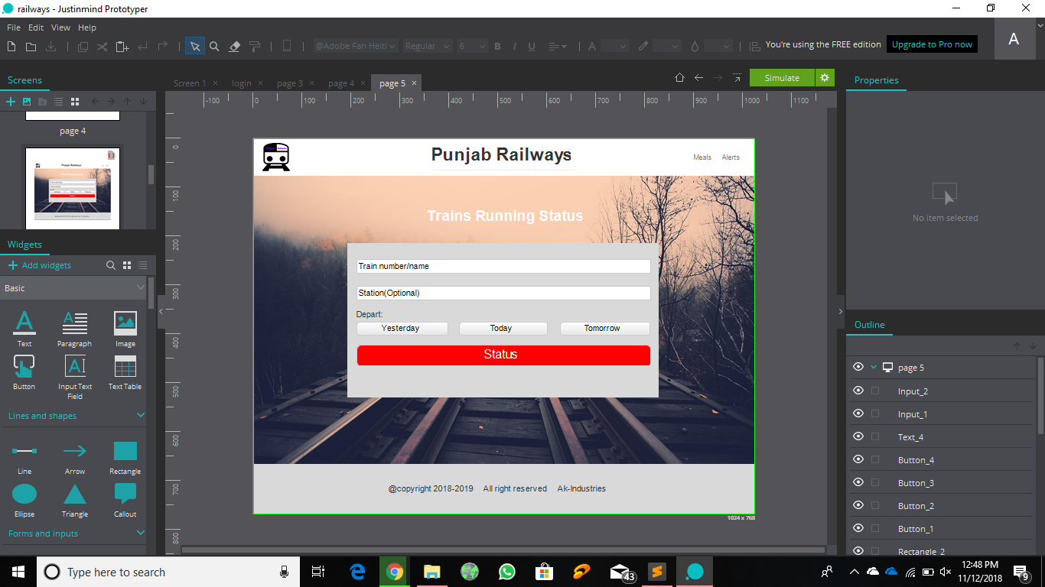

Train between stations

A train, generally an explorer advantage that continues running forward and in reverse, as a rule over a respectably short division, for instance, between a crossing point station and a branch-line end.

