BOOKMYTURF
Software Engineering & Project Management
Complete Project Documentation
Online Booking System for Sports Turfs and Courts

Project Detail | Value
Project | BookMyTurf – Online Booking for Sports Turfs and Courts
Course | Software Engineering & Project Management
Student | Arsheel Patel
Program | B.Tech Computer Science & Engineering
Academic Level | Semester III Case Study
Project Duration | 8 weeks
Team Size | 3 members
Location in Case Study | Hyderabad
Version | 1.0 – Submission Documentation

Document Control
Version | Date | Description | Owner
1.0 | October 2026 | Complete SEPM case-study documentation | Arsheel Patel

Important Data Integrity Note
Values explicitly given in the case study are treated as case facts. PERT values, loss calculations, schedule calculations and capacity are calculated from those facts. The refund policy is an academic assumption because the case study does not specify refund percentages. Defect density, DRE and actual response-time measurements are not claimed as real unless supported by an actual test log. Any illustrative examples are labelled as such.

Table of Contents
1. Executive Summary
2. Problem Statement and Scope
3. Stakeholders and Elicitation Plan
4. Software Requirements Specification (SRS)
5. MoSCoW Prioritization
6. System Architecture and Design Principles
7. UML Package
8. Estimation Sheet
9. Project Planning and Scheduling
10. Resource Allocation
11. Test Plan and Evidence
12. Risk Register and RMMM
13. Requirements Traceability Matrix
14. Issue Log and Closure Note
15. Viva / Presentation Guide
Appendices

1. Executive Summary
BookMyTurf is an online sports-facility booking system designed for a sports facility owner operating 7 football turfs and 5 badminton courts in Hyderabad. The existing phone-based process creates operational problems: double bookings occur, weekend slots may be held without payment, and the owner lacks visibility into slot profitability.
The proposed system provides live slot availability, temporary slot holds, advance payment, cancellation and refund processing, administration, and revenue reporting. The engineering plan is constrained by a fixed 8-week launch, a 3-person team and two parallel feature streams.
Business Metric | Value | Basis
Affected bookings per month | 23 | 9 double bookings + 14 unpaid no-shows
Average slot price | ₹1,400 | Case study input
Estimated monthly loss | ₹32,200 | 23 × ₹1,400
Annualized loss | ₹386,400 | ₹32,200 × 12
Calendar capacity | 40 working days | 8 weeks × 5 days
PERT person-day estimate | 32.17 | Sum of feature/task PERT estimates
Nominal capacity buffer | 7.83 person-days | 40 − 32.17

2. Problem Statement and Scope

2.1 Problem Statement
The owner currently accepts bookings by phone. Manual coordination makes it possible for two customers to receive the same slot, while unpaid reservations create weekend no-shows and prevent reliable revenue forecasting. The absence of a dashboard also makes it difficult to identify profitable facilities and time periods.

2.2 In Scope
- Player registration/login and booking history
- Facility and sport browsing
- Slot calendar and live availability
- Server-side double-booking prevention
- Temporary slot hold during payment
- Advance payment integration
- Cancellation and rule-based refund calculation
- Admin facility and booking management
- Revenue dashboard and reporting
- Testing, risk management, traceability and project controls

2.3 Out of Scope
- AI-based recommendations
- Loyalty/membership program
- Tournament management
- Native mobile applications
- Live chat
- Advanced marketing automation

2.4 Constraints
- Fixed launch date of 8 weeks
- 3-person freelance team
- 40 working days of calendar time
- Two features can be developed in parallel
- Scope may be reduced but launch date cannot move
- Payment gateway depends on an external provider

2.5 Assumptions
- A payment gateway provides payment and refund APIs.
- The database can enforce transactional slot uniqueness/locking.
- The refund policy used for testing is an academic assumption: ≥24h = 100%, 12–23h = 75%, 2–11h = 50%, <2h = 0%.
- The actual deployed software may use different UI labels or providers; this document describes the SEPM target system.

3. Stakeholders and Elicitation Plan
Stakeholder | Need / Concern | Elicitation Method
Player | Fast booking, availability, secure payment, cancellation | Questionnaire + prototype walkthrough
Owner/Admin | No double booking, revenue visibility, facility management | Interview + dashboard walkthrough
Staff | Simple booking/admin operations | Observation + task walkthrough
Payment Provider | Valid payment/refund requests | API/integration review
Project Team | Feasible scope within fixed deadline | Planning workshop

4. Software Requirements Specification (SRS)

4.1 Functional Requirements
ID | Requirement | Description
FR-01 | User Registration/Login | System shall allow users to register and authenticate securely.
FR-02 | Browse Facilities | Player shall browse football turfs and badminton courts.
FR-03 | View Slot Availability | System shall show availability by facility, date and time.
FR-04 | Prevent Double Booking | System shall ensure at most one confirmed booking for a facility/date/time slot.
FR-05 | Create Booking | Player shall create a booking for an available slot.
FR-06 | Advance Payment | System shall initiate and verify advance payment before confirmation.
FR-07 | Cancel Booking | Player shall cancel an eligible booking according to policy.
FR-08 | Calculate/Process Refund | System shall calculate the refund percentage and initiate refund processing when eligible.
FR-09 | Admin Management | Admin shall manage facilities, slots and bookings.
FR-10 | Revenue Dashboard | Admin shall view revenue and booking performance by facility/time period.

4.2 Non-Functional Requirements
ID | Quality Attribute | Measurable Target
NFR-01 | Double-booking integrity | 0 confirmed double bookings under normal operation.
NFR-02 | Concurrency | For concurrent attempts on the same slot, at most one request shall reach CONFIRMED.
NFR-03 | Payment response | ≥99% of valid payment requests shall receive a definitive success/failure response, excluding provider outages.
NFR-04 | Availability response | ≥95% of slot availability requests shall complete in <2 seconds under normal load.
NFR-05 | Booking response | ≥95% of booking confirmation requests shall complete in <3 seconds, excluding gateway processing.
NFR-06 | Availability | 99.5% monthly service availability excluding scheduled maintenance.
NFR-07 | Refund processing | Valid cancellation shall calculate refund and initiate refund within 5 seconds after validation.

4.3 Core Use Cases
Use Case | Primary Actor | Precondition | Main Result
UC-01 Register/Login | Player | Account not authenticated | Authenticated session created
UC-02 Browse Facilities | Player | System available | Facilities displayed
UC-03 View Availability | Player | Facility/date selected | Available/held/booked slots shown
UC-04 Book and Pay | Player + Payment Gateway | Slot available | Confirmed booking after successful payment
UC-05 Cancel & Refund | Player + Payment Gateway | Eligible confirmed booking | Booking cancelled and refund initiated
UC-06 Manage Facilities | Admin | Admin authenticated | Facility/slot data updated
UC-07 Manage Bookings | Admin | Admin authenticated | Bookings reviewed/updated
UC-08 Revenue Reporting | Admin | Bookings/payments available | Revenue metrics displayed

5. MoSCoW Prioritization
Must Have | Should Have | Could Have | Won’t Have
Slot availability | Booking history | Coupons | AI recommendations
Double-booking prevention | Email confirmation | Reviews | Loyalty program
Booking + payment | Exportable reports | Maps | Tournament management
Cancellation + refunds | Enhanced notifications | Memberships | Native mobile app
Admin management |  | Live chat | Advanced marketing automation
Revenue dashboard

6. System Architecture and Design Principles
The architecture separates presentation, booking/domain logic, payment integration, refund logic, reporting and persistence. This reduces coupling and improves cohesion. Booking logic should depend on a payment service interface/adapter rather than a gateway-specific implementation.
Layer / Module | Responsibility | Design Goal
Web/UI | Facility browsing, slot calendar, booking forms, dashboards | Usability; thin presentation layer
Booking Service | Availability, holds, confirmation, cancellation | High cohesion around booking lifecycle
Payment Service | Create/verify payment, gateway adapter | Low coupling to provider
Refund Service | Refund rule calculation and initiation | Isolated policy logic
Revenue Service | Aggregations and reports | Read-oriented reporting logic
Database | Users, facilities, slots, bookings, payments, refunds | Integrity + transactions
Payment Gateway | External payment processing | External dependency isolated by adapter

6.1 Double Booking Prevention
The frontend must never be the only protection. The server/database should atomically verify and reserve a slot, then create a temporary HOLD. A unique constraint or transaction/locking strategy must prevent two concurrent requests from both confirming the same slot.

6.2 Payment Failure and Recovery
If payment fails or times out, the held slot returns to AVAILABLE. If a payment succeeds but confirmation fails, the system must retain the payment reference, reconcile the transaction and either complete confirmation safely or initiate a controlled refund. A successful payment must never silently disappear.

7. UML Package
The following five diagrams are designed as separate large-format figures so they can be embedded individually in the project website. The diagrams use the same actors, classes, booking lifecycle and payment flow, maintaining internal consistency.

7.1 Use Case Diagram
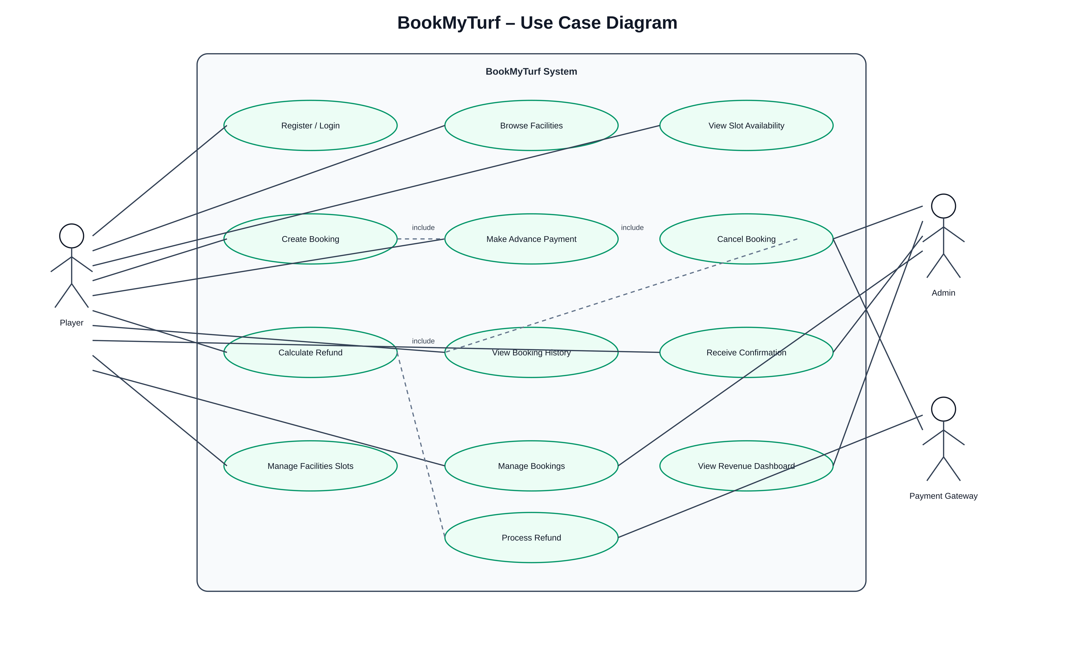
Actors: Player, Admin and Payment Gateway. The diagram maps user goals to system capabilities and shows payment/refund interaction.

7.2 Class Diagram
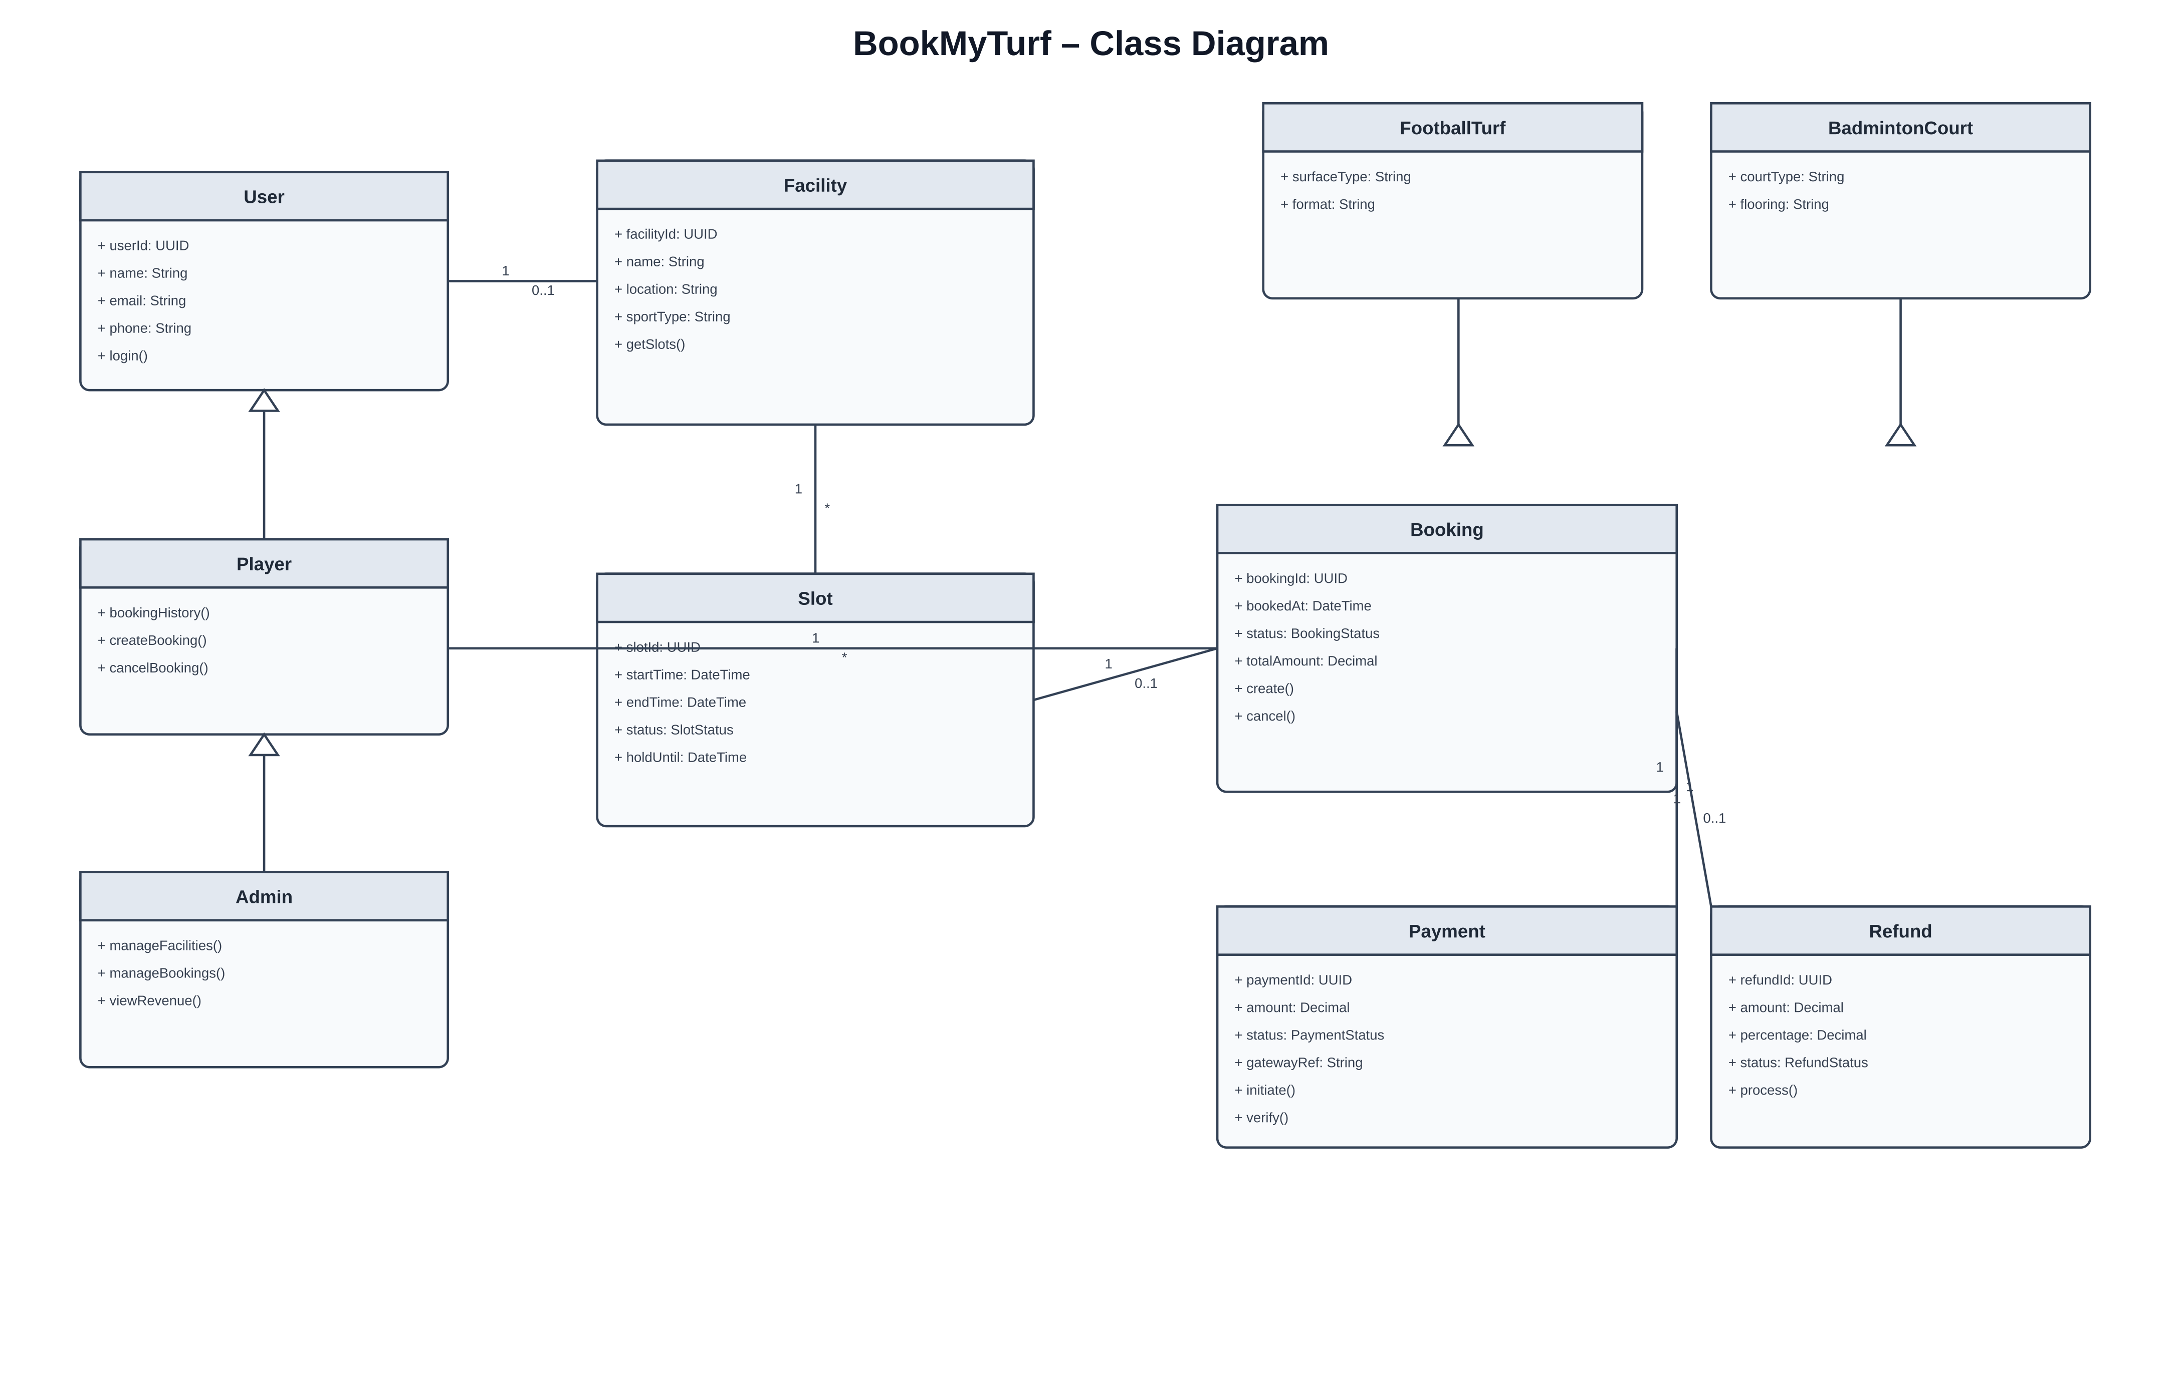
Core domain model: User, Player, Admin, Facility, Slot, Booking, Payment and Refund, with sports-specific facility types.

7.3 Sequence Diagram
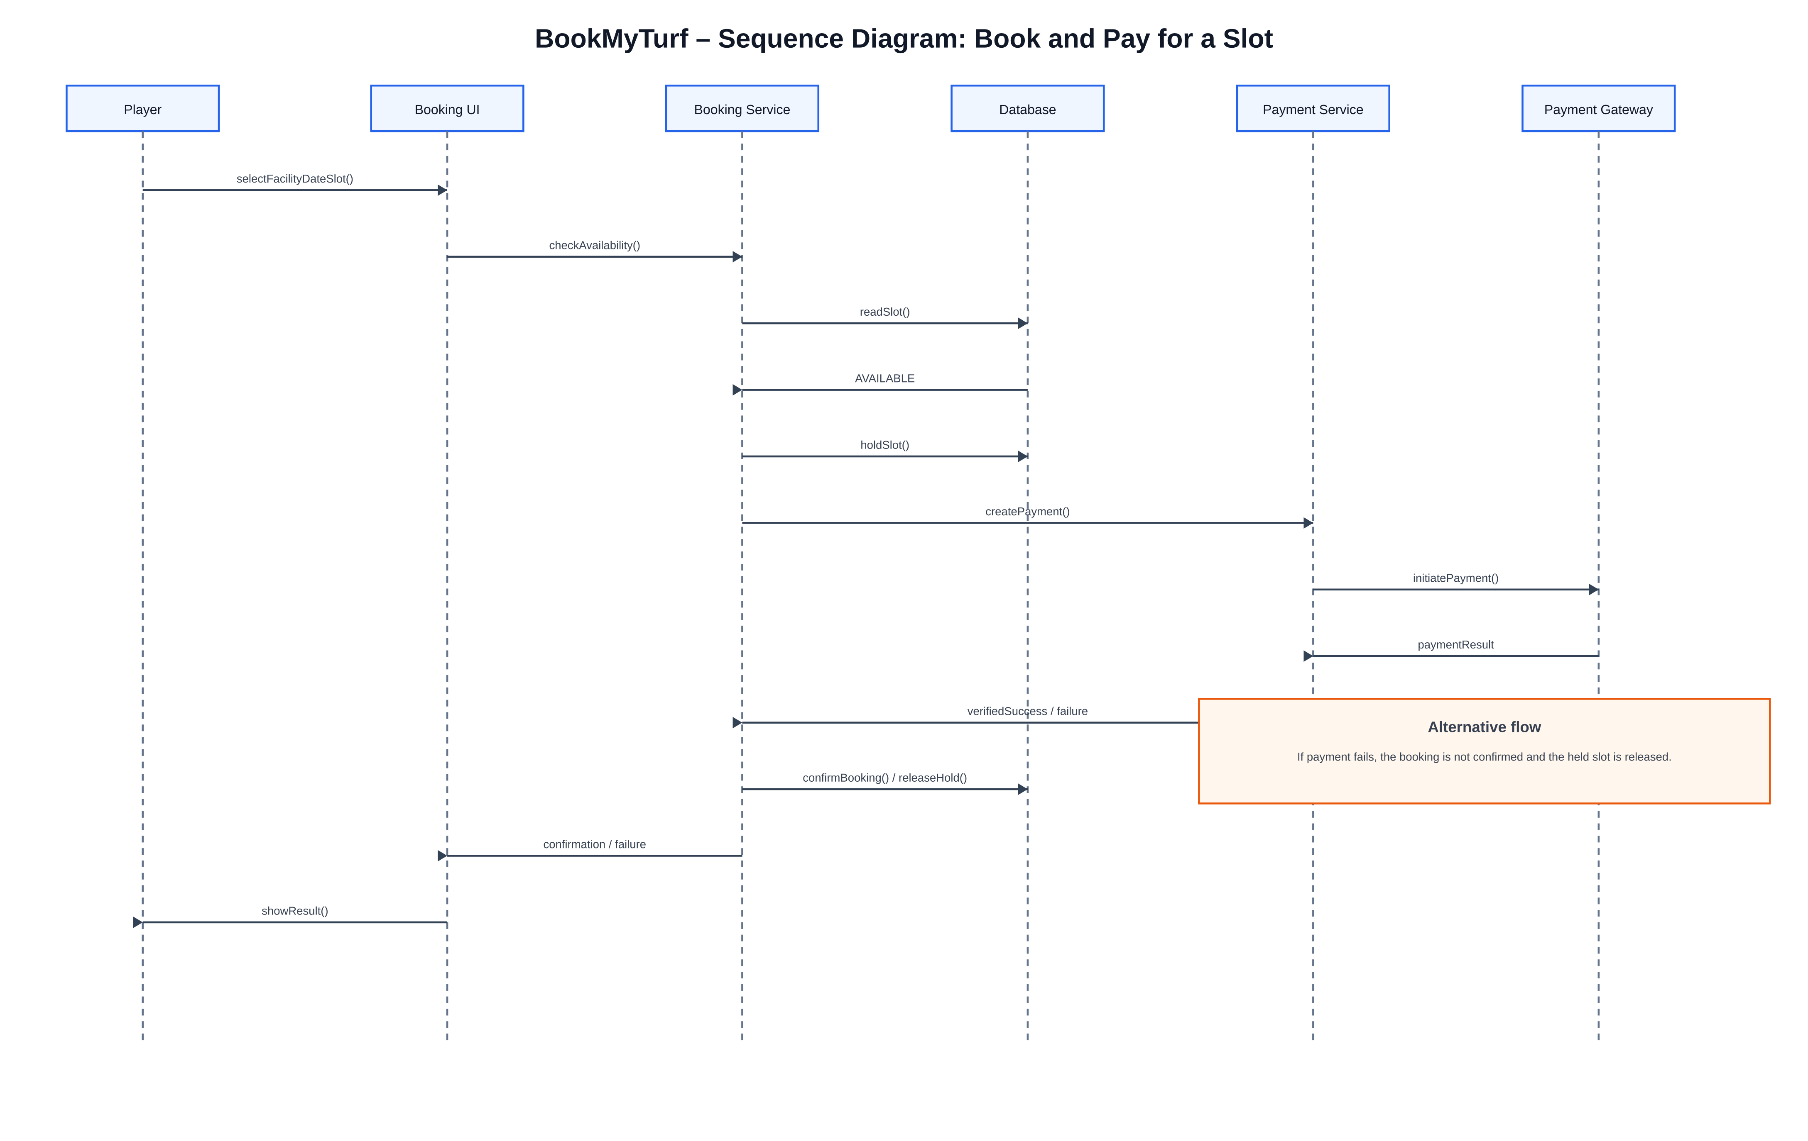
Detailed Book-and-Pay interaction, including availability check, temporary hold, payment gateway response and confirmation/release.

7.4 Activity Diagram
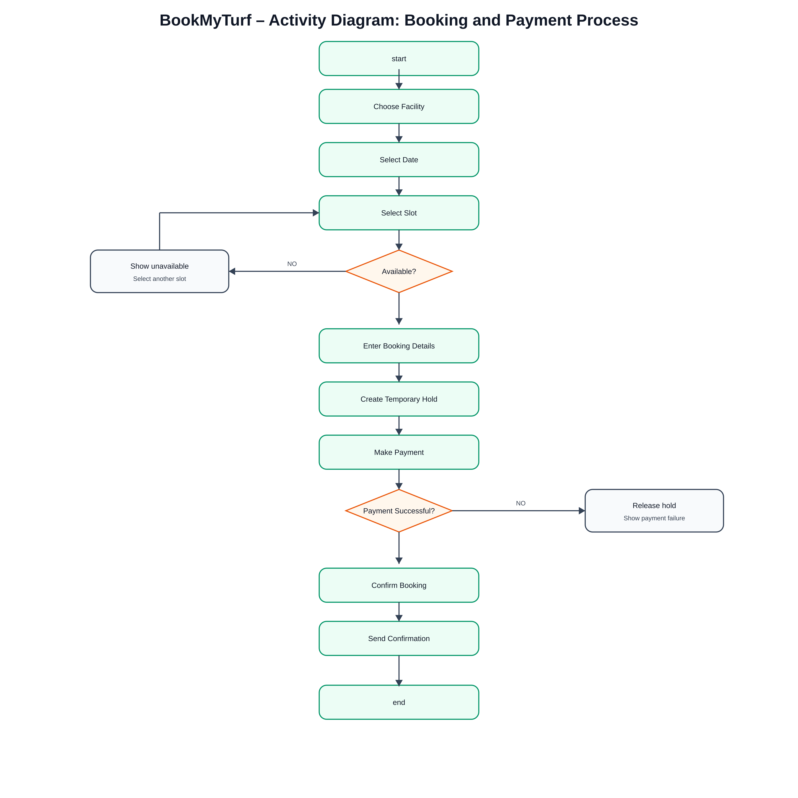
Workflow from facility selection to payment and confirmation, with explicit unavailable-slot and payment-failure branches.

7.5 State Diagram
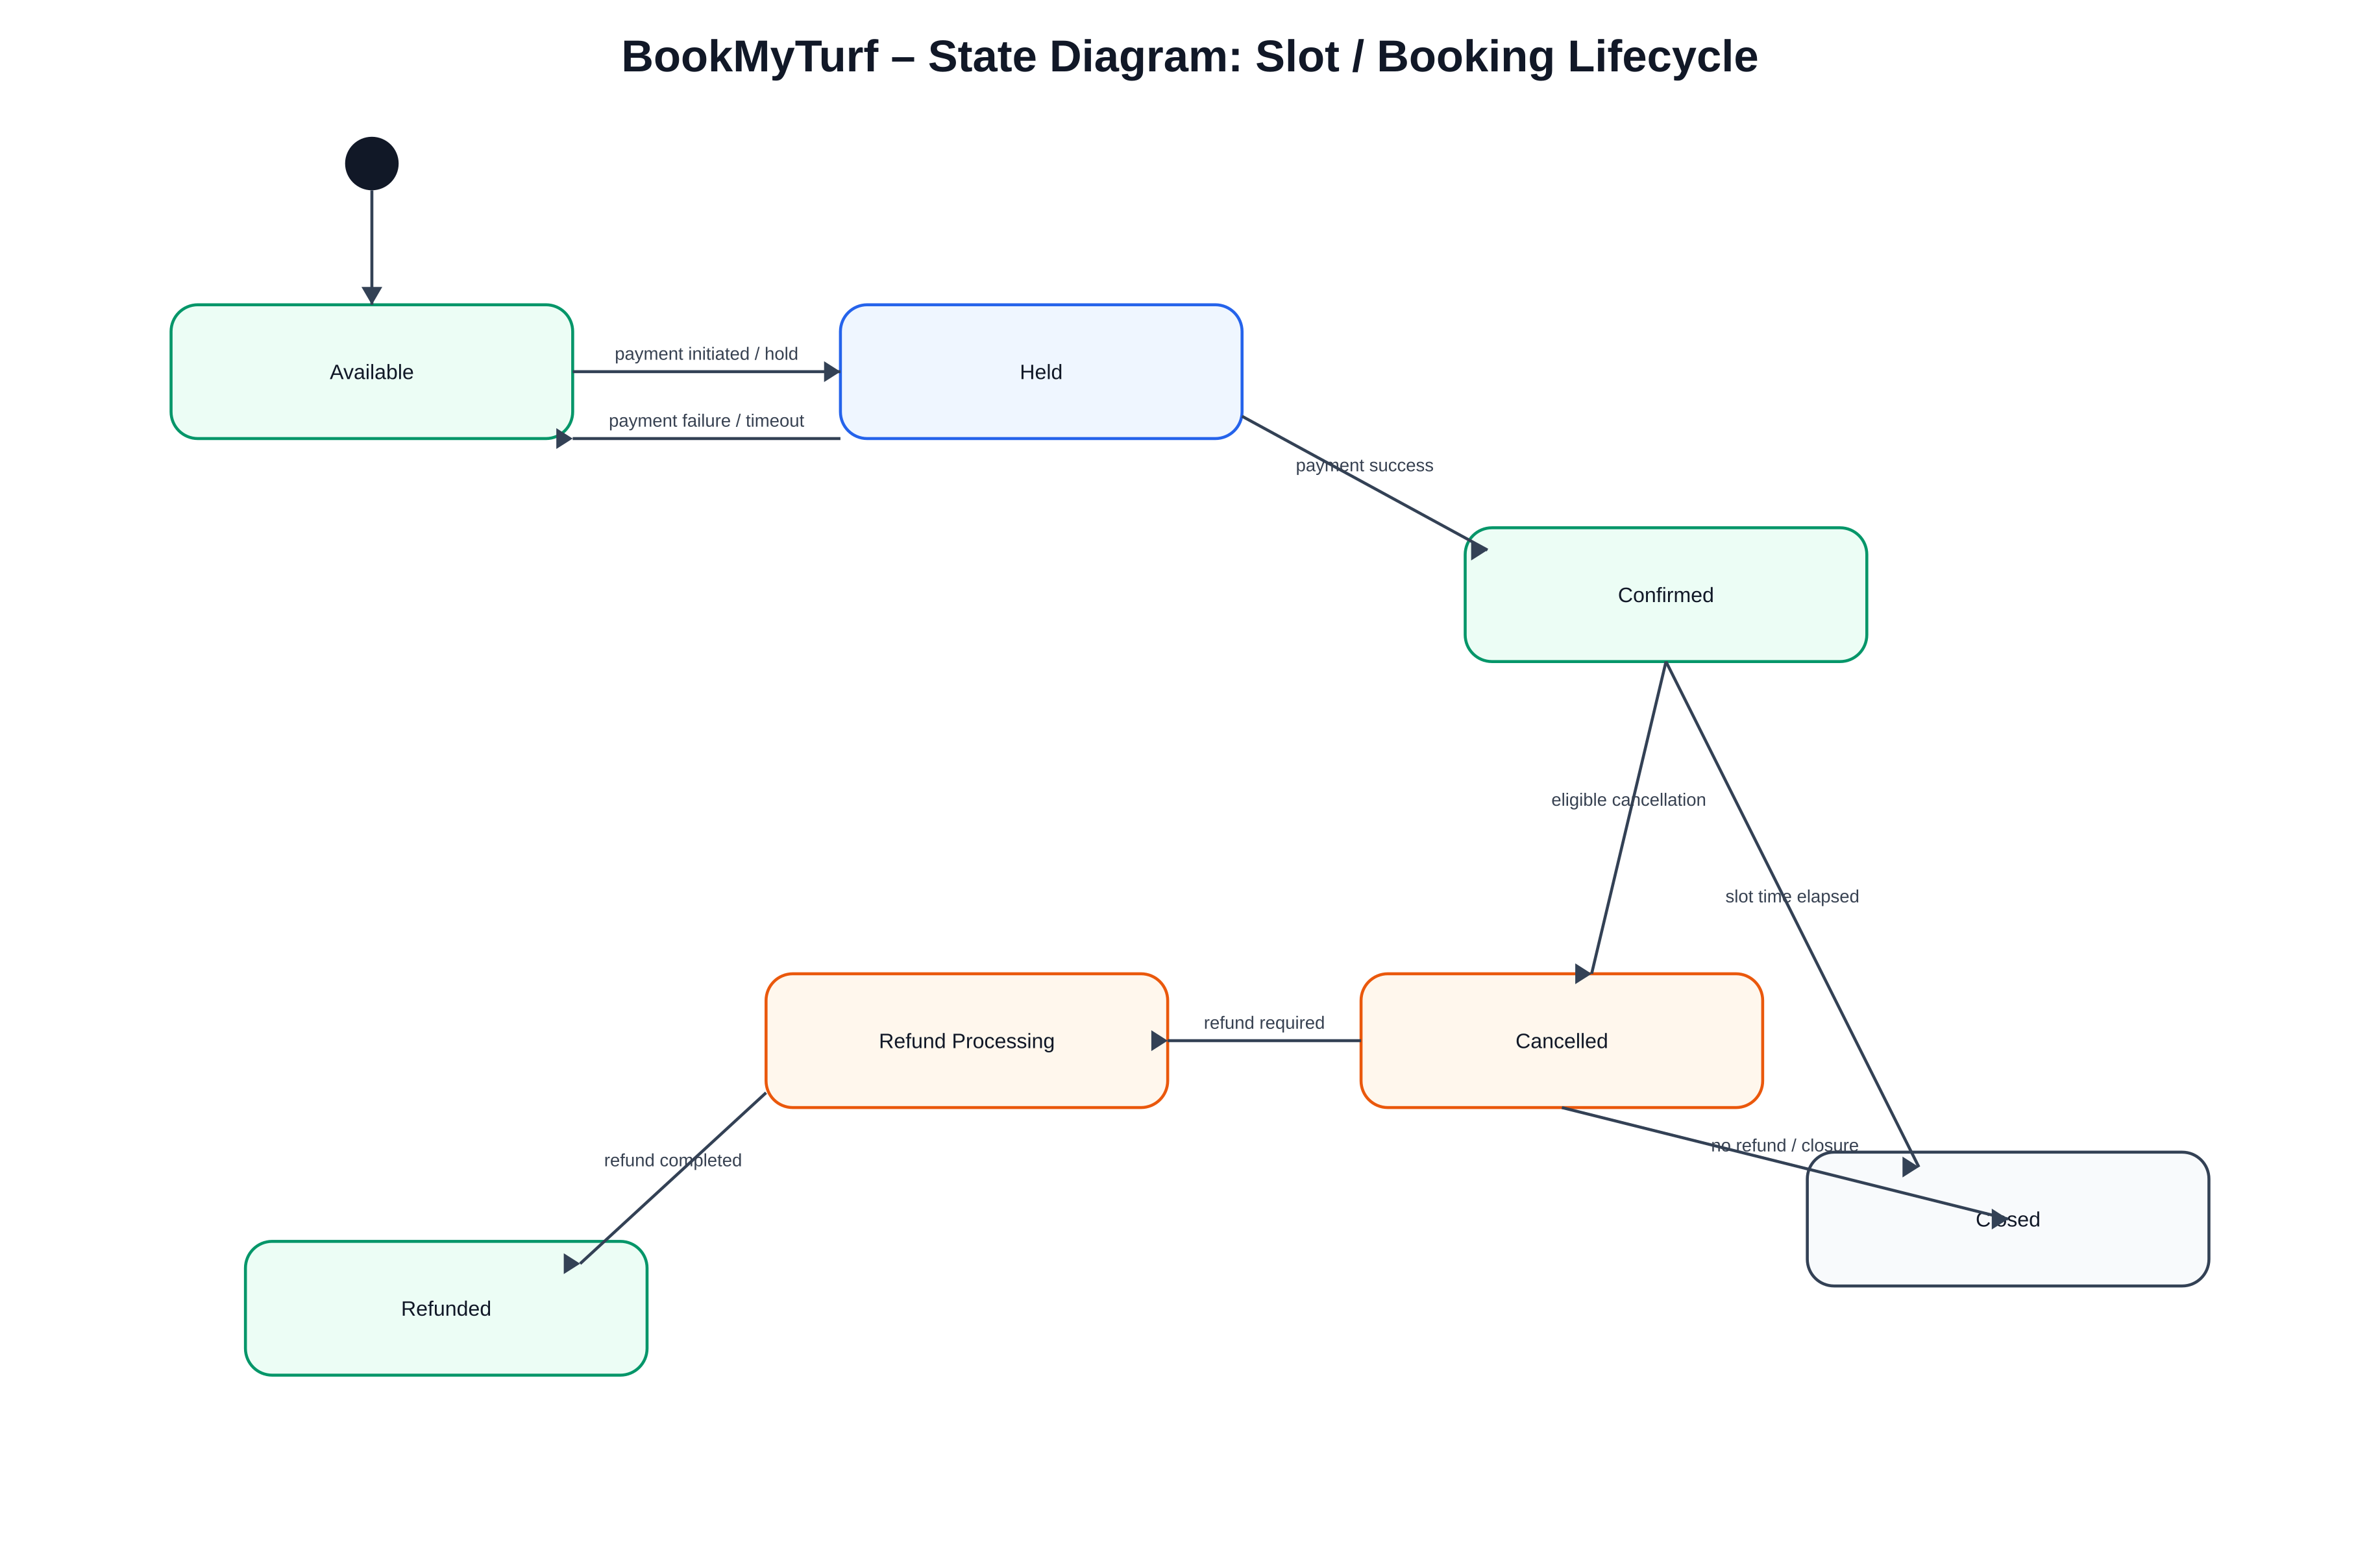
Slot/booking lifecycle showing Available, Held, Confirmed, Cancelled, Refund Processing, Refunded and Closed states.

8. Estimation Sheet
PERT expected time is calculated as TE = (O + 4M + P) / 6. The resulting values are estimates, not guarantees.
Task | Optimistic O | Most Likely M | Pessimistic P | PERT TE
Slot Calendar | 5 | 8 | 14 | 8.50
Payments & Refunds | 4 | 7 | 13 | 7.50
Revenue Dashboard | 3 | 4 | 9 | 4.67
Admin Panel | 3 | 5 | 8 | 5.17
Testing | 4 | 6 | 10 | 6.33
Total | Available Calendar | Nominal Buffer
32.17 person-days | 40 working days | 7.83 days
Capacity note: the 40-day figure is calendar capacity for the project window, while PERT totals represent estimated effort. Parallel work by the three-person team makes the calendar schedule shorter than the sum of all person-days.

9. Project Planning and Scheduling

9.1 Work Breakdown Structure
- 1. Requirements Engineering
- 1.1 Stakeholder analysis; 1.2 Elicitation; 1.3 SRS; 1.4 MoSCoW; 1.5 Traceability baseline
- 2. System Design
- 2.1 Architecture; 2.2 Use Case; 2.3 Class; 2.4 Sequence; 2.5 Activity; 2.6 State
- 3. Development
- 3.1 Slot Calendar; 3.2 Payments & Refunds; 3.3 Admin Panel; 3.4 Revenue Dashboard; 3.5 Integration
- 4. Testing
- 4.1 Functional tests; 4.2 BVA; 4.3 Equivalence classes; 4.4 Decision table; 4.5 Defect logging; 4.6 Regression
- 5. Release
- 5.1 Deployment; 5.2 Acceptance; 5.3 Closure documentation

9.2 Network / Forward Pass
ID | Task | Duration (days) | Predecessor | ES | EF | Float
R1 | Requirements | 3 | – | 0 | 3 | 0
D1 | Architecture & UML | 3 | R1 | 3 | 6 | 0
S1 | Slot Calendar | 9 | D1 | 6 | 15 | 0
P1 | Payments & Refunds | 8 | D1 | 6 | 14 | 6
A1 | Admin Panel | 5 | S1 | 15 | 20 | 0
V1 | Revenue Dashboard | 5 | A1, P1 | 20 | 25 | 0
T1 | Testing | 6 | V1 | 25 | 31 | 0
DEP | Deployment / Release | 1 | T1 | 31 | 32 | 0
Forward-pass formulas: ES = maximum predecessor EF; EF = ES + duration. The critical path is the longest dependency path with zero float. For this calendar model the critical path is R1 → D1 → S1 → A1 → V1 → T1 → DEP = 32 working days. Payments & Refunds has 6 working days of float in this simplified network.

9.3 Gantt Plan
Task | W1 | W2 | W3 | W4 | W5 | W6 | W7 | W8
Requirements | ██
Architecture & UML |  | ██
Slot Calendar |  | ██ | ██ | ██
Payments & Refunds |  | ██ | ██ | ██
Admin Panel |  |  |  | ██ | ██
Revenue Dashboard |  |  |  |  | ██ | ██
Testing |  |  |  |  |  | ██ | ██
Deployment / Release |  |  |  |  |  |  |  | ██

9.4 Milestones
Milestone | Target | Definition of Done
M1 | End of Day 6 | Requirements, architecture and UML baseline approved
M2 | End of Day 20 | Core booking, payment, admin and integration baseline complete
M3 | End of Day 32 | Release candidate tested and deployment-ready

10. Resource Allocation
Team Role | Primary Responsibilities | Peak Focus
Developer 1 – Frontend/UI | Slot calendar, player flows, responsive UI | Slot Calendar + booking UX
Developer 2 – Backend/Integration | Booking service, DB integrity, payment/refund integration | Booking + Payments
Developer 3 – Admin/QA/DevOps | Admin panel, revenue dashboard, testing, deployment and evidence | Admin + Revenue + QA
The team can rebalance effort when a stream finishes early. Payment gateway approval is treated as a project risk because it is an external dependency.

11. Test Plan and Evidence

11.1 Test Strategy
- Functional testing for every FR.
- Boundary Value Analysis for hours-before-slot cancellation input.
- Equivalence partitioning for refund bands.
- Decision-table testing for cancellation/refund rules.
- Concurrency testing for double-booking prevention.
- Integration testing for payment success/failure/refund callbacks.
- Regression testing after booking/payment changes.
- Acceptance testing against the SRS and traceability matrix.

11.2 BVA – Hours Before Slot
Boundary | Test Inputs (hours) | Expected Rule
24h boundary | 23, 24, 25 | 23h = 75%; 24h and 25h = 100%
12h boundary | 11, 12, 13 | 11h = 50%; 12h and 13h = 75%
2h boundary | 1, 2, 3 | 1h = 0%; 2h and 3h = 50%
Lower invalid boundary | -1, 0, 1 | -1 invalid; 0 and 1 = 0%

11.3 Equivalence Classes
Class | Input Range | Expected Refund
EC-1 | ≥24 hours | 100%
EC-2 | 12–23 hours | 75%
EC-3 | 2–11 hours | 50%
EC-4 | <2 hours | 0%
EC-5 | Negative input | Invalid input

11.4 Decision Table
Rule | ≥24h | 12–23h | 2–11h | <2h | Refund
R1 | Y | N | N | N | 100%
R2 | N | Y | N | N | 75%
R3 | N | N | Y | N | 50%
R4 | N | N | N | Y | 0%

11.5 Test Case Template
TC ID | FR | Scenario | Input / Precondition | Expected | Actual | Status | Defect ID
TC-001 | FR-03 | View available slot | Valid facility/date | Available slots shown | To execute | Pending | –
TC-002 | FR-04 | Concurrent booking attempt | Two users request same slot | Only one confirmed | To execute | Pending | –
TC-003 | FR-06 | Successful payment | Valid gateway success | Booking confirmed | To execute | Pending | –
TC-004 | FR-06 | Payment failure | Gateway failure | Slot released; no confirmation | To execute | Pending | –
TC-005 | FR-08 | Refund at 24h | 24h before slot | 100% refund | To execute | Pending | –

11.6 Defect Density and DRE
Defect Density = confirmed defects / KLOC. DRE = defects removed before release / (defects removed before release + defects found after release) × 100. Because no verified execution log was supplied with this documentation request, the report does not claim actual defect density or DRE values. These metrics should be populated after the project test log is finalized.
Metric | Formula | Status
Defect Density | Confirmed defects ÷ KLOC | Pending actual test log
DRE | Pre-release defects ÷ (Pre-release + Post-release defects) × 100 | Pending actual defect data

12. Risk Register and RMMM
ID | Risk | P | I | Exposure | Rank | Mitigation | Monitoring | Owner
R1 | Payment gateway approval delay | 4 | 5 | 20 | High | Apply early; use sandbox/mock gateway; track approval weekly | Approval status / integration readiness | Project Lead
R2 | Refund disputes | 3 | 5 | 15 | High | Publish refund rules; store audit trail; validate calculation | Refund failures/disputes | Backend Lead
R3 | Double-booking defect | 3 | 5 | 15 | High | DB uniqueness/locking; concurrency tests | Conflict/error logs | Backend Lead
R4 | Requirements change | 3 | 4 | 12 | Medium | MoSCoW; change control; freeze Must items | Change requests | Project Lead
R5 | Payment integration failure | 2 | 5 | 10 | Medium | Adapter; sandbox tests; retry/reconciliation | Gateway errors | Backend Lead
R6 | Team unavailability | 2 | 4 | 8 | Medium | Document work; cross-train; buffer | Task slippage | Project Lead

12.1 Probability-Impact Matrix
Impact \ Probability | 1 | 2 | 3 | 4 | 5
1 | 1 | 2 | 3 | 4 | 5
2 | 2 | 4 | 6 | 8 | 10
3 | 3 | 6 | 9 | 12 | 15
4 | 4 | 8 | 12 | 16 | 20
5 | 5 | 10 | 15 | 20 | 25
RMMM means Risk Reduction, Monitoring and Management. The top three risks are gateway approval delay, refund disputes and double-booking defects because they have the highest exposure and direct business impact.

12.2 Issue Log
Issue ID | Issue / Event | Date | Impact | Action | Owner | Status
I-001 | Populate during actual execution | TBD | TBD | Record actual occurred problems separately from risks | Project Lead | Open

13. Requirements Traceability Matrix
FR ID | Requirement | Primary Test Case | Design Evidence
FR-01 | User Registration/Login | TC-001 | Design / UML package
FR-02 | Browse Facilities | TC-002 | Design / UML package
FR-03 | View Slot Availability | TC-003 | Design / UML package
FR-04 | Prevent Double Booking | TC-004 | Design / UML package
FR-05 | Create Booking | TC-005 | Design / UML package
FR-06 | Advance Payment | TC-006 | Design / UML package
FR-07 | Cancel Booking | TC-007 | Design / UML package
FR-08 | Calculate/Process Refund | TC-008 | Design / UML package
FR-09 | Admin Management | TC-009 | Design / UML package
FR-10 | Revenue Dashboard | TC-010 | Design / UML package
Traceability rule: every functional requirement must map to at least one test case. For a final submission, add actual test execution status and defect IDs to this matrix.

14. Issue Log and Closure Note

14.1 Verification vs Validation
Concept | Meaning | BookMyTurf Example
Verification | Are we building the product correctly? | Check SRS coverage, UML consistency, code reviews, test execution.
Validation | Are we building the right product? | Confirm players can book successfully and the owner gets usable revenue visibility.

14.2 Closure Criteria
- All Must Have requirements implemented or formally descoped.
- All FRs mapped to test cases.
- No open critical defects for release.
- Double-booking concurrency test passes.
- Payment success/failure/reconciliation flows verified.
- Refund rules verified against approved business policy.
- Admin revenue dashboard reconciled against booking/payment records.
- Deployment and rollback procedure documented.
- Final risk/issue register updated.

14.3 Lessons Learned
- A fixed launch date makes MoSCoW prioritization more important than feature volume.
- Payment and refund flows require explicit failure and reconciliation paths, not only the happy path.
- Concurrency must be handled at the backend/database level.
- Separating payment integration from booking logic reduces coupling.
- Requirements traceability makes the final project easier to defend in a viva because each requirement has evidence.

15. Viva / Presentation Guide
Question | Strong Answer
What problem does BookMyTurf solve? | It replaces phone-based manual booking with a controlled digital workflow that prevents double bookings, collects advance payment, applies refund rules and gives the owner revenue visibility.
Why is there a HOLD state? | To temporarily reserve a slot during payment so concurrent users cannot take the same slot.
How do you prevent double booking? | Use an atomic server-side reservation with transaction/locking or a database uniqueness constraint, not just frontend availability.
Why PERT? | The task durations have uncertainty, so PERT combines optimistic, most-likely and pessimistic estimates using TE=(O+4M+P)/6.
What is critical path? | The longest dependency path with zero float. Any delay on it delays the release unless the plan is changed.
What is float? | The amount a non-critical task can slip without moving the project finish date.
What is cohesion? | How strongly related a module’s responsibilities are. High cohesion is preferred.
What is coupling? | How dependent one module is on another. Low coupling is preferred.
Why separate Payment Service? | To keep booking logic independent of a specific payment provider and make gateway replacement/testing easier.
What is BVA? | Testing values at and around boundaries because defects often occur where business rules change.
What is DRE? | Defect Removal Efficiency, measuring how effectively defects are removed before release.
What is a risk vs issue? | A risk may happen in the future; an issue has already happened and needs action.

Appendix A – Website Documentation Structure
Recommended website navigation: Overview → Problem → Requirements → MoSCoW → Architecture → UML → Estimation → Project Plan → Testing → Risks → Traceability → Live Demo → Conclusion. Keep each UML figure as a separate zoomable asset rather than forcing all five into one small image.

Appendix B – UML File Manifest
File | Purpose | Recommended Website Use
01_use_case.svg / .png | Use Case Diagram | UML tab / fullscreen viewer
02_class.svg / .png | Class Diagram | UML tab / zoomable architecture view
03_sequence.svg / .png | Sequence Diagram | Book-and-pay explanation
04_activity.svg / .png | Activity Diagram | Booking workflow
05_state.svg / .png | State Diagram | Slot lifecycle
BookMyTurf_SEPM_Project_Documentation.docx | Full report | Downloadable documentation
BookMyTurf_SEPM_Project_Documentation.pdf | Full report PDF | Website document viewer / download

