Manapuram LOS AWS Account Daily Report



**CLOUD UTILIZATION REPORT**

|  |  |
| --- | --- |
| Account | Manapuram LOS AWS |
| Report | Resource Utilization |
| Cloud Provider | AWS |
| Account ID | 201541569953 |
| Date | 2025-04-14 |

**Instances Covered in Report:**

|  |  |  |  |
| --- | --- | --- | --- |
| Instance ID | Name | Type | Status |
| i-045a4df8e1422972a | LOS-Jump-Server | t3a.small | running |
| i-0164ae386848f7c4f | LOS-UAT | t3a.medium | running |
| i-04ddd0bd59e0a8128 | API-Server-1 | t3a.2xlarge | running |
| i-0e2f8fab92452e733 | API-Server-2 | t3a.2xlarge | running |
| i-0ce674ee72fd4d871 | ECS Instance -  EC2ContainerService-LOS-UAT-ECS-1 | m5a.4xlarge | running |

**RDS instances Covered in Report:**

|  |  |  |  |
| --- | --- | --- | --- |
| Instance Name | Type | Status | Engine |
| digital-lending | db.r5.large | available | oracle-se2 |
| los-prod-oracle-1 | db.r6i.2xlarge | available | oracle-se2 |
| los-prod-oracle-1-rest ored | db.r6i.4xlarge | available | oracle-se2 |
| los-uat | db.t3.large | available | oracle-ee |



**Host: LOS-Jump-Server**

|  |  |
| --- | --- |
| Instance ID | i-045a4df8e1422972a |
| Type | t3a.small |
| Operating System | Linux |
| State | running |

## CPU UTILIZATION

Remarks: Average utilisation is low. No action needed at the time.

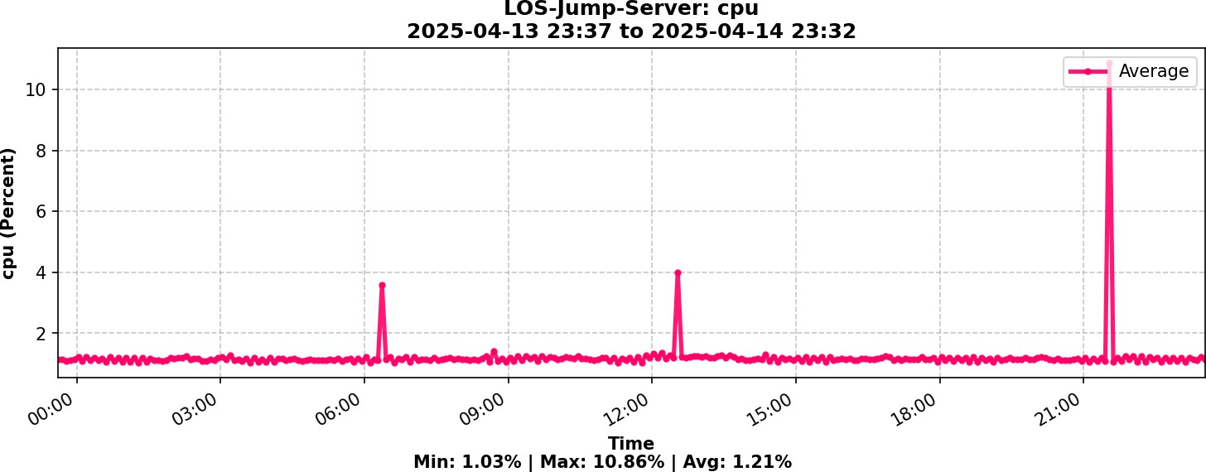

1.21%

Average

## MEMORY UTILIZATION

Remarks: Average utilisation is low. No action needed at the time.

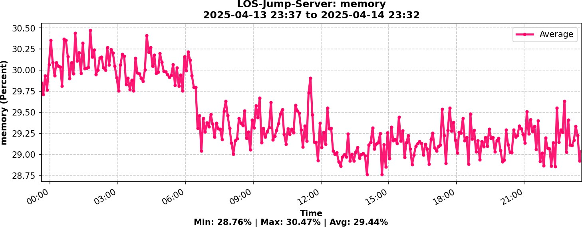

29.44%

Average

## DISK UTILIZATION



Remarks: Average Disk utilisation is Normal.

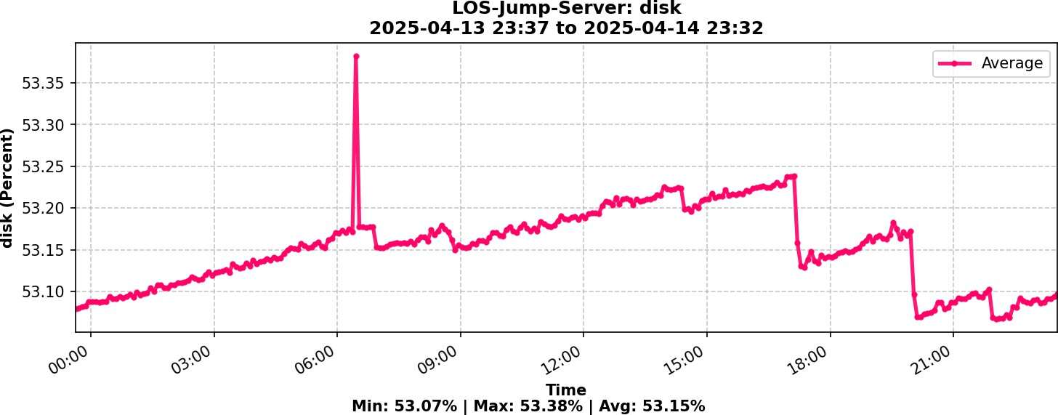

53.15%

Average



# Host: LOS-UAT

|  |  |
| --- | --- |
| Instance ID | i-0164ae386848f7c4f |
| Type | t3a.medium |
| Operating System | Linux |
| State | running |

## CPU UTILIZATION

Remarks: Average utilisation is low. No action needed at the time.

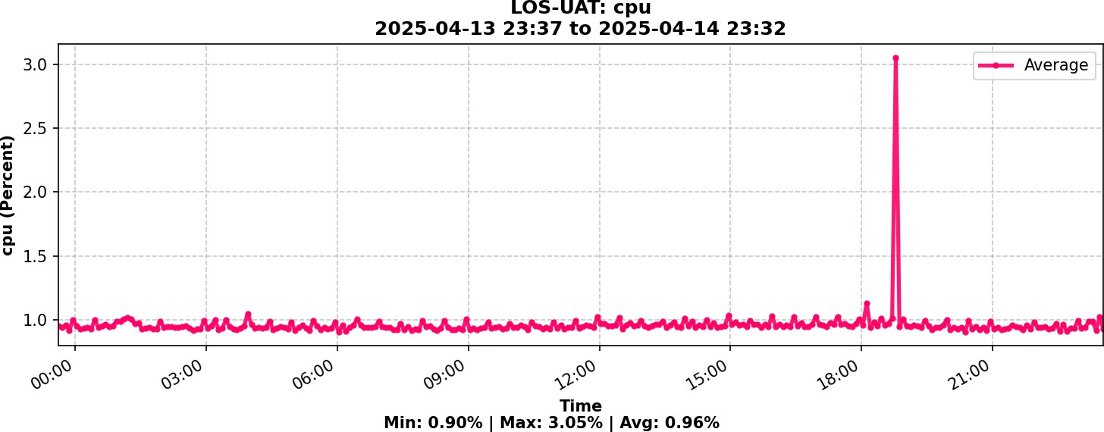

0.96%

Average

## MEMORY UTILIZATION

Remarks: Average utilisation is low. No action needed at the time.

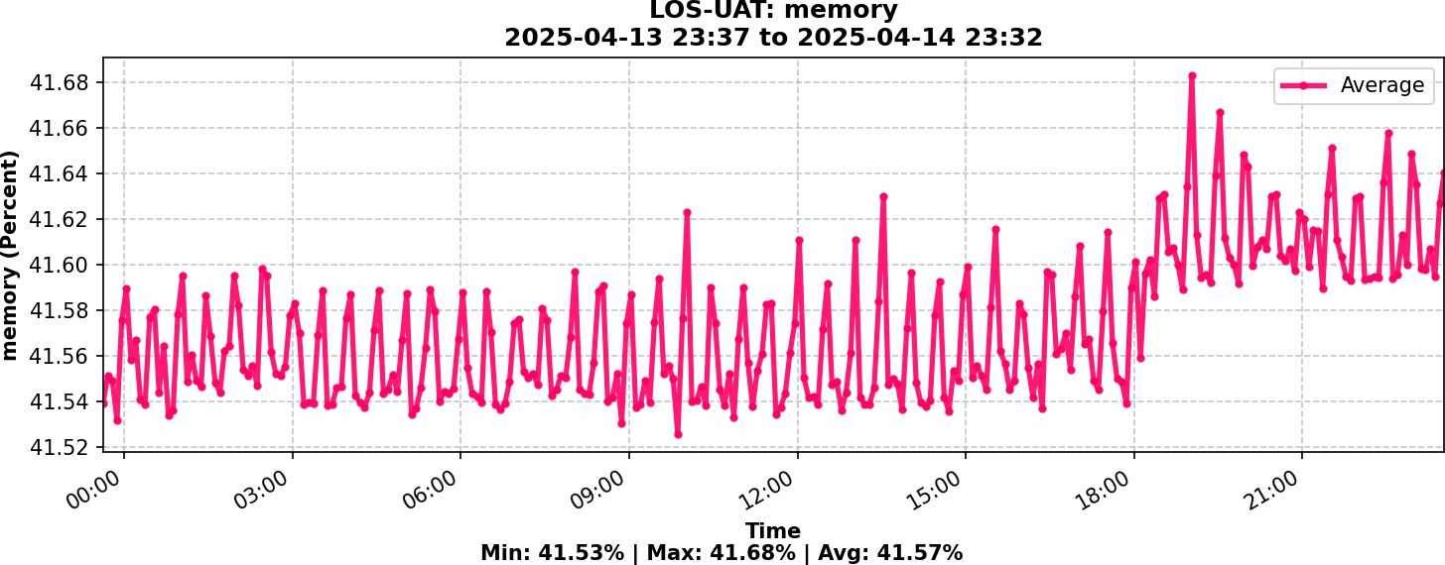

41.57%

Average

## DISK UTILIZATION



Remarks: Average Disk utilisation is Normal.

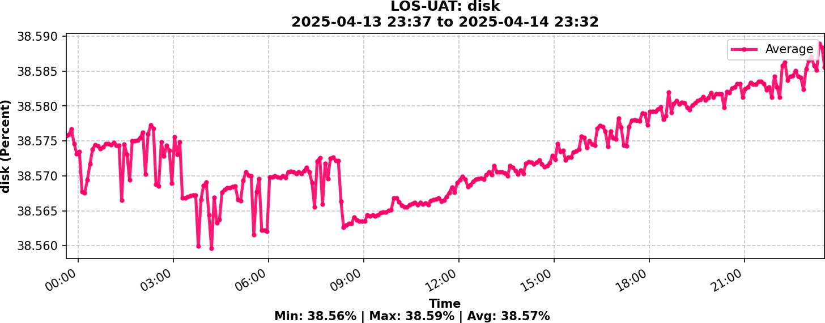

38.57%

Average



# Host: API-Server-1

|  |  |
| --- | --- |
| Instance ID | i-04ddd0bd59e0a8128 |
| Type | t3a.2xlarge |
| Operating System | windows |
| State | running |

## CPU UTILIZATION

Remarks: Average utilisation is low. No action needed at the time.

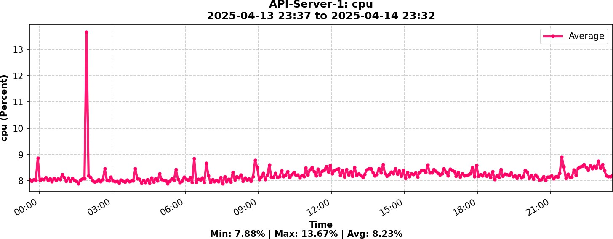

8.23%

Average

## MEMORY UTILIZATION

Remarks: Average utilisation is low. No action needed at the time.

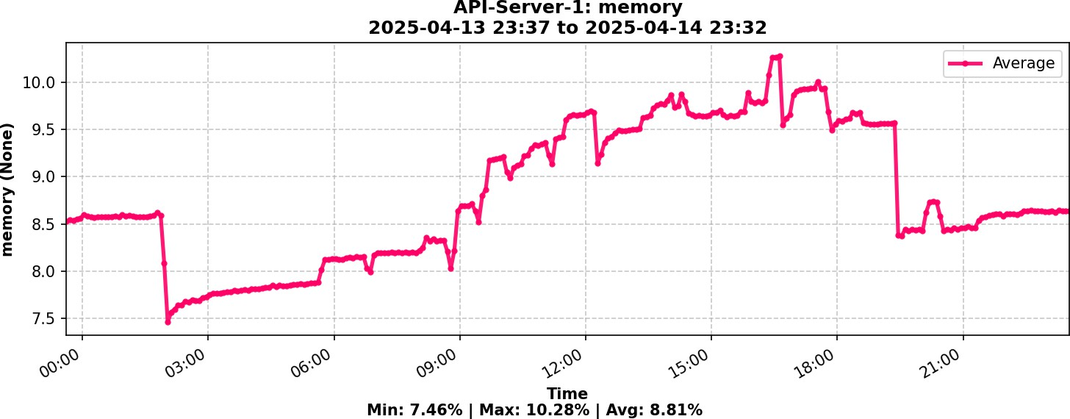

8.81%

Average

## DISK C FREE PERCENTAGE



Remarks: Average Disk utilisation is Normal.

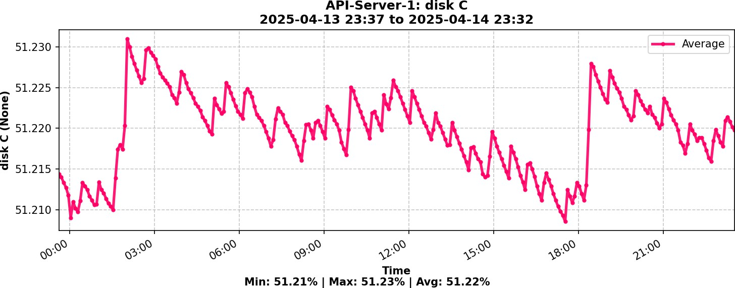

51.22%

Average

## DISK D FREE PERCENTAGE

Remarks: Average Disk utilisation is Normal.

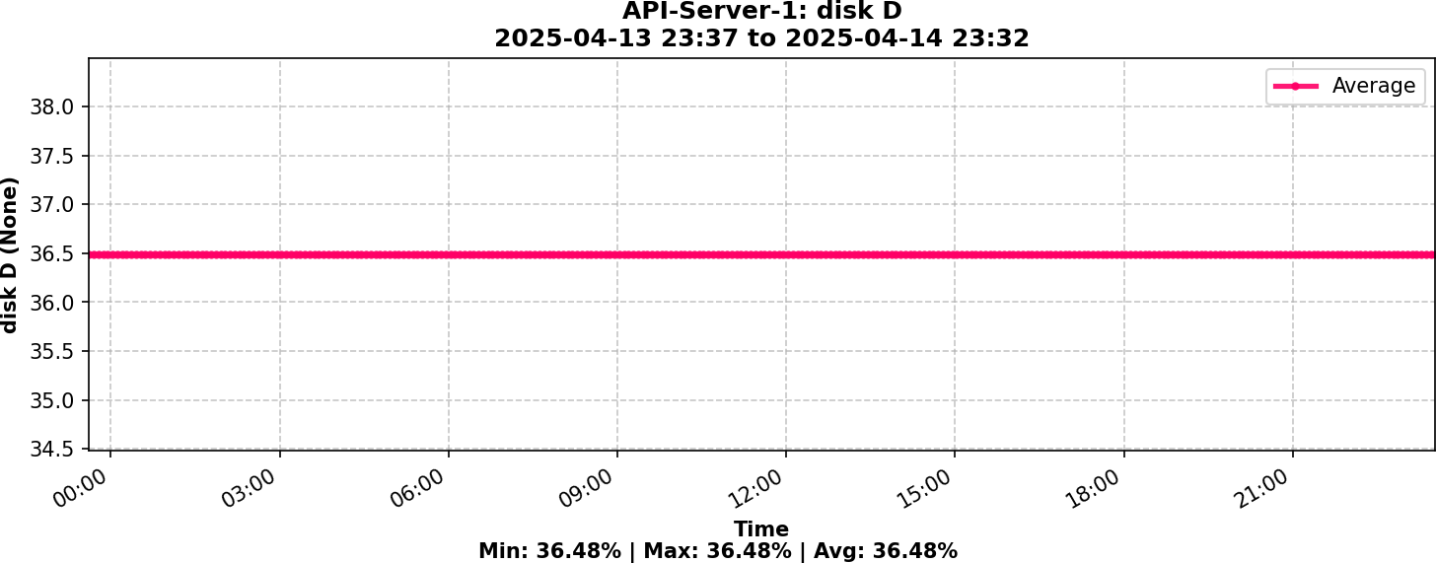

36.48%

Average



# Host: API-Server-2

|  |  |
| --- | --- |
| Instance ID | i-0e2f8fab92452e733 |
| Type | t3a.2xlarge |
| Operating System | windows |
| State | running |

## CPU UTILIZATION

Remarks: Average utilisation is low. No action needed at the time.

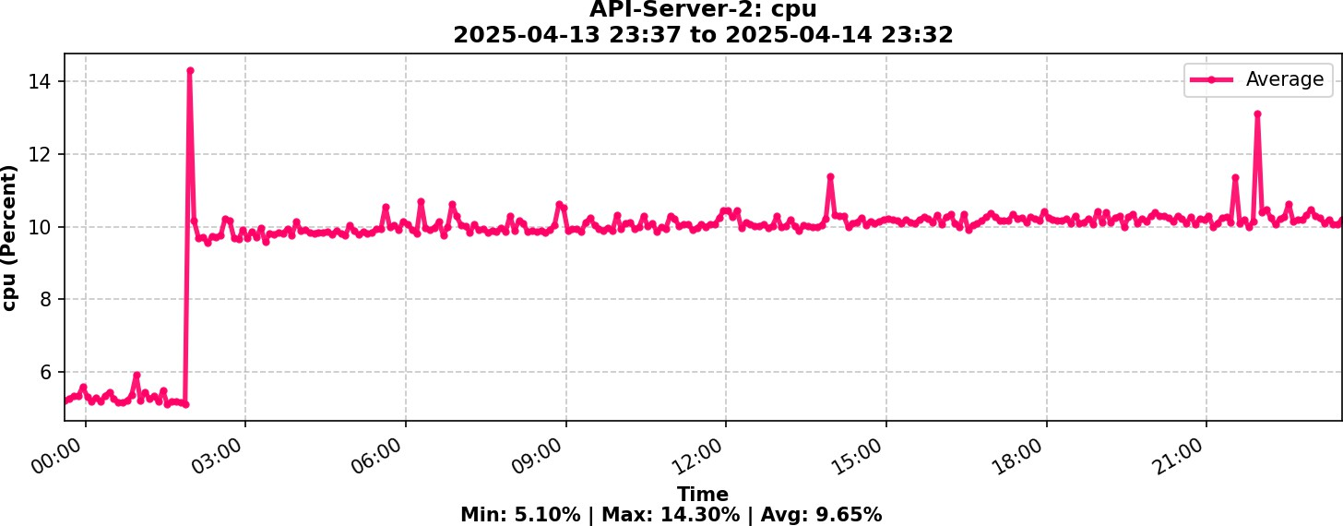

9.65%

Average

## MEMORY UTILIZATION

Remarks: Average utilisation is low. No action needed at the time.

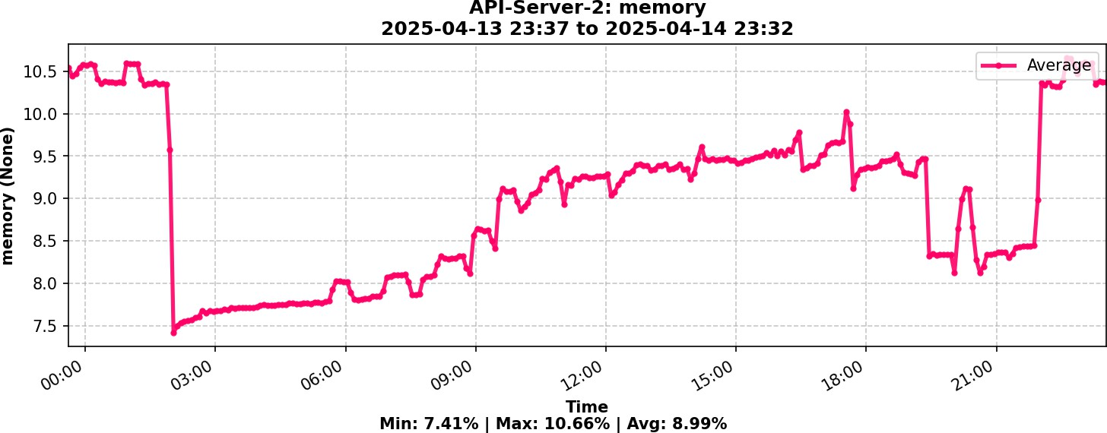

8.99%

Average

## DISK C FREE PERCENTAGE



Remarks: Average Disk utilisation is Normal.

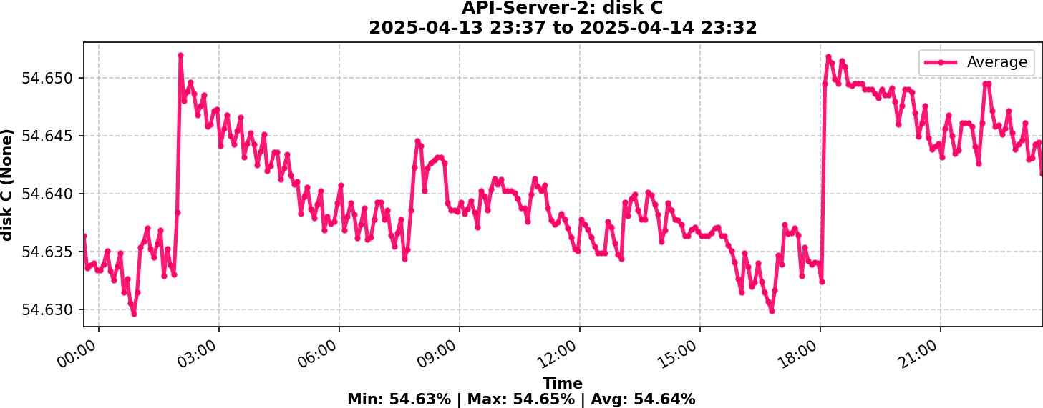

54.64%

Average

## DISK D FREE PERCENTAGE

Remarks: Average Disk utilisation is Normal.

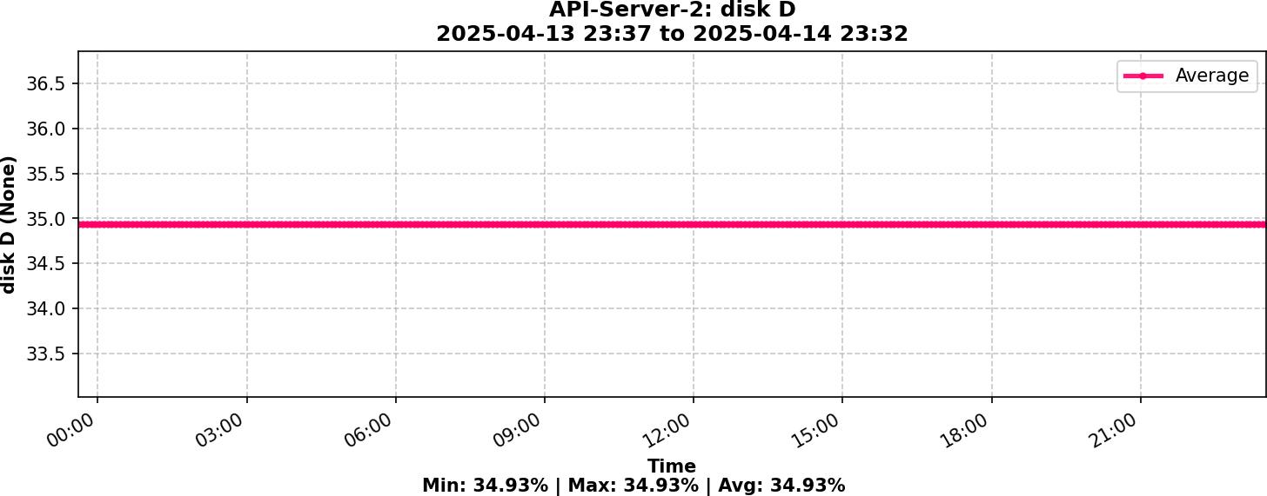

34.93%

Average



# Host: ECS Instance - EC2ContainerService-LOS-UAT-ECS-1

|  |  |
| --- | --- |
| Instance ID | i-0ce674ee72fd4d871 |
| Type | m5a.4xlarge |
| Operating System | Linux |
| State | running |

## CPU UTILIZATION

Remarks: Average utilisation is low. No action needed at the time.

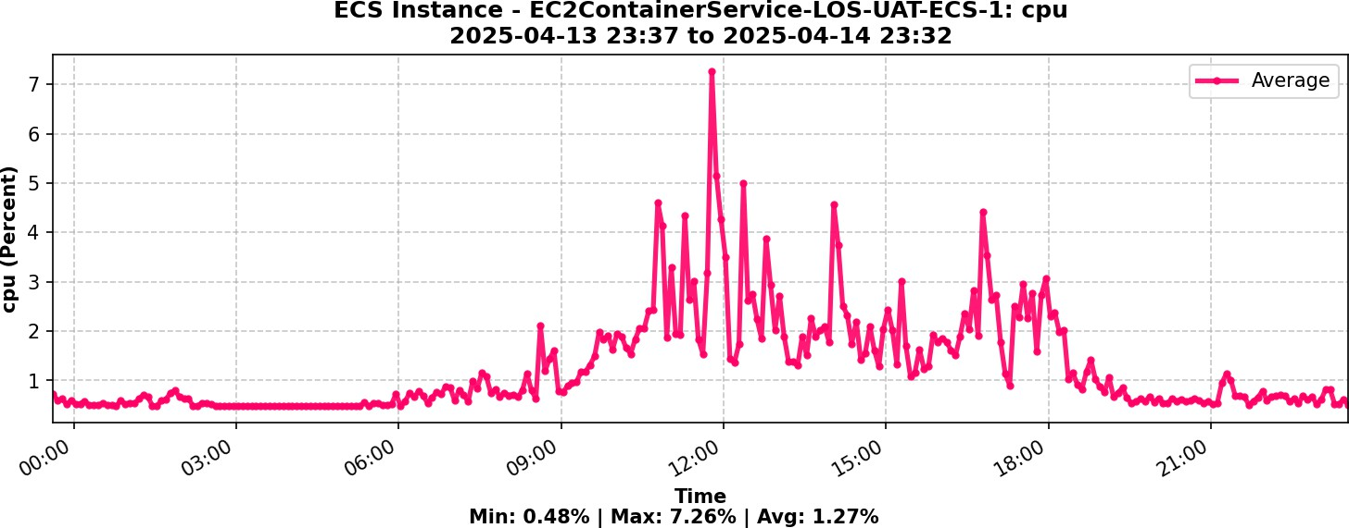

1.27%

Average

## MEMORY UTILIZATION

Remarks: Average utilisation is low. No action needed at the time.

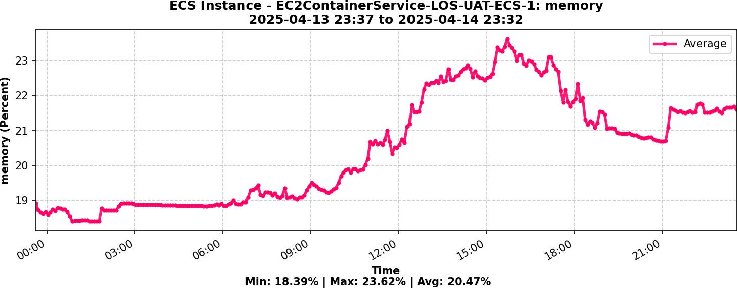

20.47%

Average

## DISK UTILIZATION



Remarks: Average Disk utilisation is Normal.

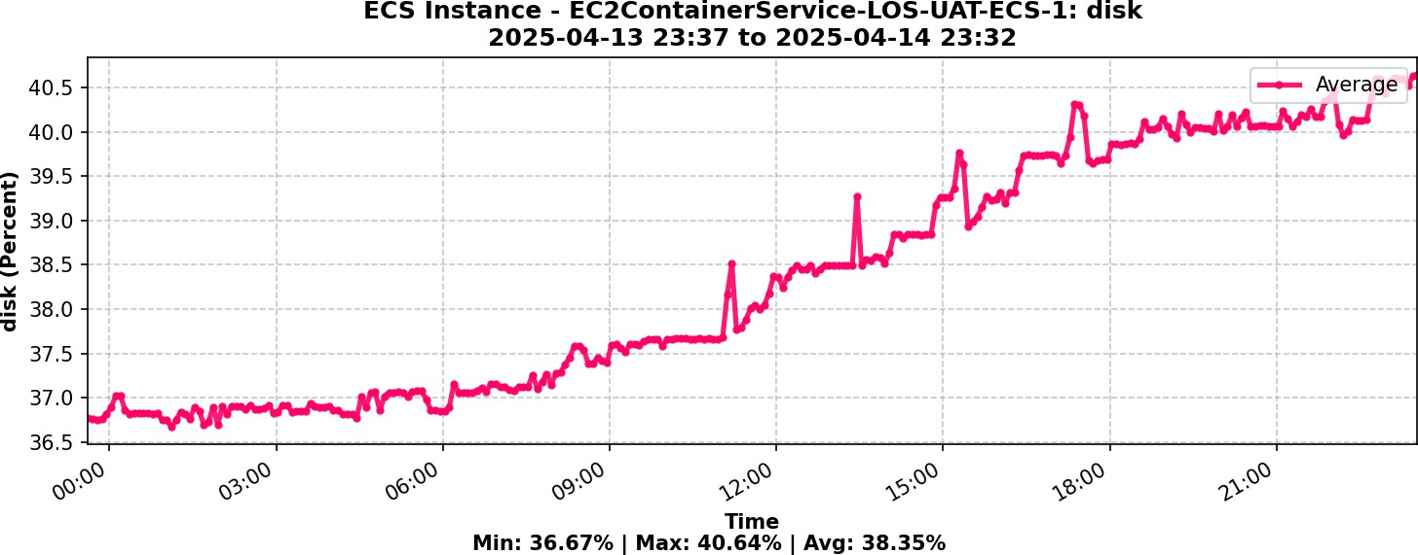

38.35%

Average



# RDS Instance : digital-lending

|  |  |
| --- | --- |
| Instance ID | digital-lending |
| Type | db.r5.large |
| Status | available |
| Engine | oracle-se2 |

## CPU UTILIZATION

Remarks: Average utilization is normal

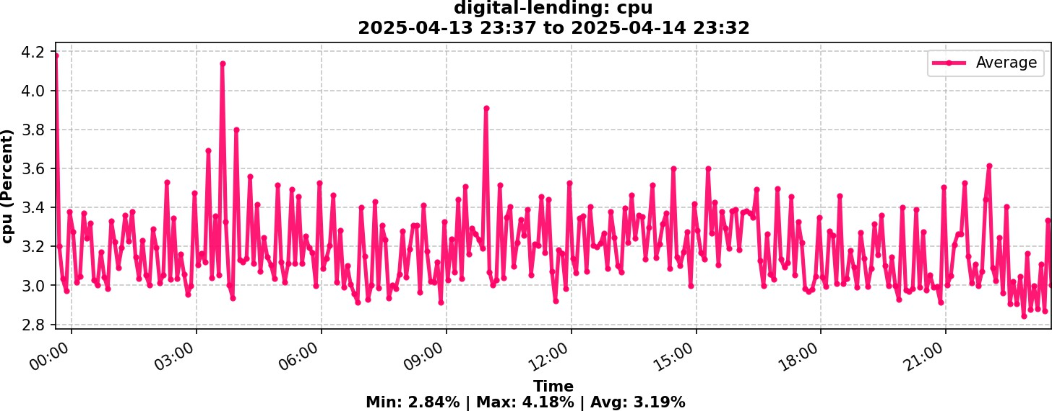

3.19%

Average

### AVAILABLE MEMORY (in GB)

Remarks: Available memory is low. Recommend increasing resources

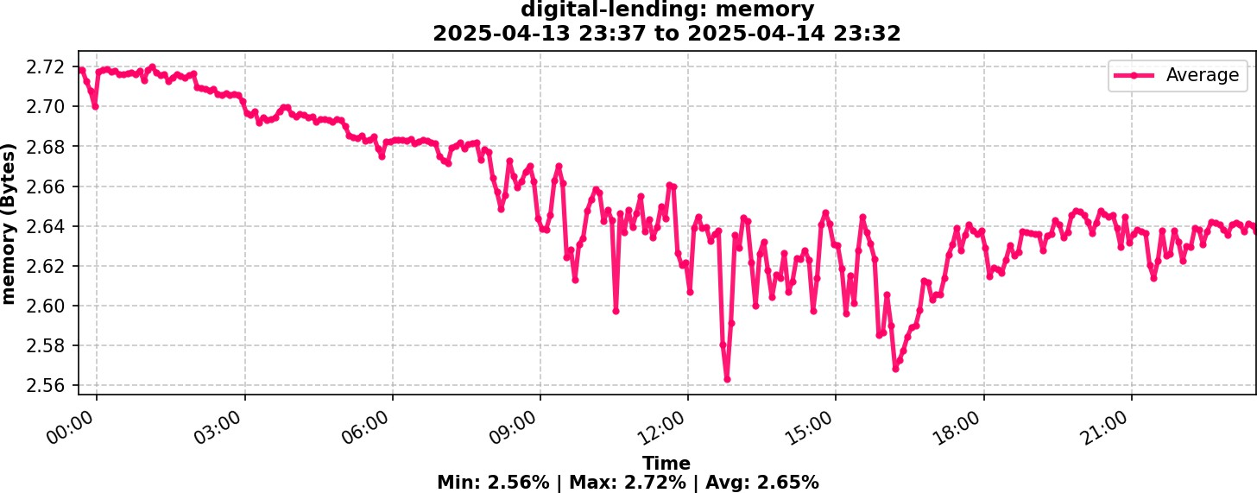

2.65

Average

### AVAILABLE DISK (in GB)



Remarks: Available disk capacity is sufficient

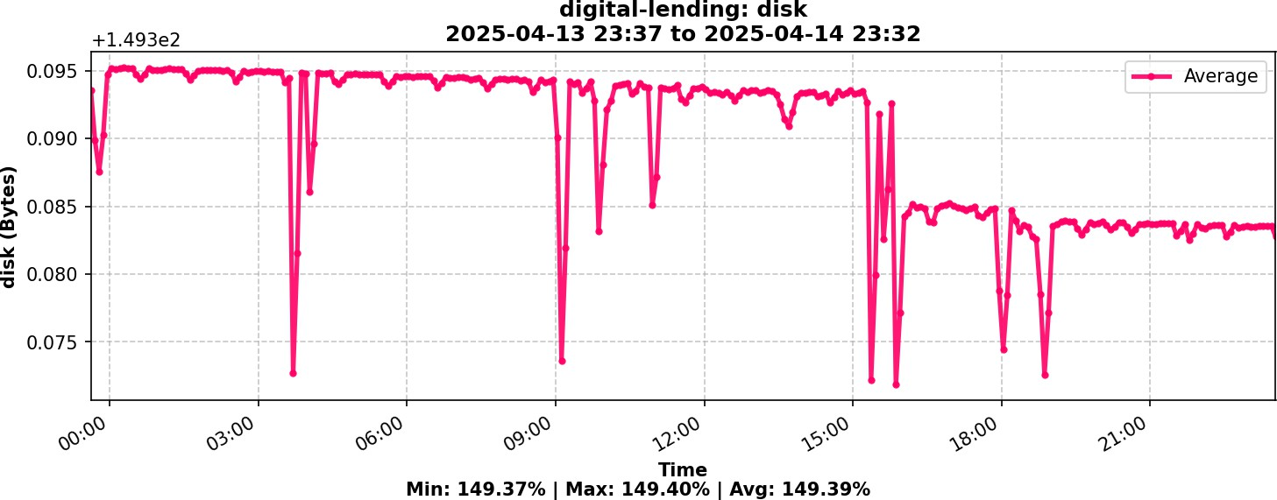

149.39

Average



# RDS Instance : los-prod-oracle-1

|  |  |
| --- | --- |
| Instance ID | los-prod-oracle-1 |
| Type | db.r6i.2xlarge |
| Status | available |
| Engine | oracle-se2 |

## CPU UTILIZATION

Remarks: Average utilization is normal

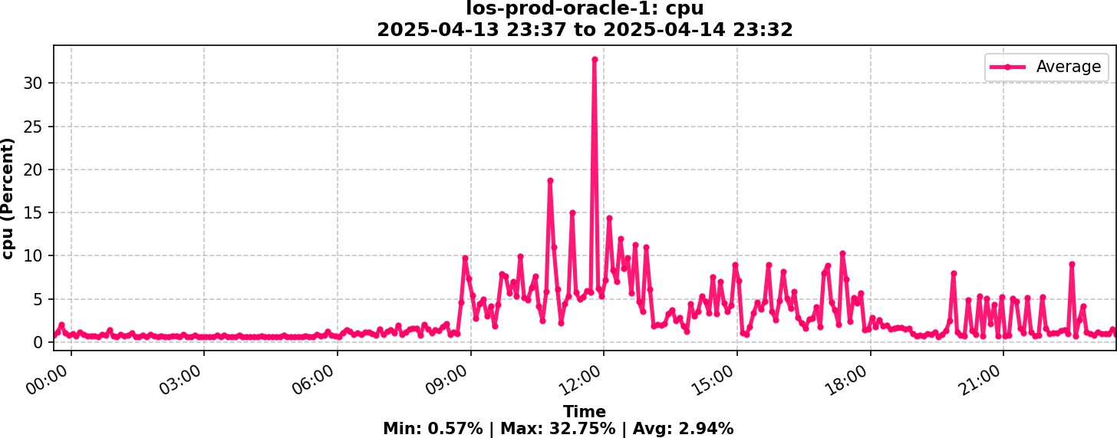

2.94%

Average

### AVAILABLE MEMORY (in GB)

Remarks: Available memory capacity is sufficient

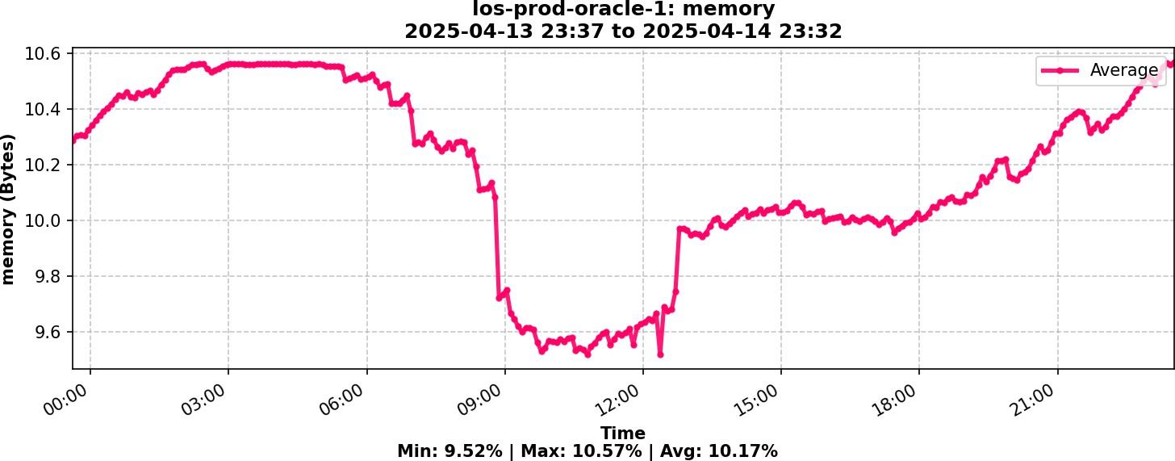

10.17

Average

### AVAILABLE DISK (in GB)



Remarks: Available disk capacity is sufficient

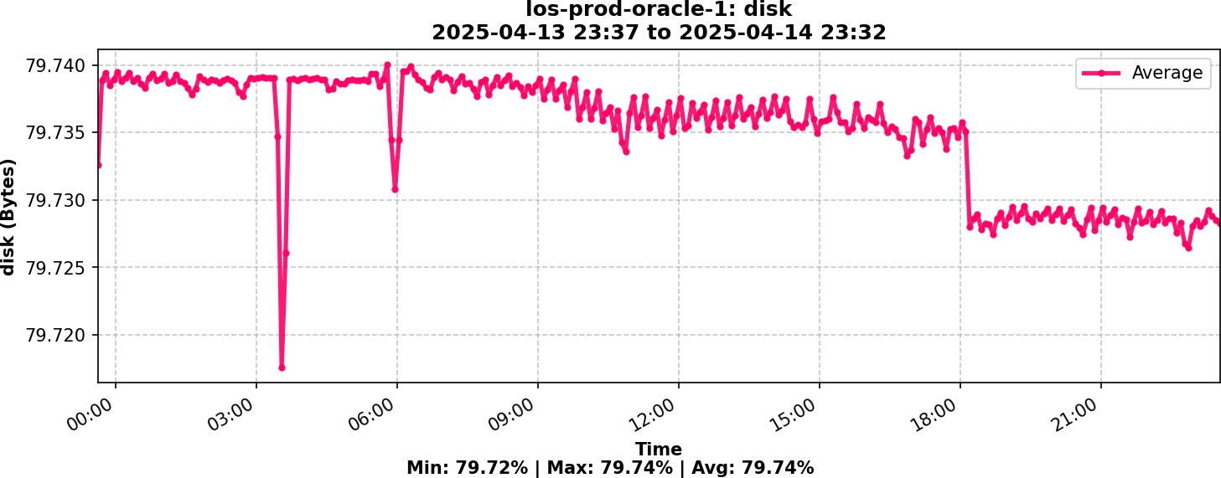

79.74

Average



# RDS Instance : los-prod-oracle-1-restored

|  |  |
| --- | --- |
| Instance ID | los-prod-oracle-1-restored |
| Type | db.r6i.4xlarge |
| Status | available |
| Engine | oracle-se2 |

## CPU UTILIZATION

Remarks: Average utilization is normal

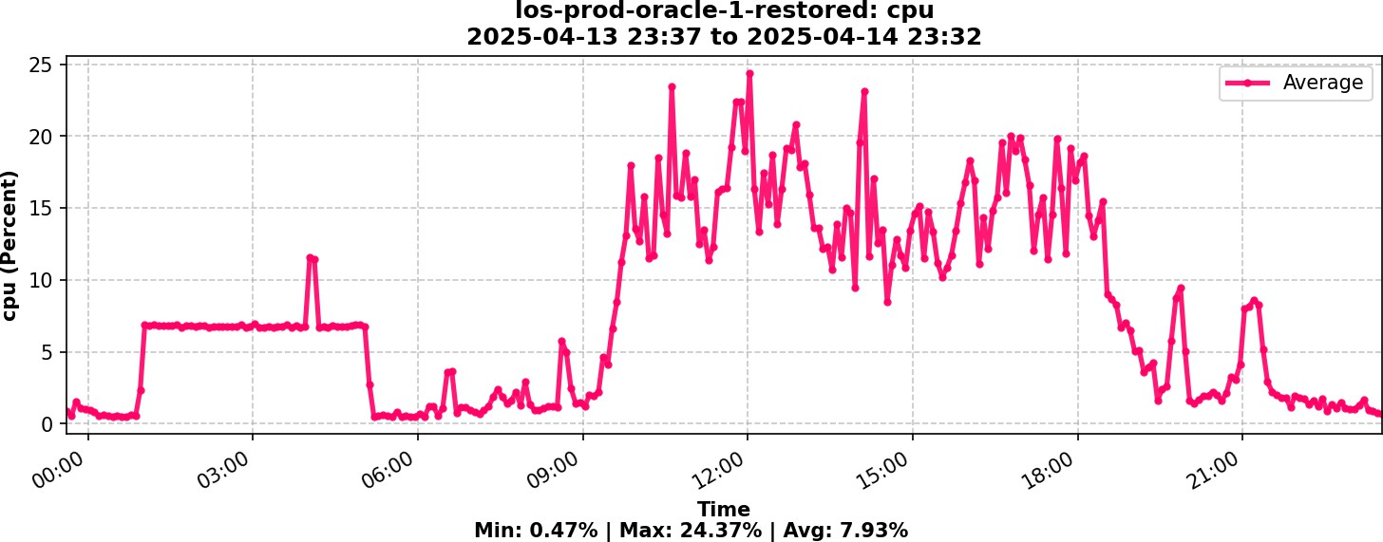

7.93%

Average

### AVAILABLE MEMORY (in GB)

Remarks: Available memory capacity is sufficient

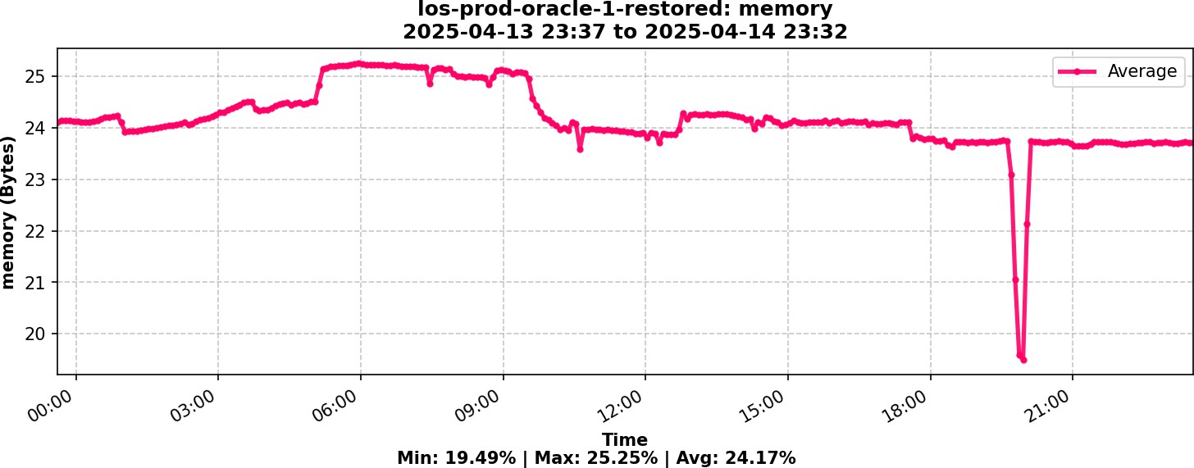

24.17

Average

### AVAILABLE DISK (in GB)



Remarks: Available disk capacity is sufficient

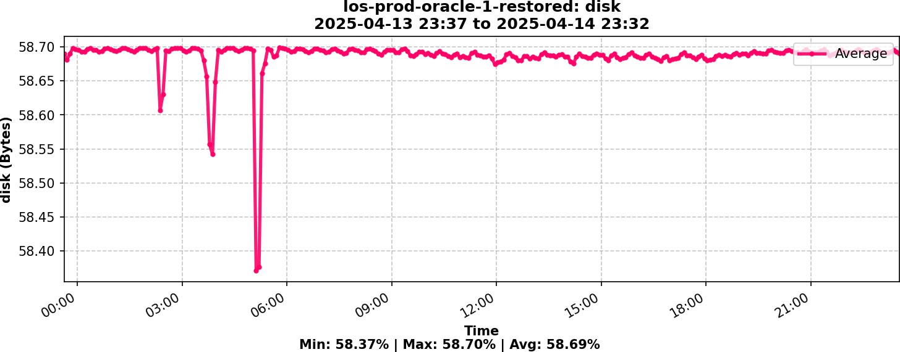

58.69

Average



# RDS Instance : los-uat

|  |  |
| --- | --- |
| Instance ID | los-uat |
| Type | db.t3.large |
| Status | available |
| Engine | oracle-ee |

## CPU UTILIZATION

Remarks: Average utilization is normal

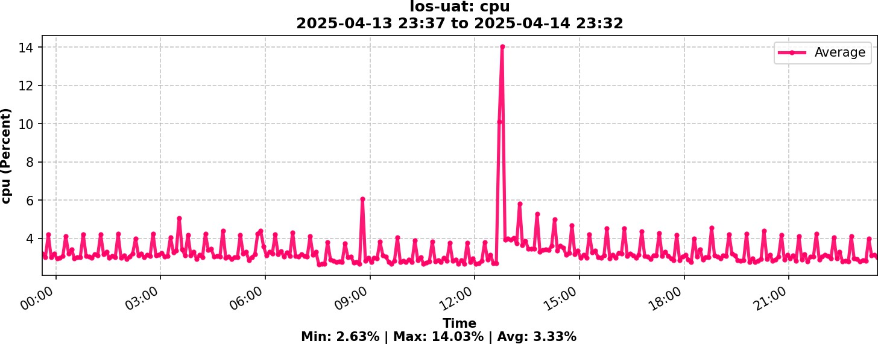

3.33%

Average

### AVAILABLE MEMORY (in GB)

Remarks: Available memory is low. Recommend increasing resources

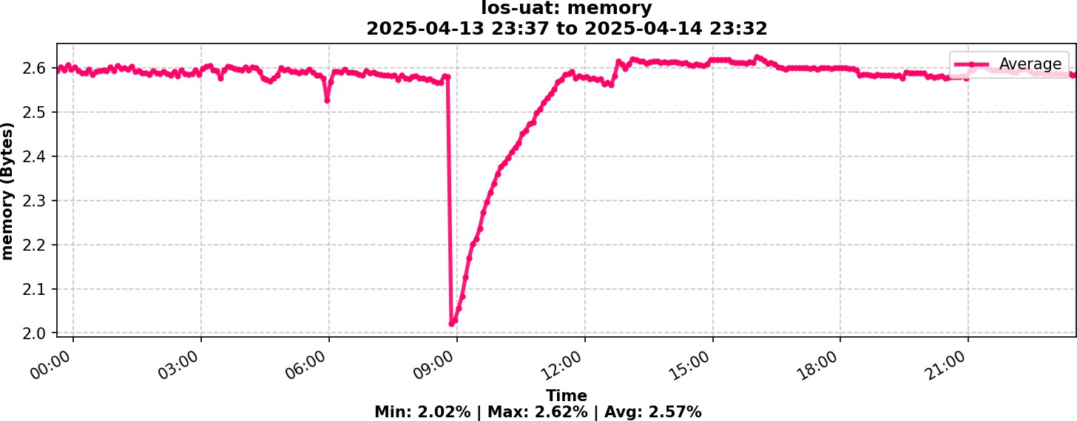

2.57

Average

### AVAILABLE DISK (in GB)



Remarks: Available disk capacity is sufficient

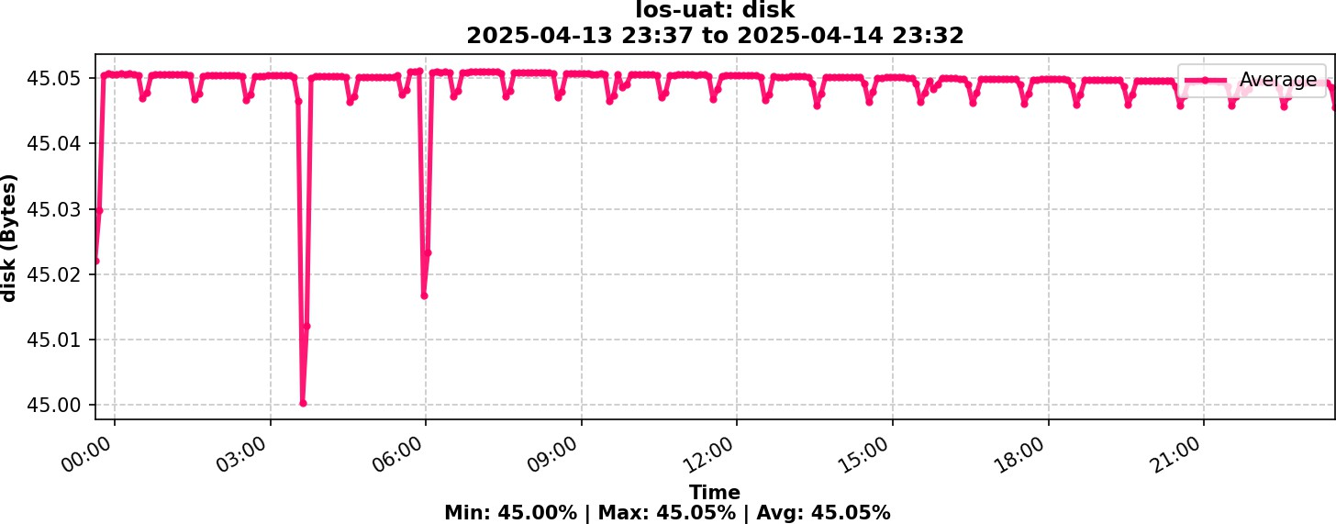

45.05

Average