CAPSTONE PROJECT PROPOSAL BUSINESS DATA MANAGEMENT

"Maximising Customer Satisfaction by Reducing Order Delay: A Tailor Shop's Labor Force Dilemma”

NAME: ARSHI KHAN

ROLL NO: 21F3002806

1. Executive Summary:

This business data management project focuses on improving the efficiency of a small tailor shop located in a town in Uttarakhand, India. The tailor shop specialises in stitching a variety of clothing items for both men and women, including suits, lehengas, kurta pyjama, and shirt pant.

The primary problem that this project seeks to address is the delay in orders, which takes two weeks longer than the promised date due to an inconsistent labor force. The tailor shop is facing challenges with employees taking unexpected leaves, which results in delays and impacts customer satisfaction.

To address this issue, the project suggests implementing several solutions such as hiring additional staff, developing a contingency plan, improving communication with employees, implementing incentives, and automating processes.

The project aims to improve the overall efficiency of the tailor shop and maximise customer satisfaction by reducing order delays. By implementing the suggested solutions, the tailor shop can reduce the time it takes to complete orders and ensure that they are delivered on time.

In conclusion, this business data management project provides solutions to address the issue of delays in orders due to an inconsistent labor force. The tailor shop can benefit from implementing these solutions, which can help optimise operations and improve customer satisfaction.

2. Background of the Company:

The tailor shop was founded in 1995 by Mr. Rajesh Kumar in a small town in Uttarakhand, India. They offer a variety of tailored clothing items for both men and women, alteration and repair services, and have a team of 10 skilled employees. The shop has a flat organisational structure, a good reputation for high-quality work, and serves customers from the local community and neighbouring towns. The mission of the shop is to provide personalised service and tailored clothing items that fit well and make customers feel good. The net worth of the tailor shop would be around 1,080,000 INR.

3. Problem Statement:

The tailor shop is facing challenges with an inconsistent labor force. The employees take unexpected leaves, resulting in a shortage of staff and delayed orders. This delay causes inconvenience to customers who are expecting their orders on the promised date. This delay in delivery has resulted in some customers canceling their orders, and there is a risk of losing their loyalty.

Furthermore, the inconsistency in the labor force has resulted in additional costs for the tailor shop, such as the cost of hiring temporary staff, overtime payments, and a decrease in productivity. These factors can affect the overall profitability of the tailor shop.

In summary, the primary problem that needs to be addressed is the inconsistency in the labor force, resulting in delayed orders, lower customer satisfaction, and additional costs for the tailor shop.

4. Problem Objectives:

* 1. To identify the root cause of the inconsistency in the labor force and find solutions to mitigate it.
  2. To improve the time management and scheduling of the employees to reduce delays in order delivery.
  3. To increase employee accountability and reduce unexpected leaves to ensure a consistent and reliable workforce.
  4. To improve customer satisfaction by delivering orders on time and providing excellent service.
  5. To reduce additional costs associated with temporary staff, overtime payments, and decreased productivity caused by an inconsistent labor force.

5. Background of the problem:

The background of the problem could be attributed to several factors such as:

1. Lack of employee motivation and job satisfaction, leading to high absenteeism rates and lower productivity.
2. Poor time management practices resulting in inconsistent workloads and delays in order delivery.
3. Insufficient training and support for employees resulting in lower job skills and effectiveness.
4. Insufficient staffing levels leading to overburdened employees and higher chances of absenteeism.
5. Inadequate employee communication and engagement resulting in reduced employee accountability and a lack of commitment to work.

It's essential to identify the underlying factors that contribute to the problem to develop effective solutions that address the root cause of the problem. This understanding of the problem's background can also help in preventing the problem from reoccurring in the future.

6. Problem Solving Approach:

### Details about the methods used with Justification

A problem-solving approach can be adopted that involves the following steps:

1. Identify the root cause of the problem: This can be achieved by analysing the data collected through employee attendance records, workload records, delivery records, customer feedback surveys, and employee feedback surveys.
2. Develop a problem statement and objectives: Once the root cause is identified, a problem statement and objectives can be defined to guide the problem-solving process.
3. Brainstorming: Brainstorming sessions with employees and management can be conducted to identify potential solutions to the problem.
4. Evaluate the potential solutions: The potential solutions identified in the brainstorming session can be evaluated based on their feasibility, cost-effectiveness, and impact on the problem.
5. Develop an action plan: An action plan can be developed that outlines the steps required to implement the selected solutions.
6. Implement the solutions: The action plan can be implemented, and the selected solutions can be put into practice.
7. Monitor and evaluate the results: The results of the solutions implemented can be monitored and evaluated to determine if they have been successful in addressing the problem.

### Details about the intended data collection with Justification:

1. Employee attendance records: These records can be collected using a software system that tracks employee time and attendance, or manually by requiring employees to sign in and out each day. This data can then be analysed to identify patterns of absenteeism and tardiness, and to determine which employees may need additional support or training.
2. Workload records: These records can be collected by tracking the amount of work assigned to each employee or department, and comparing it to their capacity. This can be done using a project management software or a spreadsheet. The data can then be analysed to identify areas of workload imbalance, and to determine if additional staffing or resources are needed.
3. Delivery records: These records can be collected by tracking the time it takes to fulfil orders, from the time the order is received to the time it is delivered. This data can be collected using a delivery tracking system or manually by recording the time stamps for each step in the process. The data can then be analysed to identify areas of delay and to determine the root cause of the delay.
4. Customer feedback surveys: These surveys can be conducted online, over the phone, or in-person. The questions should be designed to gather information on customer satisfaction, including the quality of the product or service, the timeliness of delivery, and the overall experience. The data can then be analysed to identify areas for improvement and to develop strategies for improving customer satisfaction.
5. Employee feedback surveys: These surveys can be conducted using a survey software or by conducting interviews with employees. The questions should be designed to gather information on employee satisfaction, including their perceptions of the workload, the training and support they receive, and the overall work environment. The data can then be analysed to identify areas for improvement and to develop strategies for improving employee motivation and reducing absenteeism.

### Details about the analysis tools with Justification:

1. Excel: Excel is a widely used and easily accessible tool for data analysis. It can be used for basic data manipulation, visualisation, and analysis.
2. Google Sheets: Google Sheets is a free, web-based spreadsheet tool that can be used for data analysis. It is similar to Excel in functionality and can be used for basic data manipulation and analysis.
3. Tableau Public: Tableau Public is a free data visualisation tool that allows users to create interactive visualisations and dashboards. It can be used to create compelling visualisations of data collected through customer feedback surveys, employee feedback surveys, and other sources.

7. Expected timelines:

* Project management tasks (1-5): April 2 - April 9 (7 days)
* Data collection tasks (2-4): April 10 - April 16 (7 days)
* Data analysis tasks (3-5): April 17 - April 23 (7 days)

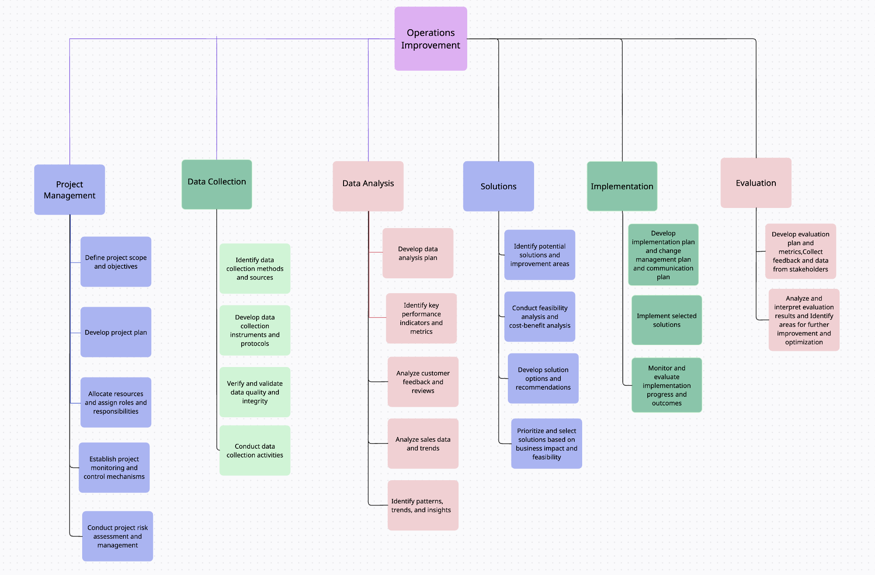

Work Breakdown Structure(WBS)

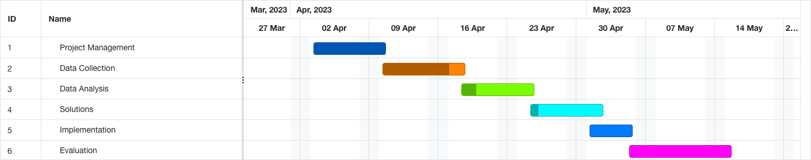

Gantt chart

* Solutions tasks (4-4): April 24 - April 30 (6 days)
* Implementation tasks (5-4): April 28 - May 4 (7 days)
* Evaluation tasks (6-4): May 4 - May 13 (10 days)

8. Expected Outcome:

1. Improved understanding of customer needs and preferences
2. Identification of areas for improvement and optimisation
3. Identification of potential solutions to address business challenges
4. Improved data collection and analysis capabilities
5. Enhanced decision-making process based on data-driven insights
6. Improved customer satisfaction and loyalty
7. Increased sales and revenue
8. Improved operational efficiency and effectiveness
9. Better alignment of resources and activities with business objectives
10. Increased competitiveness and market share.