# Final Report (CA-2)

Title: Anime Recommendation Dashboard

**COMPUTER SCIENCE AND ENGINEERING**

**Submitted by:**

|  |  |  |
| --- | --- | --- |
| S.No | Name | Reg no. |
| 1 | Arshi Bansal | 123 |
| 2 | Tanvi Sharma | 12313057 |
| 3 | Seshaveni veeramreddy | 12315723 |
| 4 | Alekhya muli | 12317735 |
| 5 | Rama sai jahnavi | 12308734 |



**Submitted To: Dr. Sandeep Kaur**

# Lovely Professional University

# Jalandhar, Punjab, India.

# Introduction:

This project, titled **“Anime Recommendation Dashboard”,** was completed as part of the Summer Internship under the curriculum of CSE343. The project was carried out by our group using publicly available datasets and modern data science tools. The work was guided and mentored by Sandeep Kaur. All members of the group contributed to various parts of the project including data analysis, model development, and dashboard design.

# Problem Definition:

The growing number of anime shows available online makes it difficult for viewers to decide what to watch next. Users often have unique preferences such as favorite genres, themes, or ratings. However, most platforms provide basic filtering options and do not offer personalized or interactive recommendations.

This project aims to solve this problem by building a **recommendation system** that suggests anime based on trends, popularity, and viewer preferences. The system also includes a visual dashboard where users can interact with the data, making it easier to discover new and relevant anime.

# Scope and Objectives

# Key objectives:

# To analyze anime datasets using Exploratory Data Analysis (EDA)

# To build a machine learning model for recommending anime based on preferences

# To design an interactive dashboard using Power BI

# To extract useful insights like top genres, top-rated shows, most popular anime, etc.

# To improve user experience in anime selection by combining analytics and recommendations

# Tools and Technologies Used

|  |
| --- |
| The tools and technologies used throughout the project include: |
| * Python – For data analysis, EDA, and model building |
| * Jupyter Notebook – For writing and executing Python code |
| * Pandas, NumPy – For data manipulation |
| * Matplotlib, Seaborn – For visualizing data |
| * Scikit-learn– For building the machine learning model |

Screenshots:   
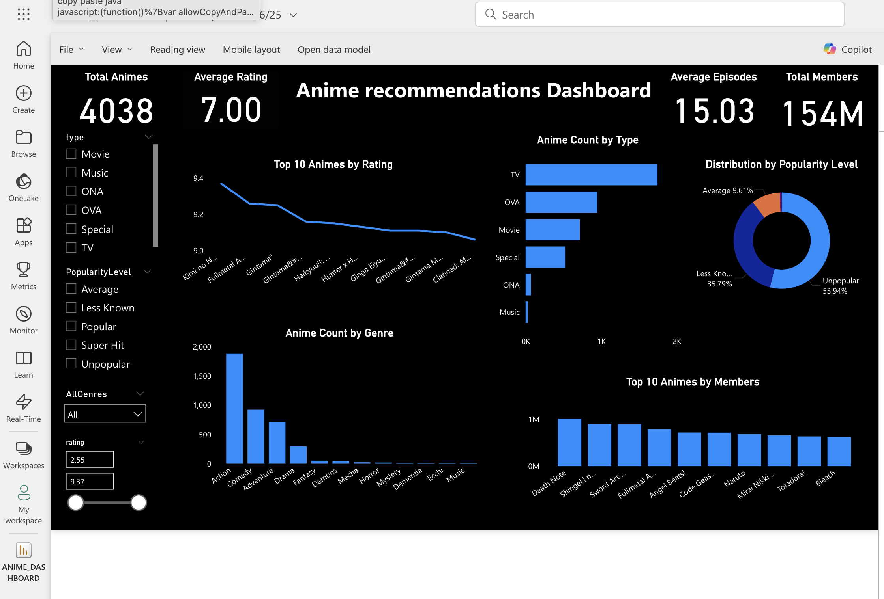

# Chart Descriptions and Analytical Purpose:

This section outlines the purpose and significance of each visualization included in the Anime Recommendation Dashboard. Each chart has been designed to extract specific insights from the dataset to enhance the understanding of anime trends, viewer preferences, and content performance.

1. **Top 10 Animes by Average Rating (Line Chart)**

This visualization presents the highest-rated anime titles based on user ratings. It highlights critically acclaimed anime such as Kimi no Na wa, Fullmetal Alchemist, and Gintama, which consistently maintain average ratings above 9.0.

**Purpose:** To identify the top-performing anime in terms of viewer satisfaction and critical acclaim.

1. **Anime Distribution by Type (Bar Chart)**

This chart illustrates the number of anime classified by their production type (e.g., TV, Movie, OVA, Special, Music, ONA). It clearly demonstrates that TV anime are the most frequently produced format, showcasing the industry's primary focus.

**Purpose:** To analyze content distribution across various anime formats and understand industry trends.

1. **Anime Popularity Classification (Donut Chart)**

This donut chart categorizes anime based on their popularity levels, such as **Unpopular**, **Less Known**, **Average**, **Popular**, and **Super Hit**. A significant portion of anime fall under the "Unpopular" and "Less Known" categories, emphasizing the long-tail nature of viewer interest.

**Purpose:** To assess how anime are distributed in terms of community engagement and popularity.

1. **Anime Count by Genre (Bar Chart)**

This bar chart visualizes the volume of anime across different genres. **Action**, **Comedy**, and **Adventure** emerge as the dominant genres, reflecting mainstream preferences and genre diversity in anime production.

**Purpose:** To explore genre prevalence and assist in understanding what themes are most commonly explored in anime.

1. **Top 10 Animes by Member Count (Bar Chart)**

This chart showcases the anime titles with the highest number of members (viewers or user interactions). Titles such as *Death Note*, *Attack on Titan*, and *Sword Art Online* appear as fan favorites with massive global audiences.

**Purpose:** To identify the most widely followed and consumed anime titles in the dataset.

1. **Interactive Slicers and Filters (Left Panel)**

The dashboard includes multiple slicers that enhance user interactivity and allow for customized data exploration:

* **Type Slicer:** Filters anime by format (e.g., TV, Movie, OVA)
* **Popularity Level Slicer:** Segments data based on predefined popularity classes
* **Genre Dropdown:** Enables genre-based filtering
* **Rating Range Slider:** Allows dynamic filtering of anime by average rating

**Purpose:** These slicers offer flexibility and empower users to drill down into specific subsets of data based on their interests.

# Insights and Observations:

• **TV-type anime** are the most produced type, far more than movies or OVA, making them the dominant format in the industry.

• **Action, Comedy, and Adventure** are the top 3 genres, with Action being the most common genre overall.

• The **average rating** across all anime is approximately **7.00**, showing most anime are moderately well-received by viewers.

• The **Top 10 highest-rated anime** include Kimi no Na wa, Fullmetal Alchemist, and Gintama, all scoring above **9.0** indicating they are fan favorites and critically acclaimed.

• The anime with the **highest number of members** include Death Note, Attack on Titan, and Sword Art Online, showing their widespread popularity and viewer base.

• Over **53% of anime are categorized as "Unpopular"**, meaning only a few anime dominate the attention of users while the rest have lower reach.

• The **average number of episodes** per anime is **15.03**, which indicates that many anime are short series or OVAs (not long-running shows).

# Conclusion:

* The Anime Recommendation Dashboard provides an effective way to explore anime trends, user preferences, and genre popularity.
* It makes it easier for viewers or platforms to identify the most suitable anime to watch or recommend based on data-driven insights.