INT 217: INTRODUCTION TO DATA MANAGEMENT
PROJECT REPORT
(Project Semester January-April 2025)

(College Statistics)

Submitted by

Arshia Singh

Registration No: 12310628

Programme and Section Btech (CSE) and K23GS
Course Code K23GS

Under the Guidance of

Baljinder Kaur (UID: 321230)

Discipline of CSE/IT

Lovely School of Computer Science

Lovely Professional University, Phagwara

CERTIFICATE

This is to certify that Arshia Singh bearing Registration no. 12310628 has completed INT 217 project titled, “College Statistics” under my guidance and supervision. To the best of my knowledge, the present work is the result of his/her original development, effort and study.

Baljinder Kaur
Signature and Name of the Supervisor
Designation of the Supervisor
School of Computer Science
Lovely Professional University
Phagwara, Punjab.

Date: 12-04-2025

DECLARATION

I, Arshia Singh, student of Btech (CSE) under CSE/IT Discipline at, Lovely Professional University, Punjab, hereby declare that all the information furnished in this project report is based on my own intensive work and is genuine.


Date: 12-04-2025 Signature
Registration No. 12310628 Arshia Singh

Table of Contents
1. INTRODUCTION 5
2. SOURCE OF DATASET 5
3. DATASET PREPROCESSING 6
e. Handling Missing Values: 6
f. Text Cleanup & Formatting: 6
g. Removal of Unusable Entries 6
h. Feature Enhancement 6
4. ANALYSIS ON DATASET 6
a. Stream-wise Fee Vs Placement Comparison 6
b. College Density Across States 7
c. Average Accommodation Rating by State 7
d. Cost-Heavy Streams Identification 8
e. Interactive Filtering & Dashboard Reset 8
f. About Me & Process Summary 9
5. CONCLUSION 10
6. FUTURE SCOPE 11
i. Integrating of Real-Time data 11
ii. User – Level Customization 11
iii. Advance Visualizations 11
iv. Machine Learning Integration 11
v. Documentation & Help Section 11
7. REFERENCES 11

INTRODUCTION
- In today’s digital era, selecting the right college is a critical decision for students and parents. With numerous institutions available across different states, comparing them on important metrics such as fees, placements, accommodation ratings, and stream availability becomes difficult without proper tools. The College Recommendation Dashboard was developed in Microsoft Excel to address this gap. It transforms a large dataset of Indian colleges into an interactive, visual, and user-friendly format to assist users in making data-driven decisions.
  - This dashboard helps users:
  - Compare colleges state-wise.
  - Analyze fee structures and ratings by stream.
  - Visually assess placement outcomes and the number of colleges available in each state.
  - Interact dynamically with charts and filters.

SOURCE OF DATASET
- The dataset used for this project includes detailed information on over 6000+ colleges across India. It was obtained by collecting the data manually.
- Google Form through which the dataset was collected:
  - https://docs.google.com/forms/d/e/1FAIpQLSe6BXzPwEklp2g6URphE5TIq3ga3kd7GJxgihIzmOSb9C5flw/viewform?usp=sharing
- Google Spreadsheet of the Responses:
  - https://docs.google.com/spreadsheets/d/1xziUtCIJKSmpaREninLlTa2TgCOHIvSj3GzTiBA_Fws/edit?usp=sharing
- The dataset includes:
  - State-wise distribution of colleges.
  - College names and categories (Engineering, Medical, Law, etc.).
  - Accommodation and Placement ratings (on a scale of 1 to 10).
  - UG and PG fee structures.
  - Streams offered, categorized into Medical, Engineering, Commerce, Arts, etc.
  - The raw data was extracted in CSV format and imported into Excel for preprocessing and visualization.

DATASET PREPROCESSING
- To ensure the accuracy and efficiency of the dashboard, several preprocessing steps were performed within Excel using formulas and functions (no external programming was used, apart from a single VBA macro to clear filters).
- Key Preprocessing Steps:
- Handling Missing Values:
  - Missing accommodation and placement ratings were filled using the state-wise median to maintain locality relevance.
  - Missing UG/PG fees were replaced with 0, assuming such entries are either free or the data is unavailable.
- Text Cleanup & Formatting:
  - Corrected inconsistent state names (e.g., “Tamil nadu” to “Tamil Nadu”).
  - Combined similar stream categories to standard ones (e.g., “Mgmt” and “Management” into “Management”).
- Removal of Unusable Entries
  - Rows with no identifiable information or all-null data were removed using Excel filters.
- Feature Enhancement
  - Created derived columns such as "Placement-to-Fee Ratio" and "Total College Count per State" using COUNTIFS and formula logic.
  - All this preprocessing was performed with built-in Excel features like IF(), ISBLANK(), MEDIAN(), COUNTIFS(), VLOOKUP(), and conditional formatting.

ANALYSIS ON DATASET
  - Stream-wise Fee Vs Placement Comparison
    - General Description
      - This analysis investigates how average fees across different streams relate to placement opportunities, helping students evaluate the return on investment.
    - Specific Requirements
      - Average UG fees and PG fees by stream
      - Placement numbers or percentages associated with each stream
    - Analysis Results
      - Streams like Engineering and Management had higher average fees but also comparatively better placement statistics. Arts and Humanities had lower fees but fewer placement records.
    - Visualizations
      - A Bar Chart was used to compare streams based on their average fees and placement figures. Slicers enabled stream-specific filtering for better user control.
      - 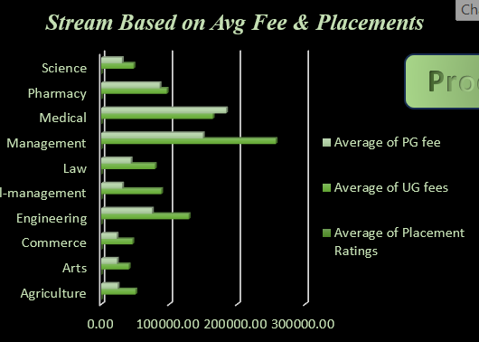

Fig 1. Bar Chart on Stream Based Avg Fee & Placements
      - 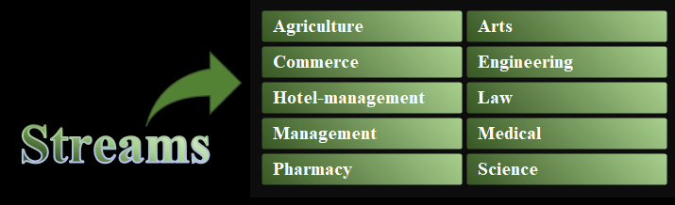

Fig 2. Stream Slicers

  - College Density Across States
    - General Description
      - The goal was to map the number of colleges available in each state, helping visualize regional concentration of educational institutions.
    - Specific Requirements
      - State-wise college counts
      - Representation in a geographical format
    - Analysis Results
      - States like Maharashtra, Tamil Nadu, and Uttar Pradesh had the highest number of colleges, whereas northeastern states had significantly fewer.
    - Visualizations
      - A Map of India was used to provide spatial distribution of colleges, visually highlighting state-wise density.
      - 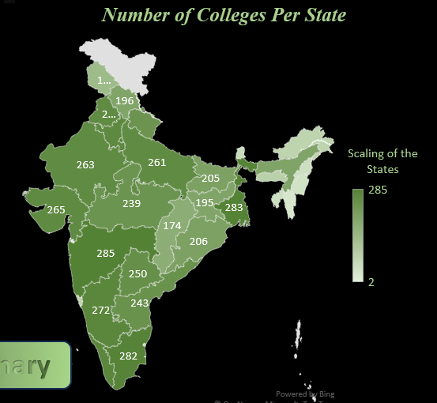

Fig 3. Map of India Depicting the Number of Colleges per State

      - 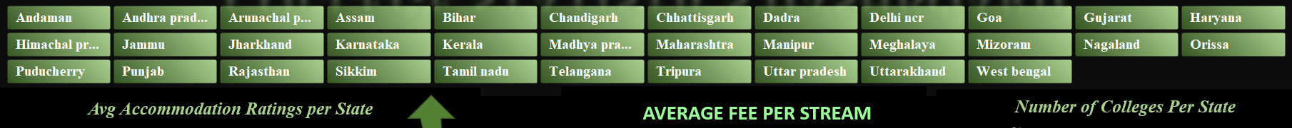

Fig 4. State Slicers

  - Average Accommodation Rating by State
    - General Description
      - Analyzed how students rate accommodation facilities in colleges across different states.
    - Specific Requirements
      - Rating scores (1 to 10 scale)
      - Grouping by state
    - Analysis Results
      - States with metropolitan or educational hubs like Delhi and Karnataka had higher accommodation ratings, whereas rural states showed inconsistent or lower scores.
    - Visualizations
      - A Line Chart was used to plot the average accommodation ratings by state, showing clear peaks and troughs across the country.
      - 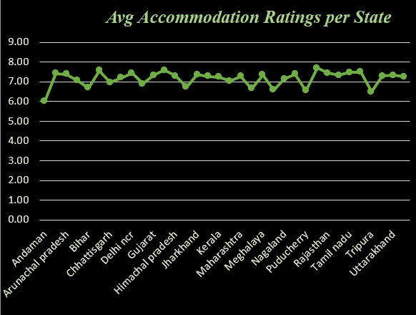

Fig 5. Line Chart Representing Avg. Accommodation Rating per state

  - Cost-Heavy Streams Identification
    - General Description
      - This analysis aimed to identify which academic streams generally require higher financial investment.
    - Specific Requirements
      - Average tuition fee per stream
      - Separate calculations for UG and PG programs
    - Analysis Results
      - Medicine, Law, and Management streams emerged as cost-heavy domains, whereas Education and Arts were relatively affordable.
    - Visualizations
      - A 3D Pie Chart was used to represent the average fee per stream, allowing quick comparison of tuition-heavy areas.
      - 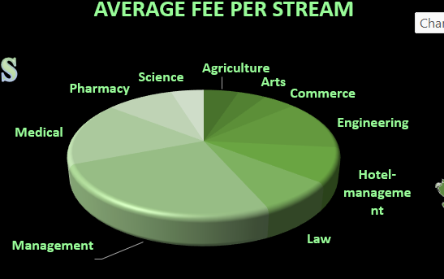

Fig 6. 3D Pie Chart for Average Fee Per Stream

  - Interactive Filtering & Dashboard Reset
    - General Description
      - Improved user experience by allowing interactive filtering and easy dashboard reset functionality.
    - Specific Requirements
      - Slicers for stream and state
      - A macro-enabled "Clear All Filters" button
    - Analysis Results
      - Users were able to explore data in a more personalized manner, filtering by state or stream. The Clear Filters button ensured smooth resetting to the default view.
    - Visualizations
      - Slicers for interactivity and a Command button for macros were added directly onto the dashboard layout.
      - 

Fig 7. Command Button for clearing all filters
  - About Me & Process Summary
    - General Description
      - This section provides a personal glimpse into the creator of the dashboard and walks users through the step-by-step journey of building the College Statistics Dashboard — combining both technical and non-technical aspects.
    - Specific Requirements
      - A short, personalized introduction that highlights interests and motivation behind the project.
      - A timeline-style breakdown of the process followed during the dashboard creation.
      - Elements like clear filters, and dynamic charts to enrich the experience.
    - Analysis Results
      - The dashboard reflects the creator’s passion for machine learning, data analysis, and visual storytelling. It also documents the real-world problem-solving process — from selecting the dataset, cleaning and structuring it, to building interactive visuals and macros for theme-switching and filter management. This adds transparency and relatability to the project.
    - Visualizations
      - Displayed as a text-rich section with bulletins and emojis, the “About Me” and “Process Summary” provide an engaging user experience. They appear in a designated sheet/tab or as a part of the dashboard layout, easily accessible through a clickable hyperlinked button with a custom gradient design.
      - 

Fig 8. About Me Active X Button
      - 

Fig 9. Process Summary ActiveX Button
      - 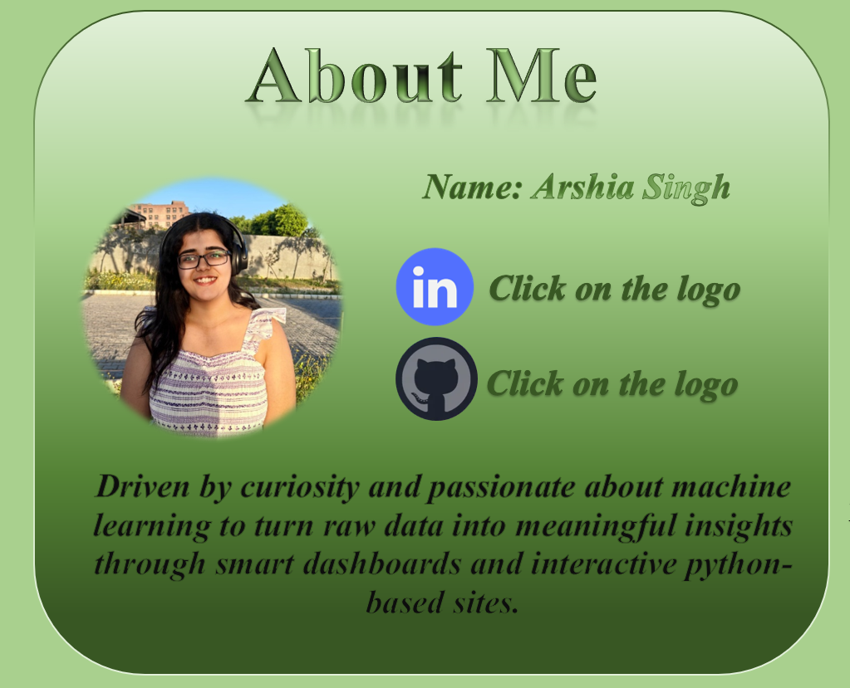

Fig 10. About Me Section (Hyperlinked)
      - 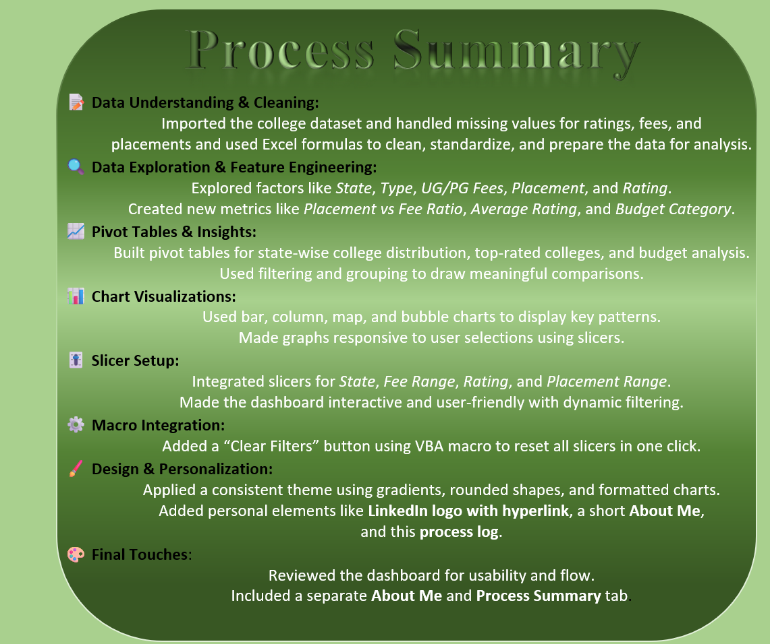

Fig 11. Process Summary Section (Hyperlinked)

CONCLUSION
  - The College Statistics Dashboard serves as a comprehensive tool to simplify complex educational data and assist prospective students and parents in making informed decisions. By integrating diverse variables such as fee structures, accommodation ratings, placement statistics, and state-wise distribution of colleges, the dashboard transforms raw data into meaningful insights.
  - The dashboard not only highlights the financial aspects—like average UG and PG fees across various streams—but also sheds light on the value each stream provides by comparing placements against investments. For instance, users can easily see which streams offer higher returns in terms of placement versus fee, which helps in evaluating educational ROI (Return on Investment). Similarly, the inclusion of accommodation ratings allows users to assess comfort and quality of life, a key but often overlooked factor in college selection.
  - Interactive elements such as slicers, a 'Clear All Filters' macro button, and various chart types (line, bar, 3D pie, and map) make the dashboard user-friendly, dynamic, and visually appealing. These features enable users to slice through data according to personal preferences—be it stream, state, or a specific institution—and derive insights relevant to their unique needs.
  - Overall, the dashboard is not just a data presentation tool; it’s a practical decision-making assistant that blends statistical rigor with accessibility. It demonstrates how Excel, when used innovatively, can go beyond basic spreadsheets to offer impactful data analysis and visualization capabilities, all within a single interface.

FUTURE SCOPE
- To expand and refine this project further, the following enhancements are suggested:
    - Integrating of Real-Time data
      - Connecting the dashboard with real-time APIs or live datasets from educational portals can keep information constantly updated, making the dashboard more relevant and timely.
    - User – Level Customization
      - Implementing forms or dropdowns where users can input their preferences (like budget, preferred location, desired stream) could help generate personalized college recommendations directly within the dashboard.
    - Advance Visualizations
      - Incorporating more sophisticated charts like heatmaps for placement density, radar charts for multi-factor stream comparison, or dynamic trend graphs could provide deeper insights for analysis.
    - Machine Learning Integration
      - Future versions could include basic machine learning models (e.g., K-Means Clustering for college grouping or Regression for fee prediction) for analytical depth beyond Excel's capabilities.
    - Documentation & Help Section
      - Adding an integrated guide or tooltips would make it easier for non-technical users to navigate and understand the dashboard functions better.

REFERENCES
  - Office VBA Reference (Microsoft Developer Network)
    - https://learn.microsoft.com/en-us/office/vba/api/overview/excel
Referred for creating and modifying macros like the "Clear All Filters" and theme toggle buttons.
  - GeeksforGeeks – Data Analysis and Visualization in Excel
    - https://www.geeksforgeeks.org/excel-data-analysis/
Helped in understanding techniques to clean, sort, and visualize data efficiently.
  - AICTE (All India Council for Technical Education)
    - https://www.aicte-india.org/
Used for understanding the structure, number of colleges, and approval standards in India.

