CSE 316: OPERATING SYSTEMS
PROJECT REPORT
(Project Semester January-April 2025)

(Real Time Monitoring Dashboard)

Submitted by

Udit Katiyar (12324411)
Abhinav Kumar (12318644)
Arshia Singh (12310628)

Programme and Section Btech (CSE) and K23GS
Course Code CSE 316

Under the Guidance of

Baljinder Kaur (UID: 321230)

Discipline of CSE/IT

Lovely School of Computer Science

Lovely Professional University, Phagwara

CERTIFICATE

This is to certify that Arshia Singh bearing Registration no. 12310628 has completed INT 217 project titled, “Real Time Monitoring Dashboard” under my guidance and supervision. To the best of my knowledge, the present work is the result of his/her original development, effort and study.

Dr. Nahida Nazir
Signature and Name of the Supervisor
Designation of the Supervisor
School of Computer Science
Lovely Professional University
Phagwara, Punjab.

Date: 12-04-2025

DECLARATION

I, Arshia Singh, student of Btech (CSE) under CSE/IT Discipline at, Lovely Professional University, Punjab, hereby declare that all the information furnished in this project report is based on my own intensive work and is genuine.


Date: 12-04-2025 Signature
Registration No. 12310628 Arshia Singh

Table of Contents

1. INTRODUCTION 5
2. OPERATING SYSTEM ROLE IN THIS PROJECT 5
3. FILE SYSTEM INTERACTION 6
b. Reading System Metrics: 6
c. Logs And Error Reports: 7
d. Configuration Files: 7
e. Streamlit Assets and About Us Page: 7
4. WORKING OF THE DASHBOARD 7
b. Launch the Application 7
c. Home Tab: Task Manager 7
Fig 3. Home Tab 8
d. Process Manager Tab 8
Fig 5. Process Manager 9
e. Alerts & Customization Tab 9
f. About Us Tab 10
5. CONCLUSION 10
6. FUTURE SCOPE 11
i. Remote Monitoring Support 11
ii. Mobile App Integration 11
iii. Advance Visualizations 11
iv. Predictive Analysis Using ML 11
v. Voice Command Integration 11
7. REFERENCES 11

INTRODUCTION
- The Real-Time Monitoring Dashboard is an interactive and intuitive tool designed for real-time monitoring and management of operating system resources and processes. It serves as a compact operating system dashboard interface that offers critical insights into system performance, resource usage, and process-level operations, making it especially useful for developers, system administrators, and power users.
- This project is structured into four key tabs, each addressing a specific functionality:
  - Home
The Home tab functions as a dynamic Task Manager, visualizing important system statistics such as CPU usage, memory consumption, and active process count. It presents these data points through responsive graphs that update in real time, offering users a quick overview of the system’s health and load.
  - Process Manager
This section provides detailed control over system processes. Users can view a list of all active processes along with their Process IDs (PIDs), memory usage, CPU time, and other relevant data. Additionally, users are empowered to manage these processes by terminating (killing) unwanted ones or interacting with specific ones, mimicking core functionalities of an OS-level process manager.
  - Alerts & Customization
The Alerts tab allows users to define custom CPU usage thresholds. Once these thresholds are breached, real-time alerts are triggered, notifying users of potential system overloads or abnormal behaviors. This customizable monitoring system ensures proactive error tracking and resource management.
  - About Us
This tab provides insights into the project’s creators, purpose, and design philosophy. It gives credit to the developers and explains the motivation and technical stack behind building this dashboard.
  - In summary, this project acts as a simplified Operating System interface tailored for real-time observation and intervention, built with modular components for easy extension and user customization.

OPERATING SYSTEM ROLE IN THIS PROJECT
  - The Operating System (OS) plays a foundational and critical role in enabling the functionality and execution of the Real-Time Monitoring Dashboard. Since this project revolves around observing and managing system-level activities, it heavily relies on the core services and capabilities provided by the OS. Here’s how the OS contributes to the project:
  - Process Management
The dashboard interacts directly with the OS to retrieve a list of all active processes, their Process IDs (PIDs), CPU usage, memory usage, and more. This is made possible through system calls and APIs that the OS provides. When a user selects a process to kill or manage, the command is forwarded to the OS, which executes it securely using permissions and kernel-level control.
  - Resource Monitoring
The Home tab collects real-time data about CPU usage, memory consumption, and system load. The OS continuously monitors and manages these resources in the background, and exposes this data through interfaces (such as /proc in Linux or psutil in Python). The dashboard taps into these interfaces to retrieve up-to-date statistics and visualize them using graphs.
  - Permission Handling and Security
Any action that involves terminating or modifying a process is subject to the OS’s security policies. The OS ensures that only authorized users or scripts can perform such actions, preventing unauthorized manipulation. This maintains system stability and ensures safe operation of the dashboard.
  - Scheduling and Multitasking
The dashboard runs as a user-space application that competes for CPU cycles with other running programs. The OS handles the scheduling of these tasks and ensures that the dashboard functions smoothly without interrupting critical system services.
  - Event and Error Reporting
In the Alerts & Customization tab, the OS allows the program to detect threshold breaches (like high CPU usage). The system’s ability to raise exceptions or notify user-level programs through logging or interrupt mechanisms makes the real-time alert feature possible.
  - File System and I/O
The OS handles the reading and writing of configuration files, logs, and system data that the dashboard may generate or access. All input/output operations, such as reading usage statistics or storing settings, are managed via the OS's file system interface.
  - In conclusion, the Operating System is the backbone of this project, offering the necessary APIs, services, and access to system-level information. The dashboard acts as a user-friendly layer built on top of these OS-provided features, allowing users to interact with their system in a more visual and manageable way.

FILE SYSTEM INTERACTION
  - The Real-Time Monitoring Dashboard interacts with the file system in several meaningful ways to support its functionality, configuration, and logging. The operating system’s file management services ensure that the project can read from and write to different directories securely and efficiently. Below are key file system interactions involved in the project:
- Key Preprocessing Steps:
- Reading System Metrics:
- The dashboard utilizes Python libraries like psutil that access real-time data about system performance. On UNIX-based systems, these libraries internally read files from the /proc directory (e.g., /proc/cpuinfo, /proc/meminfo) to gather information about CPU, memory, and processes. These are virtual files maintained by the OS to expose internal system information.
- Logs And Error Reports:
  - Any errors or threshold breaches related to CPU or memory usage can be logged for review. The application can write these logs into text files or log files (e.g., alerts_log.txt, error_log.txt) to keep track of incidents and help in debugging or future audits.

- Configuration Files:
  - The Alerts & Customization tab allows users to set specific CPU or memory thresholds. These values can be stored in a configuration file (e.g., config.json or .env), so that preferences are preserved even if the dashboard is restarted. The file system allows for reading these values at startup and updating them during runtime.
- Streamlit Assets and About Us Page:
  - The About Us section includes HTML, CSS, and possibly JavaScript files embedded within the frontend directory. These files are read and rendered through the Streamlit application using st.markdown() or custom HTML loaders. This requires file access to paths like Frontend/AboutUs/index.html, style.css, and images or assets used in the section.

WORKING OF THE DASHBOARD
  - The Real-Time Monitoring Dashboard app runs in a structured way to provide users with live insights and control over system processes. Here’s a simplified process flow for how the app functions:

  - Launch the Application
    - The app starts by loading the main interface, which includes the navigation bar (for tabs like Home, Process Manager, Alerts & Customization, and About Us).
    - System monitoring tools (like CPU usage, RAM, and disk space) start collecting real-time data in the background.
  - Home Tab: Task Manager
    - The app retrieves live system metrics (CPU, memory, and disk space) and dynamically updates the graphs showing system performance. Graphs are displayed with real-time values, such as:
      - CPU Usage: A pie or bar chart displaying the current CPU load.
      - RAM Usage: A bar chart displaying memory consumption.
      - Disk Space: A graph that shows used and available space on storage drives.
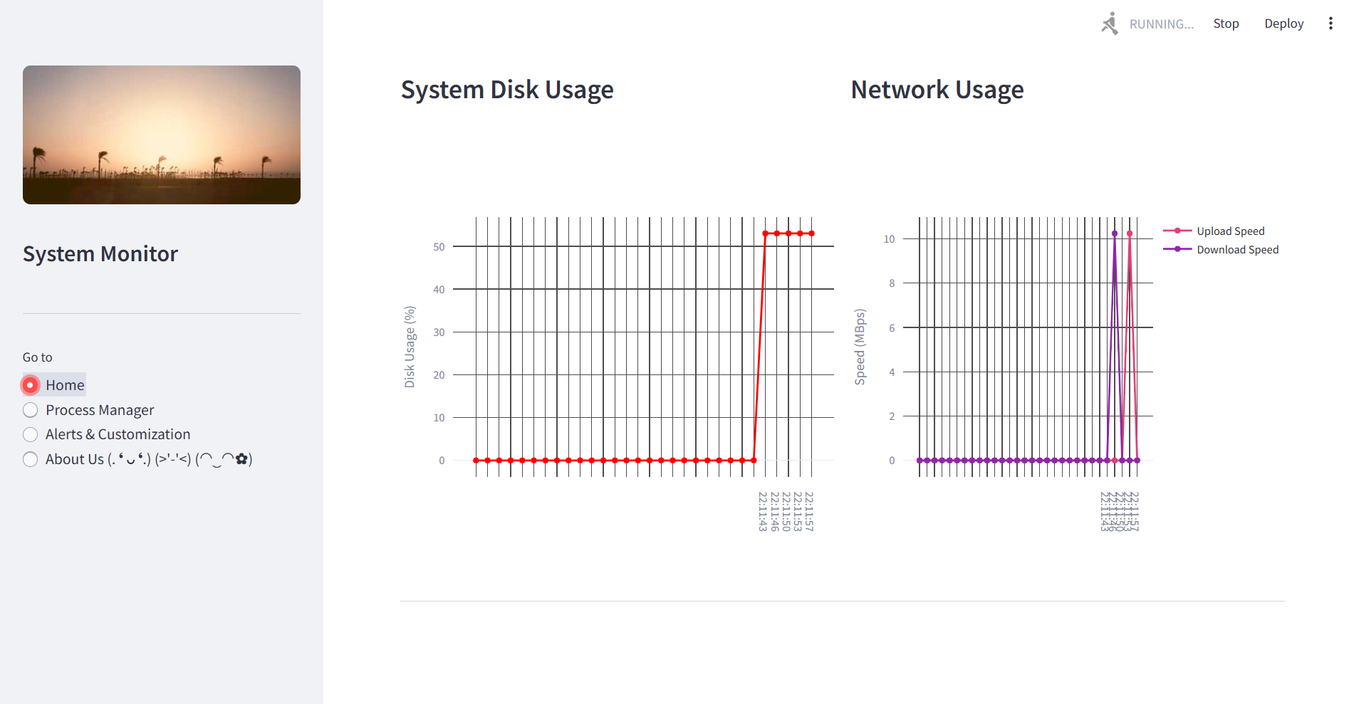

Fig 3. Home Tab

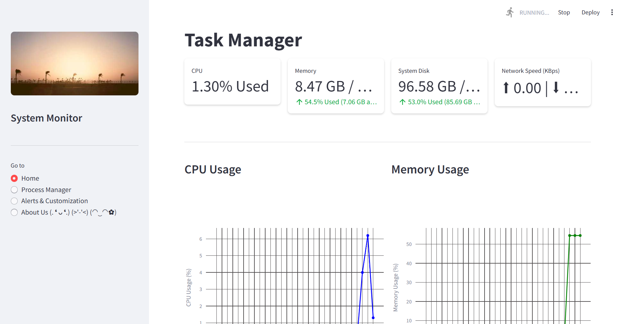

  - Process Manager Tab
    - This tab lists all running processes with details like:
      - Process name, PID, CPU usage, and memory usage.
    - The user can interact with the process list to:
      - Kill Processes: Select a process to terminate.
      - Monitor Resource Consumption: Observe individual processes and their impact on system resources.
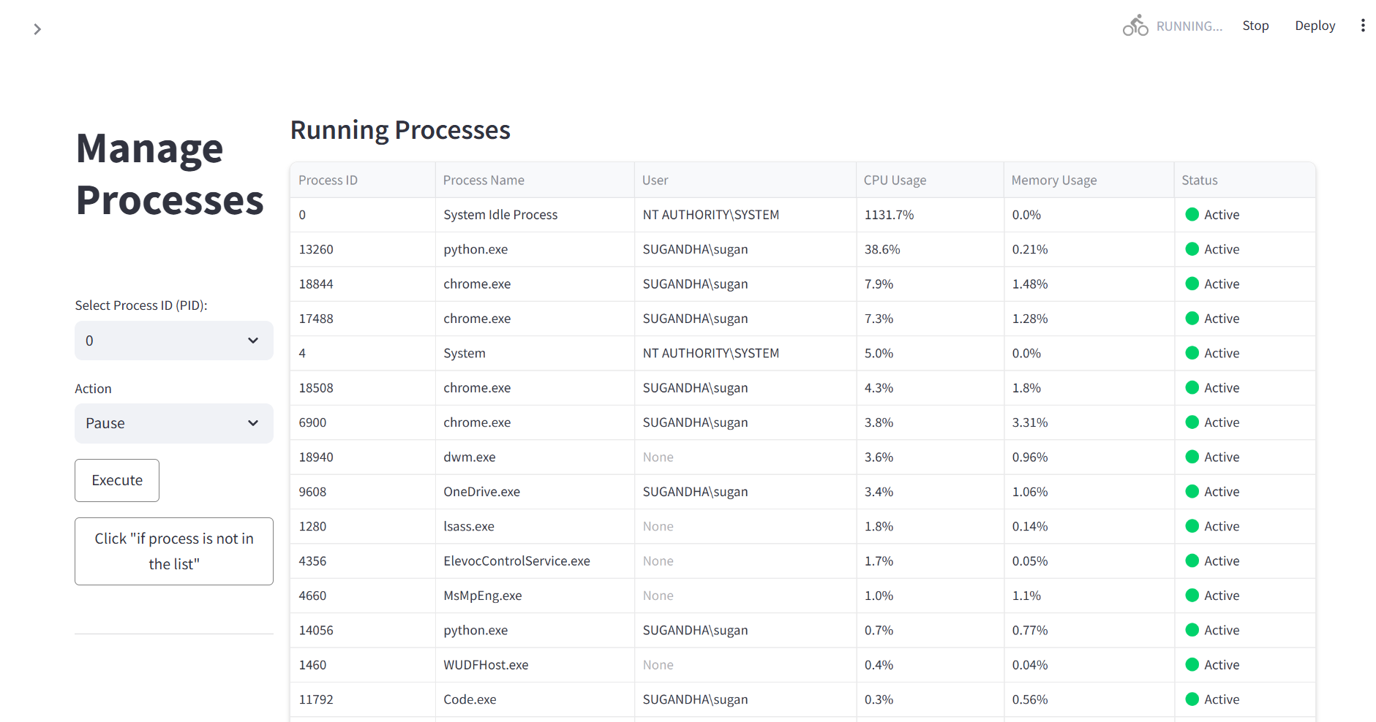

Fig 5. Process Manager

  - Alerts & Customization Tab
    - CPU Thresholds: Users can set thresholds for CPU usage (e.g., if CPU usage exceeds 90%, the app triggers an alert).
    - Error Alerts: Customizable error alerts for high memory usage, disk space warnings, or other system anomalies.
    - Notifications: The app sends notifications or visual cues when thresholds are crossed, allowing the user to take action.

    - Fig 6. Alerts & Customization Tab
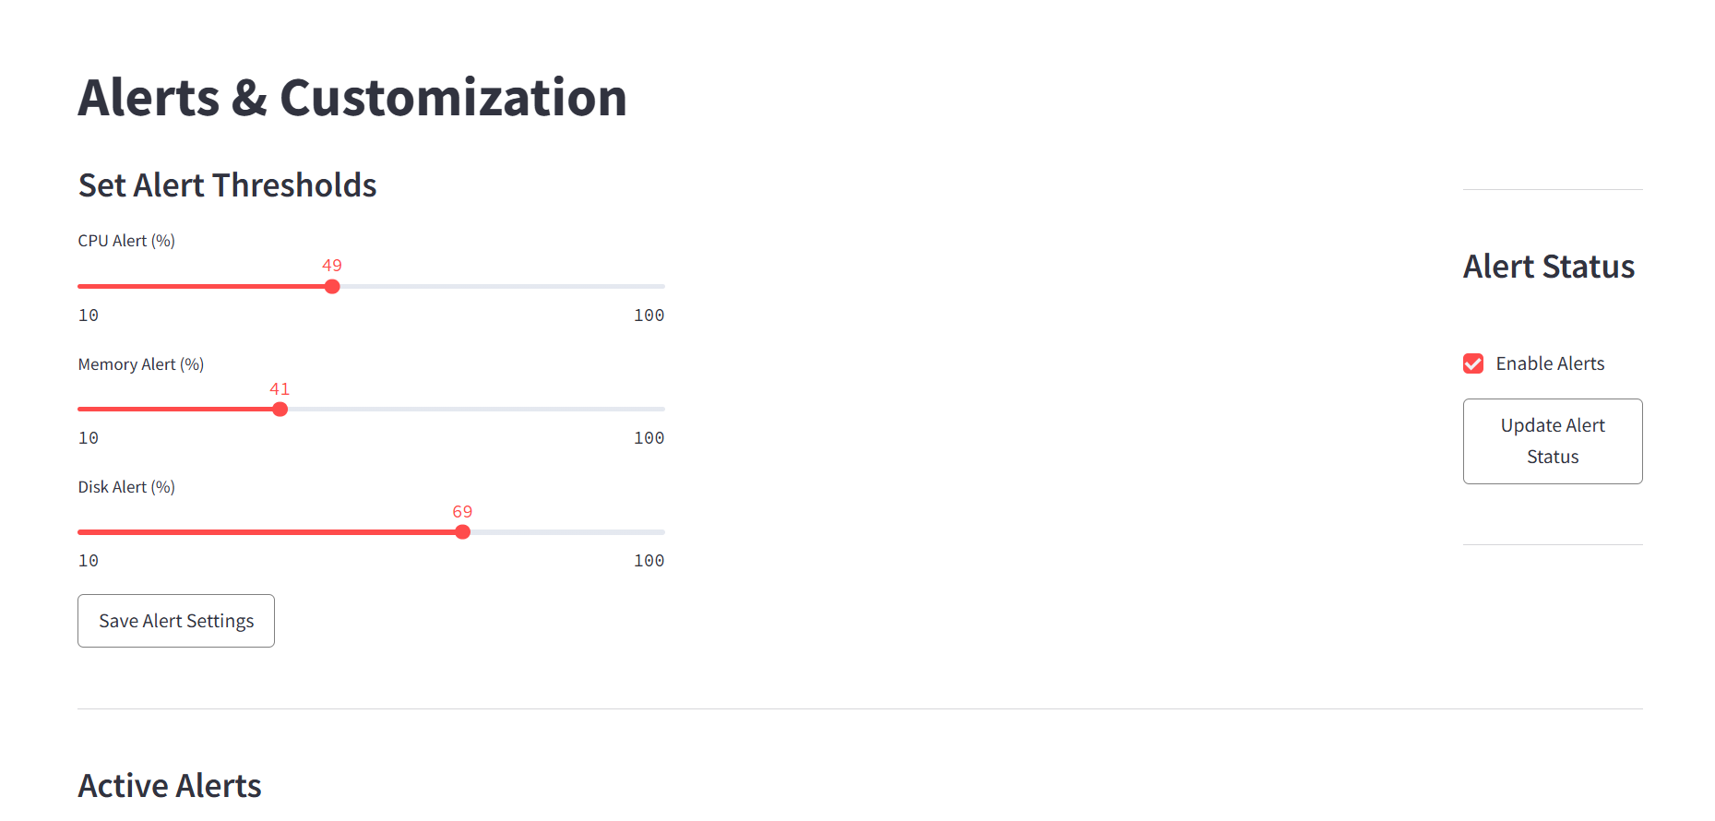
  - About Us Tab
    - Displays the background and details of the project, its purpose, and how it works.

CONCLUSION
  - The Real-Time Monitoring Dashboard project serves as an efficient and user-friendly tool to monitor and manage system processes, offering real-time insights into the health and performance of a computer's hardware and software. With key features like dynamic graphs, process management, and customizable alerts, the app provides users with full control over their system's resource consumption, enabling quick actions to optimize performance.
  - The app's modular design, including tabs for task management, process monitoring, and alerts customization, allows for seamless navigation and interaction. Whether you're tracking CPU usage, managing running processes, or setting thresholds for performance alerts, the dashboard provides an integrated view that enhances both system management and user experience.
  - In conclusion, this project not only provides essential monitoring tools but also enhances system efficiency through proactive alerts and intuitive control. Future improvements can focus on adding advanced features like remote system monitoring, integration with cloud storage, or predictive analytics for system failure prevention.

FUTURE SCOPE
  - The Real-Time Monitoring Dashboard has strong potential for future enhancements and scalability. Here are some key areas for future development:
    - Remote Monitoring Support
      - Enable users to monitor and manage systems over a network or the internet, making the dashboard useful for IT administrators and large-scale deployments.
    - Mobile App Integration
      - Develop a mobile companion app that can receive alerts, show real-time stats, or allow basic controls remotely for better accessibility and convenience.
    - Advance Visualizations
      - Incorporating more sophisticated charts like heatmaps for placement density, radar charts for multi-factor stream comparison, or dynamic trend graphs could provide deeper insights for analysis.
    - Predictive Analysis Using ML
      - Incorporate machine learning algorithms to predict potential system failures, identify suspicious process behavior, or suggest optimization steps based on usage patterns.
    - Voice Command Integration
      - Enable basic system commands via voice for accessibility and hands-free usage, integrating with tools like Google Assistant or Cortana.

REFERENCES
  - psutil – For accessing system-level information like CPU, memory, disk, and processes.
https://pypi.org/project/psutil/
  - streamlit – For building the interactive web-based dashboard UI.
https://streamlit.io/
  - pandas – For data handling and manipulation where needed.
https://pandas.pydata.org/
  - matplotlib / plotly – For plotting real-time graphs and visualizations.
https://matplotlib.org/
https://plotly.com/python/
  - Real-Time System Monitoring with Python – GeeksforGeeks
  - Building Dashboards with Python – Towards Data Science

